THE DRAWING(S) AND THE INFORMATION CONTAINED HEREIN ARE THE PROPERTY OF WOOJIN INDUSTRIAL SYSTEMS CO., LTD. THEY SHALL NOT BE DISCLOSED, REPRODUCED OR USED, IN ANY MANNER WITHOUT THE PRIOR WRITTEN CONSENT OF WOOJIN INDUSTRIAL SYSTEMS CO., LTD. |  | Failure Report  (PAC-INT Board)
DISTRIBUTION |  | R  E  V  I  S  I  O  N
 |  | R  E  V  I  S  I  O  N | 0 | Dec 08, 2011 |  | Issued |  |  | T.M.JANG | J.S.JEONG | B.J.JONE | E.K.LEE
 |  | R  E  V  I  S  I  O  N | No. | ISSUED  DATE |  | REVISION NOTE |  |  | DESIGNED | CHECKED | APPROVED | REVIEWED
 |  |  |  |  |  |  |  |  | ENGINEERING |  |  | PM
 |  | PM |  |  | REVIEWED |  | E.K.LEE |  | CUSTOMER :
 |  | ENGINEERING |  |  | APPROVED |  | B.J.JONE |  | HYUNDAI-ROTEM COMPANY
 |  |  |  |  | CHECKED |  | J.S.JEONG
 |  |  |  |  | DESIGNED |  | T.M.JANG |  | PROJECT :
 |  | ISSUED DATE |  |  | December 08, 2011 |  |  |  | SEPTA SILVERLINER V  COMMUNICATION SYSTEM
 |  | ISSUED BY |  |  | R & D CENTER
 |  | PROJECT NO. |  |  | P2009-024
 |  | ORDER NO. |  |  | P091201400 |  |  |  | 
 |  | DOCUMENT NO. |  |  |  |  |  | REVISION
 |  | WJ-RPT-005 |  |  |  |  |  | 0
TOTAL |  |  |  |  |  |  |  | 0
- General
This document is prepared as a failure report on the PAC-INT board failures occurred from the revenue service of Silverliner V trains. The result of the failure analysis and the proposed remedial action is described herein.

- Observed Problem
9 bad boards have been found in the period of 10/31/2011~12/15/2011. These bad boards caused loss of interior/exterior audio, and Intercom interface problems.

- Failure Modes
Below is the summary of the PAC-INT board failures.
Date | Car # | Ser. No. | Problem
10/31/2011 | 709 (A-end) | 11035 | No audio output at A-end
11/11/2011 | 836 | 10107 | No audio output at MPA car
11/11/2011 | Spare | 11045 | No audio output at MPA car
11/14/2011 | 813 | 11052 | No audio output at MPB car
11/16/2011 | 829 | 10055 | No manual PA
11/17/2011 | 716 (F-end) | 10058 | PEI not activated
11/28/2011 | 711 (A-end) | 11062 | No audio output at A-end
12/14/2011 | 708 (A-end) | 11054 | No audio output at A-end
12/15/2011 | 714 (F-end) | 11061 | No audio output at F-end

The observed failure mode was in 2 categories – ‘no audio’ and ‘intercom interface problem’.

Failure mode #1: Intercom interface problem
PAC-INT s/n 10055 and 10058 were in this failure mode.
Woojin and KTCC (=Intercom box manufacturer) previously had an interface issue on tone signal detection, and therefore both company’s hardware had to be changed. The PAC-INT 10055 and 10058 were NOT defective but they turned out to be an old version causing the interface problems.

Failure mode #2: No audio output
PAC-INT s/n 11035, 10107, 11045, 11052, 11062, 11054 and 11061 were in this failure mode.
The common root cause for these boards was the faulty ‘Chuk Converter (LM2611)’, resulting in a loss of -12V power. This -12V power is one of the power source that controls the operational amplifier, and therefore the system will lose its audio outputs in case of the absence of this power source.

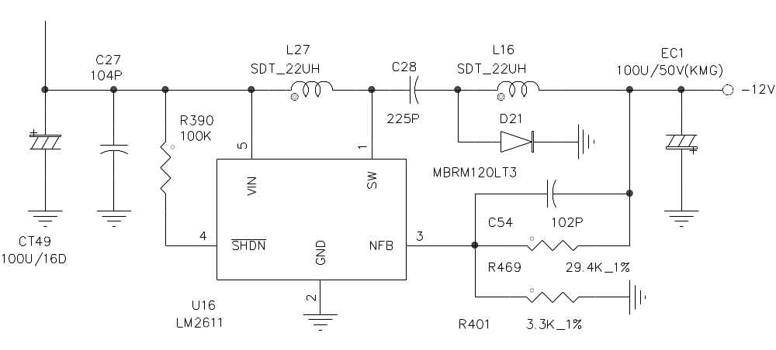

- Analysis & Tracking

4.1 Physical Inspection
No physical damage was found on the component.

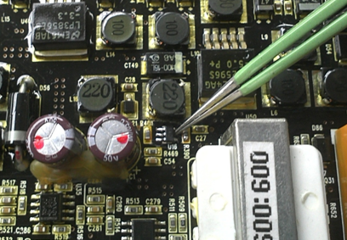

4.2 Capacity Review
The maximum current during operation read 114.7mA.

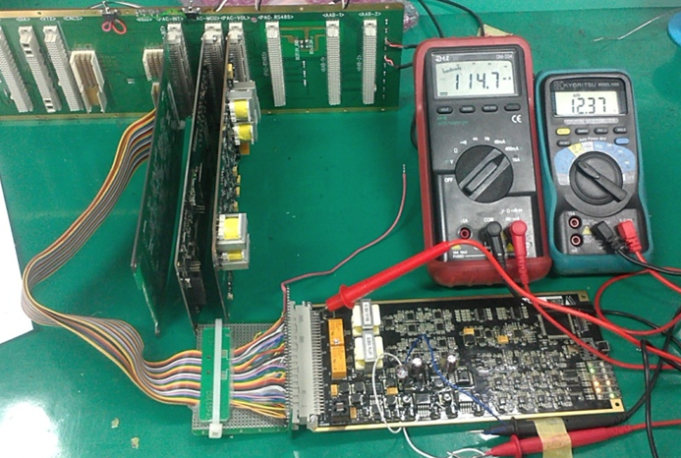

The OEM datasheet states that the capacity of this component is greater than 160mA where the input is 12V and the output is -12V.
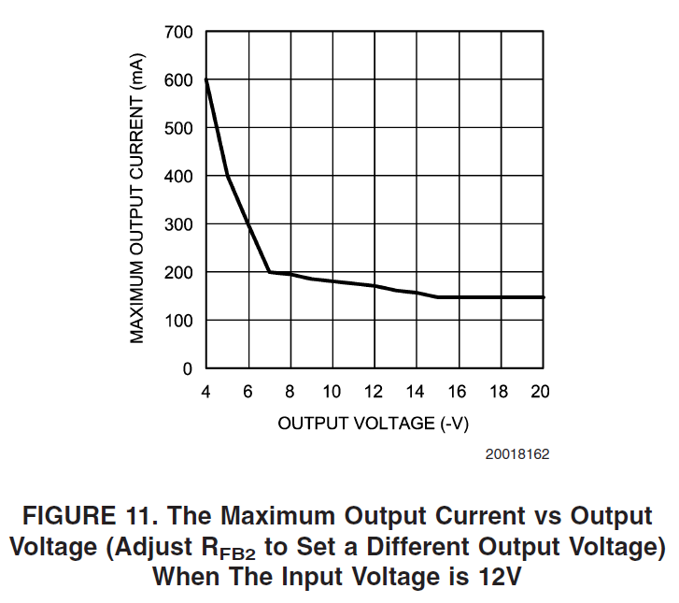

4.3 Power On/off Test
To determine the possibility of the failure during power-up, a power on/off test has been performed.
- Number of samples : 3 pcs of LM2611
- Number of times : Approximately 500 times per sample
- Test result : No defect found

According to the result of section 4.1~4.3, this issue is not considered as a design deficiency.

- Production Date Tracking
To further investigate the root cause of the PAC-INT failures, the production periods of the defective boards have been tracked.
Ser. No. | Problem | Delivery Date from sub-supplier to Woojin | Remark
11035 | No audio output at A-end | 03/21/2011 | LM2611
10107 | No audio output at MPA car | 03/28/2011 | LM2611
11045 | No audio output at MPA car | 03/21/2011 | LM2611
11052 | No audio output at MPB car | 03/21/2011 | LM2611
10055 | No manual PA | 08/24/2010 | Old version
10058 | PEI not activated | 08/24/2010 | Old version
11062 | No audio output at A-end | 03/28/2011 | LM2611
11054 | No audio output at A-end | 03/21/2011 | LM2611
11061 | No audio output at F-end | 03/28/2011 | LM2611

It has been discovered that all of the PAC-INT boards with bad LM2611 were delivered on March 2011.

- Conclusion
The major root cause of the recent PAC-INT failures is deemed to be a routine production failure of LM2611 component used on the PCB assemblies that have been delivered from 03/21/2011 to 03/28/2011.
To prevent the reoccurrence of the failure, all PAC-INT boards delivered in this period shall be recalled by Woojin.

- Remedial Action Plan
According to Woojin’s delivery record, PAC INT s/n 11021~11072 are the ones that were delivered in the mentioned period and have potential problem on LM2611 component. Out of 52 boards, 7 boards have already been replaced upon the failure, leaving 45 boards to be recalled.
Woojin will prepare 10 additional PAC-INT boards to start this product recall. This way Woojin local support team will be able to return first 10 bad boards from the site. Then this process will be repeated for 10 boards at a time until all problematic assemblies are recalled and reworked.

- Schedule
- Product recall to be completed in 1 month after Rotem’s approval

