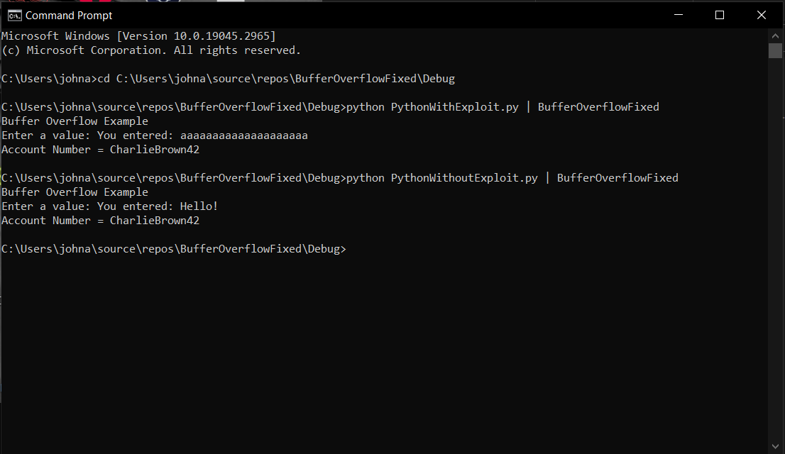

To prevent the overflow from happening what I did was first use cin.width() function and passing the size of the user input buffer as the parameter so that the maximum length of the next user input to the maximum size of the user_input buffer size. Originally at this point, it was only allowing the first nineteen characters of the user input so I increased the user_input buffer size by one to account for the null space. This corrected it to only accepting a maximum of twenty characters to be passed to the user_input variable preventing the buffer overflow. To test it I used the Python scripts provided in the command prompt and added the screenshot to that above.