Home Activity

1. What information should the app provide or display?
   1. The app should display the Shot Order by number, Time between shots, total timer count and UI elements necessary for the application functionality i.e. sharing, toolbar, menu tabs/bar.
2. What do you expect to do with the app?
   1. The app should be able to detect the shots fired and keep track of the time interval between them and total time until the user decides the application should stop gather data.
3. What to do with the information?
   1. Share the data collected by email or saving the file into a database.
4. Sketch 3-5 app’s Activities:

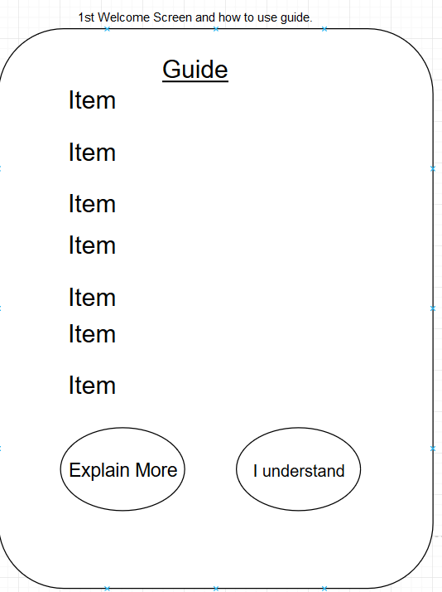

The welcome screen acts a how-to guide and disclosure about the application. This will contain information about how far you should have your device from the weapon firing. It can contain safety information related to the range or judges’ rules for the shooter. This will only pop up once on the launch of the application. Unless the user clicks help guide In the home screen activity.

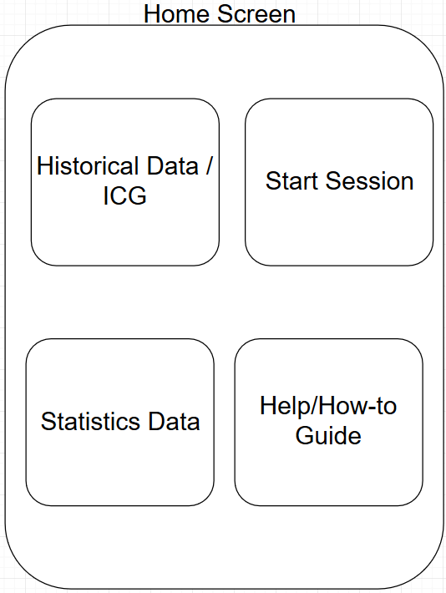

This is the home screen activity and like many apps this is where every tool is accessible in large tiles. The “Historical data” tile will launch the Historical data activity that will show a by day history. The start session tile will launch the session screen which will have the functional aspect of the app provided to the user. Statistical Data tile will launch the statically activity which will contain lifetime averages of data. Help/How-to guide will launch the welcome screen activity.

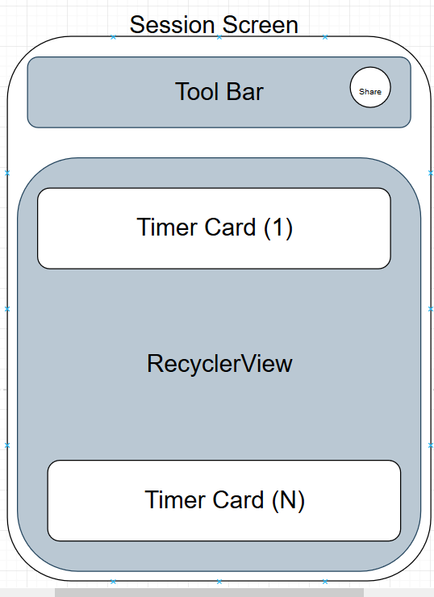

The session activity will contain the timer that will automatically start recording and keeping track of time. The toolbar will contain the stop timer and the ability to share the session via email. Once stopped is hit on the toolbar, the recycler view will display the shots fired in sequence and the interval between them.

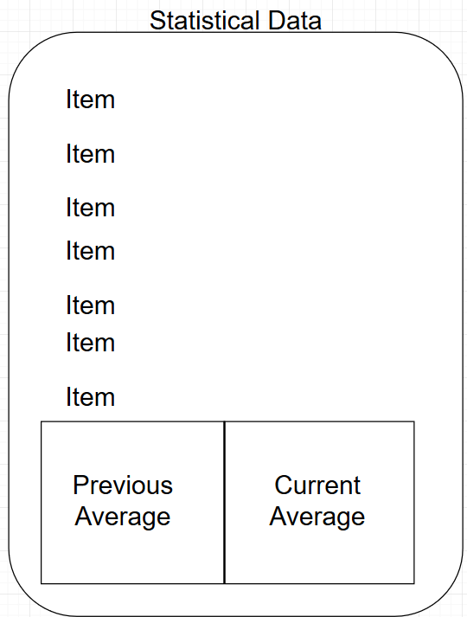

Statistical Data – Calculate and display various time statistics

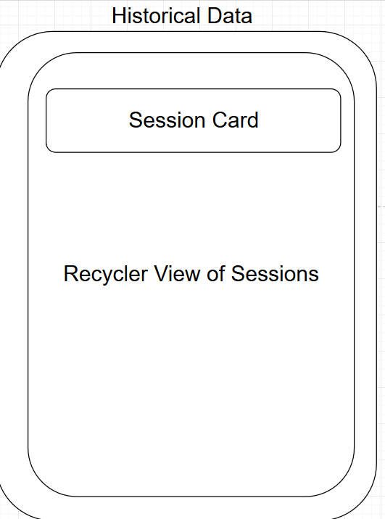

Get and display data for past shooting sessions

Task Breakdown:

1. Welcome Screen
   1. Create Scroll View
   2. Add Text View Items
   3. Create Two buttons
   4. Method for buttons to launch URL
2. Home Screen
   1. Create buttons that launch activities
3. Session Screen
   1. Start recording shots, time between them, and total time
   2. Stop session
   3. Save session data
   4. Display live session
   5. Calculate shot data
4. Statistical Data
   1. Calculate and display various time statistics
   2. Create and display number of shots for sessions
5. Historical Data
   1. Display history of sessions

Questions for Tag

1. Is a comparison of times useful?
2. What various time statistics should we calculate?
3. Any preferences on how data is shared? Email? Print?
4. Would you like GPS location saved of where session was?
5. Anything else in particular the judges could use that you would like implemented?