Now we know how Elon Musk plans to get 1 million people to Mars.

At a conference in Mexico today (Sept. 27) the SpaceX founder and CEO unveiled the company’s Interplanetary Transport System (ITS), which will combine the most powerful rocket ever built with a spaceship designed to carry at least 100 people to the Red Planet per flight. If all goes according to plan, the reusable ITS will help humanity establish a permanent, self-sustaining colony on the Red Planet within the next 50 to 100 years, Musk said at the International Astronautical Congress in Guadalajara. [SpaceX’s Interplanetary Transport for Mars in Images]

What I really want to do here is to make Mars seem possible – make it seem as though it’s something that we could do in our lifetimes, and that you can go,” he said.

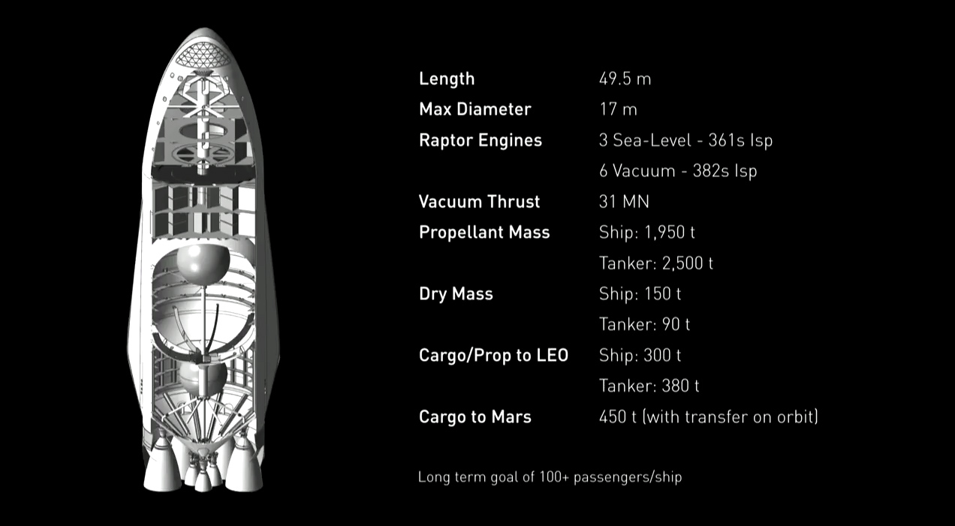

http://www.space.com/images/i/000/058/681/original/spacex-mars-transporter-spaceship-cross-section.jpg?1475011663?interpolation=lanczos-none&downsize=*:1400

A cutaway look at SpaceX's Interplanetary Transport System spaceship to ferry humans to Mars and beyond.

*Credit: SpaceX*

Mars Transport System

Length: 49.5 m

Max Diameter: 17 m

Raptor Engines:

3 Sea-Level – 361s Isp

6 Vacuum – 382s Isp

Vacuum Thrust: 31 MN

Propellant Mass:

Ship: 1950 t

Tanker: 2500 t

Cargo/Prop to LEO

Ship: 300 t

Tanker: 380 t

Cargo to Mars: 450 t (with transfer on orbit)

The ITS rocket will be more or less a scaled-up version of the first stage of SpaceX’s Falcon 9 booster, Musk said. But the 254-foot-tall (77.5 meters) ITS booster will feature 42 Raptor engines, whereas the Falcon 9 us powered by nine Merlins. When combined with its crewed spaceship, the ITS will stand a full 400 feet (122 m) high, Musk wrote on Twitter. That would make it the largest spaceflight system ever built, taller even than NASA’s legendary Saturn V moon rocket.

The Raptor engine, which SpaceX recently test-fired for the first time, is about the same size as Merlin but three times more powerful, Musk said. ITS will therefore be an incredibly potent machine, capable of lofting 300 tons to low-Earth orbit (LEO) – more than two times more than Saturn V could life. (That’s for ITS’s reusable version; an expendable variant could launch about 550 tons to LEO, Musk said.)

The spaceship, which sits atop the booster will be 162 feet (49.5 m) tall and 56 feet (17 m) wide and will have nine Raptors of its own. The booster will launch the spaceship to Earth orbit, then return to make a soft landing at its launch site, which is currently envisioned to be Launch Pad 39A at NASA’s Kennedy Space Center in Florida. [Fly Through SpaceX’s Interplanetary Spaceship | Video]

The spaceship will lift off with little if any fuel on board, to maximize the payload – people, cargo or a combination of both – that the craft is able to carry to orbit. An ITS booster will therefore launch again, topped with a tanker, and rendezvous with the orbiting spaceship to fill its tank.

Then, when the timing is right – Earth and Mars align favorably for interplanetary missions just once every 26 months- the spaceship portion of the ITS will turn its engines on and blast from Earth orbit toward the Red Planet.

The spaceship will be capable of transporting at least 100 and perhaps as many as 200 people, Musk said. It will also likely feature movie theaters, lecture halls and a restaurant, giving the Red Planet pioneers a far different experience than that enjoyed by NASA’s Apollo astronauts, who were crammed into a tiny capsule on their way to the moon.

“It’ll be, like, really fun to go,” Musk said. “You’ll have a great time.”

The powerful Raptors will allow the ship to make the trip in as little as 80 days initially, depending on exactly where Earth and Mars are at the time, Musk said. That’s a pretty quick trip; it takes six to nine months for spacecraft to reach the Red Planet using currently available technology. And Musk said he eventually thinks the ITS ship will be able to cut the travel time to just 30 days or so.

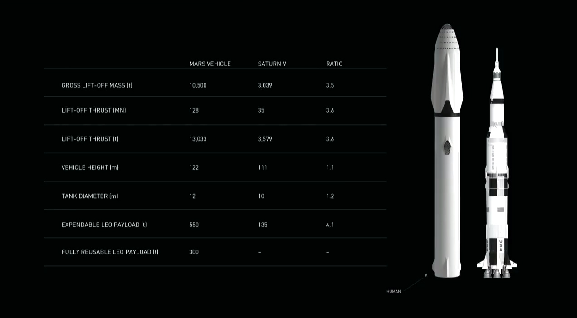

[http://www.space.com/images/i/000/058/679/original/spacex-mars-transporter-launch-capability.jpg?1475011417?interpolation=lanczos-none&downsize=*:1400](http://www.space.com/images/i/000/058/679/original/spacex-mars-transporter-launch-capability.jpg?1475011417?interpolation=lanczos-none&downsize=*:1400)

This SpaceX graphic shows how the capabilities of the company's Interplanetary Transport for Mars stacks up to NASA's massive Saturn V moon rocket.

*Credit: SpaceX*

There won’t be just one ship making the journey. When the ITS is really up and running, 1,000 or more of the ships will zoom off o Mars every 26 months.

“The Mars colonial fleet would depart en masse,” Musk said.

This fleet would land on Mars using “supersonic retropulsion,” slowing down enough to touch down softly by firing onboard thrusters rather than relying on parachutes. SpaceX said it plans to test this landing technique during the company’s upcoming “Red Dragon” mission, which aims to launch SpaceX’s uncrewed Dragon capsule toward Mars in May 2018.

Not a one-way trip

SpaceX also plans to build a solar-powered factory on Mars that will use the carbon dioxide and water ice in the planet’s air and soil, respectively, to generate methane and oxygen – the propellant used by the Raptor engine. (Musk didn’t discuss other aspects of the Mars colony; SpaceX is concentrating on the transportation architecture, reasoning that the colonists themselves will build most of the city they live in.) [SpaceX’s Interplanetary Ship Could Go Beyond Mars | Video]

The ITS spaceships will be refueled on Mars and will launch back to Earth from there, meaning prospective colonists don’t have to stay on the Red Planet forever if they don’t want to. (Getting off Mars doesn’t require a big rocket, because the planet is much smaller than Earth and therefore has a weaker gravitational pull.)

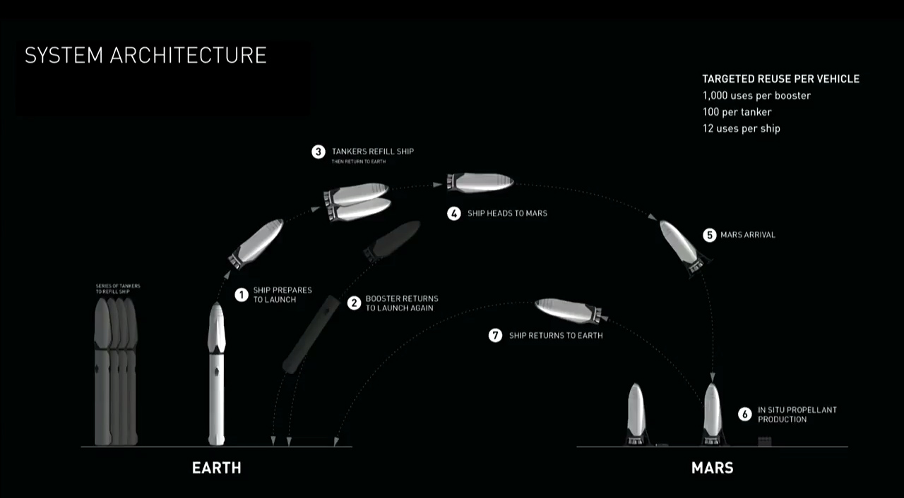

[http://www.space.com/images/i/000/058/672/original/spacex-mars-interplanetary-transport-mission-profile.jpg?1475006320?interpolation=lanczos-none&downsize=*:1400](http://www.space.com/images/i/000/058/672/original/spacex-mars-interplanetary-transport-mission-profile.jpg?1475006320?interpolation=lanczos-none&downsize=*:1400)

This SpaceX graphic depicts the mission profile for the company's Interplanetary Transport System, a colony ship to fly 100 people to Mars at a time.

*Credit: SpaceX*

“We need the spaceship back, so it’s coming,” Musk said. “you can jump on board or not.”

Each ITS spaceship will probably be able to fly at least a dozen times, and each booster should see even more action, Musk said. This reusability is the key component of SpaceX’s plan, and should be the chief driver in bringing the price of a Mars trip – which Musk said would cost about $10 billion per person using today’s technology – down to reasonable levels.

“The architecture allows for a cost per ticket of less than $200,000,” Musk said. “we think that the cost of moving to Mars ultimately could drop below $100,000.”

Coming soon?

Fewer than 5 percent of SpaceX’s personnel are working on the ITS at the moment, Musk said. And the company is currently spending just a few tens of millions of dollars on the project every year, which Musk estimated would ultimately require a company investment of about $10 billion.

But that should change as SpaceX wraps up work on the final version of the Falcon 9 and its crewed Dragon capsule, which will carry astronauts to and from the International Space Station for NASA (and perhaps ferry folks to other destinations close to Earth), Musk said.

Within two years, Musk aims to be devoting most of SpaceX’s engineers to ITS, and to be spending perhaps $300 million annually on the project. He envisions other organizations eventually aiding SpaceX in Mars colonization as well, saying the effort will be a “huge public-privae partnership.”

He said he hopes to complete the first development of the spaceship within four years, then start suborbital testing shortly thereafter. If everything goes really well, Musk said, the ITS could be launching on its first Mars mission “within the 10-year time frame.”

In the meantime, SpaceX plans to keep launching Dragons toward the Red Planet every 26 months using the company’s Falcon Heavy rocket, to test technology and to establish a “steady cadence” of robotic missions that scientists could take advantage of to send experiments to Mars, Musk said.

The ITS could also be used for many other things, possibly enabling human exploration of Jupiter’s ocean-harboring moon Europa or allowing cargo to get from New York to Tokyo in just 25 minutes, Musk said. But for now, the main goal is colonizing Mars, which Musk has long said is the reason he started SpaceX back in 2002.

“The objective is to become a spacefaring civilization and a multiplanet species,” the billionaire entrepreneur said, adding that doing so will make humanity far less susceptible to extinction. “The main reason I’m personally accumulating assets is to fund this.”

SpaceX’s Elon Musk Unveils Interplanetary Spaceship to Colonize Mars

https://www.google.com/amp/amp.space.com/34210-elon-musk-unveils-spacex-mars-colony-ship.html

Meet SpaceX’s Interplanetary Ship

SpaceX CEO Elon Musk unveiled the company’s Interplanetary Transport System for Mars colonization and beyond on Sept.27, 2016 at International Astronautical Congress in Guadalajara, Mexico.

Targeted Reuse per vehicle

1000 uses per booster

100 per tanker

12 uses per ship

Elon Musk Unveils SpaceX Raptor Engine Test for Interplanetary Transport

SpaceX has successfully test-fired the new Raptor rocket engine that will launch the company’s planned interplanetary spaceship, according to a series of tweets from the company’s CEO, Elon Musk. The engine is being developed to help propel a powerful reusable rocket to Mars and beyond as part of SpaceX’s Interplanetary Transport System.

Although Mus revealed some technical details about the engine on Twitter, he promised to reveal more tomorrow (Sept. 27) at his scheduled talk at the International Astronautical Congress even in Guadalajara, Mexico. Musk did not disclose when the test had taken place.

Earlier this month, Musk took to Twitter to announce a name change from the ambitious Mars Colonial Transporter, which can go “well beyond Mars,” he said in a series of tweets. The Raptor forms a vital part of the newly named Interplanetary Transport System.

Through Twitter, Musk confirmed that the engines’ nozzle is about 14 feet (4.3 meters) in diameter, and that the final version will generated 3 million newtons of force, with a chamber pressure three times that of the Merlin engines that currently propel SpaceX’s Falcon 9 rocket.

“Production Raptor goal is specific impulse of 382 seconds and thrust of 3 MN (~310 metric tons) at 300 bar,” he wrote on Twitter. “382s is with a 150 area ratio vacuum (or Mars ambient pressure) nozzle. Will go over specs for both versions on Tues.,” he clarified in another tweet.

Back in 2012, Musk described the Raptor engine as working similarly to the engines that propelled NASA’s space shuttles, with a two-stage cycle that is more efficient than the current Merlin engines used by the company’s Falcon 9 rocket. Rather than using liquid oxygen and kerosene as fuel as the Falcon 9’s engines do, Raptor will use liquid oxygen and methane to reduce energy costs as well, Musk said at the time.

SpaceX intends to launch an uncrewed Mars mission in 2018, using a Dragon space capsule and a Falcon Heavy rocket. The Interplanetary

Transport System could launch humans to Mars as early as 2024 if all goes well, Musk has said.

Elon Musk Unveils SpaceX Raptor Engine Test for Interplanetary Transport

<http://www.space.com/34192-spacex-raptor-rocket-test-first-photod.html>

Googling raptor engine chamber pressure

Raptor (rocket engine family)

Liquid-fuel engine

Nozzle ratio 200

Performance

Thrust 3,500 kN (790,000 lbf)

Chamber Pressure 30 MPa (4400 psi)

The commercial spaceflight company SpaceX announce on Twitter today that it plans to send its robotic dragon capsule to Mars as early as 2018.

“Red Dragons will inform the overall Mars architecture,” SpaceX representatives tweeted today (April 27), referring to the company’s eventual plans to set up a colony on Mars – a key goal of SpaceX and its founder, billionaire entrepreneur Elon Musk.

A source familiar with the company’s plans said the first test flight of a Dragon capsule to Mars would demonstrate technologies needed to land large payloads on the Red Planet. That could include supplies and habitats for Martian explorers. In addition, the source said that SpaceX intends to reveal details of its colonization architecture later this year. [SpaceX’s Red Dragon: A Private Mars Mission Plan in Pictures]

“dragon 2 is designed to be able to land anywhere in the solar system. Red Dragon Mars mission is the first test flight,” Musk tweeted today. “But wouldn’t recommend transporting astronauts beyond Earth-moon region. Wouldn’t be fun for longer journey. Internal volume ~ size of SUV.”

In November 2015, SpaceX released a video showing its Dragon V2 capsule – the crewed version of the spacecraft – during a hover test, meant to demonstrate how the capsule would gently lower itself down onto the surface of a distance world.

Last year, a group of NASA scientists explored the possibility of a Red Dragon mission, in which a SpaceX capsule could be used to pick up the rock and soil samples that will be collected by the agency’s Mars 2020 rover, and return them to Earth for further study. That mission has not been approved by NASA, nor has SpaceX confirmed that it would participate.

In January 2015, during a Reddit “Ask Me Anything” session, Musk said that plans for the company’s “Mars Colonial Transport” – the spaceflight system that will take humans to and from the Red Plane – would be released by the end of the year, but that has not yet happened. The company is currently developing a rocket called the Falcon Heavy, which the company says will have the capacity to carry humans and cargo to deep-space destinations, even Mars.

On April 8, SpaceX passed a major milestone in its development of reusable rockets when it successfully landed the first stage of its Falcon 9 rocket on a drone ship. Musk has said that reusable rockets will dramatically lower the cost of going to space, thereby making ambitious, expensive efforts such as Mars colonization more economically feasible.

SpaceX has a contract with NASA to carry cargo to the International Space Station aboard its Dragon space capsules. Orbital ATK is also a current cargo carrier for the agency. Both companies were selected by NASA for the next round of cargo delivery missions, in addition to the Sierra Nevada Corp.

SpaceX and Boeing were selected to carry astronauts to the orbiting laboratory. NASA has said it wants those crewed flights to begin as early as 2017.

NASA has also announced plans to send humans to Mars as soon as the 2030s, although details of the agency’s plan still need to be worked out.

<http://www.space.com/32719-spacex-red-dragon-mars-missions-2018.html>

The Falcon 9 rocket is the vehicle that brings Space Exploration Technologies (SpaceX)’s Dragon spacecraft into space. SpaceX regularly uses the Falcon 9 to bring its Dragon spacecraft to the International Space Station. Dragon made the first private spacecraft visit ever there in October 2012.

SpaceX views Falcon 9 as a stepping-stone to an even heavier-lift rocket, called the Falcon Heavy. Still under development and expected for a test launch in 2017, this rocket is expected to send up to 117,000 lbs. (53,000 kilograms) of cargo into space. This is about twice the weight the space shuttle used to be able to bring into space.

Starting in 2013, SpaceX made some flights of the Falcon 9 using a first stage that it says could be reusable, providing it lands in the right way. The company has achieved soft landings in the ocean and also on land. On April 8, 2016, a dragon rocket booster landed on a drone ship in the atlantic Ocean. It was the fifth attempt in 15 months.

Specs

* Height: 229.6 feet (70 meters)
* Diameter: 12 feet (3.7 m)
* Mass: 1,194,000 lbs. (541,300 kg)
* Payload to low earth orbit (LEO): 28,991 lbs. (13,150 kg)
* Payload to geosynchronous transfer orbit (GTO): 10,692 lbs. (4,50 kg)

The Falcon 9 is a two-stage rocket. The first stage has nine Merlin engines and aluminum-lithium alloy tanks containing liquid oxygen and rocket-grade kerosene (RP-1) propellant, according to SpaceX.

* Burn time: 162 seconds
* Thrust at sea level: 1.53 million lbs. or 6806 kilonewtons (kN)
* Thrust in vacuum: 1.6695 million lbs. (7,426 kN)

The second stage has one engine that ignites after stage separation

* Burn time: 397 seconds
* Thrust: 210,000 lbs. (934 kN)

Funding the fire

SpaceX first trumpeted the Falcon 9’s existence in a press release in 2005. Then priced at up to $35 million per flight (today it’s $61.2 million), the rocket was developed in response to customer demand, the company said.

At the time, SpaceX was developing the lighter falcon 1 rocket, and planned to gradually increase capabilities with an “intermediate class” Falcon 5 launcher.

“However, in response to customer requirements for low-cost enhanced launch capability, SpaceX accelerated development of an [expendable launch] – class vehicle, upgrading Falcon 5 to Falcon 9,” the firm stated.

Early listed customers of the rocket included companies such a Bigelow Aerospace, Avanti communications and MacDonald, Dettwiler and Associates.

According to SpaceX, it cost over $300 million to develop the vehicle “from a blank sheet to first launch in four and a half years.”

The company was a winner of one of NASA’s sought-after commercial orbital transportation services contracts, which was worth up to $278 million for SpaceX provided it met allits milestones. SpaceX is one of the awarded companies under NASA’s Commercial Crew Program. The program, aims to launch astronauts to the International Space Station using American vehicles around 2018.

Development

Falcon 9’s primary structure was finished in April 2007, and the first multiple engine firings took place in January 2008.

SpaceX spent the year testing the engines, culminating in a “full mission length firing” in November of that year. In an update to its followers, the California-based company touted the rocket’s ability to compensate for failed engines in flight – a selling point to customers.

“The test firing validated the design of SpaceX’s use of nine engines on the first stage as well as the ability to shut down engines without affected the functioning of the remaining engines,” SpaceX wrote in November 2008.

“This demonstrates the ability of Falcon 9 to lose engines in flight and still complete its mission successfully, much as a commercial airliner is designed to be safe in the event of an engine loss. Like an airliner, the Falcon 9 engines are enclosed in a protective sheath that ensures a fire or destructive loss of an engine doesn’t affect the rest of the vehicle.”

Falcon 9 was designed to lift the Dragon spacecraft. NASA provided money across seceral commercial crew contracts to help fund Dragon’s development, as its primary customer was intended to be NASA cargo flights to the International Space Station. SpaceX made a world-first visit to the station with Dragon in 2012, and is now one of two private-company providers for regular cargo ISS flights (along with Orbital Sciences’, which flies Cygnus spacecraft.)

Taking Flight

On Jan. 12, 2009, the Falcon 9 rocket rose to a vertical position at Cape Canaveral. It would be several months before the rocket soared into space, but SpaceX said the configuration was necessary to test all the systems in the next year.

SpaceX hoped to send the rocket up in 2009, but the actual launch date was June 7, 2010. The rocket passed all of the expected milestones, but encountered an unexpected roll during launch.

Because the Dragon spacecraft was still under development, the rocket carried a dummy payload into space. Falcon 9 initially fueled the Dragon’s fire on Dec. 8, 2010. It was the first time a rocket had carried a private unmanned space capsule into space, which then returned safety to Earth.

While Falcon 9 successfully brought Dragon to space several times, the rocket has experienced some growing pains. For example, an engine problem forced an abort before Dragon soared to the ISS for a test flight in May 2012.

An engine problem also marred Dragon’s first official cargo run to the station five months later. Dragon arrived safely at is destination, but a satellite on board did not. Orbcomm’s prototype satellite messaging service satellite fell out of orbit early, just five days after launch. However, the New Jersey company said it had received some test data during the satellite’s brief stay in space.

Falcon 9’s most catastrophic moment came in June 2015, when the rocket exploded in mid-air while carrying a Dragon spacecraft that was supposed to resupply the International Space Station. The cause was traced to a faulty strut and flights were suspended for several months.

Pinpoint Landing

SpaceX wants to use its experience with falcon 9 to develop an even heavier lift rocket: The Falcon Heavy. The first test launch for this rocket is expected in 2016. In 2011, the company stated it hoped to use Falcon Heavy to break into the defense market, then dominated by United Launch Alliance. SpaceX and the Air Force settled a lawsuit in 2015 that was related to a ULA contract award.

By 2013 and 2014, some critics charged that SpaceX was launching far fewer flights than planned. Simultaneously, the company began flying a version of the Falcon 9 with a reusable first stage. The aim is to shave launch costs.

<http://www.space.com/18962-spacex-falcon-9.html>

Space Exploration Technologies (better known as SpaceX) is the first company to ship private cargo to the International Space Station using its own rocket and spaceship, the Dragon. The California-based company has a lucrative contract with NASA to bring cargo to the station.

Additionally, the firm has customers from the private sector, military and non-governmental entities to launch cargo into space. As the company makes its money from launch services, SpaceX is firmly focused on developing technology for future space exploration.

The company is developing what will be the world’s most powerful rocket if completed: The Falcon Heavy. Additionally, found Elon Musk has publicly speculated about the possibility of Mars colonies.

Musk’s Fortune

Musk made his fortune very early in life: by age 30, in 2002, he had accumulated a reported $300 million and was looking for his next big venture.

According to the New York Times, his money came from the sale of two companies: Zip2, which was bought for $307 million in 1999, and PayPal, which eBay purchased for $1.5 billion in 2002.

Initially, Musk had the idea of sending a greenhouse to the Red Planet, dubbed the “Mars Oasis.” It was supposed to drum up public interest in exploration while also serving as a science base. The cost ended up being too high, so instead he decided to start a launching company: SpaceX.

Musk spent a third of his reported fortune - $100 million – to get SpaceX going. At the time, there was a certain amount of skepticism that he would ever be successful, and this persisted in SpaceX’s first years.

After spending 18 months toiling privately on a spacecraft, it was released to the public in 2006 under the name “Dragon.” Musk reportedly named the Drago spacecraft after the song “Puff, the Magic Dragon,” a 1960s song from folk group Peter, Paul, and Mary. He chose the name because critics believed his spaceflight aims were impossible.

Falcon 1 Flight

But Musk, a founder of several companies, already had years of business planning behind him. He sought out a stable customer – NASA – who could give funds for the early development of a rocket. Then he wooed launch clients from various sectors to diversify his customer base.

Musk firmly believed that more frequency and more reliable launches would bring down the cost of exploration. As such, his first goal for SpaceX was development of the Falcon 1 rocket.

That alone was an ambitious milestone, as the rocket would be the first privately built, liquid-fueled booster to make it into orbit. The company experienced a steep learning curve on the road to orbit.

It took four tried to get Falcon 1 flying, with previous attempts derailed by problems such as fuel laks and a rocket stage collision.

“As the saying goes, the fourth time’s the charm,” Musk told his company of 500 workers on Spt. 28, 2008. “This is one of the best days of my life.”

By this point, SpaceX’s technology had the full attention of NASA. The company received a $278 million deal in 2006 to demonstrate the ability to send and return cargo to and from the space station. Four months after Falcon 1 first flew successfully, NASA awarded SpaceX a further contract for 12 station resupply flights.

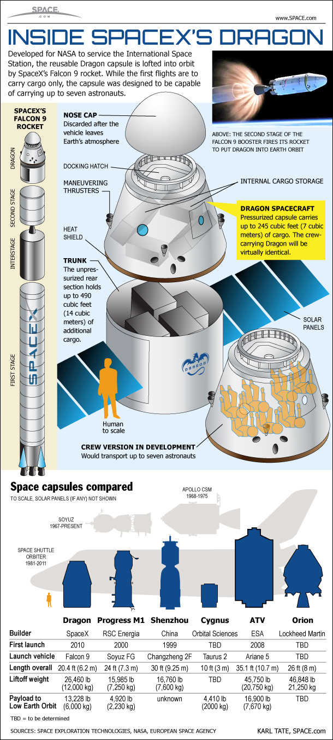

http://www.space.com/images/i/000/010/352/original/dragon-capsule-spacex-101207c-02.jpg?1308687295?interpolation=lanczos-none&downsize=*:1400

Enter the Dragon

Flying the Dragon spacecraft would require more rocket power, so SpaceX proposed developing the Falcon 9 rocket to send Dragon into orbit. SpaceX initially hoped to fly the spacecraft by 2008 or 2009, but the process took years longer than the company thought.

Both spacecraft and rocket were ready in 2010. Falcon 9 flew with a simulated Dragon payload in June 2010. In December of that year, Dragon took flight for the first time and splashed down on Earth safely.

The next and most crucial milestone was space station delivery. Dragon delivered its first truckload of cargo to the station in May 2012 under a test flight. The launch was scrubbed for a few days following an engine problem, but lifted off safely on the next try.

Regular cargo flights began with a mission in October 2012 that achieved most of its objectives, but experienced a partial rocket failure during launch that stranded a satellite on board.

SpaceX as made regular flights to ISS since then, but not without hiccups. Some critics have charged that SpaceX is not launching as regularly as promised. Also, in 2015, an explosion destroyed a Falcon 9 rocket bearing a Dragon spacecraft to the International Space Station. The cause was traced to a strut problem, grounding flights for several months.

Future thoughts

The company’s next major program goal for Dragon is to take people into space. The company is one of two funded under NASA’s Commercial Crew program. The crewed version of Dragon was unveiled to great fanfare that same year. SpaceX and its competitor, Boeing, are expected to take astronauts to the International Space Station around 2017 or 2018.

SpaceX is also attempting to build a reusable first stage of its Falcon 9 rocket. It has managed to recover the first stage after landing in water or on land, but several attempts so far to land on a barge have not been successful.

But in all these years, Musk’s dreams of flying to Mars are undimmed.

In 2011, he told delegates at the American Institute of Aeronautics and Astronautics (AIAA) in San Diego that he plans to take people to Mars in 10 to 15 years. Three years later, at the International Space Development Conference, he said the reusable rocket stage would be a step to getting to the Red Planet.

“The reason SpaceX was created was to accelerated the development of rocket technology, all for the goal of establishing a self-sustaining, permanent base on Mars,” Musk said at the time. “And I think we’re making some progress in that direction – not as fast as I’d like.”

<http://www.space.com/18853-spacex.html>

Raptor is a next-generation liquid rocket engine developed by SpaceX to power the company’s Interplanetary Transport System that aims to establish an operational cargo and crew architecture for missions between Earth and Mars, and possibly beyond – starting in the 2020s.

The dimensions of SpaceX’s Interplanetary Transport System (ITS) are unprecedented in the history of spaceflight, calling for a payload mass to the surface of Mars in the range of 450 metric tons.

Achieving this ambitious goal requires massive launch vehicle with a cluster of higher-powered engines, a propulsion system for operation in deep space and a propulsive landing and ascent architecture for operation in the Martial atmosphere. All this will be realized by SpaceX’s Raptor engine family

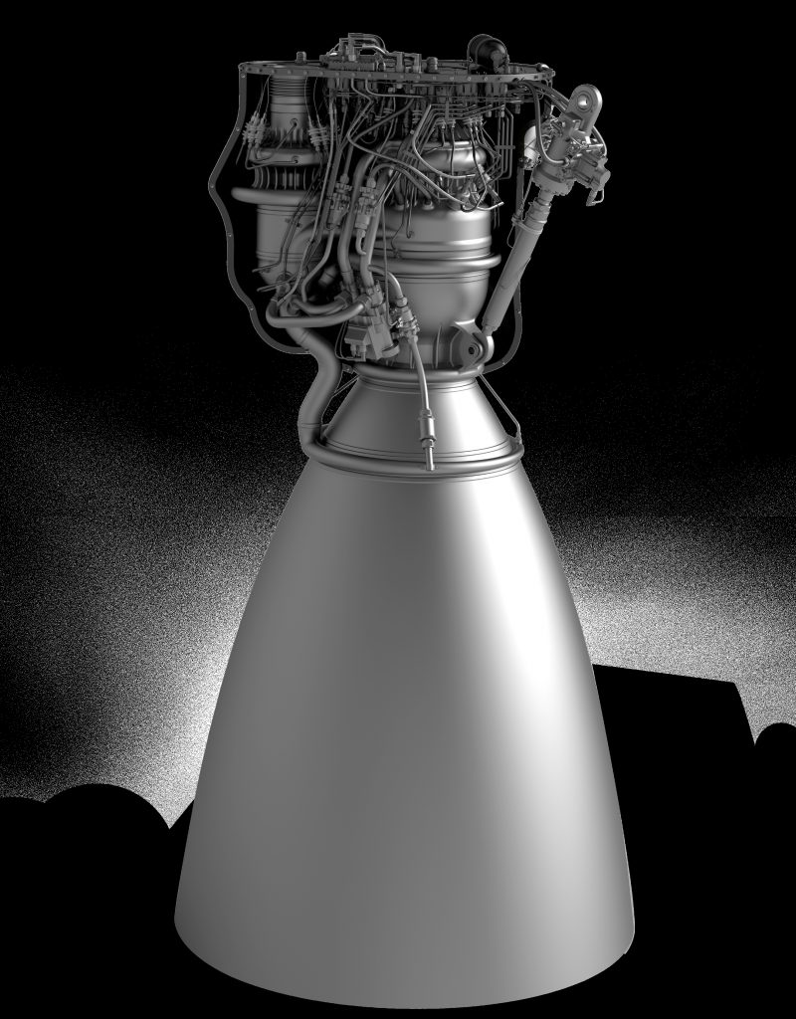

<http://spaceflight101.com/spx/wp-content/uploads/sites/113/2016/09/Raptor-CAD-800x1024.jpg>

Raptor CAD Model – Credit: SpaceX

SpaceX CEO and Chief Designer Elon Musk set his goals to Mars from the very beginnings of the company in 2002, initiating a stepwise process beginning with uncrewed flights of the small Falcon 1 before upgrading to commercial missions with the larger Falcon 9 to be followed by rewed flights to near Earth space and heavy-lift missions of the Falcon Heavy including the first precursor missions to Mars.

However, missions to explore and settle on Mars will require a much more powerful rocket with several times the thrust of SpaceX’s Falcon Heavy.

Raptor represents a family of highly reusable methane-fueled staged combustion engines that will power SpaceX’s super-heavy-lift launch vehicles for the exploration and colonization of Mars. According to Musk, ITS will incorporate a high-degree of reusability, broadening the technologies pioneered by the Falcon 9 rocket and its reusable first stage.

Raptor, first presented in 2009, started out as a low-priority project to develop a cryogenic upper stage engine powered by Liquid Hydrogen and Liquid Oxygen. By 2012, SpaceX had shifted direction in its planned propulsion architecture and Raptor’s role was broadened to become the company’s engine of choice for a large vehicle capable of transporting humans to Mars and beyond.

Raptor Specifications

The SpaceX Raptor is a cryogenic staged combustion rocket engine intended to power the high-performance lower and upper stages for the Interplanetary Transport System. It has more than three times the thrust of SpaceX’s Merlin 1D engines propelling the Falcon 9 and Falcon Heavy rockets and steps away from a Kerosene-based propellant.

The highly-reusable engine makes use of concepts first demonstrated on the Falcon 9 and Falcon Heavy rockets including deep cryogenics, cooled below their boiling point to increase their density and thus load the limited tank volume with a greater mass of propellant.

Like SpaceX’s Merlin engines, at least two versions of Raptor will be available – one for use on the first stage booster of the ITS launch vehicle and one optimized for operation in vacuum for operation outside Earth’s atmosphere for the interplanetary insertion and in the ambient Martian atmosphere for retropropulsion ahead of landing.

Raptor’s design was revealed in September 2016 during an address given by Elon Musk at the International Astronomical Congress, outlining SpaceX’s Mars transport architecture.

The expected performance parameters for the production Raptor engine call for a sea level thrust of 3,050 Kilonewtons (310 metric-ton-force) at a specific impulse of 334 seconds.

Raptor uses separate turbines and pumps on the fuel and oxidizer sides as part of a Full-Flow Staged Combustion Cycle (explained in detail below) with boost pumps delivering the necessary inlet pressure for the operation of the main turbopumps to create a combustion chamber pressure of 300 bar – he highest achieved by an operation liquid-fueled rocket engine.

Raptor specs- Sea Level Version

|  |  |
| --- | --- |
| Designation | Raptor Sea-Level |
| Type | Full-Flow Staged Combustion |
| Propellant Feed | Multi-Stage Turbopump |
| Oxidizer | Sub-Cooled Liquid Oxygen |
| Fuel | Sub-Cooled Liquid Methane |
| Thrust (Sea Level) | 3,050 Kilonewtons |
| Thrust (Vacuum) | 3,297 Kilonewtons |
| Specific Impulse (SL) | 334 Seconds |
| Specific Impulse (Vac) | 361 Seconds |
| Chamber Pressure | 300 bar |
| Throttle Range | 20 – 100% |
| Ignition | Spark Igniter |
| Re-Start Capability | Yes |
| Area Ratio | 40 |
| Mixture Ratio | 3.8 |
| Flow Rate (Calc.) | 931.2kg/sec |
| LOX Flow Rate | 737.2kg/sec |
| LCH4 Flow Rate | 194kg/sec |

The SL version of Raptor has a nozzle ratio of 40 creating a nozzle diameter on the order of 1.7 meters with an expansion optimized for operation in the discernible atmosphere since the booster will only operate at altitudes of a little over 100 Kilometers.

The baseline Raptor SL has a vacuum thrust of 3,297 Kilonewtons, per basic calculation using the known Vacuum Impulse of 361 seconds. Calculations also yield a propellant flow rate of 931 Kilograms per seconds at a mixture ratio of 3.8 (according to earlier information shared by Mr. Musk), though tank sizes on the ITS vehicles imply a mix closer to 3.7.

Like the Merlin 1D series, raptor can support extremely deep throttling with stable combustion possible down to 20% of the engine’s rate thrust. This enables the ITS Booster to fly flexible ascent profiles and actively throttle its engines on the way back to a propulsive landing, required active control of the vehicle’s thrust-to-weight ratio.

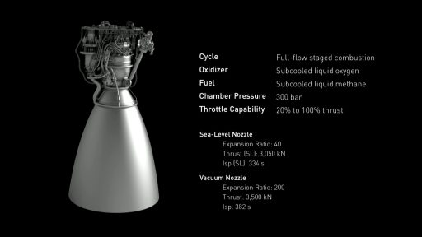

<http://spaceflight101.com/spx/wp-content/uploads/sites/113/2016/09/ITS-019-1024x576.jpg>

Raptor Specifications – Credit: SpaceX

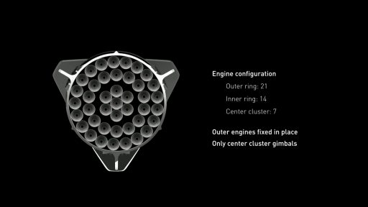

<http://spaceflight101.com/spx/wp-content/uploads/sites/113/2016/09/ITS-021-1024x576.jpg>

ITS Booster Engine Layout – Credit: SpaceX

SpaceX kept quiet on the planned Thrust-to-Weight Ratio of the Raptor engine as it is still early in its development and the number naturally changes ahead of certification testing. However, it was stated that the expected TWR is better than that of the Merlin 1D engine which, at a T/W ratio of 198 (2015/16 version), set a new record that shattered the previous best mark held by Russia’s NK-33 (137).

The creation of a high-pressure, methane-fueled, full-flow engine at a T/W ratio matching that of Merlin would represent a major milestone in space propulsion.

Because of Raptor’s excellent thrust-to-weight characteristics, SpaceX opted to go for a relatively low-thrust design with respect to the total launch thrust needed to send 450 metric tons toward Mars. The ITS Booster employs a cluster of 42 Raptor SL engines, generated a liftoff thrust of 127,800 Kilonewtons or 13,000 metric-ton-force.

The ITS Booster design calls for an outer ring of 21 engines and 14 Raptors forming an inner ring, all affixed in place with no gimbal capability which cuts tremendous mass from the engine bay. Only the seven engines clustered in the center of the Booster are gimbaled for vehicle control

For the climb to orbit, the Booster collectively fires all of its engines with multi engine-out capability. The boostback maneuver is shown to use half of the core’s engines while the atmospheric entry burn and the landing only use the inner cluster.

According to SpaceX, the Raptor manufacturing process will employ a great deal of additive manufacturing (3D printing) – a technology introduced to engine manufacturing in recent years and proven on SpaceX’s Merlin and Super Draco engines.

3D Printing allows for a great reduction of production cost and enhances the thrust to weight ratio of the engine since it enables the production of lighter parts not possible through traditional methods.

An additional advantage of 3D printing engine components is the speed at which design changes can be implements in new components to go through several iteration of the engine design in a short time span instead of spending weeks and months re-casting components based on the updated specifications.

Printed components on Raptor include propellant valves, turbopump parts, and many components of the injector system.

With the introduction of Raptor, SpaceX sticks with an overall design philosophy of simplification through commonality. Instead of developing a whole new engine for the rocket’s upper stage, the company adapts the Raptor for optimized operation in vacuum by outfitting it with a larger nozzle.

This enables the same turbopump, plumbing and chamber components to be used for the Raptor Vac engine, cutting development cost and time.

Raptor Vac is baselined for an operational thrust of 3,500 Kilonewtons (357 metric-ton-force) at a very high specific impulse of 382 seconds. The extended nozzle of the Vac engine created an area ratio of 200, calling for a nozzle dimeter around four meters.

The Raptor Vac version is used on the ITS Spacecraft and Tanker, each outfitted with six Vac engines plus three Sea Level engines that are put to use of the Tanker’s propulsive landing back on Earth and the Spaceship’s adventurous retropropulsion and landing maneuver on Mars as well as the ascent to begin the homebound trip.

Per the notional design of the Tanker/Spaceship, only the three SL Raptors in the center of the vehicle are capable of gimbaling for precise attitude control during ascent and landing maneuvers. Differential throttling on the outer vac engines is employed for control during in-space maneuvering.

Raptor Vac

|  |  |
| --- | --- |
| Designation | Raptor Vacuum |
| Type | Full-Flow Staged Combustion |
| Propellant Feed | Multi-Stage Turbopump |
| Oxidizer | Sub-Cooled Liquid Oxygen |
| Fuel | Sub-Cooled Liquid Methane |
| Thrust (Vacuum) | 3,500 Kilonewtons |
| Specific Impulse (Vac) | 382 Seconds |
| Chamber Pressure | 300 bar |
| Throttle Range | 20 – 100% |
| Ignition | Spark |
| Re-Start Capability | Yes |
| Area Ratio | 200 |
| Mixture Ratio | 3.8 |
| Flow Rate (Calc.) | 931.2kg/sec |
| LOX Flow Rate | 737.2kg/sec |
| LCH4 Flow Rate | 194kg/sec |

Opting for Methane

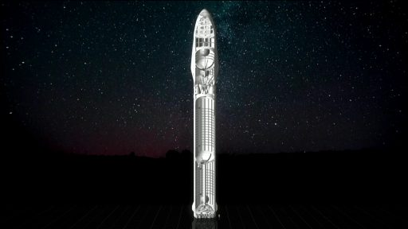

<http://spaceflight101.com/spx/wp-content/uploads/sites/113/2016/09/ITS-015-1024x576.jpg>

ITS Design – Credit: SpaceX

In choosing a methane-fueled engine design, SpaceX stepped away from the well-proven Kerosene-LOX combination used on the company’s Merlin engine series. Methane-fueled engines are a relatively new development in rocketry, being actively pursued by SpaceX’s Raptor, Blue Origin’s BE-4, Airbus Safran Launchers, and different Russian proposals (none of which is close to flight as of 2016.)

Methane offers a higher performance than Kerosene-fueled engines with a difference in specific impulse on the order of 35 seconds. Although liquid hydrogen would offer an even higher impulse in excess of 450 seconds, it comes at a much higher price.

Compared to LOX/RP-1, Methalox engines have the major advantage of having a much cleaner combustion, elimination concerns with sooting on the engines especially when looking at regular re-use without significant refurbishment between flights.

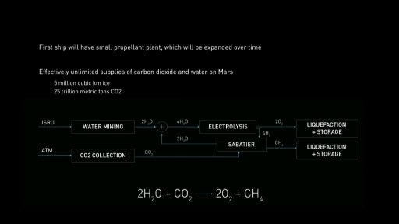

<http://spaceflight101.com/spx/wp-content/uploads/sites/113/2016/09/ITS-026-1024x576.jpg>

In-Situ Methane Production on Mars – Credit: SpaceX

Another consideration of methane for application in a Mars architecture is the possibility of ‘living off the land’ – generating methane with the resources present on Mars. In-Situ Resource Utilization is a widely studied concept for future Mars missions for the generation of oxygen, water and methane using sub-surface water and carbon dioxide present abundantly in the ambient atmosphere on Mars plus sunlight as an energy source.

SpaceX arrived at the choice of a LOX/CH4 engine after ruling out the other two possibilities, namely LOX/RP-1 and LOX/LH2, based on five requirements for the Mars transfer architecture.

LOX and Kerosene have the advantage of being a well-known combination with acceptable performance and liquid densities that support a reasonable vehicle size based on the required propellant tank volume. Cost of propellants and reusability aspects are also satisfactory for LOX/RP-1 and in-orbit propellant transfer could also be accomplished easily. But, the major drawback of Kerosene is that its in-situ production on Mars is next to impossible with the available resources.

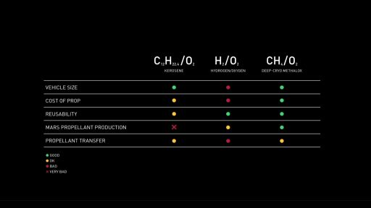

http://spaceflight101.com/spx/wp-content/uploads/sites/113/2016/09/ITS-013-1024x576.jpg

Methane Selection Criteria – Credit: SpaceX

LOX and LH2, also well-proved in rocketry, offer a clean combustion suitable for ngine re-use and could be produced easily on Mars through electrolysis of water. But all other factors quickly eliminate LOX/LH2 from the list of possible prop combinations – the low density of LH2 would require extremely large tanks, the cost of LH2 throws economical considerations out the window and in-space refueling is also hard to achieve.

Ethalox wins out over the other two candidates in all categories except for in-space propellant transfer which, regardless of propellant combination, is a challenging technological undertaking that will need extensive development efforts to be successful and efficient.

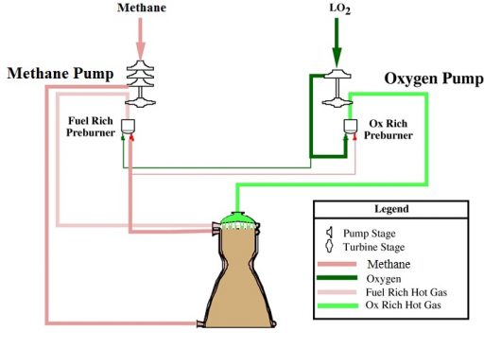Full-Flow staged Combustion Cycle

<http://spaceflight101.com/spx/wp-content/uploads/sites/113/2016/09/4352624_orig.jpg>

Full-Flow Staged Combustion Scheme (Simplified) – Image: Purdue University/Spaceflight101

SpaceX’s Raptor employs a Full-Flow Staged Combustion Cycle – a variation of a closed cycle engine that is designed to create a more benign environment within the engine plumbing – an important aspect for reusability, and also provides higher efficiency than the open cycle engines previously developed by SpaceX.

In a Full-Flow Engine, two separate turbines – one oxygen-rich and one fuel-rich – are responsible for driving the respective fuel and oxidizer turbopumps. The LOX turbine is driven by high-pressure gas generated by combusting nearly 100% of the oxidizer flow with a fraction of the fuel flow in an oxidizer rich preburner. The fuel-side uses the full fuel flow with a small fraction of oxidizer to generate the preburner gas that drives the fuel turbine.

Raptor employ boost pumps on both the fuel and oxidizer sides that operate at a lower speed than the main pumps and create an engine inlet pressure sufficient for the operation of the turbopumps. Typically, boost pumps are driven by tapoff gas from the main pumps, but the exact design used by the Raptor has not been publicly shared.

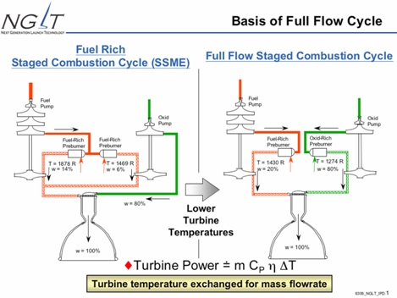

<http://spaceflight101.com/wp-content/uploads/2016/09/SSME-vs-FFSC.jpg>

Fuel-Rich Staged Combustion vs. Full-Flow Staged Combustion – Image: NGLT/IPD Presentation – U.S. Air Force

Raptor employs a regenerative cooling system – routing clean methane fuel from the turbine through the engine chamber and nozzle heat exchangers before reaching the preburner and turbine.

By the time both propellant components reach the engine injector they are completely in the gas phase.

The Full-Flow Engine Design has a number of advantages over typical staged combustion engines, first and foremost a higher performance but also factoring in reliability and reuse considerations.

Higher performance is achieved by injecting the propellants into the combustion chamber in a gaseous phase, creating a more rapid reaction.

The use of separate turbines for the fuel and oxidizer turbopump reduces overall turbine power compared to a single-shaft turbopump design where one turbine has to drive both pumps. Also, having the entire propellant flow pass through the turbines eases their cooling and creates a manageable thermal environment. Separate LOX/CH4 pumping equipment eliminates the high-pressure fuel-oxidizer interseal which is a known failure point of traditional engine designs.

The full-flow scheme also creates a more benign environment for the engine plumbing than other designs, increasing the life span of the power units for reuse on many flights.

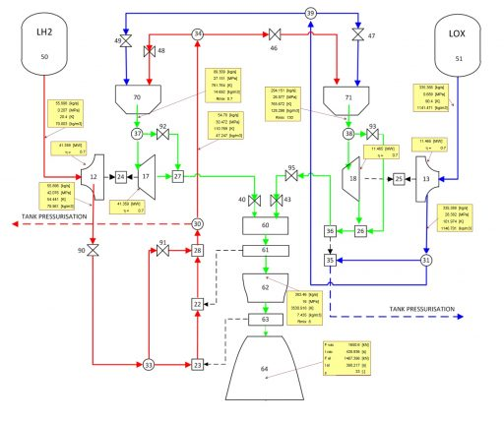http://spaceflight101.com/spx/wp-content/uploads/sites/113/2016/09/FFSCC-Concept-DLR-1024x857.jpg

1,600kN Full-Flow Engine Concept with self-pressurization – Credit: DLR-SART

Furthermore, the Full-Flow Cycle provides the option of easily integrating an autogenous tank pressurization system which would eliminate the need for a Helium pressurization system which undoubtedly caused much headache at SpaceX during the teething issues encountered by the Falcon 9.

In the IAC 2016 presentation, Musk specifically highlighted the autogenous pressurization system for the ITS Booster and Spaceship/tanker to eliminate the high-pressure helium system.

Fuel tank pressurization can be achieved through the use of gas from the fuel line after leaving the regenerative cooling circuit while oxidizer tank pressurant can be obtained from the turbopump discharge, however requiring an additional heat exchanger on one of the preburners.

Raptor is the first Methane-LOX Full-Flow Staged Combustion Engine to be tested. Only two previous Full-Flow designs proceeded into engine testing – the hypergolic-fueled RD-270 developed by Russian engine designer Energomash in the 1960s and tested 27 times with a desired thrust setting of 6,270 kN; and the joint NASA/Air Force ‘Integrated Powerhead Demonstrator’ which was run in the 90s and early 2000s to develop a full-flow hydrogen engine.

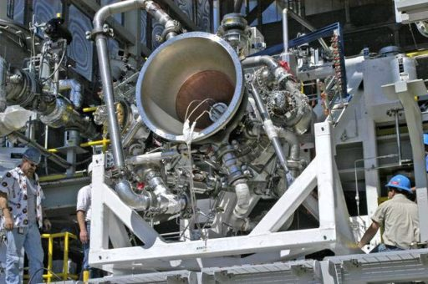

<http://spaceflight101.com/spx/wp-content/uploads/sites/113/2016/09/IPD-Air-Force.jpg>

Integrated Powerhead Demonstrator – Photo: U.S. Air Force

Raptor’s chamber pressure of 300 bar is the highest among all active launch vehicle engines. Russian engine designs were known to be the using the highest chamber pressures for decades owed to advances in metallurgy that allowed for the use of oxygen-rich staged combustion, a technology only recently mastered by U.S. manufacturers.

However, even Russian engines can not come close to Raptor with RD-191 operating at 262.6 bar and RD-180 used on the Atlas V that reaches a maximum pressure of 267 bar.

Raptor competes favorably with its direct competition, notably Blue Origin’s BE-4 that represents the second high-thrust methane-engine developed on U.S. soil. BE-4 employs an oxygen-rich staged combustion cycle and achieves a baseline sea level thrust of 2,450 Kilonewtons, though that number may rise as BE-4 heads into development testing.

Raptor Development

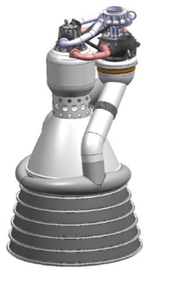

<http://spaceflight101.com/wp-content/uploads/2016/09/7881082_orig.jpg>

Merlin 2 Concept – Credit: SpaceX

Raptor was first discussed by SpaceX in 2009 when a small team of SpaceX propulsion engineers were working on a new upper stage engine burning LOX/LH2. At the same time, SpaceX was pursuing a route in which a scaled up Merlin engine, referred to as Merlin 2, would power the first stage of future Falcon rockets, continuing to use LOX/Rp-1 propellants but switching to a high-performance closed cycle design instead of the open cycle employed by the Merlin 1 series.

Per the 2010 design, the Raptor upper stage engine would have delivered a vacuum thrust of 667 Kilonewtons, baselined for use on a Falcon X or Falcon XX heavy-lift upper stage.

By early-2012, the Raptor concept was changed radically under a change in direction at SpaceX – abandoning the RP-1/LOX propellant combination for its future launch vehicle and opting for methane-fueled engines for reasons outlined above, including possible methane production using resources on Mars plus advantages of higher performance and better engine environments for re-use.

In late 2012, SpaceX acknowledged the new direction in propulsion technology and confirmed Raptor was now the name for a family of engines to power both, large boosters as well as upper stages optimized for operation in vacuum. The Raptor test program was announced in October 2013 with SpaceX planning to use NASA’s Stennis Space Center in Mississippi for component testing before moving full-scale engine testing to the company’s Rocket Development and Test Facility in McGregor, Texas.

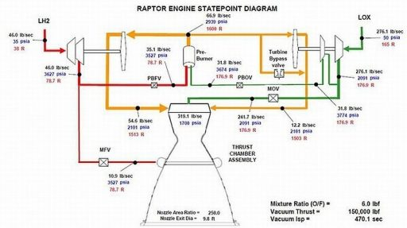

<http://spaceflight101.com/spx/wp-content/uploads/sites/113/2016/09/3807070_orig.jpg>

2010 Raptor Design – Image: SpaceX

Outfitting of the E2 test stand at Stennis to handle liquid methane was finished by April 2014 and testing of Raptor’s injectors and preburners picked up the next month. The E2 stand is only rated for engines up to 440 Kilonewtons, permitting Raptor’s injectors and preburners to be test fired but not the integrated engine system.

It was in 2013 when first performance data for Raptor was released, starting a lengthy period of confusion because SpaceX spokespeople gave wildly varying performance numbers over the next year and a half. The initial number given for Raptor’s thrust rating was 2,940 Kilonewtons, but in a presentation in early 2014, a much more powerful engine design with a thrust of over 4,400 kN was shown. In mid-2014, that number was further increased to a sea level target of nearly seven Meganewtons.

An explanation for the varying thrust targets has been given by Raptor development lead Jeff Thornburg who stated that Raptor is a highly-scalable engine design. It is likely that SpaceX worked out designs for ultra-high performance versions of the Raptor when going through the design iterations of the Mars Colonial Transporter, renamed in 2016 to Interplanetary Transport System.

In January 2015, Elon Musk clarified Raptor’s performance to a lower target of 2,300 kN which brought up the question of the number of engines SpaceX’s future launch vehicle wil require to be able to send 100 metric tons of payload to the surface of Mars – a goal that remained consistent despite the changing performance numbers on the Raptor.

Stennis testing in 2014 successfully demonstrated the engine injectors and oxygen preburner testing picked up in 2015. A total of 76 hot fires were executed in a campaign between April and August 2015 for a cumulative test time of several hundred seconds. Operations at Stennis concluded in 2015, though SpaceX may return to the facility for future testing of Raptor variations.

The first prototype Raptor reached SpaceX’s Texas facility in August 2016 as spotted by observers who keep close watch on activities at the base. SpaceX confirmed that a Raptor was delivered to McGregor, though some questions arose whether the engine was a scaled-down or full-scale version and whether initial testing would run the engine at lower pressures.

The first test firing of Raptor as performed on September 25, 2016 in the evening hours local time. This test was time perfectly to coincide with Musk’s speech at the International Astronautical Congress two days later where he was to reveal a detailed roadmap for SpaceX’s Mars Exploration and Settlement plans.

U.S. Air Force Contract

SpaceX first contacted the U.S. Air Force in 2011 to explore whether the Air Force was interested in a methane-fueled engine to compete with the established LOX-Kerosene technology used by the majority of active launchers. However, development on Raptor continued under full funding and full control by SpaceX until January 2016 when the U.S. Air Force awards a development contract to SpaceX.

The $100 million contract requires double-matching by SpaceX - $33.6 million are provided by the Air Force while SpaceX allocates $67.3 million for the development of a prototype version of a Raptor upper stage engine suitable for use on the Falcon 9 and falcon Heavy launch vehicles. The contract covers a period until 2018 and includes development work on the engine, the production of a prototype and performance testing carried out at Stennis.

A Raptor variant flying on a Falcon 9/Falcon Heavy will likely represent a scaled-down version of the ITS Raptor Vac design.

<http://spaceflight101.com/spx/spacex-raptor/>

ITS Propulsion – the evolution of the SpaceX Raptor Engine

With the spaceflight community still in awe at the unveiling of the Interplanetary Transport System (ITS), SpaceX has set itself some lofty long-term goals. However, while the realization of the plan is up for debate, the presentation has at least revealed some of the key specifications of the system, not least the Raptor engine.

The Raptor Engine:

Since the 2010 disclosure of the Raptor code name for its next-generation engine, it has been through different combustion cycles, propellants and thrust levels. This began with notional plans for 667 kN of power, once reaching as high as 6,670 kN, before now settling at 3,000 kN of sea level thrust.

In all launch vehicle designs that require new engines, the long pole has always been main rocket propulsion – with engine development a key stage for any space project.

Having a full array of seasoned test stand capabilities is a basic requirement, as NPO Energomash found out with the excruciating development of the RD-170 that resulted in the destruction of its test stand.

Full flow engines, like the Raptor, are usually considered to be impossible to test in the subsystems evaluation stage. The main problem is the highly integrated nature of the cycle.

In the full flow staged combustion cycle, almost all the fuel is first burned with a tiny bit of oxidizer in the fuel preburner to generate hot gas. Then, all that gas mass is put through the turbines, to drive the turbopumps, which are used to feed the preburners.

Rocket pumps have to increase the pressure to enormous levels. This is required because even after going through the cooling passages – the preburner and the turbine – it still needs to be injected into the main combustion chamber at the required pressure level.

In the Raptor’s case, this is expected to be a record-breaking 30 MPa – more than 300 atmospheres of pressure. For comparison, the previous record holder for chamber pressure, the RD-170 derivative RD-191, was 25.74 MPa.

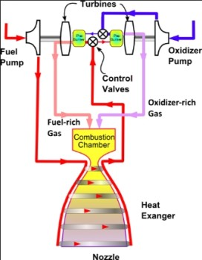

https://www.nasaspaceflight.com/wp-content/uploads/2016/10/2016-10-02-225655.jpg

In the full flow case, the same process of converting to hot gas and driving the turbopumps also needs to be done with the oxidizer. While complex, this cycle allows for the use of all available mass to power the turbomachinery, thus enabling the highest possible chamber pressure.

The higher the chamber pressure, the higher the efficient of the engine, as measured by specific impulse. It also reduces the physical size of the engine hardware, since it required less plumbing/piping, while the throat of the engine is also physically smaller.

Also, to test the combustion chamber and its injectors, you need the turbopumps and the preburners.

As such, individual testing of each subsystem is almost impossible for full flow engines, unless you have a test stand capable of supplying extremely high-pressure liquid and hot gas of both the fuel and oxidizer at the same time.

Enter the famous Stennis Space Center and its critical E2 test stand.

While incapable of handling the full size of the expected Raptor engine unit, the Stennis test stand enabled the individual testing of each subcomponent of the 1MN scaled prototype that SpaceX currently has at its test facility in McGregor, Texas.

During late 2013, the SpaceX engineers arrived at Stennis to help upgrade its unique E2 test stand, enabling it to supply liquid and hot gaseous methane.

On April 21, 2014 the upgraded test stand was officially inaugurated and a full test program of each individual subsystem was tested and validated.

Since the final thrust level of the Raptor had not been settled, it was decided that the first integrated test engine would be a 1MN sub-scale engine.

It enabled the full testing at Stennis E2 and allowed for the development of robust startup and shutdown sequences, characterize hardware durability and anchor analytical models that would be used for future designs.

The physics of mixing gasses in the combustion chamber is not as well developed as the more traditional gas-liquid or liquid-liquid forms in the west.

SpaceX engineers developed specialized software to compute just the mixing process in detail while adding approximations for the rest of the flow. This still allowed for very high fidelity simulations to be carried with reasonable computing resources.

However, this modeling breakthrough still requires validation with real results first, which will be realized by the demonstrator engine.

Once the final engine thrust was defined, the engine could be scaled up with relative ease. The full flow cycle is very helpful in that sense and the 1MN thrust level would already be considered a big engine.

With the production engines – as currently envisioned – it would need to triple its thrust. Not trivial, but still within what could be considered highly representative as a demonstrator.

On August 8, 2016, the first integrated Raptor demonstrator left its Hawthorne base for SpaceX’s very own Raptor test stand in its McGregor testing facility.

With a thrust of 1MN (225 klbg) at sea level, this was to be the first methane full flow engine to ever reach a test stand. In fact, it was the second full flow engine for any propellant.

Glushko’s RD-270 was the pioneer in 1967 – interestingly also designed for a Mas bounded rocket, the UR-700.

However, that engine never solved its combustion instability issues and its hypergolic propellant made it an environmental tragedy waiting to happen. The launch vehicle was never provided with a green light.

The raptor demonstrator turbomachinery is capable of producing 27 MW of power, with more power “per unit of thrust” of any hydrocarbon engine.

It also demonstrates the use of 3D printing, with 40 percent of the engine utilizing this technology when measured by mass.

Experts analysis via L2 also implied that the integrated nature of the design would be difficult to construct and assemble if built by the traditional method.

Then came the recent – and timely – milestone. On September 26, at around 3am UTC, the first ignition test of the demonstrator was performed.

Via the standard procedure for the first ignition test of a new engine – called a “burp test” – a short firing tests the ignition phase, usually without the engine reaching full power.

However, this first test was more than just a burp test, with SpaceX’s CTO and founder, Elon Musk, showing a video – during his overview at the IAC forum in Guadalajara – of the Raptor igniting and firing for approximately nine seconds before shutting down.

In L2 McGregor photos, the engine has been observed without the sporting of an extension. Mr. Musk has since confirmed that the development engine will eventually have a nozzle with an expansion ratio of 150, the maximum possible within Earth’s atmosphere.

Should all go to plane with the development, the Raptor will provide the required thrust to launch the massive ITS off the launch pad.

Raptor will come in two versions, one optimized for the first stage – and thus with a short nozzle – and another one for the spacecraft – with a long nozzle optimized for vacuum and Mars’ weak atmosphere.

As is traditional for SpaceX, both engines variations would have the same powerpack and thrust chamber. The only difference would be on the nozzle.

They will also have a version with – and without – Thrust Vector Control (TVC). The use of fixed engines on the outer rings of the ITS allows for more tight packing and reduced dry mass.

The vectored inner engines would supply control authority. Differential throttling may be an option in case of an emergency.

The first stage model is documented as sporting a sea level thrust of 3,050 kN with an isp of 334 seconds, and 3,285 kN and 361 seconds in vacuum. Its diameter will be less than two meters.

The vacuum version of the Raptor will produce 3.5 MN of thrust, with a specific impulse of 382 seconds, thanks to its 200 expansion ratio nozzle. It will have an estimated diameter of four meters.

With an estimated 80 MW of power on the turbopumps, both engines would use subcooled liquid methane and oxygen as propellant. This improves the specific impulse, the thrust and reduces the risk of cavitation on the turbopump.

Also, Raptor will have some changes that are critical to reducing the fluids from five to two, eliminating the issues related to hypergolics.

The engine will have heat exchangers to heat methane and oxygen so the ITS can self-pressurize. The helium pressurization system has provided quite a few headaches to SpaceX on its current rockets and as such is not surprising its engineers saw the option to eliminate it entirely as preferable.

Additionally, it will eliminate the TEA-TEB hypergolic cartridges currently used by Merlin engines. Instead, Raptor has implemented a new spark ignition system that, at least theoretically, would allow for unlimited re-ignitions.

Raptor will also be able to throttle from 100 percent to 20 percent of thrust, providing additional options during its powered phases.

Having a 30 MPa chamber pressure not only allows for the best specific impulse – shot of the much heavier hydrogen-fuelled engines – but it also reduces size and mass significantly.

In fact, Mr. Musk stated that he expects Raptor to actually have the highest thrust to weight ratio ever for a production rocket engine. A record currently held by the company’s other engine, the Merlin 1D.

The small size, which Elon characterized as similar to the Merlin 1D, makes SpaceX confident that it will be able to produce them in mass. Currently, SpaceX is producing Merlins at a rate of 300 per year.

With 51 engines per each ITS, SpaceX will need quite a number of the for its initial fleet.

The first stage will sport 42 engines on the first stage, and nine on the second. Interestingly, the second stage – as currently envisioned – would use six vacuum and three atmospheric optimized Raptors.

However, for each trip at least two upper stages would be needed, one spacecraft and at least on tanker. Numerous tankers are likely to be required for each ITS heading out to Mars.

While the ITS sports numerous technological breakthroughs – such as the fully composite tanks and methane-oxygen thrusters – Raptor is the most critical technology in enabling a design that SpaceX currently expect could reduce the cost per passenger (plus cargo) to Mars, from around 10 billion to just 140,000 dollars.

The reality of that goal is open to debate, but SpaceX has shown a path towards that ambitious future.

<https://www.nasaspaceflight.com/2016/10/its-propulsion-evolution-raptor-engine/>

SpaceX intends to launch an uncrewed Mars mission in 2018, using a Dragon space capsule and a Falcon Heavy rocket. The Interplanetary Transport System could launch humans to Mars as early as 2024 if all goes well, Musk has said.

<http://www.space.com/34192-spacex-raptor-rocket-test-first-photos.html>

Designed to fly three Apollo astronauts to the moon and back, the Saturn V made its first unmanned test flight in 1967. A total of 13 Saturn V rockets were launched from 1967 to 1973, carrying Apollo missions as well as the Skylab space station. Every part of the giant rocket is used and then discarded during a mission. Only the tiny command module survives to return to Earth.

The Saturn V rocket’s first stage carries 203,400 gallons (770,000 liters) of kerosene fuel and 318,000 gallons (1.2 million liters) of liquid oxygen needed for combustion. At liftoff, the stage’s five F-1 rocket engines ignite and produce 7.5 million pounds of thrust.

At an altitude of 42 miles (67 kilometers), the F-1 engines shut down. Explosive bolts fire, and the severed first stage falls into the Atlantic Ocean.

The second stage carries 260,000 gallons (984,000 liters) of liquid hydrogen fuel and 80,000 gallons (303,000 liters) of liquid oxygen.

A few seconds after the second stage’s five rocket engines are ignited, an interstage skirt at the bottom end of the second stage is jettisoned. Shortly after that, the emergency escape rocket on top of the vehicle, only usable below 19 miles altitude, is fired off and discarded.

At 9 minutes and 9 seconds after launch, the second stage is discarded and the third stage’s rocket engine is fired. The third stage carries 66,700 gallons (252,750 liters) of liquid hydrogen fuel and 19,359 gallons (73,280 liters) of liquid oxygen.

The third stage’s single rocket engine is fired until 11 minutes and 39 seconds after launch, when the vehicle has attained sufficient speed to reach Earth orbit. About two and a half hours later, the third stage engine is restarted to send the Apollo spacecraft out of earth orbit and toward the moon.

After the astronauts in Apollo dock with the lunar landing module and pull away from the now-useless third stage, this last remaining part of the Saturn V coasts away into deep space or is commanded to fly to a crash landing on the moon.

<http://www.space.com/18422-apollo-saturn-v-moon-rocket-nasa-infographic.html>

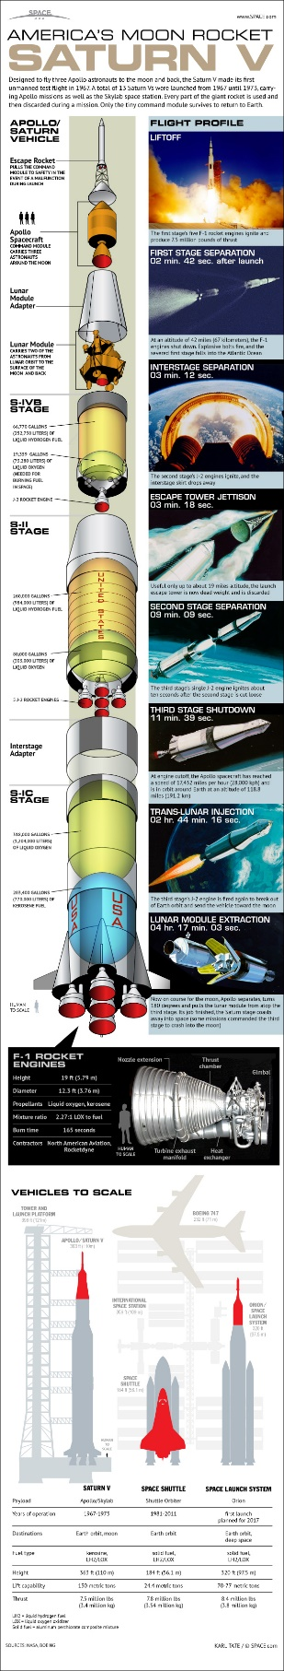

<http://www.space.com/images/i/000/023/504/original/saturn-v-moon-rocket-45th-anniversary-121112a-02.jpg>

The rocket that launched men to the moon was first tested in 1967.

*Credit: Karl Tate, SPACE.com contributor*

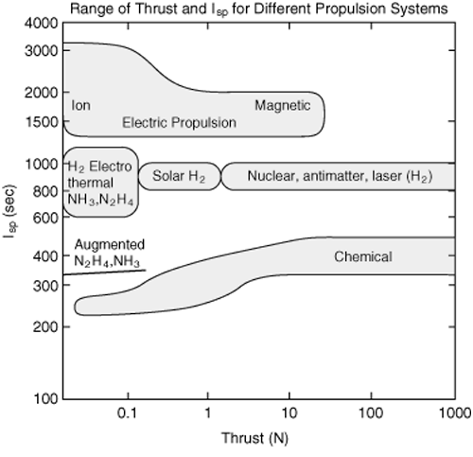

http://www.daviddarling.info/images2/specific_impulse_for_different_propulsion_systems.gif

<http://ssd.jpl.nasa.gov/>

<http://ssd.jpl.nasa.gov/?horizons>

<http://ssd.jpl.nasa.gov/horizons.cgi>

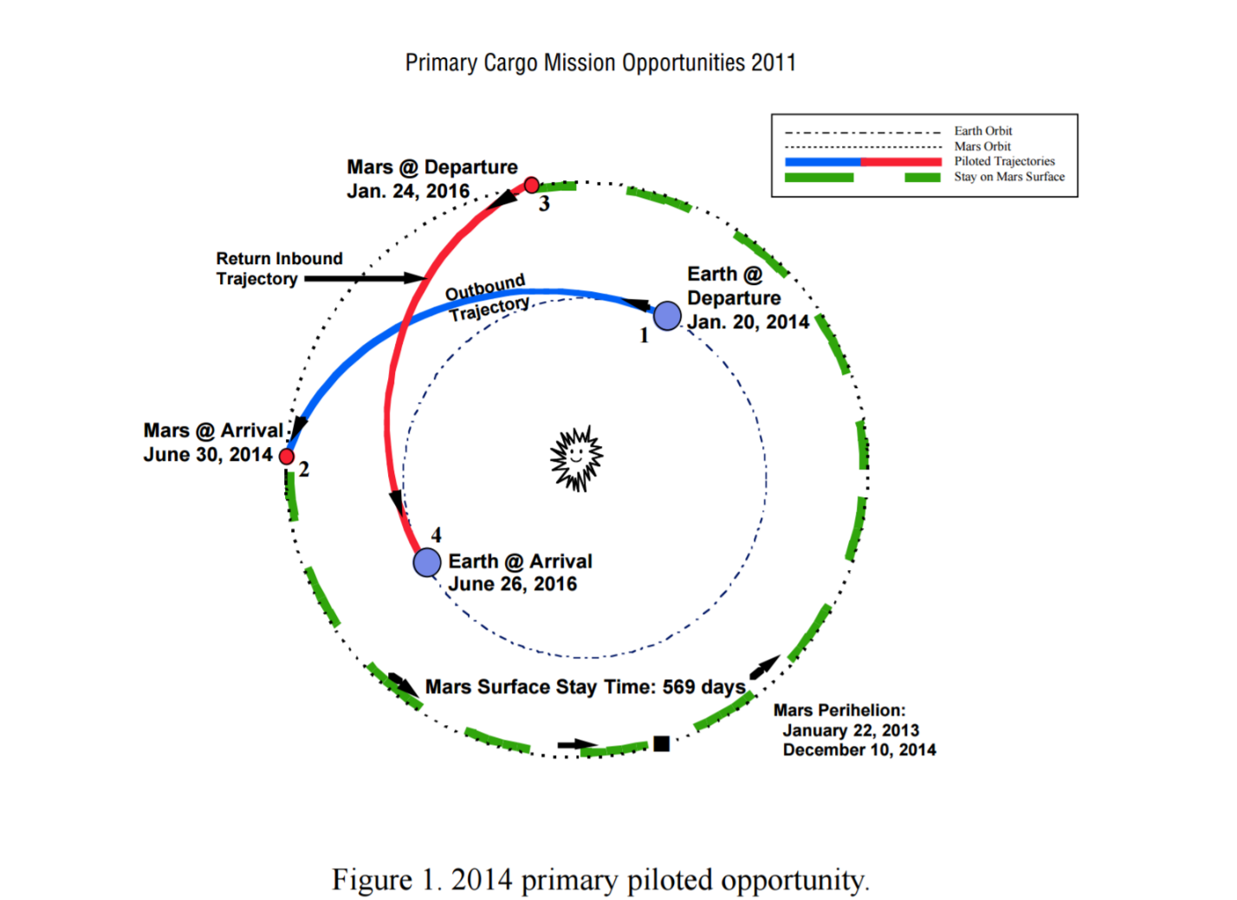

The design reference mission (DRM) is currently envisioned to consist of three trans-Mars injection (TMI)/flights: two cargo missions in 2011, followed by a piloted mission in 2014. The cargo missions will be on slow (near Hohmann-transfer) trajectories with an in-flight time of 193–383 days. The crew will be on higher energy, faster trajectories lasting no longer than 180 days each way in order to limit the crew’s exposure to radiation and other hazards. Their time spent on the surface of Mars will be approximately 535–651 days (figure 1). A summary of the primary cargo and piloted trajectories is summarized in table 1.

Figure 2 shows an overview of the DRM opportunity and figure 3 shows the DRM architecture. Each payload component will be delivered to orbit by a launch vehicle capable of lifting 80 mt into lowEarth orbit (LEO) in two phases, 30 days apart, and approximately 1 month before the expected departure date. Each mission will be initially assembled in LEO at an altitude of approximately 400 km (inclination ~ 28.5°), from where the TMI burn will be performed to initiate the transfer to Mars. In order to minimize the effect of velocity losses, two periapse burns will be performed at departure. The TMI propulsion system will be a nuclear thermal propulsion system consisting of three engines capable of producing 15,000 lb of thrust (lbf ), each (with effective specific impulse (Isp) of 931 sec)

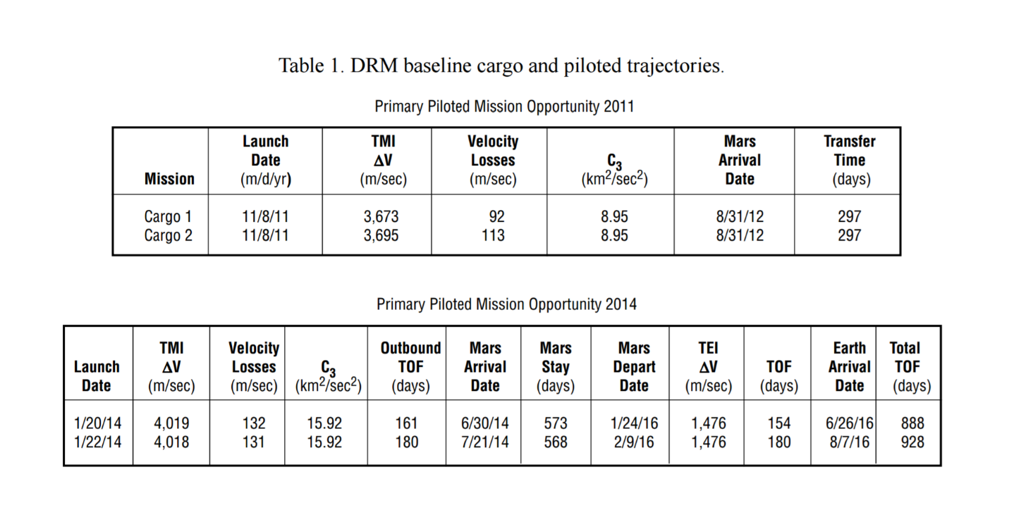

The cargo 1 payload will consist of the liquid oxygen/methane (lox/CH4) trans-Earth-injection (TEI) stage to be used for crew return, the crew’s return habitat, and an aerobrake. The cargo 2 payload will consist of the empty Mars ascent stage, the lox/CH4 production plant, the Earth crew return vehicle (ECRV), surface mobility units, the descent stage, and an aerobrake. The piloted mission payload will consist of the six-person crew, surface payload materials, a two-level surface habitat, a lox/CH4 descent stage, and an aerobrake. Mars aerocapture will be into a 250 × 33,793 km altitude, approximately 40° inclination orbit. A restriction of 8.7 km/sec for Mars arrival entry speed (relative to Mars) was provided as the upper limit for safe entry.1 Using equation (1),2 it can be determined that this corresponds to an arrival V infinity (V∞) limit of 7.167 km/sec:

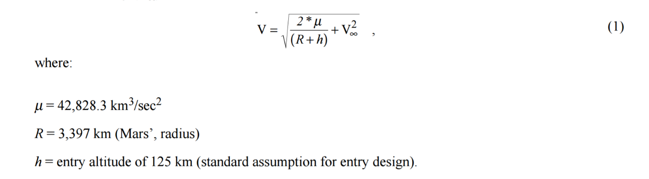

where: µ = 42,828.3 km3/sec2 R = 3,397 km (Mars’, radius) h = entry altitude of 125 km (standard assumption for entry design). The same orbit will be used by the crew for Mars departure. Upon arrival back at Earth, the ECRV will perform a near-ballistic reentry. An upper limit of 14.5 km/sec for Earth arrival speed was given as the upper limit for safe reentry.1 Again, using equation (1), this corresponds to an arrival V∞ limit of 9.36 km/sec where: µ = 398,600.44 km3/sec2 R = 6,378.14 km (Earth’s radius) h = entry altitude of 125 km. A more detailed list of assumptions used to develop these trajectories may be found in appendix C.

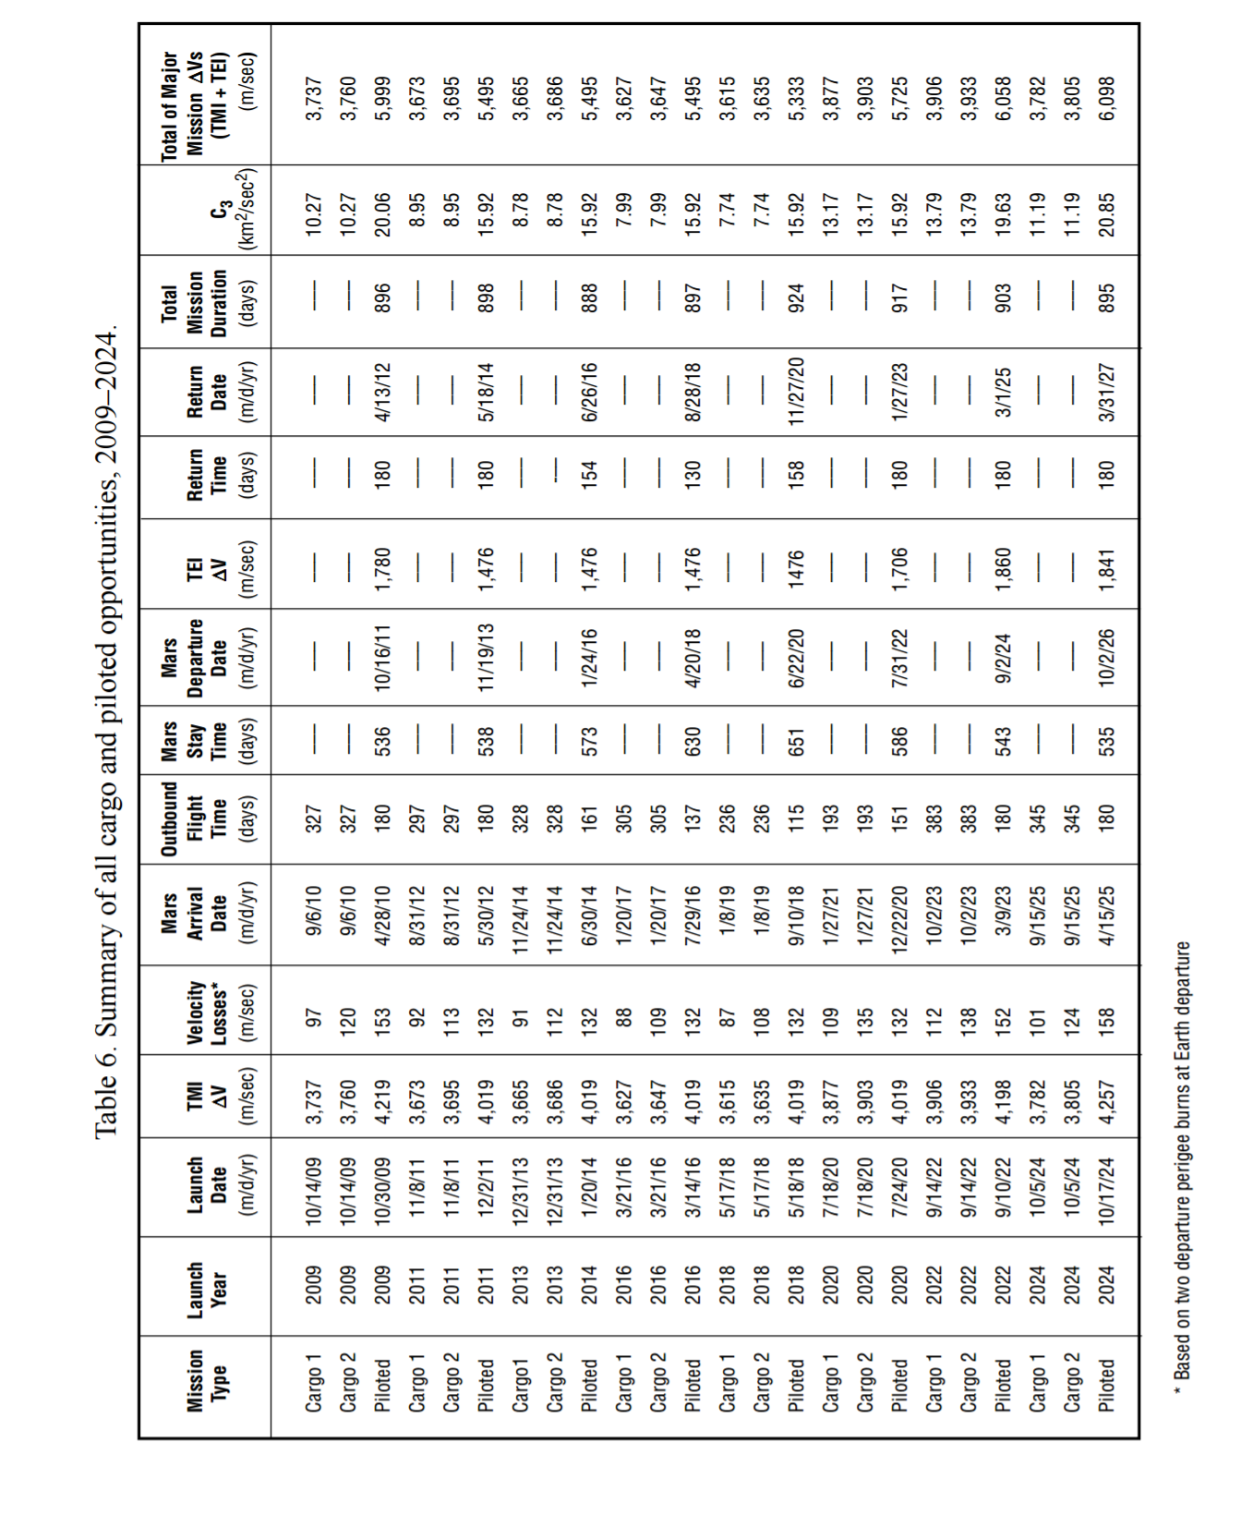

http://www.ltas-vis.ulg.ac.be/cmsms/uploads/File/InterplanetaryMissionDesignHandbook.pdf

General Comments



http://www.space.com/images/i/000/058/681/original/spacex-mars-transporter-spaceship-cross-section.jpg?1475011663?interpolation=lanczos-none&downsize=*:1400

A cutaway look at SpaceX's Interplanetary Transport System spaceship to ferry humans to Mars and beyond.

*Credit: SpaceX*

“Take it down to the physics” (p. 293)

“People in the technology industry have tended to liken Musk’s drive and the scope of his ambition to that of Bill Gates and Steve Jobs. ‘Elon has that deep appreciation for technology, the no-holds-barred attitude of a visionary, and that determination to go after long-term things that the both had,’ said Edward Jung” (p.345)

“Each facet of Musk’s life might be an attempt to soothe a type of existential depression that seems to gnaw at his every fiber. He sees man as self-limiting and in peril and wants to fix the situation.” (p. 344)

“There’s a degree to which it’s just never enough for Musk, no matter what is is. Case in point: the December 2010 launch in which SpaceX got the Dragon capsule to orbit Earth and return successfully. This had been one of the company’s great achievements, and people had worked tirelessly for months, if not years. The launch had taken place on December 8, and SpaceX had a Christmas party on December 16. About ninety minutes before the party starte, Musk had called his top executives to SpaceX for a meeting. Six of them, including Mueller, were decked out in party attire and ready to celebrate the holidays and SpaceX’s historic achievement around Dragon. Musk laid into them for about an hour because the truss structure for a future rocket was running behind schedule.” (p. 259)

“No more landings at sea. No more throwing spaceships away. ‘That is how a twenty-first-century spaceship should land’, Musk said. ‘You can just reload propellant and fly again. So long as we continue to throw away rockets and spacecraft, we will never have true access to space.’” (p. 257)

“One of the company’s next milestones will be the first flight of the Falcon Heavy, which is designed to be the world’s most powerful rocket. SpaceX has found a way to combine three Falcon 9s into a single craft with 27 of the Merlin engines and the ability to carry more than 53 metric tons of stuff into orbit. Part of the genius of Musk and Mueller’s designs is that SpaceX can reuse the same engine in different configurations – from the Falcon 1 up to the Falcon Heavy – saving on cost and time. ‘We make our main combustion chambers, turbo pump, gas generators, injectors, and main valves,’ Mueller said. ‘We have complete control. We have our own test site, while most of the other guys use government test sites. The labor hours are cut in half and so is the work around the materials. Four years ago, we could make two rockets a year and now we can make twenty a year.’ SpaceX boasts that the Falcon Heavy can take up twice the payload of the nearest competitor – the Delta IV Heavy from Boeing/ULA – at one-third the cost. SpaceX is also busy building a spaceport from the ground up. The goal is to be able to launch many rockets an hour from this facility located in Brownsville, Texas, by automating the processes needed to stand a rocket up on the pad, fuel it, and send it off.

Just as it did in the early days, SpaceX continues to experiment with these new vehicles during actual launches in ways that other companies would dare not do. SpaceX will often announce that it’s trying out a new engine or its landing legs and place the emphasis on that one upgrade in the marketing material up to a launch. It’s common, though, for SpaceX to test out a dozen other objectives in secret during a mission.” (p. 257-259)

“there have also been numerous times when SpaceX has done pioneering work on advancing very complex hardware systems. A classic example of this is one of the factory’s weirder-looking contraptions, a two-story machine designed to perform what’s known as friction stir welding. The machine allows for SpaceX to automate the welding process for massive sheets of metal like the ones that make up the bodies of the Falcon rockets. An arm takes one of the rocket’s body panels, lines it up against another body panel, and then joins them together with a weld that could run twenty feet or more. Aerospace companies typically try to avoid welds whenever possible because they create weaknesses in the metal, and that’s limited the size of metal sheets they can use and forced other design constraints. From the early days of SpaceX, Musk pushed the company to master friction stir welding, I which a spinning head is smashed at high speeds into the join between two pieces of metal in a bid to make their crystalline structures merge. It’s as if you heated two sheets of aluminum foil and then joined them by putting your thumb down on the seam and twisting the metal together. This type of welding tends to result in much stronger bonds than traditional welds. Companies had performed friction stir welding before but not on structures as large as a rocket’s body or to the degree to which SpaceX has used the technique. As a result of its trials and errors, SpaceX can now join large, thin sheets of metal and shave hundreds of pounds off the weight of the Falcon rockets, as it’s able to use lighter-weight alloys and avoid using rivets, fasteners, and other support structures.” (p.227-228)

|  |  |
| --- | --- |
| Type | Full-Flow Staged Combustion |
| Oxidizer | Sub-Cooled Liquid Oxygen |
| Fuel | Sub-cooled Liquid Methane |
| Throttle Range |  |
| Ignition | Spark Igniter |
| Re-Start Capability | Yes |
| Mixture Ratio |  |
| Flow rate (Calc.) |  |
| LOX Flow Rate |  |
| LCH 4 Flow Rate |  |

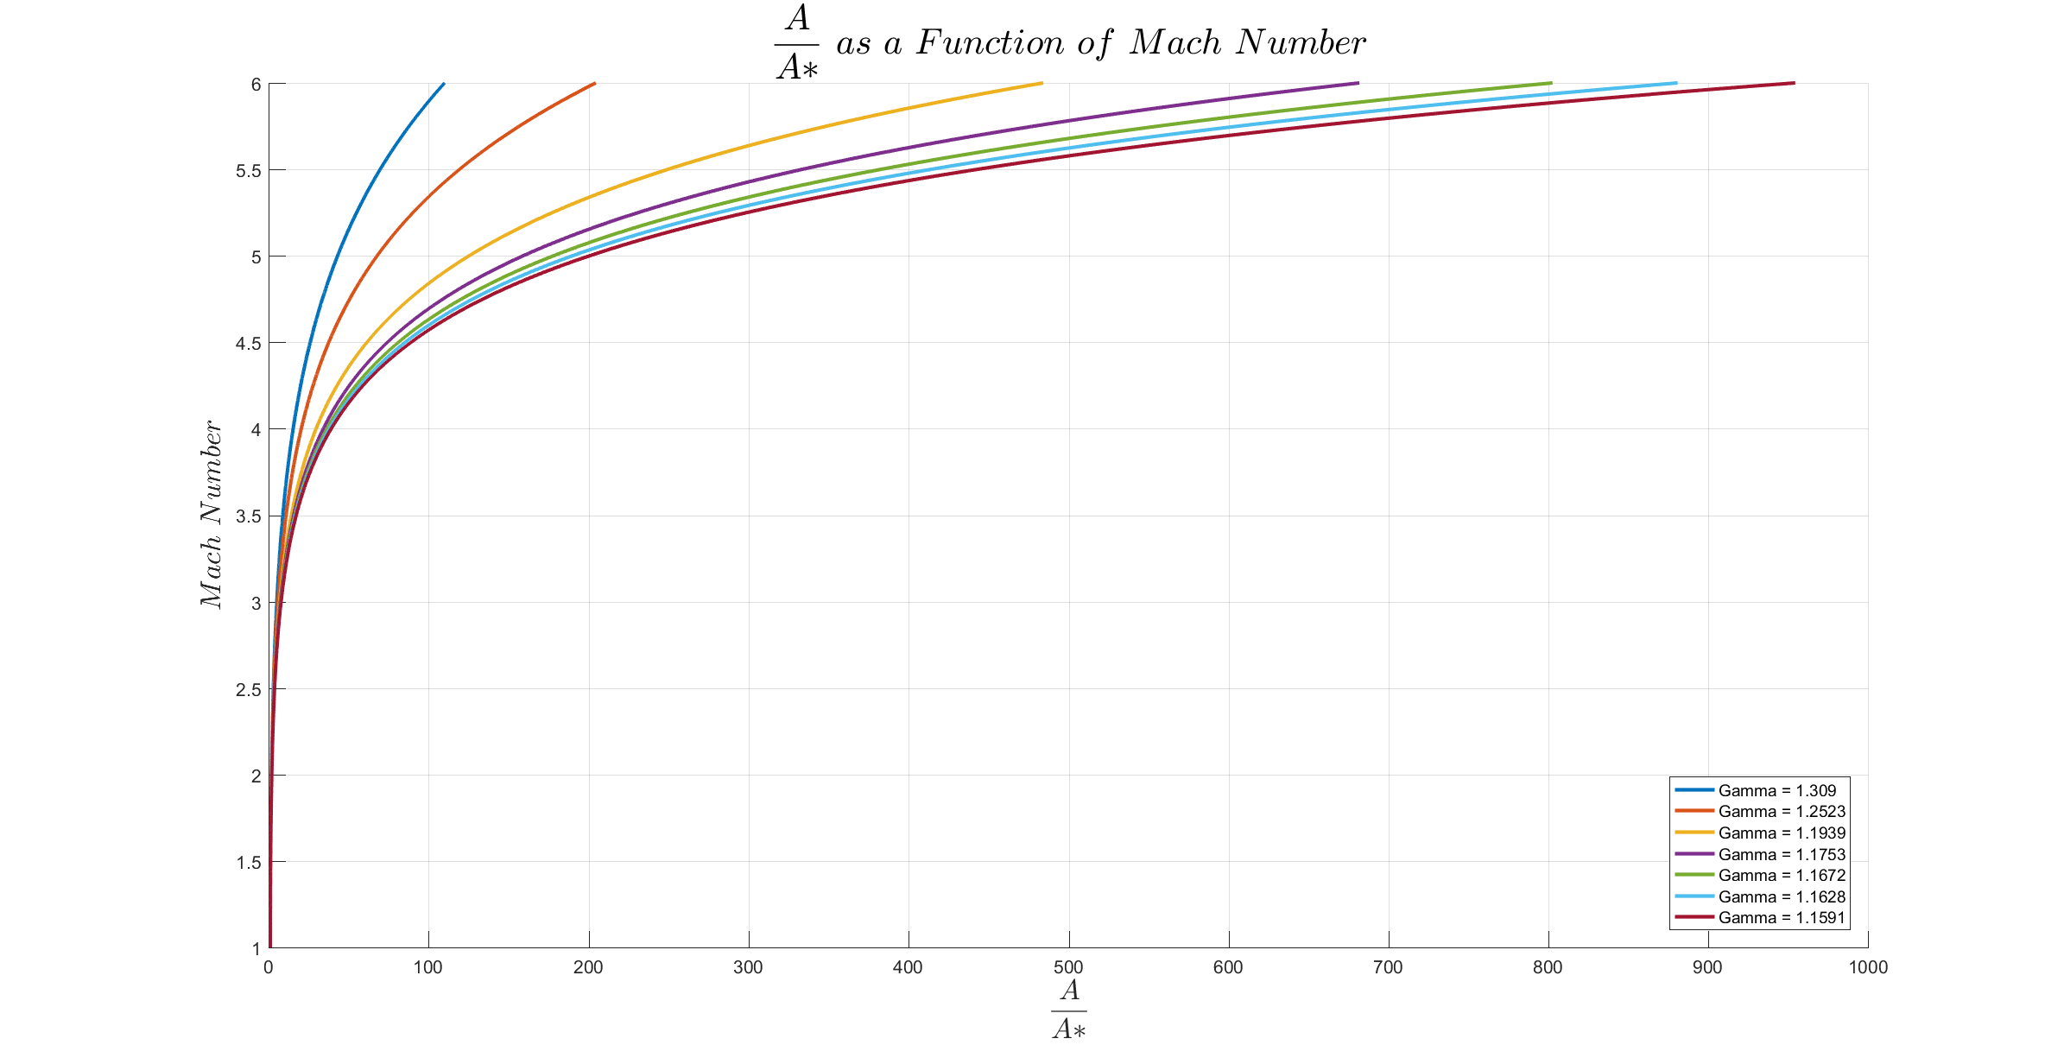

**Area Ratio 40**

Exit Temperature: 1377.06 K

Gamma: 1.2218

Design Pressure: 50380 Pa

Design Altitude: 5518.35 m

Design Thrust: 3076845.76 N

Ground Thrust: 2948642.96 N

Vacuum Thrust: 3203626.74 N

Pe/Po : 0.001674

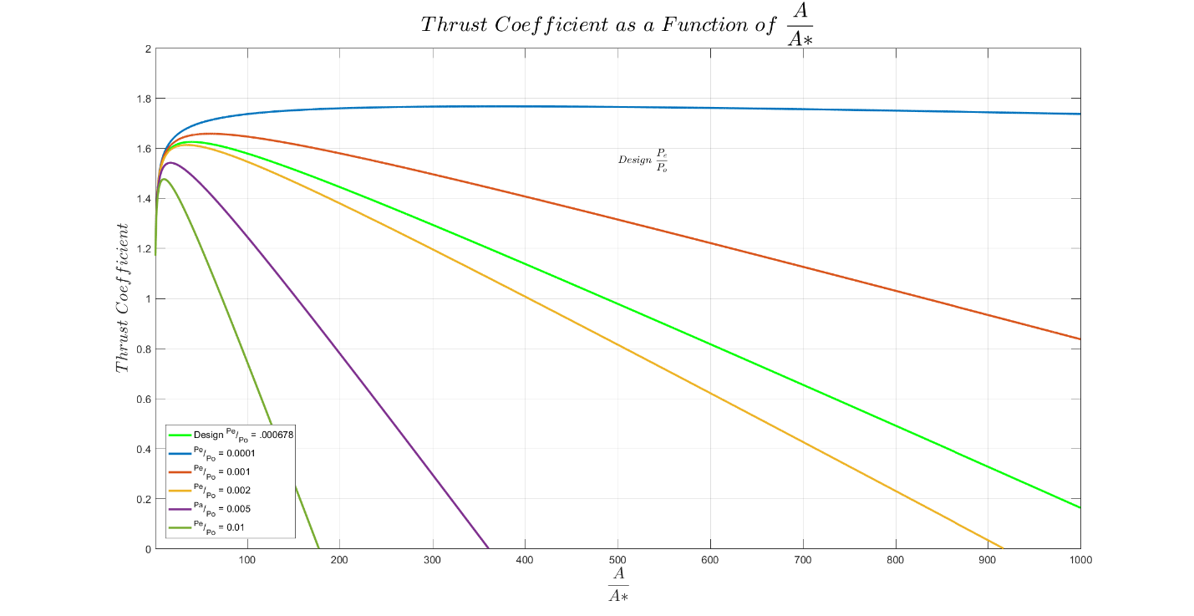

**Area Ratio 200**

Exit Temperature: 936.39 K

Gamma: 1.2587

Design Pressure: 5250 Pa

Design Altitude: 19088.91 m

Design Thrust: 3167504.35 N

Ground Thrust: 1958643.42 N

Vacuum Thrust: 3233562.32 N

Pe/Po : 0.000174

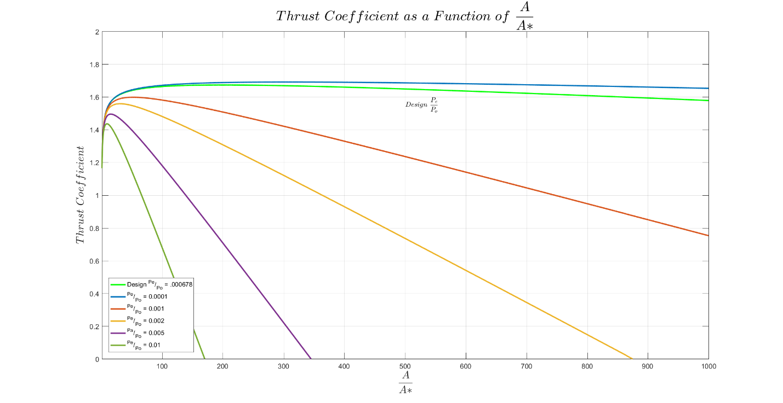

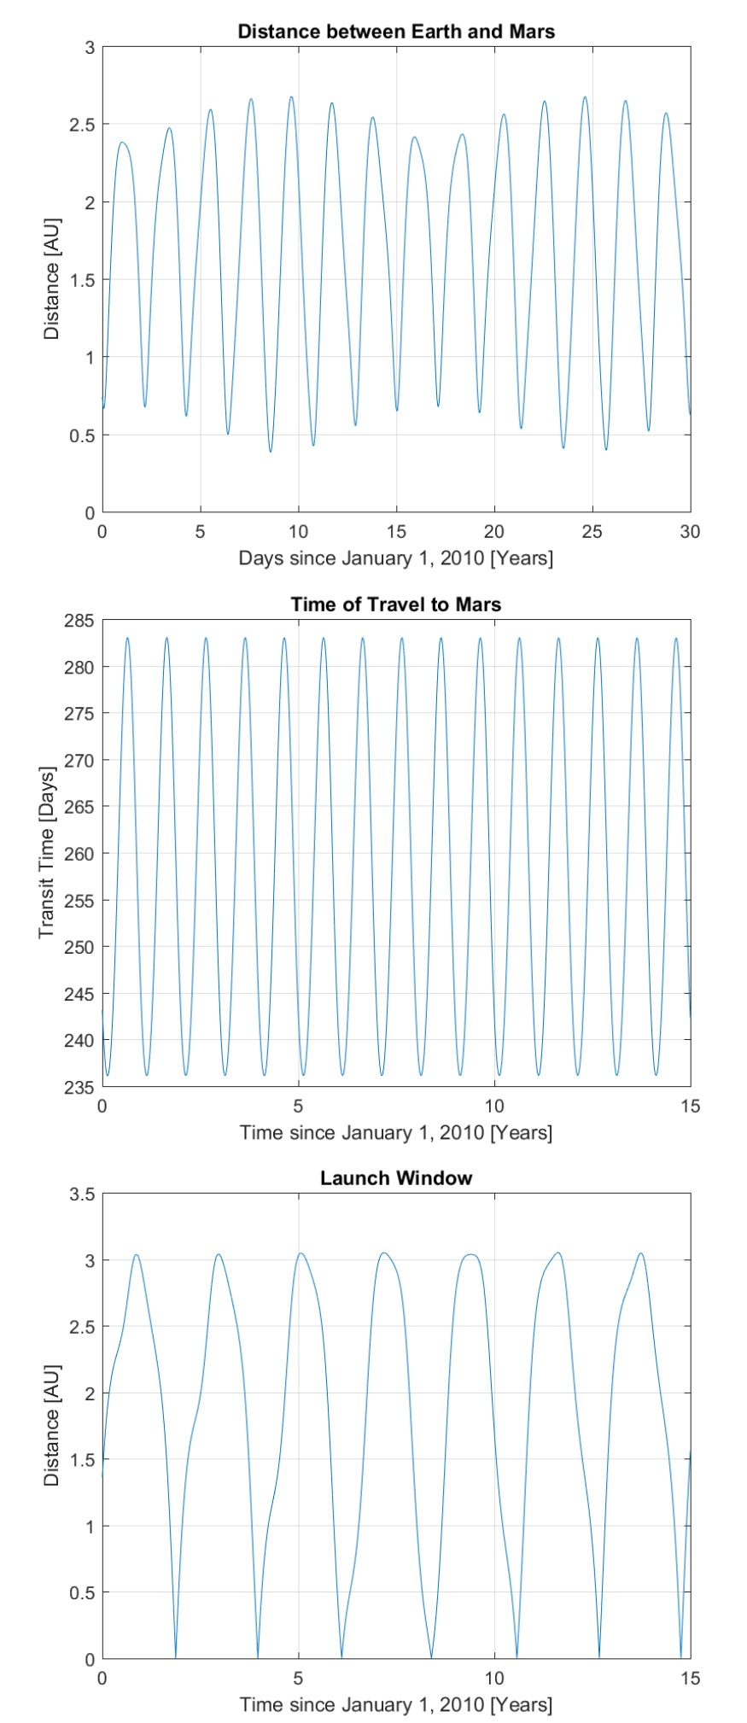Time Step of 180 seconds

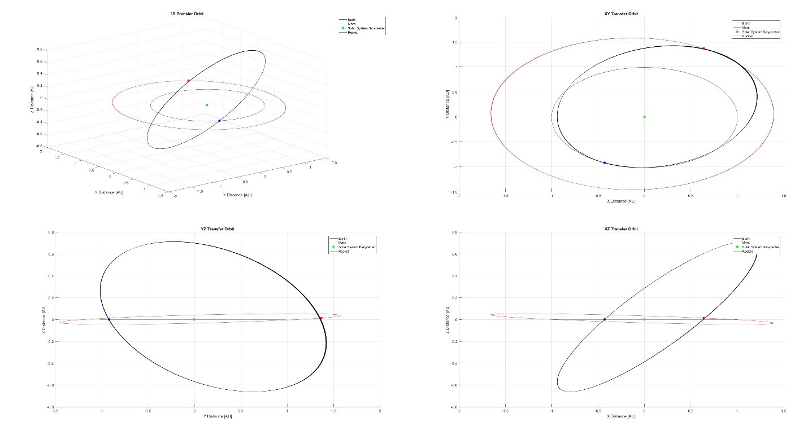

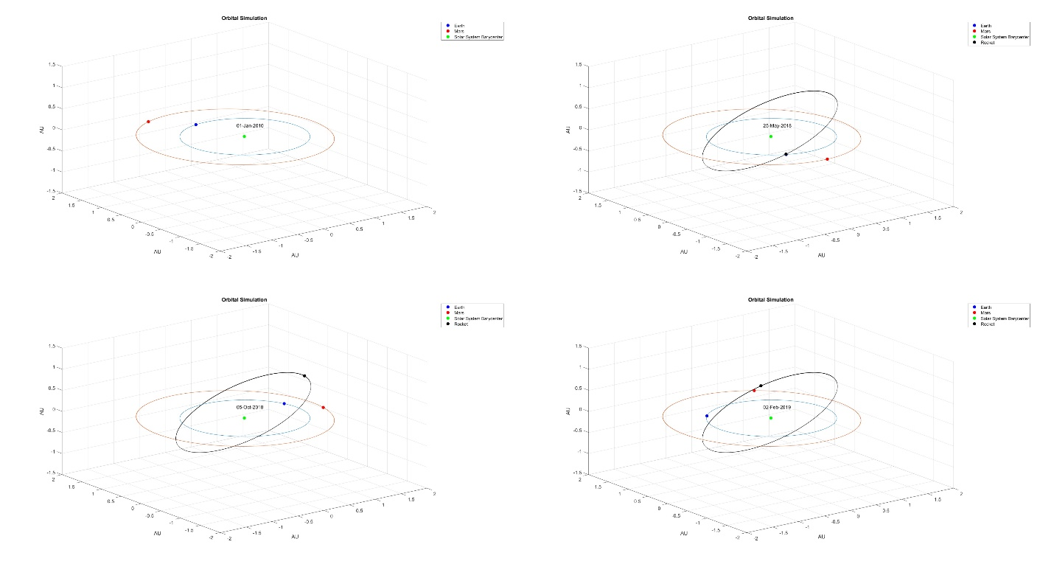

APPENDIX

**Listing 1:** MATLAB Code used to simulate Earth and Mars orbit and Hohmann Transfer between them.

## Author: Jered Dominguez-Trujillo

Date: March 6, 2017

clear vars; close all;  
set(gcf,'position',get(0,'screensize'))

## Declare Variables

AU = 149597870700;  
G = 6.674275935628303e-11;  
MSolarSystem = 1.999*10^30;  
RMars = 3.3899*10^6;  
EarthYear = 365.24237; EarthDay = 86400;  
dt = 1; inx = 1;  
StartYear = 2010; years = 30;  
length = years * EarthYear * EarthDay;  
dates = datetime(StartYear,01,01):caldays(1):datetime(StartYear+years+1,01,01);  
t = zeros(1, ceil(length/dt));  
t(inx) = 0;  
  
axEarth = zeros(1, ceil(length/dt)); ayEarth = zeros(1, ceil(length/dt));  
azEarth = zeros(1, ceil(length/dt));  
vxEarth = zeros(1, ceil(length/dt)); vyEarth = zeros(1, ceil(length/dt));  
vzEarth = zeros(1, ceil(length/dt));  
xEarth = zeros(1, ceil(length/dt)); yEarth = zeros(1, ceil(length/dt));  
zEarth = zeros(1, ceil(length/dt));  
rEarth = zeros(1, ceil(length/dt));  
alphaEarth = zeros(1, ceil(length/dt)); betaEarth = zeros(1, ceil(length/dt));  
gammaEarth = zeros(1, ceil(length/dt));  
  
axMars = zeros(1, ceil(length/dt)); ayMars = zeros(1, ceil(length/dt));  
azMars = zeros(1, ceil(length/dt));  
vxMars = zeros(1, ceil(length/dt)); vyMars = zeros(1, ceil(length/dt));  
vzMars = zeros(1, ceil(length/dt));  
xMars = zeros(1, ceil(length/dt)); yMars = zeros(1, ceil(length/dt));  
zMars = zeros(1, ceil(length/dt));  
rMars = zeros(1, ceil(length/dt));  
alphaMars = zeros(1, ceil(length/dt)); betaMars = zeros(1, ceil(length/dt));  
gammaMars = zeros(1, ceil(length/dt));  
  
axRocket = zeros(1, ceil(length/dt)); ayRocket = zeros(1, ceil(length/dt));  
azRocket = zeros(1, ceil(length/dt));  
vxRocket = zeros(1, ceil(length/dt)); vyRocket = zeros(1, ceil(length/dt));  
vzRocket = zeros(1, ceil(length/dt));  
xRocket = zeros(1, ceil(length/dt)); yRocket = zeros(1, ceil(length/dt));  
zRocket = zeros(1, ceil(length/dt));  
rRocket = zeros(1, ceil(length/dt));  
alphaRocket = zeros(1, ceil(length/dt)); betaRocket = zeros(1, ceil(length/dt));  
gammaRocket = zeros(1, ceil(length/dt));

## Data Gathered for Earth and Mars for January 1, 2010 from JPL

axEarth(inx) = 0; ayEarth(inx) = 0; azEarth(inx) = 0;  
vxEarth(inx) = -2.978405751621624e+04; vyEarth(inx) = -5.451137243323289e+03;  
vzEarth(inx) = 1.551580077431058;  
xEarth(inx) = -2.689245210784379e+10; yEarth(inx) = 1.451618583042868e+11;  
zEarth(inx) = -2.608728054337204e+06;  
rEarth(inx) = sqrt(xEarth(inx)^2+yEarth(inx)^2+zEarth(inx)^2);  
alphaEarth(inx) = acos(xEarth(inx)/rEarth(inx)); betaEarth(inx) = acos(yEarth(inx)/rEarth(inx));  
gammaEarth(inx) = acos(zEarth(inx)/rEarth(inx)); axMars(inx) = 0; ayMars(inx) = 0; azMars(inx) = 0;  
vxMars(inx) = -2.074332689615267e+04; vyMars(inx) = -8.817501559049284e+03;  
vzMars(inx) = 3.248028553828797e+02;  
xMars(inx) = -1.097178350768191e+11; yMars(inx) = 2.179958733988708e+11;  
zMars(inx) = 7.239687840140940e+09;  
rMars(inx) = sqrt(xMars(inx)^2+yMars(inx)^2+zMars(inx)^2);  
alphaMars(inx) = acos(xMars(inx)/rMars(inx)); betaMars(inx) = acos(yMars(inx)/rMars(inx));  
gammaMars(inx) = acos(zMars(inx)/rMars(inx));  
distanceEarthtoMars = zeros(1, ceil(length/dt));  
distanceEarthtoMars(inx) = sqrt((xMars(inx)-xEarth(inx))^2+(yMars(inx)-yEarth(inx))^2+(zMars(inx)-zEarth(inx))^2);

## Calculate Earth and Mars Trajectories

while t(inx) < length  
 inx = inx + 1;  
 alphaEarth(inx)=acos(xEarth(inx-1)/rEarth(inx-1));  
 betaEarth(inx)=acos(yEarth(inx-1)/rEarth(inx-1));  
 gammaEarth(inx) = acos(zEarth(inx-1)/rEarth(inx-1));  
 rEarth(inx) = sqrt(xEarth(inx-1)^2+yEarth(inx-1)^2+zEarth(inx-1)^2);  
 axEarth(inx) = -(G*MSolarSystem)/(rEarth(inx)^2)*cos(alphaEarth(inx));  
 ayEarth(inx) = -(G*MSolarSystem)/(rEarth(inx)^2)*cos(betaEarth(inx));  
 azEarth(inx) = -(G*MSolarSystem)/(rEarth(inx)^2)*cos(gammaEarth(inx));  
 vxEarth(inx)=vxEarth(inx-1)+axEarth(inx)*dt; vyEarth(inx)=vyEarth(inx-1)+ayEarth(inx)*dt;  
 vzEarth(inx)=vzEarth(inx-1)+azEarth(inx)*dt;  
 xEarth(inx)=xEarth(inx-1)+vxEarth(inx)*dt; yEarth(inx)=yEarth(inx-1)+vyEarth(inx)*dt;  
 zEarth(inx)=zEarth(inx-1)+vzEarth(inx)*dt;  
 alphaMars(inx)=acos(xMars(inx-1)/rMars(inx-1));betaMars(inx)=acos(yMars(inx-1)/rMars(inx-1));  
 gammaMars(inx) = acos(zMars(inx-1)/rMars(inx-1));  
 rMars(inx) = sqrt(xMars(inx-1)^2+yMars(inx-1)^2+zMars(inx-1)^2);  
 axMars(inx) = -(G*MSolarSystem)/(rMars(inx)^2)*cos(alphaMars(inx));  
 ayMars(inx) = -(G*MSolarSystem)/(rMars(inx)^2)*cos(betaMars(inx));  
 azMars(inx) = -(G*MSolarSystem)/(rMars(inx)^2)*cos(gammaMars(inx));  
 vxMars(inx)=vxMars(inx-1)+axMars(inx)*dt; vyMars(inx)=vyMars(inx-1)+ayMars(inx)*dt;  
 vzMars(inx)=vzMars(inx-1)+azMars(inx)*dt;  
 xMars(inx)=xMars(inx-1)+vxMars(inx)*dt; yMars(inx) = yMars(inx-1) + vyMars(inx) * dt;  
 zMars(inx) = zMars(inx-1) + vzMars(inx) * dt;  
 distanceEarthtoMars(inx) = sqrt((xMars(inx)-xEarth(inx))^2+(yMars(inx)-yEarth(inx))^2+(zMars(inx)-zEarth(inx))^2);  
  
 t(inx) = t(inx-1) + dt;  
end

## Find Time and Distance of Closest Approach

closestApproach = find(distanceEarthtoMars==min(distanceEarthtoMars))*dt/EarthDay/EarthYear;  
ApproachYear = StartYear + floor(closestApproach);  
ApproachDay = floor(rem(closestApproach, 1) * EarthYear);  
datesApproach = datetime(ApproachYear,01,01):caldays(1):datetime(ApproachYear,12,31);  
fprintf('Mars Closest Approach to Earth between %s and %s occurs on %s at a distance of %.4f AU\n',...  
 num2str(StartYear), num2str(StartYear + years), datestr(datesApproach(ApproachDay)), ...  
 min(distanceEarthtoMars)/AU);

## Calculating Transit Time and Target Distance if Launched at Each Time Step

alphaEarth = round(atan2(real(yEarth), real(xEarth)), 3);  
alphaMars = round(atan2(real(yMars), real(xMars)), 3);  
TransitTime = zeros(1, ceil(inx)); TargetDistance = zeros(1, ceil(inx));  
for ii = 1:0.5*inx  
 if alphaEarth(ii) > 0  
 value = alphaEarth(ii) - round(pi, 3);  
 else  
 value = alphaEarth(ii) + round(pi, 3);  
 end  
 MarsOppositeInx = find(abs(alphaMars - value)<0.0001);  
 if isempty(MarsOppositeInx) == 0  
 d = sqrt((xEarth(ii) - xMars(MarsOppositeInx(1)))^2+(yEarth(ii) - yMars(MarsOppositeInx(1)))^2+(zEarth(ii) - zMars(MarsOppositeInx(1)))^2);  
 TransitTime(ii) = ((sqrt((((d/AU))/2)^3))/2)*EarthYear;  
 TimeinSeconds=TransitTime(ii)*EarthDay; TimeSteps=real(ceil(TimeinSeconds/dt));  
 TargetDistance(ii) = sqrt(((xMars(MarsOppositeInx(1)) - xMars(ii+TimeSteps))^2+...  
 (yMars(MarsOppositeInx(1)) - yMars(ii+TimeSteps))^2+...  
 (zMars(MarsOppositeInx(1)) - zMars(ii+TimeSteps))^2));  
 else  
 TransitTime(ii) = TransitTime(ii - 1); TargetDistance(ii) = TargetDistance(ii - 1);  
 end  
end

## Print Appropriate Launch Dates

LaunchDates = find(TargetDistance(1:floor(0.5*inx))/AU < 5*RMars/AU);  
datecount = size(LaunchDates);  
for ii = 1:datecount(2)  
 Val = LaunchDates(ii)*dt/EarthDay/EarthYear;  
 LaunchHour = round(rem(LaunchDates(ii)/24, 1) * 24, 0);  
 LaunchYear = StartYear + floor(Val); LaunchDay = floor(rem(Val, 1) * EarthYear);  
 datesLaunch = datetime(LaunchYear,01,01):caldays(1):datetime(LaunchYear,12,31);  
 fprintf('Launch to Mars: %s. Closest Approach to Mars: %.4f Mars Radii. Travel Time: %.4f Days\n',...  
 datestr(datesLaunch(LaunchDay)), TargetDistance(LaunchDates(ii))/RMars, ...  
 TransitTime(LaunchDates(ii)));  
end

## Calculate Rocket Start and End Positions

LaunchofInterest = LaunchDates(end); % 2018 Launch  
if alphaEarth(LaunchofInterest) > 0  
 val = alphaEarth(LaunchofInterest) - round(pi, 3);  
else  
 val = alphaEarth(LaunchofInterest) + round(pi, 3);  
end  
MarsOppositeInx = find(abs(alphaMars - val)<0.0001);  
dEtoM = sqrt(((xEarth(LaunchofInterest)-xMars(MarsOppositeInx(1)))^2)+...  
 ((yEarth(LaunchofInterest)-yMars(MarsOppositeInx(1)))^2)+...  
 ((zEarth(LaunchofInterest)-zMars(MarsOppositeInx(1)))^2));  
Vp = sqrt(G*MSolarSystem*((2/rEarth(LaunchofInterest))-(1/(dEtoM/2))));

## Initial Rocket Parameters Calculated to Complete Transfer Orbit

inx = 1; t = zeros(1, ceil(length/dt)); t(inx) = 0; rad = 0 ; vtest = 100000; axRocket(inx) = 0; ayRocket(inx) = 0; azRocket(inx) = 0;  
while vtest > Vp  
 vxRocket(inx) = ((-1*vxEarth(LaunchofInterest))/abs(vxEarth(LaunchofInterest)))*...  
 (-abs(vxEarth(LaunchofInterest)) + (Vp-abs(vxEarth(LaunchofInterest)))*(1-cos(rad)));  
 vyRocket(inx) = ((-1*vyEarth(LaunchofInterest))/abs(vyEarth(LaunchofInterest)))*...  
 (abs(vyEarth(LaunchofInterest))+(Vp+abs(vyEarth(LaunchofInterest)))*cos(pi-rad));  
 vzRocket(inx) = ((vzEarth(LaunchofInterest))/abs(vzEarth(LaunchofInterest)))*...  
 (abs(vzEarth(LaunchofInterest))-(Vp-abs(vzEarth(LaunchofInterest)))*cos(rad));  
 vtest = sqrt(vxRocket(inx)^2 + vyRocket(inx)^2 + vzRocket(inx)^2); rad = rad + 0.00001;  
end  
xRocket(inx) = xEarth(LaunchofInterest); yRocket(inx) = yEarth(LaunchofInterest);  
zRocket(inx) = zEarth(LaunchofInterest);  
rRocket(inx) = sqrt(xRocket(inx)^2+yRocket(inx)^2+zRocket(inx)^2);  
alphaRocket(inx)=acos(xRocket(inx)/rRocket(inx));betaRocket(inx)=acos(yRocket(inx)/rRocket(inx));  
gammaRocket(inx) = acos(zRocket(inx)/rRocket(inx));

## Calculate Rocket Trajectory

while t(inx) < length  
 inx = inx + 1;  
 alphaRocket(inx) = acos(xRocket(inx-1)/rRocket(inx-1));  
 betaRocket(inx) = acos(yRocket(inx-1)/rRocket(inx-1));  
 gammaRocket(inx) = acos(zRocket(inx-1)/rRocket(inx-1));  
 rRocket(inx) = sqrt(xRocket(inx-1)^2+yRocket(inx-1)^2+zRocket(inx-1)^2);  
 axRocket(inx) = -(G*MSolarSystem)/(rRocket(inx)^2)*cos(alphaRocket(inx));  
 ayRocket(inx) = -(G*MSolarSystem)/(rRocket(inx)^2)*cos(betaRocket(inx));  
 azRocket(inx) = -(G*MSolarSystem)/(rRocket(inx)^2)*cos(gammaRocket(inx));  
 vxRocket(inx) = vxRocket(inx-1) + axRocket(inx) * dt;  
 vyRocket(inx) = vyRocket(inx-1) + ayRocket(inx) * dt;  
 vzRocket(inx) = vzRocket(inx-1) + azRocket(inx) * dt;  
 xRocket(inx)=xRocket(inx-1)+vxRocket(inx)*dt; yRocket(inx)=yRocket(inx-1)+vyRocket(inx)*dt;  
 zRocket(inx) = zRocket(inx-1) + vzRocket(inx) * dt;  
 t(inx) = t(inx - 1) + dt;  
end

## Plot Animation from 2010 Until Arrival at Mars

flag =false;  
for ii = 1:LaunchofInterest + (real(max(TransitTime))*EarthDay/dt)  
 if rem(t(ii), EarthDay) == 0 && t(ii) > 0  
 clf; hold on; view(3)  
 plot3(real(xEarth(ii))/AU, real(yEarth(ii))/AU, real(zEarth(ii))/AU, 'bo', ...  
 'MarkerFaceColor','b')  
 plot3(real(xMars(ii))/AU, real(yMars(ii))/AU, real(zMars(ii))/AU, 'ro', ...  
 'MarkerFaceColor','r')  
 plot3(0, 0, 0, 'go', 'MarkerFaceColor','g')  
 if ii >= LaunchofInterest  
 plot3(real(xRocket(ii-LaunchofInterest))/AU, real(yRocket(ii-LaunchofInterest))/AU,...  
 real(zRocket(ii-LaunchofInterest))/AU, 'ko', 'MarkerFaceColor', 'k')  
 plot3(real(xRocket)/AU, real(yRocket)/AU, real(zRocket)/AU, 'k', 'linewidth', 0.25)  
 flag = true;  
 end  
 plot3(real(xEarth/AU), real(yEarth/AU), real(zEarth/AU))  
 plot3(real(xMars/AU), real(yMars/AU), real(zMars/AU))  
 xlim([-2, 2]); ylim([-2, 2]); zlim([-1.5, 1.5])  
 xlabel('AU'); ylabel('AU'); zlabel('AU')  
 title('Orbital Simulation')  
 text(0, 0.2, 0.2, datestr(dates(ceil(t(ii)/EarthDay))));  
 if flag == true  
 legend({'Earth', 'Mars', 'Solar System Barycenter', 'Rocket'})  
 else  
 legend({'Earth', 'Mars', 'Solar System Barycenter'})  
 end  
 grid on  
 print(['Simulation\Time' num2str(ii)], '-dpng')  
 pause(0.01)  
 end  
end

## Plot and Save Figures

clf; close all;  
set(gcf,'position',get(0,'screensize'))  
figure(1); hold on; view(3);  
plot3(xEarth/AU, yEarth/AU, zEarth/AU, 'b');  
plot3(xMars/AU, yMars/AU, zMars/AU, 'r'); plot3(0, 0, 0, 'go', 'MarkerFaceColor','g')  
plot3(xRocket/AU, yRocket/AU, zRocket/AU, 'k');  
plot3(xEarth(LaunchofInterest)/AU, yEarth(LaunchofInterest)/AU, zEarth(LaunchofInterest)/AU, 'bo', 'MarkerFaceColor', 'b');  
plot3(xMars(MarsOppositeInx(1))/AU, yMars(MarsOppositeInx(1))/AU, zMars(MarsOppositeInx(1))/AU, 'ro', 'MarkerFaceColor', 'r');  
legend({'Earth', 'Mars', 'Solar System Barycenter', 'Rocket'})  
title('3D Transfer Orbit');  
xlabel('X Distance [AU]'); ylabel('Y Distance [AU]'); zlabel('Z Distance [AU'); grid on;  
print('3D Transfer Orbit', '-dpng');  
  
figure(2); set(gcf,'position',get(0,'screensize')); hold on; plot(xEarth/AU, yEarth/AU, 'b'); plot(xMars/AU, yMars/AU, 'r');  
plot(0, 0, 'go', 'MarkerFaceColor', 'g'); plot(xRocket/AU, yRocket/AU, 'k');  
plot(xEarth(LaunchofInterest)/AU, yEarth(LaunchofInterest)/AU, 'bo', 'MarkerFaceColor', 'b')  
plot(xMars(MarsOppositeInx(1))/AU, yMars(MarsOppositeInx(1))/AU, 'ro', 'MarkerFaceColor', 'r')  
legend({'Earth', 'Mars', 'Solar System Barycenter', 'Rocket'})  
title('XY Transfer Orbit');  
xlabel('X Distance [AU]'); ylabel('Y Distance [AU]'); grid on;  
print('XY Transfer Orbit', '-dpng');  
  
figure(3); set(gcf,'position',get(0,'screensize')); hold on; plot(yEarth/AU, zEarth/AU, 'b'); plot(yMars/AU, zMars/AU, 'r');  
plot(0, 0, 'go', 'MarkerFaceColor', 'g'); plot(yRocket/AU, zRocket/AU, 'k');  
plot(yEarth(LaunchofInterest)/AU, zEarth(LaunchofInterest)/AU, 'bo', 'MarkerFaceColor', 'b')  
plot(yMars(MarsOppositeInx(1))/AU, zMars(MarsOppositeInx(1))/AU, 'ro', 'MarkerFaceColor', 'r')  
legend({'Earth', 'Mars', 'Solar System Barycenter', 'Rocket'})  
title('YZ Transfer Orbit');  
xlabel('Y Distance [AU]'); ylabel('Z Distance [AU]'); grid on;  
print('YZ Transfer Orbit', '-dpng');  
  
figure(4); set(gcf,'position',get(0,'screensize')); hold on; plot(xEarth/AU, zEarth/AU, 'b'); plot(xMars/AU, zMars/AU, 'r');  
plot(0, 0, 'go', 'MarkerFaceColor', 'g'); plot(xRocket/AU, zRocket/AU, 'k');  
plot(xEarth(LaunchofInterest)/AU, zEarth(LaunchofInterest)/AU, 'bo', 'MarkerFaceColor', 'b')  
plot(xMars(MarsOppositeInx(1))/AU, zMars(MarsOppositeInx(1))/AU, 'ro', 'MarkerFaceColor', 'r')  
legend({'Earth', 'Mars', 'Solar System Barycenter', 'Rocket'})  
title('XZ Transfer Orbit');  
xlabel('X Distance [AU]'); ylabel('Z Distance [AU]'); grid on;  
print('XZ Transfer Orbit', '-dpng');  
  
figure(5);  
plot(t(1:inx)/EarthDay/EarthYear, real(distanceEarthtoMars(1:inx)) / AU);  
ylim([0, 3]);  
xlabel('Days since January 1, 2010 [Years]'); ylabel('Distance [AU]');  
title('Distance between Earth and Mars');  
xlim([0 years]); grid on;  
print('Distance Earth and Mars', '-dpng');  
  
figure(6);  
plot(t(1:floor(0.5*inx))/EarthDay/EarthYear, real(TargetDistance(1:floor(0.5*inx)))/AU);  
xlabel('Time since January 1, 2010 [Years]'); ylabel('Distance [AU]');  
title('Launch Window'); grid on;  
print('Launch Window', '-dpng');  
  
figure(7);  
plot(t(1:floor(0.5*inx))/EarthDay/EarthYear, real(TransitTime(1:floor(0.5*inx))));  
xlabel('Time since January 1, 2010 [Years]'); ylabel('Transit Time [Days]');  
title('Time of Travel to Mars'); grid on;  
print('Time of Travel', '-dpng');

Mars Closest Approach to Earth between 2010 and 2040 occurs on 31-Jul-2018 at a distance of 0.3822 AU

Launch to Mars: 15-Nov-2011. Closest Approach to Mars: 4.5530 Mars Radii. Travel Time: 259.9679 Days

Launch to Mars: 15-Nov-2011. Closest Approach to Mars: 3.2827 Mars Radii. Travel Time: 259.9679 Days

Launch to Mars: 15-Nov-2011. Closest Approach to Mars: 2.0128 Mars Radii. Travel Time: 259.9678 Days

Launch to Mars: 15-Nov-2011. Closest Approach to Mars: 0.7450 Mars Radii. Travel Time: 259.9678 Days

Launch to Mars: 15-Nov-2011. Closest Approach to Mars: 0.5363 Mars Radii. Travel Time: 259.9677 Days

Launch to Mars: 15-Nov-2011. Closest Approach to Mars: 1.8025 Mars Radii. Travel Time: 259.9677 Days

Launch to Mars: 15-Nov-2011. Closest Approach to Mars: 3.0723 Mars Radii. Travel Time: 259.9676 Days

Launch to Mars: 15-Nov-2011. Closest Approach to Mars: 4.3426 Mars Radii. Travel Time: 259.9676 Days

Launch to Mars: 19-Dec-2013. Closest Approach to Mars: 4.9977 Mars Radii. Travel Time: 246.4415 Days

Launch to Mars: 19-Dec-2013. Closest Approach to Mars: 3.6568 Mars Radii. Travel Time: 246.4415 Days

Launch to Mars: 19-Dec-2013. Closest Approach to Mars: 2.3195 Mars Radii. Travel Time: 246.4414 Days

Launch to Mars: 19-Dec-2013. Closest Approach to Mars: 0.9997 Mars Radii. Travel Time: 246.4414 Days

Launch to Mars: 19-Dec-2013. Closest Approach to Mars: 0.4804 Mars Radii. Travel Time: 246.4414 Days

Launch to Mars: 19-Dec-2013. Closest Approach to Mars: 1.7533 Mars Radii. Travel Time: 246.4414 Days

Launch to Mars: 19-Dec-2013. Closest Approach to Mars: 3.0869 Mars Radii. Travel Time: 246.4414 Days

Launch to Mars: 19-Dec-2013. Closest Approach to Mars: 4.4268 Mars Radii. Travel Time: 246.4414 Days

Launch to Mars: 07-Feb-2016. Closest Approach to Mars: 4.5945 Mars Radii. Travel Time: 236.3494 Days

Launch to Mars: 07-Feb-2016. Closest Approach to Mars: 3.2280 Mars Radii. Travel Time: 236.3495 Days

Launch to Mars: 07-Feb-2016. Closest Approach to Mars: 1.9240 Mars Radii. Travel Time: 236.3495 Days

Launch to Mars: 07-Feb-2016. Closest Approach to Mars: 0.9767 Mars Radii. Travel Time: 236.3496 Days

Launch to Mars: 07-Feb-2016. Closest Approach to Mars: 1.4755 Mars Radii. Travel Time: 236.3497 Days

Launch to Mars: 07-Feb-2016. Closest Approach to Mars: 2.7149 Mars Radii. Travel Time: 236.3497 Days

Launch to Mars: 07-Feb-2016. Closest Approach to Mars: 4.0663 Mars Radii. Travel Time: 236.3498 Days

Launch to Mars: 07-Feb-2016. Closest Approach to Mars: 4.5964 Mars Radii. Travel Time: 236.3474 Days

Launch to Mars: 07-Feb-2016. Closest Approach to Mars: 3.2299 Mars Radii. Travel Time: 236.3475 Days

Launch to Mars: 23-May-2018. Closest Approach to Mars: 3.7236 Mars Radii. Travel Time: 258.6313 Days

Launch to Mars: 23-May-2018. Closest Approach to Mars: 2.4251 Mars Radii. Travel Time: 258.6314 Days

Launch to Mars: 23-May-2018. Closest Approach to Mars: 1.1268 Mars Radii. Travel Time: 258.6314 Days

Launch to Mars: 23-May-2018. Closest Approach to Mars: 0.1761 Mars Radii. Travel Time: 258.6314 Days

Launch to Mars: 23-May-2018. Closest Approach to Mars: 1.4714 Mars Radii. Travel Time: 258.6315 Days

Launch to Mars: 23-May-2018. Closest Approach to Mars: 2.7698 Mars Radii. Travel Time: 258.6315 Days

Launch to Mars: 23-May-2018. Closest Approach to Mars: 4.0683 Mars Radii. Travel Time: 258.6316 Days

Launch to Mars: 23-May-2018. Closest Approach to Mars: 3.7234 Mars Radii. Travel Time: 258.6546 Days

Launch to Mars: 23-May-2018. Closest Approach to Mars: 2.4250 Mars Radii. Travel Time: 258.6547 Days

Launch to Mars: 23-May-2018. Closest Approach to Mars: 1.1269 Mars Radii. Travel Time: 258.6547 Days

Launch to Mars: 23-May-2018. Closest Approach to Mars: 0.1755 Mars Radii. Travel Time: 258.6547 Days

Launch to Mars: 23-May-2018. Closest Approach to Mars: 1.4710 Mars Radii. Travel Time: 258.6548 Days

Launch to Mars: 23-May-2018. Closest Approach to Mars: 2.7693 Mars Radii. Travel Time: 258.6548 Days

Launch to Mars: 23-May-2018. Closest Approach to Mars: 4.0677 Mars Radii. Travel Time: 258.6549 Days

Launch to Mars: 23-May-2018. Closest Approach to Mars: 3.7233 Mars Radii. Travel Time: 258.6784 Days

Launch to Mars: 28-Jul-2020. Closest Approach to Mars: 4.3587 Mars Radii. Travel Time: 280.7415 Days

Launch to Mars: 28-Jul-2020. Closest Approach to Mars: 3.4474 Mars Radii. Travel Time: 280.7415 Days

Launch to Mars: 28-Jul-2020. Closest Approach to Mars: 2.7506 Mars Radii. Travel Time: 280.7414 Days

Launch to Mars: 28-Jul-2020. Closest Approach to Mars: 2.4577 Mars Radii. Travel Time: 280.7414 Days

Launch to Mars: 28-Jul-2020. Closest Approach to Mars: 2.7036 Mars Radii. Travel Time: 280.7413 Days

Launch to Mars: 28-Jul-2020. Closest Approach to Mars: 3.3722 Mars Radii. Travel Time: 280.7413 Days

Launch to Mars: 28-Jul-2020. Closest Approach to Mars: 4.2695 Mars Radii. Travel Time: 280.7412 Days

Launch to Mars: 04-Sep-2022. Closest Approach to Mars: 4.1052 Mars Radii. Travel Time: 282.2414 Days

Launch to Mars: 04-Sep-2022. Closest Approach to Mars: 4.9070 Mars Radii. Travel Time: 282.2413 Days

Launch to Mars: 03-Oct-2024. Closest Approach to Mars: 4.6783 Mars Radii. Travel Time: 275.3410 Days

Launch to Mars: 03-Oct-2024. Closest Approach to Mars: 3.7848 Mars Radii. Travel Time: 275.3409 Days

Launch to Mars: 03-Oct-2024. Closest Approach to Mars: 3.1032 Mars Radii. Travel Time: 275.3408 Days

Launch to Mars: 03-Oct-2024. Closest Approach to Mars: 2.7930 Mars Radii. Travel Time: 275.3407 Days

Launch to Mars: 03-Oct-2024. Closest Approach to Mars: 2.9729 Mars Radii. Travel Time: 275.3406 Days

[Published with MATLAB® R2016a](http://www.mathworks.com/products/matlab)

# Author: Jered Dominguez-Trujillo

## Assign Variables

clear; clc; clf; close all;  
WaterM = 18.01528;  
WaterR = 8.3144598/WaterM; AirR = 0.2869;  
g = 9.80665; Ttp = 216.65; Ptp = 22573; Pref = 101325; Tref = 288.15;  
To = 3500; Po = 300*10^5 + Pref;  
NozzleArea = 0.062912356383544;  
% AeRatio = 200;  
AeRatio = 40;  
AExit = AeRatio * NozzleArea; AThroat = AExit / AeRatio;

## Define Cp, Cv, and Gamma as functions of temperature

Cp = @(T) ((T >= 0.5 && T <= 1.7).*((30.092 + (6.832514.*T) +...  
 (6.793435.*(T.^2)) - (2.53448.*(T.^3)) + (0.082139./(T.^2)))...  
 ./ WaterM)) + ((T > 1.7 && T <= 6).*((41.96426 + (8.622053.*T) -...  
 (1.49978.*(T.^2)) + (0.098119.*(T.^3)) + (-11.1576./(T.^2)))...  
 ./ WaterM));  
Cv = @(T) Cp(T) - WaterR;  
Gamma = @(T) Cp(T)/Cv(T);

## Establish A/A* as a function of Pe/Po and Me; Accommodating variation of Gamma (T)

set(gcf, 'Position', get(0, 'Screensize'));  
hold on  
TempArray = [0.5, 1:1:6];  
leg = cell(length(TempArray), 1);  
count = 1;  
for i = TempArray  
 G = Gamma(i);  
 leg{count} = ['Gamma = ' num2str(G)];  
 Me = (1:0.001:6);  
 A = (1./Me).*((2+(G - 1).*(Me.^2))./(G + 1)).^((G + 1)./(2.*(G-1)));  
 count = count + 1;  
 plot(A, Me)  
end  
title('$$\frac{A}{A*}\ as\ a\ Function\ of\ Mach\ Number$$',...  
 'interpreter', 'latex', 'fontsize', 20)  
ylabel('$$Mach\ Number$$', 'interpreter', 'latex', 'fontsize', 16)  
xlabel('$$\frac{A}{A*}$$', 'interpreter', 'latex', 'fontsize', 16)  
legend(leg, 'location', 'southeast')  
set(findall(gcf,'Type','Line'),'LineWidth', 2)  
grid on  
print('Area Ratio as Function of Mach Number', '-dpng')  
  
close all; clf;

## Calculating Design Exit Pressure and Altitude

criticalRatio = 300;  
Pa = 200;  
while criticalRatio > AeRatio  
 Pa = Pa + 10;  
 Temp = To / (((Po/Pa)^(Gamma(To/1000)-1)/Gamma(To/1000)));  
  
 G = Gamma(Temp/1000);  
 Me = 1; ARatioList = (1:0.025:1000);  
  
 inx = 1;  
 guess = (1/Me)*((2+(G-1)*Me^2)/(G+1))^((G+1)/(2*(G-1)));  
  
 for ratio = ARatioList  
 while guess < ratio  
 Me = Me + 0.0025;  
 guess = (1/Me)*((2+(G-1)*Me^2)/(G+1))^((G+1)/(2*(G-1)));  
 end  
  
 PRatio(inx) = 1/((1+((G-1)/2)*Me^2)^(G/(G-1)));  
 Term1 = 2*G/(G-1);  
 Term2 = (2/(G+1))^((G+1)/(G-1));  
 Term3 = (1 - (PRatio(inx))^((G-1)/G));  
 Term4 = sqrt(Term1 * Term2 * Term3);  
 Cf(inx) = Term4 + (PRatio(inx) - Pa/Po) * ratio;  
 inx = inx + 1;  
 end  
  
 criticalRatio = ARatioList(Cf==max(Cf));  
end  
  
height = ((1 - (Pa/Pref)^(1/5.2561))/(0.0065))*Tref;

## Calculating Thrust

DesignThrust = Po * AThroat * max(Cf);  
GroundThrust = DesignThrust - ((Pref - Pa)*AExit);  
VacuumThrust = DesignThrust - ((0 - Pa)*AExit);

## Printing Results

fprintf('Exit Temperature: %.2f K\n', Temp);  
fprintf('Gamma: %.4f \n', G);  
fprintf('Design Pressure: %.0f Pa\n', Pa);  
fprintf('Design Altitude: %.2f m\n', height);  
fprintf('Design Thrust: %.2f N\n', DesignThrust);  
fprintf('Ground Thrust: %.2f N\n', GroundThrust);  
fprintf('Vacuum Thrust: %.2f N\n', VacuumThrust);  
fprintf('Pe/Po : %.6f \n', Pa/Po);

## Plotting Thrust Coefficient of Design as a Function or A/A*

set(gcf, 'Position', get(0, 'Screensize'));  
  
plot(ARatioList, Cf, 'g')  
  
% line([AeRatio AeRatio], [0 max(Cf)], 'Color', 'k');  
% text(80, max(Cf)/1.5,'$$ \frac{A}{A*}\ =\ 77.5$$', 'interpreter', 'latex')  
% text(60.5, max(Cf)+0.05, ['Max \tau_{c} =' num2str(max(Cf))]);  
text(500, 1.55, '$$Design\ \frac{P_{e}}{P_{o}}$$', 'interpreter', 'latex')  
  
hold on  
TGamma = G;  
  
for PaPo = [0.0001, 0.001, 0.002, 0.005, 0.01]  
 Me = 1;  
 Term = (1/Me)*((2+(TGamma-1)*Me^2)/(TGamma+1))^((TGamma+1)/(2*(TGamma-1)));  
 inx = 1;  
 for a = ARatioList  
 while Term < a  
 Me = Me + 0.01;  
 Term = (1/Me)*((2+(TGamma-1)*Me^2)/(TGamma+1))^((TGamma+1)/(2*(TGamma-1)));  
 end  
  
 Me;  
  
 ratio = 1/((1+((TGamma-1)/2)*Me^2)^(TGamma/(TGamma-1)));  
  
 Term1 = 2*TGamma/(TGamma-1);  
 Term2 = (2/(TGamma+1))^((TGamma+1)/(TGamma-1));  
 Term3 = (1-(ratio)^((TGamma-1)/TGamma));  
 Term4 = sqrt(Term1*Term2*Term3);  
 Cf(inx) = Term4+(ratio-(PaPo))*a;  
 inx = inx + 1;  
 end  
 plot(ARatioList, Cf)  
 axis tight  
end  
  
title('$$Thrust\ Coefficient\ as\ a\ Function\ of\ \frac{A}{A*}$$',...  
 'interpreter', 'latex', 'fontsize', 20)  
xlabel('$$\frac{A}{A*}$$', 'interpreter', 'latex', 'fontsize', 16)  
ylabel('$$Thrust\ Coefficient$$', 'interpreter', 'latex', 'fontsize', 16)  
legend({'Design ^{Pe}/_{Po} = .000678', '^{Pe}/_{Po} = 0.0001',...  
 '^{Pe}/_{Po} = 0.001', '^{Pe}/_{Po} = 0.002', '^{Pa}/_{Po} = 0.005',...  
 '^{Pe}/_{Po} = 0.01'}, 'location', 'southwest')  
ylim([0 2])  
set(findall(gcf,'Type','Line'),'LineWidth', 2)  
grid on  
  
print('Thrust Coefficient 40', '-dpng')

**Area Ratio 40**

Exit Temperature: 1377.06 K

Gamma: 1.2218

Design Pressure: 50380 Pa

Design Altitude: 5518.35 m

Design Thrust: 3076845.76 N

Ground Thrust: 2948642.96 N

Vacuum Thrust: 3203626.74 N

Pe/Po : 0.001674

**Area Ratio 200**

Exit Temperature: 936.39 K

Gamma: 1.2587

Design Pressure: 5250 Pa

Design Altitude: 19088.91 m

Design Thrust: 3167504.35 N

Ground Thrust: 1958643.42 N

Vacuum Thrust: 3233562.32 N

Pe/Po : 0.000174

[Published with MATLAB® R2016a](http://www.mathworks.com/products/matlab)