1. Deploy K8s cluster and flask app in zone-1:

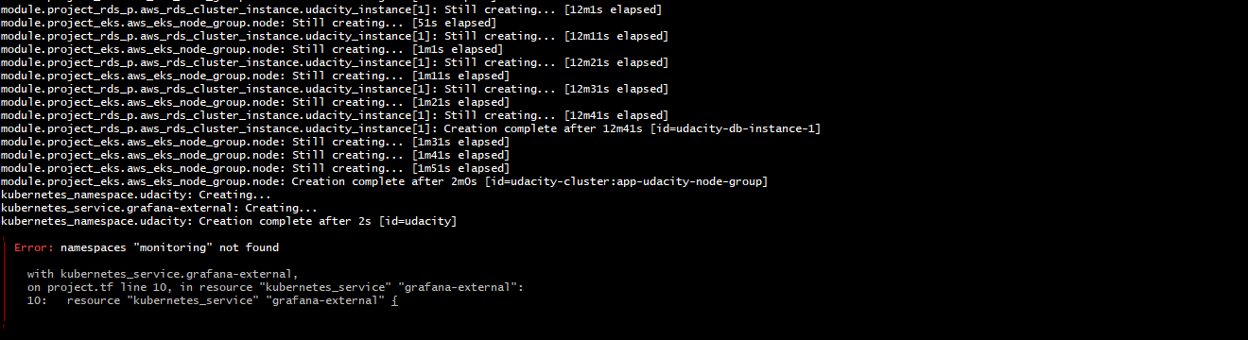

1. Grafana Dashboard showing Application metrics:

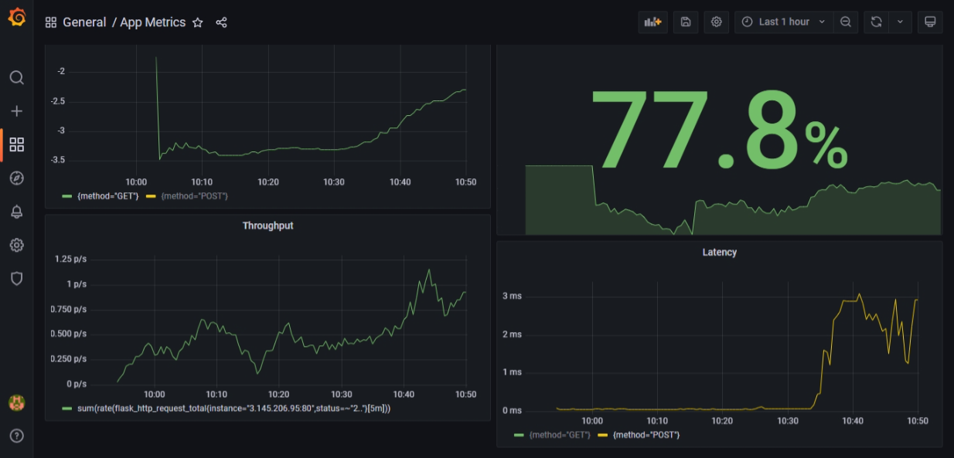

1. Deploy HA infra to zone-1:

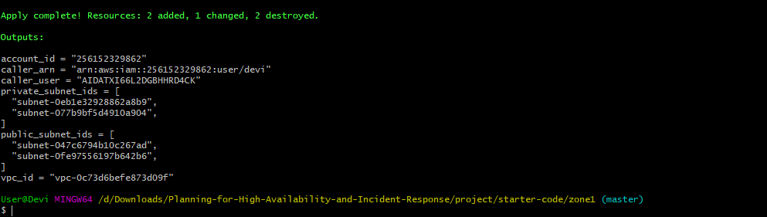

Target group and LB in zone-1

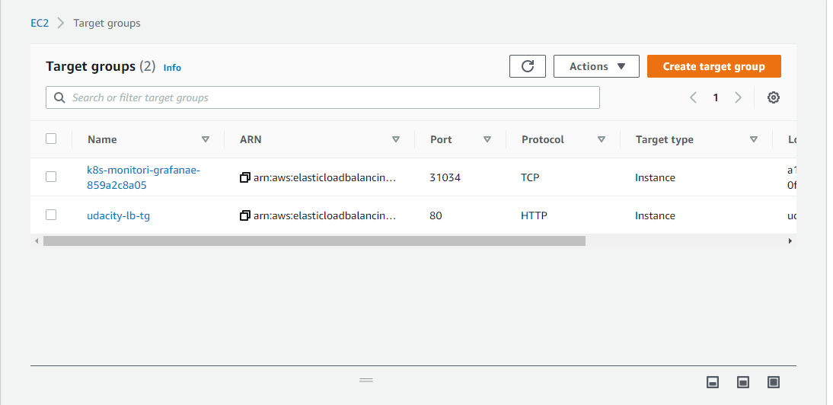

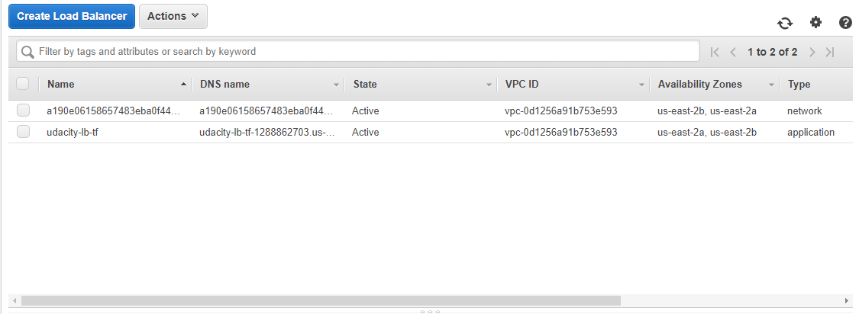

1. Deploy DR Infra to zone-2:

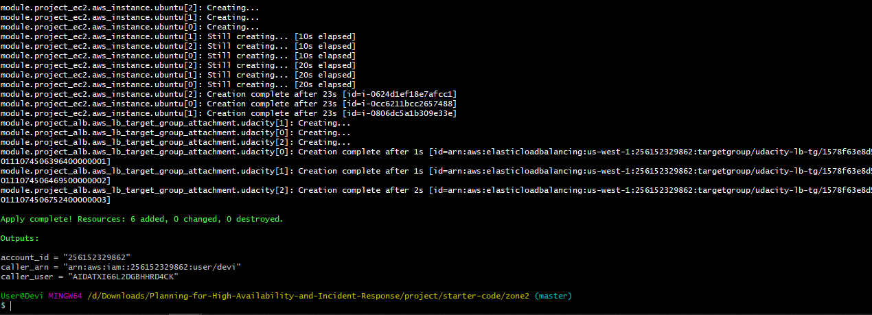

1. Deploy RDS to zone-1 and zone-2:

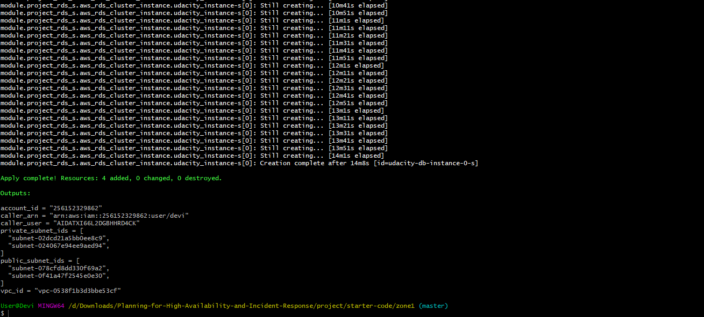

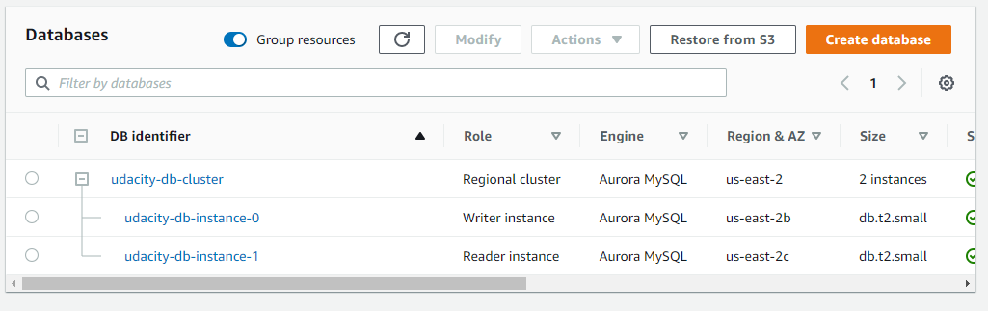

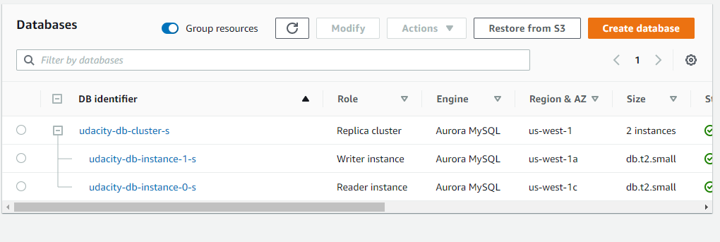

1. Destroy all resources in all zones:

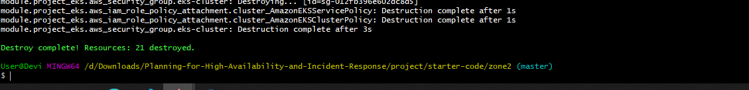

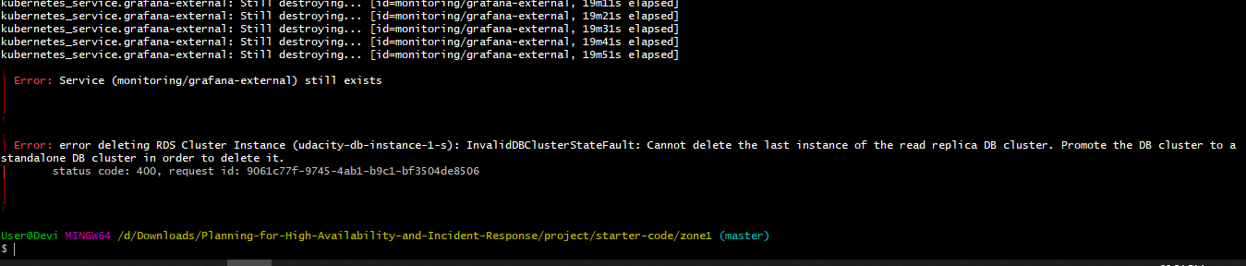

Make DR cluster a Primary one and then destroy via terraform.

