Q1: According to the number of trajectory points in the region, classify the regions in different periods (hot/cold). (25 mark)

the following figures are three typical heat map generated by dataset “2014-07-03” which from left to right are period from 9 to 10 o’clock , 15 to 16 o’clock and 20 to 21 o’clock. The latitude and longitude are artificially selected basically by real Xiamen map.

From the heat map you can find that center of Xiamen island is more busy and taxies appear more times on Xiamen island than other areas.

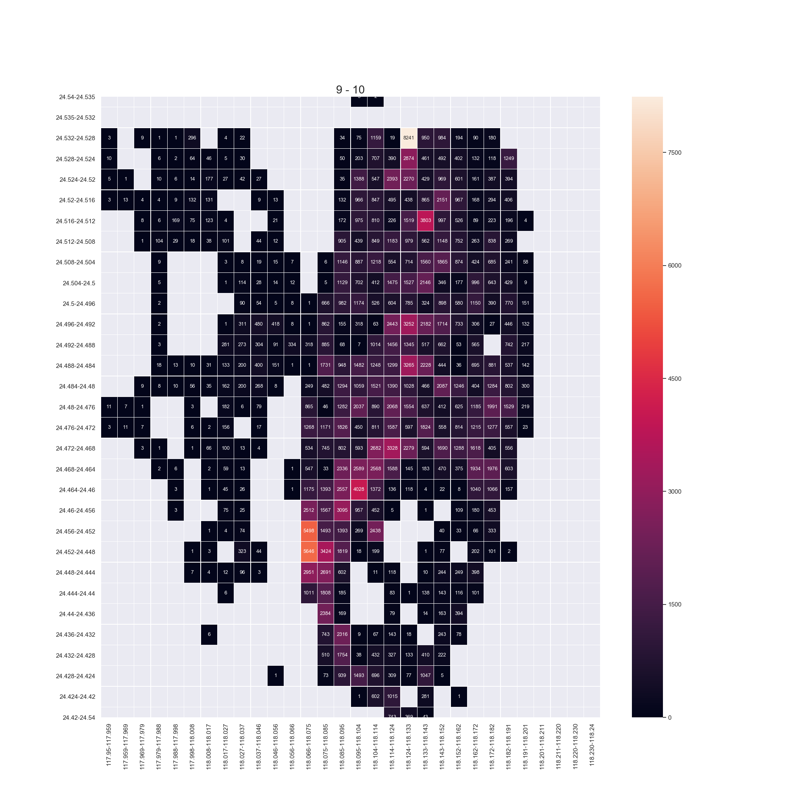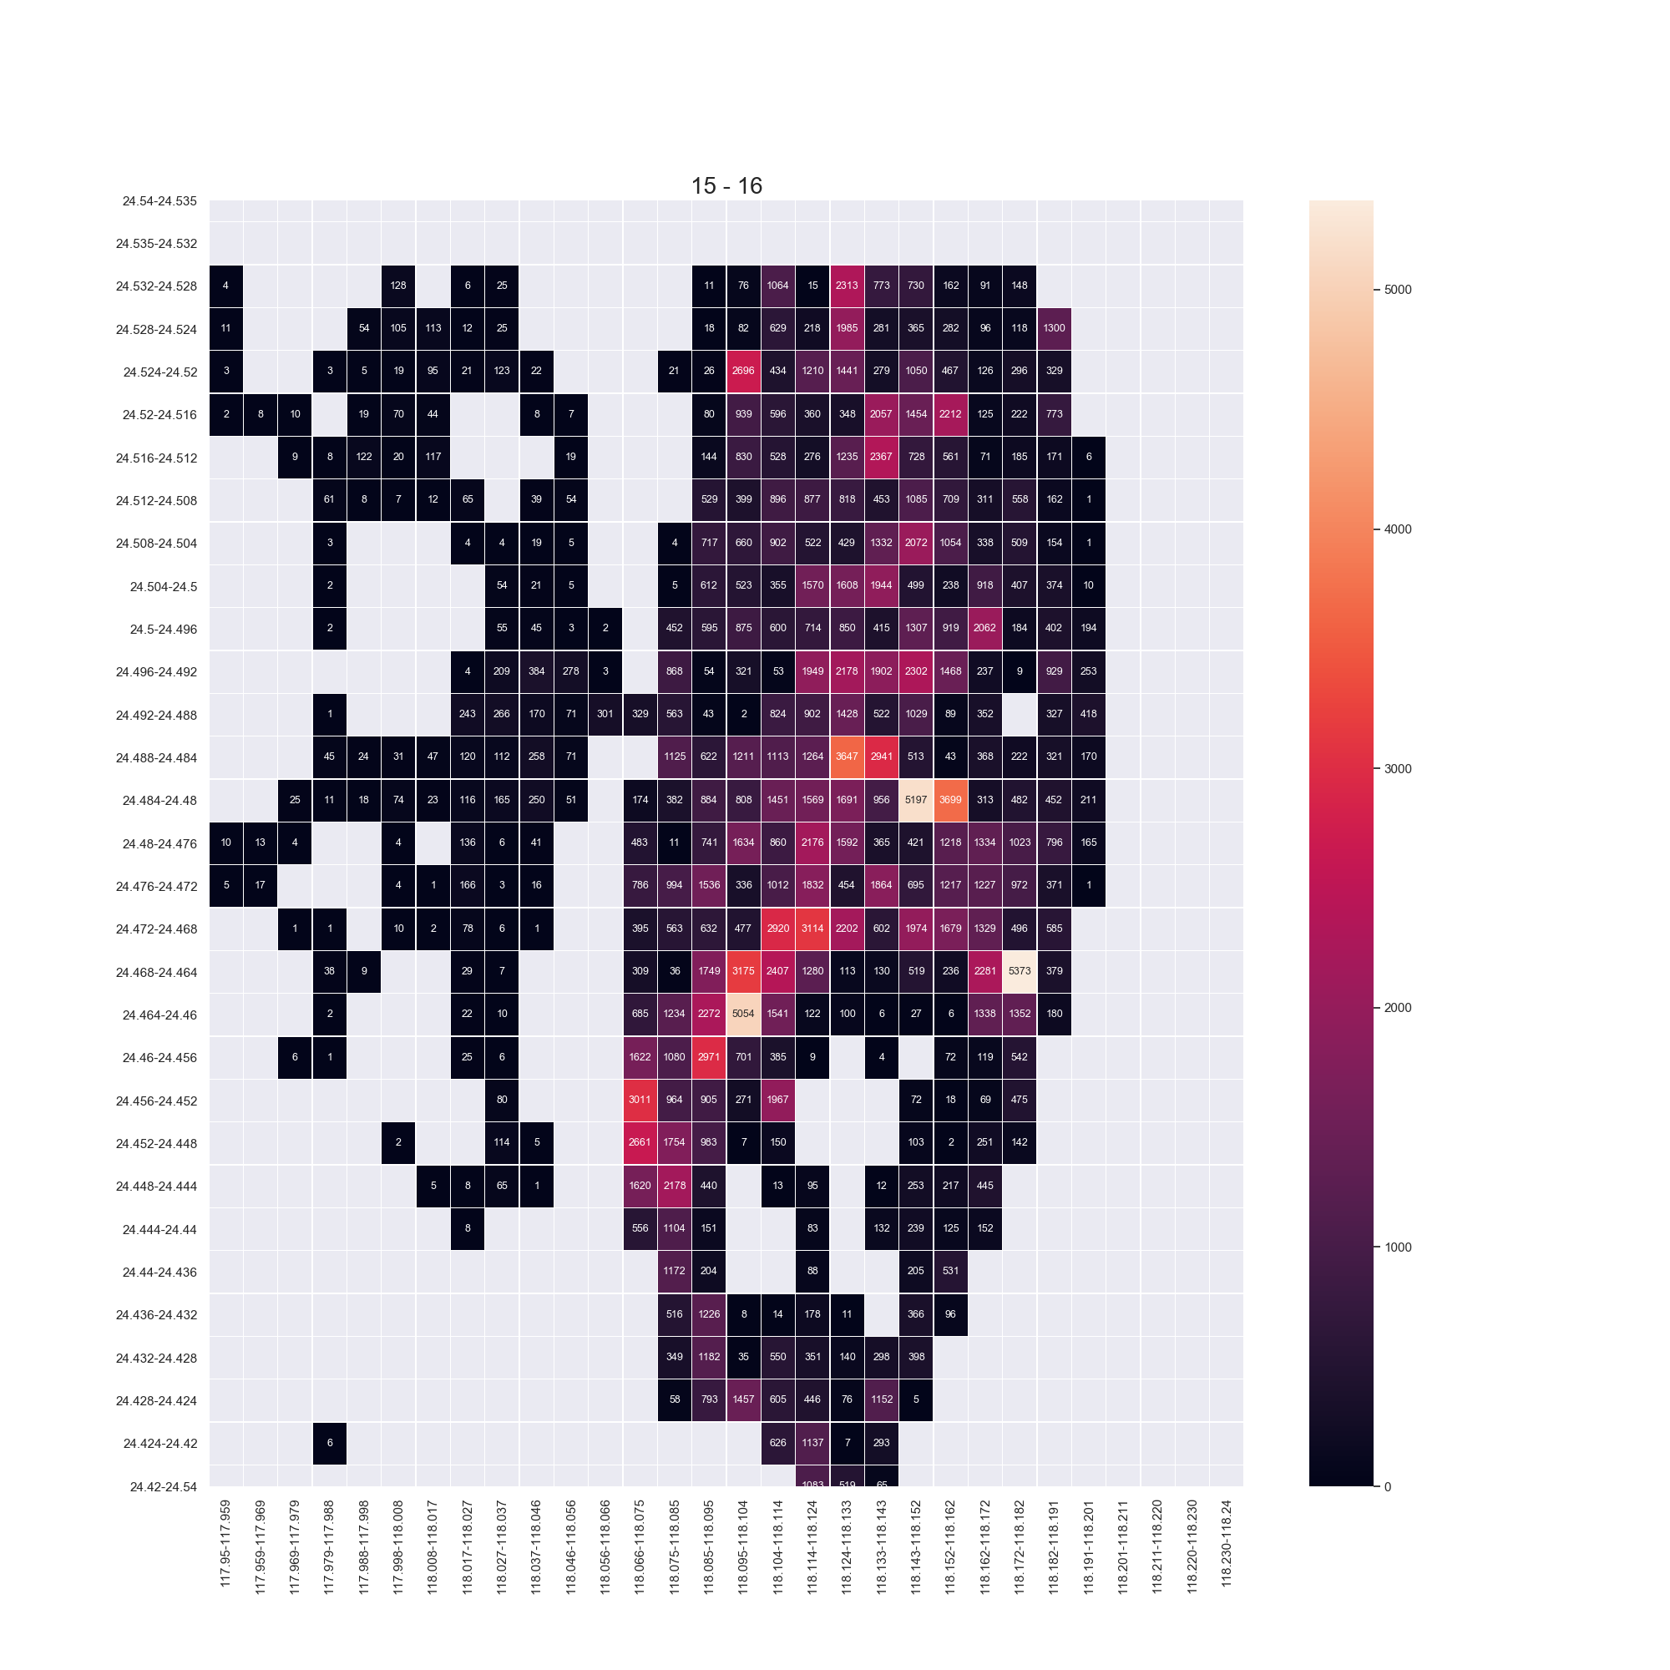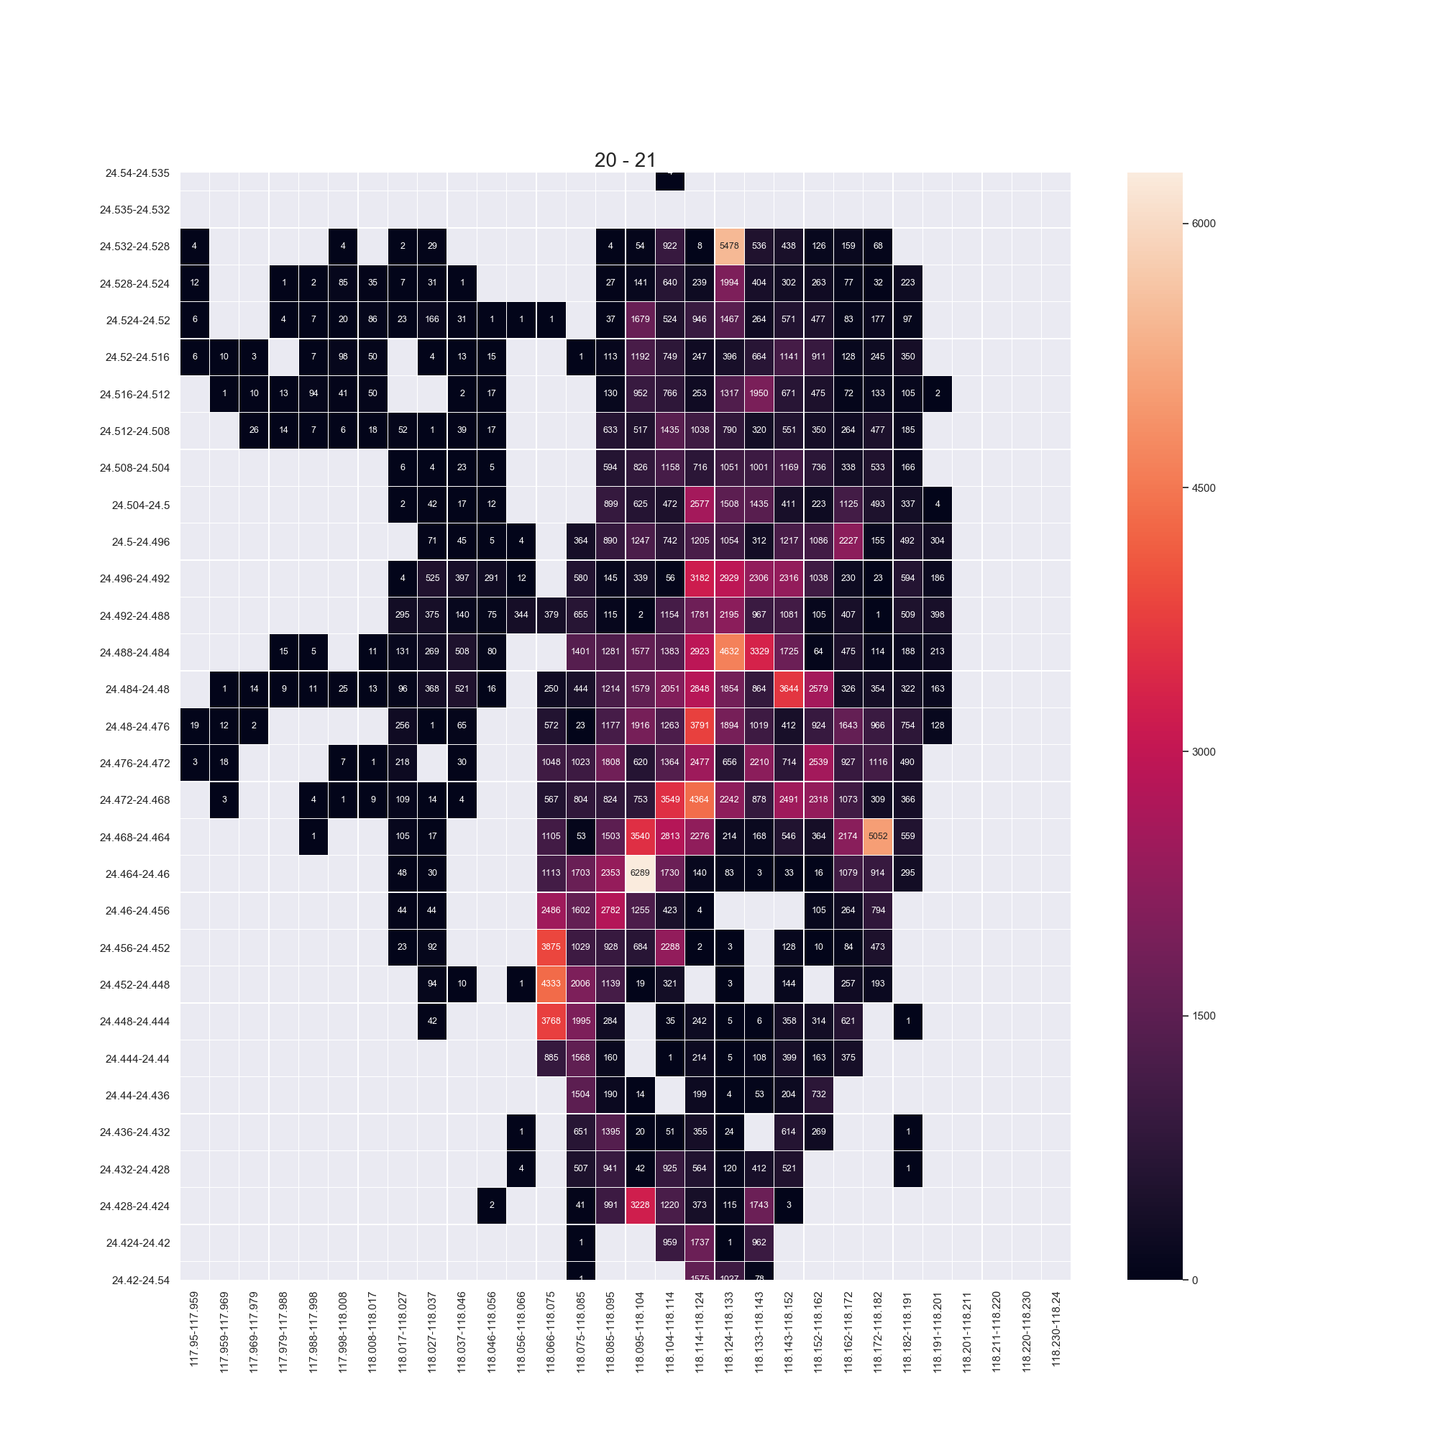

Q2: Split the map into grids, calculate and visualize the Source-Destination relationships. (25 mark)

The following figures are scatter plots generated by dataset “2014-07-01” and three time period are randomly selected from 6 to 7, 19 to 20 and 22 to 23.

The red ones represent source locations whereas the blue ones represent destinations and these points are connected by grey lines in figures.

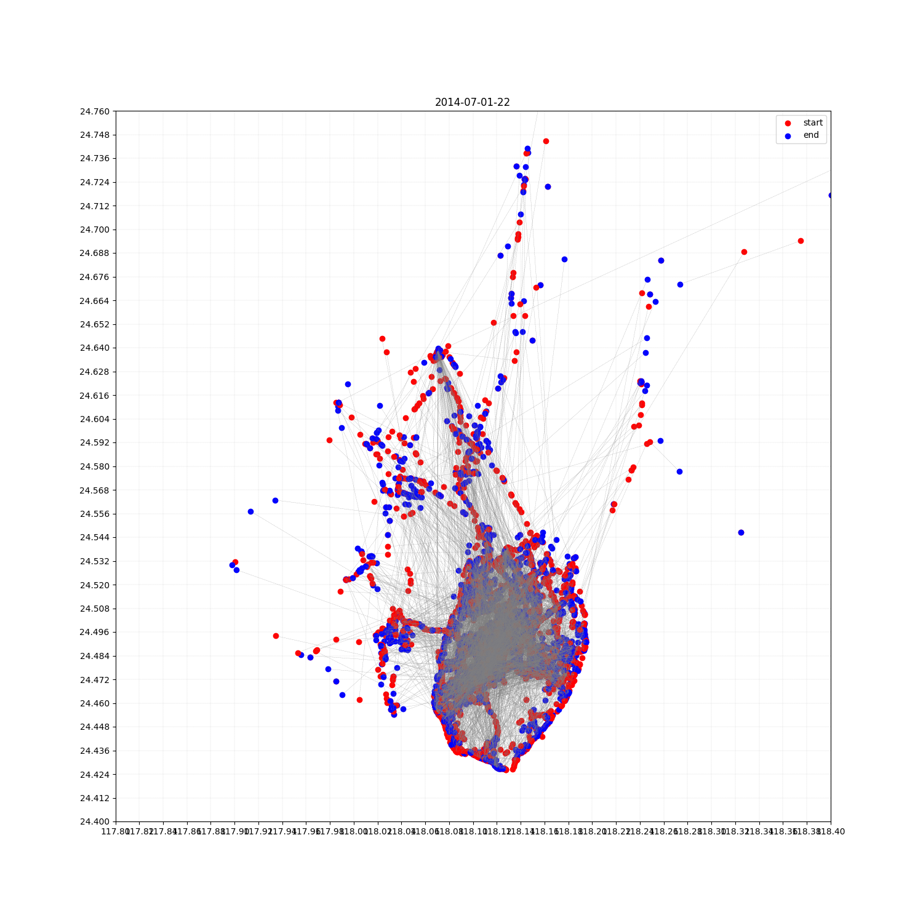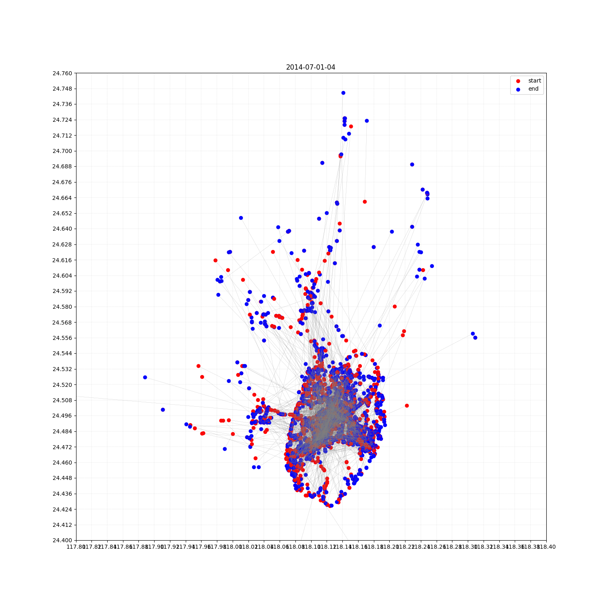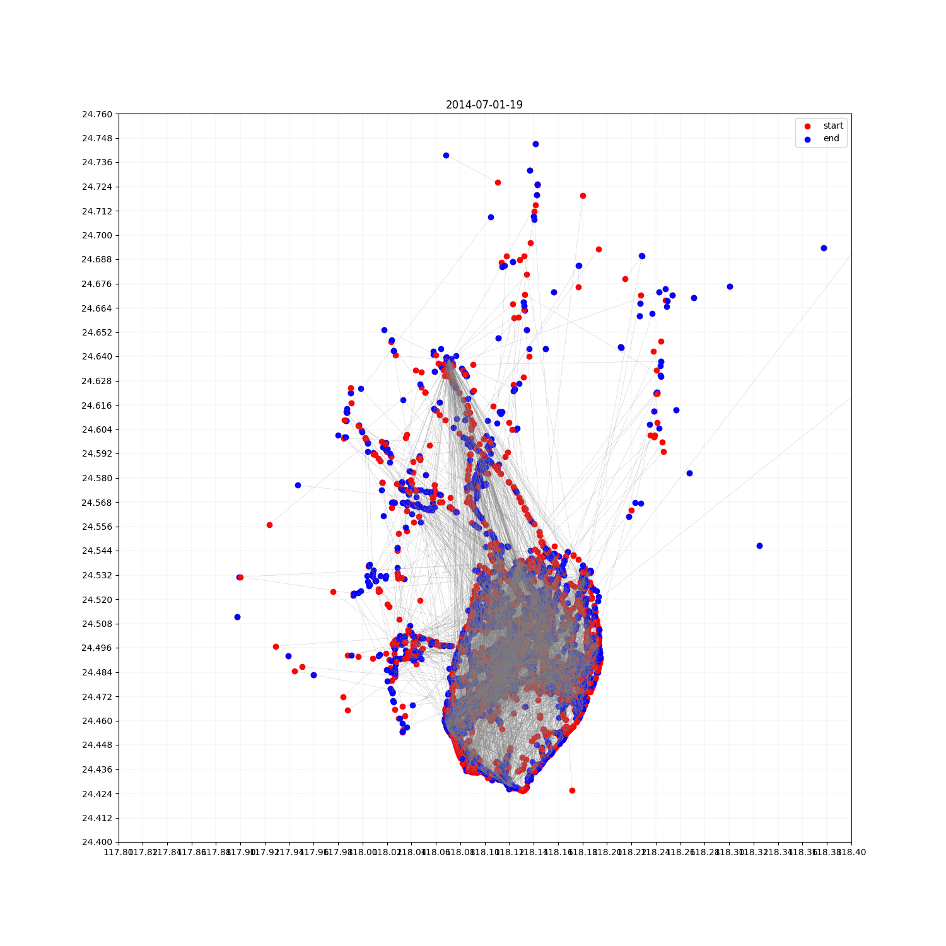

Q3: Define the data analysis problems by yourself, and draw interesting conclusions and make predictions defined by the problem. (50 mark)