How big is the market?
- Global home security system market revenue is estimated to reach USD 106.3 Billion by 2030 with a CAGR of 8.6% from 2022 to 2030
- North America home security system market value gathered more than USD 21.3 billion in 2021
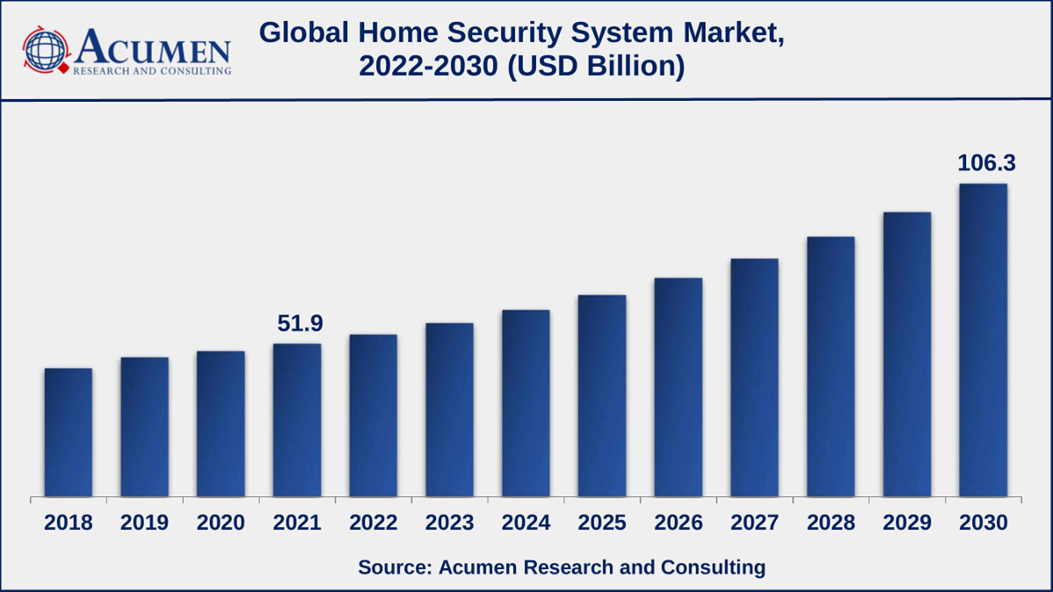Home Security System Market Dynamics
Market Drivers
- Growing crime rates
- Increasing popularity of smart home technology
- Rising concerns of home safety
Market Restraints
- High installation and maintenance cost
- Privacy concerns and cybersecurity threats
Market Opportunities
- Increase in e-commerce and online sales
- Growth in Internet-of-Things (IoT) devices
Niche Vs Mass Market
- Niche is the Home Security
- Mass would be just building Security

