**KLN90B/MD41**

**for X-Plane 11**

**V0.95b_SASL_V3**

**INSTALATION MANUAL**

This example will use the freeware Yak-18T model by PWDT as its target. If you don’t have it yet you are missing a lot! Download it from:

<https://forums.x-plane.org/index.php?/files/file/51672-pwdt-yakovlev-yak-18t/>

Before continuing with installation make sure you have a backup of the plane you are going to modify!

1. Plugin install
2. Download original KLN90B package from <https://www.x737.eu/index.php?kln90b>

Only the manual is needed.

It is a great idea to read it!

The nav database will be automatically generated on first run from existing x-plane database (default or custom).

1. Extract files from this package to your aircraft folder.

If your aircraft has folder called cockpit_3d DO NOT overwrite it! If the same panel space is used by other plugins or x-plane there might be incompatibility.

1. If 2D panel is all you need, edit file main.lua located in “/plugins/ KLN90B /data/modules” and disable 3D panel drawing by setting draw3d = false:

ANY EDIT OF LUA FILES SHOULD BE DONE WITH NOTEPAD OR OTHER EDITOR THAT DOES NOT CHANGE ENCODING AND DOES NOT ADD ANY HIDDEN SYMBOLS!

This is not mandatory but may save some resources.

You can open 2D kln90b/md41 panels from Plugins menu

Skip 3D model install

1. 3D models install

For this example, I will be installing only kln90b. Yak-18T does not have autopilot or any sophisticated navigation equipment so md41 is not needed. But if you need it on your aircraft, install it the same way and at the same time as kln90b.

1. Install 3D model

Open the target aircraft in plane maker and from visualization settings hide all objects that obstruct aircraft panel from view. For detailed manual on Plane Maker see https://developer.x-plane.com/manuals/planemaker/

Click on “Misc Objects” from Standard menu.

A list of all attached objects will appear. Scroll to the bottom of the list and click “Add” at the bottom left corner.

A new empty object will appear at the end of the list. Click the little square next to the object name and select kln90b.obj located in “/objects/kln90b/” folder. Move object to some EMPTY space of your liking on the panel.

Set object options like on the screen shot.

Lighting – Inside

Hi-res checked

Shadow – interior only

Positioning is a trial and error. The initial position will be 0,0,0 aircraft reference so you may need to zoom out and rotate the plane to see kln90b object. For yak18 it is in front of the plane. First move it so you can see it clearly inside the cockpit and then fine tune position and rotation.

When you are happy with the position of kln90b close this window and save the aircraft. From “Menu” click “Save” or “Save As” if you want to keep unmodified version of the aircraft. Be careful, if “Save As” is selected, to save the acf file in the main plane folder.

Do not close Plane Maker yet just minimize it.

It is a good idea at this point to load the aircraft in x-plane and check if position is OK.

1. Add click regions to cockpit panel.

*Check the size of your panel.png in /cockpit_3D/ -PANELS-/ if your aircraft has this folder. Else just copy the folder from the archive and proceed with install. If it is not 1024x1024, or has something else drawn in bottom right corner, remapping and repositioning of the plugin display will be needed. Send me a PM or e-mail for instructions, it is not covered in this manual. Long story short – find empty space 210x110 pixels on your panel.png and reposition display by editing main.lua component kln90_panel position table first 2 values. Start x-plane and switch on kln90b via 2d, press ctrl+alt+shift+space to create snapshot of panel.png and use it to remap and export new click_regions using blender.*

Open “/objects/kln90b/” folder with file browser and run file kln_installer.exe. It will open a console window and you will be asked to choose .acf file that you just modified from a list of .acf files found in plane main folder. Enter the number of that file and press enter. Next you will be asked to enter the cockpit.obj of that plane. Chose the cockpit obj from the list and press enter. The program will search for kln90b/md41 entries in the file and if found will print their positions. Verify that the positions are correct. If cockpit.obj has offset of its own it will be added to kln90b/md41 offset.

New cockpit object will be generated in “/objects/kln90b/” folder with “_kln90b” added to the original filename. Copy that file to plane main folder. Restore Plane Maker and in Misc Objects change panel object to the new one located in plane main folder.

Click rescan button if you don’t see it in the selection list.

It may exist in 2 places so check the list and replace both.

Save again and close Plane maker.

Start X-Plane and load the aircraft. From View menu check “Show Instruments Click Regions” and verify everything is aligned.

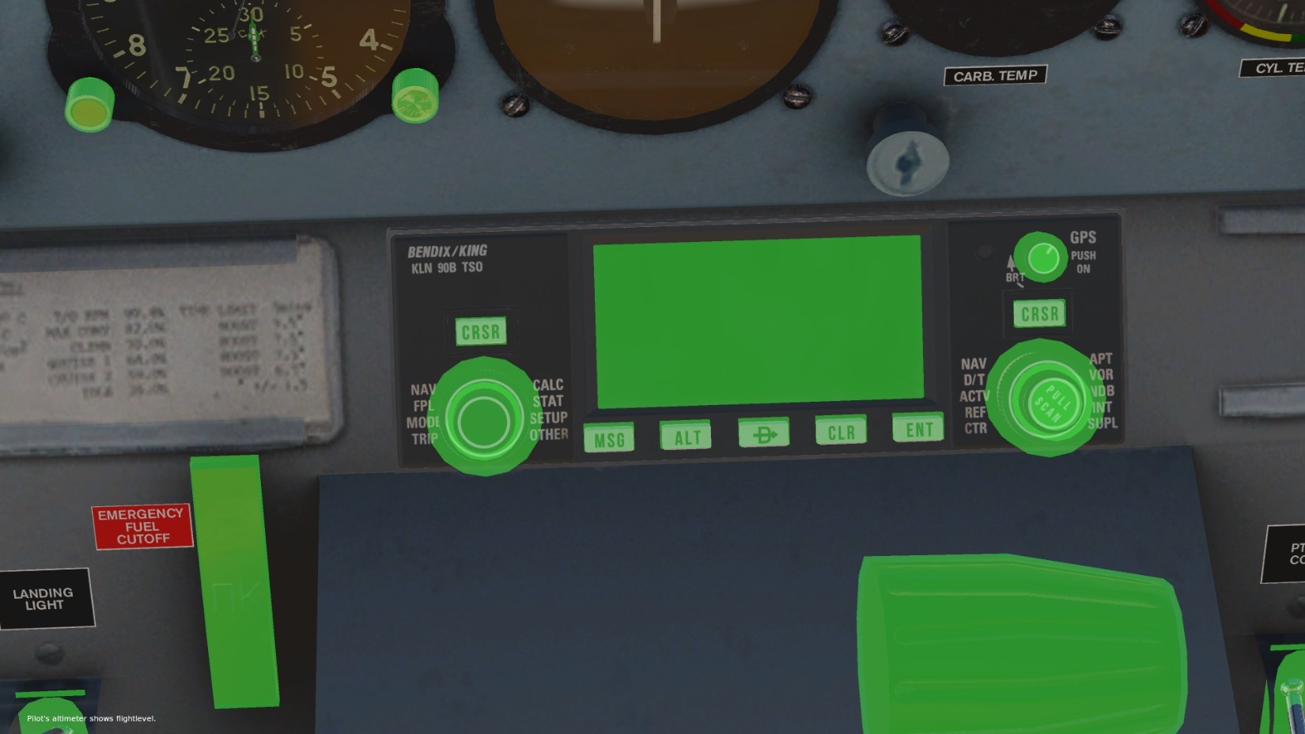

If anything goes wrong start over. Installer software will not change any original files. It just creates new one and overwrites it every time it is used.

If automatic, click regions install fails there is manual way to add them to cocpit.obj with the help of offset_calculator.exe. README in “/objects/kln90b/”.

3. Final touches

By default, power to the kln90b is linked to main battery switch, but this can be easily tailored to some other electrical system on the aircraft. Open for edit “/plugins/KLN90B/data/modules/Custom Module/KLN90_panel.lua” and on the 4-th line you can change the dataref simulating power to the system. For example, Yak-18T can use “sim/cockpit2/switches/avionics_power_on” which will tie the power to the instruments switch.

To find out which dataref to use try this tool <https://forums.x-plane.org/index.php?/forums/topic/82960-datareftool-is-an-improved-datarefeditor-open-source-better-search-change-detection/&tab=comments#comment-883264>

To make the autopilot turn anticipation more precise there is a value called roll_rate in main.lua. This should match autopilot constant set up in acf file. Default is 8 deg/sec.

4. NAV Database

Since v 0.90B this plugin is not using the Navigraph compiled database for KLN90B. Instead, it is generating its own database from existing x-plane 11 database. If newer than default x-plane database exists in /Custom Data folder it will use it else it will use the default x-plane 11 database. For its own database the plugin will create a new folder /Custom Data/KLN90B_Navdata. The initial generation of the database will take place upon first launch of the plugin and may add a minute or so to the loading time depending on how many custom airports the user has (20 seconds on my machine with default airports only). After the initial database creation, the plugin will use its database and will not slow down loading time anymore.

In order to add all installed airports including the custom ones the plugin will parse all available apt.dat files in /Custom Scenery folder. If user installs custom airport later and the data in KLN90B is not correct or does not exist, the database should be updated using the update procedure in SET0 page.

Remember to use the update on SET0 page every time you update navigraph database or add new custom airport with custom navdata.

Only airports with ICAO codes not longer than 4 symbols will be included in the database including the ones marked as closed or fictional.

The unit will also use the procedures described in x-plane CFIP files(default or custom) and will show all available approaches not just the non precision ones.

5. Fictional SET11 page

To accommodate new features included in the code new fictional set 11 page was created.

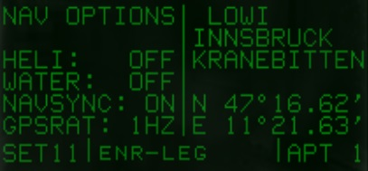

Because the x-plane 11 database is larger than the old one and includes heliports/helipads and water ports/water runways new fictional SET11 page is created to allow the user to choose weather to display them. By default, the unit will not show these airports/runways. Upon changing the settings in SET11 page the user should reload the plugin trough the widget or use “reload current aircraft and art” from developers menu for the settings to take effect.

Kln90b is overriding default GPS and writes its data to the GPS datarefs to be displayed by the navigational instruments(HSI), but some aircrafts are created not to use any GPS and thus do not use those datarefs. Instead the instruments on the panel are linked only to the NAV datarefs(AWX C47 for example). To make instruments on the panel synchronize with the kln there is a new option NAVSYNC. Set this to ON to make non HSI instrument sync with kln90b.

Since v0.95b autopilot code has been rewritten. The kln will no longer directly control aircraft heading. All computed data will be passed to the X-Plane GPS dararefs and the default plane autopilot will compute the necessary course to stay on track. As per manual kln90b is updating the GPS data once per second. It is possible that this slow rate is not enough for some fast aircraft and their autopilot may oscillate around the desired track. There is a new option GPSRATE which can be used to set higher update rate. 1HZ, 5HZ and 10HZ are available. It is strongly recommended to leave this setting to its default and realistic value of 1HZ if no issues with the autopilot on high speeds are observed.

Enjoy 😊

Please do not hesitate to report any bugs or issues you may encounter!

If you like my work and want to buy me a beer or a coffee

[Please donate!](https://www.paypal.com/cgi-bin/webscr?cmd=_donations&business=KDP7Q5DY8R59W&currency_code=EUR&source=url)

Disclaimer:

This package is provided to the X-Plane community for free, “as-is” and without any warranty. Use of any software or information provided as part of this package is on your own risk. The author is not liable for any damages arising out of the use of the package and its contents.

The author of this package is not in any way affiliated with EADT and the creator of the original KLN90B implementation for X-Plane. This is adaptation of the original code to SASL v3 for X-Plane 11. The code is property of its original creator and used in this project with his permission. Any licenses and restrictions on the original code apply to this implementation.

Credits go to:

1. Falcon - author of the original kln90b for X-Plane

2. Alexander Babichev - author of SASL https://www.1-sim.com/

3. Unknown to me contributors to kln90b code. Drop me a note to add your name if you see parts of your work.

4. Todir author of this package – 2D/3D models, SASL v3 adaptation and bugfixes

Material textures <https://freepbr.com> and https://cc0textures.com

Sounds from <https://freesound.org/>

If you want to include the 3D models to a freeware aircraft you are making, please do so. Drop me a note and I will send you the blender files. For payware aircraft contact me.

radonovt@gmail.com

For code distribution, if you got permission from Falcon you got mine too.