Jason De Leon

00305640

Assignment 1

Server Setup

**Computer Specs:**

Ryzen 5900x (12 Core CPU)

32GB of RAM @ 3600Mhz (4x8GB)

RTX 4090 MSI Liquid Suprim

Samsung 980 Pro 500Gb PCIE M.2 SSD (boot drive)

VM running on my Boot drive.

Western Digital Black 1TB PCIE M.2 SSD

Samsung Qvo 870 2.5” SSD for main storage.

Recommend Specs to run both VM simultaneously:

Any Quad core and up CPU

Minimum 16 Gb of RAM (4Gb for each VM)

At least a 500 Gb HDD

Please be Aware that in order to start any Virtual Machine you must enable Virtualization on you CPU. This differs from system to system please rely on your Motherboard manufacturer manual on how to enable such feature as this can only be found in the BIOS settings.

You’ll know if you’ve enabled it when you check your Task manager under the Performance Tab and see it there.

You can get to this page when you hit the “More Details” at the bottom. Performance should be on the top.

Please go to <https://www.virtualbox.org/> to download the virtualizing software we will be using for this assignment.

It should look something like this:

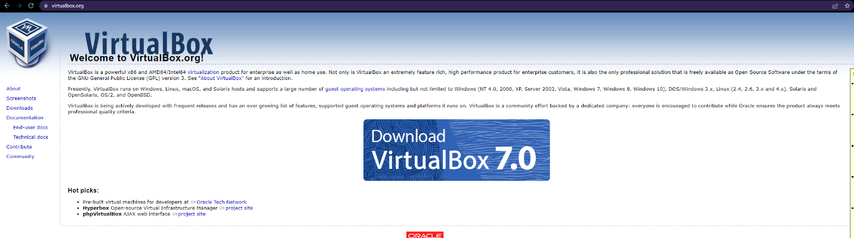

Hit the big download link and follow the prompts given.

Once you’ve finished the install please proceed with the rest of this document.

These are the links to where I got my ISO’s from.

<http://isoredirect.centos.org/centos/7/isos/x86_64/> (select whichever is in your region. They should have it listed for you.)

<https://ubuntu.com/download/server> (Select he LTS version)

When setting up a New Vm Please click the “NEW” sign on the top:

This will be the next prompt After hitting the +.

Please note that I’ve already Name my server and ISO Image. If you haven’t done that, please start by naming the server to whatever you want a select the ISO you would like to use

After you named, select the ISO, and then hit NEXT. You get the ability to determine how much resources the VM can have.

I chose 2 CPU cores and 8 gb of Ram. **SELECT WHAT YOUR SYSTEM CAN HANDLE!!!**

Please hit next.

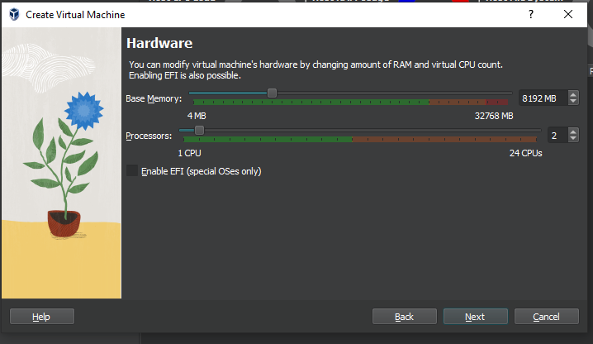

This is the overview of my system settings.

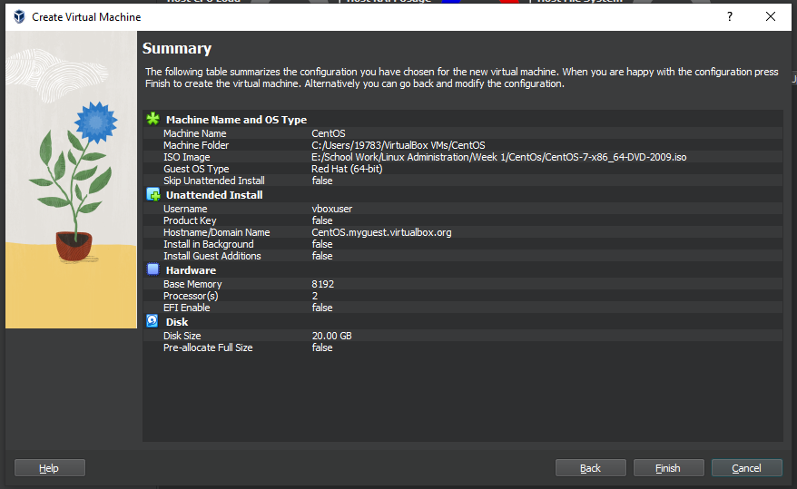

You will get an error once you hit finish after the overall setting. To bypass this issue just reselect the ISO, then hit “Mount and Retry Boot”.

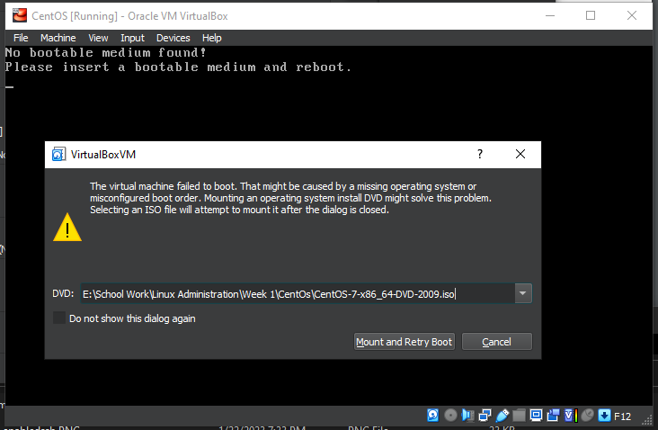

You would see a lot of text while the VM gets initialized. Don’t worry it will pause then you would get the option the select a language.

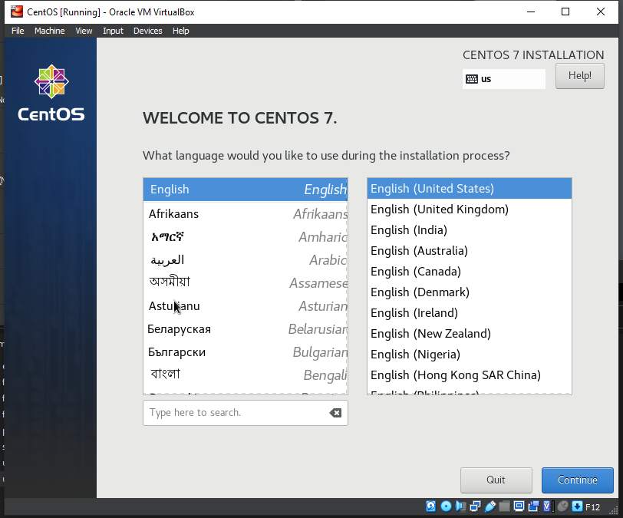

After the language you get the chance to do more configurations.

When you get to this page you will have to do three things.

One, you have to select Virtualization Host as it is strictly Command prompt and won’t show you a GUI.

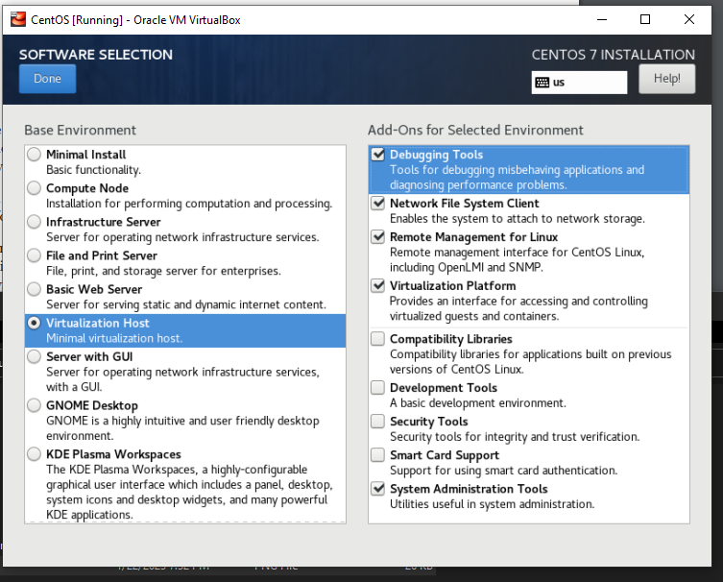

Second, you will see an error on Installation Source or Installation Destination. To get over that all you must do is select the item and reselect the drive you made during the hardware setup.

THIRD:

**\*\*\*\*\*\*\*\* PLEASE ENABLE NETWORK \*\*\*\*\*\*\*\***

To enable Network. Just selected the Network setting and enabled it. You will see a slide like button when you get on the setting and just turn it on. You will get an IP once it’s on.

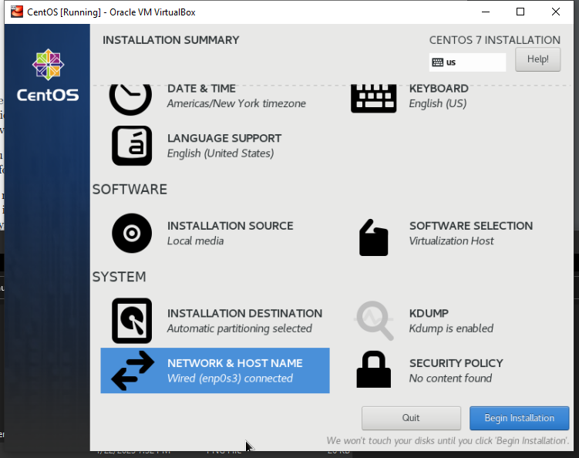

Once you’re done with that please hit “Begin Installation”

You’ll be taken to a new page where you can make a user with a password:

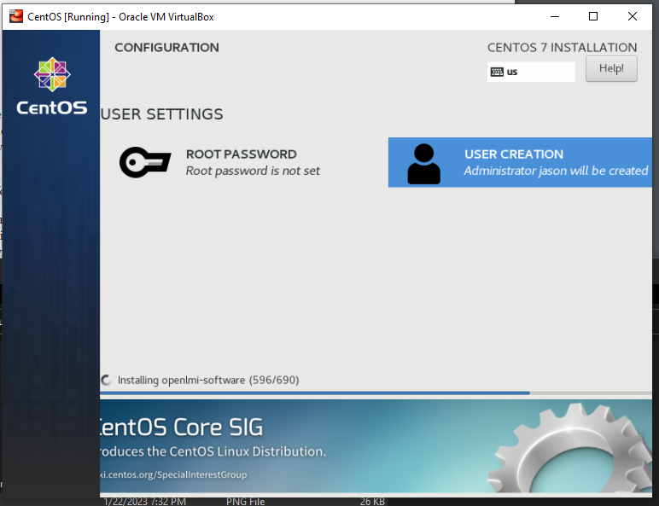

Please select user Creation and make an account. **PLEASE CLICK THE OPTION TO MAKE USER AN ADMIN**.

Once everything is done installing you will get an option on the bottom right to finish. Hit that and you will see a bunch of letters fly on your screen. Once you’re don you will be given the ability to sign in.

To check if your network is able to communicate please ping a website. I did the following:

Ping google.com

Ctrl C to stop.

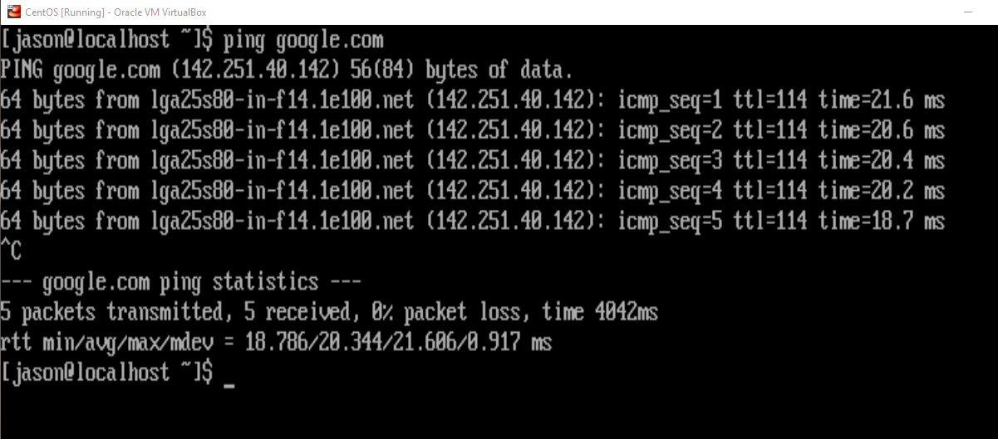

**SIDE NOTE:**

**THIS IS SAVE YOU SOME TIME. PLEASE POWER THE SYSTEM “POWEROFF”**

**HIT THE GEAR ICON WHILE YOU HAVE CENTOS OR SECOND VM SELECTED**

**YOU WILL GET THIS PROMPT:**

**CLICK SYSTEM AND CHECK OFF NETWORK:**

**AFTER DOING THE PREVIOUS STEP THEN SELECT THE NETWORK OPTION ON THE LEFT.**

**I SELECTED BRIDGE ADAPTER AND SELECTED THE PORT ON MY PC THAT IS CONNECTED TO MY NETWORK.**

**THIS WILL GIVE THE VM A STANDALONE IP**

**PLEASE DO THIS FOR BOTH VM’S IF NOT THE Ips WILL BE DUPLICATED AND CAUSE ISSUES DOWN THE ROAD WITH SCP**

If the server doesn’t have the ability to SCP try installing ssh client by running this command:

Yum install openssh-clients

Type yes or Y

To transfer files from server to server please type the following.

**Scp “HostFileName” “ServerName”@”IpAddress”:~/”NewFileName”**

This is a file being transferred from CentOs to Ubuntu from the perspective of CentOs

This is a file being transferred from Ubuntu to CentOs from the perspective of both.

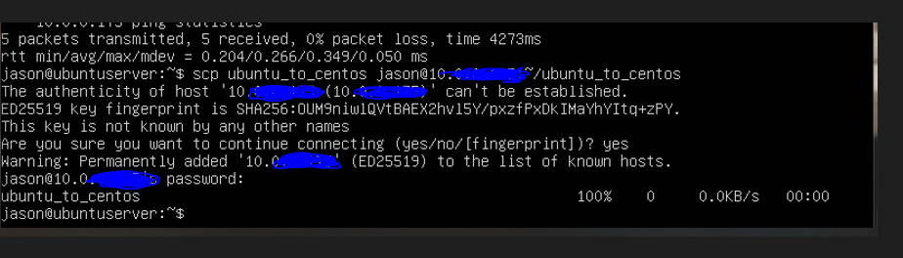

**Ubuntu Server VM**

Just like we did with Centos. Please hit the “NEW” sign and instead of doing CentOs use whatever you decide to use for a second VM. I did Ubuntu.

To get Ubuntu go to the following [Link](https://ubuntu.com/download/server) and download the “Ubuntu Server 22.04.1 LTS” or whatever the new version is.

Name the server and select the ISO

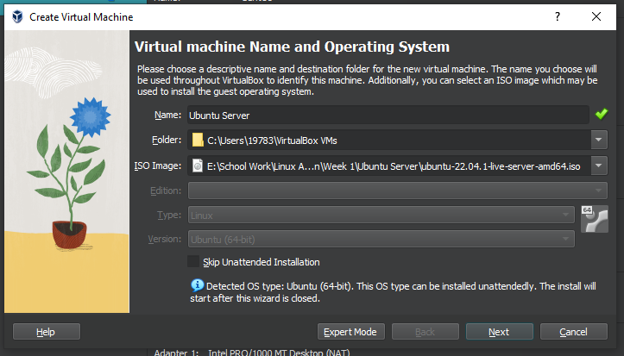

I basically copied the same setting as CentOs,

8gb of ram and 2 Cores

Only difference being is that the VM auto created 25gb storage rather than 20gb

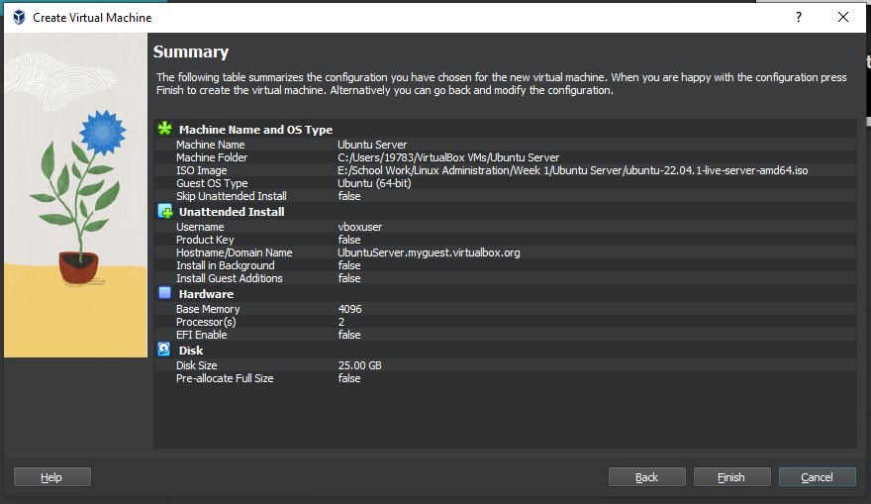

When you hit Finish. The new Vm will appear to your left. Just double click it and run it.

You will boot in and give a few second to take you to your second prompt of selecting the language you wanna use.

Select your language.

You will be given the opportunity to update the installer or continue. I suggest updating the installer, but that’s up to you to decide.

Afterwards it will ask you to select your keyboard layout. Just hit done if it’s correct. If not select what you use.

Next prompt please select Ubuntu Server (Minimized) This will be command prompt and that’s what we need for this class

Once you selected it, please hit done five more times after this. Last one will have you hit continue on the popup to be able to continue.

You will be given option to create a server name and user.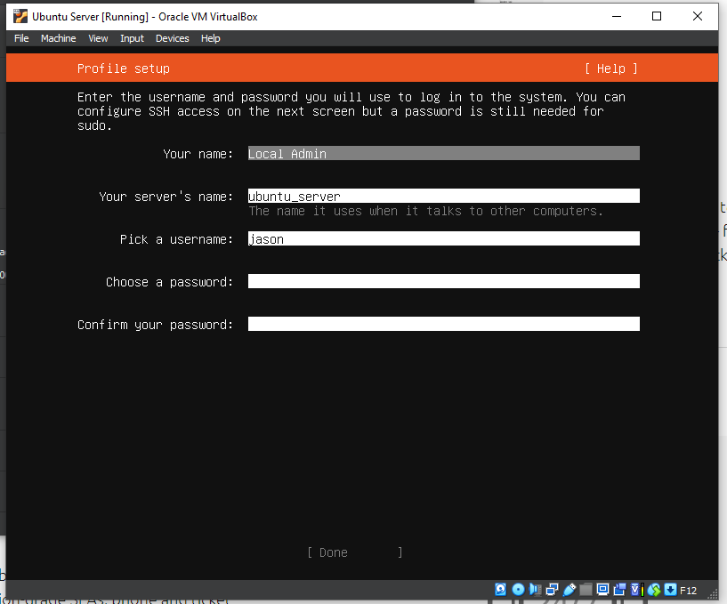

Once filled out hit done.

You’ll be given the opportunity to Install OpenSSh Server. I suggest you install it to enable SSH.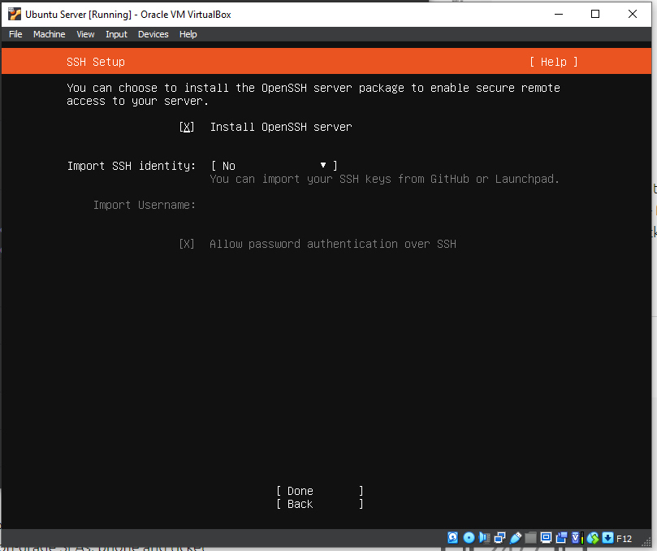

Hit done once you’ve checked it off. Afterwards you get the opportunity to install extra packages or tools. Install what you want. I installed the following for my system.

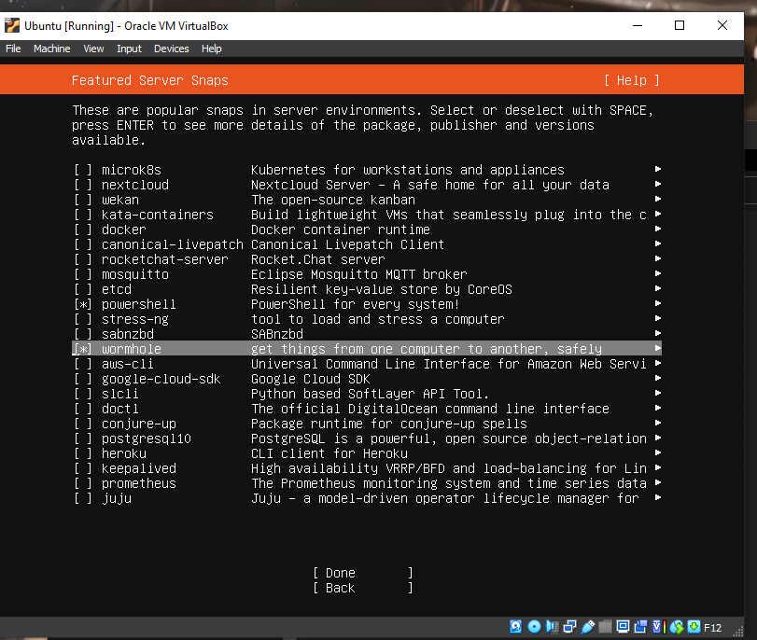

The Server will be doing a few things please give it time to configure itself. You know you’re done when you get the option to only:

“Reboot Now”

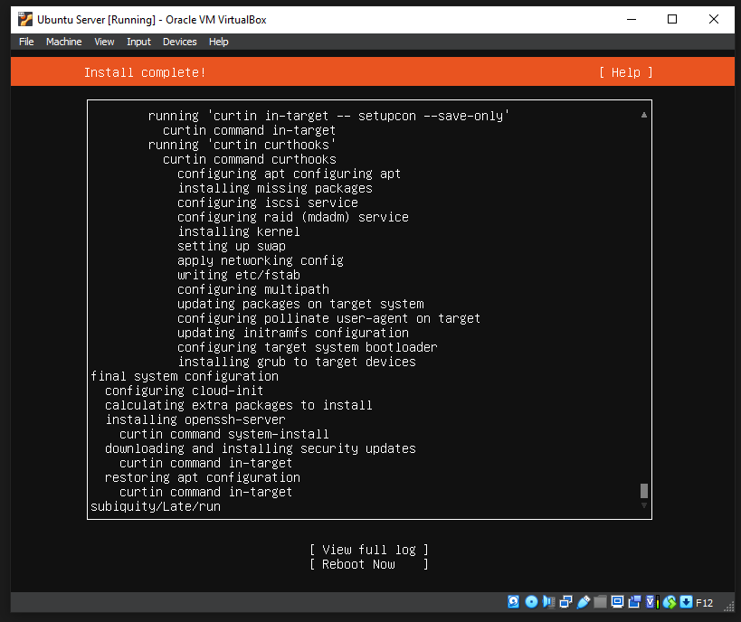

After you have rebooted you will be given the opportunity to sign in. Please sign in with the credentials you’ve just created.

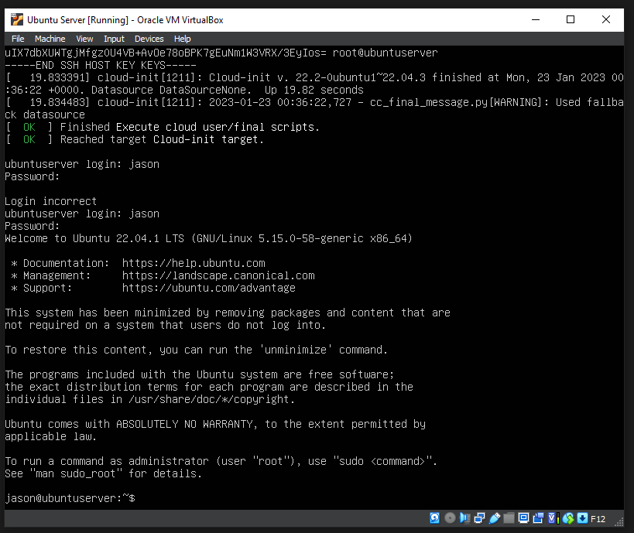

Once signed in please test if the internet is working. By either doing “Ip Addr” or pinging a website ex.

Google.com.

