Baltimore City Community College Case Study

**Business Profile**

Baltimore City Community College (BCCC) is located in the heart of Baltimore just a few blocks away from Druid Hill Park and a few transit stops from the Inner Harbor or many other points of interest. The college boasts of an enrollment that averages more than 5,000 students. As part of its charter, BCCC offers continuing education programs in addition to associates degree granting programs in each of the following five areas: Behavioral and Social Sciences, Business, Pre-Health Professions, STEM-related fields, and Visual and Performing Arts. The Workforce Development and Continuing Education department manages the continuing education programs with a focus on community partnerships between the school and various businesses, local government, and professional associations. While details for each program varies, with differences in credit/noncredit offerings, class locations, costs, and so on the goal of the department is to identify training needs for Baltimore residents and offer quality education services for those needed areas. The Cyber Security Academy, which operates under the direction of the Workforce Development and Continuing Education department, offers courses in A+ Certification, Network+ Certification, and Security+ Certification. These programs are offered as non-credit, however, employers view candidates with one or more of these certifications much more favorably than job seekers who do not have these certifications when applying for certain positions. Grants fund some of the classes offered by the Cyber Security Academy, which means that having access to information to make ease of applying for grants and for reporting activity to maintain the grants paramount for this organization’s continued success.

**Business Process Description**

The Department of Workforce Development and Continuing Education at the Baltimore City Community College offers a Cybersecurity training program to the citizens of Baltimore city. The program consists of four classes:

● Essential skills

● A+ certification

● Network + certification

● Security + certification.

The applicants go through a testing process upon hearing about the program to determine their cognitive aptitude and that data is then sorted out by the director and the coordinator to 4 Database to benefit Baltimore City Community College determine which students will be accepted to the program. Once the student is accepted they are registered for the Essential Skills class which will last approximately four weeks. Information gathered from the student includes educational records, date of birth, social security number, and proof of residence to begin their student profile. During that process students are taught various skills that help them discover their own potential as well as prepare them for the interview process when looking for employment. When the student has successfully completed the Essential Skills class they are then registered for the first available A+ Certification course. The information is yet again collected to verify and confirm their residential status and their general information such as student name, address, phone number, and current email address. In order to follow the grant guidelines that support the program, the attendance and grades of each student are kept to track their progress and sincerity about completing the program. Attendance information is currently submitted daily via sign in sheet which if then converted to data in an excel spreadsheet as a form of record keeping. Grades are submitted weekly via individual class excel spreadsheets. The collected data is stored in both hard copy and electronic copies. This process is repeated for all the classes currently running. There are fourteen classes that meet twice weekly and two classes that meet once a week. All students are encouraged to attempt the certification exam upon completion of each course, and if the student passes, that certificate is added to their file. Program enrollment varies from 60 to 100+ students.

**Problem Statement**

The department’s decentralized approach to knowledge management has resulted in a much higher level of effort to collect, update, and find information related to the day to day functioning of their programs. Compiling information to complete specific reports may sometimes take multiple days to track down all of the required information. If the department were to obtain and employ a centralized database for record keeping, they could gain administrative and operational efficiencies that would allow them to focus more time on servicing their core competencies and goals versus chasing paper and disparate spreadsheets.

User Requirements & Questions Process

Model Requirements

Tracked student information

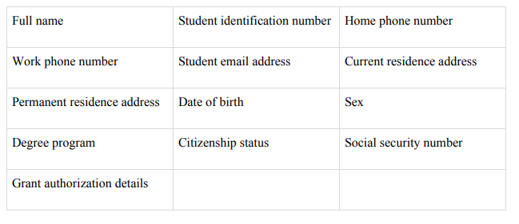

The Workforce Development Department keeps track of student data. Each student's full name, student identification number, home phone number, work phone number, student email address, current residence address, permanent residence address, date of birth, sex, degree program, citizenship status, social security number, and grant authorization details are collected during the registration process. Students can register, drop and/or withdraw a course.

Tracked course information

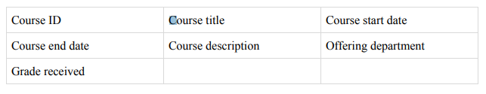

Each Course has an identification number, course title, begin date, end date, course description and grade received and offering department.

~~If a student withdraws from the course prior to the first class meeting or the college itself cancels the course, a 100% refund is made. Refunds will not be granted for classes that are dropped after the first class date.~~

Tracked department information

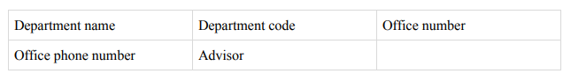

~~Each department is described by department name, department code, office number, office phone number and advisor.~~

Tracked Instructor information



For Instructor, the college tracks the advisor’s name and the number of the department to which he/ she is assigned. An Instructor may advise any number of students but each student has just one advisor. Tracked admin information

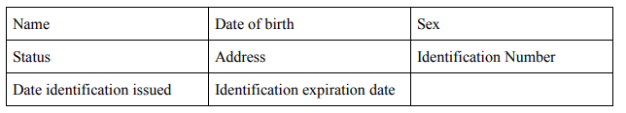

Administrators issue the identification card. To issue an identification card particular details are necessary such as name, date of birth, sex, status (student, staff or visitor), address, identification number, date the identification was issued and the identification expiration date.

**Data Model Requirements**

Allow users to input information for the department, students, staff, courses, programs, and grade

records. A few examples of some user requirements that this database will meet is listed as the

following:

1. Allow user to update all the above information.

2. Allow user to access specific information for students, staff, courses, etc.

3. Allow user to generate a list of the number of students currently assigned under a specific

department.

4. Allow user to generate a list of staff assigned to a specific course.

5. Allow user to generate a list of courses offered by a program during a specific semester.

6. Allow user to retrieve grade records for a specific course.

7. Allow user to retrieve grade records for each student.

8. Allow user to retrieve a list of visitors on a specific day.

9. Allow user to separate information according to identification status (student, staff, or

visitor).

10. Allow user to verify all students have an advisor.

**Expected Database Queries**

The expected database queries are listed below:

1. List the names of the courses offered by a specific program.

2. List what courses are offered in a specific department during a specific semester.

3. List the first and last names of staff that teach a course in a specific program.

4. List the first and last names of staff that are also an advisor.

5. List the first and last names of students who has a specific staff member as an advisor.

6. Retrieve how many students withdrew/dropped a specific course during a specific

semester.

7. Generate a list of professors who have taught at Baltimore City Community College for

more than or equal to five years as of a specific semester.

8. List all of the first and last names of students enrolled in a specific program who are

female.

9. Find the name of the student who has a specific ID no.

10. List the grade records all of the courses during a specific semester for a particular student.