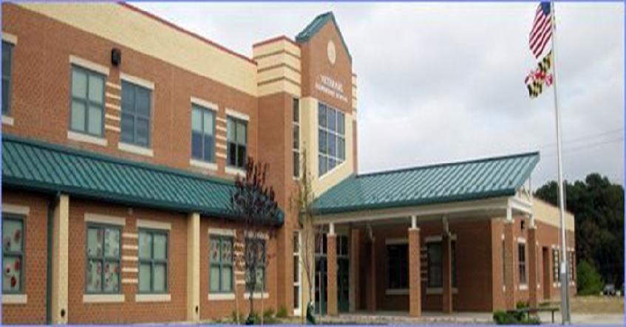

[Grab your reader’s attention with a great quote from the document or use this space to emphasize a key point. To place this text box anywhere on the page, just drag it.]

DATABASE FOR PUBLIC ELEMENTARY SCHOOL

VETERANS ELEMENTARY SCHOOL

DATABASE MANAGEMENT SYSTEMS

PROJECT PREPARED BY:

TOWSON UNIVERSITY

Spring 2014

Table of Contents

Team Members 2

Signature of interviewee 2

Introduction of Public Elementary School Database 3

Public Elementary School System Profile 3

Public Elementary School System Process Description 4

User Requirements 5

**a. Process Modeling Requirements……………………………………………………………………….5**

**b. Data Modeling Requirements……………………………………………………………………………6**

**c. Expected Database Queries…………………………………………………………………………… 6**

Entity Relationship Diagram 7

Assumptions: 7

Task List 8

# **Team Members**

# 

# **Signature of interviewee**

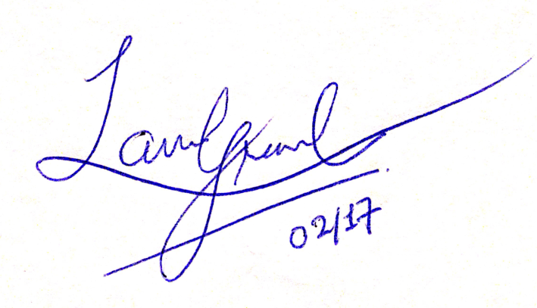

# 

# **Introduction of Public Elementary School Database**

The development of a database project for Elementary school began in February of 2014. It is being developed to help an Elementary school to keep track of all the records of students as well as the staff members. In addition, it helps to keep a record about all the before and after school activities and all the regular school activities. Currently, all such records are tracked manually as well as through computers. Thus, it affects the efficiency and the performance of the Elementary school organization. The database will help in finding and tracking records easily and efficiently to help save both money and time for the organization.

A team of four students are currently working on this project. The database will be made in Oracle and the user interface for the database will be created using JAVA Swing. This project is currently being done for the Database Management Systems class and it incorporates the database and software knowledge that the students have and will be learning throughout the semester.

# **Public Elementary School System Profile**

Elementary School System is non-profit organization. The purpose of this organization is to educate every child. They support “No Child Left Behind” policy. Education is compulsory over an age range starting between five and ending somewhere between ages sixteen and eighteen, depending on the state. Education is only mandatory until age 16, however. There are generally six years of primary (elementary) school, during which students customarily advance together from one grade to the next. These elementary schools have both local and international students. Education is made available free to all the people irrespective of their financial background.

Elementary school education is available everywhere and is controlled and funded by the state, local, and federal government. Public school curricula, funding, teaching, employment, and other policies are set through locally elected school boards, who have jurisdiction over individual school districts. Educational standards and mandate standardized tests for public school systems are set by the state governments.

As the organization continues to grow, it becomes important to keep track of all the activities of staff and students of the school system. Therefore, Public Elementary school system would benefit from this database to keep track of all these different areas.

# **Public Elementary School System Process Description**

**How Elementary school system Works**

In most schools, education is divided into three levels: elementary school, middle school and high school. Children are usually divided by age groups into grades, ranging from Pre-kindergarten for the youngest children, up to twelfth grade as the final year of high school.

Most curriculum of the public elementary education is determined by individual school districts. The school district selects curriculum guides and textbooks that reflect a state's learning standards and benchmarks for a given grade level. Learning Standards are the goals by which states and school districts must meet adequate yearly progress (AYP) as mandated by No Child Left Behind (NCLB) policy.

In general, a student learns basic arithmetic and algebra in mathematics, English proficiency (such as basic grammar, spelling, and vocabulary), and fundamentals of other subjects. Learning standards are identified for all areas of a curriculum by individual States, including those for mathematics, social studies, science, physical development, the fine arts, and reading. While the concept of State Learning standards has been around for some time, No Child Left Behind has mandated that standards exist at the State level.

In Public Elementary schools, students are assessed throughout the school year by their teachers, and report cards are issued to parents at varying intervals. Generally the scores for individual assignments and tests are recorded for each student in a grade book (either on a paper or on the school website) along with the maximum number of points for each assignment. Based on this information, each child is assigned one of these three grade levels:- above grade level (A), below grade level (B) and on grade level (O).

The Public Elementary School System has many elements for whom it has to keep information: Students, teacher and home-room teacher. It is difficult to keep all of this information up to date and readily accessible in paper format. Therefore, an electronic database that keeps all this information is needed to ensure that the school is running efficiently and hassle free.

# 

# **User Requirements**

**a. Process Modeling Requirements**

Veterans Elementary school has students and many levels of Staff in it. Each Staff has certain information such as Name (First Name, Middle Initial, Last Name), Address, Phone Number, Date of Birth, Sex, SSN, Schedule, Salary, StaffType and Staff ID (unique for each staff member). The Staffs are categorized into Teacher and Homeroom Teacher. Each Home Room Teacher is assigned to a classroom. He/she monitors and supervises the classroom. Each Grade has a team lead who is a home room teacher. But not all home room teachers are team lead of a grade. Each student has information such as Name (First name, Middle Initial, Last Name), Address, Sex, Commute type, Room Number, Grade ID and a unique Student ID. Each student belongs to a Guardian. Guardian contains information such as Name (First name, Middle Initial, Last Name), Phone Number and a unique Guardian ID. The Commute Type attribute is divided into a Walker, Car Rider or a Bus Rider. Each Student is enrolled in a particular Grade (e. g. kindergarten, first grade, second grade, etc.) and every Grade contains at least one Classroom (e.g. Room No. 1). A teacher can teach many courses and in many classrooms. Teacher has years/experience as an attribute. Each Course has Course Name and a unique Course ID. Each Student has a Score Record which can be First Quarter Report, Second Quarter Report, Third Quarter Report and a Final Report. Each Score Record contains information such as Student ID, Course ID and Subject Level (Above Grade A, Below Grade B, or On Grade O). Each Score Record is generated by a Home Room Teacher. Each Home Room Teacher generates many Score Records. Each Student may register for Before and After School Programs. Each Program has Start Time, End Time, Schedule, Supervisor ID and a unique Program ID. Each Program is supervised by a Supervisor. Each Supervisor has information such as Name (First name, Middle Initial, Last Name) and a unique Supervisor ID. Each Supervisor may supervise different programs given they are on different times (morning and evening) or day.

**b. Data Modeling Requirements**

Allow user to manually input information for students, staffs, classrooms, courses, programs, score records, guardians, and grade.

1. Allow user to manually update all the above information.
2. Allow user to generate list of staffs, students, courses, score records, etc.
3. Allow user to create guardian information for parent teacher conference and incidents of emergency.
4. Allow user to generate list of students enrolled in after school programs.
5. Allow user to produce list of students who ride buses.
6. Allow user to create score records for each student.

There are many other user requirements that this database will generate.

# **c. Expected Database Queries**

1. Find details of each student in second grade.
2. Find the list of teachers who teach in third grade.
3. Find the list of homeroom teachers.
4. Find the list of students who are registered for after school programs.
5. Find the guardian who has more than 2 students.
6. Find the team lead of fourth grade.
7. Find the number of classrooms for third grade.
8. Find the commute type of student whose student ID is std011.
9. Find the list of teachers who teaches Math.
10. Find the list of teachers whose years of experience is greater than 5.
11. List the students who do not ride a bus.

# **Entity Relationship Diagram**

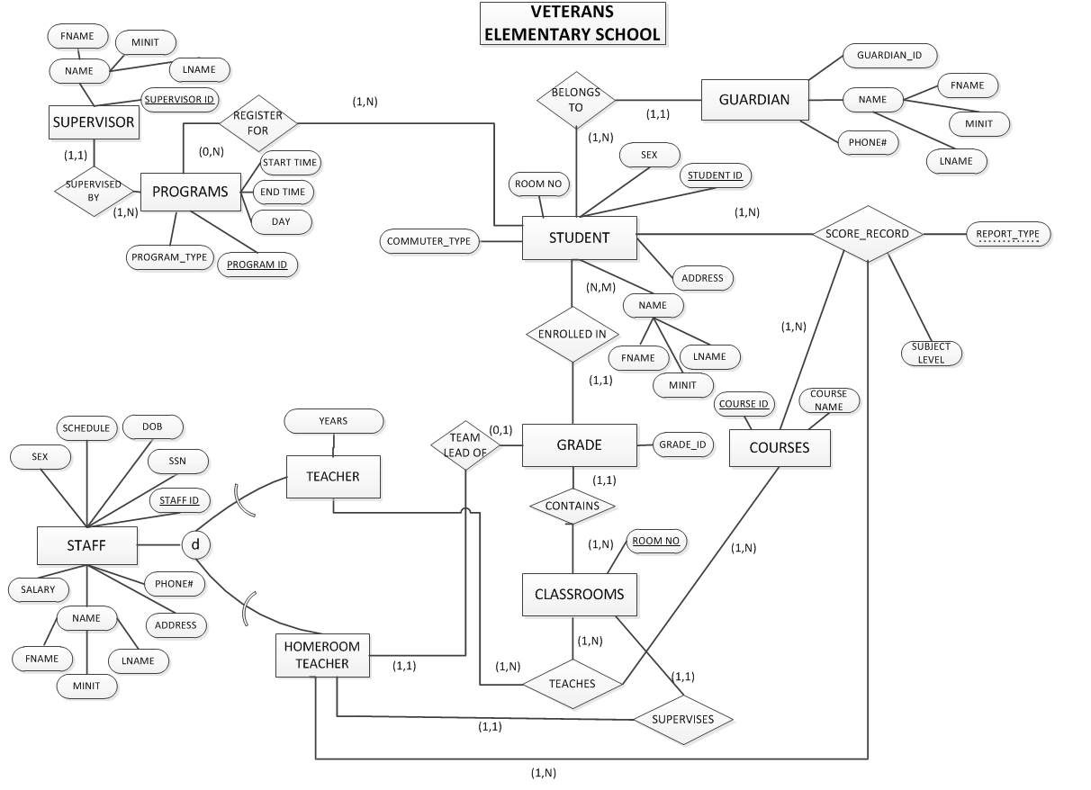

# **Assumptions:**

* Each Program needs at least one student.
* Each Guardian may have many students.
* Each Supervisor can supervise many Programs given that the programs are run on different day or time.

**Please insert the schema for the above ERD here.**

# 

# **Task List**

|  |  |  |  |  |
| --- | --- | --- | --- | --- |
| Task Name | Duration | Start | Finish | Member Names |
| Research on organization | 3 days | Mon 2/3/14 | Wed 2/5/14 | All |
| Finalized the organization | 1 days | Thu 2/06/14 | Fri 2/07/14 | All |
| Prepared questions for the interviewee | 3 days | Wed 2/12/14 | Fri 2/14/14 | All |
| Received a signature from the interviewee | 1 days | Mon 2/17/14 | Mon 2/17/14 | Sweta and Padma |
| Analyzed the school requirements | 3 days | Tue 2/18/14 | Thu 2/20/14 | All |
| Drew the ERD | 3 days | Fri 2/21/14 | Sun 2/23/14 | All |
| Listed the possible queries | 3 days | Mon 2/24/14 | Wed 2/26/14 | All |
| Discussed the requirements of the project | 2 days | Thu 2/27/14 | Fri 2/28/14 | All |
| Finalized the project | 3 days | Mon 3/03/14 | Wed 3/05/14 | All |
| Submit project |  |  |  |  |
| Created the schema |  |  |  |  |
| Create a database in MySQL |  |  |  |  |
| Create a user interface in JAVA Swing |  |  |  |  |
| Testing database and interface |  |  |  |  |
| Discuss the requirements of final project |  |  |  |  |
| Finalize the project |  |  |  |  |
| Submit final project |  |  |  |  |
| Prepare the Powerpoint |  |  |  |  |
| Practice for the presentation |  |  |  |  |
| Presentation in class |  |  |  |  |