**App Launch Plan**

Jeremy Depenhart

**What will be included in your app’s description and what kind of icon will best represent your app once it is made available in the app store?**

For this project, I created an event tracker app. Its functions and features are simple, so I believe the app’s page needs to reflect this. As such, I think a good description would be as follows; The Event Tracker allows you to plan ahead! With it, you can create and organize your events and display them in a simple, easy to grasp user interface. You can also intuitively edit events by clicking on them. Adding new events is also made simple through the tap of a button. When it’s the date of an event, Event Tracker will automatically send you a text, provided you granted it the permission to do so. The app also allows for multiple users and a unique event list for each account. Account creation is simple, only a username and password are needed. Once logged in, your screen will be populated with only the event you saved.

The app’s logo should also reflect this simple nature. I think a simplified view of the UI would make a great aesthetic for the app’s page. Simple text displaying the app’s name could also appear above it:

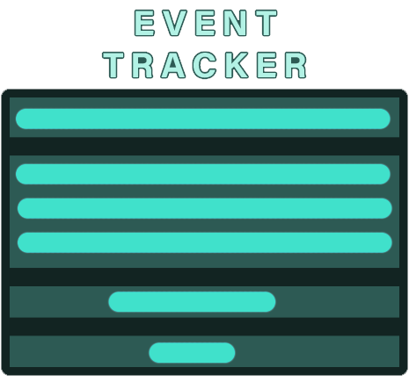

**Which version(s) of Android will your app successfully run on? Have you included the most current version?**

Event Tracker was established on Android Pie, which is version 9 of the OS. It rubs the Android Gradle Plugin version 7.3.1 and Gradle version 7.4.2. It also has a compile SDK version of 28. Despite this initial setup, Event Tracker has been tested to run on both Android OS versions 13 and 14. Version 13 was tested on an emulated Pixel 2 API 33 and version 14 was tested on an emulated Pixel 6 Pro API 34. Since the latest version of Android OS is 14, so the Event Tracker works on the newest versions of the OS.

**What permissions will your app ask for?**

The Event Tracker requests permission from the user to send SMS messages. This is done so that it can provide text notifications on the day of an event. The user can also decline this permission and the app will still run as intended, but without text notifications. Upon Launching the user can click on a setting button on the top-right corner of the screen. There they will find a button asking to allow SMS notifications. Upon clicking it, the user will be greeted with a one-time dialog requesting access to SMS messaging. Event Tracker will only send texts to the phone it is installed on and only when it is the day of an event.

**What is your plan for monetization of the app?**

Since the app is simple, I do not feel it needs monetization in its current form. There are plenty of apps that compete with Event Tracker, and I believe adding monetization at launch will only harm its popularity. As the app gains more features, and grows a userbase, some forms of monetization may be added. One possible avenue is a premium version which could allow for more event details, longer descriptions, and more.