Assignment:1

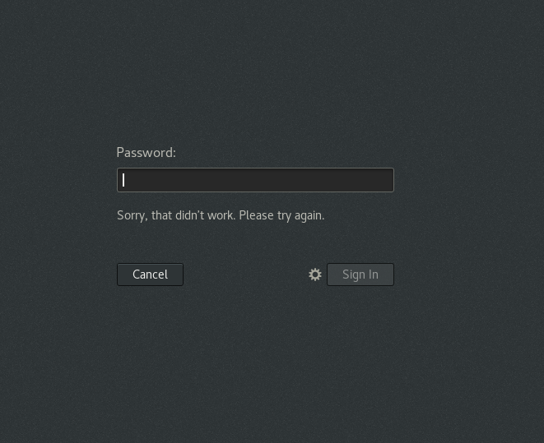  
  
because the User does not exist, it needs to be created.  
$ adduser uname1

$ passwd uname2

Assignment:2

* Change your password into IneuR0n#42 and hit the Enter key

Explain what happen and give screenshot?

Explanation: it changed the password.

Assignment:3

* Try again to change password but use like password 1234 or abcd

Explanation: it again changed the password.

* Try again to change password but now don’t use any password just hit Enter key

Explanation: it thrown an error for Authentication token manipulation.  
Assignment:3

* Enter the command cd / and then ls and then hit Enter key

cd- call directory

cd / -call last directory

ls- list directories and files.

* Enter the command now cd /home and then hit Enter key

cd /home – call last directory and enter home.

Shows users

* Enter cd .. and hit Enter key [ Note: here we have space after cd then use double dot]

$ cd .. goes one directory back from the current place.

* Now enter cd /var/www/html and then type cd and hit Enter key

No such file or directory in /var/www/html

* Now type cd /root and then hit Enter key

2 config. Files were listed.

Kickstart files. Upon my understandings these files have primary settings that need to turn ON an OS.

Assignment:4

* Go to cd /etc and type ls

$ cd /etc contains all system files and system config files.  
more or less Windows Drice C:/program files.

* Then type **ls -al** and hit **Enter** key

$cd -l showed the permission for all the files and folders

* Then use ls -i and hit Enter key

$cd -i appears like index number of the files and folders.

* Then use ls –help and see other options about ls command
  + This command shows the different attributes to use with commands.
  + Similar to that the other command is

$ man <cmd name>

Assignment-5

* Open terminal after restart the linux
* Check which location you working, type pwd and take screenshot
* Now use cd /var and hit Enter key
* Ls, and see what output comes.
* Do explore other help options of each command to learn more other things we can do with these commands