**Dynamic and team-oriented Full Stack Web Developer, adept in web design, creative coding, and debugging, bolstered by certification in Full Stack Development. Skilled in technical troubleshooting, cross-functional collaboration, and project implementations. Dedicated to leveraging 6 years of experience in restaurant operations and management to augment performance, drive innovation, and achieve 100% customer satisfaction.**

# Projects

**Chat App (August 1 - August 12)**  
Developed a real-time chat application using React Native, incorporating user authentication, image sharing, and location services features.

**Movie Application with React (May 6 - July 18)**  
Developed a full-stack movie application with a Node.js back end and React front end, integrating RESTful APIs for data management and user interaction.

**Node.js Back End API for Movie Application (March 29 - May 22)**  
Designed and developed a Node.js back-end API for a movie application, featuring RESTful endpoints for comprehensive data management and user interactions.

**Meet App (July 17 - July 31)**  
Created a meeting scheduling app using serverless functions and AWS Lambda, showcasing skills in cloud-based application development.

# Employment history

Shift Supervisor, CKA Management Nov 2020 - Present

Middletown, NJ, USA

Leadership and Team Collaboration: Managed and trained a team of 20+ employees, focusing on enhancing team cohesion and performance. This experience demonstrates strong leadership and communication skills crucial for leading development teams and collaborating on projects.

Problem-Solving and Technical Compliance: Addressed and resolved operational issues, contributing to overall improvements in compliance. This background in troubleshooting and process improvements equips me with the problem-solving skills necessary for debugging and refining web applications.

Effective Communication: Optimized communication between front-line staff and management in a quick-service restaurant, resulting in a 15% improvement in order accuracy and customer satisfaction. Sharpened the ability to relay information efficiently and manage high-pressure interactions, to ensure clear and effective communication in development teams and projects.

# Education

Career Foundry Jan 2024 - Present

Full Stack Developer Certification

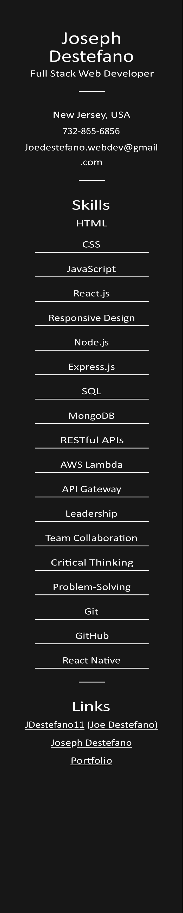Career Foundry

*Full Stack Developer Certification* Started: January 8, 2024 – Present Key Skills Acquired:

Front-End Technologies: Proficiency in HTML5, CSS3, JavaScript ES6+, React.js

(including component-based architecture, state management, and hooks)

Back-End Technologies: Experience with Node.js, Express.js, and MongoDB, including server-side development, RESTful API integration, and database management

Web Development Practices: Building scalable, responsive web applications emphasizing best practices, performance optimization, and cross-browser compatibility.