AMERICAN UNIVERSITY STAT 412/612 Homework 2

Use the following libraries in order to write code and execute output.

library(ggplot2) library(tidyverse)

Show and use R coding to answer the following questions. ( **Use Tidyverse methods to generate graphs and plots**)

1) Explore the **Midwest** data frame.

a) How many rows, columns, and variables are in the **Midwest** data frame?

b) Name three categorical variables in the data frame.

c) Give a description for the variable percollege.

Use the **Midwest** data frame for problems **2,3,4,5,6,7, and 9**

2) Write R code to produce a histogram for the variable poptotal.

3) Write r code to produce a boxplot for the variable area, and then use your box plot to find Q1, Q2, and Q3

4) Write r code to produce side by side boxplots for the quantitative variable area with respect to the categorical variable state.

5) Write r code to produce a scatter plot for the variables popdensity and popwhite. Let popdensity be the independent variable x and popwhite be dependent variable y.

6) Write r code that will produce smooth lines plots and scatter plots on the same axis system for popwhite and popdensity with respect to the categorical variable state.

7) Again, using the variables popdensity and popwhite, write r code that will produce the same basic scatter plot, but also make the following changes:

a) Your scatter plot should have purple data points.

b) The label of the dependent variable should be changed to Population Density and the label of the independent variable should be changed to White Population

c) Add a linear regression line to your graph.

d) Add the following title to your graph; White vs Density Scatter Plot

8) Write R code that will generate the following graph (use the **mpg** data frame)

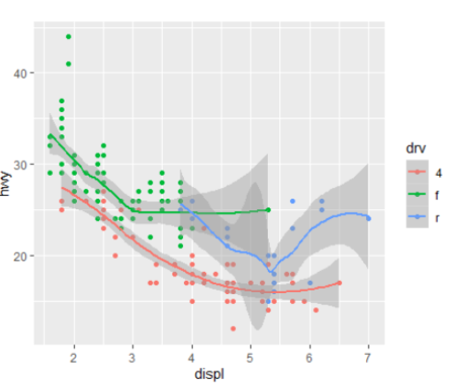

#9 Write R code that will produce the following facet plot using the **midwest** data frame

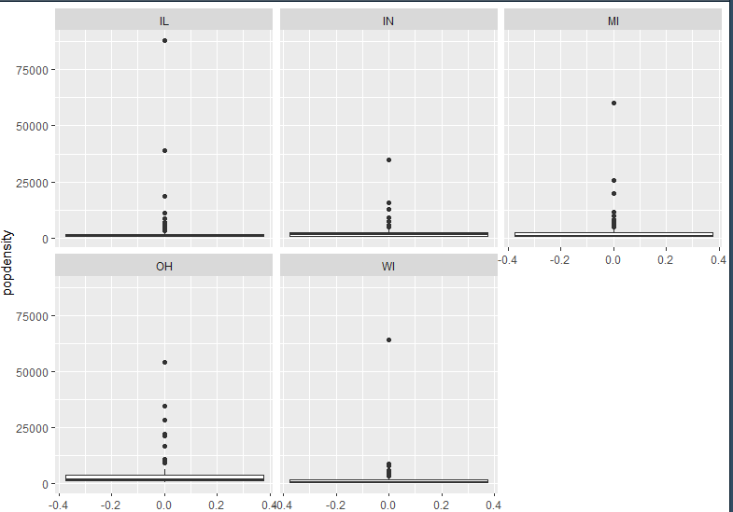

#10 Write R code that will produce the following facet plot using the **mpg** data frame

