Looking at Data — Distributions

1. | A study is conducted on students taking a statistics class. Several variables are recorded in the survey. Identify each variable as categorical or quantitative.
A) | Type of car the student owns.
B) | Number of credit hours taken during that semester.
C) | The time the student waited in line at the bookstore to pay for his/her textbooks.
D) | Home state of the student.
Answer: |  | A) categorical, B) quantitative, C) quantitative, D) categorical
Topic: |  | 1.1 Displaying Distributions with Graphs

2. | Researchers are conducting a state-wide survey for the U.S. Postal Service. The survey records many different variables of interest. Which of the following variables is categorical?
A) | County of residence.
B) | Number of people, both adults and children, living in the household.
C) | Total household income, before taxes, in 2010.
D) | Age of respondent.
Answer: |  | A
Topic: |  | 1.1 Displaying Distributions with Graphs

3. | A particularly common question in the study of wildlife behavior involves observing contests between “residents” of a particular area and “intruders.” In each contest, the “residents” either win or lose the encounter (assuming there are no ties). Observers might record several variables, some of which are listed below. Which of these variables is categorical?
A) | The duration of the contest (in seconds).
B) | The number of animals involved in the contest.
C) | Whether the “residents” win or lose.
D) | The total number of contests won by the “residents.”
Answer: |  | C
Topic: |  | 1.1 Displaying Distributions with Graphs

4. | A description of different houses on the market includes the following three variables. Which of these variables is quantitative?
A) | The square footage of the house.
B) | The monthly gas bill.
C) | The monthly electric bill.
D) | All of the above.
Answer: |  | D
Topic: |  | 1.1 Displaying Distributions with Graphs

5. | Jason is buying a new computer. He is comparing various models using many different variables. These variables play an important role in making the decision about which computer he will buy. Identify each of the following variables as categorical or quantitative.
A) | Does the computer come with a CD/DVD writer?
B) | What is the hard drive size of the computer?
C) | Is the computer a laptop or a desktop model?
D) | How much does the computer cost?
Answer: |  | A) categorical, B) quantitative, C) categorical, D) quantitative
Topic: |  | 1.1 Displaying Distributions with Graphs

6. | A sample of employees of a large pharmaceutical company has been obtained. The length of time (in months) they have worked for the company was recorded for each employee. A stemplot of these data is shown below. In the stemplot 6|2 represents  62 months.  6 2 2 3 3 4 5 7 8 9  7 0 0 0 2 3 4 4 4 5 6 7 8 8 8 9  8 0 0 1 1 2 3 4 4 4 5 7 9 9 9  9 0 0 0 1 1 1 2 3 5 8  What would be a better way to represent this data set?
A) | Display the data in a time plot.
B) | Display the data in a boxplot.
C) | Split the stems.
D) | Use a histogram with class width equal to 10.
Answer: |  | C
Topic: |  | 1.1 Displaying Distributions with Graphs

7. | Data are collected from 1100 randomly selected students who graduated between 2005 and 2008 from the University of Florida. Some of the variables that were collected are listed below. Identify each of the following variables as categorical or quantitative.
A) | Gender of the student.
B) | School/college from which the student graduated.
C) | Annual salary of the first job after graduation.
D) | Graduation date in terms of semester (e.g., Fall 2005, Spring 2006, etc.).
Answer: |  | A) categorical, B) categorical, C) quantitative, D) categorical
Topic: |  | 1.1 Displaying Distributions with Graphs

8. | Refer to the previous question. A pie chart of the departments in the school/college from which the 1100 sampled students graduated is shown below:  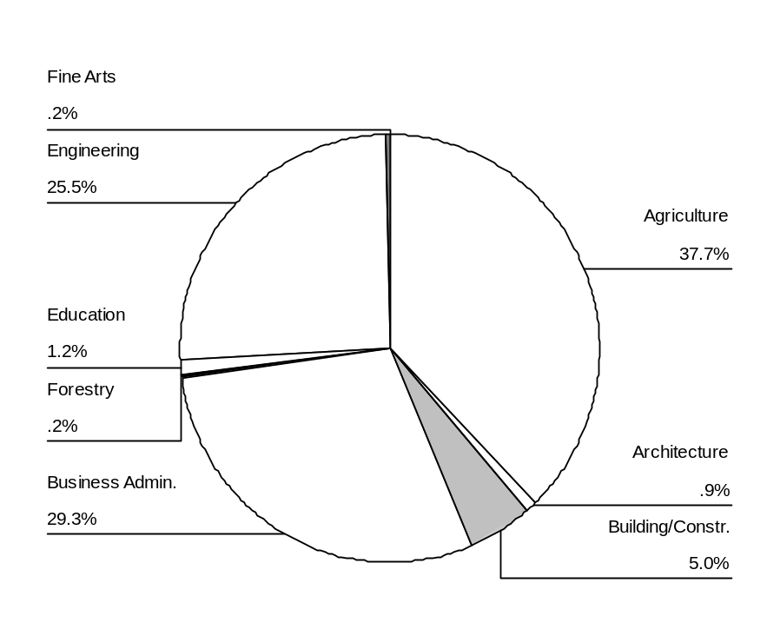  Based on the graph, (approximately) how many of the sampled students graduated with a degree in Building/Construction or Architecture?
A) | 55
B) | 59
C) | 65
D) | 99
Answer: |  | C
Topic: |  | 1.1 Displaying Distributions with Graphs

9. | A distributor of appliances is doing a customer satisfaction survey for a manufacturer of DVD players. A sample of 68 clients is asked to rate a particular DVD player on appearance, functionality, ease of use, and price on a 1 to 10 scale, where 1 corresponds to the worst rating and 10 to the best rating possible. A bar graph of the ease of use ratings classified by gender is given below:  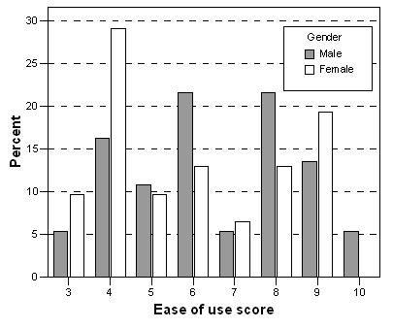  What percentage of the sampled female clients rated the DVD player as not so easy to use (a rating of 4 or lower)?
A) | 28%
B) | 29%
C) | 38%
D) | 62%
Answer: |  | C
Topic: |  | 1.1 Displaying Distributions with Graphs

10. | When drawing a histogram, it is important to
A) | have a separate class interval for each observation to get the most informative plot.
B) | make sure the heights of the bars exceed the widths of the class intervals so that the bars are true rectangles.
C) | label the vertical axis so the reader can determine the counts or percent in each class interval.
D) | make certain the mean and median are contained in the same class interval, so that the correct type of skewness can be identified.
Answer: |  | C
Topic: |  | 1.1 Displaying Distributions with Graphs

Use the following to answer questions 11–13:

In a statistics class with 136 students, the professor records how much money each student has in their possession during the first class of the semester. The histogram shown below represents the data he collected:

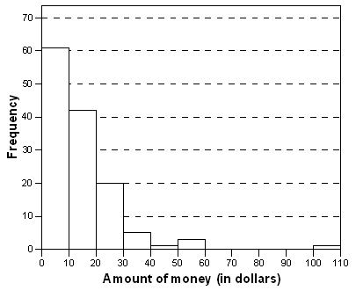

11. | What is approximately the percentage of students with under $10.00 in their possession?
A) | 35% |  | C) | 44%
B) | 40% |  | D) | 50%
Answer: |  | C
Topic: |  | 1.1 Displaying Distributions with Graphs

12. | Which of the following description(s) is/are correct regarding the shape of the histogram?
A) | Skewed right |  | D) | An outlier is present.
B) | Skewed left |  | E) | Unimodal
C) | Symmetric |  | F) | Bimodal
Answer: |  | A, D, E
Topic: |  | 1.1 Displaying Distributions with Graphs

13. | What is approximately the number of students with $30.00 or more in their possession?
A) | Less than 5 |  | C) | About 30
B) | About 10 |  | D) | More than 100
Answer: |  | B
Topic: |  | 1.1 Displaying Distributions with Graphs

Use the following to answer questions 14 and 15:

The histogram below represents the height (in inches) of the gold medal–winning high jumps for the Olympic Games up to Sydney 2000:

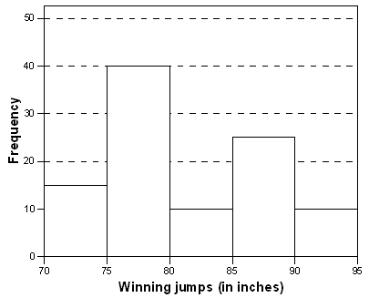

14. | What is approximately the mean height?
A) | 75 inches |  | C) | 82 inches
B) | 77.5 inches |  | D) | 90 inches
Answer: |  | C
Topic: |  | 1.2 Describing Distributions with Numbers

15. | What is approximately the percentage of these winning jumps that were at least 7’1” high (85 inches)?
A) | 9% |  | C) | 23%
B) | 14% |  | D) | 35%
Answer: |  | D
Topic: |  | 1.1 Displaying Distributions with Graphs

Use the following to answer questions 16 and 17:

A consumer agency is testing appliances for a series of articles in their magazine. Currently they are working with cooktops and ranges. They have selected 16 of the most commonly used models. Using a series of tests, the agency will estimate the lifetime of these models.A histogram of these (estimated) lifetimes is shown below:

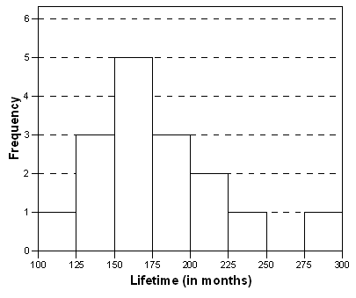

16. | What is the proportion of these appliances that is estimated to last longer than 15 years?
A) | More than half
B) | Less than half
C) | Equal to 4/16 = 0.25
D) | Unable to determine from this graph.
Answer: |  | D
Topic: |  | 1.1 Displaying Distributions with Graphs

17. | Select all correct descriptions for the shape of the histogram of the estimated lifetimes of these 16 appliances.
A) | Symmetric
B) | Unimodal
C) | Skewed right
D) | Skewed left
Answer: |  | B and C
Topic: |  | 1.1 Displaying Distributions with Graphs

Use the following to answer questions 18–21:

During the early part of the 1994 baseball season, many sports fans and baseball players noticed that the number of home runs being hit seemed to be unusually large. Below are separate stemplots for the number of home runs by American League and National League teams based on the team-by-team statistics on home runs hit through Friday, June 3, 1994 (from the Columbus Dispatch sports section, Sunday, June 5, 1994).

American League National League

2 2 9
3 5 3 1
4 0 3 9 4 2 6 7 8 8
5 1 4 7 8 8 5 3 5 5 5
6 4 8 8 6 3 3 7
7 5 7 7

Legend: 2|9 represents 29.

18. | What is the median for the number of home runs for the American League teams?
A) | 45
B) | 50
C) | 50.5
D) | 57.5
Answer: |  | D
Topic: |  | 1.1 Displaying Distributions with Graphs

19. | Determine whether each of the following statements is true or false.
A) | The American League plot is reasonably symmetric.
B) | The National League plot is bimodal.
C) | The median number of home runs hit by National League teams for this time period was higher than the median for the American League teams.
D) | The lowest number of home runs hit by any team for this time period is 29.
Answer: |  | A) True, B) False, C) False, D) True
Topic: |  | 1.1 Displaying Distributions with Graphs

20. | What is the mean for the number of home runs for the National League teams?
A) | 45
B) | 50
C) | 50.1
D) | 57.5
Answer: |  | C
Topic: |  | 1.1 Displaying Distributions with Graphs

21. | What is the maximum number of home runs from a National League team?
A) | 7
B) | 70
C) | 67
D) | 48
Answer: |  | C
Topic: |  | 1.1 Displaying Distributions with Graphs

Use the following to answer questions 22 and 23:

The Consumers Union measured the gas mileage in miles per gallon of 38 automobiles from the 1978–1979 model-year on a special test track. The pie chart below provides information about the country of manufacture of the automobiles used in this study by the Consumers Union:
Sweden
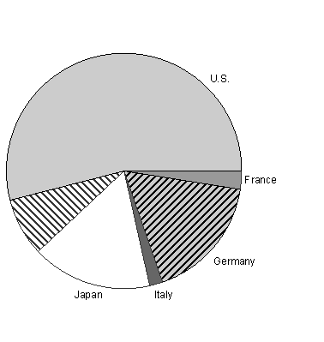

22. | What conclusion can we draw based on this pie chart?
A) | Italian cars get significantly lower gas mileage than cars of other countries. This is because their slice of the pie is the smallest of the chart.
B) | More than half of the cars in the study were from the United States.
C) | Swedish cars get gas mileages that are between those of Japanese and U.S. cars.
D) | Mercedes-Benz, Audi, Porsche, and BMW represent approximately a quarter of the cars tested.
Answer: |  | B
Topic: |  | 1.1 Displaying Distributions with Graphs

23. | Which of the following bar graphs represents the same data as the pie chart in the previous problem?
A) | 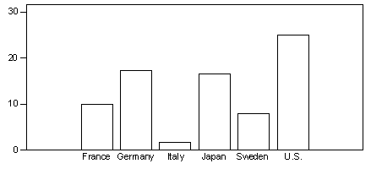
B) | 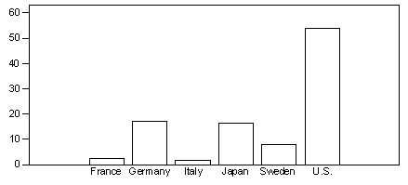
C) | 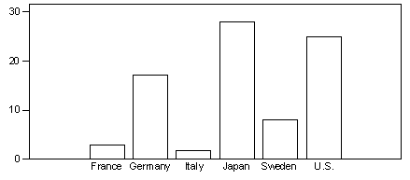
D) | 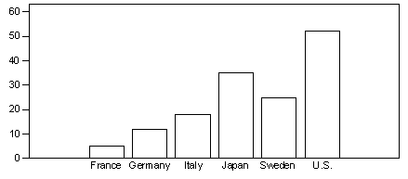
Answer: |  | B
Topic: |  | 1.1 Displaying Distributions with Graphs

Use the following to answer questions 24 and 25:

A study is being conducted on air quality at a small college in the South. As part of this study, monitors were posted at every entrance to this college from 6 a.m. to 10 p.m. on a randomly chosen day. The monitors recorded the mode of transportation used by each person as they entered the campus. Based on the information recorded, the following bar graph was constructed:

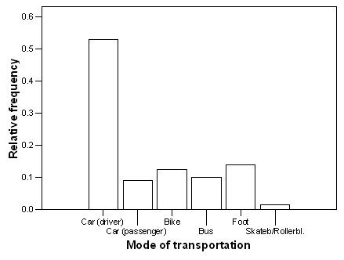

24. | Approximately what percentage of people entering campus on this particular day arrived by car?
A) | 9%
B) | 31%
C) | 53%
D) | 62%
Answer: |  | D
Topic: |  | 1.1 Displaying Distributions with Graphs

25. | If 1200 people entered campus on this particular day, (approximately) how many people arrived by bus?
A) | 10
B) | 100
C) | 120
D) | 135
Answer: |  | C
Topic: |  | 1.1 Displaying Distributions with Graphs

Use the following to answer questions 26–28:

The timeplot below gives the number of burglaries committed each month for a city in Ohio. The plot is for the three-year period January 1987–December 1989.

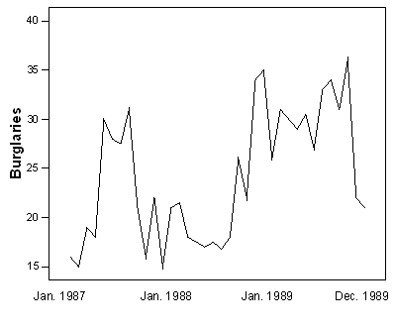

26. | What is approximately the number of burglaries in December 1989, the last date recorded in the timeplot?
A) | 22 |  | C) | 32
B) | 27 |  | D) | 37
Answer: |  | A
Topic: |  | 1.1 Displaying Distributions with Graphs

27. | Determine whether each of the following statements is true or false.
A) | The number of burglaries in each month of 1988 was lower than the number of burglaries in each month of 1989.
B) | The median number of burglaries per month in 1988 was a little over 25.
C) | The total number of burglaries in 1989 was higher than in 1988.
D) | The graph is bimodal.
Answer: |  | A) False, B) False, C) True, D) False
Topic: |  | 1.1 Displaying Distributions with Graphs

28. | What is approximately the maximum number of burglaries for a month in 1988?
A) | 20 |  | C) | 30
B) | 25 |  | D) | 35
Answer: |  | D
Topic: |  | 1.1 Displaying Distributions with Graphs

29. | A study of 2007 model automobiles was conducted. In the study the following variables were considered: the Region in which the car was manufactured (Europe, North America, Asia); the Type of automobile (compact, midsize, large); the fuel economy in city driving of the automobile (MPG-City), volume of the engine in liters (EngSize), and the type of Fuel used (regular, premium, diesel). The variables Region, Type, MPG-City, EngSize, and Fuel are, respectively:
A) | quantitative, categorical, categorical, quantitative, quantitative.
B) | categorical, categorical, quantitative, categorical, categorical.
C) | categorical, categorical, quantitative, categorical, quantitative.
D) | categorical, categorical, quantitative, quantitative, categorical.
E) | Unable to determine without knowing the values of the various variables.
Answer: |  | D
Topic: |  | 1.1 Displaying Distributions with Graphs

30. | Which of the following statements is FALSE?
A) | The distribution of a categorical variable lists the categories and gives the counts or the percent of individuals in each category.
B) | A bar chart is a useful graphical tool for describing the shape of the distribution of a categorical variable.
C) | A stemplot is particularly valuable for displaying the shape of the distribution of a categorical variable when there are few observations.
D) | A histogram shows the distribution of counts or percents among the values of a single quantitative variable.
E) | Bar graphs, unlike histograms, can have blank spaces between the bars to separate the items being compared.
Answer: |  | B and C
Topic: |  | 1.1 Displaying Distributions with Graphs

31. | When examining a distribution of a quantitative variable, which of the following features do we look for?
A) | Overall shape, center, and spread.
B) | Symmetry or skewness.
C) | Deviations from overall patterns such as outliers.
D) | The number of peaks or modes.
E) | All of the above.
Answer: |  | E
Topic: |  | 1.1 Displaying Distributions with Graphs

32. | In the fuel efficiency study of 2007 compact model automobiles the following histogram of the distribution of the miles per gallon fuel efficiency rating in city driving (MPG-City) for automobiles manufactured in Europe was obtained:
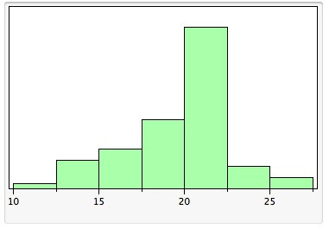
 | From the histogram above, showing the distribution of MPG-City, we can see that
A) | the shape of the distribution is roughly symmetric with one peak.
B) | the distribution is skewed to the left.
C) | the distribution is skewed to the right.
D) | the distribution is roughly symmetric with outlier values to the left.
E) | the shape of the distribution would be easier to see if a stemplot had been constructed instead of the histogram.
Answer: |  | B
Topic: |  | 1.1 Displaying Distributions with Graphs

33. | The following stemplot displays the number of forest fires (in thousands) that occurred each year over the period from 1970 to 2000 in Canada:

5 2
6 0137
7 36
8 0125999
9 11223458
10 111237
11 23
12 2
where 5|2 represents 5200 fires.
 | From the stemplot we can see that
A) | the shape of the distribution is skewed to the left.
B) | there appears to be one large peak.
C) | there were a total of 9 years in which more than 10,000 fires occurred.
D) | Only 1 year had fewer than 6000 fires.
E) | All of the above.
Answer: |  | E
Topic: |  | 1.1 Displaying Distributions with Graphs

34. | Statistics were gathered on the number of homicides committed with guns in Australia in the years from 1980 to 2004. From these data the following graph was constructed:
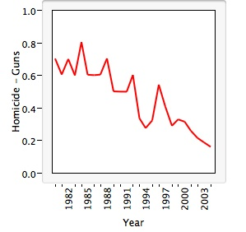
 | This plot is a graph of a(n) _____________ and it shows that there is(are) ___________ in the data.
A) | categorical variable; skewness to the right
B) | histogram; multiple peaks
C) | line; an increasing trend
D) | quantitative variable; outlier values
E) | time series; a decreasing trend
Answer: |  | E
Topic: |  | 1.1 Displaying Distributions with Graphs

35. | Which of the following variables is categorical?
A) | The number of Facebook friends you have.
B) | Amount of time a student spends on the internet in one day.
C) | Available food choices in the student cafeteria.
D) | None of the above.
Answer: |  | C
Topic: |  | Topic: 1.1 Displaying Distributions with Graphs

36. | According to the American Cancer Society, the decline in colorectal cancer mortality, primarily attributed to early detection and treatment, have not been consistent among race/ethnic groups. A colorectal exam is one method for early detection of colorectal cancer. In 2008, 29.5% of Whites, 56.9% of African Americans, and 62.4% of Hispanics had not received a colorectal exam within the last ten years. What is the best method to display these data?
A) | Histogram
B) | Pie chart
C) | Bar graph
D) | Stem-and-leaf plot
Answer: |  | C
Topic: |  | 1.1 Displaying Distributions with Graphs

Use the following to answer questions 37–40:

Malaria is a leading cause of infectious disease and death worldwide. The table below represents the mean number of reported malaria cases (between 1996 and 2006) for each of 10 West African countries as published in the journal Statistica Neerlandica.

Country | Mean number of reported malaria cases
Benin | 745,340
Burkina Faso | 1,098,680
Cote d’Ivoire | 1,203,705
The Gambia | 229,505
Ghana | 2,956,957
Liberia | 613,171
Mali | 691,245
Senegal | 1,111,249
Sierra Leone | 321,340
Togo | 453,837

37. | What is the best method to display these data?
A) | Histogram
B) | Pie chart
C) | Bar graph
D) | Stem-and-leaf plot
Answer: |  | C
Topic: |  | 1.1 Displaying Distributions with Graphs

38. | The variable “country” is a quantitative variable.
A) | True
B) | False
Answer: |  | B
Topic: |  | 1.1 Displaying Distributions with Graphs

39. | Making a histogram of the data would tell us if the distribution of the malaria data are symmetric.
A) | True
B) | False
Answer: |  | B
Topic: |  | 1.1 Displaying Distributions with Graphs

40. | Why is it not appropriate to use a histogram to display these data?
A) | A pie chart is much easier to read.
B) | The data are categorical and therefore a histogram is not appropriate.
C) | The width of the bins would be too large to display a histogram.
D) | None of the above.
Answer: |  | B
Topic: |  | 1.1 Displaying Distributions with Graphs

Use the following to answer questions 41–50:

The World Malaria Report (2008) has information on the number of reported malaria cases from 2005–2006 for the ten countries listed in West Africa. The data are presented in the table below:

Country/area | 2005 | 2006
Benin | 803,462 | 861,847
Burkina Faso | 1,615,695 | 2,060,867
Côte d'Ivoire | 1,280,914 | 1,253,408
Gambia | 161,698 | 266,188
Ghana | 3,452,969 | 3,511,452
Liberia | 116,681 | 1,105,272
Mali | 962,706 | 1,022,592
Senegal | 1,346,158 | 1,555,310
Sierra Leone | 233,833 | 160,666
Togo | 437,662 | 566,450

41. | The mean reported West African malaria cases in 2005 is ___________.
A) | less than 116,698
B) | greater than 1,600,000
C) | 100,000
D) | greater than 200,000
Answer: |  | D
Topic: |  | 1.1 Displaying Distributions with Graphs

42. | The median reported malaria cases in 2005 is _________.
A) | less than 1,000,000
B) | less than 200,000
C) | 100,000
D) | 3,000,000
Answer: |  | A
Topic: |  | 1.1 Displaying Distributions with Graphs

43. | The mean reported malaria cases in 2006 is _________.
A) | less than 2,000,000
B) | less than 200,000
C) | 100,000
D) | 3,000,000
Answer: |  | A
Topic: |  | 1.1 Displaying Distributions with Graphs

44. | The median reported malaria cases in 2006 is _________.
A) | around 1,000,000
B) | less than 200,000
C) | 100,000
D) | 3,000,000
Answer: |  | A
Topic: |  | 1.1 Displaying Distributions with Graphs

46. | The mean number of malaria cases in 2006 is probably ______.
A) | higher than in 2005
B) | lower than in 2005
C) | exactly the same
Answer: |  | A
Topic: |  | 1.1 Displaying Distributions with Graphs

45. | The median number of malaria cases in 2006 is probably ________.
A) | higher than in 2005
B) | lower than in 2005
C) | exactly the same
Answer: |  | A
Topic: |  | 1.1 Displaying Distributions with Graphs

47. | If the number of reported malaria cases in Ghana in 2005 were mistyped and reported as 30,452,969, what would happen to the mean and median?
A) | Both would remain unchanged.
B) | The mean would change, but the median would stay the same.
C) | The mean and median would change.
D) | You cannot tell without doing the actual calculation.
Answer: |  | B
Topic: |  | 1.2 Describing Distributions with Numbers

48. | If the number of reported malaria cases in Sierra Leone were mistyped and reported as 1,160,666, what would happen to the mean and median?
A) | Both would remain unchanged.
B) | The mean would change, but the median would stay the same.
C) | The mean and median would change.
D) | You cannot tell without doing the actual calculation.
Answer: |  | C
Topic: |  | 1.2 Describing Distributions with Numbers

49. | If the number of malaria cases for Ghana were removed from this data set, what would happen to the mean of the entire data set for the year 2005?
A) | The mean would not change.
B) | The mean would change.
C) | You cannot tell without doing the calculation.
Answer: |  | B
Topic: |  | 1.2 Describing Distributions with Numbers

50. | If the number of malaria cases for Sierra Leone were removed from this data set, what would happen to the mean of the entire data set for the year 2006?
A) | The mean would not change.
B) | The mean would change.
C) | You cannot tell without doing the calculation.
Answer: |  | B
Topic: |  | 1.2 Describing Distributions with Numbers

51. | Which of the following variables is quantitative?
A) | The amount of time a student spends on the internet in a week.
B) | The number of tenured professors at a large university.
C) | The number of hurricanes each year for the years 2000–2010.
D) | All of the above.
E) | None of the above.
Answer: |  | D
Topic: |  | 1.1 Displaying Distributions with Graphs

52. | The National Oceanic and Atmospheric Administration’s (NOAA) National Climatic Data Center (NCDC; http://www7.ncdc.noaa.gov) collect several weather variables. Identify whether each of the listed variables from NCDC are quantitative or categorical.
A) | The amount of rainfall in one year in every state.
B) | Mean temperature in California across 25 years.
C) | Number of days with precipitation of at least 1mm.
D) | Departure of precipitation from average.
Answer: |  | - quantitative, B) quantitative, C) quantitative, D) quantitative
Topic |  | 1.1 Displaying Distributions with Graphs

53. | On the first day of class, statistics professors ask each student to fill out a demographic questionnaire to learn information about their class. Which of the following variables are categorical?
A) | Gender
B) | Marital status
C) | Highest education level of your mother (e.g. high school grad, college grad, etc.).
D) | All of the above.
E) | None of the above.
Answer: |  | D
Topic: |  | 1.1 Displaying Distributions with Graphs

54. | On the first day of class, statistics professors ask each student to fill out a demographic questionnaire to learn information about their class. Which of the following variables are quantitative?
A) | Gender
B) | Marital status
C) | Highest education level of your mother (e.g. high school grad, college grad, etc.).
D) | Household income
Answer: |  | D
Topic: |  | 1.1 Displaying Distributions with Graphs

Use the following to answer questions 55–57:
Students taking a statistical programming class were asked their proficiency in the statistical software SAS. The results are shown in the chart below:

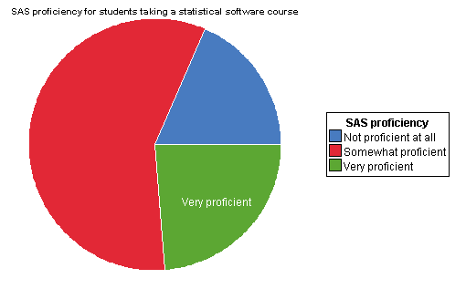

55. | From the pie chart, we can see that most students are _____.
A) | Not proficient at all
B) | Somewhat proficient
C) | Very proficient
Answer: |  | B
Topic: |  | 1.1 Displaying Distributions with Graphs

56. | It would have been better to display the data in a histogram.
A) | True
B) | False
C) | Both displays work equally well.
Answer: |  | B
Topic: |  | 1.1 Displaying Distributions with Graphs

57. | A bar graph would give the same information?
A) | True
B) | False
Answer: |  | A
Topic: |  | 1.1 Displaying Distributions with Graphs

Use the following to answer questions 58–62:
The bar graph below represents the highest education level achieved for 30 random females and 60 random males asked on a street corner in downtown Washington, DC.

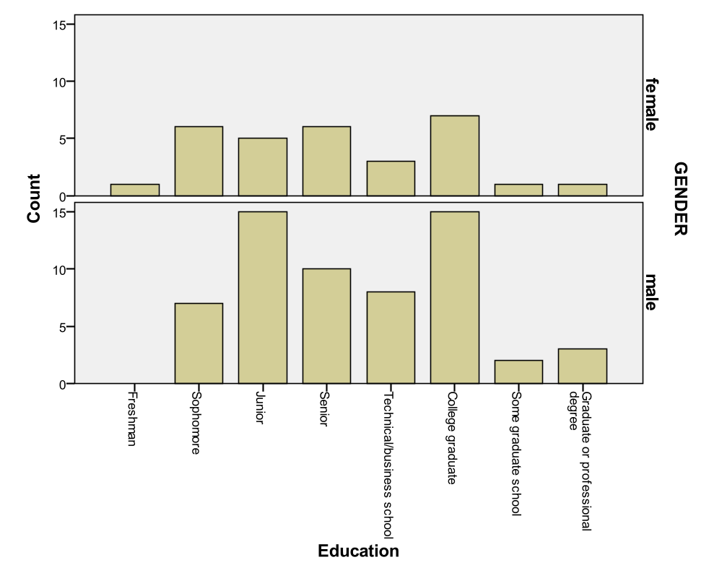

58. | Approximately how many people are college graduates?
A) | 15
B) | 7
C) | 22
D) | 1
Answer: |  | C
Topic: |  | 1.1 Displaying Distributions with Graphs

59. | More men than women are college graduates.
A) | True
B) | False
C) | Cannot be determined from the information given.
Answer: |  | A
Topic: |  | 1.1 Displaying Distributions with Graphs

60. | What percentage of women completed at most their junior year?
A) | 5%
B) | 17%
C) | 67%
D) | 100%
Answer: |  | B
Topic: |  | 1.1 Displaying Distributions with Graphs

61. | What percentage of men completed at most their freshman year?
A) | 1%
B) | 100%
C) | 0%
D) | Cannot be determined from the information given.
Answer: |  | C
Topic: |  | 1.1 Displaying Distributions with Graphs

62. | How many males completed at least some graduate school?
A) | 5
B) | 2
C) | 3
D) | 60
Answer: |  | B
Topic: |  | 1.1 Displaying Distributions with Graphs

63. | A consumer group surveyed the prices for white cotton extra-long twin sheet sets in five different department stores and reported the average price as $16. We visited four of the five stores, and found the prices to be $12, $15, $17, and $22. Assuming that the consumer group is correct, what is the price of the item at the store that we did not visit?
A) | $10 |  | C) | $15
B) | $14 |  | D) | $17
Answer: |  | B
Topic: |  | 1.2 Describing Distributions with Numbers

64. | The average salary of all female workers is $35,000. The average salary of all male workers is $41,000. What must be true about the average salary of all workers?
A) | It must be $38,000.
B) | It must be larger than the median salary.
C) | It could be any number between $35,000 and $41,000.
D) | It must be larger than $38,000.
Answer: |  | C
Topic: |  | 1.2 Describing Distributions with Numbers

65. | A researcher reports that, on average, the participants in his study lost 10.4 lbs after two months on his new diet. A friend of yours comments that she tried the diet for two months and lost no weight, so clearly the report must be a fraud. Which of the following statements is correct?
A) | Your friend must not have followed the diet correctly because she did not lose weight.
B) | Because your friend did not lose weight, the report must not be correct.
C) | The report gives only the average. This does not imply that all participants in the study lost 10.4 lbs or even that all participants lost weight. Your friend’s experience does not necessarily contradict the study results.
D) | In order for the study to be correct, we must now add your friend’s results to those of the study and recompute the new average.
Answer: |  | C
Topic: |  | 1.2 Describing Distributions with Numbers

66. | The ages (to the nearest year) of the 667 people participating in a large workshop are summarized as follows:  What is true about the median age?
  Age | 18 | 19 | 20 | 21 | 22 | 23 | 24 | 25 | 32
  Number of students | 14 | 120 | 200 | 200 | 90 | 30 | 10 | 2 | 1
A) | It could be any number between 19 and 20.
B) | It must be 20.
C) | It must be 21.
D) | It must be over 21.
Answer: |  | B
Topic: |  | 1.2 Describing Distributions with Numbers

67. | As part of a large ongoing study on the treatment of women with breast cancer, the treatment time (in months) of eight patients whose lymph nodes were cancer-free is recorded. Treatment time is defined as the time from the moment the cancer treatment starts until the patient is declared cancer-free.  What is the mean treatment time for these 8 women?
  9.47 | 8.60 | 19.33 | 16.33 | 8.50 | 9.40 | 17.67 | 9.30
A) | 10.5 months
B) | 11.67 months
C) | 12.325 months
D) | 15 months
Answer: |  | C
Topic: |  | 1.2 Describing Distributions with Numbers

68. | The median age of five people in a meeting is 30 years. One of the people, whose age is 50 years, leaves the room. What is the median age of the remaining four people in the room?
A) | 40 years
B) | 30 years
C) | 25 years
D) | This cannot be determined from the information given.
Answer: |  | D
Topic: |  | 1.2 Describing Distributions with Numbers

Use the following to answer questions 69–72:

The Environmental Protection Agency records data on the fuel economy of many different makes of cars.

69. | Some of the variables they collect are listed below. Identify each variable as categorical or quantitative.
A) | The manufacturer of the car (GM, Ford, Mazda, etc.).
B) | Mileage of the car (miles per gallon).
C) | Weight of the car (in lbs).
D) | Size of the car (small, medium, full-size, pick-up truck, etc.).
Answer: |  | A) categorical, B) quantitative, C) quantitative, D) categorical
Topic: |  | 1.1 Displaying Distributions with Graphs

70. | Data on the mileage of 20 randomly selected cars are listed below. The values are ordered for convenience.  What is the median mileage for these 20 cars?
  12 | 13 | 15 | 16 | 16 | 17 | 18 | 18 | 19 | 19
  20 | 20 | 22 | 23 | 24 | 26 | 26 | 27 | 27 | 29
A) | 17.5 miles per gallon
B) | 19 miles per gallon
C) | 19.5 miles per gallon
D) | 20 miles per gallon
Answer: |  | C
Topic: |  | 1.2 Describing Distributions with Numbers

71. | If the value 29 were misrecorded and should really be 21, what would the median mileage be for these 20 cars?
A) | It would change to 20 miles per gallon.
B) | It would stay the same.
C) | It would change to 21 miles per gallon.
D) | We cannot determine this from the given information.
Answer: |  | B
Topic: |  | 1.2 Describing Distributions with Numbers

72. | What is the interquartile range for the mileage data?
A) | 8.5 miles per gallon
B) | 16.5 miles per gallon
C) | 17 miles per gallon
D) | 25 miles per gallon
Answer: |  | A
Topic: |  | 1.2 Describing Distributions with Numbers

73. | A set of midterm exam scores has a median that is much larger than the mean. Which of the following statements is most consistent with this information?
A) | A stemplot of the data would be symmetric.
B) | A stemplot of the data would be skewed left.
C) | A stemplot of the data would be skewed right.
D) | The data set must be so large that it would be better to draw a histogram rather than a stemplot.
Answer: |  | B
Topic: |  | 1.2 Describing Distributions with Numbers

74. | A consumer agency is testing appliances for a series of articles in their magazine. Currently they are working with cooktops and ranges. They have selected 16 of the most commonly used models. Using a series of tests, the agency will estimate the lifetime of these models. A histogram of these (estimated) lifetimes is shown below:  Answer each of the following questions with yes, no, or can’t tell.
A) | Is the shortest lifetime in this data set equal to 100 months?
B) | Is the median lifetime in this data set somewhere between 150 and 175 months?
C) | Is the range of this data set equal to 200 months?
D) | Is it possible that all of these 16 appliances had estimated lifetimes that were longer than 10 years?
Answer: |  | A) Can’t tell, B) Yes, C) Can’t tell, D) Yes
Topic: |  | 1.2 Describing Distributions with Numbers

75. | Which of the following is likely to have a mean that is smaller than the median?
A) | The salaries of all National Football League players.
B) | The scores of students (out of 100 points) on a very easy exam in which most score perfectly, but a few do very poorly.
C) | The number of text messages sent by students and faculty at a large university.
D) | The scores of students (out of 100 points) on a very difficult exam on which most score poorly, but a few do very well.
Answer: |  | B
Topic: |  | 1.2 Describing Distributions with Numbers

76. | The salaries of Major League Baseball players range from several hundred thousand dollars per year to many millions. Suppose a histogram is made of all last year’s salaries of Major League Baseball players. Which shape would best describe the shape of this histogram?
A) | Skewed to the left
B) | Bell-shaped
C) | Skewed to the right
D) | Bimodal
Answer: |  | C
Topic: |  | 1.1 Displaying Distributions with Graphs

77. | A reporter wishes to portray baseball players as overpaid. Which measure of center should he report as the average salary of major league players?
A) | The mean
B) | The median
C) | Either the mean or median. They will be equal in this case.
D) | Neither the mean nor the median. Both will be much lower than the actual average salary.
Answer: |  | A
Topic: |  | 1.2 Describing Distributions with Numbers

Use the following to answer questions 78–82:

The Insurance Institute for Highway Safety publishes data on the total damage suffered by compact automobiles in a series of controlled, low-speed collisions. The cost for a sample of 9 cars, in hundreds of dollars, is provided below:

10 | 6 | 8 | 10 | 4 | 3.5 | 7.5 | 8 | 9

78. | What is the median cost of the total damage suffered for this sample of cars?
A) | $400 |  | C) | $800
B) | $730 |  | D) | $1000
Answer: |  | C
Topic: |  | 1.2 Describing Distributions with Numbers

79. | What is the first quartile for the above data?
A) | $350 |  | C) | $600
B) | $500 |  | D) | $800
Answer: |  | B (or D if using some software packages)
Topic: |  | 1.2 Describing Distributions with Numbers

80. | What is the interquartile range of the above data?
A) | $300 |  | C) | $400
B) | $350 |  | D) | $450
Answer: |  | D (or A if using software packages)
Topic: |  | 1.2 Describing Distributions with Numbers

81. | What is the mean of the total damage suffered for this sample of cars?
A) | $239
B) | $733
C) | $800
D) | $950
Answer: |  | B
Topic: |  | 1.2 Describing Distributions with Numbers

82. | Using the correct units, what is the value of the variance?
A) | 224.85 dollars
B) | 238.48 dollars²
C) | 50,555.54 dollars²
D) | 56,875 dollars²
Answer: |  | D
Topic: |  | 1.2 Describing Distributions with Numbers

Use the following to answer questions 83 and 84:

During the early part of the 1994 baseball season, many sports fans and baseball players noticed that the number of home runs being hit seemed to be unusually large. The number of home runs by American League and National League teams based on the team-by-team statistics on home runs hit through Friday, June 3, 1994 are given below (from the Columbus Dispatch sports section, Sunday, June 5, 1994).

American League
35 | 40 | 43 | 49 | 51 | 54 | 57 | 58 | 58 | 64 | 68 | 68 | 75 | 77

National League
29 | 31 | 42 | 46 | 47 | 48 | 48 | 53 | 55 | 55 | 55 | 63 | 63 | 67

83. | What is the mean number of home runs hit by American League teams?
A) | 48.5 |  | C) | 57.5
B) | 56.9 |  | D) | 58.1
Answer: |  | B
Topic: |  | 1.2 Describing Distributions with Numbers

84. | The mean and standard deviation of the number of home runs hit by National League teams are 50 and 11, respectively. Suppose we wish to measure how many more home runs than last year’s average of 40 these teams have had this year by subtracting 40 from each number (a team with 55 home runs has 55 – 40 = 15 more home runs than last year’s average). What are the mean and standard deviation of these new numbers?
A) | 50 and 11 |  | C) | 50 and –29
B) | 10 and 11 |  | D) | 10 and –29
Answer: |  | B
Topic: |  | 1.2 Describing Distributions with Numbers

Use the following to answer questions 85 and 86:

In a statistics class with 136 students, the professor records how much money each student has in their possession during the first class of the semester. The histogram shown below represents the data he collected:

85. | From the histogram, which of the following is true?
A) | The mean is larger than the median.
B) | The mean is smaller than the median.
C) | The mean and median are approximately equal.
D) | It is impossible to compare the mean and median for these data.
Answer: |  | A
Topic: |  | 1.2 Describing Distributions with Numbers

86. | What is the range of the data set?
A) | 90
B) | 100
C) | 110
D) | This cannot be determined from just the histogram.
Answer: |  | D
Topic: |  | 1.2 Describing Distributions with Numbers

Use the following to answer questions 87 and 88:

The Michigan Department of Transportation (M-DOT) is working on a major project: 80% of the highways in Michigan need to be repaved. To speed completion of this project, many contractors will be working for M-DOT. Contractors are currently bidding on the next part of the project. To help make a decision about which contractor to hire, M-DOT collects many variables besides just the estimated cost. One of those variables is the contractor’s estimate of the number of workdays required to finish the job. Twenty contractors have bid on the next job. The boxplot below represents their estimates of the number of work days required:

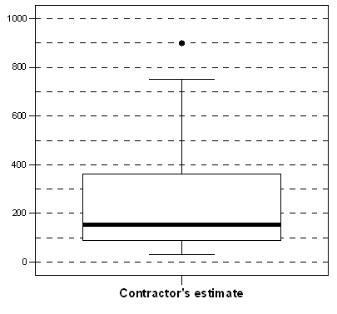

87. | What is (approximately) the interquartile range, based on the boxplot?
A) | 140 days
B) | 270 days
C) | 360 days
D) | 760 days
Answer: |  | B
Topic: |  | 1.2 Describing Distributions with Numbers

88. | Determine whether each of the following statements is true or false.
A) | The median number of days is approximately 180.
B) | The minimum number of days is approximately 40.
C) | The maximum number of days is approximately 750.
D) | Twenty-five percent of contractors estimated the number of days to be more than 100.
Answer: |  | A) True, B) True, C) False, D) False
Topic: |  | 1.2 Describing Distributions with Numbers

Use the following to answer questions 89 and 90:

The asking prices (in thousands of dollars) for a sample of 13 houses currently on the market in Neighborville are listed below. For convenience, the data have been ordered.

175 | 199 | 205 | 234 | 259 | 275 | 299 | 304 | 317 | 345 | 355 | 384 | 549

89. | What is the five-number summary?
A) | 175 |  | 234 | 299 | 345 | 549
B) | 175 |  | 219.5 | 299 | 350 | 549
C) | 175 |  | 219.5 | 299 | 350 | 384
D) | 175 |  | 234 | 299 | 331 | 549
Answer: |  | B (or A if using software packages)
Topic: |  | 1.2 Describing Distributions with Numbers

90. | Use the 1.5 × IQR rule to determine if there are any outliers present. What is/are the value(s) of the outlier(s)?
A) | No outliers present
B) | One outlier: 175
C) | One outlier: 549
D) | Two outliers: 175 and 549
Answer: |  | C
Topic: |  | 1.2 Describing Distributions with Numbers

Use the following to answer questions 91–93:

The following boxplot is of the birth weights (in ounces) of 160 infants born in a local hospital:

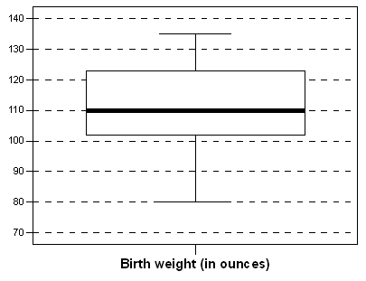

91. | Fill in the blank. The median birth weight is approximately ________________.
A) | 90 ounces
B) | 100 ounces
C) | 110 ounces
D) | 120 ounces
Answer: |  | C
Topic: |  | 1.2 Describing Distributions with Numbers

92. | Fill in the blank. About 40 of the birth weights were below _______________.
A) | 92 ounces
B) | 102 ounces
C) | 112 ounces
D) | 122 ounces
Answer: |  | B
Topic: |  | 1.2 Describing Distributions with Numbers

93. | Fill in the blank. Approximately ______________ children had birth weights between 102 and 122 ounces.
A) | 40
B) | 50
C) | 80
D) | 100
Answer: |  | C
Topic: |  | 1.2 Describing Distributions with Numbers

94. | This is a standard deviation contest. Which of the following sets of four numbers has the largest possible standard deviation?
A) | 7, 8, 9, 10
B) | 5, 5, 5, 5
C) | 0, 0, 10, 10
D) | 0, 1, 2, 3
Answer: |  | C
Topic: |  | 1.2 Describing Distributions with Numbers

95. | A sample of 16 people is taken, and their weights are measured. The standard deviation of these 16 measurements is computed to be 5.4. What is the variance of these measurements?
A) | 2.24 lbs
B) | 2.24 lbs²
C) | 29.16 lbs
D) | 29.16 lbs²
Answer: |  | D
Topic: |  | 1.2 Describing Distributions with Numbers

96. | There are three children aged 3, 4, and 5 in a room. If another 4-year-old child enters the room, what will happen to the mean and variance?
A) | The mean will stay the same, but the variance will increase.
B) | The mean will stay the same, but the variance will decrease.
C) | The mean and variance will both stay the same.
D) | The mean and variance will both decrease.
Answer: |  | B
Topic: |  | 1.2 Describing Distributions with Numbers

97. | The standard deviation s is a useful measure of a characteristic of a distribution of data values. Which of the following statements about s is FALSE?
A) | The standard deviation measures the spread of the data around the mean.
B) | The standard deviation is appropriate as a measure of spread when the mean is chosen as the measure of center.
C) | The standard deviation can never be zero.
D) | The standard deviation is not resistant; a few outliers can make s very large.
E) | As the data values become more spread out about their mean, s becomes larger.
Answer: |  | C
Topic: |  | 1.2 Describing Distributions with Numbers

98. | The salaries paid to the eight employees of a small market research company are as follows: the five telephone interviewers are each paid $32,000; two administrative assistants are paid $48,000; a supervisor is paid $60,000; the senior manager is paid $190,000. The number of employees earning more than the mean salary is
A) | 4
B) | 0
C) | 1
D) | 2
E) | 7
Answer: |  | D
Topic: |  | 1.2 Describing Distributions with Numbers

99. | The following data are the magnitudes of earthquakes around the world recorded on January 13, 2008:  4.1 4.8 3.1 5.3 5.1 4.7 3.0 2.9 U 4.6 3.1 3.0 U 2.5.  Because of equipment problems, two earthquakes were unrecorded although it was known that both had a value less than 2.7. The median magnitude of earthquakes on this date is
A) | 2.95
B) | 3.9
C) | 4.0
D) | 3.1
E) | Cannot determine without knowing the exact value of the missing magnitudes.
Answer: |  | D
Topic: |  | 1.2 Describing Distributions with Numbers

100. | Agricultural fairs often hold competitions for produce grown by local gardeners. The following data are the weight (in pounds) of tomatoes entered into an annual fair in Roland, Manitoba, Canada in 2007:  2.48 1.52 1.15 1.13 1.00 0.99 0.96 0.94 0.75  The Interquartile Range (IQR) for these data is:
A) | 1.73 pounds
B) | 0.58 pounds
C) | 0.19 pounds
D) | 1.00 pounds
E) | 0.385 pounds
Answer: |  | E (or C if using software packages)
Topic: |  | 1.2 Describing Distributions with Numbers

101. | Apply the 1.5 × IQR rule to the data in the previous question to check for outlier values. In this case _____________.
A) | there are no outliers
B) | the value 0.75 is the only outlier
C) | the values 0.75 and 2.48 are both outliers
D) | the value 2.48 is the only outlier
E) | the values 1.52 and 2.48 are both outliers
Answer: |  | D
Topic: |  | 1.2 Describing Distributions with Numbers

102. | At a Canadian agricultural fair held in Neguac, New Brunswick giant pumpkins were entered into a competition. The following stem-and-leaf plot of the weight (in pounds) of the 35 pumpkins in the competition was constructed:  0 9  1 0378  2 449  3 22  4 12346679  5 3669  6 012269  7 16  8 0  9 04  10 8  11 9  where, for example 9|4 represents 940 pounds.  The Quartiles, Q₁ and Q₃, for these data are:
A) | Q₁ = 90, Q₃ = 1190
B) | Q₁ = 320, Q₃ = 640
C) | Q₁ = 322, Q₃ = 716
D) | Q₁ = 320, Q₃ = 660
E) | Q₁ = 490, Q₃ = 660
Answer: |  | D
Topic: |  | 1.2 Describing Distributions with Numbers

103. | The New England Patriots are a top ranked team in the National Football League (NFL) and the Saskatchewan Roughriders are the 2007 champions of the Canadian Football League (CFL). From the 2007 rosters of these two teams, the weight of the players was determined and the following side-by-side boxplots of their weights is provided below:  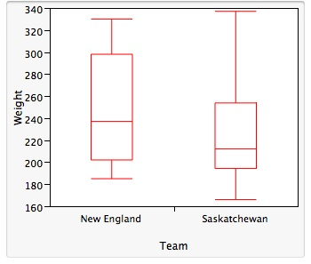  Which of the following statements about these side-by-side boxplots is (are) TRUE?
A) | The weights of the New England team exhibit less overall variation than the Saskatchewan team.
B) | The median weight for the New England team is higher than the median weight for the Saskatchewan team.
C) | The IQR for the Saskatchewan team is greater than the IQR of the New England team.
Answer: |  | B
Topic: |  | 1.2 Describing Distributions with Numbers

104. | The fuel efficiency of 2007 model midsized automobiles was studied and the following side-by-side boxplots of the distribution of the miles per gallon in city driving (MPG-City) for automobiles manufactured in North America, Asia, and Europe is given below:  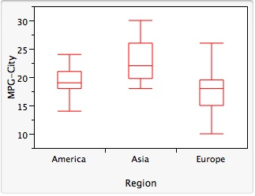  From these boxplots we can see that:
A) | The MPG-City for 75% of automobiles from Asia is higher than the MPG-City for 75% of European automobiles.
B) | 75% of the cars from Asia have higher fuel efficiency than 50% of the cars from North America.
C) | The median fuel efficiency rating is highest for automobiles manufactured in Asia.
D) | The overall variability in fuel efficiency rating is highest for European-built automobiles.
E) | All of the above.
F) | A, B, and C
Answer: |  | F
Topic: |  | 1.2 Describing Distributions with Numbers

105. | A study was conducted on the distance that various brand name golf balls would travel. The study involved the use of a standard testing machine using a 7 iron. A selection of results from the study is given below for the distance (in yards) for each brand of ball.  144.0 145.8 138.7 141.3 142.8 143.8 145.8 144.5  The mean and the standard deviation s of these measurements (in yards) are, respectively:
A) | 143.90, 3.10
B) | 143.34, 2.39
C) | 142.25, 5.73
D) | 1.43.34, 2.24
E) | 143.90, 2.39
Answer: |  | B
Topic: |  | 1.2 Describing Distributions with Numbers

106. | A similar study to that done in question 105 was conducted using a different golf club. It was determined that the mean distance was = 237.8 yards with a standard deviation of s = 4.58 yards. It was later determined that the measuring instrument had been calibrated incorrectly and hence gave measurements that were consistently too large by 2.5 yards. Since the results of the study were to be published in Europe, it was desired to convert all measurements from yards into meters. A statistician determined that the appropriate transformation to correct the error and convert to meters in this case would be  y = 0.9144x – 2.286  where x is the measurement in yards and y in meters.  The mean and standard deviation (in meters), respectively, should now be reported as _____.
A) | 217.4, 1.90
B) | 217.4, 4.19
C) | 215.2, 4.19
D) | 215.2, 1.90
E) | Unable to determine without knowing the actual measurements.
Answer: |  | C
Topic: |  | 1.2 Describing Distributions with Numbers

107. | For describing the distribution of a set of data, when is the five-number summary preferred over the mean and standard deviation s?
A) | When the distribution is reasonably symmetric.
B) | When the distribution has little skewness and there are no outliers.
C) | If the data are provided in increasing order of magnitude.
D) | If the data exhibit skewness and there are strong outliers.
E) | Never, because the mean and standard deviation are always more reliable.
Answer: |  | D
Topic: |  | 1.2 Describing Distributions with Numbers

Use the following scenario to answer questions 108–115:

A sample was taken of 20 salaries of employees in a large company. The following are the annual salaries (in thousands of dollars). For convenience, the data have been ordered.

28 | 31 | 34 | 35 | 37 | 41 | 42 | 42 | 42 | 47
49 | 51 | 52 | 52 | 60 | 61 | 67 | 72 | 75 | 77

108. | What is the median salary of the 20 employees?
Answer: | $48,000
Topic: | 1.2 Describing Distributions with Numbers

109. | A histogram of the 20 salaries is slightly skewed to the right. What do we know about the mean salary of these 20 salaries, based on this information?
Answer: | The mean is probably higher than the median.
Topic: | 1.2 Describing Distributions with Numbers

110. | What is the first quartile of the 20 salaries?
Answer: | $39,000
Topic: | 1.2 Describing Distributions with Numbers

111. | What is the interquartile range of the 20 salaries?
Answer: | $21,500
Topic: | 1.2 Describing Distributions with Numbers

112. | Suppose each employee in the company receives a $3000 raise for next year (each employee’s salary is increased by $3000). For each of the following summary measures, indicate how it would change after the raise.
A) | The median salary.
B) | The interquartile range of the salaries.
C) | The standard deviation of the salaries.
Answers: | A) The median will increase by $3000.  B) The interquartile range remains unchanged.  C) The standard deviation remains unchanged.
Topic: | 1.2 Describing Distributions with Numbers

A boxplot of a different sample of 20 salaries from this same company is shown below:

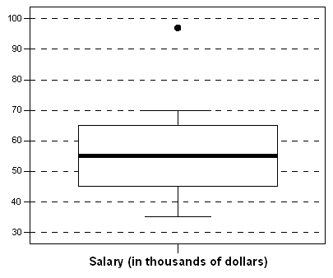

113. | For each of the following sentences, fill in the blank.
A) | The maximum salary is approximately __________________ dollars.
B) | The minimum salary is approximately __________________ dollars.
C) | The interquartile range is approximately __________________ dollars.
D) | Seventy-five percent of the employees in this sample of 20 earn more than approximately _____________ dollars.
Answers: | A) $97,000, B) $35,000, C) $20,000, D) $45,000
Topic: | 1.2 Describing Distributions with Numbers

114. | Based on this boxplot, answer each of the following questions with yes, no, or can’t tell.
A) | Is the salary distribution fairly symmetric?
B) | Do about 10 employees make more than $55,000?
C) | Does nobody make more than $71,000?
D) | Is the range of the salaries roughly $35,000?
Answers: | A) Can’t tell, B)Yes, C)No, D)No
Topic: | 1.2 Describing Distributions with Numbers

115. | Based on this boxplot, determine the (approximate) values of the five-number summary.
Answer: | Min = $35,000, Q₁ = $45,000, M = $55,000, Q₃ = $65,000, Max = $97,000
Topic: | 1.2 Describing Distributions with Numbers

Use the following to answer questions 116–123:
Psychopathic Personality Disorder (psychopathy) is defined as a condition that negatively affects one’s level of empathy, conscience, and impulse control. A questionnaire was developed by Lilienfeld (1990) to asses one's level of psychopathy. Ninety random people were asked to take Lilienfeld’s test. Their results are shown in the histogram below:

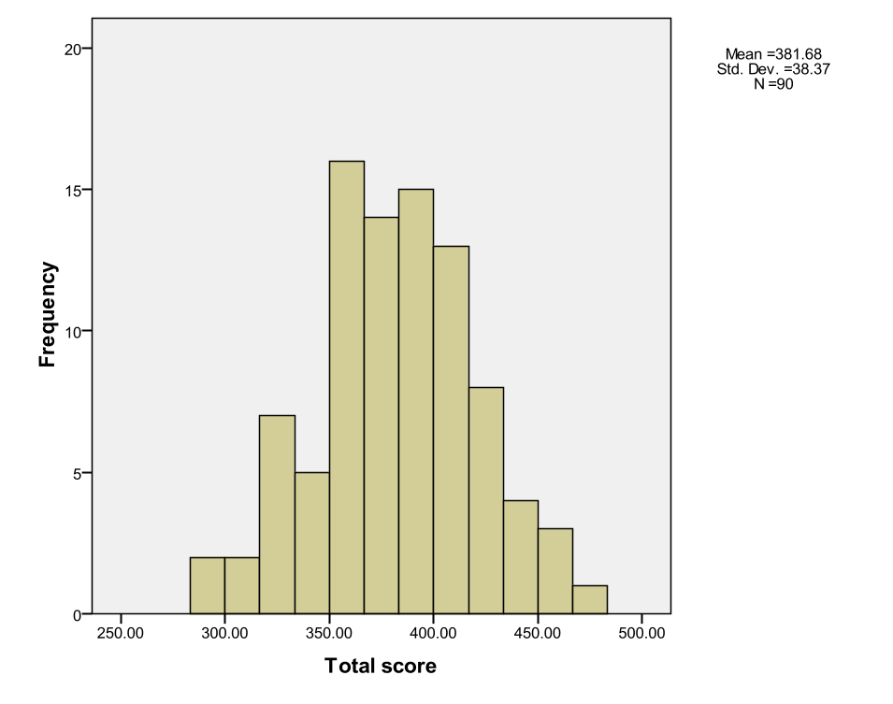

116. | The scores on Lilienfeld’s questionnaire range from 275 to 475.
A) | True
B) | False
C) | Cannot be determined from the information given.
Answer: |  | C
Topic: |  | 1.2 Describing Distributions with Numbers

117. | The data would be better represented in a pie chart.
A) | True
B) | False
C) | Both displays work equally well.
Answer: |  | B
Topic: |  | 1.2 Describing Distributions with Numbers

118. | The data are ______.
A) | heavily skewed to the right
B) | heavily skewed to the left
C) | reasonably Normal
Answer: |  | C
Topic: |  | 1.2 Describing Distributions with Numbers

119. | The mean score of these data is around _______.
A) | 380
B) | 17
C) | 0
D) | Cannot be determined from the data given.
Answer: |  | A
Topic: |  | 1.2 Describing Distributions with Numbers

120. | The minimum score is _____.
A) | less than 300
B) | greater than 500
C) | 250
D) | Cannot be determined from the data given.
Answer: |  | A
Topic: |  | 1.2 Describing Distributions with Numbers

121. | The maximum score is _____.
A) | less than 300
B) | greater than 500
C) | 250
D) | between 450 and 460
E) | None of the above.
Answer: |  | E
Topic: |  | 1.2 Describing Distributions with Numbers

122. | There are outliers in the data set.
A) | True
B) | False
C) | Can’t tell
Answer: |  | B
Topic: |  | 1.2 Describing Distributions with Numbers

123. | The histogram is unimodal.
A) | True
B) | False
C) | Can’t tell
Answer: |  | A
Topic: |  | 1.2 Describing Distributions with Numbers

Use the following to answer questions 124 and 125:

The number of Facebook friends students at a university have are Normally distributed with a mean of 1,200 and a standard deviation of 200.

124. | What percent of students have at least 1000 Facebook friends?
A) | 84.13%
B) | 15.86%
C) | 42.07%
D) | None of the above.
Answer: |  | A
Topic: |  | 1.3 Density Curves and Normal Distributions

125. | What percent of students have exactly 1000 Facebook friends?
A) | 84.13%
B) | 15.86%
C) | 42.07%
D) | None of the above.
Answer: |  | D
Topic: |  | 1.3 Density Curves and Normal Distributions

Use the following density curve to answer questions 127–128:

0.5
00.51.01.52.0X
Density

126. | Determine whether each of the following statements regarding this density curve is true or false.
A) | It is symmetric.
B) | The total area under the curve is 1.
C) | The median is 1.
D) | The mean is 1.
Answer: |  | A) True, B) True, C) True, D) True
Topic: |  | 1.3 Density Curves and Normal Distributions

127. | For this density curve, what percent of the observations lie above 1.5?
A) | 25%
B) | 50%
C) | 75%
D) | 80%
Answer: |  | A
Topic: |  | 1.3 Density Curves and Normal Distributions

128. | For this density curve, what percent of the observations lie between 0.5 and 1.2?
A) | 25%
B) | 35%
C) | 50%
D) | 70%
Answer: |  | B
Topic: |  | 1.3 Density Curves and Normal Distributions

129. | For the density curve below, which of the following is true?  Density  0.00.250.50.751.0X  3  2  1  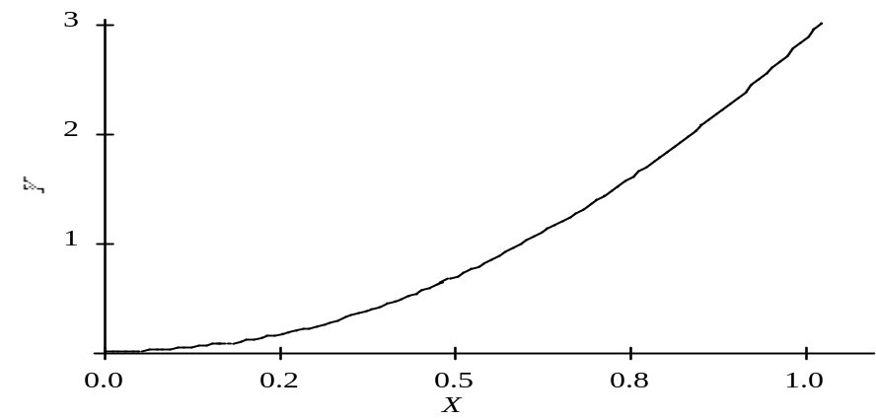
A) | The mean and median are equal.
B) | The mean is greater than the median.
C) | The mean is less than the median.
D) | The mean could be either greater than or less than the median.
Answer: |  | C
Topic: |  | 1.3 Density Curves and Normal Distributions

130. | Which of the following statements about a density curve are FALSE?
A) | A density curve always has area beneath it equal to 1.
B) | A density curve can adequately describe outliers observed in data.
C) | A density curve is always on or above the horizontal axis.
D) | A density curve comes in many shapes, some of which are symmetric while others are skewed.
E) | The area under a density curve above any range of values is the proportion of all observations that fall in that range.
Answer: |  | B
Topic: |  | 1.3 Density Curves and Normal Distributions

131. | The following curve is to be a density curve for the variable x:  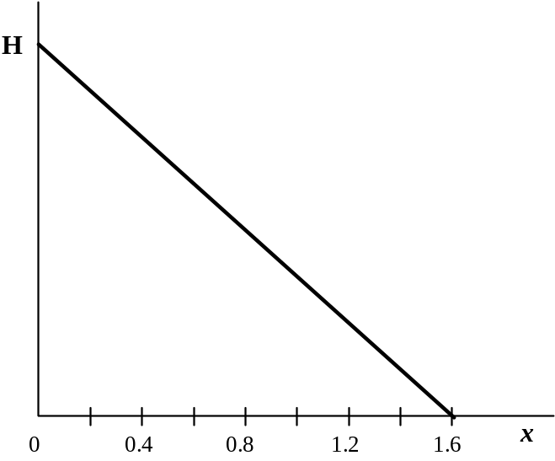  What must be the value of the point on the vertical axis labeled H for this to be a proper density function?
A) | 1.60
B) | 1.00
C) | 0.80
D) | 1.25
E) | 0.625
Answer: |  | D
Topic: |  | 1.3 Density Curves and Normal Distributions

132. | Which of the following statements about the mean and the median of a density curve are FALSE?
A) | The median is the point on the axis that divides the area under the density curve in two equal halves.
B) | The median and the mean have the same value if the density curve is symmetric.
C) | The mean is the “balance point” of the density curve.
D) | The median of a skewed density curve is pulled away from the mean in the direction of the long tail.
E) | For a symmetric density curve, both the mean and the median are at the center of the curve.
Answer: |  | D
Topic: |  | 1.3 Density Curves and Normal Distributions

133. | For the density curve displayed below, what is the mean?  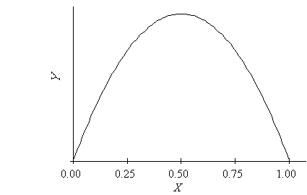  Density  0.00.250.50.751.0X
A) | 0.25
B) | 0.50
C) | 0.71
D) | 0.75
Answer: |  | B
Topic: |  | 1.3 Density Curves and Normal Distributions

134. | Determine whether each of the following statements regarding a Normal density curve is true or false.
A) | It is symmetric.
B) | It has a peak centered above its mean.
C) | The quartiles lie 1 standard deviation below and above the mean.
D) | The spread of the curve is proportional to the standard deviation.
Answer: |  | A) True, B) True, C) False, D) True
Topic: |  | 1.3 Density Curves and Normal Distributions

Use the following information to answer questions 135 and 136:

Many residents of suburban neighborhoods own more than one car but consider one of their cars to be the main family vehicle. The age of these family vehicles can be modeled by a Normal distribution with a mean of 2 years and a standard deviation of 6 months.

135. | What percentage of family vehicles is between 1 and 3 years old?
A) | Cannot be determined based on the information given.
B) | 68%
C) | 95%
D) | 99.7%
Answer: |  | C
Topic: |  | 1.3 Density Curves and Normal Distributions

136. | What is the standardized value for a family vehicle that is 3 years and 3 months old?
A) | 0.22
B) | 2.5
C) | 2.6
D) | 2.92
Answer: |  | B
Topic: |  | 1.3 Density Curves and Normal Distributions

137. | Items produced by a manufacturing process are supposed to weigh 90 grams. However, there is variability in the items produced, and they do not all weigh exactly 90 grams. The distribution of weights can be approximated by a Normal distribution with a mean of 90 grams and a standard deviation of 1 gram. What percentage of the items will either weigh less than 87 grams or more than 93 grams?
A) | 6%
B) | 94%
C) | 99.7%
D) | 0.3%
Answer: |  | D
Topic: |  | 1.3 Density Curves and Normal Distributions

138. | The time to complete an exam is approximately Normal with a mean of 70 minutes and a standard deviation of 10 minutes. Using the 68-95-99.7 rule, what percentage of students will complete the exam in under an hour?
A) | 68%
B) | 32%
C) | 16%
D) | 5%
Answer: |  | C
Topic: |  | 1.3 Density Curves and Normal Distributions

139. | Using the standard Normal distribution tables, what is the area under the standard Normal curve corresponding to Z < 1.1?
A) | 0.1357
B) | 0.2704
C) | 0.8413
D) | 0.8643
Answer: |  | D
Topic: |  | 1.3 Density Curves and Normal Distributions

140. | Using the standard Normal distribution tables, what is the area under the standard Normal curve corresponding to Z > –1.22?
A) | 0.1151
B) | 0.1112
C) | 0.8849
D) | 0.8888
Answer: |  | D
Topic: |  | 1.3 Density Curves and Normal Distributions

141. | Using the standard Normal distribution tables, what is the area under the standard Normal curve corresponding to –0.5 < Z < 1.2?
A) | 0.3085
B) | 0.8849
C) | 0.5764
D) | 0.2815
Answer: |  | C
Topic: |  | 1.3 Density Curves and Normal Distributions

142. | The variable Z has a standard Normal distribution. Find the value z such that 85% of the observations fall below z.
A) | z = –1.04
B) | z = 0.80
C) | z = 0.85
D) | z = 1.04
Answer: |  | D
Topic: |  | 1.3 Density Curves and Normal Distributions

143. | The variable Z has a standard Normal distribution. Find the value z such that the event  Z > z has proportion of 0.08.
A) | z = –1.41
B) | z = 0.53
C) | z = 0.82
D) | z = 1.41
Answer: |  | D
Topic: |  | 1.3 Density Curves and Normal Distributions

Use the following to answer questions 144 and 145:

The temperature at any random location in a kiln used for manufacturing bricks is Normally distributed with a mean of 1000°F and a standard deviation of 50°F.

144. | If bricks are fired at a temperature above 1125°F, they will crack and must be discarded. If the bricks are placed randomly throughout the kiln, what is the percentage of bricks that crack during the firing process?
A) | 0.62%
B) | 2.28%
C) | 47.72%
D) | 49.38%
Answer: |  | A
Topic: |  | 1.3 Density Curves and Normal Distributions

145. | When glazed bricks are put in the oven, if the temperature is below 900°F they will discolor. If the bricks are placed randomly throughout the kiln, what percentage of glazed bricks will discolor?
A) | 0.62%
B) | 2.28%
C) | 47.72%
D) | 49.38%
Answer: |  | B
Topic: |  | 1.3 Density Curves and Normal Distributions

146. | The scores on a university examination are Normally distributed with a mean of 62 and a standard deviation of 11. If the bottom 5% of students will fail the course, what is the lowest mark that a student can have and still be awarded a passing grade?
A) | 62
B) | 57
C) | 44
D) | 40
Answer: |  | C
Topic: |  | 1.3 Density Curves and Normal Distributions

147. | The preparation time to mail envelopes with a weekly report to all executives in a company has a Normal distribution with a mean of 35 minutes and a standard deviation of 2 minutes. On 95% of such occasions, the mailing preparation takes less than x minutes. What is the value of x?
A) | x = 31.71
B) | x = 34.75
C) | x = 35.25
D) | x = 38.29
Answer: |  | D
Topic: |  | 1.3 Density Curves and Normal Distributions

148. | A softdrink machine can be regulated so that it discharges an average of μ ounces per cup. If the ounces of fill are Normally distributed with a standard deviation of 0.4 oz, what value should μ be set at so that 6-oz cups will overflow only 2% of the time?
A) | 5.18
B) | 5.60
C) | 6.00
D) | 6.82
Answer: |  | A
Topic: |  | 1.3 Density Curves and Normal Distributions

149. | The weights of packets of cookies produced by a certain manufacturer have a Normal distribution with a mean of 202 g and a standard deviation of 3 g. What is the weight that should be stamped on the packet so that only 1% of packets are underweight?
A) | 195 g
B) | 202 g
C) | 209 g
D) | Not enough information to tell.
Answer: |  | A
Topic: |  | 1.3 Density Curves and Normal Distributions

Use the following to answer questions 150 and 151:

A company produces packets of soap powder labeled “Giant Size 32 oz.” The actual weight of soap powder in such a box has a Normal distribution with a mean of 33 oz and a standard deviation of 0.7 oz. To avoid dissatisfied customers, a box of soap is considered underweight if it weighs less than 32 oz. To avoid losing money, the top 5% (the heaviest 5%) is labeled overweight.

150. | What proportion of boxes is underweight?
A) | 0.0766
B) | 0.2420
C) | 0.7580
D) | 0.9234
Answer: |  | A
Topic: |  | 1.3 Density Curves and Normal Distributions

151. | How heavy does a box have to be in order for the box to be labeled overweight?
A) | 31.60 oz
B) | 31.85 oz
C) | 34.15 oz
D) | 34.40 oz
Answer: |  | B
Topic: |  | 1.3 Density Curves and Normal Distributions

Use the following to answer questions 152–154:

Chocolate bars produced by a certain machine are labeled with 8.0 oz. The distribution of the actual weights of these chocolate bars is Normal with a mean of 8.1 oz and a standard deviation of 0.1 oz. A chocolate bar is considered underweight if it weighs less than 8.0 oz.

152. | What proportion of chocolate bars weighs less than 8.0 oz?
A) | 0.159
B) | 0.341
C) | 0.500
D) | 0.841
Answer: |  | A
Topic: |  | 1.3 Density Curves and Normal Distributions

153. | What proportion of chocolate bars weighs between 8.2 and 8.3 oz?
A) | 0.136
B) | 0.477
C) | 0.636
D) | 0.819
Answer: |  | A
Topic: |  | 1.3 Density Curves and Normal Distributions

154. | How should the chocolate bar wrappers be labeled so that only 1% of such bars are underweight?
A) | 7.77 oz
B) | 7.87 oz
C) | 8.23 oz
D) | 8.33 oz
Answer: |  | B
Topic: |  | 1.3 Density Curves and Normal Distributions

Use the following to answer questions 155–157:

A market research company employs a large number of typists to enter data into a computer database. The time it takes for potential new typists to learn the computer system is known to have a Normal distribution with a mean of 90 minutes and a standard deviation of 18 minutes. A candidate is automatically hired if she learns the computer system in less than 100 minutes. A cut-off time is set at the slowest 10% of the learning distribution. Anyone slower than this cut-off time is definitely not hired.

155. | What proportion of candidates takes more than two hours to learn the computer system?
A) | 0.048
B) | 0.452
C) | 0.711
D) | 0.952
Answer: |  | A
Topic: |  | 1.3 Density Curves and Normal Distributions

156. | What proportion of candidates will be hired automatically?
A) | 0.048
B) | 0.452
C) | 0.711
D) | 0.952
Answer: |  | C
Topic: |  | 1.3 Density Curves and Normal Distributions

157. | What is the cut-off time the market research company uses?
A) | 1 hour and 7 minutes
B) | 1 hour and 53 minutes
C) | 2 hours
D) | 2 hours and 8 minutes
Answer: |  | B
Topic: |  | 1.3 Density Curves and Normal Distributions

158. | Which of the following statements about the standardized z-score of a value of a variable X, which has a mean of m and a standard deviation of s, is (are) TRUE?
A) | The z -score has a mean equal to 0.
B) | The z-score has a standard deviation equal to 1.
C) | The z-score tells us how many standard deviation units the original observation fall away from the mean.
D) | The z-score tells us the direction the observation falls away from the mean.
E) | All of the above statements about the z-score are true.
Answer: |  | E
Topic: |  | 1.3 Density Curves and Normal Distributions

Use the following information to answer questions 159 to 163:
A well-known maker of jams and jellies packages its jams in jars labeled “250 mL”. The process used to fill the jars is known to dispense an amount of jam that is a Normally distributed variable with μ = 252 mL and σ = 0.9 mL.
159. | What proportion of the jars filled by the process will contain less than 250 mL?
A) | 0.5
B) | 0.9868
C) | 0.0068
D) | 0.0131
E) | 0
Answer: |  | D
Topic: |  | 1.3 Density Curves and Normal Distributions

160. | What proportion of jars from this filling process will contain no more than 253.5 mL?
A) | 0.9678
B) | 0.9522
C) | 0.9973
D) | .0027
E) | 0.0475
Answer: |  | B
Topic: |  | 1.3 Density Curves and Normal Distributions

161. | What percentage of jars will be filled with between 251 ml and 254 mL?
A) | 85.3%
B) | 1.3%
C) | 14.7%
D) | 13.4%
E) | 8.5%
Answer: |  | A
Topic: |  | 1.3 Density Curves and Normal Distributions

162. | What proportion of jars will be filled with what the label claims is 250 mL?
A) | 0.9868
B) | 0
C) | 0.0068
D) | 0.0132
E) | 0.0027
Answer: |  | B
Topic: |  | 1.3 Density Curves and Normal Distributions

163. | If changing σ while keeping μ the same were possible for this process, what should σ be set at so that the percentage of jars filled with less than 250 mL will be at most 0.2%?
A) | σ = 2.38
B) | σ = 1
C) | σ = 0.69
D) | σ = 0.82
E) | Not within ± 0.2 of any of the above.
Answer: |  | C
Topic: |  | 1.3 Density Curves and Normal Distributions

164. | A tool and die company has been contracted to produce metal castings into which a hole is to be drilled to a diameter of 2.5 cm. Because of the variability in the drilling process, the actual diameter of the hole is a Normally distributed variable with a mean of 2.5 cm and a standard deviation of 0.1 cm. The proportion of castings produced by this process with a hole whose diameter is within 0.2 cm of the desired value is:
A) | 0.9772.
B) | 0.9549.
C) | 0.9974.
D) | 0.6826.
E) | 0.0228.
Answer: |  | B
Topic: |  | 1.3 Density Curves and Normal Distributions

165. | In 1998 the World Health Organization reported the findings of a major study on the quality of blood pressure monitoring around the world. In its report it stated that for Canada the results for diastolic blood pressure (DBP) had a mean of 78 mmHg and a standard deviation of 11 mmHg. Assuming that diastolic blood pressure measurements are Normally distributed, the DBP reading that represents the 80th percentile of the distribution is:
A) | 85.4.
B) | 93.6.
C) | 87.3
D) | 86.8.
E) | 68.8.
Answer: |  | C
Topic: |  | 1.3 Density Curves and Normal Distributions

166. | In the blood pressure study by the WHO, the mean systolic blood pressure (SBP) in the United States was reported to be 120 mmHg. The 75th percentile of the distribution of SBP measurements was found to be 109.2 mmHg. From this, it can be determined that the SBP standard deviation σ is:
A) | 9.4.
B) | 16.0.
C) | 5.5.
D) | 10.8.
E) | Not within ± 0.5 of any of the above.
Answer: |  | E
Topic: |  | 1.3 Density Curves and Normal Distributions

167. | A stemplot of a set of data is roughly symmetric, but a quantile plot does not show a straight line. What conclusion can we draw?
A) | The data are Normal but not standard Normal.
B) | The data are standard Normal.
C) | The data are not Normal.
D) | The data are Normal.
Answer: |  | C
Topic: |  | 1.3 Density Curves and Normal Distributions

168.  –1.250.001.25  Normal scores  20  16  12  8  Observed values | Consider the following Normal quantile plot:  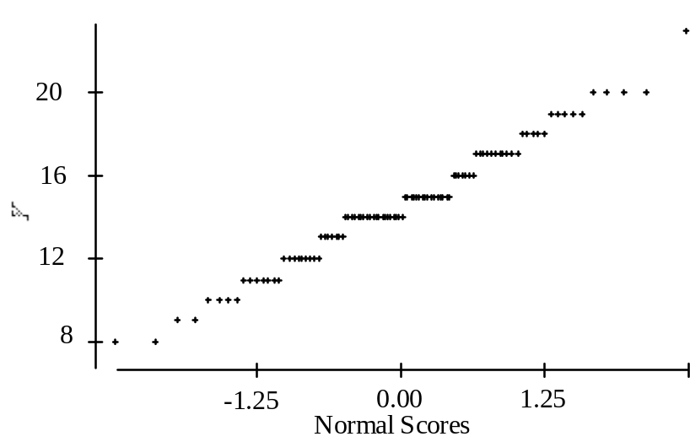  What is the most striking feature of the plot?
A) | The granularity.
B) | The strong skewness indicated by the plot.
C) | The many outliers evident in the plot.
D) | The fact that Y is categorical.
Answer: |  | A
Topic: |  | 1.3 Density Curves and Normal Distributions

169. | A quantile plot of the horsepower of a sample of 65 cars is shown below:  Normal scores  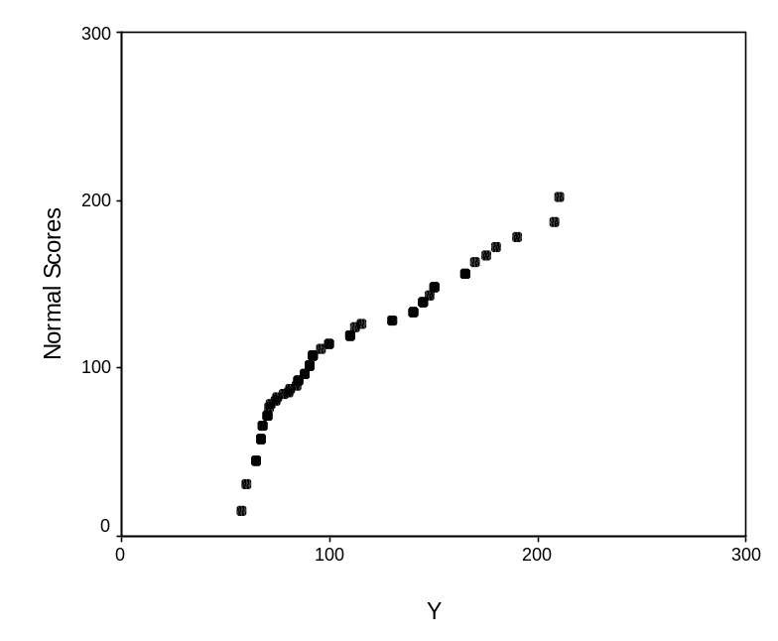  Horsepower  Which of the following descriptions best describes the shape of the distribution of horsepower?
A) | Normal
B) | Normal with some outliers
C) | Left-skewed
D) | Right-skewed
Answer: |  | C
Topic: |  | 1.3 Density Curves and Normal Distributions

170. | Which of the following statements about Normal quantile plots is (are) FALSE?
A) | In constructing a Normal quantile plot, each data point is plotted against its corresponding Normal score.
B) | The Normal quantile plot is a very useful graphical tool for assessing the adequacy of the Normal model.
C) | If the points on a Normal quantile plot lie close to a straight line, the plot indicates that the Normal model is an adequate representation for the data.
D) | Because you will see the usual mound-like appearance of the Normal distribution on a histogram, it is more helpful than the quantile plot for assessing Normality.
E) | On a quantile plot, outliers will appear as points that are far away from the overall pattern of the plot.
Answer: |  | D
Topic: |  | 1.3 Density Curves and Normal Distributions

Use the following scenario to answer questions 171–173:

Battery packs in electric go-carts need to last a fairly long time. The run-times (time until it needs to be recharged) of the battery packs made by a particular company are Normally distributed with a mean of 2 hours and a standard deviation of 20 minutes.

171. | What percentage of these battery packs lasts longer than 3 hours?
Answer: | 0.13%
Topic: | 1.3 Density Curves and Normal Distributions

172. | What is the third quartile for the run-time distribution?
Answer: | 2 hours and 13.5 minutes
Topic: | 1.3 Density Curves and Normal Distributions

173. | Battery packs that have a run-time in the highest 10% of the run-time distribution are highly sought after by go-cart drivers. How long does the battery pack have to last for it to fall in this highly sought-after class?
Answer: | 2 hours and 25.6 minutes
Topic: | 1.3 Density Curves and Normal Distributions

Use the following scenario to answer questions 174 and 175:

A machine fills 64 oz jugs with detergent. Assume the distribution of the amount of detergent in these jugs is Normal. Under standard circumstances, the mean amount should be 64 oz with a standard deviation of 0.4 oz. A quality control inspector regularly checks the amount poured into the jugs to see if the machine needs an adjustment or not, which is needed when the machine either overfills or underfills the jugs.

174. | If the machine is running on target, what proportion of jugs receives more than 65 oz of detergent?
Answer: | 0.0062
Topic: | 1.3 Density Curves and Normal Distributions

175. | The quality control inspector will adjust the machine if he finds too many jugs that fall in the most extreme 5% of the distribution. Most extreme is defined as either too little (bottom 2.5%) or too much (top 2.5%). If the machine is running on target, what are the bounds for which the machine will be classified as working fine?
Answer: | 63.2 oz and 64.8 oz
Topic: | 1.3 Density Curves and Normal Distributions

