**Sussex Open 2016 – Reported NIF: 35. Modified NIF: 34**

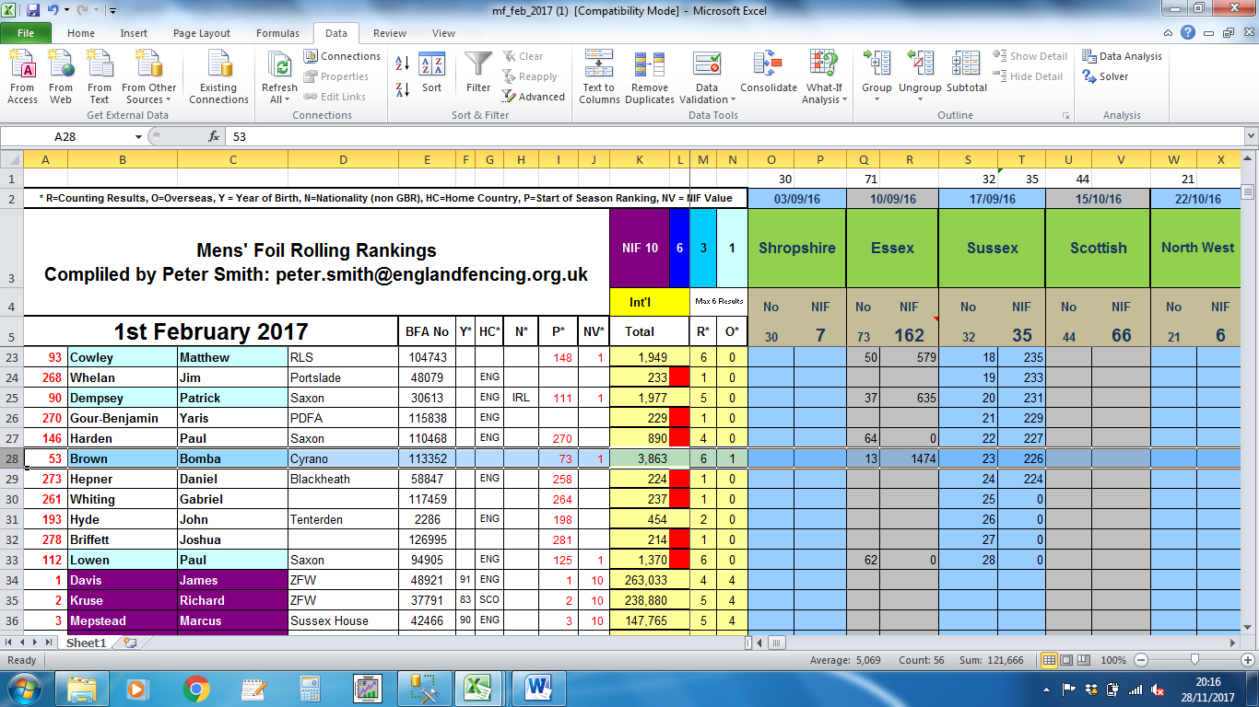

From the results presented at: <http://www.sussexfencing.org/index.php/results1/34-2016-sussex-open-results>

Bomba Brown was not in the results so his NIF value shouldn’t be added to the results dropping the NIF down to 34.

**Northern Ireland Open 2016 – Reported NIF: 10, Modified NIF: 20**

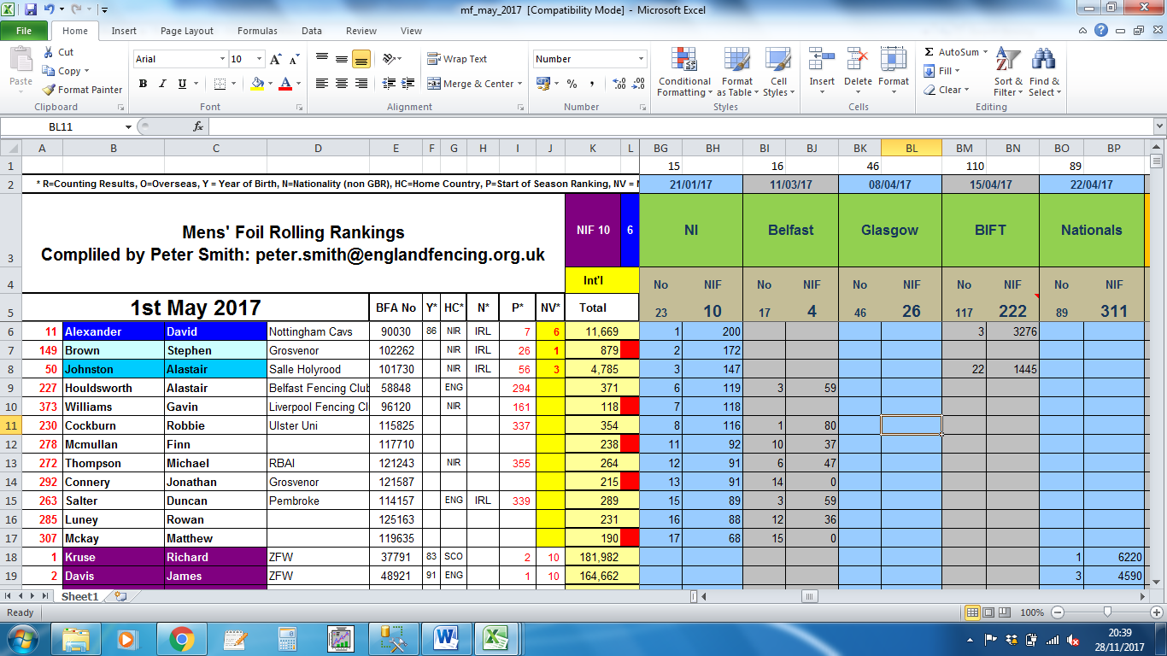

Results from the 1st May 2017 – These are based on the March 2017 rankings and produce a NIF of 10.

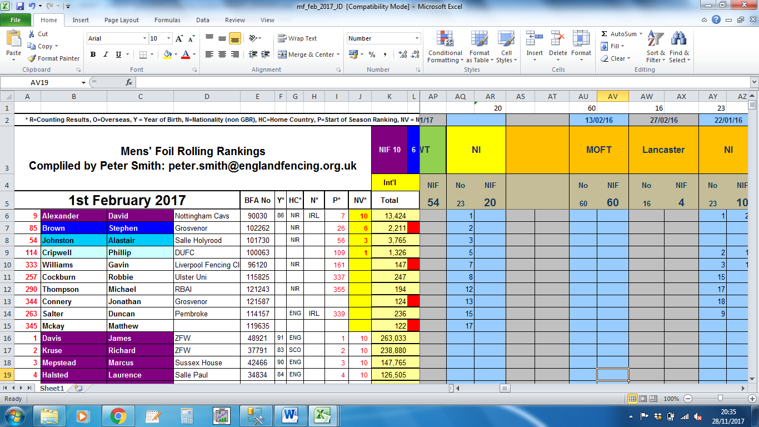

Modified results from 1st February 2017 based on the September 2016 rankings. This gives a ranking of 20 NIF points.

Based on the ranking from March 2017 this completion produces a NIF of 10, however the competition was run on 21/1/17, so should use the September 2016 rankings, which produces a NIF of 20.