Programming Summary

Jose Dixon

June 1, 2022

library(tidyverse)  
library(reshape)  
library(ggplot2)  
library(modelr)  
options(na.action = na.warn)

Hadley Wickman Intro to Data Science This is the website for “R for Data Science”.<https://r4ds.had.co.nz>

getwd()

## [1] "C:/Users/z3696/Documents/Document-Classification/classifier/Output"

table <- read.csv("~/Document-Classification/classifier/Output/Table.csv")  
head(table)

## Year Sampling Technique Classifier Precision Recall  
## 1 2010 Imbalanced N/A Na\xefve Bayes 74.49 16.70  
## 2 2010 Imbalanced N/A Logistic Reg 72.82 21.18  
## 3 2010 Imbalanced N/A XGBoost 12.66 75.05  
## 4 2010 Imbalanced N/A DecisionTree 59.00 22.77  
## 5 2010 Imbalanced N/A Random Forest 22.65 69.45  
## 6 2010 Undersampling NearMiss Na\xefve Bayes 76.67 35.38

precision = table[, 5]  
recall = table[, 6]  
classifier = table[ , 4]  
sampling = table[ , 2]  
technique = table[ , 3]

## Chapter 3 Data Visualization

ggplot(data = table) +   
 geom_point(mapping = aes(x = precision, y = recall))

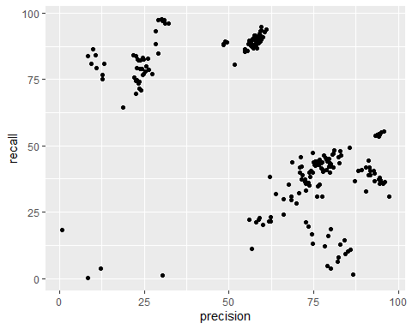

ggplot(data = table) +   
 geom_point(mapping = aes(x = precision, y = recall))



ggplot(data = table) +   
 geom_point(mapping = aes(x = precision, y = recall))



ggplot(data = table) +   
 geom_point(mapping = aes(x = precision, y = recall, color = technique))

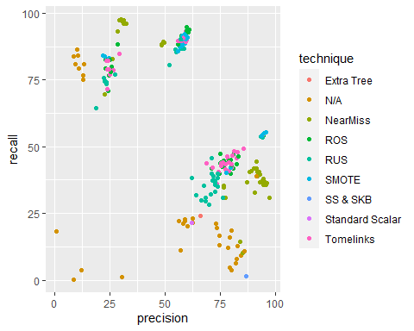

ggplot(data = table) +   
 geom_point(mapping = aes(x = precision, y = recall, size = technique))

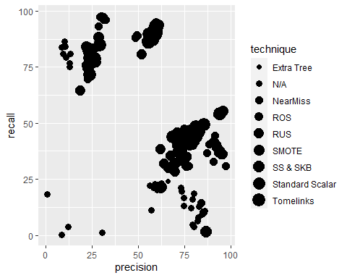

# Left  
ggplot(data = table) +   
 geom_point(mapping = aes(x = precision, y = recall, alpha = technique))

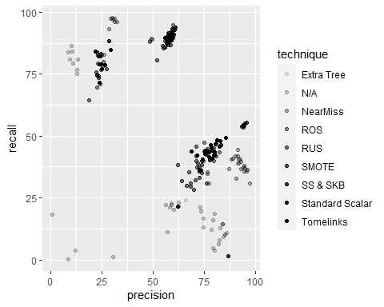

# Right  
ggplot(data = table) +   
 geom_point(mapping = aes(x = precision, y = recall, shape = technique))

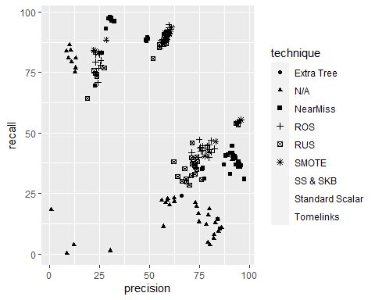

ggplot(data = table) +   
 geom_point(mapping = aes(x = precision, y = recall), color = "blue")

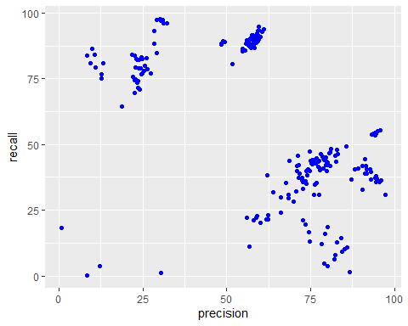

ggplot(data = table) +   
 geom_point(mapping = aes(x = precision, y = recall)) + facet_wrap(~ Technique, nrow = 2)

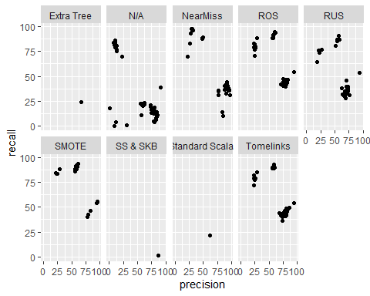

ggplot(data = table) +   
 geom_point(mapping = aes(x = precision, y = recall)) +   
 facet_grid(Sampling ~ Technique)

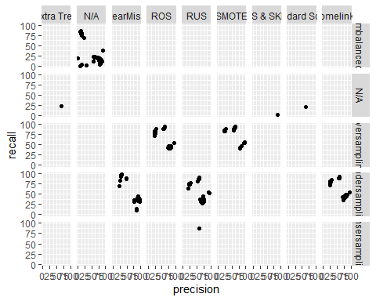

ggplot(table, aes(precision, recall)) + geom_boxplot()

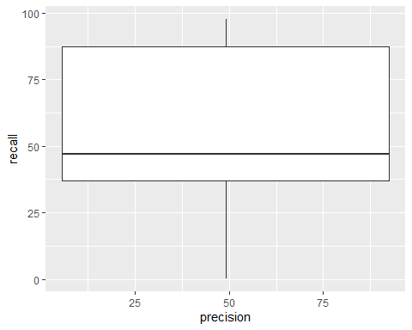

ggplot(data = table) +   
 geom_point(mapping = aes(x = precision, y = recall)) +  
 geom_smooth(mapping = aes(x = precision, y = recall))

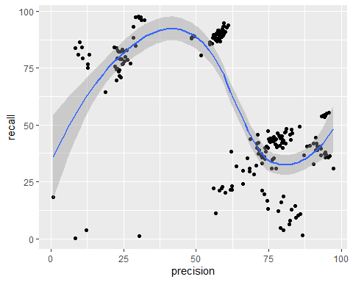

ggplot(data = table) +   
 stat_summary(  
 mapping = aes(x = precision, y = recall),  
 fun.min = min,  
 fun.max = max,  
 fun = median  
 )

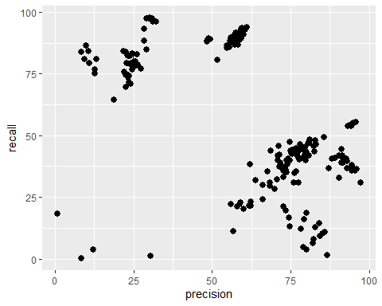

# Problematic Code  
# ggplot(table, aes(x = precision, y = recall)) +   
# geom_point(size = 2, colour = "grey30") +   
# geom_abline(  
# aes(intercept = a1, slope = a2, colour = -dist),   
# data = table(models, rank(dist) <= 10)  
# )  
# Error in x[!nas] : object of type 'closure' is not subsettable

ggplot(data = table) +  
 geom_boxplot(mapping = aes(x, y, alpha = classifier))

## Error in FUN(X[[i]], ...): object 'x' not found



ggplot(data = table) +  
 geom_count(mapping = aes(x = precision, y = recall, alpha = classifier))

## Error in grid.Call(C_textBounds, as.graphicsAnnot(x$label), x$x, x$y, : invalid input 'Na<ef>ve Bayes' in 'utf8towcs'



x <- precision  
y <- recall  
ggplot(table) +   
 geom_histogram(mapping = aes(x = y), binwidth = 0.1)

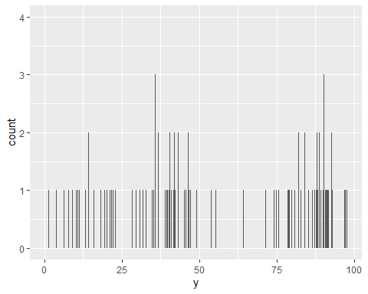

ggplot(data = table) +   
 geom_point(mapping = aes(x = precision, y = recall))



## Chapter 7 EDA

ggplot(data = table) +  
 geom_bar(mapping = aes(x = classifier))

## Error in grid.Call(C_textBounds, as.graphicsAnnot(x$label), x$x, x$y, : invalid input 'Na<ef>ve Bayes' in 'utf8towcs'



table %>%   
 count(cut_width(Precision, 0.5))

## cut_width(Precision, 0.5) n  
## 1 [0.25,0.75] 1  
## 2 (8.25,8.75] 2  
## 3 (9.25,9.75] 1  
## 4 (9.75,10.2] 1  
## 5 (10.2,10.8] 1  
## 6 (10.8,11.2] 1  
## 7 (11.8,12.2] 1  
## 8 (12.2,12.8] 1  
## 9 (12.8,13.2] 2  
## 10 (18.2,18.8] 1  
## 11 (21.8,22.2] 3  
## 12 (22.2,22.8] 5  
## 13 (22.8,23.2] 3  
## 14 (23.2,23.8] 4  
## 15 (23.8,24.2] 2  
## 16 (24.2,24.8] 3  
## 17 (24.8,25.2] 2  
## 18 (25.2,25.8] 2  
## 19 (25.8,26.2] 1  
## 20 (26.2,26.8] 1  
## 21 (26.8,27.2] 1  
## 22 (28.2,28.8] 3  
## 23 (28.8,29.2] 2  
## 24 (29.8,30.2] 1  
## 25 (30.2,30.8] 2  
## 26 (30.8,31.2] 2  
## 27 (32.2,32.8] 1  
## 28 (48.2,48.8] 2  
## 29 (48.8,49.2] 1  
## 30 (49.2,49.8] 1  
## 31 (51.2,51.8] 1  
## 32 (54.2,54.8] 1  
## 33 (54.8,55.2] 1  
## 34 (55.2,55.8] 1  
## 35 (55.8,56.2] 3  
## 36 (56.2,56.8] 4  
## 37 (56.8,57.2] 3  
## 38 (57.2,57.8] 7  
## 39 (57.8,58.2] 9  
## 40 (58.2,58.8] 4  
## 41 (58.8,59.2] 10  
## 42 (59.2,59.8] 6  
## 43 (59.8,60.2] 2  
## 44 (60.2,60.8] 2  
## 45 (60.8,61.2] 2  
## 46 (61.8,62.2] 2  
## 47 (62.2,62.8] 2  
## 48 (63.8,64.2] 1  
## 49 (65.8,66.2] 2  
## 50 (67.2,67.8] 1  
## 51 (68.2,68.8] 3  
## 52 (69.8,70.2] 1  
## 53 (70.2,70.8] 1  
## 54 (70.8,71.2] 3  
## 55 (71.2,71.8] 2  
## 56 (71.8,72.2] 1  
## 57 (72.2,72.8] 4  
## 58 (72.8,73.2] 2  
## 59 (73.2,73.8] 4  
## 60 (73.8,74.2] 1  
## 61 (74.2,74.8] 4  
## 62 (74.8,75.2] 3  
## 63 (75.2,75.8] 3  
## 64 (75.8,76.2] 2  
## 65 (76.2,76.8] 4  
## 66 (77.2,77.8] 5  
## 67 (77.8,78.2] 2  
## 68 (78.2,78.8] 2  
## 69 (78.8,79.2] 4  
## 70 (79.2,79.8] 3  
## 71 (79.8,80.2] 6  
## 72 (80.2,80.8] 1  
## 73 (80.8,81.2] 3  
## 74 (81.8,82.2] 1  
## 75 (82.2,82.8] 3  
## 76 (82.8,83.2] 4  
## 77 (83.8,84.2] 2  
## 78 (84.2,84.8] 1  
## 79 (84.8,85.2] 1  
## 80 (85.2,85.8] 1  
## 81 (85.8,86.2] 1  
## 82 (86.8,87.2] 2  
## 83 (87.8,88.2] 1  
## 84 (88.8,89.2] 1  
## 85 (90.2,90.8] 2  
## 86 (90.8,91.2] 1  
## 87 (91.2,91.8] 2  
## 88 (91.8,92.2] 2  
## 89 (92.2,92.8] 1  
## 90 (92.8,93.2] 2  
## 91 (93.2,93.8] 2  
## 92 (93.8,94.2] 2  
## 93 (94.2,94.8] 5  
## 94 (94.8,95.2] 2  
## 95 (95.2,95.8] 2  
## 96 (95.8,96.2] 1  
## 97 (97.2,97.8] 1

table %>%   
 count(Classifier)

## Classifier n  
## 1 DecisionTree 55  
## 2 Logistic Reg 55  
## 3 Random Forest 6  
## 4 XGBoost 54  
## 5 Na\xefve Bayes 55

table %>%   
 count(cut_width(Recall, 0.5))

## cut_width(Recall, 0.5) n  
## 1 [0.25,0.75] 1  
## 2 (1.25,1.75] 2  
## 3 (3.75,4.25] 2  
## 4 (4.75,5.25] 1  
## 5 (6.25,6.75] 1  
## 6 (7.75,8.25] 1  
## 7 (8.75,9.25] 1  
## 8 (10.2,10.8] 1  
## 9 (10.8,11.2] 1  
## 10 (11.2,11.8] 1  
## 11 (11.8,12.2] 1  
## 12 (12.2,12.8] 1  
## 13 (13.2,13.8] 1  
## 14 (14.2,14.8] 2  
## 15 (15.8,16.2] 1  
## 16 (16.2,16.8] 1  
## 17 (18.2,18.8] 2  
## 18 (19.2,19.8] 1  
## 19 (20.2,20.8] 1  
## 20 (20.8,21.2] 2  
## 21 (21.2,21.8] 2  
## 22 (21.8,22.2] 2  
## 23 (22.8,23.2] 2  
## 24 (23.8,24.2] 1  
## 25 (28.2,28.8] 1  
## 26 (29.2,29.8] 1  
## 27 (29.8,30.2] 1  
## 28 (30.8,31.2] 4  
## 29 (31.8,32.2] 1  
## 30 (32.2,32.8] 1  
## 31 (32.8,33.2] 2  
## 32 (34.8,35.2] 3  
## 33 (35.2,35.8] 1  
## 34 (35.8,36.2] 5  
## 35 (36.2,36.8] 2  
## 36 (36.8,37.2] 5  
## 37 (37.2,37.8] 1  
## 38 (37.8,38.2] 3  
## 39 (38.8,39.2] 3  
## 40 (39.2,39.8] 1  
## 41 (39.8,40.2] 4  
## 42 (40.2,40.8] 6  
## 43 (40.8,41.2] 2  
## 44 (41.2,41.8] 2  
## 45 (41.8,42.2] 5  
## 46 (42.2,42.8] 4  
## 47 (43.2,43.8] 7  
## 48 (43.8,44.2] 4  
## 49 (44.2,44.8] 3  
## 50 (44.8,45.2] 1  
## 51 (45.2,45.8] 2  
## 52 (45.8,46.2] 1  
## 53 (46.2,46.8] 4  
## 54 (46.8,47.2] 2  
## 55 (47.8,48.2] 1  
## 56 (48.2,48.8] 1  
## 57 (48.8,49.2] 1  
## 58 (53.2,53.8] 1  
## 59 (53.8,54.2] 4  
## 60 (54.2,54.8] 1  
## 61 (54.8,55.2] 1  
## 62 (55.2,55.8] 1  
## 63 (64.2,64.8] 1  
## 64 (69.2,69.8] 2  
## 65 (70.2,70.8] 1  
## 66 (71.2,71.8] 1  
## 67 (73.2,73.8] 1  
## 68 (73.8,74.2] 1  
## 69 (74.2,74.8] 2  
## 70 (74.8,75.2] 1  
## 71 (75.2,75.8] 1  
## 72 (76.8,77.2] 4  
## 73 (77.8,78.2] 1  
## 74 (78.2,78.8] 1  
## 75 (78.8,79.2] 3  
## 76 (79.2,79.8] 1  
## 77 (79.8,80.2] 1  
## 78 (80.2,80.8] 1  
## 79 (80.8,81.2] 2  
## 80 (81.8,82.2] 2  
## 81 (82.2,82.8] 2  
## 82 (82.8,83.2] 2  
## 83 (83.8,84.2] 5  
## 84 (84.2,84.8] 1  
## 85 (85.2,85.8] 2  
## 86 (86.2,86.8] 3  
## 87 (86.8,87.2] 1  
## 88 (87.2,87.8] 3  
## 89 (87.8,88.2] 5  
## 90 (88.2,88.8] 8  
## 91 (88.8,89.2] 5  
## 92 (89.2,89.8] 4  
## 93 (89.8,90.2] 4  
## 94 (90.2,90.8] 6  
## 95 (90.8,91.2] 2  
## 96 (91.2,91.8] 4  
## 97 (91.8,92.2] 2  
## 98 (92.8,93.2] 4  
## 99 (93.2,93.8] 3  
## 100 (94.2,94.8] 1  
## 101 (95.8,96.2] 2  
## 102 (96.8,97.2] 1  
## 103 (97.2,97.8] 3

smaller <- table %>%  
 filter(Classifier > 60)

ggplot(data = smaller, mapping = aes(x = Precision)) +  
 geom_histogram(binwidth = 0.1)

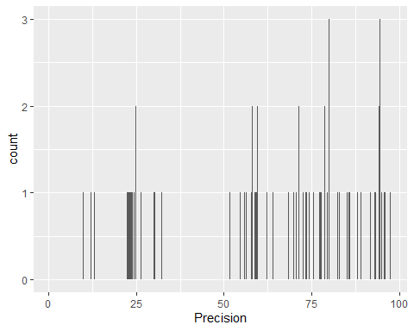

ggplot(data = smaller, mapping = aes(x = Precision)) +  
 geom_histogram(binwidth = 0.1)



ggplot(data = smaller, mapping = aes(x = Recall, colour = classifier)) +  
 geom_freqpoly(binwidth = 0.1)

## Error in `check_aesthetics()`:  
## ! Aesthetics must be either length 1 or the same as the data (170): colour



ggplot(data = smaller, mapping = aes(x = Recall)) +  
 geom_histogram(binwidth = 0.01)

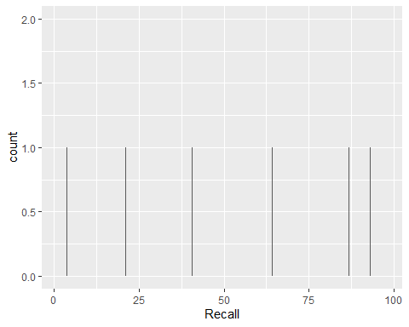

ggplot(data = smaller, mapping = aes(x = Precision, colour = classifier)) +  
 geom_freqpoly(binwidth = 0.1)

## Error in `check_aesthetics()`:  
## ! Aesthetics must be either length 1 or the same as the data (170): colour



ggplot(data = smaller, mapping = aes(x = Precision)) +  
 geom_histogram(binwidth = 0.01)

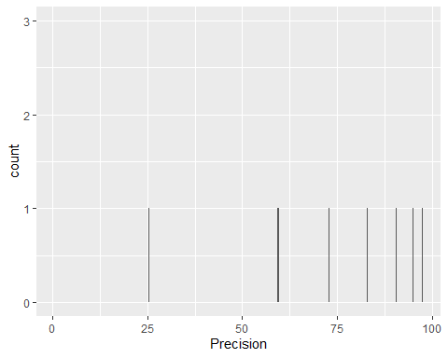

ggplot(data = smaller, mapping = aes(x = Precision)) +   
 geom_histogram(binwidth = 0.25)

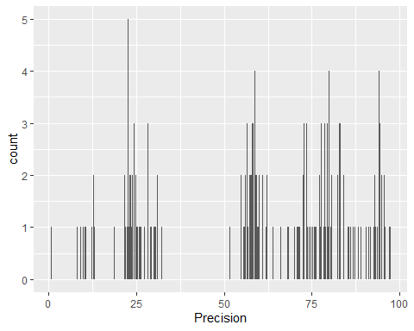

ggplot(table) +   
 geom_histogram(mapping = aes(x = y), binwidth = 0.5)

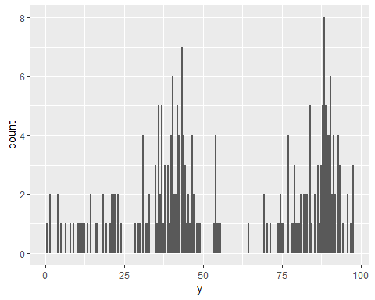

ggplot(table) +   
 geom_histogram(mapping = aes(x = y), binwidth = 0.5) +  
 coord_cartesian(ylim = c(0, 50))

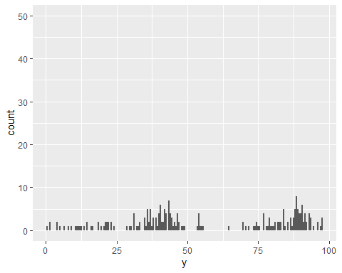 # unusual <- table %>% # filter(y < 30 | y > 60) %>% # select(x, y) %>% # arrange(y) # unusual

ggplot(data = table, mapping = aes(x = x, y = y)) +   
 geom_point()

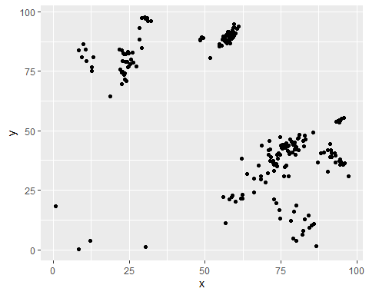

ggplot(data = table, mapping = aes(x = x, y = y)) +   
 geom_point(na.rm = TRUE)



ggplot(data = table, mapping = aes(x = precision)) +   
 geom_freqpoly(mapping = aes(colour = classifier), binwidth = 500)

## Error in grid.Call(C_textBounds, as.graphicsAnnot(x$label), x$x, x$y, : invalid input 'Na<ef>ve Bayes' in 'utf8towcs'

 ggplot(data = table, mapping = aes(x = precision)) + geom_freqpoly(mapping = aes(colour = classifier), binwidth = 500) ggplot(data = table, mapping = aes(x = precision, y = ..recall..)) + geom_freqpoly(mapping = aes(colour = classifier), binwidth = 500) ggplot(data = table, mapping = aes(x = precision, y = recall)) + geom_boxplot() ggplot(data = table, mapping = aes(x = classifier, y = precision)) + geom_boxplot() ggplot(data = table, mapping = aes(x = classifier, y = recall)) + geom_boxplot() ggplot(data = table) + geom_boxplot(mapping = aes(x = reorder(classifier, precision, FUN = median), y = precision)) ggplot(data = table) + geom_boxplot(mapping = aes(x = reorder(classifier, precision, FUN = median), y = precision)) + coord_flip() ggplot(data = table) + geom_count(mapping = aes(x = classifier, y = sampling)) table %>% count(Classifier, Sampling) table %>% count(Classifier, Sampling) %>%  
ggplot(mapping = aes(x = Classifier, y = Sampling)) + geom_tile(mapping = aes(fill = n)) ggplot(data = table) + geom_point(mapping = aes(x = Precision, y = Recall), alpha = 50 / 100) ggplot(data = smaller) + geom_bin2d(mapping = aes(x = Precision, y = Recall)) # install.packages(“hexbin”) library(hexbin) ggplot(data = smaller) + geom_hex(mapping = aes(x = Precision, y = Recall))

ggplot(data = smaller, mapping = aes(x = Precision, y = Recall)) + geom_boxplot(mapping = aes(group = cut_width(Precision, 0.1)))

ggplot(data = smaller, mapping = aes(x = Precision, y = Recall)) + geom_boxplot(mapping = aes(group = cut_number(Precision, 20)))

ggplot(data = table) + geom_point(mapping = aes(x = x, y = y)) + coord_cartesian(xlim = c(0, 90), ylim = c(0, 90))

ggplot(data = table) + geom_point(mapping = aes(x = Precision, y = Recall))

library(modelr)

mod <- lm(log(Recall) ~ log(Precision), data = table)

table1 <- table %>% add_residuals(mod) %>% mutate(resid = exp(resid))

ggplot(data = table1) + geom_point(mapping = aes(x = Precision, y = resid))

ggplot(data = table1) + geom_boxplot(mapping = aes(x = Precision, y = resid)) ggplot(data = table, mapping = aes(x = precision)) + geom_freqpoly(binwidth = 0.25) ggplot(table, aes(Precision)) + geom_freqpoly(binwidth = 0.25) table %>% count(Classifier, Sampling) %>% ggplot(aes(Classifier, Sampling, fill = n)) + geom_tile()

<br>  
  
Chapter 9 Wrangle  
  
```r  
table %>%   
 count(Precision) %>%   
 filter(n > 1)

## Precision n  
## 1 21.81 2  
## 2 22.65 2  
## 3 24.91 2  
## 4 28.27 2  
## 5 57.47 2  
## 6 58.71 2  
## 7 58.76 3  
## 8 59.57 2  
## 9 60.53 2  
## 10 60.96 2  
## 11 83.06 2  
## 12 84.04 2  
## 13 94.27 2

table %>%   
 count(Precision, Recall) %>%   
 filter(n > 1)

## Precision Recall n  
## 1 22.65 69.45 2  
## 2 28.27 88.45 2  
## 3 57.47 88.06 2  
## 4 58.71 89.86 2  
## 5 58.76 88.66 2  
## 6 60.53 92.82 2  
## 7 60.96 93.67 2  
## 8 83.06 46.47 2  
## 9 84.04 14.30 2

table %>%   
 count(Precision, Recall) %>%   
 filter(n > 1)

## Precision Recall n  
## 1 22.65 69.45 2  
## 2 28.27 88.45 2  
## 3 57.47 88.06 2  
## 4 58.71 89.86 2  
## 5 58.76 88.66 2  
## 6 60.53 92.82 2  
## 7 60.96 93.67 2  
## 8 83.06 46.47 2  
## 9 84.04 14.30 2

Chapter 23 Model Basics

x <- precision  
y <- recall  
# models <- tibble(  
# a1 = c(precision),  
# a2 = c(recall)  
# )  
models <- tibble(  
 a1 = precision,  
 a2 = recall  
)  
models

## # A tibble: 225 × 2  
## a1 a2  
## <dbl> <dbl>  
## 1 74.5 16.7  
## 2 72.8 21.2  
## 3 12.7 75.0  
## 4 59 22.8  
## 5 22.6 69.4  
## 6 76.7 35.4  
## 7 76.4 34.8  
## 8 26.0 82.9  
## 9 77.5 31   
## 10 22.6 69.4  
## # … with 215 more rows

ggplot(table, aes(x=precision, y=recall)) +   
 geom_abline(aes(intercept = a1, slope = a2), data = models, alpha = 1/4) +  
 geom_point()

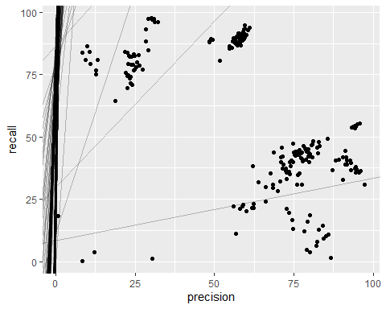

model1 <- function(a, data) {  
 a[1] + data$x * a[2]  
}  
model1(c(7, 1.5), table)

## numeric(0)

#> [1] 8.5 8.5 8.5 10.0 10.0 10.0 11.5 11.5 11.5 13.0 13.0 13.0 14.5 14.5 14.5  
#> [16] 16.0 16.0 16.0 17.5 17.5 17.5 19.0 19.0 19.0 20.5 20.5 20.5 22.0 22.0 22.0  
  
measure_distance <- function(mod, data) {  
 diff <- data$y - model1(mod, data)  
 sqrt(mean(diff ^ 2))  
}  
  
table_dist <- function(a1, a2) {  
 measure_distance(c(a1, a2), table)  
}  
# test2 <- c(precision[1],recall[2])  
# test2  
measure_distance(c(7.5, 1), table)

## [1] NaN

models <- models %>%   
 mutate(dist = purrr::map2_dbl(a1, a2, table_dist))  
models

## # A tibble: 225 × 3  
## a1 a2 dist  
## <dbl> <dbl> <dbl>  
## 1 74.5 16.7 NaN  
## 2 72.8 21.2 NaN  
## 3 12.7 75.0 NaN  
## 4 59 22.8 NaN  
## 5 22.6 69.4 NaN  
## 6 76.7 35.4 NaN  
## 7 76.4 34.8 NaN  
## 8 26.0 82.9 NaN  
## 9 77.5 31 NaN  
## 10 22.6 69.4 NaN  
## # … with 215 more rows

#> # A tibble: 250 x 3  
#> a1 a2 dist  
#> <dbl> <dbl> <dbl>  
#> 1 -15.2 0.0889 30.8  
#> 2 30.1 -0.827 13.2  
#> 3 16.0 2.27 13.2  
#> 4 -10.6 1.38 18.7  
#> 5 -19.6 -1.04 41.8  
#> 6 7.98 4.59 19.3  
#> # . with 244 more rows  
  
ggplot(table, aes(x = precision, y = recall)) +   
 geom_point(size = 2, colour = "grey30") +   
 geom_abline(  
 aes(intercept = a1, slope = a2, colour = -dist),   
 data = filter(models, rank(dist) <= 10)  
 )

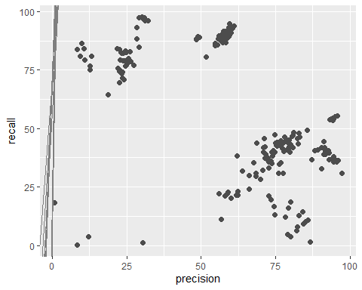

ggplot(models, aes(a1, a2)) +  
 geom_point(data = filter(models, rank(dist) <= 10), size = 4, colour = "red") +  
 geom_point(aes(colour = -dist))

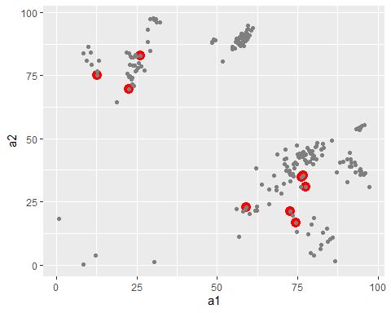

grid <- expand.grid(  
 a1 = seq(-5, 20, length=25, along.with=precision),  
 a2 = seq(1, 3, length = 25, along.with=recall)  
) %>%   
 mutate(dist = purrr::map2_dbl(a1, a2, table_dist))  
  
grid %>%   
 ggplot(aes(a1, a2)) +  
 geom_point(data = filter(grid, rank(dist) <= 10), size = 4, colour = "red") +  
 geom_point(aes(colour = -dist))

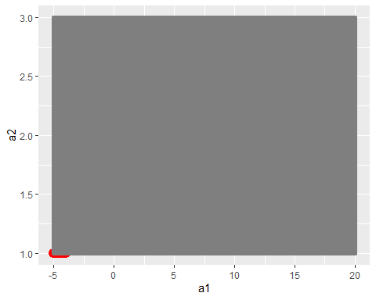

ggplot(table, aes(x=precision, y=recall)) +   
 geom_point(size = 2, colour = "grey30") +   
 geom_abline(  
 aes(intercept = a1, slope = a2, colour = -dist),   
 data = filter(grid, rank(dist) <= 10)  
 )

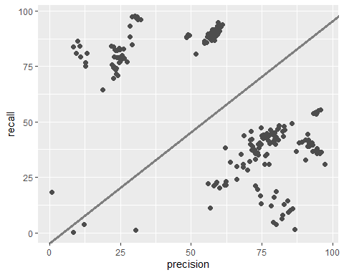

# best <- optim(c(0, 0), measure_distance, data = table)  
# best$par  
  
# ggplot(table, aes(x, y)) +   
# geom_point(size = 2, colour = "grey30") +   
# geom_abline(intercept = best$par[1], slope = best$par[2])  
  
table_mod <- lm(y ~ x, data = table)  
coef(table_mod)

## (Intercept) x   
## 95.3192201 -0.6232934

tablea <- tibble(  
 x = rep(1:10, each = 3),  
 y = x * 1.5 + 6 + rt(length(x), df = 2)  
)  
  
measure_distance <- function(mod, data) {  
 diff <- data$y - model1(mod, data)  
 mean(abs(diff))  
}  
  
model1 <- function(a, data) {  
 a[1] + data$x * a[2] + a[3]  
}  
  
grid <- table %>%   
 data_grid(x)   
grid

## # A tibble: 211 × 1  
## x  
## <dbl>  
## 1 0.74  
## 2 8.31  
## 3 8.44  
## 4 9.32  
## 5 9.95  
## 6 10.5   
## 7 10.8   
## 8 12.1   
## 9 12.7   
## 10 12.8   
## # … with 201 more rows

#> # A tibble: 10 x 1  
#> x  
#> <int>  
#> 1 1  
#> 2 2  
#> 3 3  
#> 4 4  
#> 5 5  
#> 6 6  
#> # . with 4 more rows  
  
grid <- grid %>%   
 add_predictions(table_mod)   
grid

## # A tibble: 211 × 2  
## x pred  
## <dbl> <dbl>  
## 1 0.74 94.9  
## 2 8.31 90.1  
## 3 8.44 90.1  
## 4 9.32 89.5  
## 5 9.95 89.1  
## 6 10.5 88.7  
## 7 10.8 88.6  
## 8 12.1 87.8  
## 9 12.7 87.4  
## 10 12.8 87.4  
## # … with 201 more rows

#> # A tibble: 10 x 2  
#> x pred  
#> <int> <dbl>  
#> 1 1 6.27  
#> 2 2 8.32  
#> 3 3 10.4   
#> 4 4 12.4   
#> 5 5 14.5   
#> 6 6 16.5   
#> # . with 4 more rows  
  
ggplot(table, aes(x)) +  
 geom_point(aes(y = y)) +  
 geom_line(aes(y = pred), data = grid, colour = "red", size = 1)

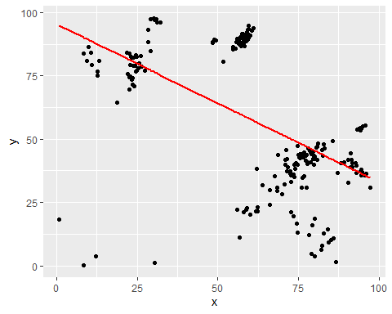

table <- table %>%   
 add_residuals(table_mod)  
table

## Year Sampling Technique Classifier Precision Recall  
## 1 2010 Imbalanced N/A Na\xefve Bayes 74.49 16.70  
## 2 2010 Imbalanced N/A Logistic Reg 72.82 21.18  
## 3 2010 Imbalanced N/A XGBoost 12.66 75.05  
## 4 2010 Imbalanced N/A DecisionTree 59.00 22.77  
## 5 2010 Imbalanced N/A Random Forest 22.65 69.45  
## 6 2010 Undersampling NearMiss Na\xefve Bayes 76.67 35.38  
## 7 2010 Undersampling NearMiss Logistic Reg 76.37 34.83  
## 8 2010 Undersampling NearMiss XGBoost 26.04 82.92  
## 9 2010 Undersampling NearMiss DecisionTree 77.47 31.00  
## 10 2010 Undersampling NearMiss Random Forest 22.65 69.45  
## 11 2010 Oversampling SMOTE Na\xefve Bayes 57.98 88.41  
## 12 2010 Oversampling SMOTE Logistic Reg 58.15 88.40  
## 13 2010 Oversampling SMOTE XGBoost 94.16 54.34  
## 14 2010 Oversampling SMOTE DecisionTree 56.43 87.71  
## 15 2010 Oversampling SMOTE Random Forest 58.17 90.11  
## 16 2010 Oversampling ROS Na\xefve Bayes 57.95 89.05  
## 17 2010 Oversampling ROS Logistic Reg 57.91 88.23  
## 18 2010 Oversampling ROS XGBoost 94.52 54.08  
## 19 2010 Oversampling ROS DecisionTree 56.46 88.55  
## 20 2010 Oversampling ROS Random Forest 57.68 89.70  
## 21 2010 Undersampling RUS Na\xefve Bayes 67.54 35.25  
## 22 2010 Undersampling RUS Logistic Reg 57.29 86.59  
## 23 2010 Undersampling RUS XGBoost 93.31 53.88  
## 24 2010 Undersampling RUS DecisionTree 54.84 85.36  
## 25 2010 Unsersampling RUS Random Forest 58.32 86.82  
## 26 2010 Undersampling Tomelinks Na\xefve Bayes 58.00 88.92  
## 27 2010 Undersampling Tomelinks Logistic Reg 73.39 35.93  
## 28 2010 Undersampling Tomelinks XGBoost 94.27 54.13  
## 29 2010 Undersampling Tomelinks DecisionTree 56.52 88.80  
## 30 2010 Undersampling Tomelinks Random Forest 57.96 89.30  
## 31 2012 Imbalanced N/A Na\xefve Bayes 82.95 12.68  
## 32 2012 Imbalanced N/A Logistic Reg 80.00 18.73  
## 33 2012 Imbalanced N/A XGBoost 13.06 80.78  
## 34 2012 Imbalanced N/A DecisionTree 62.30 23.00  
## 35 2012 Undersampling NearMiss Na\xefve Bayes 91.79 40.57  
## 36 2012 Undersampling NearMiss Logistic Reg 91.84 39.06  
## 37 2012 Undersampling NearMiss XGBoost 30.11 97.70  
## 38 2012 Undersampling NearMiss DecisionTree 95.96 36.43  
## 39 2012 Oversampling SMOTE Na\xefve Bayes 58.71 89.86  
## 40 2012 Oversampling SMOTE Logistic Reg 58.76 88.66  
## 41 2012 Oversampling SMOTE XGBoost 21.81 84.12  
## 42 2012 Oversampling SMOTE DecisionTree 57.47 88.06  
## 43 2012 Oversampling ROS Na\xefve Bayes 76.52 42.70  
## 44 2012 Oversampling ROS Logistic Reg 77.85 40.72  
## 45 2012 Oversampling ROS XGBoost 22.85 79.33  
## 46 2012 Oversampling ROS DecisionTree 79.77 39.89  
## 47 2012 Undersampling RUS Na\xefve Bayes 72.59 37.17  
## 48 2012 Undersampling RUS Logistic Reg 73.62 34.90  
## 49 2012 Undersampling RUS XGBoost 22.10 75.75  
## 50 2012 Undersampling RUS DecisionTree 69.89 28.39  
## 51 2012 Undersampling Tomelinks Na\xefve Bayes 59.57 89.88  
## 52 2012 Undersampling Tomelinks Logistic Reg 77.36 41.44  
## 53 2012 Undersampling Tomelinks XGBoost 23.72 79.00  
## 54 2012 Undersampling Tomelinks DecisionTree 78.82 40.96  
## 55 2013 Imbalanced N/A Na\xefve Bayes 74.70 13.27  
## 56 2013 Imbalanced N/A Logistic Reg 73.53 19.52  
## 57 2013 Imbalanced N/A XGBoost 12.76 76.85  
## 58 2013 Imbalanced N/A DecisionTree 56.04 22.23  
## 59 2013 Undersampling NearMiss Na\xefve Bayes 90.40 41.79  
## 60 2013 Undersampling NearMiss Logistic Reg 89.11 40.89  
## 61 2013 Undersampling NearMiss XGBoost 30.99 97.43  
## 62 2013 Undersampling NearMiss DecisionTree 94.91 37.03  
## 63 2013 Oversampling SMOTE Na\xefve Bayes 58.71 89.86  
## 64 2013 Oversampling SMOTE Logistic Reg 58.76 88.66  
## 65 2013 Oversampling SMOTE XGBoost 21.81 84.13  
## 66 2013 Oversampling SMOTE DecisionTree 57.47 88.06  
## 67 2013 Oversampling ROS Na\xefve Bayes 75.12 43.64  
## 68 2013 Oversampling ROS Logistic Reg 75.63 42.43  
## 69 2013 Oversampling ROS XGBoost 24.54 76.83  
## 70 2013 Oversampling ROS DecisionTree 74.68 40.05  
## 71 2013 Undersampling RUS Na\xefve Bayes 71.84 39.03  
## 72 2013 Undersampling RUS Logistic Reg 71.37 37.24  
## 73 2013 Undersampling RUS XGBoost 23.37 73.38  
## 74 2013 Undersampling RUS DecisionTree 66.15 30.01  
## 75 2013 Undersampling Tomelinks Na\xefve Bayes 59.20 89.18  
## 76 2013 Undersampling Tomelinks Logistic Reg 75.19 42.75  
## 77 2013 Undersampling Tomelinks XGBoost 24.91 76.92  
## 78 2013 Undersampling Tomelinks DecisionTree 74.29 40.53  
## 79 2014 Imbalanced N/A Na\xefve Bayes 84.51 9.13  
## 80 2014 Imbalanced N/A Logistic Reg 84.04 14.30  
## 81 2014 Imbalanced N/A XGBoost 10.54 83.97  
## 82 2014 Imbalanced N/A DecisionTree 62.37 21.66  
## 83 2014 Undersampling NearMiss Na\xefve Bayes 49.33 88.80  
## 84 2014 Undersampling NearMiss Logistic Reg 84.04 14.30  
## 85 2014 Undersampling NearMiss XGBoost 29.21 97.28  
## 86 2014 Undersampling NearMiss DecisionTree 95.63 35.76  
## 87 2014 Oversampling SMOTE Na\xefve Bayes 59.31 91.58  
## 88 2014 Oversampling SMOTE Logistic Reg 59.65 91.14  
## 89 2014 Oversampling SMOTE XGBoost 95.00 54.98  
## 90 2014 Oversampling SMOTE DecisionTree 58.76 91.31  
## 91 2014 Oversampling ROS Na\xefve Bayes 75.44 44.17  
## 92 2014 Oversampling ROS Logistic Reg 80.77 41.96  
## 93 2014 Oversampling ROS XGBoost 23.00 82.52  
## 94 2014 Oversampling ROS DecisionTree 82.50 43.45  
## 95 2014 Undersampling RUS Na\xefve Bayes 57.43 90.28  
## 96 2014 Undersampling RUS Logistic Reg 72.78 35.83  
## 97 2014 Undersampling RUS XGBoost 94.27 53.47  
## 98 2014 Undersampling RUS DecisionTree 54.68 86.53  
## 99 2014 Undersampling Tomelinks Na\xefve Bayes 75.27 43.66  
## 100 2014 Undersampling Tomelinks Logistic Reg 80.05 42.08  
## 101 2014 Undersampling Tomelinks XGBoost 23.23 82.18  
## 102 2014 Undersampling Tomelinks DecisionTree 59.33 93.08  
## 103 2014 N/A Standard Scalar DecisionTree 61.90 21.62  
## 104 2014 N/A Extra Tree Na\xefve Bayes 66.09 24.14  
## 105 2014 N/A SS & SKB Logistic Reg 86.79 1.42  
## 106 2015 Imbalanced N/A Na\xefve Bayes 82.11 6.44  
## 107 2015 Imbalanced N/A Logistic Reg 78.39 12.22  
## 108 2015 Imbalanced N/A XGBoost 9.32 80.94  
## 109 2015 Imbalanced N/A DecisionTree 58.11 21.06  
## 110 2015 Undersampling NearMiss Na\xefve Bayes 48.34 88.34  
## 111 2015 Undersampling NearMiss Logistic Reg 88.13 40.58  
## 112 2015 Undersampling NearMiss XGBoost 31.02 96.18  
## 113 2015 Undersampling NearMiss DecisionTree 93.00 36.82  
## 114 2015 Oversampling SMOTE Na\xefve Bayes 59.16 90.34  
## 115 2015 Oversampling SMOTE Logistic Reg 59.19 90.36  
## 116 2015 Oversampling SMOTE XGBoost 24.50 83.16  
## 117 2015 Oversampling SMOTE DecisionTree 79.51 42.27  
## 118 2015 Oversampling ROS Na\xefve Bayes 74.87 47.24  
## 119 2015 Oversampling ROS Logistic Reg 79.57 45.13  
## 120 2015 Oversampling ROS XGBoost 25.46 79.86  
## 121 2015 Oversampling ROS DecisionTree 80.83 46.89  
## 122 2015 Undersampling RUS Na\xefve Bayes 73.66 39.95  
## 123 2015 Undersampling RUS Logistic Reg 73.87 38.19  
## 124 2015 Undersampling RUS XGBoost 23.48 74.19  
## 125 2015 Undersampling RUS DecisionTree 70.75 32.26  
## 126 2015 Undersampling Tomelinks Na\xefve Bayes 78.06 46.37  
## 127 2015 Undersampling Tomelinks Logistic Reg 78.63 45.33  
## 128 2015 Undersampling Tomelinks XGBoost 26.37 78.69  
## 129 2015 Undersampling Tomelinks DecisionTree 80.56 46.69  
## 130 2016 Imbalanced N/A Na\xefve Bayes 8.44 0.25  
## 131 2016 Imbalanced N/A Logistic Reg 30.32 1.33  
## 132 2016 Imbalanced N/A XGBoost 0.74 18.29  
## 133 2016 Imbalanced N/A DecisionTree 12.13 3.89  
## 134 2016 Undersampling NearMiss Na\xefve Bayes 48.45 87.85  
## 135 2016 Undersampling NearMiss Logistic Reg 87.21 36.76  
## 136 2016 Undersampling NearMiss XGBoost 28.26 93.04  
## 137 2016 Undersampling NearMiss DecisionTree 90.49 32.91  
## 138 2016 Oversampling SMOTE Na\xefve Bayes 56.65 87.29  
## 139 2016 Oversampling SMOTE Logistic Reg 57.18 87.52  
## 140 2016 Oversampling SMOTE XGBoost 93.65 54.06  
## 141 2016 Oversampling SMOTE DecisionTree 55.60 85.72  
## 142 2016 Oversampling ROS Na\xefve Bayes 57.52 91.43  
## 143 2016 Oversampling ROS Logistic Reg 70.99 41.93  
## 144 2016 Oversampling ROS XGBoost 24.10 70.74  
## 145 2016 Oversampling ROS DecisionTree 55.83 88.20  
## 146 2016 Undersampling RUS Na\xefve Bayes 62.03 38.16  
## 147 2016 Undersampling RUS Logistic Reg 63.96 31.90  
## 148 2016 Undersampling RUS XGBoost 18.65 64.27  
## 149 2016 Undersampling RUS DecisionTree 51.68 80.64  
## 150 2016 Undersampling Tomelinks Na\xefve Bayes 68.65 43.90  
## 151 2016 Undersampling Tomelinks Logistic Reg 71.44 42.05  
## 152 2016 Undersampling Tomelinks XGBoost 23.60 71.46  
## 153 2016 Undersampling Tomelinks DecisionTree 55.92 89.48  
## 154 2017 Imbalanced N/A Na\xefve Bayes 82.28 7.92  
## 155 2017 Imbalanced N/A Logistic Reg 79.39 15.98  
## 156 2017 Imbalanced N/A XGBoost 10.83 79.20  
## 157 2017 Imbalanced N/A DecisionTree 58.87 22.11  
## 158 2017 Undersampling NearMiss Na\xefve Bayes 48.98 89.36  
## 159 2017 Undersampling NearMiss Logistic Reg 93.06 39.56  
## 160 2017 Undersampling NearMiss XGBoost 97.36 30.88  
## 161 2017 Undersampling NearMiss DecisionTree 94.23 37.48  
## 162 2017 Oversampling SMOTE Na\xefve Bayes 57.74 91.47  
## 163 2017 Oversampling SMOTE Logistic Reg 57.82 90.42  
## 164 2017 Oversampling SMOTE XGBoost 22.55 83.77  
## 165 2017 Oversampling SMOTE DecisionTree 77.72 40.32  
## 166 2017 Oversampling ROS Na\xefve Bayes 76.68 44.67  
## 167 2017 Oversampling ROS Logistic Reg 77.66 43.73  
## 168 2017 Oversampling ROS XGBoost 25.33 78.13  
## 169 2017 Oversampling ROS DecisionTree 78.78 44.65  
## 170 2017 Undersampling RUS Na\xefve Bayes 70.85 39.82  
## 171 2017 Undersampling RUS Logistic Reg 72.51 36.51  
## 172 2017 Undersampling RUS XGBoost 22.63 74.59  
## 173 2017 Undersampling RUS DecisionTree 68.33 30.97  
## 174 2017 Undersampling Tomelinks Na\xefve Bayes 58.69 90.82  
## 175 2017 Undersampling Tomelinks Logistic Reg 77.32 43.37  
## 176 2017 Undersampling Tomelinks XGBoost 24.40 78.95  
## 177 2017 Undersampling Tomelinks DecisionTree 78.95 44.18  
## 178 2018 Imbalanced N/A Na\xefve Bayes 79.06 4.85  
## 179 2018 Imbalanced N/A Logistic Reg 91.19 39.00  
## 180 2018 Imbalanced N/A XGBoost 8.31 83.80  
## 181 2018 Imbalanced N/A DecisionTree 56.80 11.33  
## 182 2018 Undersampling NearMiss Na\xefve Bayes 91.44 41.73  
## 183 2018 Undersampling NearMiss Logistic Reg 85.23 10.28  
## 184 2018 Undersampling NearMiss XGBoost 30.41 97.00  
## 185 2018 Undersampling NearMiss DecisionTree 94.46 35.84  
## 186 2018 Oversampling SMOTE Na\xefve Bayes 59.13 91.79  
## 187 2018 Oversampling SMOTE Logistic Reg 59.94 90.74  
## 188 2018 Oversampling SMOTE XGBoost 95.68 55.37  
## 189 2018 Oversampling SMOTE DecisionTree 59.07 92.05  
## 190 2018 Oversampling ROS Na\xefve Bayes 59.51 93.60  
## 191 2018 Oversampling ROS Logistic Reg 80.01 43.26  
## 192 2018 Oversampling ROS XGBoost 24.91 82.35  
## 193 2018 Oversampling ROS DecisionTree 59.57 94.69  
## 194 2018 Undersampling RUS Na\xefve Bayes 57.13 90.33  
## 195 2018 Undersampling RUS Logistic Reg 72.71 35.90  
## 196 2018 Undersampling RUS XGBoost 22.68 74.60  
## 197 2018 Undersampling RUS DecisionTree 68.43 29.72  
## 198 2018 Undersampling Tomelinks Na\xefve Bayes 76.05 44.14  
## 199 2018 Undersampling Tomelinks Logistic Reg 79.88 43.31  
## 200 2018 Undersampling Tomelinks XGBoost 23.90 82.25  
## 201 2018 Undersampling Tomelinks DecisionTree 82.42 45.59  
## 202 2019 Imbalanced N/A Na\xefve Bayes 80.14 3.79  
## 203 2019 Imbalanced N/A Logistic Reg 85.94 10.82  
## 204 2019 Imbalanced N/A XGBoost 9.95 86.31  
## 205 2019 Imbalanced N/A DecisionTree 59.93 20.26  
## 206 2019 Undersampling NearMiss Na\xefve Bayes 91.34 44.56  
## 207 2019 Undersampling NearMiss Logistic Reg 92.64 40.48  
## 208 2019 Undersampling NearMiss XGBoost 32.26 96.06  
## 209 2019 Undersampling NearMiss DecisionTree 94.48 37.98  
## 210 2019 Oversampling SMOTE Na\xefve Bayes 60.53 92.82  
## 211 2019 Oversampling SMOTE Logistic Reg 60.96 93.67  
## 212 2019 Oversampling SMOTE XGBoost 28.27 88.45  
## 213 2019 Oversampling SMOTE DecisionTree 83.06 46.47  
## 214 2019 Oversampling ROS Na\xefve Bayes 60.53 92.82  
## 215 2019 Oversampling ROS Logistic Reg 60.96 93.67  
## 216 2019 Oversampling ROS XGBoost 28.27 88.45  
## 217 2019 Oversampling ROS DecisionTree 83.06 46.47  
## 218 2019 Undersampling RUS Na\xefve Bayes 71.22 45.77  
## 219 2019 Undersampling RUS Logistic Reg 75.98 30.80  
## 220 2019 Undersampling RUS XGBoost 27.22 76.95  
## 221 2019 Undersampling RUS DecisionTree 72.62 32.97  
## 222 2019 Undersampling Tomelinks Na\xefve Bayes 81.20 48.30  
## 223 2019 Undersampling Tomelinks Logistic Reg 82.89 48.10  
## 224 2019 Undersampling Tomelinks XGBoost 29.04 84.70  
## 225 2019 Undersampling Tomelinks DecisionTree 85.60 49.16  
## resid  
## 1 -32.19009215  
## 2 -28.75099218  
## 3 -12.37832520  
## 4 -35.77490745  
## 5 -11.75162379  
## 6 -12.15131246  
## 7 -12.88830049  
## 8 3.83134096  
## 9 -16.03267771  
## 10 -11.75162379  
## 11 29.22933325  
## 12 29.32529313  
## 13 17.71008971  
## 14 27.56322843  
## 15 31.04775900  
## 16 29.85063445  
## 17 29.00570271  
## 18 17.67447534  
## 19 28.42192723  
## 20 30.33234522  
## 21 -17.97198152  
## 22 26.97926078  
## 23 16.72029029  
## 24 24.22219187  
## 25 27.85125302  
## 26 29.75179912  
## 27 -13.64571493  
## 28 17.56865198  
## 29 28.70932484  
## 30 30.10686738  
## 31 -30.93702969  
## 32 -26.72574533  
## 33 -6.39900782  
## 34 -33.48803911  
## 35 2.46288427  
## 36 0.98404894  
## 37 21.14814523  
## 38 0.92201789  
## 39 31.13433746  
## 40 29.96550213  
## 41 2.39480973  
## 42 28.56145360  
## 43 -4.92480648  
## 44 -6.07582621  
## 45 -1.74696510  
## 46 -5.70910282  
## 47 -12.90434967  
## 48 -14.53235744  
## 49 -5.79443518  
## 50 -23.36724195  
## 51 31.69036981  
## 52 -5.66123999  
## 53 -1.53469981  
## 54 -5.23123158  
## 55 -35.48920053  
## 56 -29.96845385  
## 57 -10.51599585  
## 58 -38.15985601  
## 59 2.81650639  
## 60 1.11245786  
## 61 21.42664346  
## 62 0.86755978  
## 63 31.13433746  
## 64 29.96550213  
## 65 2.40480973  
## 66 28.56145360  
## 67 -4.85741728  
## 68 -5.74953763  
## 69 -3.19359920  
## 70 -8.72166640  
## 71 -11.51181975  
## 72 -13.59476766  
## 73 -7.37285251  
## 74 -24.07835939  
## 75 30.75975124  
## 76 -5.70378674  
## 77 -2.87298062  
## 78 -8.48475084  
## 79 -33.51469194  
## 80 -28.63763985  
## 81 -4.77970728  
## 82 -34.78440857  
## 83 24.22784504  
## 84 -28.63763985  
## 85 20.16718114  
## 86 0.04633105  
## 87 33.22831352  
## 88 33.00023329  
## 89 18.87365619  
## 90 32.61550213  
## 91 -4.12796339  
## 92 -3.01580938  
## 93 1.53652892  
## 94 -0.44751174  
## 95 30.75652186  
## 96 -14.12592392  
## 97 16.90865198  
## 98 25.29246492  
## 99 -4.74392327  
## 100 -3.34458065  
## 101 1.33988641  
## 102 34.74077939  
## 103 -35.11735649  
## 104 -29.98575700  
## 105 -39.80358291  
## 106 -37.70059618  
## 107 -34.23924775  
## 108 -8.57012527  
## 109 -38.03963860  
## 110 23.15078454  
## 111 0.19163030  
## 112 20.19534226  
## 113 -0.53293068  
## 114 31.89481950  
## 115 31.93351831  
## 116 3.11146907  
## 117 -3.49115911  
## 118 -1.41324064  
## 119 -0.59376150  
## 120 0.40983076  
## 121 1.95158823  
## 122 -9.45742570  
## 123 -11.08653408  
## 124 -6.49429024  
## 125 -18.96120959  
## 126 -0.29493459  
## 127 -0.97965733  
## 128 -0.19297221  
## 129 1.58329900  
## 130 -89.80862349  
## 131 -75.09096314  
## 132 -76.56798293  
## 133 -83.86867072  
## 134 22.72934682  
## 135 -4.20179966  
## 136 15.33505238  
## 137 -6.00739720  
## 138 27.28035298  
## 139 27.84069850  
## 140 17.11221005  
## 141 25.05589488  
## 142 31.96261827  
## 143 -9.14161917  
## 144 -9.55784831  
## 145 27.67925237  
## 146 -18.49632834  
## 147 -23.55337201  
## 148 -19.42479752  
## 149 17.53258461  
## 150 -8.63012581  
## 151 -8.74113712  
## 152 -9.14949502  
## 153 29.01534878  
## 154 -36.11463629  
## 155 -29.85595432  
## 156 -9.36895218  
## 157 -36.51593559  
## 158 24.56969234  
## 159 2.24446693  
## 160 -3.75537130  
## 161 0.89372025  
## 162 32.13974283  
## 163 31.13960630  
## 164 2.50604687  
## 165 -6.55685436  
## 166 -2.85507953  
## 167 -3.18425196  
## 168 -1.40119738  
## 169 -1.56616332  
## 170 -11.33888025  
## 171 -13.61421315  
## 172 -6.62408966  
## 173 -21.75957970  
## 174 32.08187159  
## 175 -3.75617173  
## 176 -1.16086028  
## 177 -1.93020343  
## 178 -41.19164115  
## 179 0.51890821  
## 180 -6.33965164  
## 181 -48.58615300  
## 182 3.40473156  
## 183 -31.91592066  
## 184 20.63513326  
## 185 -0.60292226  
## 186 33.32612070  
## 187 32.78098838  
## 188 19.68749573  
## 189 33.54872309  
## 190 35.37297220  
## 191 -2.18951239  
## 192 2.55701938  
## 193 36.50036981  
## 194 30.61953383  
## 195 -14.09955446  
## 196 -6.58292498  
## 197 -22.94725036  
## 198 -3.77775439  
## 199 -2.22054054  
## 200 1.82749301  
## 201 1.64262479  
## 202 -41.57848424  
## 203 -30.93338232  
## 204 -2.80745040  
## 205 -37.70524455  
## 206 6.17240222  
## 207 2.90268369  
## 208 20.84822612  
## 209 1.54954360  
## 210 35.22873151  
## 211 36.34674768  
## 212 10.75128531  
## 213 2.92153258  
## 214 35.22873151  
## 215 36.34674768  
## 216 10.75128531  
## 217 2.92153258  
## 218 -5.15826168  
## 219 -17.16138493  
## 220 -1.40317279  
## 221 -17.08565087  
## 222 3.59220680  
## 223 4.44557270  
## 224 7.48122126  
## 225 7.19469791

#> # A tibble: 30 x 3  
#> x y resid  
#> <int> <dbl> <dbl>  
#> 1 1 4.20 -2.07   
#> 2 1 7.51 1.24   
#> 3 1 2.13 -4.15   
#> 4 2 8.99 0.665  
#> 5 2 10.2 1.92   
#> 6 2 11.3 2.97   
#> # . with 24 more rows  
  
ggplot(table, aes(resid)) +   
 geom_freqpoly(binwidth = 0.5)

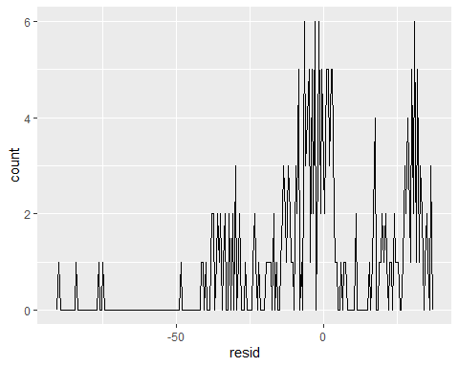

ggplot(table, aes(x, resid)) +   
 geom_ref_line(h = 0) +  
 geom_point()

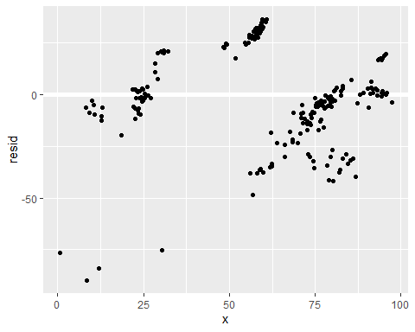

ggplot(table) +   
 geom_point(aes(x, y))



mod2 <- lm(y ~ x, data = table)  
  
grid <- table %>%   
 data_grid(x) %>%   
 add_predictions(mod2)  
grid

## # A tibble: 211 × 2  
## x pred  
## <dbl> <dbl>  
## 1 0.74 94.9  
## 2 8.31 90.1  
## 3 8.44 90.1  
## 4 9.32 89.5  
## 5 9.95 89.1  
## 6 10.5 88.7  
## 7 10.8 88.6  
## 8 12.1 87.8  
## 9 12.7 87.4  
## 10 12.8 87.4  
## # … with 201 more rows

#> # A tibble: 4 x 2  
#> x pred  
#> <chr> <dbl>  
#> 1 a 1.15  
#> 2 b 8.12  
#> 3 c 6.13  
#> 4 d 1.91  
  
ggplot(table, aes(x)) +   
 geom_point(aes(y = y)) +  
 geom_point(data = grid, aes(y = pred), colour = "red", size = 4)

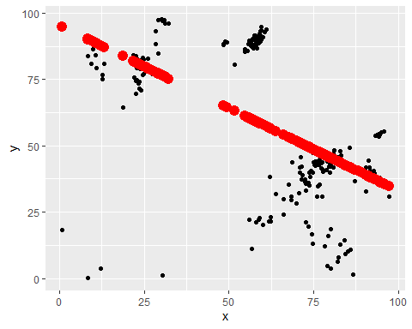

# tibble(x = "e") %>%   
# add_predictions(mod2)  
  
ggplot(table, aes(x, y)) +   
 geom_point(aes(colour = classifier))

## Error in grid.Call(C_textBounds, as.graphicsAnnot(x$label), x$x, x$y, : invalid input 'Na<ef>ve Bayes' in 'utf8towcs'



#> Error in model.frame.default(Terms, newdata, na.action = na.action, xlev = object$xlevels): factor x has new level e  
  
mod1 <- lm(y ~ x + classifier, data = table)  
mod2 <- lm(y ~ x * classifier, data = table)  
  
grid <- table %>%   
 data_grid(x, classifier) %>%   
 gather_predictions(mod1, mod2)  
grid

## # A tibble: 2,110 × 4  
## model x classifier pred  
## <chr> <dbl> <chr> <dbl>  
## 1 mod1 0.74 DecisionTree 85.1  
## 2 mod1 0.74 Logistic Reg 83.9  
## 3 mod1 0.74 Random Forest 106.   
## 4 mod1 0.74 XGBoost 93.6  
## 5 mod1 0.74 Na�ve Bayes 91.5  
## 6 mod1 8.31 DecisionTree 81.1  
## 7 mod1 8.31 Logistic Reg 79.9  
## 8 mod1 8.31 Random Forest 102.   
## 9 mod1 8.31 XGBoost 89.6  
## 10 mod1 8.31 Na�ve Bayes 87.5  
## # … with 2,100 more rows

# # Problematic Code   
# Stuck At The Moment  
# ggplot(table, aes(x, y, colour = classifier)) +   
# geom_point() +   
# geom_line(data = grid, aes(y = pred)) +   
# facet_wrap(~ model)  
  
  
# Leftover Code  
#> # A tibble: 80 x 4  
#> model x1 x2 pred  
#> <chr> <int> <fct> <dbl>  
#> 1 mod1 1 a 1.67  
#> 2 mod1 1 b 4.56  
#> 3 mod1 1 c 6.48  
#> 4 mod1 1 d 4.03  
#> 5 mod1 2 a 1.48  
#> 6 mod1 2 b 4.37  
#> # . with 74 more rows  
  
# ggplot(table, aes(x, y, colour = classifier)) +   
# geom_point() +   
# geom_line(data = grid, aes(y = pred)) +   
# facet_wrap(~ model)  
#   
# best <- optim(c(0, 0), measure_distance, data = table)  
# best$par  
# #> [1] 4.222248 2.051204  
#   
# data_dist <- function(x, y) {  
# measure_distance(c(x, y), table)  
# }  
#   
# models <- models %>%   
# mutate(dist = purrr::map2_dbl(x, y, data_dist))  
# models  
#   
#   
# ggplot(table, aes(x=precision, y=recall)) +   
# geom_point(size = 2, colour = "grey30") +   
# geom_abline(intercept = best$par[1], slope = best$par[2])  
# #ggplot(classifier, aes(color, price)) + geom_boxplot()  
# #ggplot(classifier, diamonds, aes(clarity, price)) + geom_boxplot()  
#   
# ggplot(table, aes(x, y)) +   
# geom_point(size = 2, colour = "grey30") +   
# geom_abline(  
# aes(intercept = a1, slope = a2, colour = -dist),   
# data = filter(models, rank(dist) <= 0)  
# )  
# grid <- expand.grid(  
# a1 = seq(-5, 20, length = 25),  
# a2 = seq(1, 3, length = 25)  
# ) %>%   
# mutate(dist = purrr::map2_dbl(x, y, data_dist))  
#   
# grid %>%   
# ggplot(aes(x, y)) +  
# geom_point(data = filter(grid, rank(dist) <= 10), size = 4, colour = "red") +  
# geom_point(aes(colour = -dist))   
#   
ggplot(foo, aes(x, y, colour = classifier)) +   
 geom_point() +   
 geom_line(data = grid, aes(y = pred)) +   
 facet_wrap(~ model)

## Error in ggplot(foo, aes(x, y, colour = classifier)): object 'foo' not found

foo <- foo %>%   
 gather_residuals(mod1, mod2)

## Error in as.data.frame(data): object 'foo' not found

ggplot(foo, aes(x, y, colour = classifier)) +   
 geom_point() +   
 facet_grid(model ~ classifier)

## Error in ggplot(foo, aes(x, y, colour = classifier)): object 'foo' not found

mod1 <- lm(y ~ x + classifier, data = table)  
mod2 <- lm(y ~ x * classifier, data = table)  
  
# Problematic Code  
# grid <- foo %>%   
# data_grid(  
# x = seq_range(x, 5),   
# y = seq_range(y, 5)   
# ) %>%   
# gather_predictions(mod1, mod2)  
# grid  
  
  
ggplot(foo, aes(x, y)) +   
 geom_tile(aes(y = classifier)) +   
 facet_wrap(~ model)

## Error in ggplot(foo, aes(x, y)): object 'foo' not found

ggplot(foo, aes(x, y, colour= classifier, group = classifier)) +   
 geom_line() +  
 facet_wrap(~ model)

## Error in ggplot(foo, aes(x, y, colour = classifier, group = classifier)): object 'foo' not found

ggplot(foo, aes(y, x, colour = classifier, group = classifier)) +   
 geom_line() +  
 facet_wrap(~ model)

## Error in ggplot(foo, aes(y, x, colour = classifier, group = classifier)): object 'foo' not found

ggplot(foo, aes(x, y)) +   
 geom_tile(aes(fill = classifier)) +   
 facet_wrap(~ model)

## Error in ggplot(foo, aes(x, y)): object 'foo' not found

Chapter 24 Model Building

library(tidyverse)  
library(modelr)  
options(na.action = na.warn)  
  
# library(nycflights13)  
# library(lubridate)  
# 24.2  
ggplot(foo, aes(x, classifier)) + geom_boxplot()

## Error in ggplot(foo, aes(x, classifier)): object 'foo' not found

ggplot(foo, aes(y, classifier)) + geom_boxplot()

## Error in ggplot(foo, aes(y, classifier)): object 'foo' not found

# 24.2.1  
ggplot(foo, aes(x, y)) +   
 geom_hex(bins = 50)

## Error in ggplot(foo, aes(x, y)): object 'foo' not found

ggplot(foo, aes(x, classifier)) +   
 geom_hex(bins = 50)

## Error in ggplot(foo, aes(x, classifier)): object 'foo' not found

ggplot(foo, aes(y, classifier)) +   
 geom_hex(bins = 50)

## Error in ggplot(foo, aes(y, classifier)): object 'foo' not found

foo2 <- foo2 %>%   
 add_residuals(mod_foo, "lclassifier")

## Error in response_var(model): object 'mod_foo' not found

ggplot(foo2, aes(x, lclassifier)) +   
 geom_hex(bins = 50)

## Error in ggplot(foo2, aes(x, lclassifier)): object 'foo2' not found

# grid <- foo2 %>%   
# data_grid(x = seq_range(x), 20)) %>%   
# mutate(x = log2(x)) %>%   
# add_predictions(mod_foo2, "l_x") %>%   
# mutate(x = 2 ^ x)  
  
lm1 <- lm(y ~ classifier, data=foo)

## Error in is.data.frame(data): object 'foo' not found

lm2 <- lm(x ~ classifier, data=foo)

## Error in is.data.frame(data): object 'foo' not found

ggplot(foo, aes(x, y)) +   
 geom_hex(bins = 50) +   
 geom_line(data = foo, colour = "red", size = 1)

## Error in ggplot(foo, aes(x, y)): object 'foo' not found

# foo2 <- foo %>%  
# filter(x <= 1) %>%  
# mutate(l_x = log2(l_x), l_y = log2(y))  
  
# ggplot(foo2, aes(l_x, l_y)) +   
# geom_hex(bins = 50)  
  
mod_foo <- lm(l_x ~ l_y, data = foo2)

## Error in is.data.frame(data): object 'foo2' not found

foo2 <- foo2 %>%   
 add_residuals(mod_foo, "l_y")

## Error in response_var(model): object 'mod_foo' not found

ggplot(foo2, aes(x, l_y)) + geom_boxplot()

## Error in ggplot(foo2, aes(x, l_y)): object 'foo2' not found

ggplot(foo2, aes(y, l_y)) + geom_boxplot()

## Error in ggplot(foo2, aes(y, l_y)): object 'foo2' not found

mod_foo2 <- lm(l_y ~ l_x, data = foo2)

## Error in is.data.frame(data): object 'foo2' not found

grid <- foo2 %>%  
 data_grid(x = seq_range(x, 225)) %>%  
 mutate(l_x = log2(x)) %>%  
 add_predictions(mod_foo2, "l_y") %>%  
 mutate(l_y = log2(y))

## Error in stats::predict(model, data): object 'mod_foo2' not found

foo <- foo %>%   
 add_residuals(mod_foo2, sampling)

## Error in response_var(model): object 'mod_foo2' not found

ggplot(foo2, aes(l_x, "sampling")) +   
 geom_hex(bins = 50)

## Error in ggplot(foo2, aes(l_x, "sampling")): object 'foo2' not found

ggplot(foo2, aes(l_x, classifier)) + geom_boxplot()

## Error in ggplot(foo2, aes(l_x, classifier)): object 'foo2' not found

ggplot(foo2, aes(l_y, classifier)) + geom_boxplot()

## Error in ggplot(foo2, aes(l_y, classifier)): object 'foo2' not found

Chapter 24.2.2

foo = tibble(x=x, y=y, classifier=classifier, sampling=sampling, technique=technique)  
 mod_foo <- lm(y ~ x + classifier + sampling + technique, data = foo)  
  
grid <- foo %>%   
 data_grid(classifier, .model = mod_foo) %>%   
 add_predictions(mod_foo)   
grid

## # A tibble: 30 × 5  
## classifier x sampling technique pred  
## <chr> <dbl> <chr> <chr> <dbl>  
## 1 Na�ve Bayes 62.3 Undersampling N/A 65.7  
## 2 Na�ve Bayes 62.3 Undersampling NearMiss 64.5  
## 3 Na�ve Bayes 62.3 Undersampling ROS 50.1  
## 4 Na�ve Bayes 62.3 Undersampling RUS 54.8  
## 5 Na�ve Bayes 62.3 Undersampling SMOTE 65.7  
## 6 Na�ve Bayes 62.3 Undersampling Tomelinks 65.7  
## 7 DecisionTree 62.3 Undersampling N/A 59.7  
## 8 DecisionTree 62.3 Undersampling NearMiss 58.5  
## 9 DecisionTree 62.3 Undersampling ROS 44.1  
## 10 DecisionTree 62.3 Undersampling RUS 48.8  
## # … with 20 more rows

ggplot(grid, aes(x, pred)) +   
 geom_point()

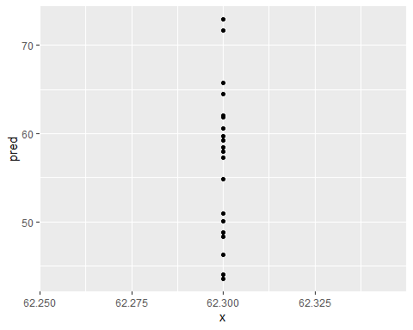

#> # A tibble: 5 x 5  
#> cut lcarat color clarity pred  
#> <ord> <dbl> <chr> <chr> <dbl>  
#> 1 Fair -0.515 G VS2 11.2  
#> 2 Good -0.515 G VS2 11.3  
#> 3 Very Good -0.515 G VS2 11.4  
#> 4 Premium -0.515 G VS2 11.4  
#> 5 Ideal -0.515 G VS2 11.4  
  
ggplot(grid, aes(classifier, pred)) +   
 geom_point()

## Error in grid.Call(C_textBounds, as.graphicsAnnot(x$label), x$x, x$y, : invalid input 'Na<ef>ve Bayes' in 'utf8towcs'

# 24.2.2  
  
 foo <- foo %>%   
 add_residuals(mod_foo, "lclassifier")  
  
 ggplot(foo, aes(x, lclassifier)) +   
 geom_hex(bins = 50)

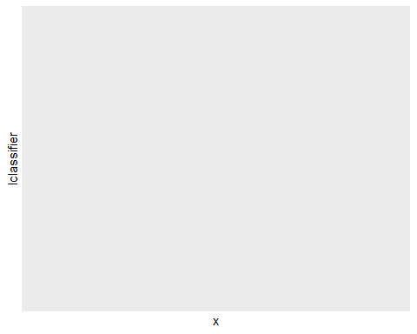

foo <- foo %>%   
 add_residuals(mod_foo)  
  
  
ggplot(foo, aes(x, classifier)) +   
 geom_line()

## Error in grid.Call(C_textBounds, as.graphicsAnnot(x$label), x$x, x$y, : invalid input 'Na<ef>ve Bayes' in 'utf8towcs'



#   
# foo2 %>%  
# filter(abs(l_x) > 1) %>%  
# add_predictions(mod_foo) %>%  
# mutate(pred = pred) %>%  
# select(l_x, pred, l_y:all_of(foo), x:y) %>%  
# arrange(x)

Chapter 24.3

ggplot(foo, aes(x, classifier)) +   
 geom_line()

## Error in grid.Call(C_textBounds, as.graphicsAnnot(x$label), x$x, x$y, : invalid input 'Na<ef>ve Bayes' in 'utf8towcs'

ggplot(foo, aes(y, classifier)) +   
 geom_line()

## Error in grid.Call(C_textBounds, as.graphicsAnnot(x$label), x$x, x$y, : invalid input 'Na<ef>ve Bayes' in 'utf8towcs'

ggplot(foo, aes(x, y)) +   
 geom_line()

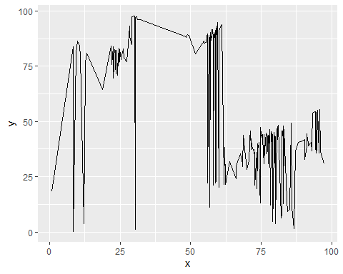

Chapter 24.3.1

ggplot(foo, aes(classifier, x)) +   
 geom_boxplot()

## Error in grid.Call(C_textBounds, as.graphicsAnnot(x$label), x$x, x$y, : invalid input 'Na<ef>ve Bayes' in 'utf8towcs'

ggplot(foo, aes(classifier, y)) +   
 geom_boxplot()

## Error in grid.Call(C_textBounds, as.graphicsAnnot(x$label), x$x, x$y, : invalid input 'Na<ef>ve Bayes' in 'utf8towcs'

mod <- lm(x ~ classifier, data = foo)  
  
  
grid <- foo %>%   
 data_grid(classifier) %>%   
 add_predictions(mod, "x")  
  
ggplot(foo, aes(classifier, x)) +   
 geom_boxplot() +  
 geom_point(data = grid, colour = "red", size = 4)

## Error in grid.Call(C_textBounds, as.graphicsAnnot(x$label), x$x, x$y, : invalid input 'Na<ef>ve Bayes' in 'utf8towcs'

foo <- foo %>%   
 add_residuals(mod)  
  
foo %>%   
 ggplot(aes(y, resid)) +   
 geom_ref_line(h = 0) +   
 geom_line()

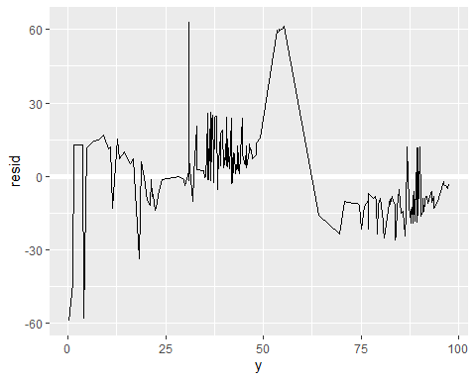

ggplot(foo, aes(y, resid, colour = classifier)) +   
 geom_ref_line(h = 0) +   
 geom_line()

## Error in grid.Call(C_textBounds, as.graphicsAnnot(x$label), x$x, x$y, : invalid input 'Na<ef>ve Bayes' in 'utf8towcs'

foo %>%   
 ggplot(aes(y, resid)) +   
 geom_ref_line(h = 0) +   
 geom_line(colour = "grey50") +   
 geom_smooth(se = FALSE, span = 0.20)

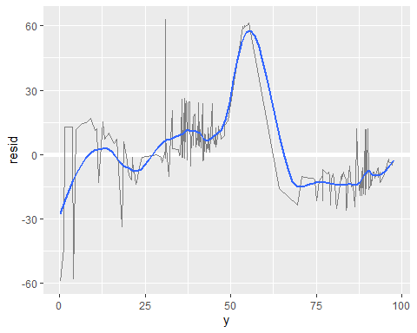

foo %>%   
 filter(classifier == "XGBoost") %>%   
 ggplot(aes(x, y)) +   
 geom_point() +   
 geom_line()

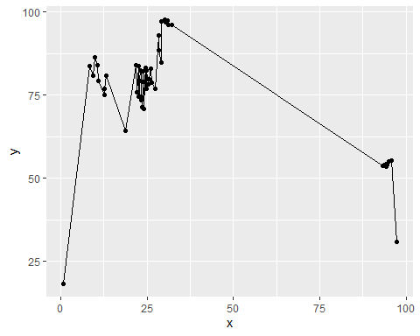

foo %>%   
 filter(classifier == "DecisionTree") %>%   
 ggplot(aes(x, y)) +   
 geom_point() +   
 geom_line()

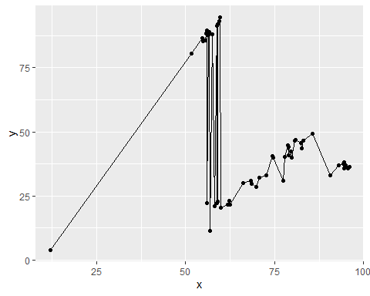

foo %>%   
 filter(classifier == "Logistic Reg") %>%   
 ggplot(aes(x, y)) +   
 geom_point() +   
 geom_line()

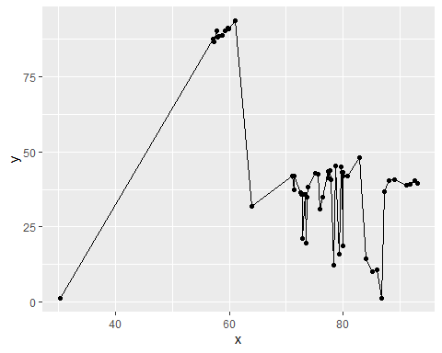

foo %>%   
 ggplot(aes(x, y, colour = classifier)) +  
 geom_boxplot()

## Error in grid.Call(C_textBounds, as.graphicsAnnot(x$label), x$x, x$y, : invalid input 'Na<ef>ve Bayes' in 'utf8towcs'

mod3 <- lm(x ~ classifier, data = foo)  
mod4 <- lm(y ~ classifier, data = foo)  
  
foo %>%   
 gather_residuals(precision = mod3, recall = mod4) %>%   
 ggplot(aes(x, resid, colour = model)) +  
 geom_line(alpha = 0.75)

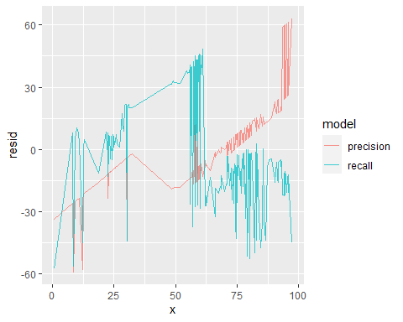

grid <- foo %>%   
 data_grid(x, classifier) %>%   
 add_predictions(mod2, "x")  
  
ggplot(foo, aes(classifier, x)) +  
 geom_boxplot() +   
 geom_point(data = grid, colour = "red") +   
 facet_wrap(~ classifier)

## Error in grid.Call(C_textBounds, as.graphicsAnnot(x$label), x$x, x$y, : invalid input 'Na<ef>ve Bayes' in 'utf8towcs'

library(splines)  
mod6 <- MASS::rlm(x ~ classifier, data = foo)  
  
foo %>%   
 add_residuals(mod6, "resid") %>%   
 ggplot(aes(y, resid)) +   
 geom_hline(yintercept = 0, size = 2, colour = "white") +   
 geom_line()

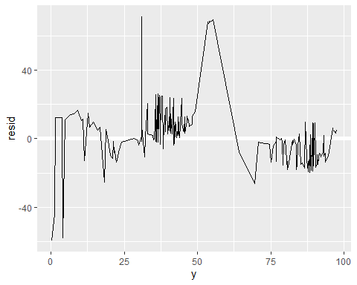

foo %>%   
 data_grid(y, classifier) %>%   
 add_predictions(mod6) %>%   
 ggplot(aes(y, pred, colour = classifier)) +   
 geom_line() +  
 geom_point()

## Error in grid.Call(C_textBounds, as.graphicsAnnot(x$label), x$x, x$y, : invalid input 'Na<ef>ve Bayes' in 'utf8towcs'



Chapter 25.1

foo %>%   
 ggplot(aes(x, y, group = classifier)) +  
 geom_line(alpha = 1/3)

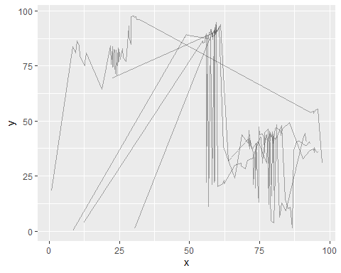

xg <- filter(foo2, classifier == "XGBoost")

## Error in filter(foo2, classifier == "XGBoost"): object 'foo2' not found

xg %>%   
 ggplot(aes(x, y)) +   
 geom_line() +   
 ggtitle("XGBoost Full Data ")

## Error in ggplot(., aes(x, y)): object 'xg' not found

xg_mod <- lm(x ~ y, data = foo)  
xg %>%   
 add_predictions(xg_mod) %>%  
 ggplot(aes(classifier, pred)) +   
 geom_line() +   
 ggtitle("XGBoost Linear trend + ")

## Error in predict.lm(model, data): object 'xg' not found

xg %>%   
 add_residuals(xg_mod) %>%   
 ggplot(aes(x, resid)) +   
 geom_hline(yintercept = 0, colour = "white", size = 3) +   
 geom_line() +   
 ggtitle("Precision Remaining pattern")

## Error in as.data.frame(data): object 'xg' not found