Hotel

Name: President

Description

Located on famous Central Avenue, our downtown San Jose hotel is walking distance to the city's shopping, dining and cultural landmarks, including the National Theater, National Museum, Gold Museums, Costa Rican Congress, Plaza de La Cultura and the National Cathedral. Go explore Costa Rica's national parks, towering volcanoes, beautiful beaches and natural wonders.

Amenities

Casino Cafeteria

Wi-Fi Spa

Wake Up Calls Bar/Lounge

Room Supervised Child Care ($)

Guest Garage Parking Access to computers, Printer, Fax, Copier

Airport Transfers

Room

**Standard Room**

designed for relaxation, 215 - 375 square feet of comfortable living and working space with a 32" LCD TV with 52 premium channels, spacious bathroom, mini bar, laptop-size safes, WiFi, desk or dinning tables, telephones with voicemail, and one king bed or two beds

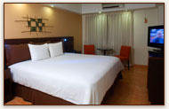

**Junior suite**

Junior Suites offer 500 - 650 square feet of spaces to unwind, work and spread out. These spacious San Jose accommodations features separate living room and bedroom areas with 32" LCD TV, spacious bathroom, laptop size safes, mini bar, and

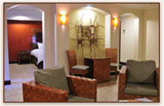all our signature amenities. Enjoy a restful night's sleep in the plush king-size bed with premium mattress and high thread count linens.

**Spa Room**

Spa Rooms are designed for relaxation, comfort and rejuvenation. This spacious 480 foot square foot room features comfortable king bed or two full beds, premium mattress and high thread linens, 32" LCD TV, wireless internet, work desk, and , laptop size safe. Slip into lavish bathrooms with a two-person Jacuzzi and mix a refreshing cocktail from the mini bar and relax in the lovely lounging area.

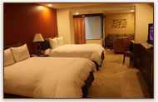

**Gran Spa Suite**

Rates the life of luxury and relaxation awaits you in our Grand Spa Suites, featuring 650 square feet of lavish living and lounging space. Contemporary color plates and chic, modern furniture define these lovely urban retreats. Grand Spa Suites feature a plush king bed with premium mattress and high thread count linens and a luxurious bathroom with a glass enclosed, two-person Jacuzzi. Relax with a drink from the mini bar in the comfortable living room. Watch a movie on the 32" LCD TV, and savor views of San Jose's Central Mountain chain.

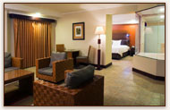

Rates **2015**

|  |  |  |  |
| --- | --- | --- | --- |
| SINGLE AND DOUBLE ROOM | HIGH SEASON GREEN SEASON PEAK SEASON |  |  |
| Standard Room | $ 86.00 $ 86.00 $ 86.00 |  |  |
| Junior Suite | $109.00 $109.00 $109.00 |  |  |
| Spa Room | $121.00 $121.00 $121.00 |  |  |
| Gran Spa Suite | $136.00 $136.00 $136.00 |  |  |
|  |  |  |  |
|  |  |  |  |

Rates do not include 13 % tax.

Extra person 20%

Check in 2:00 p.m. Check Out 12:00 p.m.

**CHILD POLICY**

In 3-9 years, a surcharge of $ 8.00 plus tax ( 23 % ) is charged by way of

breakfast. From 10 years is considered an adult fare .