Inferring the intrinsic mutational fitness landscape of influenza-like evolving antigens from yearly protein sequence data

Julia Doelger, Mehran Kardar, Arup K. Chakraborty May 3, 2021

# Introduction

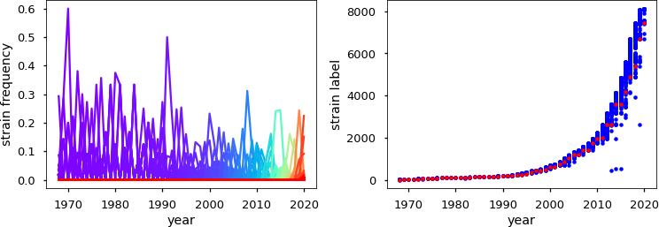

Figure 1: Strain succession for the evolution of HA (H3N2) sequences between 1968 and 2020. (left) Each unique HA sequence (strain) is shown with its observed frequency in each year as a solid line, with line colors ranging from purple (old strains) to red (new strains). (right) Strain labels here are counted from old strains (low labels) to new strains (high labels). The respective strain, which is the most prevalent in each year is marked as red circle. Blue circles indicate strains that were observed with some non-zero frequency.

Global seasonal influenza epidemics are caused by influenza A and B viruses that, although being effectively targeted by human immune responses and long- term immune memory, are able to persistently escape the population-wide im- mune memory via sequence mutations [Petrova and Russell, 2018]. The domi- nantly targeted antigen of influenza virus is the glycoprotein HA that is located on the viral surface together with the other surface glycoprotein NA, which also acts as antigen. HA is responsible for binding to sialic acid on human cell surfaces and it thereby enables viral cell entry. The human immune sys- tem produces antibodies, which primarily bind to different regions (epitopes)

on HA thereby blocking the virus from cell attachment and entry. There are 5 dominant and easily accessible epitope regions on the head of HA that have been identified in the circulating subtype H3, which are labeled with the let- ters A-E [Wiley et al., 1981, Skehel et al., 1984]. These also represent the parts of the protein sequence, where the virus predominantly produces amino acid substitutions that abrogate antibody binding and thus lead to immune escape [Gerhard et al., 1981].

These interlinked dynamics of the mutating virus and responding human im- munity cause a gradual evolution of the viral antigen that is known as antigenic drift [Smith et al., 2004], which leads to characteristic strain succession patterns in seasonal influenza (Fig. 1). Antigenic drift is also responsible for the fact that there is currently no long-term protective vaccine against seasonal influenza and why still around half a million people die globally from influenza infection [Carrat and Flahault, 2007]. Therefore it is important to create more effective vaccines and other immunization strategies, which target the virus where it is most vulnerable.

Even for the currently widely used seasonally updated influenza vaccines, the choice of vaccine strains is not trivial. For best efficacy one needs to make ac- curate predictions of the viral strains that will be prevalent in the future, based on past and current sequence information. Every year the WHO uses detailed information from international laboratories and worldwide experts to create rec- ommendations on the composition of the influenza virus vaccine [WHO, 2021], but many seasonal vaccines still have a low effectivity compared to other viral vaccines. Thus many computational and experimental efforts are undertaken, which exclusively work on the task of analyzing and predicting the evolution of influenza antigenic sequences, with the goal of making seasonal vaccines

more effective [Smith et al., 2004, Koel et al., 2013, L- uksza and L¨assig, 2014,

Neher et al., 2014, Bedford et al., 2014, Li et al., 2016, Hadfield et al., 2018]. But, although periodically updated vaccinations are continually improved and are currently the most effective method for preventive control of seasonal influenza epidemics, such relatively short-term predictions do generally not lead to long- term effective treatment plans [Paules et al., 2017].

Other approaches aim for cross-protective influenza treatments that are effec- tive against a wide range of strains. Such approaches typically consider strongly conserved epitopes like the receptor binding site (RBS) or the stem of HA which are both shielded to a certain extent by the more easily targetable head epitopes of the protein [Raj˜ao and P´erez, 2018, Throsby et al., 2008, Ekiert et al., 2011,

Corti et al., 2011, Dreyfus et al., 2012, Yamayoshi et al., 2017, Brandenburg et al., 2013,

Ekiert et al., 2012, Schmidt et al., 2015, Whittle et al., 2011]. These methods are complicated by the lower accessibility of the targeted regions to antibodies, and specialized methods for sophisticated vaccine protocols and drug designs are being developed to target these hidden protein regions [Steel et al., 2010,

Yassine et al., 2015, Lu et al., 2014, Impagliazzo et al., 2015, Krammer et al., 2013, Hai et al., 2012, Nachbagauer et al., 2014, Eggink et al., 2014, Strauch et al., 2017, Kadam and Wilson, 2018, Amitai et al., 2020]. Additionally, it is for such mu- tationally conserved sites generally not known if they are functionally conserved

such that escape mutations are unviable or if they so far exhibited less amino acid substitutions, mainly because they are typically under a lower immune pres- sure than the exposed HA head epitopes [Amitai, 2020, Amitai et al., 2020]. If the latter is true, those regions might not stay conserved for long if they are heavily targeted by new preventive treatments and if the virus can easily pro- duce escape mutations.

Although the easily accessible sites on the head of HA are found to generally quickly escape human immune memory via amino acid substitution, mutations at some of those strongly targeted sites will be functionally more costly to the virus. For a long-term protective immunization approach it therefore would be useful to find and target primarily those sites on the HA head that are most vulnerable, i.e. that have difficulty finding viable mutational escape routes. We can further imagine targeting several sites simultaneously by specifically designed multi-clonal immune responses. In this case it would be useful to choose such combinations of sites as targets, which together are most vulnerable, and do not easily allow the combinations of mutations that lead to escape from the simultaneous responses. The information about the cost of such single and combined mutations at different protein sites is encoded in the intrinsic mutational fitness landscape of the viral sequence.

Previous studies were able to use equilibrium thermodynamics methods and an approach called Adaptive Cluster Expansion (ACE) to computationally infer intrinsic mutational fitness landscapes for other highly mutable viruses, HIV as

well as polio, from sequence prevalence data [Dahirel et al., 2011, Ferguson et al., 2013, Shekhar et al., 2013, Mann et al., 2014, Barton et al., 2016b, Butler et al., 2016, Chakraborty and Barton, 2017, Louie et al., 2018, Barton et al., 2019, Quadeer et al., 2020,

Cocco and Monasson, 2011, Barton et al., 2016a]. The result of such fitness inference was used to propose a novel cross-protective immunization method against HIV using multidimensionally conserved parts of the proteome, which is currently in clinical development [Murakowski et al., 2021]. Seasonal influenza evolves very differently in the human population than HIV. Since it is targeted by a population-wide immune memory that continually catches up with the viral evolution, it is permanently driven away from past strains as opposed to HIV, which evolves much more freely in its sequence landscape and is able to periodically revisit old strains [Pompei et al., 2012]. This immune-driven, non-equilibrium nature of influenza evolution requires a different method for the inference of the intrinsic mutational fitness landscape than the equilibrium methods that were successful for HIV.

Recently a marginal path likelihood (MPL) method has been proposed for

the inference of mutational fitness effects from sequence time series [Sohail et al., 2020]. However, this method considers selection due to a fitness landscape that is as- sumed to be time-invariant, and it does not try to disentangle intrinsic from immune-mediated fitness effects. The assumption of time-invariance of total fit-

ness is not true for seasonal influenza evolution in the human population, since the population-wide immune-memory against each emerging mutant accumu- lates with every season and thus creates an ever changing fitness landscape that depends on the viral evolutionary history.

Here we present a new method, with which we can infer the single and pairwise mutational intrinsic fitness costs from population-level sequence time series of an influenza-like evolving antigen. We test our inference approach on computer simulations and propose its application to investigate yearly protein sequence time series data from influenza A/H3N2, in order to obtain combina- tions of vulnerable antibody targets.

# Model of influenza antigen evolution

In our model of influenza evolution, we assume that at the beginning of a flu season a population *N*pop of viral units enters a human population. The distri- bution of unique antigenic sequences (strains) in the viral population is assumed with the observed frequency of sequences in the previous season. For simplicity we treat mutation and fitness-based selection as separate steps in each season. Each viral unit, before spreading in the new season, is allowed to mutate into a different sequence with a certain probability, which depends on the viral muta- tion rate and the number of viral generations between flu seasons.

During the spread of viral infections in a season, each strain *Sj* is assumed to grow exponentially with a fitness (growth rate) *F* (**S***j, t*). If the frequency of strain **S***j* after random mutation is given as *x*m(**S***j, t*), its probability (=expected frequency) to survive into the next season after growth and selection is calculated as

exp (*F* (**S***j, t*)) *x*m(**S***j, t*)

*p*(**S***i, t* + 1) = exp (*F* (**S** *, t*)) *x*

*i*

*i*

*.* (1)

(**S** *, t*)

m

*i*

In the end of each season a fixed number *N*pop of sequences survive into the next year and we sample the number *N* (**S***j, t*) of selected sequences for each strain from a multinomial distribution with probabilities given by Eq. 1.

The viral fitness *F* (**S***j,* **x**(*t*l *< t*)) = *F*int(**S***j*) + *F*host(**S***j,* **x**(*t*l *< t*)) is com- posed of two components, the intrinsic fitness *F*int(**S***j*) of strain **S***j* that signifies

the intrinsic ability of a virus with that strain identity to spread in a completely susceptible human population, and a fitness cost *F*host(**S***j,* **x**(*t*l *< t*)) *<* 0 that depends on the accumulated amount of immune memory in the human host population against that specific strain until time *t*.

The first, intrinsic fitness component, which is time-invariant is modeled with an Ising-type representation as

*F*int(**S***j*) = *F*0 + *hαsα* + *Jαβsαsβ.* (2)

*α*

*α<β*

*j*

*j*

*j*

*j*

Here *F*0 represents the intrinsic fitness of a reference strain, the second term rep- resents the fitness change due to independent mutations at each site *α* compared to the reference strain (*sα* = 0 if unmutated, 1 otherwise), and the last term represents the additional fitness change due to coupled mutations at pairs of sites *α* and *β*. The single-mutation coefficients *hα* and the mutational coupling

coefficients *Jαβ* describe the intrinsic mutational fitness landscape, which we would like to infer from the sequence data. This fitness landscape determines, how easy or difficult it is for the virus to create escape mutations if specific sites or pairs of sites are targeted by a host response. Note, that by using this Ising- type approximation of the intrinsic fitness landscape with single mutations and pairwise mutational couplings with respect to a reference sequence, we reduce the number of fitness parameters for binary sequences with length *L* = 20 from 2*L* = 1048576 unique strains to *L* (*L* + 1)*/*2 = 210 fitness parameters *h, J* .

· { }

The host-dependent fitness component describes the decrease in the rate of spread of infections in a less susceptible population due to immune memory accumulated against each respective strain from previous infections. This com- ponent depends on the evolutionary history of the viral population and in our model it is calculated with a functional form similar to that previously used in other influenza evolutionary models [L- uksza and L¨assig, 2014], i.e.

*F*host(**S***j,* **x**(*t*l *< t*)) = −*σ*h *x*(**S***i, t*l) exp −|**S**ep − **S**ep|*/D*0 *.* (3)

*t*I*<t*

*i*

*j*

*i*

This immune-mediated fitness decreases the strain fitness over time and is pro- portional to the prevalence *x*(**S***i, t*l) of antigenically similar strains **S***i* in pre- vious years *t*l. This accumulating fitness cost forces the virus to continuously evolve away from previously prevalent sequences. Here |**S**ep − **S**ep| describes the

mutational (Hamming) distance between strain **S***i* and **S***j* within their immune-

*j*

*i*

targeted epitope regions and *D*0 is the cross-immunity distance, i.e., the typical mutational distance within epitope regions, beyond which two strains are dis- similar enough to not be targeted by immune responses that were raised against the respective other.

The main motivation for the development of our model is to infer the intrinsic mutational fitness landscape of seasonal influenza, i.e., the goal is to use our model to infer the intrinsic fitness coefficients *h, J* from yearly observations of antigenic strain frequencies, in order to learn about the vulnerability to immune targeting of different single and pairs of protein sites.

{ }

On this account we developed an inference approach, which we test on computer-generated data that we produce via simulation of our sequence evo- lution model with a known fitness landscape.

Under a range of parameter choices, our simulations produce influenza-like immune-driven strain succession patterns, which are qualitatively similar to those observed for the evolution of HA (H3N2) in the human population (Figs. 1 and 2). This similarity indicates that our model is able to capture the essential dynamics of antigenic evolution in seasonal influenza. One difference in these figures (Figs. 1B and 2B) is the approximately exponential increase of total sequence diversity in strains based on full HA amino acid sequence data versus the more linear increase of total sequence diversity in a simulation of binary sequences of length 20. This dependence of strain diversity growth on various parameters and its underlying mechanism should be further investigated when translating our procedures to infer the fitness landscape of influenza.

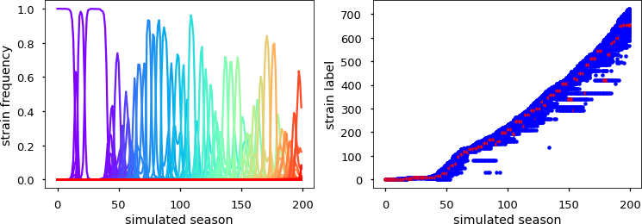

Figure 2: Strain succession for the evolution of simulated data over 200 time steps. (left) Each unique sequence (strain) is shown with its observed frequency in each simulated season as a solid line, with line colors ranging from purple (old strains) to red (new strains). (right) Strain labels here are counted from old strains (low labels) to new strains (high labels). The respective strain, which is the most prevalent in each simulated season is marked as red circle. Blue circles indicate strains that were observed with some non-zero frequency. For the shown example the parameter values for simulation and analysis are:

*N*pop = 105, *L* = 20, *µ* = 10−4, *σ*h = 1, *D*0 = 5, *N*simu = 200, *B* = 103.

# Inference of intrinsic fitness coefficients for single and pairwise mutations from influenza- like sequence data

Our fitness inference approach is based on the assumption that the selection of strains that survive into the next year is very stringent in each season. Strin- gent selection in our case means that only sequences in a very narrow fitness range around the currently fittest strain survive into the next season. With this assumption all strains **S***j*(*t*) that are observed, i.e. selected, in a given season *t* will have similar total fitness. Thus we assume

*F* (**S***j,* **x**(*t*l *< t*)) ≈ *F* (*t,* **x**(*t*l *< t*)) (4)

with *F* (*t,* **x**(*t*l *< t*)) being a constant for each season *t*, conditional on the specific evolutionary history **x**(*t*l *< t*). From this assumption we obtain the following relation for the observed strains **S***j* in each given year, i.e.,

−*F*host(**S***j,* **x**(*t*l *< t*)) ≈ *hαsα* + *Jαβsαsβ* + *F* ∗(*t,* **x**(*t*l *< t*))*,* (5)

*α*

*α<β*

−

*j*

*j*

*j*

where *F* ∗(*t,* **x**(*t*l *< t*)) = *F*0 *F* (*t,* **x**(*t*l *< t*)) is another constant at time *t*, conditional on the evolutionary history until *t*. If we approximate the evolu- tionary history **x**(*t*l *< t*) with the observed strain frequencies starting from the first year of observation and assume the model parameters *σ*h and *D*0 to

be known, e.g. as fit parameters to dependent cross-immunity studies, we can calculate *F*host(**S***j,* **x**(*t*l *< t*)) for each observed strain in each season. We use these host-dependent fitness values together with Eq. (5) to infer the intrinsic fitness coefficients *h, J* as well as the additional parameters *F* ∗ (one ad-

{ } { }

ditional parameter per season). We here treat *Ft*∗ as independent parameters,

although they generally depend on other model parameters and on evolutionary

history via the full path integral of the system. Finally we are mainly inter- ested in the coefficients *h, J* , which describe the intrinsic mutational fitness landscape of the virus. For the regression we minimize the sum of squared resid- uals between the data *Y*data(**S***j, t*) given by the LHS of Eq. (5) and the model *Y*model(**S***j, t,* {*h, J, F* ∗}) given by the RHS of Eq. (5), i.e.,

{ }

{*h, J, F* ∗} = arg min

 1 (*Y*

data

(**S***j, t*) − *Y*

model

(**S***j, t,* {*h, J, F* ∗}))2

{*h,J,F* ∗}

2

*j*

+ *λh h*2 + *λJ J* 2

2

*α*

2

*αβ*

*α*

*α<β*

+ *λF* ∗ *F* ∗2 *,* (6)

*t*I

where we also take into account regularization with coefficients *λh, λJ , λF* ∗ that are based on different Gaussian prior distributions for each type of coefficient.

2

*t*I

Table 1: Parameters for simulation of influenza-like sequence evolution and for intrinsic fitness inference

|  |  |  |
| --- | --- | --- |
| Parameter | Description | Values |
| {*h, J* } | fitness coefficients for single mutations and pair-  wise mutational couplings | values  from HIV protein p24 |
| *L* | length of sequence representation | [5*,* 100] |
| *µ* | mutation rate (per sequence site) | 10−4 |
| *D*0 | cross-immunity distance | 5 |
| *N*pop | population size | [10*,* 106] |
| *σ*h | host-fitness coefficient | 1 |
| {*λh, λJ , λF* ∗ } | regularization coefficients for inference | {0*,* 1*,* 0} |
| *n*seasons | number of years/seasons used for inference | [10, 100] |
| *B* | number of sampled sequences per year | [10*,* 106] |

The parameters for simulation and inference with explored values and ranges are collected in Tab. (1). For the simulations we used as input a set of fitness coefficients *h, J* , the values of which we chose from previously inferred mu- tational fitness coefficients of HIV protein p24 [Mann et al., 2014][include and refer to SI file with used fitness parameters]. We used a fixed population size, to which the number of viral units was reduced at the beginning of each season. The evolution in the simulation starts at the unmutated reference sequence at season 0 and we ran each simulation for 200 seasons. For inference we used

{ }

data from a number *n*seasons of seasons, without including the first 100 seasons, and for analysis we subsampled a number *B* of sequences per season. Muta- tion was assumed with a probability *µ* (per season) to mutate between the two mutational states per site.

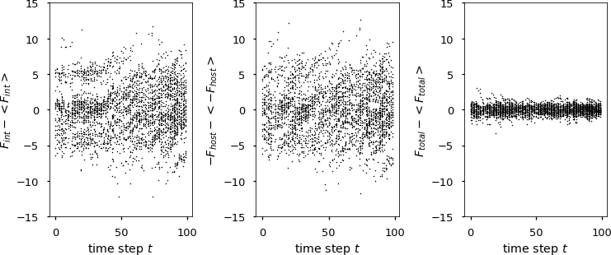

Figure 3: Fitness deviations from the mean of selected strains for each sim- ulated season between season 100 and 200. (left) intrinsic fitness component *F*int, (middle) immune-dependent fitness component *F*host, (right) total fitness *F*total = *F*int +*F*host. For the shown example the parameter values for simulation

and analysis are: *N*pop = 105, *L* = 20, *µ* = 10−4, *σ*h = 1, *D*0 = 5, *N*simu = 200,

*B* = 103.

For an example set of sampled data from one simulation we see that the distribution of total fitness is more narrow than the distributions of the intrinsic and immune-dependent fitness components (Fig. 3), which indicates that the stringent selection assumption, which our inference approach depends on, seems valid for this specific computer-generated data set.

For each set of computer-generated and subsampled sequence data, we com- pared the inferred with the simulated intrinsic fitness coefficients (Fig. 4). The correlation coefficients between simulated and inferred coefficients and in par- ticular the Pearson correlation *rhJ* between the total fitness effects of double mutations indicates if the specific fitness inference on the particular sequence data set can successfully distinguish between pairs of sites, at which escape mutations lead to either low or high (negative) fitness costs.

Besides the correlation coefficient *rhJ* we use another measure for inference performance, if we are only interested in identifying those pairs of sites that have the most deleterious fitness effect, i.e. those whose fitness cost is below a certain threshold with

*hα* + *hβ* + *Jαβ < F*threshold *<* 0*.* (7)

In this case we can use typical classification performance measures to assess how well our inference method can distinguish between deleterious and more neutral or beneficial double mutations.

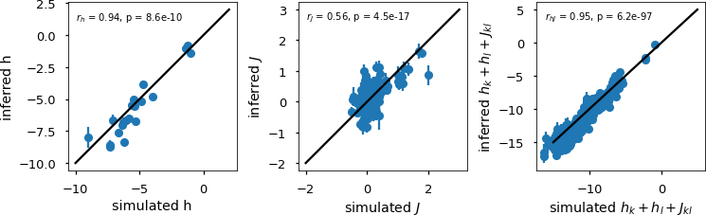

Figure 4: Parameter correlations for the inference on one simulated data set. Inferred values of the fitness coefficients are shown against the fitness coefficients that were used as input values for the simulation. (left) single-site mutational fitness coefficients *h*, (middle) coupling coefficients *J* for simultaneous mutations at any two sites, (right) total fitness changes *hk* + *hl* + *Jkl* due to simultaneous mutations at any two sites *k* and *l*. Pearson correlation coefficients *r* together with their respective p values are shown in each panel for the respective set of parameters. For the shown example the parameter values for simulation and

analysis are: *N*pop = 105, *L* = 20, *µ* = 10−4, *σ*h = 1, *D*0 = 5, *N*simu = 200,

3

*B* = 10 , *n*seasons = 100, *λh* = 0, *λJ* = 1, *λF* ∗ = 0.

We compare the classification of each pair (based on the inferred coefficients) with the classification of the simulation input values by calculating the precision- recall curve (PRC) as well as the receiver operating characteristic curve (ROC) and the respective areas under the curves (AUC) (Fig. 5), which approach 1 in the case of perfect classification skill.

When calculating the inference performance for one simulation with sequence length *L* = 20 in terms of correlation *rhJ* and classification performance (AUC) for various sample sizes (Fig. 6), we find that a minimum total number of sampled strains *n*sample = *n*seasons *B* is required for accurate inference. In the shown example a total sample size of *n*sample 105 strains is required for high inference performance.

≥

∗

The inference performance further strongly depends on the sequence length *L* (Fig. 7A) and on the population size *N*pop (Fig. 7B). Inference performance in terms of the correlation *r*hJ between inferred and simulated double-mutational fitness coefficients decreases with increasing sequence dimension and increases with increasing population size towards its upper limit 1.

# Discussion

We here presented a method for inferring the intrinsic mutational fitness land- scape of influenza-like antigens from population-level protein sequence time se- ries. Our approach is able to infer single as well as pairwise mutational effects for binary sequences with several tens of sites. By simulating the influenza

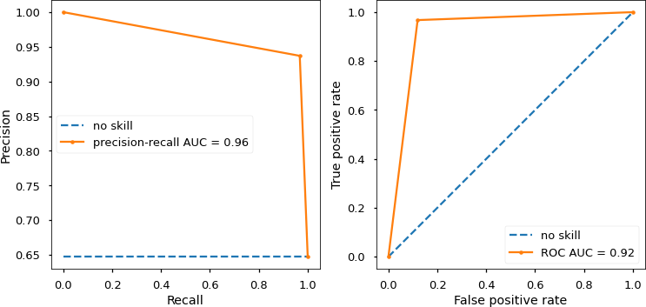

Figure 5: Classification performance for the inference on one simulated data set. Double mutations are classified as deleterious if their total fitness cost is lower than *F*threshold = 10. (left) The precision-recall curve (PRC) and (right) the ROC curve for the deleterious-mutation classifier from inferred fitness coefficients. Blue, dashed lines show a no-skill classifier for comparison and the area under the classifier curve (AUC) is given in each panel, respectively. For the shown example the parameter values for simulation and analysis are:

−

*N*pop = 105, *L* = 20, *µ* = 10−4, *σ*h = 1, *D*0 = 5, *N*simu = 200, *B* = 103,

*n*seasons = 100, *λh* = 0, *λJ* = 1, *λF* ∗ = 0, *F*threshold = −10.

evolutionary dynamics, we were able to analyze inference performance under different conditions such as for various sequence lengths and sample sizes. Our inference approach only relies on the raw strain frequency data as function of time and does not depend on a separate inference of sequence phylogenies, as opposed to other analyses [L- uksza and L¨assig, 2014, Neher et al., 2014]. We propose this approach for the inference of the intrinsic mutational fitness land- scape of seasonal influenza based on the HA spike protein (A/H3N2), for which global sequence data since 1968 are available.

In comparison to the recently proposed marginal path likelihood method (MPL) for sequence time series [Sohail et al., 2020], we were able to disentangle time-varying immune-dependent fitness effects from the intrinsic fitness, and we not only inferred the fitness effects of single mutations but also of double muta- tions at pairs of sites. The MPL method further considers a Wrightian fitness description, i.e. it models the growth linear with fitness between selection steps. For influenza evolution on the human population level, we instead assume that viral populations grow largely independently, exponentially with fitness, over many generations between the selection bottlenecks that happen at the end of flu seasons. Therefore we here use a Malthusian growth description ( exp(*F* )). The MPL method in particular is found to obtain improved inference perfor- mance compared to previous methods that do not take into account genetic

∼

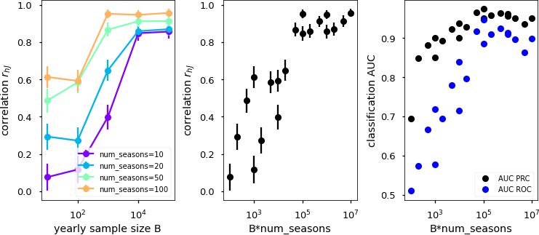

Figure 6: Inference performance for varying yearly sample size *B* per season and varying number *n*seasons of seasons used for inference. (left) The correlation coefficient *rhJ* between inferred and simulated double-mutational fitness costs as function of yearly sample size *B* for various *n*seasons. (middle) The performance measure *rhJ* as function of total sample size *B n*seasons. (right) The area (AUC) under the ROC curve and under the precision-recall curve (PRC) for

∗

classification of deleterious double mutations with *F*threshold = −10, shown as function of total sample size *B n*seasons. For the shown example the fixed parameter values for simulation and analysis are: *N*pop = 105, *L* = 20, *µ* = 10−4, *σ*h = 1, *D*0 = 5, *N*simu = 200, *λh* = 10−4, *λJ* = 1, *λF* ∗ = 10−4.

∗

linkage effects like hitchhiking or clonal interference [Sohail et al., 2020]. Since we use whole-sequence information together with sequence-observation time we also account for genetic linkage and clonal interference or hitchhiking are not expected to strongly pollute our inference results. However, we do not use the exact path integral description for fitness inference, as opposed to MPL, which is why our more empirical inference method is limited to certain parameter regimes with strong immune-driven selection.

In order to make meaningful predictions based on observed influenza protein sequence data, our inference approach needs to be translated to this more com- plex system, which generally has a high-dimensional sequence landscape with around hundred residues in the head epitope regions of HA (A/H3N2) and 20 possible amino acids per residue. The inference performance will also be con- strained by a relatively small number of samples, around 3 104 HA sequences in total between 1968 and 2020 [Squires et al., 2012, Zhang et al., 2017] [put fasta file in SI and refer to it here].

∗

For using our inference approach on the influenza protein data, one fur- ther needs to make sure that the cross-immunity function in *F*host (Eq. 3), which we use as response function, adequately captures the cross-immunity between different strains. The total mutational distance in the epitope re- gions, which we use in our model and which has been used in previous studies

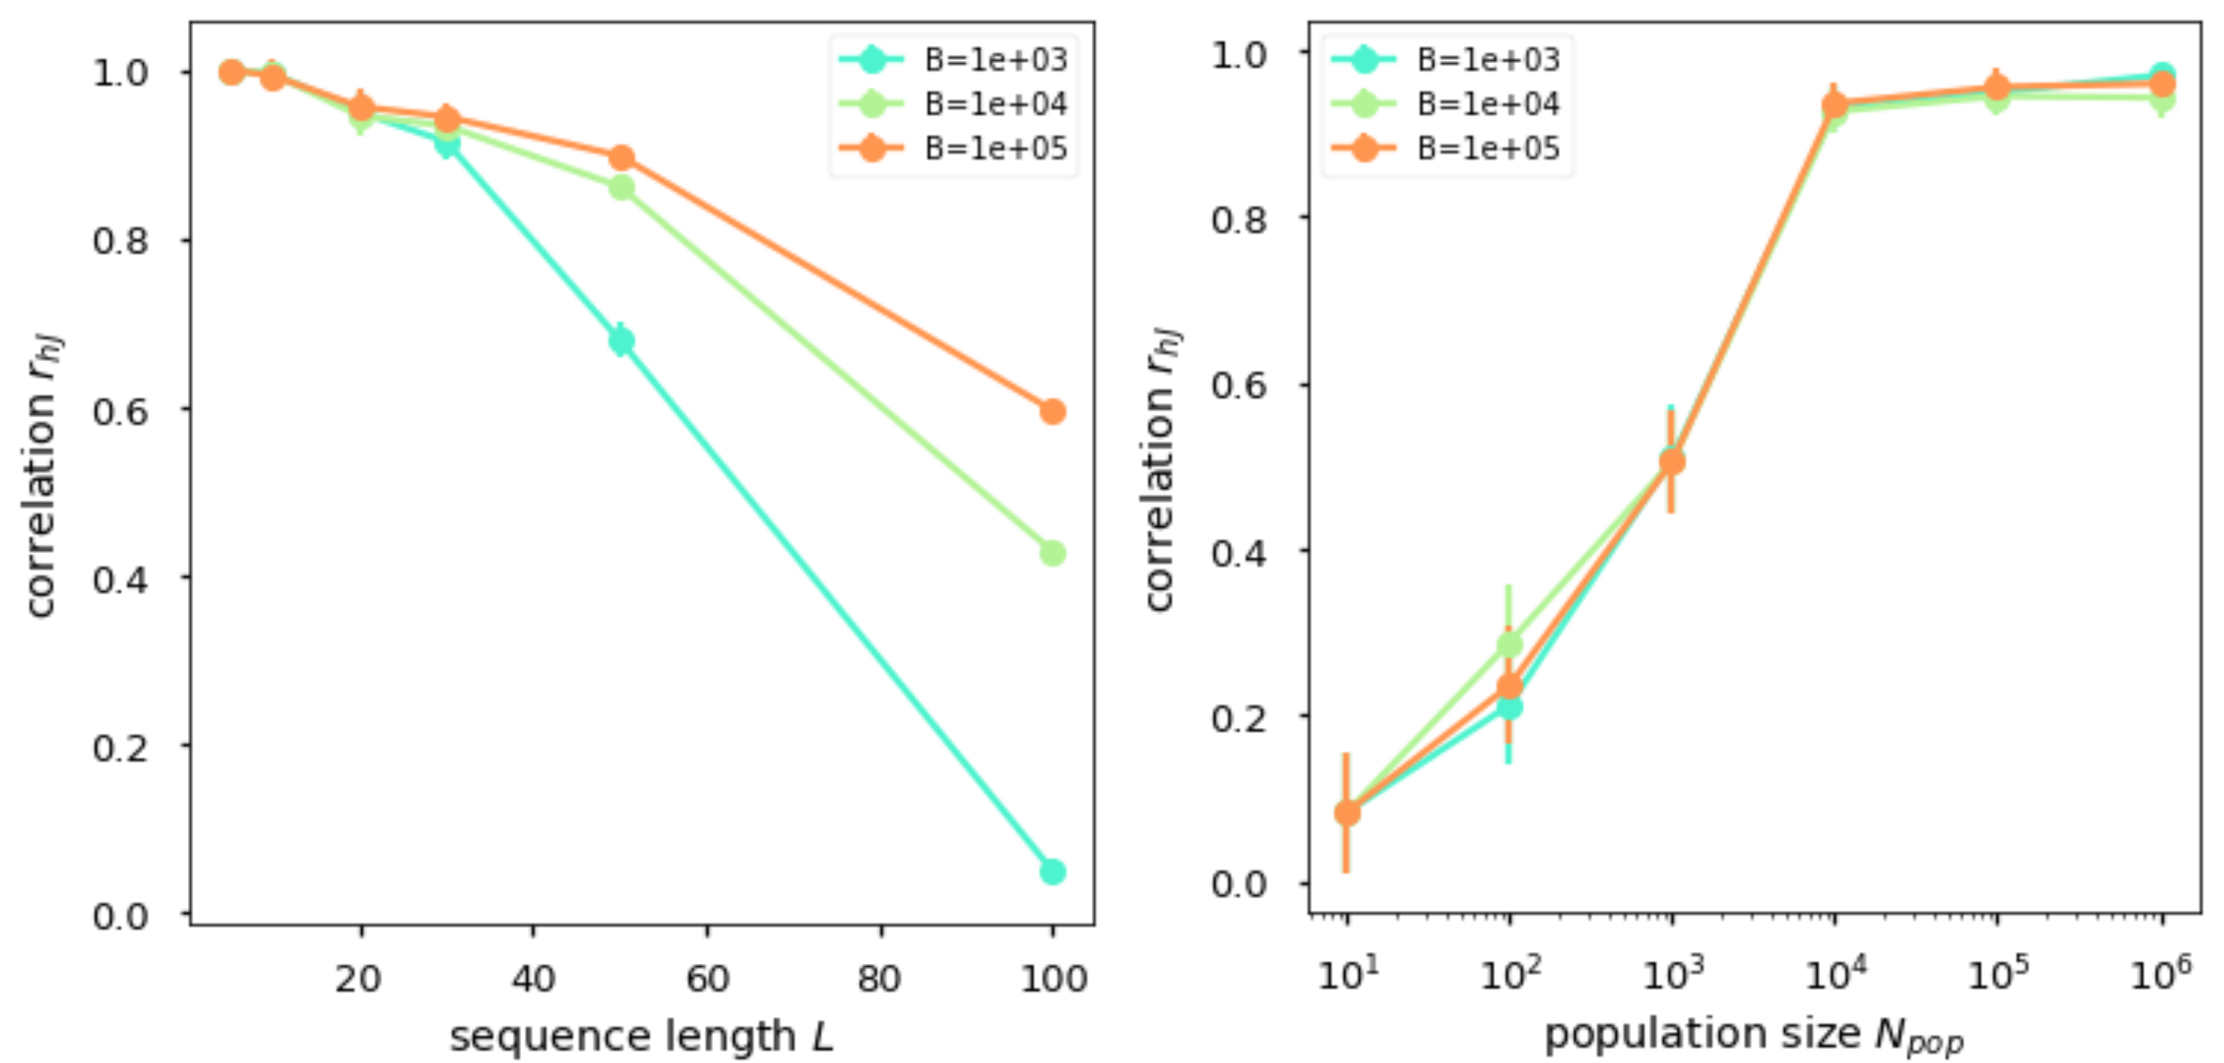

Figure 7: Inference performance in terms of the correlation coefficient *rhJ* be- tween inferred and simulated double-mutational fitness costs, for varying sim- ulation and analysis parameters. (left) Inference performance as function of sequence length *L*, (right) inference performance as function of population size *N*pop. For both parameter explorations the yearly sample size *B* was varied between 103 and 105 (see plot colors). For the shown simulation results the fixed parameter values for simulation and analysis are: *N*pop = 105, *L* = 20,

*µ* = 10−4, *σ*h = 1, *D*0 = 5, *N*simu = 200, *n*seasons = 100, *λh* = 10−4, *λJ* = 1,

*λF* ∗ = 10−4.

[L- uksza and L¨assig, 2014] for estimating cross-immunity only roughly captures the cross-immunity measurements from hemagglutination inhibition (HI) assays.

Such HI data suggest a typical cross-immunity distance *D*0 of 5 amino acids or 14 nucleotide residues for seasonal influenza A (H3N2) strains [L- uksza and L¨assig, 2014, Ant, 2021]. Better fitting cross-immunity functions could be constructed from strain antigenic distances in 2- to 5-dimensional antigenic maps, which can be inferred from the available HI data [Smith et al., 2004, Ant, 2021]. For this method, however, each viral strain needs to be measured against at least a few other viral strains to be accurately placed in the map. Another possibility might

be to get a better cross-immunity prediction based on genetic data, if we used the separate mutational distances within each of the 5 head epitopes, instead of the total distance between epitope sequences. It is intuitive to assume that it does make a difference for the cross-immunity between two strains, whether the mutations between those strains occur only within one epitope region or whether the mutated sites are scattered across different epitopes thereby poten- tially inhibiting the binding of a wider range of antibodies that target different regions on the protein.

For testing fitness inference performance on real data, we generally do not have much information on the intrinsic effects of various mutations besides from some in-vitro mutational assays [Wu et al., 2017, Wu et al., 2018], which are lo-

cally constrained to small parts of the sequence space and which only measure fitness in terms of functional replication in cells, not across the human popula- tion. The application of classical machine-learning methods of testing inference based on predictions on held-out data are also challenging due to the complex time-dependent nature and general sparsity and heterogeneity of available se- quence data.

In conclusion we have proposed a method for inferring the intrinsic muta- tional fitness landscape of influenza-like viruses from time series of observed antigenic sequences, which can hopefully contribute to the development of new cross- and long-term protective immunization strategies against seasonal in- fluenza.

# Methods

**References**

[Ant, 2021] (2021). Antigenic cartography. [www.antigenic-cartography.org.](http://www.antigenic-cartography.org/) Ac- cessed: 2021-04-29.

[WHO, 2021] (2021). WHO recommendations on the composition of influenza virus vaccines. h[ttps://www.who.int/influenza/vaccines/virus/recommendations/en/.](http://www.who.int/influenza/vaccines/virus/recommendations/en/)

Accessed: 2021-04-28.

[Amitai, 2020] Amitai, A. (2020). Viral surface geometry shapes influenza and coronavirus spike evolution. *bioRxiv*.

[Amitai et al., 2020] Amitai, A., Sangesland, M., Barnes, R. M., Rohrer, D., Lonberg, N., Lingwood, D., and Chakraborty, A. K. (2020). Defining and manipulating b cell immunodominance hierarchies to elicit broadly neutraliz- ing antibody responses against influenza virus. *Cell Systems*, 11(6):573–588.

[Barton et al., 2016a] Barton, J. P., De Leonardis, E., Coucke, A., and Cocco,

S. (2016a). Ace: adaptive cluster expansion for maximum entropy graphical model inference. *Bioinformatics*, 32(20):3089–3097.

[Barton et al., 2016b] Barton, J. P., Goonetilleke, N., Butler, T. C., Walker,

B. D., McMichael, A. J., and Chakraborty, A. K. (2016b). Relative rate and location of intra-host hiv evolution to evade cellular immunity are predictable. *Nature communications*, 7(1):1–10.

[Barton et al., 2019] Barton, J. P., Rajkoomar, E., Mann, J. K., Murakowski,

D. K., Toyoda, M., Mahiti, M., Mwimanzi, P., Ueno, T., Chakraborty, A. K., and Ndung’u, T. (2019). Modelling and in vitro testing of the hiv-1 nef fitness landscape. *Virus evolution*, 5(2):vez029.

[Bedford et al., 2014] Bedford, T., Suchard, M. A., Lemey, P., Dudas, G., Gre- gory, V., Hay, A. J., McCauley, J. W., Russell, C. A., Smith, D. J., and Rambaut, A. (2014). Integrating influenza antigenic dynamics with molecu- lar evolution. *elife*, 3:e01914.

[Brandenburg et al., 2013] Brandenburg, B., Koudstaal, W., Goudsmit, J., Klaren, V., Tang, C., Bujny, M. V., Korse, H. J., Kwaks, T., Otterstrom,

J. J., Juraszek, J., et al. (2013). Mechanisms of hemagglutinin targeted in- fluenza virus neutralization. *PloS one*, 8(12):e80034.

[Butler et al., 2016] Butler, T. C., Barton, J. P., Kardar, M., and Chakraborty,

A. K. (2016). Identification of drug resistance mutations in hiv from con- straints on natural evolution. *Physical Review E*, 93(2):022412.

[Carrat and Flahault, 2007] Carrat, F. and Flahault, A. (2007). Influenza vac- cine: the challenge of antigenic drift. *Vaccine*, 25(39-40):6852–6862.

[Chakraborty and Barton, 2017] Chakraborty, A. K. and Barton, J. P. (2017). Rational design of vaccine targets and strategies for hiv: A crossroad of statistical physics, biology, and medicine. *Reports on Progress in Physics*, 80(3):032601.

[Cocco and Monasson, 2011] Cocco, S. and Monasson, R. (2011). Adaptive cluster expansion for inferring boltzmann machines with noisy data. *Physical Review Letters*, 106(9):090601.

[Corti et al., 2011] Corti, D., Voss, J., Gamblin, S. J., Codoni, G., Macagno, A., Jarrossay, D., Vachieri, S. G., Pinna, D., Minola, A., Vanzetta, F., et al. (2011). A neutralizing antibody selected from plasma cells that binds to group 1 and group 2 influenza a hemagglutinins. *Science*, 333(6044):850–856.

[Dahirel et al., 2011] Dahirel, V., Shekhar, K., Pereyra, F., Miura, T., Arty- omov, M., Talsania, S., Allen, T. M., Altfeld, M., Carrington, M., Irvine,

D. J., et al. (2011). Coordinate linkage of hiv evolution reveals regions of im- munological vulnerability. *Proceedings of the National Academy of Sciences*, 108(28):11530–11535.

[Dreyfus et al., 2012] Dreyfus, C., Laursen, N. S., Kwaks, T., Zuijdgeest, D., Khayat, R., Ekiert, D. C., Lee, J. H., Metlagel, Z., Bujny, M. V., Jongeneelen, M., et al. (2012). Highly conserved protective epitopes on influenza b viruses. *Science*, 337(6100):1343–1348.

[Eggink et al., 2014] Eggink, D., Goff, P. H., and Palese, P. (2014). Guiding the immune response against influenza virus hemagglutinin toward the conserved stalk domain by hyperglycosylation of the globular head domain. *Journal of virology*, 88(1):699–704.

[Ekiert et al., 2011] Ekiert, D. C., Friesen, R. H., Bhabha, G., Kwaks, T., Jon- geneelen, M., Yu, W., Ophorst, C., Cox, F., Korse, H. J., Brandenburg, B., et al. (2011). A highly conserved neutralizing epitope on group 2 influenza a viruses. *Science*, 333(6044):843–850.

[Ekiert et al., 2012] Ekiert, D. C., Kashyap, A. K., Steel, J., Rubrum, A., Bhabha, G., Khayat, R., Lee, J. H., Dillon, M. A., O’Neil, R. E., Faynboym,

A. M., et al. (2012). Cross-neutralization of influenza a viruses mediated by a single antibody loop. *Nature*, 489(7417):526–532.

[Ferguson et al., 2013] Ferguson, A. L., Mann, J. K., Omarjee, S., Ndung’u, T., Walker, B. D., and Chakraborty, A. K. (2013). Translating hiv sequences into quantitative fitness landscapes predicts viral vulnerabilities for rational immunogen design. *Immunity*, 38(3):606–617.

[Gerhard et al., 1981] Gerhard, W., Yewdell, J., Frankel, M. E., and Webster,

R. (1981). Antigenic structure of influenza virus haemagglutinin defined by hybridoma antibodies. *Nature*, 290(5808):713–717.

[Hadfield et al., 2018] Hadfield, J., Megill, C., Bell, S. M., Huddleston, J., Potter, B., Callender, C., Sagulenko, P., Bedford, T., and Neher, R. A. (2018). Nextstrain: real-time tracking of pathogen evolution. *Bioinformatics*, 34(23):4121–4123.

[Hai et al., 2012] Hai, R., Krammer, F., Tan, G. S., Pica, N., Eggink, D., Maa- mary, J., Margine, I., Albrecht, R. A., and Palese, P. (2012). Influenza viruses expressing chimeric hemagglutinins: globular head and stalk domains derived from different subtypes. *Journal of virology*, 86(10):5774–5781.

[Impagliazzo et al., 2015] Impagliazzo, A., Milder, F., Kuipers, H., Wagner,

M. V., Zhu, X., Hoffman, R. M., van Meersbergen, R., Huizingh, J., Wannin- gen, P., Verspuij, J., et al. (2015). A stable trimeric influenza hemagglutinin stem as a broadly protective immunogen. *Science*, 349(6254):1301–1306.

[Kadam and Wilson, 2018] Kadam, R. U. and Wilson, I. A. (2018). A small- molecule fragment that emulates binding of receptor and broadly neutralizing antibodies to influenza a hemagglutinin. *Proceedings of the National Academy of Sciences*, 115(16):4240–4245.

[Koel et al., 2013] Koel, B. F., Burke, D. F., Bestebroer, T. M., Van Der Vliet, S., Zondag, G. C., Vervaet, G., Skepner, E., Lewis, N. S., Spronken, M. I., Russell, C. A., et al. (2013). Substitutions near the receptor binding site determine major antigenic change during influenza virus evolution. *Science*, 342(6161):976–979.

[Krammer et al., 2013] Krammer, F., Pica, N., Hai, R., Margine, I., and Palese,

P. (2013). Chimeric hemagglutinin influenza virus vaccine constructs elicit broadly protective stalk-specific antibodies. *Journal of virology*, 87(12):6542– 6550.

[Li et al., 2016] Li, C., Hatta, M., Burke, D. F., Ping, J., Zhang, Y., Ozawa,

M., Taft, A. S., Das, S. C., Hanson, A. P., Song, J., et al. (2016). Selec- tion of antigenically advanced variants of seasonal influenza viruses. *Nature Microbiology*, 1(6):1–10.

[Louie et al., 2018] Louie, R. H., Kaczorowski, K. J., Barton, J. P., Chakraborty, A. K., and McKay, M. R. (2018). Fitness landscape of the human immunodeficiency virus envelope protein that is targeted by antibod- ies. *Proceedings of the National Academy of Sciences*, 115(4):E564–E573.

[Lu et al., 2014] Lu, Y., Welsh, J. P., and Swartz, J. R. (2014). Production and stabilization of the trimeric influenza hemagglutinin stem domain for potentially broadly protective influenza vaccines. *Proceedings of the National Academy of Sciences*, 111(1):125–130.

[L- uksza and L¨assig, 2014] L- uksza, M. and L¨assig, M. (2014). A predictive fit- ness model for influenza. *Nature*, 507(7490):57–61.

[Mann et al., 2014] Mann, J. K., Barton, J. P., Ferguson, A. L., Omarjee, S., Walker, B. D., Chakraborty, A., and Ndung’u, T. (2014). The fitness land- scape of HIV-1 gag: advanced modeling approaches and validation of model predictions by in vitro testing. *PLoS Comput Biol*, 10(8):e1003776.

[Murakowski et al., 2021] Murakowski, D. K., Barton, J. P., Peter, L., Chan- drashekar, A., Bondzie, E., Gao, A., Barouch, D. H., and Chakraborty, A. K. (2021). Adenovirus-vectored vaccine containing multidimensionally conserved parts of the hiv proteome is immunogenic in rhesus macaques. *Proceedings of the National Academy of Sciences*, 118(5).

[Nachbagauer et al., 2014] Nachbagauer, R., Wohlbold, T. J., Hirsh, A., Hai, R., Sjursen, H., Palese, P., Cox, R. J., and Krammer, F. (2014). Induction of broadly reactive anti-hemagglutinin stalk antibodies by an h5n1 vaccine in humans. *Journal of virology*, 88(22):13260–13268.

[Neher et al., 2014] Neher, R. A., Russell, C. A., and Shraiman, B. I. (2014).

Predicting evolution from the shape of genealogical trees. *eLife*, 3:e03568.

[Paules et al., 2017] Paules, C. I., Marston, H. D., Eisinger, R. W., Baltimore, D., and Fauci, A. S. (2017). The pathway to a universal influenza vaccine. *Immunity*, 47(4):599–603.

[Petrova and Russell, 2018] Petrova, V. N. and Russell, C. A. (2018). The evolu- tion of seasonal influenza viruses. *Nature Reviews Microbiology*, 16(1):47–60.

[Pompei et al., 2012] Pompei, S., Loreto, V., and Tria, F. (2012). Phylogenetic properties of rna viruses. *PLoS One*, 7(9):e44849.

[Quadeer et al., 2020] Quadeer, A. A., Barton, J. P., Chakraborty, A. K., and McKay, M. R. (2020). Deconvolving mutational patterns of poliovirus outbreaks reveals its intrinsic fitness landscape. *Nature Communications*, 11(1):1–13.

[Raj˜ao and P´erez, 2018] Raj˜ao, D. S. and P´erez, D. R. (2018). Universal vac- cines and vaccine platforms to protect against influenza viruses in humans and agriculture. *Frontiers in Microbiology*, 9:123.

[Schmidt et al., 2015] Schmidt, A. G., Therkelsen, M. D., Stewart, S., Kepler,

T. B., Liao, H.-X., Moody, M. A., Haynes, B. F., and Harrison, S. C. (2015). Viral receptor-binding site antibodies with diverse germline origins. *Cell*, 161(5):1026–1034.

[Shekhar et al., 2013] Shekhar, K., Ruberman, C. F., Ferguson, A. L., Barton,

J. P., Kardar, M., and Chakraborty, A. K. (2013). Spin models inferred from patient-derived viral sequence data faithfully describe hiv fitness landscapes. *Physical Review E*, 88(6):062705.

[Skehel et al., 1984] Skehel, J., Stevens, D., Daniels, R., Douglas, A., Knossow, M., Wilson, I., and Wiley, D. (1984). A carbohydrate side chain on hemag- glutinins of hong kong influenza viruses inhibits recognition by a monoclonal antibody. *Proceedings of the National Academy of Sciences*, 81(6):1779–1783.

[Smith et al., 2004] Smith, D. J., Lapedes, A. S., De Jong, J. C., Bestebroer,

T. M., Rimmelzwaan, G. F., Osterhaus, A. D., and Fouchier, R. A. (2004). Mapping the antigenic and genetic evolution of influenza virus. *science*, 305(5682):371–376.

[Sohail et al., 2020] Sohail, M. S., Louie, R. H., McKay, M. R., and Barton,

J. P. (2020). Mpl resolves genetic linkage in fitness inference from complex evolutionary histories. *Nature Biotechnology*, pages 1–8.

[Squires et al., 2012] Squires, R. B., Noronha, J., Hunt, V., Garc´ıa-Sastre, A., Macken, C., Baumgarth, N., Suarez, D., Pickett, B. E., Zhang, Y., Larsen,

C. N., et al. (2012). Influenza research database: an integrated bioinfor- matics resource for influenza research and surveillance. *Influenza and other respiratory viruses*, 6(6):404–416.

[Steel et al., 2010] Steel, J., Lowen, A. C., Wang, T. T., Yondola, M., Gao, Q., Haye, K., Garc´ıa-Sastre, A., and Palese, P. (2010). Influenza virus vaccine based on the conserved hemagglutinin stalk domain. *MBio*, 1(1).

[Strauch et al., 2017] Strauch, E.-M., Bernard, S. M., La, D., Bohn, A. J., Lee,

P. S., Anderson, C. E., Nieusma, T., Holstein, C. A., Garcia, N. K., Hooper,

K. A., et al. (2017). Computational design of trimeric influenza-neutralizing proteins targeting the hemagglutinin receptor binding site. *Nature Biotech- nology*, 35(7):667–671.

[Throsby et al., 2008] Throsby, M., van den Brink, E., Jongeneelen, M., Poon,

L. L., Alard, P., Cornelissen, L., Bakker, A., Cox, F., van Deventer, E., Guan, Y., et al. (2008). Heterosubtypic neutralizing monoclonal antibodies cross- protective against h5n1 and h1n1 recovered from human igm+ memory b cells. *PloS one*, 3(12):e3942.

[Whittle et al., 2011] Whittle, J. R., Zhang, R., Khurana, S., King, L. R., Man- ischewitz, J., Golding, H., Dormitzer, P. R., Haynes, B. F., Walter, E. B., Moody, M. A., et al. (2011). Broadly neutralizing human antibody that recognizes the receptor-binding pocket of influenza virus hemagglutinin. *Pro- ceedings of the National Academy of Sciences*, 108(34):14216–14221.

[Wiley et al., 1981] Wiley, D., Wilson, I., and Skehel, J. (1981). Structural iden- tification of the antibody-binding sites of hong kong influenza haemagglutinin and their involvement in antigenic variation. *Nature*, 289(5796):373–378.

[Wu et al., 2018] Wu, N. C., Thompson, A. J., Xie, J., Lin, C.-W., Nycholat,

C. M., Zhu, X., Lerner, R. A., Paulson, J. C., and Wilson, I. A. (2018). A complex epistatic network limits the mutational reversibility in the influenza hemagglutinin receptor-binding site. *Nature communications*, 9(1):1–13.

[Wu et al., 2017] Wu, N. C., Xie, J., Zheng, T., Nycholat, C. M., Grande, G., Paulson, J. C., Lerner, R. A., and Wilson, I. A. (2017). Diversity of function- ally permissive sequences in the receptor-binding site of influenza hemagglu- tinin. *Cell Host & Microbe*, 21(6):742–753.

[Yamayoshi et al., 2017] Yamayoshi, S., Uraki, R., Ito, M., Kiso, M., Nakatsu, S., Yasuhara, A., Oishi, K., Sasaki, T., Ikuta, K., and Kawaoka, Y. (2017). A broadly reactive human anti-hemagglutinin stem monoclonal antibody that inhibits influenza a virus particle release. *EBioMedicine*, 17:182–191.

[Yassine et al., 2015] Yassine, H. M., Boyington, J. C., McTamney, P. M., Wei, C.-J., Kanekiyo, M., Kong, W.-P., Gallagher, J. R., Wang, L., Zhang, Y., Joyce, M. G., et al. (2015). Hemagglutinin-stem nanoparticles generate het- erosubtypic influenza protection. *Nature medicine*, 21(9):1065–1070.

[Zhang et al., 2017] Zhang, Y., Aevermann, B. D., Anderson, T. K., Burke,

D. F., Dauphin, G., Gu, Z., He, S., Kumar, S., Larsen, C. N., Lee, A. J., et al. (2017). Influenza research database: An integrated bioinformatics resource for influenza virus research. *Nucleic acids research*, 45(D1):D466–D474.