1. Introduction

1.1 Purpose of the Document

The document establishes the management approach for developing an e-commerce platform that promotes computer hardware and accessories through online transactions. This document establishes an organized system to direct the complete development process. The plan contains essential components including project targets alongside scope and budget information together with risk assessment and stakeholder involvement standards and quality maintenance approaches and release schedule management procedures. Every party involved in the project receives a copy of this document which establishes their common alignment regarding the project goals and operational framework along with expected achievements. The website introduces an approachable interface which enables users to search products while maintaining transaction security throughout the buying process as well as account management.

1.2 Project Overview

The main target of this initiative is building an end-to-end e-commerce website that allows the sale of computer hardware components and peripheral devices. The platform will show products along with complete details through an interface which combines safe payment features with user-friendly organization methods. Through user accounts customers will obtain access to view previous orders with support to alter their account settings. Through the backend system administrators will obtain tools to control product listings and inventory tracking and customer transaction oversight.

The website design will feature future growth capabilities which provide users with a smooth interface experience across various devices. The development process will follow agile principles to create flexible adaptability for all stages. The application offers users search filters for products while providing shopping cart and safe login authentication. The document details how the website was built starting from initial design through to final deployment while focusing on design work and coding alongside testing procedures that enabled the delivery of a premium-quality end product. The project design details its release strategy together with its financial plan as well as risk management protocols and approaches for communicating with stakeholders.

1.3 Scope and Coverage of the Document

The official document contains comprehensive information about website development starting with design work and ending with complete deployment. The document will explain the project charter which includes the purpose and objectives together with the scope and essential requirements of the e-commerce website. The website solution architecture contains a complete description of the system structure together with its individual parts and their communications elements. The document establishes a release plan and kanban tracking system and project outline with main tasks and milestones.

The project scope requires developers to work on creating both the graphical user interface with experience elements and managing backend functionalities including product management and user interactions together with payment solutions. Testing phases and performance reviews are included in the quality assurance methods covered by the document. Regular updates and communication flow to stakeholders will be possible through effective stakeholder management practices. The budget analysis as well as risk management processes will be implemented to ensure the attainment of scope and completion within time and budget constraints.

2. Project Charter

2.1 Purpose and Objectives

The main goal of this project involves building a complete e-commerce system which will sell computer hardware together with accessories. Through this platform customers will experience a safe and simple process for product selection and online purchase. The website presents a structured interactive interface that includes necessary elements such as product listings and extended information and guarantees secure checkout abilities. The main objective focuses on developing a user-friendly online shopping process with expandable capabilities and user-friendly operations on all devices.

The project also aims to streamline the management of products and customer interactions. Company executives will operate through the system to control products for listing and view and accept client orders and handle stock quantities. The website building process will emphasize high-performance quality combined with secure systems which result in reliable user platforms.

2.2 Scope

The scope of this project is limited to the development of a single e-commerce website with the primary focus on selling computer hardware and accessories. The scope includes:

* Frontend Development: This involves the design and development of the user interface (UI) that will include the homepage, product listing pages, product detail pages, shopping cart, user login, and account management features.
* Backend Development: This will cover the creation of the database, inventory management, order processing, user authentication, and secure payment integration. The backend will also handle all server-side logic for product display and order fulfillment.
* Payment Integration: Secure payment gateway integration to allow customers to complete their purchases safely. It will support common payment methods like credit cards and digital wallets.
* User Authentication: The website will allow customers to create accounts, log in, and manage their personal information. Passwords and personal details will be securely stored.
* Testing & Quality Assurance: The website will go through various testing phases, including functional testing, usability testing, and security testing to ensure a smooth and secure user experience.
* Deployment: The website will be deployed on a reliable hosting platform, ensuring scalability and uptime. Post-launch support and troubleshooting will be provided.

2.3 Key Requirements and Acceptance Criteria

To ensure the website meets the expectations of both the client and users, the following key requirements and acceptance criteria have been established:

* User-Friendly Interface: The website must be visually appealing and easy to navigate, with a responsive design that works seamlessly on both desktop and mobile devices.
* Security: User data, including personal and payment information, must be encrypted and stored securely. Payment transactions should be completed using industry-standard security protocols (e.g., SSL).
* Product Listings and Search Functionality: The website must include a catalog of products with filters for easy navigation. Users must be able to search for products by category, brand, or specifications.
* Shopping Cart and Checkout: Users should be able to add products to their cart, view a summary, and proceed to checkout. The checkout process should be simple and include a secure payment method.
* Admin Panel: An easy-to-use admin panel for managing product listings, tracking orders, and managing customer accounts.
* Performance: The website must load within 3 seconds on a standard internet connection and support up to 1,000 concurrent users.
* Cross-browser Compatibility: The website must work across major browsers (Chrome, Firefox, Safari, Edge).

Acceptance criteria will be met once the website fulfills these requirements and passes the testing phases.

2.4 Exclusions

This project does not include the following:

* Mobile Application Development: The project is limited to developing the e-commerce website and does not cover the development of a mobile application at this stage.
* Third-party Integrations Beyond Payments: The website will only integrate payment systems and will not include additional third-party services like loyalty programs or advanced analytics.
* Shipping Integration: While the website will allow customers to place orders, it will not include real-time shipping integration or tracking features at this stage.
* Advanced Marketing Tools: The website will not include advanced marketing tools like email campaigns, SEO optimization, or analytics beyond basic user data.

2.5 Stakeholders

The primary stakeholders in this project include:

* Project Manager: Oversees the development process, timelines, and team coordination.
* Client (E-commerce Business Owner): Defines the business requirements, provides feedback, and ensures the website meets business goals.
* Development Team: Responsible for designing, coding, and deploying the website. This includes frontend developers, backend developers, and database administrators.
* Quality Assurance Team: Conducts testing to ensure the website meets all functionality, performance, and security requirements.
* End Users (Customers): The website’s primary audience, who will be using the site to browse and purchase products.
* Admin Team: Responsible for managing the website's inventory, processing orders, and customer service.

2.6 Total Budget

The estimated total budget for this project is LKR 90,000. This includes:

1. Development Costs: LKR 55,000 for the frontend and backend development.
2. Testing and Quality Assurance: LKR 15,000 for thorough testing and debugging.
3. Design Costs: LKR 10,000 for UI/UX design.
4. Deployment & Hosting: LKR 10,000 for hosting and deployment setup.

2.7 Milestones and Dates

The following milestones and deadlines have been set for the project:

* Project Kickoff: May 1, 2024
* UI/UX Design Completion: May 15, 2024
* Frontend Development Completion: June 5, 2024
* Backend Development Completion: June 20, 2024
* Testing Phase: June 25, 2024 – July 5, 2024
* Final Review and Revisions: July 10, 2024
* Deployment & Go Live: July 15, 2024

3. Project Solution Architecture

3.1 Context

The solution architecture context explores the complete design features along with user interactions that occur inside the computer hardware and accessory e-commerce website. The system contains three essential components including frontend user interface together with backend servers and third-party services which must interact. The main focus directs toward making a system which delivers smooth user-friendly shopping capabilities while supporting business requirements including product handling and customer verification alongside secure purchasing infrastructure.

The system integrates with secure payment gateways which will handle the transaction process and it connects to database systems for product and customer data control functions. Users can access the system through every platform because it operates on desktop computers and cellular devices as well as handheld devices. Agency-level access must exist for administering product catalogues as well as order tracking and customer service management.

3.2 Structure

The architecture will follow a layered approach, consisting of the following primary components:

* Frontend (Client-Side): The frontend will be responsible for delivering the website's user interface. It will handle interactions such as product browsing, cart management, user login, and order placement. The frontend will be built using HTML, CSS, and JavaScript, with frameworks like React or Vue.js for efficient component management and responsiveness.
* Backend (Server-Side): The backend will manage the business logic, database interactions, and third-party service integrations. It will include the user authentication system, product management, inventory tracking, and payment processing. The backend will be developed using server-side technologies like Node.js or PHP, along with a relational database like MySQL or PostgreSQL to store product and customer data.
* Database Layer: The relational database will store product information, user profiles, order details, and transaction data. This database will need to be optimized for fast read/write operations and secure data storage.
* Payment Gateway Integration: The website will integrate with external payment systems such as PayPal, Stripe, or local banking services to ensure secure online transactions.

3.3 Behaviour

The behavior of the system focuses on how it responds to user actions and external requests. Key behaviors of the system include:

* Product Search: The system will allow users to search for products by category, specifications, or price range. The backend will process these requests and fetch relevant data from the database.
* Shopping Cart and Checkout: As users add items to their cart, the system will dynamically update the cart interface. When users proceed to checkout, the system will calculate the total cost, including taxes and shipping, and guide the user through the payment process.
* User Authentication: Users will be required to log in or register before making purchases. The backend will securely handle user credentials and session management.
* Order Management: The system will track the user's order status, from placement to delivery. Admin users will have access to a dashboard to manage and process orders.

3.4 System Allocations

The system's resources will be allocated as follows:

* Server Resources: The web server will host both the frontend and backend components. The backend server will manage the application logic and communicate with the database server. The frontend will be delivered through a Content Delivery Network (CDN) for faster loading times.
* Database: A relational database system (e.g., MySQL or PostgreSQL) will be used to manage product data, user information, and transactions. The database will be optimized for scalability, ensuring that it can handle growing data as the website expands.
* Security Resources: The system will allocate resources for secure data transmission (SSL/TLS) and encryption for sensitive user information (e.g., passwords and payment details).

3.5 Communications

Communication between the components of the system will be managed using RESTful APIs. The frontend will send requests to the backend via these APIs to fetch product data, place orders, and authenticate users. Communication between the backend and the database will use SQL queries to fetch, insert, and update data.

The payment gateway will be integrated using secure APIs to handle payment processing and transaction status updates. This ensures that the user’s sensitive financial information is never stored on the server.

4. Release Plan

4.1 Release Goals and Objectives

The primary goal of this release is to launch a fully functional e-commerce website that enables users to browse, select, and purchase computer hardware and accessories seamlessly. The objectives for this release include:

* Ensuring a user-friendly interface that works across desktop and mobile devices.
* Providing secure and efficient online payment capabilities.
* Implementing a reliable inventory management system for administrators.
* Ensuring the platform is scalable to accommodate future growth.

The release will focus on delivering a stable, high-quality product by incorporating essential features, ensuring performance optimization, and securing user data. The goal is to launch a version of the website that meets business needs while maintaining flexibility for future feature expansions.

4.2 Feature Discussion

Key features planned for this release include:

Product Catalog: Display of product categories, detailed descriptions, and product images. Users will be able to search and filter products based on specifications, price range, and category.

* Shopping Cart and Checkout: Functionality for users to add products to their cart, view order summaries, and proceed with secure payment processing.
* User Authentication: Secure user login and registration functionality, ensuring that users can manage their accounts and order history.
* Payment Gateway Integration: Integration with payment systems like PayPal, Stripe, or a local provider for secure transactions.
* Admin Dashboard: A backend interface for administrators to manage product listings, inventory, and order processing.
* Responsive Design: The site will be optimized for both desktop and mobile viewing, ensuring that users can easily navigate on any device.

4.3 Risk and External Dependencies

Several risks and dependencies need to be addressed to ensure a smooth release:

* Payment Gateway Integration: The integration of external payment gateways could face delays if there are any issues with the provider’s API or security compliance.
* Third-Party Dependencies: Any delays in third-party services such as shipping integrations, or external APIs could impact the delivery timeline.
* Security Vulnerabilities: Any security flaws discovered during testing could delay the release, requiring additional development time to address.
* Performance Bottlenecks: Initial user traffic may cause unexpected performance issues, especially if the hosting platform is not optimized.

4.4 Team Velocity and Sprint Planning

The development team will follow an Agile methodology, dividing the project into sprints. The team’s velocity is estimated to be 20 story points per sprint, based on previous sprint data. Each sprint will focus on a specific feature or functionality, with time allocated for testing and bug fixes. The first sprint will focus on UI/UX design, while subsequent sprints will focus on backend development, payment integration, and testing.

4.5 Story and Epic Prioritization

The user stories will be prioritized based on their business value and impact on the user experience. Epics include:

* Product Catalog and Search Functionality
* Shopping Cart and Checkout Process
* User Authentication and Profile Management
* Admin Dashboard for Product Management
* Payment Integration

The highest priority will be given to core features such as product catalog, payment gateway, and shopping cart functionality, followed by user authentication and the admin dashboard.

4.6 Iteration Planning

Each iteration will last two weeks, with regular sprint reviews and retrospectives to ensure continuous improvement. During each sprint, developers will focus on completing specific stories and functionalities, followed by testing and review. At the end of each iteration, a working version of the website will be demoed to stakeholders, and feedback will be incorporated into the next iteration.

4.7 Feedback and Commitment

Regular feedback sessions will be held with stakeholders after each sprint to ensure the project aligns with their expectations. This will provide an opportunity for stakeholders to request adjustments or changes to features, ensuring that the final product meets the client’s needs. All team members will commit to the agreed-upon sprint goals, and adjustments will be made if necessary to accommodate unexpected changes.

5. Kanban Chart

5.1 Kanban Board Overview

A Kanban board is a visual tool used in project management to track work items across different stages. It typically consists of several columns, each representing a stage in the workflow, from Commitment to Complete. Tasks move through these stages as they progress. In a software development project, the columns usually include To Do, In Progress, Testing, and Completed. Kanban provides transparency, improves collaboration, and helps teams manage their work efficiently. By visualizing tasks and their status, teams can quickly identify bottlenecks, prioritize tasks, and allocate resources more effectively.

**5.2 Detailed Kanban Chart**

|  |  |  |  |  |
| --- | --- | --- | --- | --- |
| **Commitment** | **Development** | **Work in Progress** | **Acceptance** | **Complete** |
| Proposals (4) | Implement User Login (3) | Implement Product Search (5) | User Testing (4) | Deployment (2) |
| Selected (2) | Design Homepage (4) | Payment Integration (6) | Bug Fixing (2) | Website Live (1) |
| Initiated (1) | UI Design (3) | User Profile (3) | Final Review (1) | Final Delivery (1) |
| Approved (3) | Set Up Database (2) | Inventory Management (4) | Final Approval (1) |  |
|  |  | Cart Functionality (2) | User Feedback (3) |  |

Key Columns:

Commitment: Tasks that are approved or planned to be worked on.

* Proposals (ideas, initial planning).
* Selected (tasks chosen to be worked on).
* Initiated (tasks that have started).
* Approved (tasks awaiting action or resources).

Development: Tasks in progress, being actively developed.

* Tasks such as UI design, database setup, and user authentication are typically in this stage.
* Work in Progress: Tasks that are actively being worked on, like developing cart functionality or payment integration.
* Acceptance: Tasks in this stage are in the testing or feedback phase.

Tasks include user testing, bug fixing, and final review.

* Complete: Fully completed tasks, including deployment and the final live version.

6. Project Plan using XL

6.1 High-level Tasks and Milestones

A high-level project plan is crucial for outlining the primary tasks, milestones, and deliverables for the development of the e-commerce website. Below is an overview of the key tasks and their associated milestones:

|  |  |  |
| --- | --- | --- |
| **Task** | **Milestone** | **Deadline** |
| **Project Kickoff** | Initial Project Meeting | May 1, 2024 |
| **UI/UX Design** | Design Approval | May 15, 2024 |
| **Frontend Development** | Complete Homepage Design | June 5, 2024 |
| **Backend Development** | Complete User Authentication Setup | June 15, 2024 |
| **Payment Gateway Integration** | Payment Gateway Successfully Integrated | June 25, 2024 |
| **Product Catalog Implementation** | Full Product Catalog Ready | June 30, 2024 |
| **Testing Phase** | Initial Testing Phase Completed | July 10, 2024 |
| **Final Review and Fixes** | Review and Updates Based on Feedback | July 20, 2024 |
| **Deployment & Go Live** | Website Fully Live | August 1, 2024 |

The high-level tasks above represent the major steps in the development process. These milestones should be tracked to ensure the project stays on schedule. A Gantt chart or timeline can be created using MS-Excel for further detailed tracking.

**7. Preliminary Budget**

**7.1 Estimated Cost Breakdown**

The preliminary budget for the project includes costs associated with development, design, testing, and other overheads.

|  |  |
| --- | --- |
| **Category** | **Cost (LKR)** |
| **Development Costs** | LKR 45,000 |
| **UI/UX Design** | LKR 15,000 |
| **Testing & QA** | LKR 10,000 |
| **Hosting & Deployment** | LKR 5,000 |
| **Miscellaneous Costs** | LKR 5,000 |

**7.2 Labour Costs and Effort Estimation**

The effort estimation for various tasks is calculated based on the hourly rate and expected time needed to complete each task. Here's a breakdown:

|  |  |  |  |
| --- | --- | --- | --- |
| **Role** | **Estimated Hours** | **Hourly Rate (LKR)** | **Total Cost (LKR)** |
| **Frontend Developer** | 100 hours | LKR 500 | LKR 50,000 |
| **Backend Developer** | 120 hours | LKR 600 | LKR 72,000 |
| **UI/UX Designer** | 40 hours | LKR 750 | LKR 30,000 |
| **QA Tester** | 30 hours | LKR 400 | LKR 12,000 |

**7.3 Other Overheads**

These are costs outside the direct development and design tasks, including software licenses, tools, and miscellaneous expenses.

|  |  |
| --- | --- |
| **Category** | **Cost (LKR)** |
| **Software Licenses** | LKR 3,000 |
| **Project Management Tools** | LKR 2,000 |

**7.4 Cost Justification and Assumptions**

* **Development Costs:** The costs are justified based on the estimated time and hourly rates for developers.
* **UI/UX Design Costs:** Based on the number of screens and the complexity of the design.
* **Hosting and Deployment:** Estimated cost for web hosting services for the first year.

**7.5 High-Level Risks and Errors**

* **Risk of Delays:** Dependencies on third-party APIs may cause delays.
* **Cost Overruns:** Unexpected issues may require additional testing or revisions.

**7.6 Contingency Plans**

* A **10% contingency** (LKR 9,000) will be added to handle unforeseen challenges such as additional development time or unexpected issues.

**7.7 Final Budget**

The total estimated budget for the project is:

|  |  |
| --- | --- |
| **Category** | **Total Cost (LKR)** |
| **Total Development** | LKR 180,000 |
| **Total Budget** | LKR 90,000 |

8. Conclusion

8.1 Summary of Progress

The project to develop the e-commerce website for selling computer hardware and accessories is progressing as planned. The project scope has been defined clearly, with the key objectives outlined, including designing a user-friendly platform, integrating secure payment systems, and enabling efficient product management.

The project charter and solution architecture have been established, and we have successfully mapped out the key tasks, milestones, and deadlines for the project. The Kanban board has been implemented to manage task progress, ensuring that each step is tracked from development to deployment.

We have also created the project plan in Excel, including key high-level tasks and milestones, ensuring alignment with the overall timeline. The preliminary budget has been estimated, covering costs for development, testing, design, and other overheads, with a contingency plan in place to manage unforeseen risks.

As of now, initial planning and project setup phases are completed, and the design and development stages are on track. Stakeholders have been kept informed, and their feedback has been incorporated into the process to ensure the final product meets all expectations.

8.2 Next Steps

The next steps focus on executing the core development tasks:

* UI/UX Design Finalization: Complete the user interface design and get approval from stakeholders.
* Frontend and Backend Development: Start coding the frontend and backend features, including user authentication, product catalog, and payment integration.
* Testing and Quality Assurance: Begin rigorous testing to ensure the website functions smoothly across various devices and platforms. Testing will also include security checks.
* Deployment and Go Live: Once testing is complete, deploy the website on a reliable hosting platform and monitor performance for the final release.

The team will continue to monitor the project progress against milestones, ensuring any issues are addressed promptly to ensure timely delivery.

Appendix

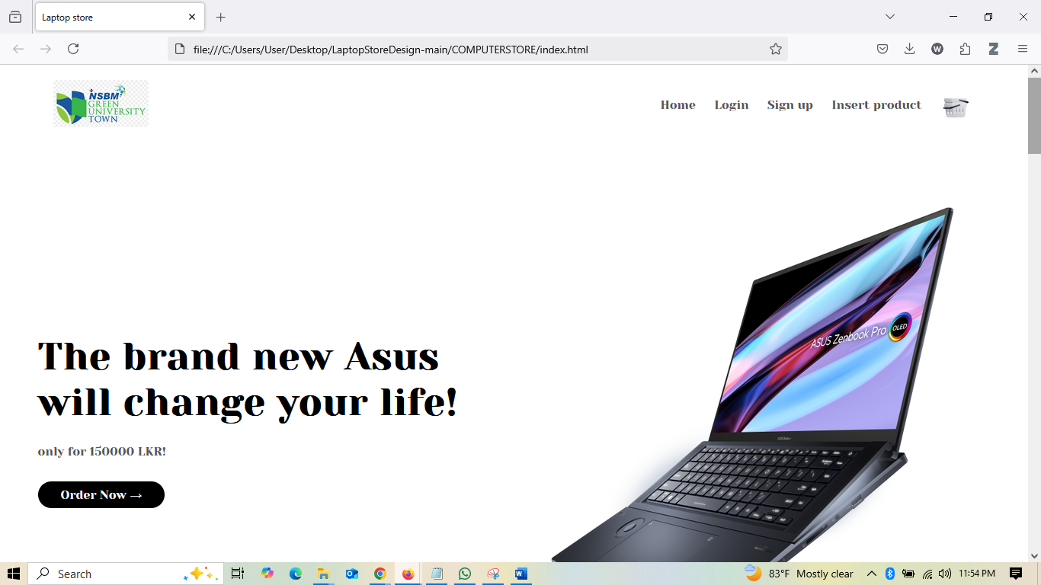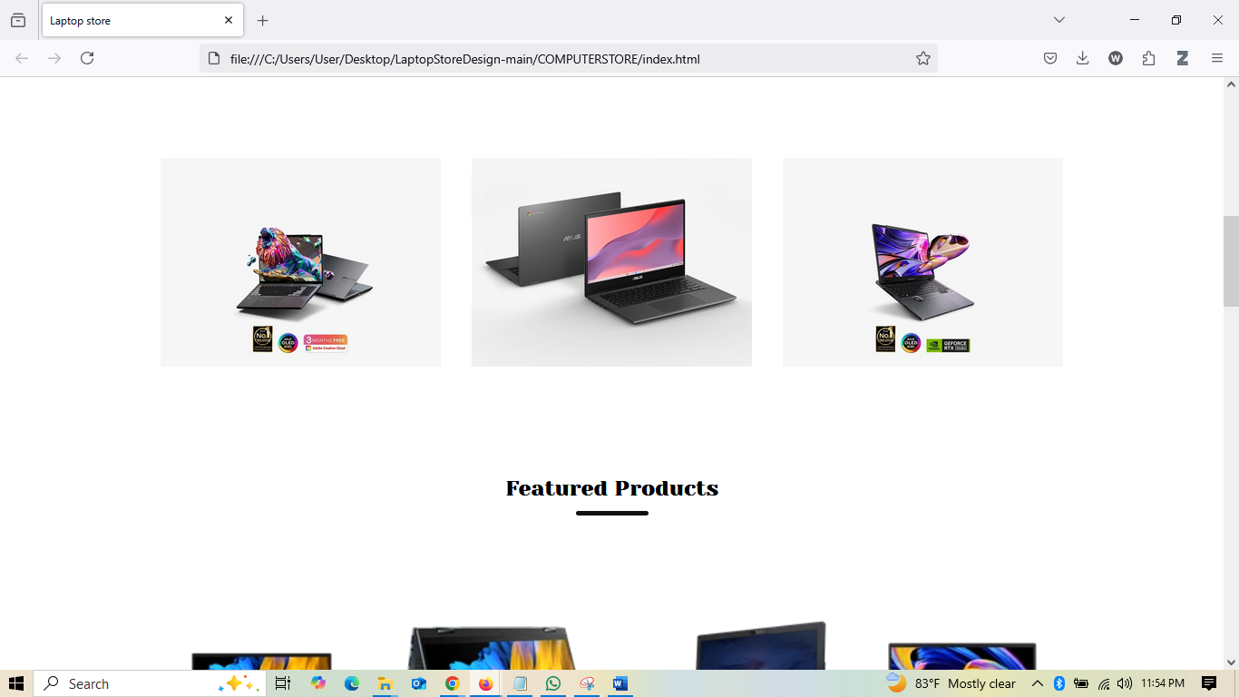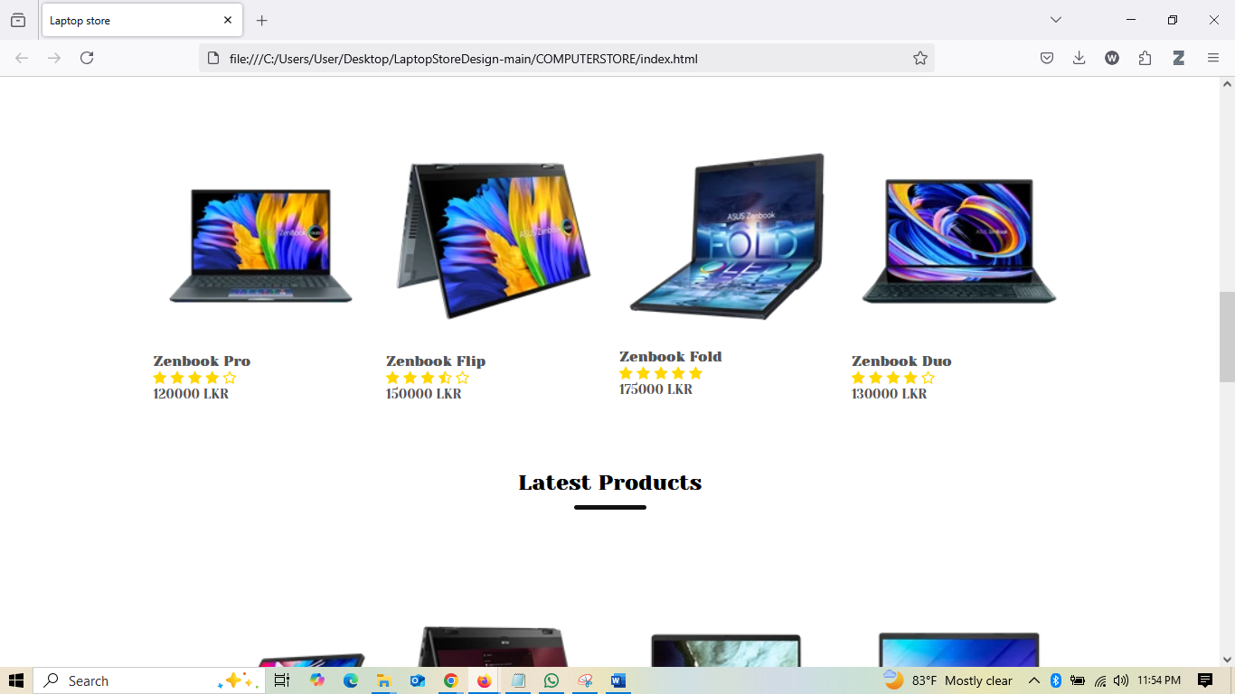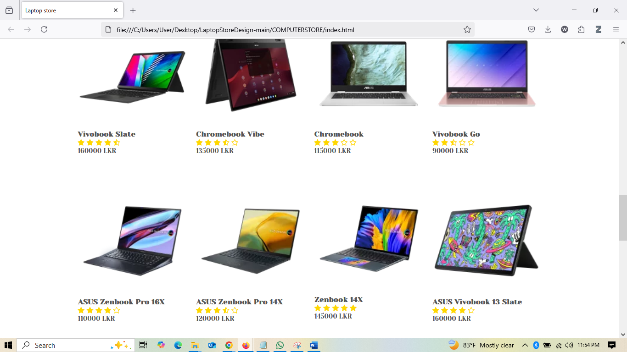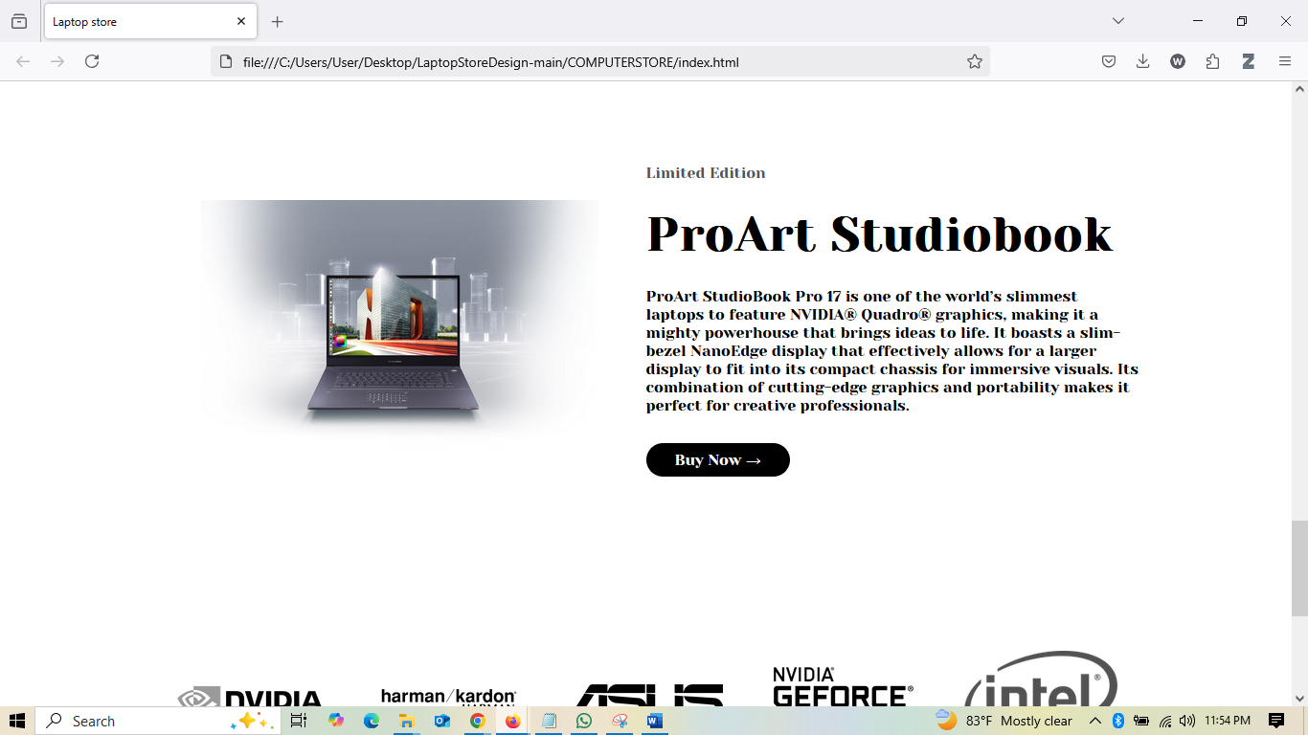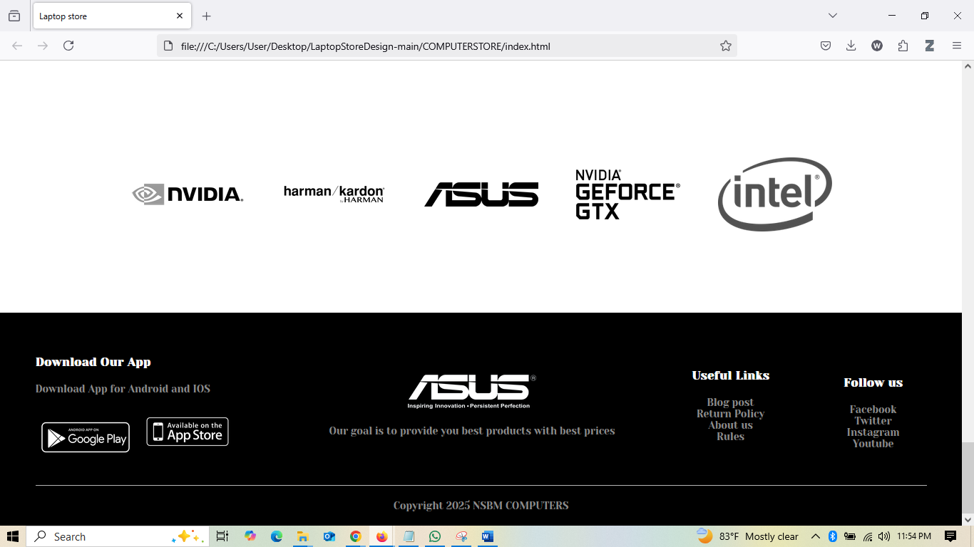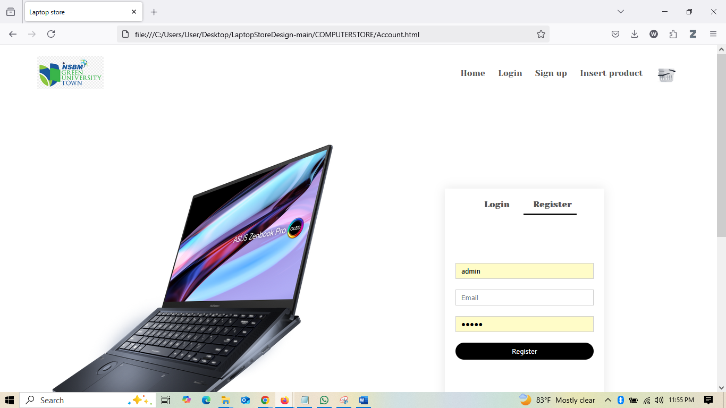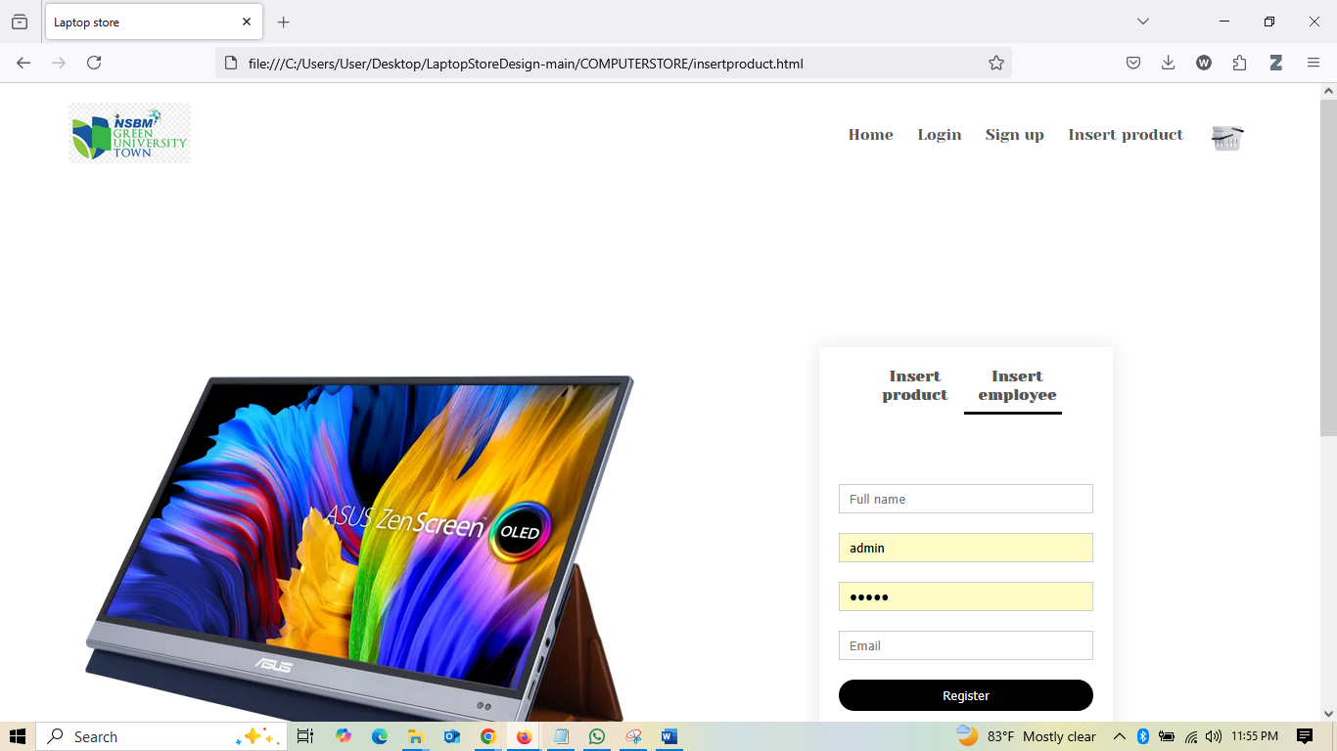

APP UI

