ASD 2026 · ASSIGNMENT 1
Release 0 Technical Report
Agentic AI Banking Application
Group 44
Juno Wardrop · Binh Nguyen · Ivan · Sang · Gia Tran
Repository github.com/JE-Wardrop/project-ASD
Showcase video [URL — paste here, set to Unlisted]
Submitted 6 September 2026

How to finish this report
Every section below is written from the state of the repository. Passages marked TO COMPLETE need something that cannot be read out of the code — a screenshot, a URL, an attendance record, or a teammate’s own account of their work. Nothing else should need rewriting.
Three things must agree with each other or marks are lost: the architecture diagrams in this report, docker-compose.yml, and what the showcase video shows. In particular every diagram must place Ollama outside the Docker boundary, because that is how the team actually runs it.

1. Project Overview
This project implements an agentic AI banking application as five integrated microservice feature sets. Each student designs, builds and maintains three containers of their own — a frontend, a backend/API, and a SQLite database service — which are then integrated into a single multi-container application started from one shared Docker Compose configuration.
A shared containerised HTMX index page provides the single entry point and routes users to all five student frontends. Every feature exposes AI-Mode, implemented inside its own backend. On any machine running the application, all five backends call one Ollama runtime installed on that host, which serves an approved open-source model. The runtime is therefore shared between the five features rather than between team members: each developer machine runs its own instance. A shared agentic loop implementing Plan → Act → Observe → Adapt reviews each student’s services from the terminal and writes its findings to a log.
The architectural rule that shapes the whole system is cross-feature database isolation: each database container owns its schema, and every other backend reaches that data only through the owning feature’s API. No backend opens another feature’s SQLite file.

Individual feature allocation
Student | Name | Feature | Frontend | Backend | Database
student-1 | Juno Wardrop | Card Management | 8101 | 8201 | 8301
student-2 | Binh Nguyen | Bank Account Management | 8102 | 8202 | 8302
student-3 | Ivan | Notification Management | 8103 | 8203 | 8303
student-4 | Sang | User Management | 8104 | 8204 | 8304
student-5 | Gia Tran | Transaction Management | 8105 | 8205 | 8305
Host ports follow the team convention frontend 810N, backend 820N, database 830N, where N is the student number. Inside the Docker network containers address each other by service name.

2. Project Analysis and Planning

2.1 Agile team project plan
The team worked in short iterations across the Release 0 window, from 12 August to 6 September 2026, coordinating through a shared Microsoft Teams channel and the weekly lab. Work was divided by feature rather than by layer, so each student owned a vertical slice — frontend, backend and database — and could deliver and demonstrate independently.
Source control followed the process required by the specification: main as the integration branch, feature branches per student (feature/transaction, card_managament, user_management), and merges into main through pull requests. The repository holds 113 commits from all five members.
TO COMPLETE Add the specific ceremony cadence the team actually used — stand-up frequency, how the backlog was reviewed, and how integration checkpoints were agreed.

2.2 Sprint backlog
The product backlog is maintained as a spreadsheet at docs/report/Group44-Product-Backlog.xlsx and reproduced in full in Appendix C. It holds 31 user stories carrying 97 acceptance criteria, written in the standard form — as a role, I want an outcome, so that a benefit — with each story estimated in story points, prioritised, and assigned to a release and an iteration.
Feature | Stories | Criteria | Points | Status | Owner
Transaction Management | 8 | 36 | 37 | Done | Gia Tran
Card Management | 5 | 13 | 16 | In Progress | Juno Wardrop
Bank Account Management | 6 | 17 | 24 | Done | Binh Nguyen
Notification Management | 2 | 5 | 8 | To-do | Ivan
User Management | 5 | 12 | 18 | Done | Sang
Architecture | 2 | 5 | 8 | Done | All
AI-Mode | 1 | 3 | 3 | Done | Gia Tran
DevOps | 2 | 6 | 13 | In Progress | All
Total | 31 | 97 | 127
Release R0 accounts for 119 of the 127 points; the remaining 8 belong to Notification Management, which is carried to R1. The non-functional entries are recorded as backlog items in their own right rather than as prose, so that constraints such as cross-feature data isolation and the rule that monetary figures are never computed by the model are testable and can be tracked to completion like any other work.
TO COMPLETE Each student: review the stories for your own feature in the spreadsheet, correct anything mis-stated, add anything missing, and confirm the point estimates. The specification requires this contribution to be individual.

2.3 Overall project plan
The project runs across three releases, each ending in a showcase. Every release builds on the one before it rather than replacing it, so the architecture established in Release 0 has to be sound enough to extend twice.
Release | Showcase | Capability added | Architectural consequence
Release 0 | Week 6 | Microservices architecture, AI-Mode with Ollama and an approved LLM, the Plan → Act → Observe → Adapt loop, Docker Compose, per-student CI | Establishes the boundaries: one feature per student, three containers each, cross-feature access only through published APIs
Release 1 | Week 9 | MCP server, RAG server, grounded AI responses using retrieved context; the five workflow files extended to build and validate MCP and RAG | AI-Mode stops answering from the model alone and starts answering from retrieved project data, so each feature needs its content indexed
Release 2 | Week 12 | Multi-Agent Server with planner, worker and reviewer agents, human review, pre-commit pytest and post-commit AI-assisted testing, cloud deployment | The application must run somewhere with no host Ollama, which forces the runtime decision recorded in section 6 to be revisited

Release 0 — what was delivered
Work ran from 12 August to 6 September 2026. The first two weeks established the shared repository, the agreed port convention and the Docker Compose skeleton; the middle weeks were spent on individual features, each built as a vertical slice and integrated as it became ready; the final week was integration, AI-Mode, the agentic loop and the showcase recording. Four of the five features are delivered. Notification Management is not, and is carried into Release 1.

Release 1 — planned
- Stand up the MCP server and the RAG server as shared services in ai-services/, alongside the existing agentic loop
- Index each feature’s own data so AI-Mode answers are grounded in retrieved context rather than the model’s own weights
- Deliver Notification Management and add its three services to the shared Compose configuration
- Extend all five workflow files to build and validate the MCP and RAG integration
- Close the two integration items recorded in section 14: the Accounts call moving to the backend API, and distinguishing an absent account from an unreachable service

Release 2 — planned
- Add the Multi-Agent Server with planner, worker and reviewer agents, and a human review step
- Add pre-commit pytest and post-commit AI-assisted test generation
- Deploy the integrated application to Azure or AWS with AI-Mode enabled and MCP, RAG and the multi-agent system disabled, as the specification requires
- Revisit the Ollama runtime decision: a cloud deployment has no host runtime, so the containerised option rejected in Release 0 becomes the only option
TO COMPLETE Confirm the Release 1 and Release 2 task allocation with the team, and add the agreed dates for each internal checkpoint.

2.4 Requirements — Transaction Management (Gia Tran)

Functional requirements
ID | Requirement
TM-F1 | Record deposits, withdrawals and transfers as transactions
TM-F2 | List transaction history, filterable by type, status and account
TM-F3 | Retrieve a single transaction by ID
TM-F4 | Validate transfers against the Account service before recording them
TM-F5 | Cancel a pending transaction by updating status, not deleting the row
TM-F6 | Explain a failed or pending transaction in plain English through AI-Mode
TM-F7 | Summarise an account’s money flow through AI-Mode

Non-functional requirements
ID | Requirement
TM-N1 | All monetary figures are computed in Python; the model only phrases them
TM-N2 | All SQL uses parameterised queries — no string interpolation
TM-N3 | Account data is only ever read through the Account service API
TM-N4 | Amounts are stored positive; direction derives from transaction type
TM-N5 | Cross-service failures degrade gracefully rather than corrupting a transaction

2.5 Feature plan — Transaction Management (Gia Tran)
The feature was delivered in five increments, each committed separately and validated before the next began, so that it was integrable at every point rather than only at the end:
- Database schema and seed data — the table, its constraints, indexes and trigger
- Database API — CRUD over HTTP, owning the SQLite file
- Backend API — business rules, cross-service validation, HTML fragments for HTMX
- Frontend — normal-mode CRUD interface served by nginx
- AI-Mode and agentic loop — LLM integration and the shared review loop

2.6 Risk management plan — Transaction Management (Gia Tran)
Risk | L | I | Mitigation | Outcome
Account service unavailable when a transfer is attempted | H | H | Wrap every cross-service call; return 503 rather than assuming the account does not exist | Occurred. Transfers fail cleanly
Model inventing monetary figures | M | H | Compute all totals in Python; pass finished numbers to the model | Mitigated by design
Small model returning JSON or preamble instead of prose | H | M | Anti-preamble rules and worked examples in the system prompt | Occurred; resolved
Ollama unreachable from inside a container | M | H | host.docker.internal with an extra_hosts gateway mapping | Mitigated
Notification service never delivered | M | L | Treat notification as best-effort; failure logs a warning, no rollback | Occurred. Transactions still complete

2.7 Data design — Transaction Management (Gia Tran)

Conceptual
One entity, Transaction, representing a single movement of money. It references accounts owned by the Account service but does not own or store any account data.

Entity relationship
The entity relationship diagram is reproduced at full size as Figure 1 in Appendix D. It covers the integrated application: the TRANSACTION entity and its two relationships to ACCOUNT are the part owned by this feature, and the remaining entities are shown so the relationships that cross feature boundaries are visible. USER, ACCOUNT and NOTIFICATION are owned by other students.
The logical model, Figure 2 in Appendix D, resolves that diagram into tables, keys and foreign keys.
A transaction references at most two accounts, one as sender and one as receiver. Conceptually that is a many-to-many relationship: a transaction involves two accounts, and an account has many transactions. Because the number of accounts per transaction is fixed at two and the two roles are not interchangeable, it resolves into two role-named one-to-many relationships rather than a junction table — which is exactly what the two foreign-key columns implement. Neither is declared as a database foreign key, because accounts live in another feature’s database and are reached only through its API.

Logical model
Attribute | Type | Constraints
transaction_id | INTEGER | Primary key, autoincrement
sender_account_id | INTEGER | NULL for DEPOSIT
receiver_account_id | INTEGER | NULL for WITHDRAWAL
transaction_type | TEXT | DEPOSIT / WITHDRAWAL / TRANSFER
amount | REAL | Greater than zero
currency | TEXT | Default 'AUD'
status | TEXT | PENDING / COMPLETED / FAILED / CANCELLED
description | TEXT | Optional
created_at | TEXT | Default datetime('now')
updated_at | TEXT | Maintained by trigger on update

Physical model
SQLite, owned by the student-5 database container and persisted on a named volume. Three decisions are worth drawing out.
A single table-level CHECK enforces which account columns may be null for each transaction type — a deposit must have a receiver and no sender, a withdrawal the reverse, and a transfer both, which must differ. A meaningless row is therefore impossible at the storage layer rather than merely discouraged by application code.
The amount column is constrained positive. Direction is derived from transaction_type, so a negative amount is never stored and cannot silently reverse a transfer.
Five indexes support the queries the frontend actually issues — sender, receiver, type, status, and created_at DESC for the history view — and the trigger trg_txn_updated_at maintains the timestamp on every update. The database is seeded with 15 rows spanning all three transaction types and all four statuses, so every interface state can be demonstrated without creating data first.

3. Repository Structure
The repository follows the standard structure defined for the unit.
project-ASD/
├── .github/workflows/ student-1.yml … student-5.yml
├── ai-services/ shared agentic loop and prompt assets
├── docs/ architecture, prompts, agentic loop logs
├── scripts/ build, run, test and deployment scripts
├── shared/ shared home page, CSS theme, assets
├── student-1/ … student-5/
│ ├── frontend/ HTML, CSS, JS, Dockerfile
│ ├── backend/ Flask API, AI-Mode, Dockerfile
│ ├── database/ SQLite service, schema, seed, Dockerfile
│ └── tests/ pytest suites
├── docker-compose.yml one shared configuration
├── agentic_loop.py launcher for the shared agentic loop
├── README.md overview and setup instructions
└── .gitignore
Specification requirement | Where it is satisfied
GitHub Actions workflow files | .github/workflows/
Documentation, diagrams and reports | docs/
Project overview and setup instructions | README.md
Version control exclusions | .gitignore
Docker Compose configuration | docker-compose.yml
Integrated home page, shared CSS and assets | shared/
Each student’s frontend, backend, database, tests, Docker | student-1/ … student-5/
Shared AI services | ai-services/
Build, testing and deployment scripts | scripts/

4. Individual Software Architecture
Each student owns three containers. The pattern is identical across the team: a static or templated frontend, a Flask backend that holds the business rules and AI-Mode, and a Flask database service that owns the SQLite file and exposes CRUD over HTTP.

4.1 Card Management — student-1 (Juno Wardrop)
Frontend on 8101, backend on 8201, database on 8301. The backend uses a Flask application factory with two blueprints, normal_mode and ai_mode, and service modules for the database API, the LLM client and prompt loading. The database service exposes card CRUD plus freeze and unfreeze operations.
TO COMPLETE Juno: confirm this description, add your architecture diagram, and note any design decisions specific to Card Management.

4.2 Bank Account Management — student-2 (Binh Nguyen)
Frontend on 8102, backend on 8202, database on 8302. The backend registers three blueprints — normal_ui for the HTML interface, api for machine-readable endpoints consumed by other features, and ai_mode. The API blueprint exposes GET /accounts/<id>/balance, which is the endpoint Transaction Management calls to validate transfers. Normal-mode routes cover listing, lookup by id, user and status, balance, creation, update, freeze, unfreeze, close and delete.
This feature is also the only one that configures a second, larger review model, used by the shared agentic loop for its second-opinion pass.
TO COMPLETE Binh: confirm this description and add your architecture diagram.

4.3 Notification Management — student-3 (Ivan)
Not implemented in Release 0. The directory contains only a Dockerfile, and no services appear in the shared Docker Compose configuration. Features that would notify this service degrade gracefully: a failed notification logs a warning and does not roll back the originating operation.
TO COMPLETE Ivan: if any part of this feature lands before submission, replace this paragraph. Otherwise it stands as written and is repeated in section 12.

4.4 User Management — student-4 (Sang)
Frontend on 8104, backend on 8204, database on 8304. The backend is implemented as a single Flask module rather than the blueprint layout used by the other features, exposing user listing, lookup, registration, login, update and delete, plus POST /users/help for AI-Mode. The frontend calls that endpoint from ai-help.js.
TO COMPLETE Sang: confirm this description and add your architecture diagram. Four placeholder modules in backend/routes, backend/services and backend/views are currently empty files — either populate or delete them before submission.

4.5 Transaction Management — student-5 (Gia Tran)
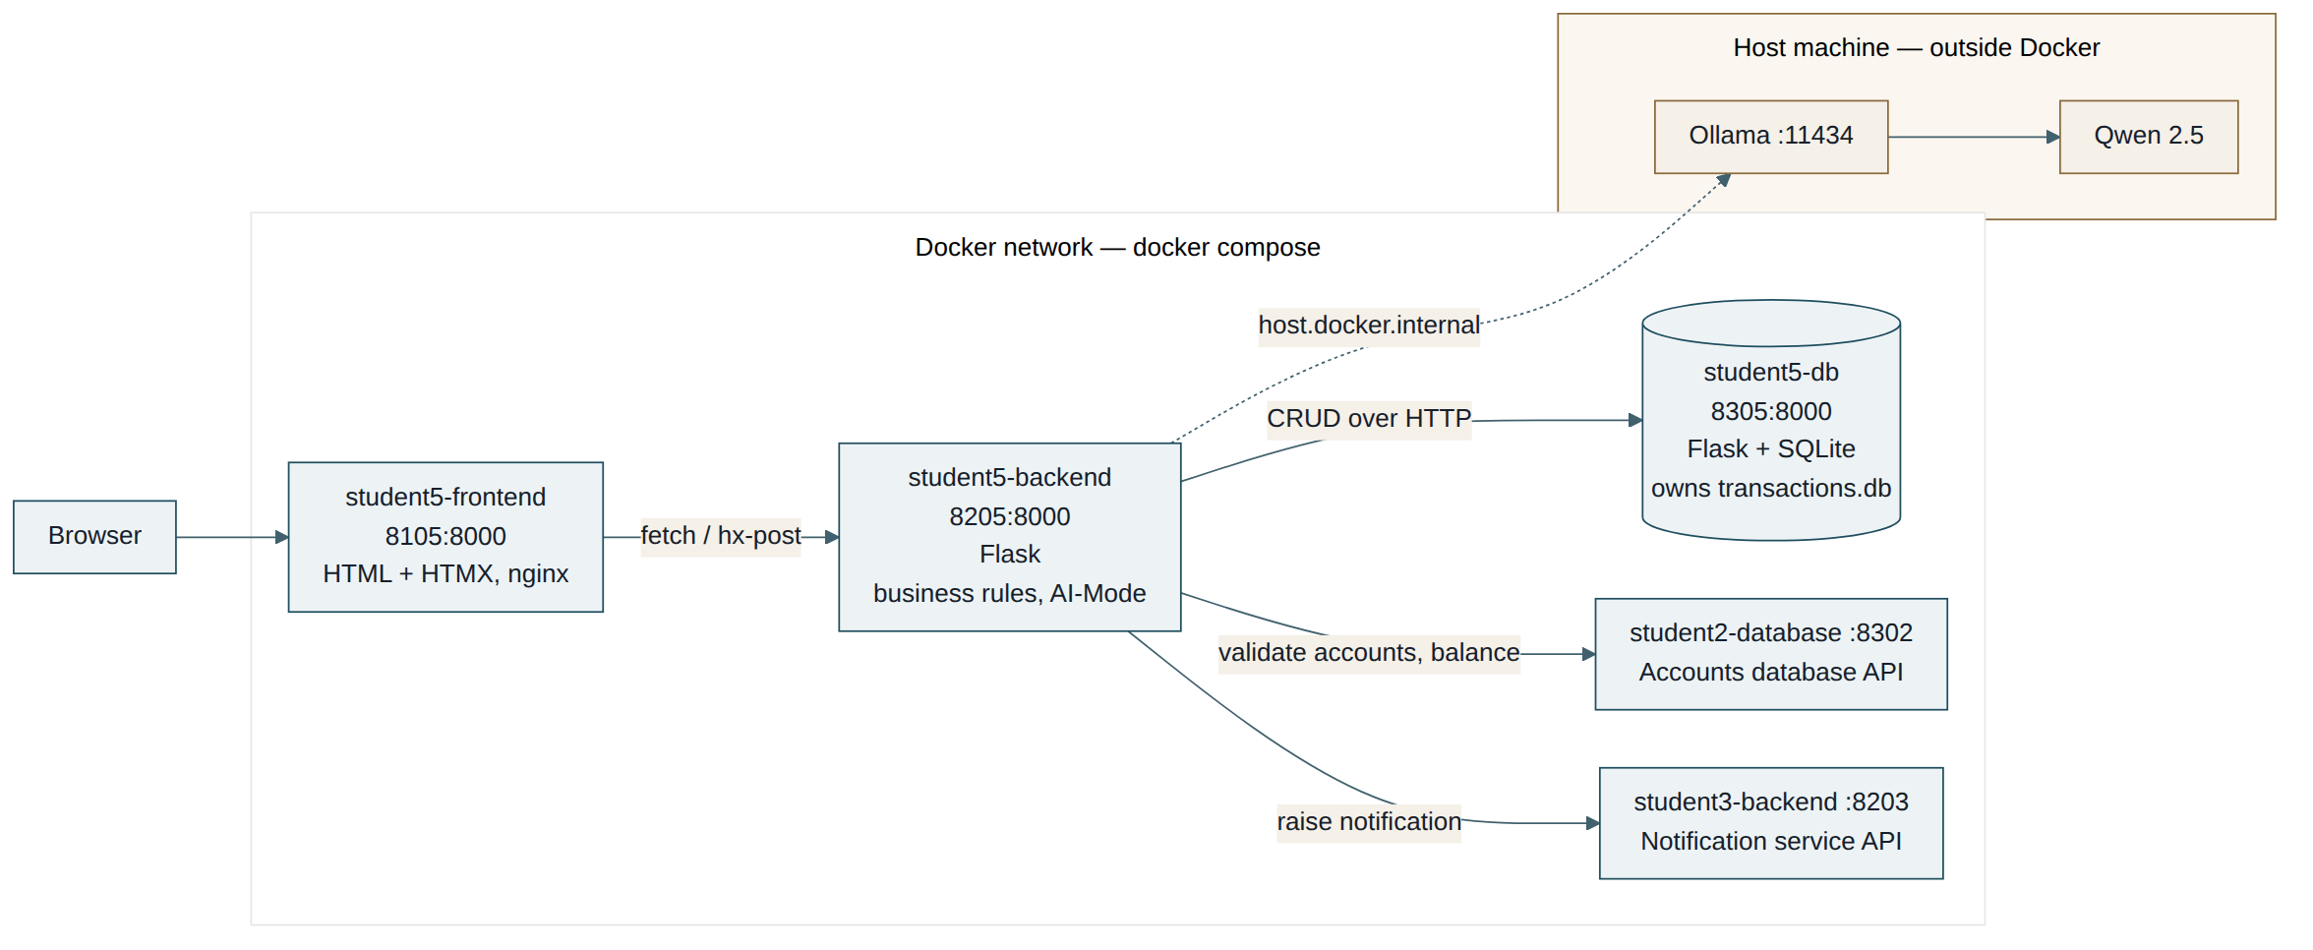
Figure 3 — Individual software architecture, Transaction Management
The frontend is static HTML served by nginx, using HTMX for partial updates. It has two tabs — normal mode for CRUD and AI Mode for analysis — and contains no business logic.
The backend is a Flask application factory registering two blueprints:
Blueprint | Routes
normal_ui | GET /transactions · GET /transactions/<id> · GET /accounts/<id>/transactions · POST /transactions/deposit · POST /transactions/withdraw · POST /transactions/transfer · PUT /transactions/<id> · DELETE /transactions/<id> · GET,POST,DELETE /ui/* HTML fragments for HTMX
ai_mode | POST /ai/analyse · POST /transactions/<id>/ai/explain
Every outbound dependency is isolated in its own service module: database_api.py for the feature’s own database, accounts_api.py for Bank Account Management, notifications_api.py for Notification Management, llm_client.py for Ollama, and prompt_loader.py for prompt files. The backend contains no SQLite code at all — it is structurally incapable of opening any database file, its own included.
Account validation is currently addressed to the Accounts database service at student2-database:5002, not to the Accounts backend. That service exposes the two operations this feature needs — GET /accounts/<id> and PATCH /accounts/<id>/balance — which the Accounts backend does not currently publish. This satisfies the cross-feature rule, since the data is reached through the owning container’s exposed HTTP API and never through its SQLite file, but it bypasses that feature’s business layer. Section 14 records the consequence.
The database service owns transactions.db on a named volume and exposes CRUD over HTTP. No other backend reads that file.

5. Integrated Software Architecture
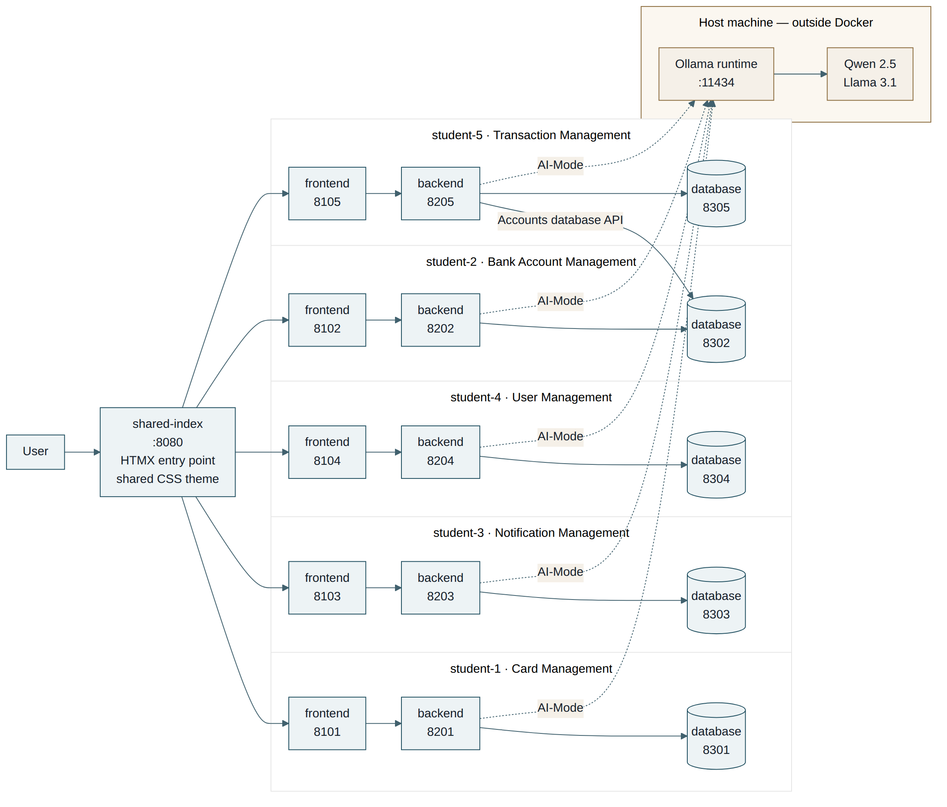
Figure 4 — Integrated Release 0 software architecture
The shared index is the single entry point and routes to all five student frontends. Backends communicate with one another only through published APIs — Transaction Management calls the Account service to validate transfers and the Notification service to raise notifications. No backend reaches another feature’s database directly.
Ollama is drawn outside the container boundary deliberately: it runs as a host process, not as a Compose service. Section 6 and the architecture decision record in docs/architecture/ollama-runtime.md explain that choice.
The diagram shows the Release 0 architecture as designed. Where a feature is not yet delivered, that is recorded in section 14, Known Issues and Limitations, rather than in the diagram.

6. Docker Compose Architecture
One shared docker-compose.yml at the repository root builds and starts thirteen containers on a single default bridge network. The file contains no image: entries — every container is built from a Dockerfile in this repository.
Service | Feature | Host port | Container port
shared-index | Shared entry point | 8080 | 8000
student-1-frontend | Card Management | 8101 | 80
student-1-backend | Card Management | 8201 | 5001
student-1-database | Card Management | 8301 | 5002
student2-frontend | Bank Account Management | 8102 | 80
student2-backend | Bank Account Management | 8202 | 5001
student2-database | Bank Account Management | 8302 | 5002
student4-frontend | User Management | 8104 | 80
student4-backend | User Management | 8204 | 5001
student4-database | User Management | 8304 | 5002
student5-frontend | Transaction Management | 8105 | 8000
student5-backend | Transaction Management | 8205 | 8000
student5-db | Transaction Management | 8305 | 8000
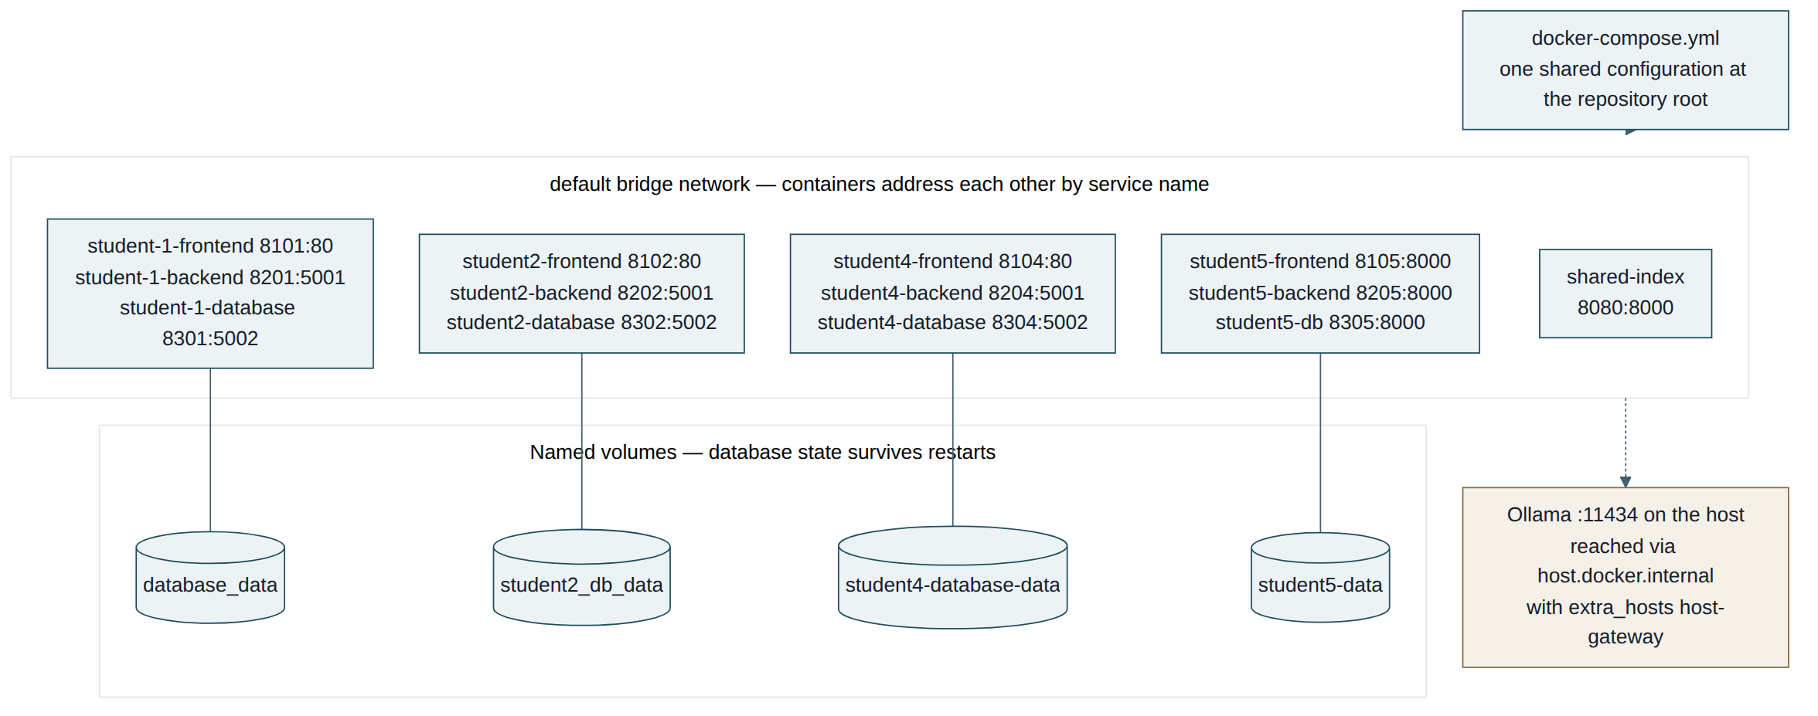
Figure 5 — Docker Compose architecture
Four named volumes persist database state across restarts: database_data, student2_db_data, student4-database-data and student5-data. Containers address one another by service name; only the host-facing ports are published.
The four backends that use AI-Mode declare OLLAMA_BASE_URL: http://host.docker.internal:11434/v1 together with extra_hosts: - "host.docker.internal:host-gateway". The gateway mapping is what makes the host runtime reachable on Linux as well as on Docker Desktop, so the same configuration works across the operating systems in use by the team.

7. DevOps Pipeline Architecture
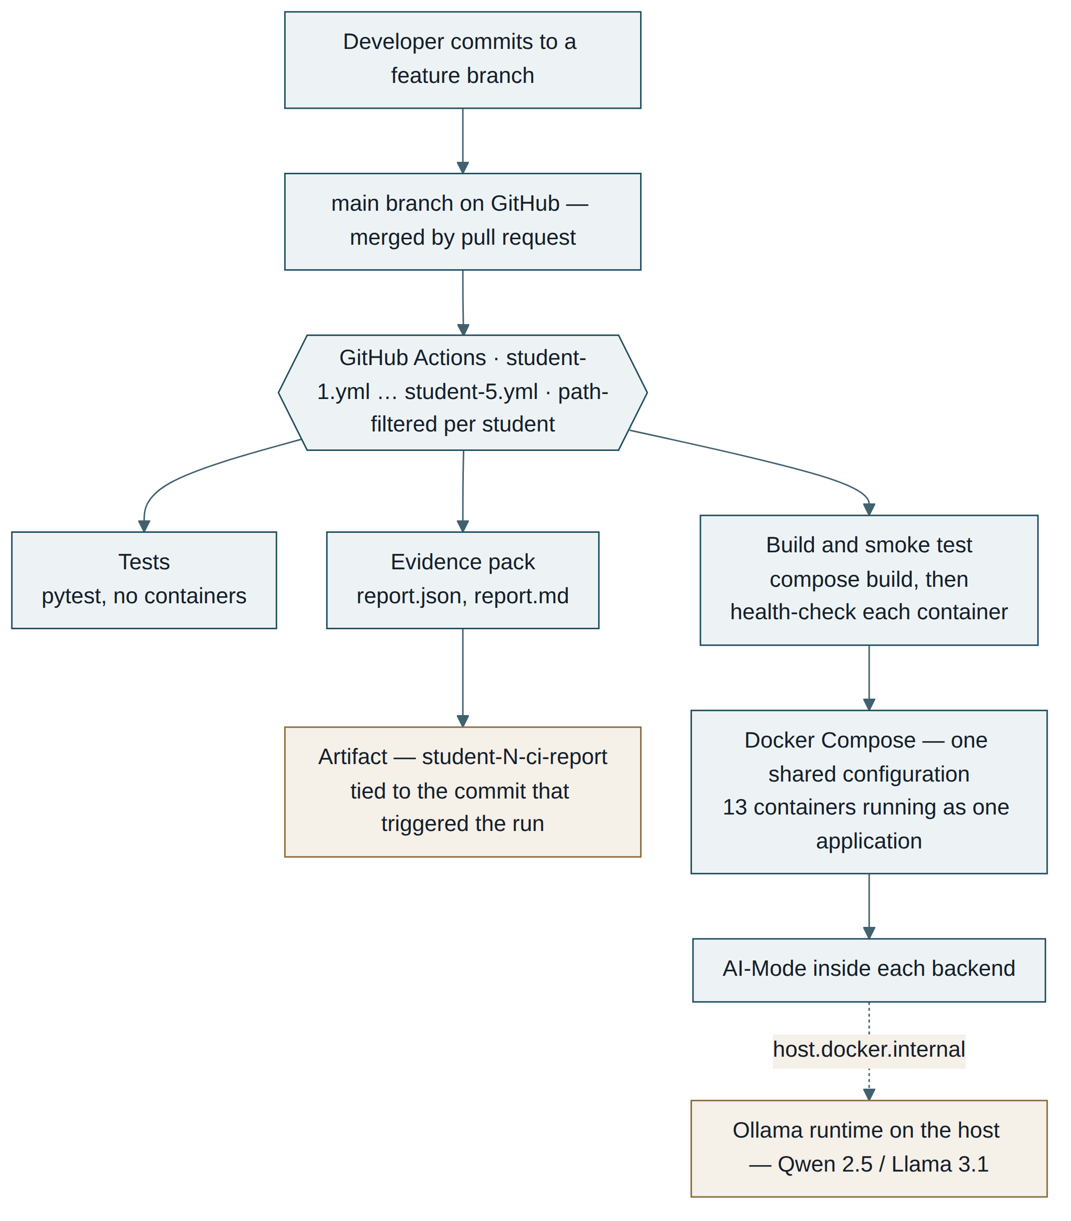
Figure 6 — DevOps pipeline architecture

7.1 From a commit to the main branch
Work begins on a feature branch, as section 7.2 of the specification requires, and reaches main only through a pull request. The repository holds four feature branches alongside main — feature/transaction, card_managament, user_management — so integration happens as a reviewed merge rather than by pushing directly to the shared branch. This matters for a five-person team sharing one docker-compose.yml: a bad merge to that file breaks the application for everyone at once.

7.2 What GitHub Actions does with that commit
Five workflow files live in .github/workflows/, one per student, as the specification names them. Each is filtered by path, so a push is only picked up by the workflows whose files it touched:
on:
push:
paths:
- "student-5/**"
- "docker-compose.yml"
- ".github/workflows/student-5.yml"
The consequence is that the pipeline reports per-student health rather than one shared pass or fail. A student whose feature does not yet build cannot turn another student’s workflow red, and each of us can see the state of our own microservices at a glance. The shared Compose file is included in every filter, because a change there affects all five features.

7.3 The three jobs
The student-5 workflow runs three jobs, and the other students’ workflows follow the same shape. Tests installs the Python dependencies and runs the pytest suite. It needs no containers at all, so it finishes in seconds and gives the fastest possible signal that a change has broken the feature’s logic.
Build and smoke test is the integration check. It validates the Compose file, builds the three student-5 images, starts them, and then polls each service until it answers. The checks request /health rather than /, which is deliberate: a Flask container that starts but cannot reach its database still serves a page at the root, so checking the root would pass a service that is in fact broken. Only the three student-5 services are built, so another student’s Dockerfile failing does not fail this job.
Evidence pack generates report.json and report.md summarising the run and uploads them as the artifact student-5-ci-report. Because the artifact is attached to the run, it is tied to the specific commit that produced it — which is what makes it usable as evidence in this report rather than a screenshot taken at an unknown moment.

7.4 What the pipeline does not cover
The lower chain in Figure 6 — Docker Compose, the thirteen running containers, AI-Mode, and the Ollama runtime — is the deployment path, not a continuation of the pipeline. It is what a developer gets by running docker compose up -d on their own machine, and what the showcase video demonstrates.
Continuous integration stops at the health checks. GitHub-hosted runners have no Ollama installation and no GPU, and host.docker.internal on a runner points at nothing, so an AI-Mode request made there would fail for reasons that have nothing to do with the code. The team chose not to pull a containerised Ollama into every workflow run: the image is roughly 1.7 GB before any model weights, which would add several minutes to a pipeline whose present value is that it answers in about two.
AI-Mode is therefore validated by manual testing and by the showcase demonstration rather than by the pipeline. This is recorded in section 14 as a known limitation, with an Ollama service scoped to the workflow as a candidate improvement for Release 1.

8. Agentic AI Workflow
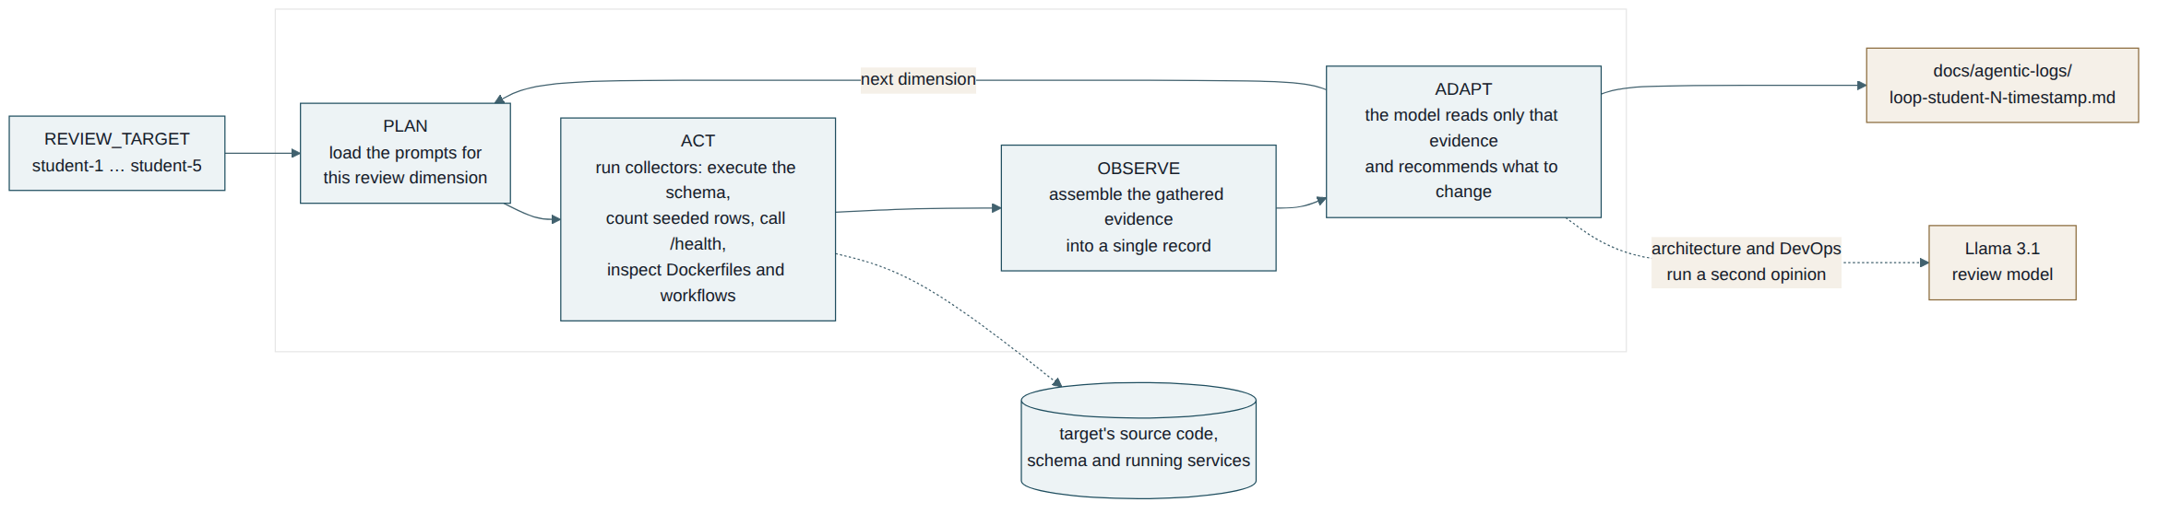
Figure 7 — Plan → Act → Observe → Adapt workflow
The loop is shared by the whole team and lives in ai-services/agentic_loop/. It is a terminal program rather than a service: it is run on demand, prints each phase as it executes, and writes a timestamped transcript to docs/agentic-logs/ when the operator exits the menu.
It reviews four dimensions — database, endpoints, architecture and DevOps pipeline — and can be pointed at any student folder through the REVIEW_TARGET environment variable. The architecture and DevOps reviews run a second, larger model over the first model’s output as a second opinion.
The design principle is that the model never inspects the repository itself. Collectors gather concrete evidence first — a schema that actually executes, a row count, an HTTP response — and the model sees only that evidence. This keeps recommendations grounded in what the code does rather than what it appears to say.
REVIEW_TARGET=student-5 python agentic_loop.py

9. GitHub Actions Workflows
The specification requires five workflow files, student-1.yml to student-5.yml, in .github/workflows/. All five exist. Their current state is set out below.

9.1 student-1.yml — Card Management
Triggered by pushes and pull requests touching student-1/**, shared/frontend/**, docker-compose.yml or the workflow file. Two jobs: a tests job that installs dependencies, runs a syntax check and then pytest, and a build-and-smoke job that validates the compose file and builds the student-1 services.

9.2 student-2.yml — Bank Account Management
Same trigger pattern scoped to student-2/**. Two jobs: unit-tests, which sets up Python and runs the database unit tests, and build-and-smoke, which builds the student-2 images.

9.3 student-3.yml — Notification Management
The file exists but is empty, so no pipeline runs for this feature. This follows from the feature itself not being implemented.
TO COMPLETE Ivan: populate this workflow, or record it in section 12 as a known limitation.

9.4 student-4.yml — User Management
The file exists but is empty, so no pipeline runs for this feature.
TO COMPLETE Sang: populate this workflow before submission — an empty file will read as a missing deliverable under the DevOps criterion.

9.5 student-5.yml — Transaction Management
Triggered by pushes and pull requests touching student-5/**, docker-compose.yml or the workflow file itself. Three jobs:
Job | What it does
tests | Installs dependencies and runs the pytest suite — 82 test functions across four files, with no containers required
build-and-smoke | Validates the compose file, builds only the three student-5 images, starts them, and health-checks each over HTTP
evidence-pack | Generates report.json and report.md and uploads them as the artifact student-5-ci-report, tied to the commit that triggered the run
The smoke checks request /health rather than /, so a container that starts but cannot serve is caught rather than passing silently. Because the workflow builds only the student-5 services, another student’s build failure cannot turn it red.

10. Implementation Summary

Card Management — student-1
TO COMPLETE Juno: summarise what was delivered, in one paragraph.

Bank Account Management — student-2
TO COMPLETE Binh: summarise what was delivered, in one paragraph. Mention the balance endpoint other features consume.

Notification Management — student-3
Not delivered in Release 0.

User Management — student-4
TO COMPLETE Sang: summarise what was delivered, in one paragraph.

Transaction Management — student-5 (Gia Tran)
Full CRUD is delivered across the frontend, backend and database microservices. Deposits, withdrawals and transfers are recorded with type-specific validation enforced both in the backend and at the schema level. Transfers call the Account service to verify that both accounts exist and that funds are sufficient before any row is written, and notify the Notification service afterwards on a best-effort basis.
Cancellation updates a transaction’s status rather than deleting the row, preserving the audit trail a banking system requires. AI-Mode provides two capabilities: explaining why an individual transaction failed or is still pending, and summarising an account’s money flow. In both cases the monetary figures are computed in Python and only the wording comes from the model, so a hallucinated amount is not possible.

11. Evidence

11.1 Local testing evidence
Transaction Management is covered by 82 test functions across four files:
File | Tests | Covers
test_backend_api.py | 26 | Backend routes against a monkeypatched database API and a fake Account service
test_database_api.py | 27 | Database service CRUD, constraints and error paths
test_helpers_unit.py | 20 | Money formatting and the summarising helpers
test_html_formatters.py | 9 | HTML fragment builders returned to HTMX
Cross-service failure paths are exercised with a fake Account service, so the tests do not depend on another student’s container being up.
TO COMPLETE Paste a screenshot of pytest passing locally. Other students: add your own suites and screenshots here.

11.2 GitHub Actions evidence
TO COMPLETE Screenshot: the Actions tab showing green runs. Screenshot: the Tests job expanded, showing the collected test count. Screenshot: Build and smoke test showing the health checks passing. Screenshot: the Artifacts section showing student-5-ci-report. Record the run number alongside them.

11.3 Docker Compose evidence
TO COMPLETE Screenshot: docker compose up -d completing. Screenshot: docker compose ps showing all thirteen containers up. Screenshot: localhost:8080 with the service status strip responding.

11.4 Application screenshots
TO COMPLETE Each student: screenshots of your own feature. For Transaction Management — the history table, a transfer being created, AI-Mode explaining a failed transaction, and the AI-Mode account summary.

12. Agentic Loop Workflow Record
The shared agentic loop lives in ai-services/agentic_loop/ and was designed, built and maintained by Gia Tran (student-5). It began from the review-loop pattern taught in the Week 4–5 laboratory, which used a single hard-coded target and a prompt set written for the laboratory’s enrolment domain. Everything in the current implementation — the engine, the collectors, the pipelines, the configuration and the prompt assets — was rewritten for this project. The twenty Python modules under that directory are all authored under one contributor in the repository history.
It is shared in the sense that matters for the team: any student’s services can be reviewed through it without changing a line of code, and the review record it produces is available to everyone.

12.1 What was built
Module | Responsibility
config/targets.py | Registry of the five students with their feature, owner and three ports; resolves a target from the REVIEW_TARGET environment variable so the loop is not bound to one feature
config/review_config.py | Defines the four review dimensions and which prompt files each one loads
core/orchestrator.py | Runs one dimension through PLAN, ACT, OBSERVE and ADAPT, labelling each phase as it executes
core/ai_runner.py | Calls Ollama through the OpenAI-compatible endpoint; selects the implementation model or the larger review model
core/prompt_registry.py | Resolves and reads prompt files, failing loudly when one is missing
core/reporter.py | Prints the menu and results, and writes a timestamped transcript to docs/agentic-logs/
collectors/db_collector.py | Executes the target’s schema and seed SQL in memory, counts rows per table, and calls the database service
collectors/endpoints_collector.py | Exercises the target’s backend endpoints over HTTP
collectors/architecture_collector.py | Checks the three tiers exist, each has a Dockerfile, and no backend contains SQLite code
collectors/devops_collector.py | Inspects the target’s workflow file and Docker configuration
pipelines/ | One module per dimension, substituting the gathered evidence into the prompt templates

12.2 The design principle
The model never inspects the repository itself. Each collector gathers concrete, verifiable evidence first — a schema that actually executes, a real row count, an HTTP status code, the presence or absence of a file — and only that evidence is passed to the model. The model’s role is to read the evidence and recommend what to change, not to guess at code it cannot see. This is what keeps the recommendations grounded, and it is the reason the architecture collector can assert that a backend contains no SQLite code rather than merely believing it does not.
The architecture and DevOps dimensions run a second pass: the first model’s output is handed to a larger review model together with the same evidence, which either confirms the finding or disputes it. If that model is unavailable the loop degrades to the first pass rather than failing.

12.3 Prompt assets
The prompt set was rewritten from the laboratory’s enrolment domain to this project’s banking domain. All prompt files under ai-services/prompts/ are authored by Gia Tran:
ai-services/prompts/service/implementation/system_prompt.txt
ai-services/prompts/service/implementation/task_prompt.txt
ai-services/prompts/service/implementation/context_prompt.txt
ai-services/prompts/architecture/implementation/architecture_system_prompt.txt
ai-services/prompts/architecture/implementation/architecture_task_prompt.txt
ai-services/prompts/architecture/review/agent_review_prompt.txt
ai-services/prompts/devops/implementation/devops_system_prompt.txt
ai-services/prompts/devops/implementation/devops_task_prompt.txt
ai-services/prompts/devops/review/agent_review_prompt.txt
The task prompts carry two placeholders, {{REVIEW_TARGET}} and {{VALIDATION_EVIDENCE}}, which the pipelines substitute at run time. That is what allows one prompt set to serve all five students rather than one prompt set per feature.

12.4 Review record
Four runs against student-5 are recorded in docs/agentic-logs/, all dated 3 September 2026. Each log names the target, lists the dimensions reviewed, and reproduces the evidence the collectors gathered alongside the model’s recommendations.
TO COMPLETE Paste one complete log as Appendix A. This is the review record the Agentic AI Workflow criterion asks for, and the criterion also requires the loop to be demonstrated in the terminal — which the showcase video covers.
TO COMPLETE Other students: if you run the loop against your own feature before submission, add your log here so the record covers more than one target.

13. Prompt Engineering and Context Management
TO COMPLETE Students 1, 2 and 4: document your prompt engineering and context management here, or in docs/prompts/ and reference it.

Gia Tran
Documented in full in docs/prompts/student-5.md: the context management strategy used while developing with AI assistance, nine prompt-log entries, and a table of six AI suggestions that were rejected or corrected.
Two of those corrections shaped the architecture. The first was a proposal to build a separate AI service that all backends would call, which would have inserted a fifth hop into a request workflow the specification defines as Frontend → Backend/API → Ollama → LLM; it was discarded and AI-Mode kept inside each backend. The second was a prompt design that left arithmetic on monetary values to the model, which was replaced by computing every figure in Python and passing the model finished numbers to phrase.

14. Known Issues and Limitations

Group
- Notification Management (student-3) is not implemented and has no services in the shared Docker Compose configuration. Operations that would notify it degrade gracefully rather than failing.
- student-3.yml and student-4.yml exist but are empty, so no pipeline runs for those two features.
- Continuous integration does not exercise AI-Mode. GitHub-hosted runners have no Ollama installation, and the team chose not to pull a container image of it into every workflow run. The pipeline therefore verifies that each service builds, starts and answers its health endpoint; AI-Mode is validated manually and in the showcase demonstration. Adding an Ollama service scoped to the workflow is a candidate for Release 1.
- Ollama runs on the host rather than as a Compose service. This is a deliberate decision, recorded with its reasoning, cross-platform networking and the alternative that was tested and rejected in docs/architecture/ollama-runtime.md. It means Ollama is a documented prerequisite rather than something docker compose up provides.
- The compiled OLLAMA_BASE_URL defaults differ across backends. Compose overrides all of them so containers behave identically; the difference is visible only when a backend is run directly on the host. Standardisation is planned for Release 1.
- Internal container ports are not uniform — student-5 listens on 8000 while the other features use 80, 5001 and 5002. Published host ports do follow the team convention, so this is invisible from outside the network.

Transaction Management — student-5
- accounts_api.py does not yet distinguish "the account does not exist" from "the Account service is unreachable"; both currently resolve to the same absent value. Separating them is scheduled for Release 1.
- PUT /transactions/<id> exists but the interface exposes only cancellation, on the grounds that a completed financial transaction should not be editable.
- Account validation calls the Accounts database service directly rather than the Accounts backend. This is compliant — the data is retrieved through the owning container’s exposed API, never its SQLite file — but it bypasses that feature’s business layer, so the frozen-account rule is currently duplicated in accounts_api.py. Moving the call to the Accounts backend is planned for Release 1, once that backend publishes an account lookup and a balance adjustment endpoint.
TO COMPLETE Students 1, 2 and 4: add the known limitations of your own features.

15. Commit and Contribution Logs

15.1 Commit history
The repository holds 113 commits between 12 August and 6 September 2026, across main and four feature branches.
Author | Commits
JE-Wardrop | 39
gibtran | 32
Sang | 24
SamuelD | 7
Binh Nguyen / gbinhnguyen | 8
AssassinMath | 3
Several members committed under more than one identity. Map each Git author to a team member in the contribution table below so the assessor can follow the history.
TO COMPLETE Screenshot: git log --oneline --graph --all, and the repository Insights → Contributors view.

15.2 Contribution logs
Student | Contribution
Juno Wardrop | [TO COMPLETE]
Binh Nguyen | [TO COMPLETE]
Ivan | [TO COMPLETE]
Sang | [TO COMPLETE]
Gia Tran | Transaction Management feature across frontend, backend and database; shared home page and CSS theme; sole author of the shared agentic loop in ai-services/ — engine, four collectors, four pipelines, target registry and all nine prompt assets; student-5.yml CI pipeline; Ollama runtime architecture decision record; repository README and helper scripts

15.3 Attendance checkpoints
TO COMPLETE Add the attendance record for each laboratory checkpoint.

Appendix A — Agentic loop transcript
TO COMPLETE Paste one complete run from docs/agentic-logs/ here.

Appendix B — Setup instructions
Reproduced from README.md so the report is self-contained.
# 1. Install Docker and Ollama
# 2. Pull the approved models
ollama pull qwen2.5:0.5b
ollama pull llama3.1:8b

# 3. Start the runtime (Linux needs all interfaces)
OLLAMA_HOST=0.0.0.0 ollama serve

# 4. Confirm it answers
curl http://localhost:11434/api/tags

# 5. Start the application
git clone git@github.com:JE-Wardrop/project-ASD.git
cd project-ASD
docker compose up -d --build

# 6. Open http://localhost:8080

Appendix D — Data design diagrams
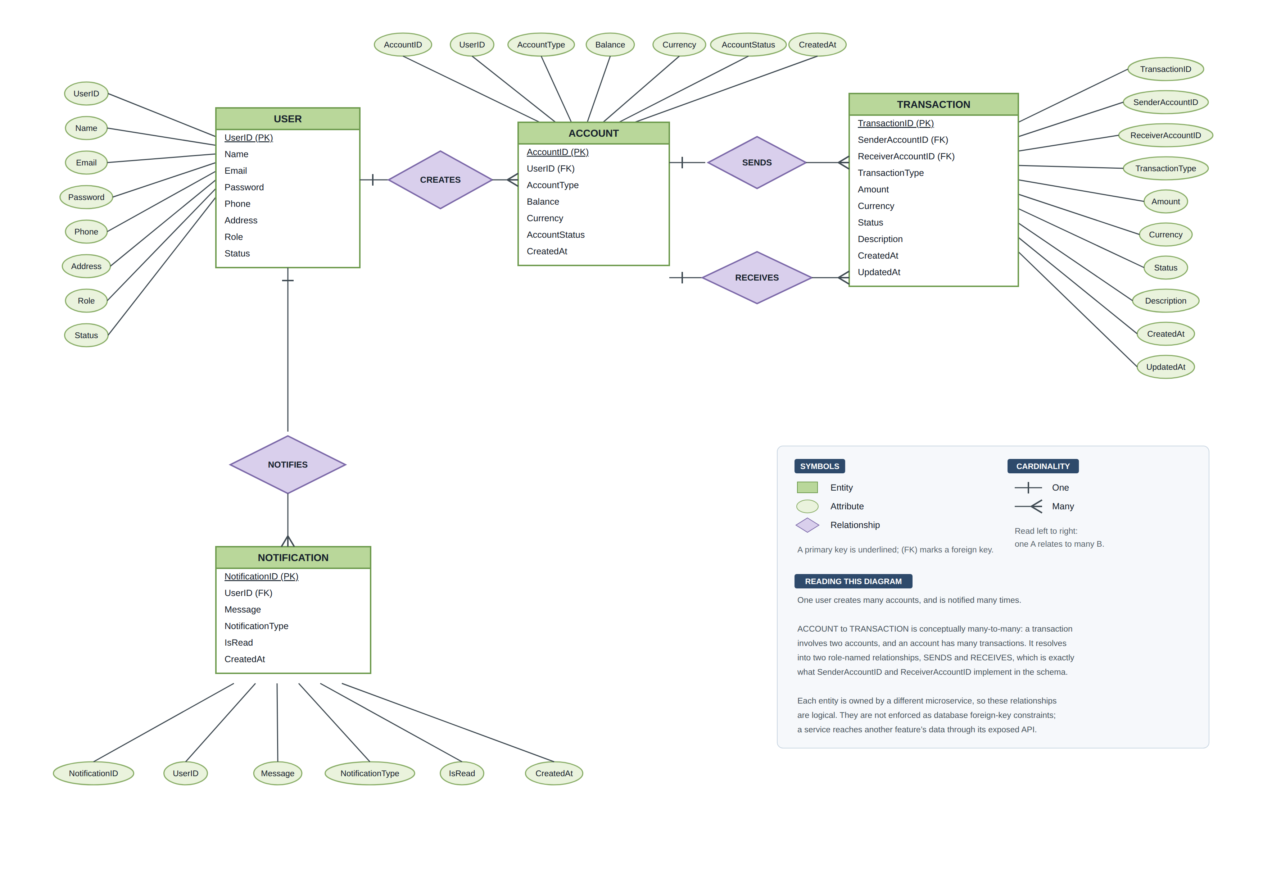
Figure 1 — Entity relationship diagram, Chen notation
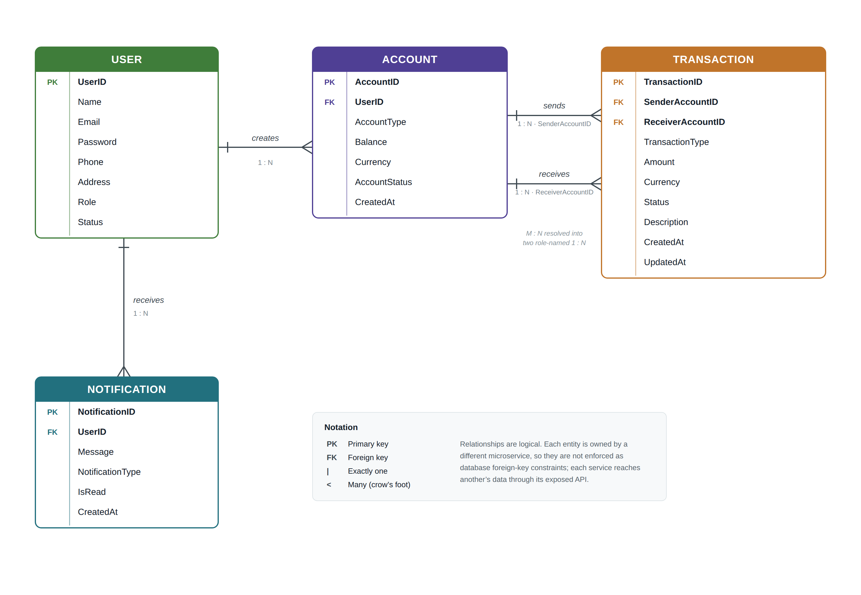
Figure 2 — Logical data model

Appendix C — Product Backlog
Reproduced from docs/report/Group44-Product-Backlog.xlsx, which remains the working copy. Estimates are story points on a Fibonacci scale. Release R0 is this submission; R1 is the next release. Iterations I1 and I2 divide the work within a release.
ID | Title | User story | Acceptance criteria | Est. | Priority | Status | Rel / Itr | Assignee
Functional Requirement
US-501 | Record a Deposit | As a customer,  I want to record a deposit into an account,  so that money paid in is reflected in my transaction history. | US-501.AC1 Deposit requires a receiver account and no sender account  US-501.AC2 Amount must be greater than zero  US-501.AC3 Transaction is stored with type DEPOSIT  US-501.AC4 New transaction appears at the top of the history | 3 | High | Done | R0 / I1 | Gia Tran
US-502 | Record a Withdrawal | As a customer,  I want to record a withdrawal from an account,  so that money taken out is reflected in my transaction history. | US-502.AC1 Withdrawal requires a sender account and no receiver account  US-502.AC2 Withdrawal is rejected when the balance is insufficient  US-502.AC3 Transaction is stored with type WITHDRAWAL  US-502.AC4 A rejected withdrawal creates no transaction record | 3 | High | Done | R0 / I1 | Gia Tran
US-503 | Transfer Between Accounts | As a customer,  I want to transfer money from one account to another,  so that I can move funds without visiting a branch. | US-503.AC1 Both sender and receiver accounts must exist  US-503.AC2 Sender and receiver must be different accounts  US-503.AC3 Both accounts are validated through the Account service API  US-503.AC4 Transfer is rejected when the sender has insufficient funds  US-503.AC5 Both balances are updated after a successful transfer  US-503.AC6 The Notification service is called after the transaction is recorded  US-503.AC7 Transaction is stored with type TRANSFER and status COMPLETED | 8 | High | Done | R0 / I1 | Gia Tran
US-504 | View Transaction History | As a customer,  I want to view my transaction history,  so that I can track money in and out of my account. | US-504.AC1 History loads without any action from the user  US-504.AC2 History can be filtered by transaction type  US-504.AC3 History can be filtered by status  US-504.AC4 History can be filtered by account  US-504.AC5 Records are ordered with the most recent first  US-504.AC6 Data is read through the database API, never the SQLite file | 5 | High | Done | R0 / I1 | Gia Tran
US-505 | View a Single Transaction | As a customer,  I want to open one transaction and see its details,  so that I can check an individual payment. | US-505.AC1 All stored fields are displayed for the selected transaction  US-505.AC2 A request for a non-existent transaction returns a clear message | 2 | Medium | Done | R0 / I2 | Gia Tran
US-506 | Cancel a Pending Transaction | As a customer,  I want to cancel a transaction that has not completed,  so that I can stop a payment I no longer want. | US-506.AC1 Only transactions with status PENDING can be cancelled  US-506.AC2 Cancelling updates the status to CANCELLED  US-506.AC3 The record is never deleted, so the audit trail is preserved  US-506.AC4 The cancelled row remains visible in the history | 3 | High | Done | R0 / I2 | Gia Tran
US-507 | Explain a Transaction (AI-Mode) | As a customer,  I want to ask why a transaction failed or is pending,  so that I understand the outcome without contacting support. | US-507.AC1 Explain is offered on PENDING, FAILED and CANCELLED transactions  US-507.AC2 The response is plain English with no JSON or code  US-507.AC3 All figures are computed in the backend, not by the model  US-507.AC4 The request follows Frontend to Backend to Ollama to LLM  US-507.AC5 An unavailable model returns a readable message, not a blank panel | 8 | High | Done | R0 / I2 | Gia Tran
US-508 | Summarise Account Activity (AI-Mode) | As a customer,  I want to see a plain-English summary of an account,  so that I can understand my money flow at a glance. | US-508.AC1 Summary reports money in, money out and the largest single movement  US-508.AC2 Only COMPLETED transactions are counted in the totals  US-508.AC3 Totals are calculated in Python and passed to the model as text  US-508.AC4 The model only phrases the figures and cannot invent an amount | 5 | Medium | Done | R0 / I2 | Gia Tran
US-101 | Add a New Card | As a customer/staff,  I want to add a card to an account,  so that I can pay with a card linked to my account. | US-101.AC1 Card holder name, number, type, expiry, status and balance are required  US-101.AC2 A new card is stored in the database  US-101.AC3 The new card appears in the card list | 5 | High | In Progress | R0 / I1 | Juno Wardrop
US-102 | View Cards | As a customer/staff,  I want to view the cards on the system,  so that I can see which cards exist and their state. | US-102.AC1 All cards can be listed  US-102.AC2 A single card can be retrieved by its ID  US-102.AC3 Cards can be filtered by card type | 3 | High | In Progress | R0 / I1 | Juno Wardrop
US-103 | Update Card Details | As a customer/staff,  I want to update a card record,  so that card information stays correct. | US-103.AC1 Updated details are saved in the database  US-103.AC2 A partial update leaves untouched fields unchanged | 3 | Medium | In Progress | R0 / I2 | Juno Wardrop
US-104 | Delete a Card | As a customer/staff,  I want to remove a card,  so that cards I no longer use are not shown. | US-104.AC1 The card is removed from the database  US-104.AC2 Deleting a non-existent card returns a clear message | 2 | Medium | In Progress | R0 / I2 | Juno Wardrop
US-105 | Freeze and Unfreeze a Card | As a customer/staff,  I want to freeze or unfreeze a card,  so that I can stop a lost card being used. | US-105.AC1 A card can be frozen by card number  US-105.AC2 A frozen card can be unfrozen  US-105.AC3 Card status is only ever Frozen or Unfrozen | 3 | High | In Progress | R0 / I2 | Juno Wardrop
US-201 | Open an Account | As a customer/staff,  I want to open a bank account,  so that I can hold and move money in the system. | US-201.AC1 Required account fields are validated before saving  US-201.AC2 A new account is stored with an opening balance  US-201.AC3 The new account appears in the account list | 5 | High | Done | R0 / I1 | Binh Nguyen
US-202 | View Accounts | As a customer/staff,  I want to view accounts on the system,  so that I can find an account and check its state. | US-202.AC1 All accounts can be listed  US-202.AC2 An account can be retrieved by ID  US-202.AC3 Accounts can be filtered by user  US-202.AC4 Accounts can be filtered by status | 3 | High | Done | R0 / I1 | Binh Nguyen
US-203 | View Account Balance | As a customer/staff,  I want to see the balance of an account,  so that I know how much money is available. | US-203.AC1 The current balance is returned for a valid account  US-203.AC2 The balance endpoint is available to other features over HTTP | 3 | High | Done | R0 / I1 | Binh Nguyen
US-204 | Update Account Details | As a customer/staff,  I want to update an account record,  so that account information stays correct. | US-204.AC1 Updated details are saved in the database  US-204.AC2 Balance cannot be edited directly through this operation | 3 | Medium | Done | R0 / I2 | Binh Nguyen
US-205 | Freeze, Unfreeze and Close an Account | As a staff,  I want to change the operating status of an account,  so that accounts under investigation cannot be used. | US-205.AC1 An account can be frozen and unfrozen  US-205.AC2 An account can be closed  US-205.AC3 A frozen or closed account is rejected by the Transaction service | 5 | High | Done | R0 / I2 | Binh Nguyen
US-206 | Adjust Balance from Another Feature | As a system,  I want to allow another feature to adjust a balance through the API,  so that transfers can update both sides without touching my database file. | US-206.AC1 A balance adjustment endpoint accepts a signed delta  US-206.AC2 The endpoint is reachable from the Transaction backend over HTTP  US-206.AC3 No other feature opens the accounts SQLite file directly | 5 | High | Done | R0 / I2 | Binh Nguyen
US-301 | Notify After a Transaction | As a customer,  I want to be notified when a transaction is recorded on my account,  so that I know immediately when money moves. | US-301.AC1 A notification is created when a transaction completes  US-301.AC2 The notification records the account, amount and transaction type  US-301.AC3 A failure to notify does not roll back the transaction | 5 | High | To-do | R1 / I1 | Ivan
US-302 | View Notification History | As a customer,  I want to view the notifications raised on my account,  so that I can review activity I may have missed. | US-302.AC1 Notifications are listed most recent first  US-302.AC2 Notifications can be filtered by account | 3 | Medium | To-do | R1 / I1 | Ivan
US-401 | Register an Account | As a customer/staff,  I want to register for the system,  so that I can access the banking application. | US-401.AC1 Required registration fields are validated  US-401.AC2 Email format is validated  US-401.AC3 User details are saved after a valid registration | 5 | High | Done | R0 / I1 | Sang
US-402 | Log In and Log Out | As a customer/staff,  I want to log in and out of the system,  so that my session is secure. | US-402.AC1 Credentials are validated against stored user records  US-402.AC2 An error message is shown when credentials are invalid  US-402.AC3 The user is returned to the login page after logging out | 3 | High | Done | R0 / I1 | Sang
US-403 | View and Update Profile | As a customer/staff,  I want to view and update my user details,  so that my information stays up to date. | US-403.AC1 A user can retrieve their own details  US-403.AC2 Updated details are saved in the database | 3 | Medium | Done | R0 / I2 | Sang
US-404 | Delete a User | As a staff,  I want to remove a user from the system,  so that accounts that are no longer needed are not retained. | US-404.AC1 The user record is removed  US-404.AC2 Deleting a non-existent user returns a clear message | 2 | Medium | Done | R0 / I2 | Sang
US-405 | Ask for Help (AI-Mode) | As a customer/staff,  I want to ask a question about user management,  so that I can get help without reading documentation. | US-405.AC1 A question is sent to the backend and answered in plain English  US-405.AC2 The request follows Frontend to Backend to Ollama to LLM | 5 | Medium | Done | R0 / I2 | Sang
Non-Functional Requirement
NFR-01 | Cross-Feature Data Isolation | As a developer,  I want to reach another feature’s data only through its exposed API,  so that each feature owns its own schema. | NFR-01.AC1 No backend contains SQLite code for another feature  NFR-01.AC2 Cross-feature reads and writes are made over HTTP  NFR-01.AC3 The agentic loop flags any violation of this rule | 5 | High | Done | R0 / I1 | All
NFR-02 | AI Must Not Compute Money | As a developer,  I want to compute every monetary figure in application code,  so that the model cannot invent or miscalculate an amount. | NFR-02.AC1 All totals are calculated in Python before the prompt is built  NFR-02.AC2 The model receives finished figures as plain text  NFR-02.AC3 No arithmetic is delegated to the model | 3 | High | Done | R0 / I2 | Gia Tran
NFR-03 | SQL Injection Safety | As a developer,  I want to use parameterised queries for every database operation,  so that user input cannot alter a query. | NFR-03.AC1 No SQL string is built by concatenation or interpolation  NFR-03.AC2 All values are passed as query parameters | 3 | High | Done | R0 / I1 | All
NFR-04 | Containerisation | As a developer,  I want to run every microservice as a container from one Compose file,  so that the whole application starts with a single command. | NFR-04.AC1 Every frontend, backend and database has a Dockerfile  NFR-04.AC2 One shared docker-compose.yml starts all services  NFR-04.AC3 Database state survives a restart through named volumes | 8 | High | Done | R0 / I1 | All
NFR-05 | Per-Student CI Pipeline | As a developer,  I want to validate my own microservices on every push,  so that a teammate’s broken build does not block me. | NFR-05.AC1 Each student has a workflow file filtered to their own directory  NFR-05.AC2 The pipeline runs tests, builds images and health-checks them  NFR-05.AC3 Each run uploads an evidence artefact tied to the commit | 5 | High | In Progress | R0 / I2 | All

