A Note on the Delta Rule and Back Propagation
Workshop on the Practice of Connectionism

The delta rule is based on the notion of gradient descent. Gradient descent is a tool that is used to find the X-value at which some function (F) is the minimum or the maximum. While this function can be anything, the most common application of gradient descent is to minimize some function that computes the amount of error. In this case, we will use it to find the set of weights (W) at which the error function is at a minimum.

In a gradient descent paradigm, all you do is compute the derivative of the function you want to minimize (the error function).

If that error function is complete (e.g. if it was based on the entire training set and could compute the global error) then you can solve for the place at which the derivative is 0. This will be the minimum (indeed, this is how the formulas for means and standard deviation were derived).

If that error function is not complete (e.g. it is based on only a single exemplar in the training set), then you compute the derivative for that single exemplar, and adjust the weights by a small proportion of that derivative.

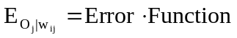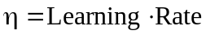
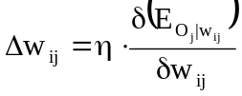
In this case, we will use an incomplete error function (though it is possible to derive the delta-rule for the complete set). For completely arbitrary (but useful) reasons, we will use the least-squared difference between some target output (t_{j}) and the actual output (o_{j}) as the error term. If this difference is 0, then the target equals the output and the function is minimized. If it is non zero, then we will still have work to do.

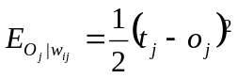
Now, o_{j} is some function (F, the activation function of the input), leaving us with:
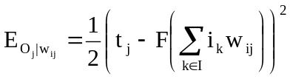
Since we only care about a single input (i_{i}) we can pull out that term from the summation.
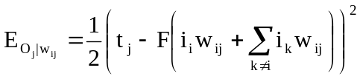

Now we take the derivative using the polynomial rule.
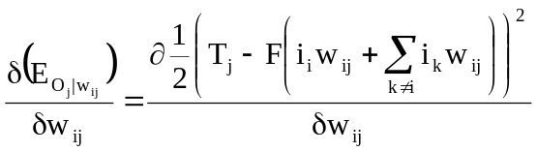
Note that after using the polynomial rule, the chain rule says that we have to multiply the derivative of the polynomial by the derivative of the inside.
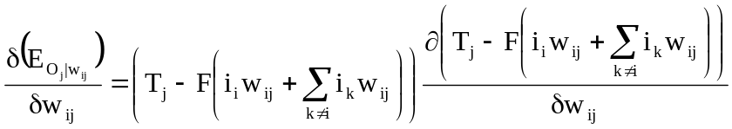
Here, the derivative of T_{j} is 0 (since it does not depend on the weights). Thus, we get
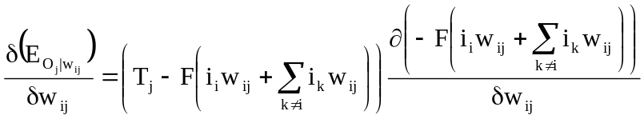
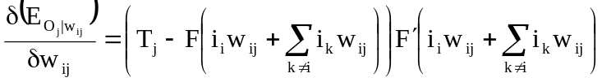
Finally, because F(i*w) (in the first term) is the same as the output (and we don’t need to do any more derivatives), we can simplify to

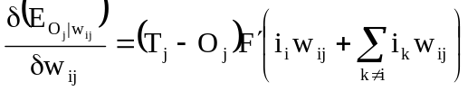
Thus, the generalized delta rule is
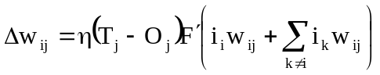
If we want to apply it to any specific network, we just need to determine what the activation function (of the output nodes) is, take the derivative and we can compute the delta rule.

For example, for a linear activation function

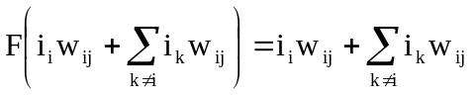
Since the summation term does not include w_{ij}, its derivative is 0 and the derivative of the activation function is therefore
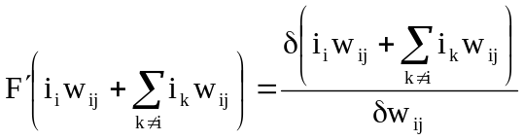
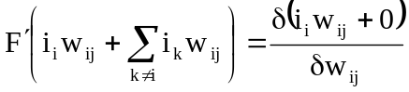
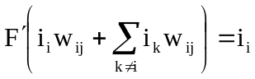
Thus, the delta rule for the linear activation function is
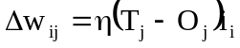

The logistic activation function is a bit more complex

  - Now upgrade to your logistic activation function

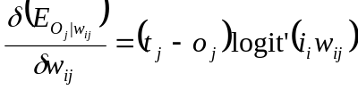
Demonstrate why logit' = logit * (1-logit)

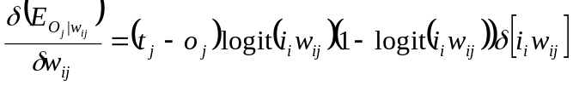
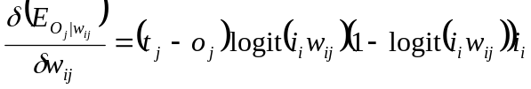
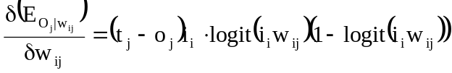

  - Matrix Form
    - (T – O) = <1,numout>
    - (logit’(in*w)) = O = <1,numout>
        - Use dot product to maintain combination
    - I = <1,numin>
    - I’ * ((T-O).*O.*(1-O))
        - Same logic as hebb rule:
<numin, 1> <1, numout> = <numin, numout>

- Introduce AND problem.
  - Use logistic activation (looking for a binary value).
  - Fails: why?
  - Work out weights on board.
  - What do we need: bias weights.
    - Two ways to implement them:
      - As independent weights
      - As part of the regular matrix (and always have input node b on).

- Now try OR.
  - Work out weights on board.
  - Try it with and without bias weights.

- Now try XOR.
Fails.
Work out weights on board. What do we need? Hidden layer?
Talk about linear separability
Frame it in terms of generalizability and similarity space.

- Back Propagation
  - Introduce multilevel networks.
  - In, hidden, output.
  - Two sets of weights: In2Hid, Hid2Out.
  - Training:
    - based on deltaRule.
      - Change error signal for each layer.
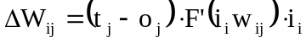 Generalized
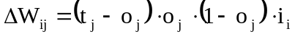 Logistic

    - Hid2Out
      - Delta rule
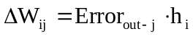
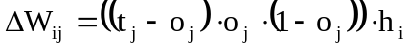
      - In matrix form
Error_{out} = (T – O) .* O .* (1-O)

    - In2Hid
      - Back-propagate the error through the weight matrix. Now use deltarule.
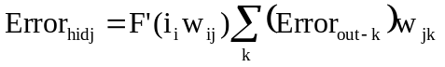
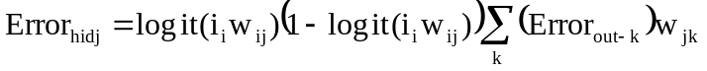
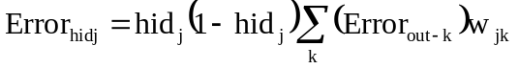
      - Matrix terms
<1 x numout > * <numhid x numout>
<1 x numout > * < numout x numhid > = <1 x numhid>

Error_{hid} = H .* (1 – H) .* (error_{out} * hid2out^{T})

      - We’ve got error term, now apply it to delta rule

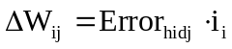
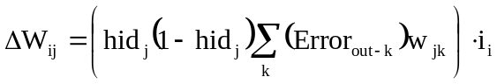
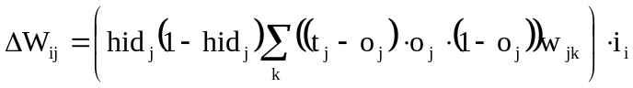
      - In matrix terms

Error_{hid} = H .* (1 –H ) .* (error_{out} * hid2out^{T})

Error_{hid} = H .* (1 –H ) .* [ ( (T – O) .* O .* (1-O) )* hid2out^{T}]
<1 x h >

ΔW_{i-h} = η * I^{T} * [ H .* (1 –H ) .* [ ( (T – O) .* O .* (1-O) )* hid2out^{T}] ]
<i x 1> <1 x h>

- Now try XOR Network.
      - Still fails.
      - What do we need to add?
        - Momentum.
        - Discuss local minimum problem.

