Easy Crypt (Formally One Chat)

~~1. Insert a key into the key box key: default~~

~~2. add any text into the first box press encrypt~~

Servers Are Down

Encryption2

1. press generate and generate roll numbers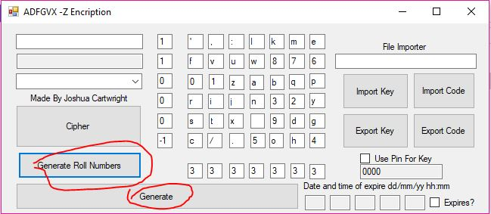

2. click the drop down box and select normal to encrypted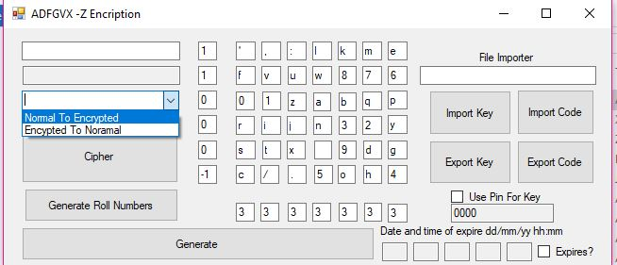

3. add text to the first box

4. click cipher

