**TCP/IP Reference**

This book assumes basic familiarity with TCP/IP and networking concepts. You won't find a primer on the OSI seven-layer model or a rundown of the Berkeley Socket API within these pages. For a comprehensive guide to TCP/IP, I recommend “[*The TCP/IP Guide*](http://www.amazon.com/dp/159327047X?tag=secbks-20)” by Charles Kozierok or the old classic “[*TCP/IP Illustrated, Volume I*](http://www.amazon.com/dp/0201633469?tag=secbks-20)” by W. Richard Stevens.

While TCP/IP familiarity is expected, even the best of us occasionally forget byte offsets for packet header fields and flags. This section provides quick reference diagrams and field descriptions for the IPv4, TCP, UDP, and ICMP protocols. These beautiful diagrams are used by permission of author Matt Baxter.

Figure 1. IPv4 header

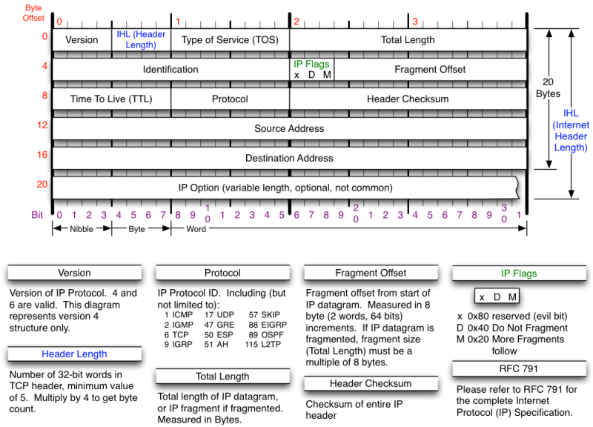

Figure 2. TCP header

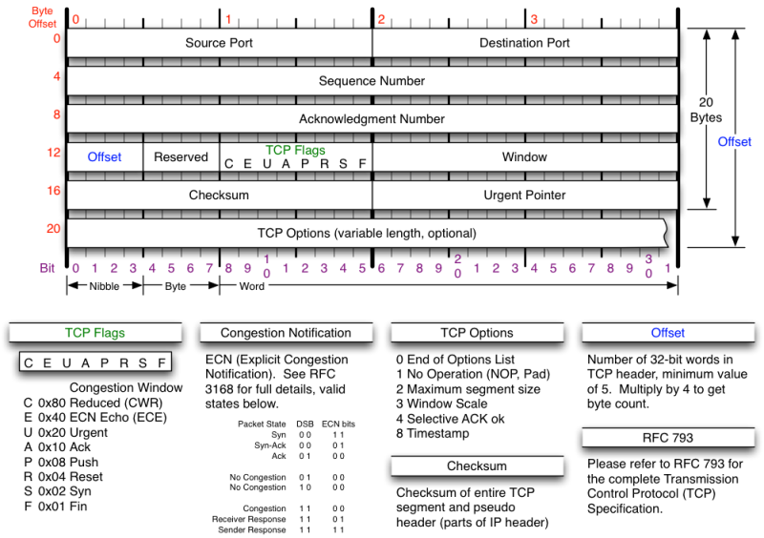

Figure 3. UDP header

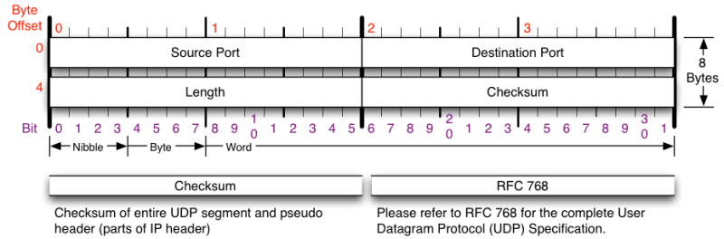

Figure 4. ICMP header

