SAMRT PARKING SYSYTEM AND FIRE DETECTION
TEAM MEMBERS:
- JEEVALAKSHMIV(23ECE071)
- SUVEDHA B(23ECE087)
- SWETHA S(23ECE089)

INTRODUCTION
With the growth of urban areas, parking management and safety in public spaces have become major challenges. This project provides a smart IoT-based solution that helps in monitoring parking slot availability while also ensuring safety by detecting fire, gas leaks, and high temperatures.
OBJECTIVE
To design and implement an IoT-based system that not only monitors parking slot availability but also ensures safety by detecting fire, gas leakage, and abnormal temperature rise. The system provides real-time updates and sends notifications to the user through the Blynk IoT platform.
COMPONENTS USED
- ESP32 Microcontroller
- Ultrasonic Sensors (HC-SR04)
- DHT11 Temperature Sensor
- MQ2 Gas Sensor
- 16x2 LCD with I2C Module
- Buzzer and LED
- Jumper Wires and Breadboard
- Blynk IoT App / Web Dashboard
CIRCUIT DAIGRAM
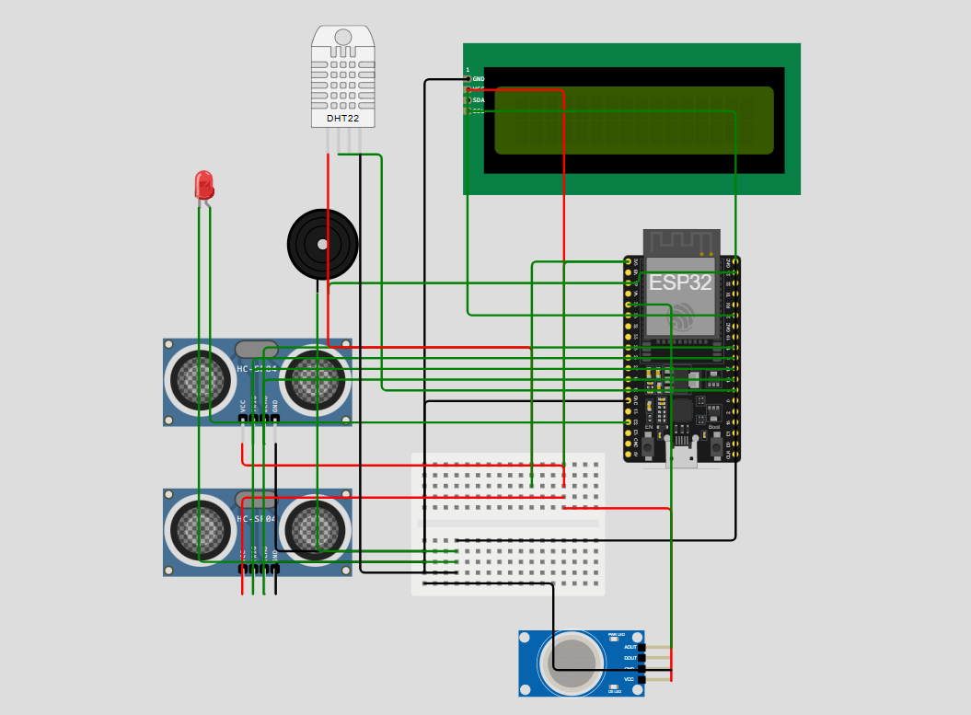

WORKING
- Parking Monitoring
    - Ultrasonic sensors are placed in parking slots.
    - If the measured distance is less than a set threshold, the slot is marked as Occupied; otherwise, it is Available.

- Temperature Monitoring
  - The DHT22 continuously checks the surrounding temperature.
  - If the temperature exceeds a safe level, an overheat alert is generated.

- Fire and Gas Detection
  - The flame sensor triggers an alert if fire is detected.
  - The MQ2 sensor monitors smoke and gas levels; when they cross the threshold, a gas alert is triggered.
- Alerts and Outputs
  - LCD shows slot status and alert messages in real-time.
  - Buzzer and LED activate to provide instant warning signals.
  - ESP32 sends the data to the Blynk IoT cloud, where users can monitor on:
    - Mobile dashboard
    - Web dashboard
  - If a dangerous situation is detected, the user receives a push notification on their phone.
FEATURES
- Real-time parking slot monitoring
- Multi-sensor safety integration (fire, gas, temperature)
- Alerts via LCD, buzzer, LED, and Blynk app
- Remote monitoring on both web and mobile
- IoT-based scalable solution for smart cities
TOOLS USED
- Arduino IDE – Programming & uploading
- Wokwi – Circuit simulation
- Blynk IoT – Cloud platform for monitoring

