High Level Design (HLD)

|  |
| --- |
| Credit Risk System |

Revision Number: 1.0

Last date of revision: 21/12/2021

Jeevan Shriram Arande

Raj Shukla

1. **Introduction**

Normally, most of the bank's wealth is obtained from providing credit loans so that a marketing bank must be able to reduce the risk of non-performing credit loans. The risk of providing loans can be minimized by studying patterns from existing lending data. One technique that you can use to solve this problem is to use data mining techniques. Data mining makes it possible to find hidden information from large data sets by way of classification.

The goal of this project, you have to build a model to predict whether the person, described by the attributes of the dataset, is a good (1) or a bad (0) credit risk

# Problem Statement

To create an ML solution for Credit Risk Prediction and to implement the following use case:

1. Based on the existing current customer risk data, build a model to predict a credit risk profile (Good or Bad).
2. Mitigate the risk by not providing loans to people with non-performing loans.
3. Provide loans to customers with good credit history.

# Database Information

|  |
| --- |
| **status**: status of the debtor's checking account with the bank (categorical) |
| duration: credit duration in months (quantitative) |
| **credit_history**: history of compliance with previous or concurrent credit contracts (categorical) |
| purpose: purpose for which the credit is needed (categorical) |
| amount: credit amount in DM (quantitative; result of monotonic transformation; actual data and type of |
| **savings**: debtor's savings (categorical) |
| **employment_duration**: duration of debtor's employment with current employer (ordinal; discretized quantitative) |
| **installment_rate**: credit installments as a percentage of debtor's disposable income (ordinal; discretized quantitative) |
| **personal_status_sex**: combined information on sex and marital status; categorical; sex cannot be recovered from the |
| **other_debtors**: Is there another debtor or a guarantor for the credit? (categorical) |
| **present_residence**: length of time (in years) the debtor lives in the present residence (ordinal; discretized quantitative) |
| **property**: the debtor's most valuable property, i.e. the highest possible code is used. Code 2 is used, if codes 3 |
| age: age in years (quantitative) |
| **other_installment_plans**: installment plans from providers other than the credit-giving bank (categorical) |
| **housing**: type of housing the debtor lives in (categorical) |
| **number_credits**: number of credits including the current one the debtor has (or had) at this bank (ordinal, discretized |
| **job**: quality of debtor's job (ordinal) |
| **people_liable**: number of persons who financially depend on the debtor (i.e., are entitled to maintenance) (binary, |
| **telephone**: Is there a telephone landline registered on the debtor's name? (binary; remember that the data are |
| **foreign_worker**: Is the debtor a foreign worker? (binary) |

# Tools Used

  Matplotlib logo — Matplotlib 3.5.1 documentation     

# Design Details

1. **Process Flow**

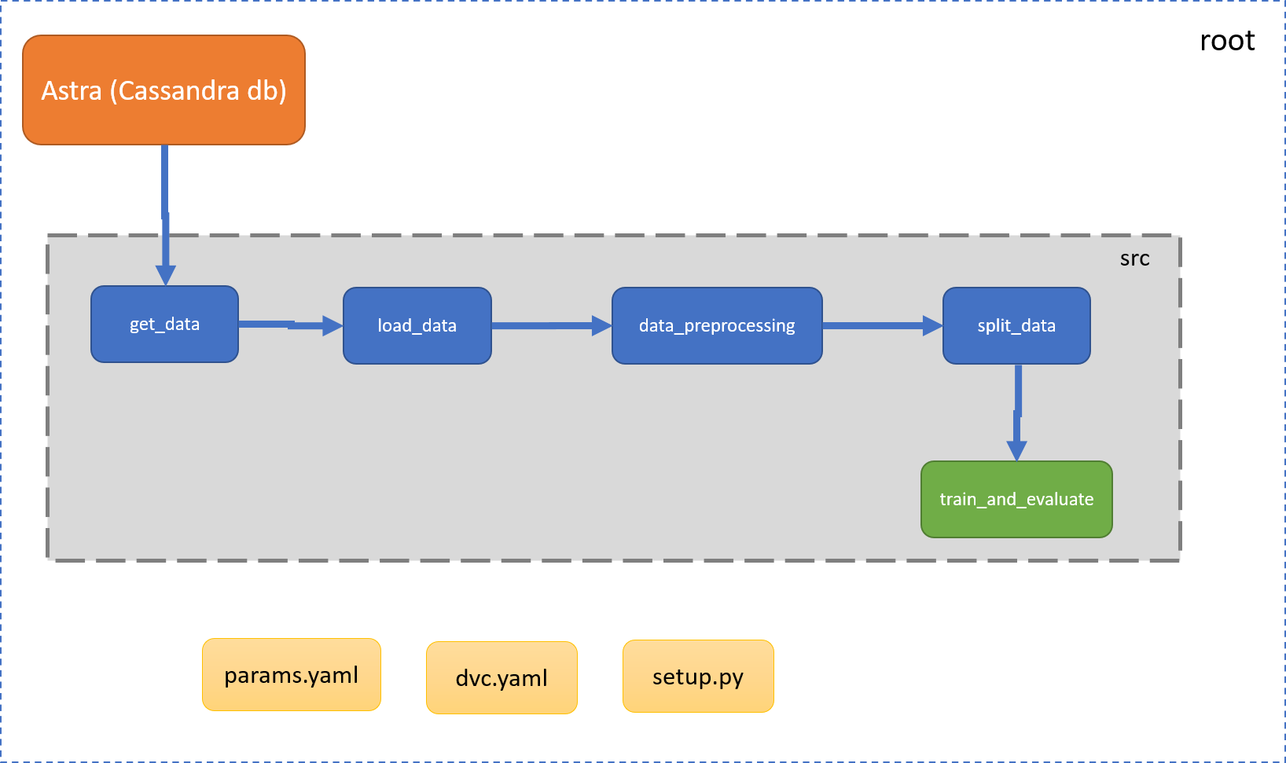

1. **Deployment Process**

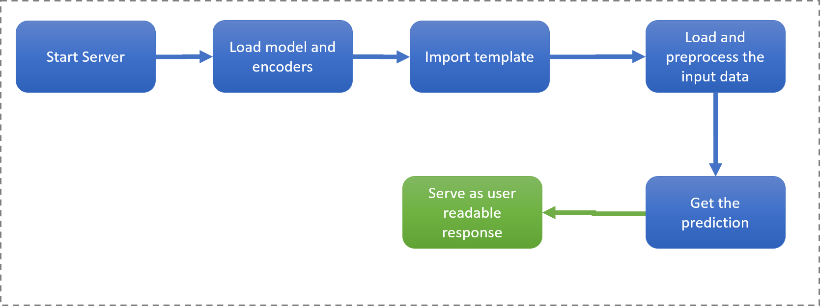

# Conclusion

The project is designed in Flask, hence is it accessible to everyone. The above designing process will help banks and loan lenders predict whether customers have good or bad credit risk, so the bank or respective departments can take necessary action, based on the model's predictions. The UI is made to be user-friendly so that the user will not need much knowledge of any tools but just need the information for results.