Wireframe

|  |
| --- |
| Credit Risk System |

Revision Number: 1.0

Last date of revision: 30/12/2021

Jeevan Shriram Arande

Raj Shukla

1. **Input:**

The data input for the Flask API Application comes from a HTML Form

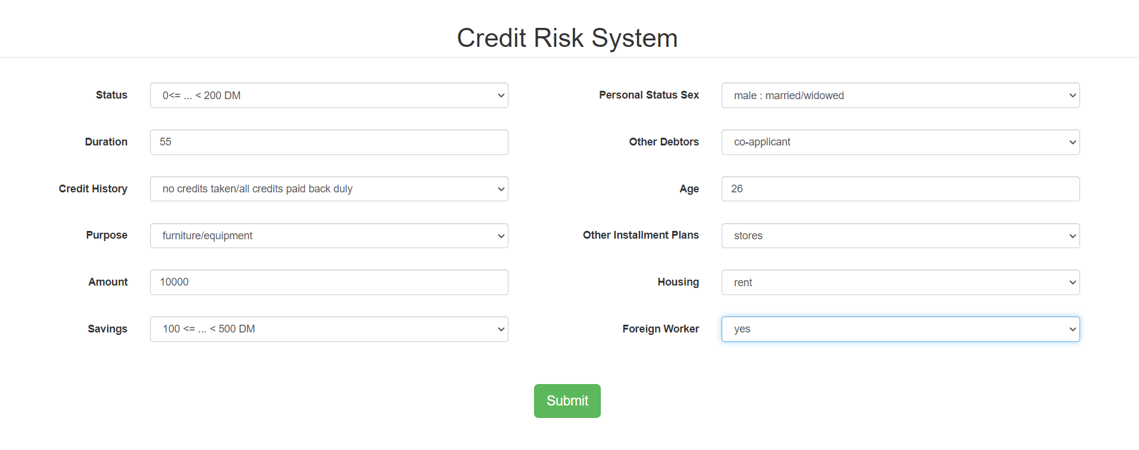

1. **Output:**

Based on the data entered in the form, the data is sent to the Flask application where the data is pre-processed and the prediction is made from fitted model.

Output - **Credit Risk: Bad**

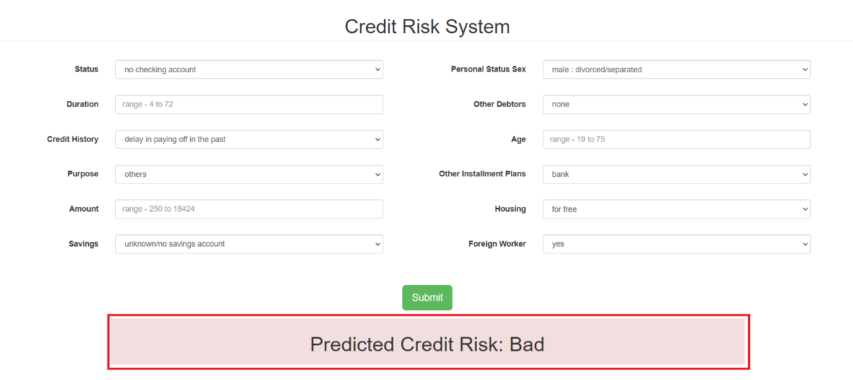

Output - **Credit Risk: Good**

