PHASE 3: Submission Document

FAKE NEWS DETECTION USING NLP

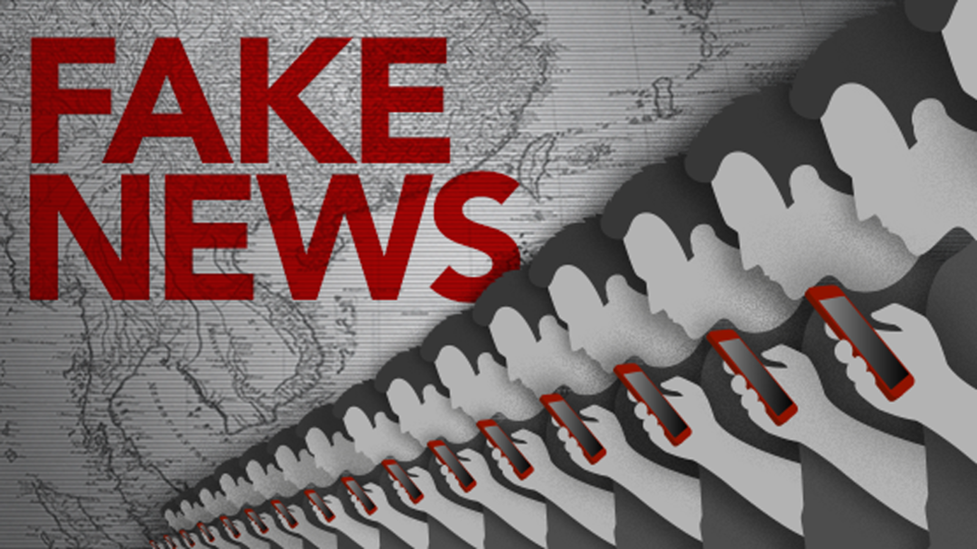
Introduction:
Fake news can spread misinformation, which can lead to incorrect beliefs or assumptions about important topics. In some cases, fake news can pose a threat to public safety. For example, during a health crisis, false information about treatments or preventative measures can lead to harmful behaviour.
Therefore, detecting and combating fake news is crucial to maintain the integrity of information that we consume and share, and to ensure informed decision-making in various aspects of our lives.

Project Overview:
To get the accurately classified collection of news as real or fake we have to build a machine learning model.
To deals with the detection of fake or real news, we will develop the project in python with the help of ‘sklearn’, we will use ‘TfidfVectorizer’ in our news data which we will gather from online media.
After the first step is done, we will initialize the classifier, transform and fit the model. In the end, we will calculate the performance of the model using the appropriate performance matrix/matrices. Once will calculate the performance matrices we will be able to see how well our model performs.
The practical implementation of these tools is very simple and will be explained step by step in this documentation.
Design Thinking:
Data set:
Here I will explain the data set.
In this python project, we have used the CSV dateset. True data set contains 21418 rows and 4 columns and False data set contains 23503 rows and 4 columns.
Data Collection:
This data set has four columns:
1. title: this represents the title of the news.
2. text: this column has the news itself.
3.subject: this column shows subject of the news
4.date: this column shows when news has created

TRUE NEWS:
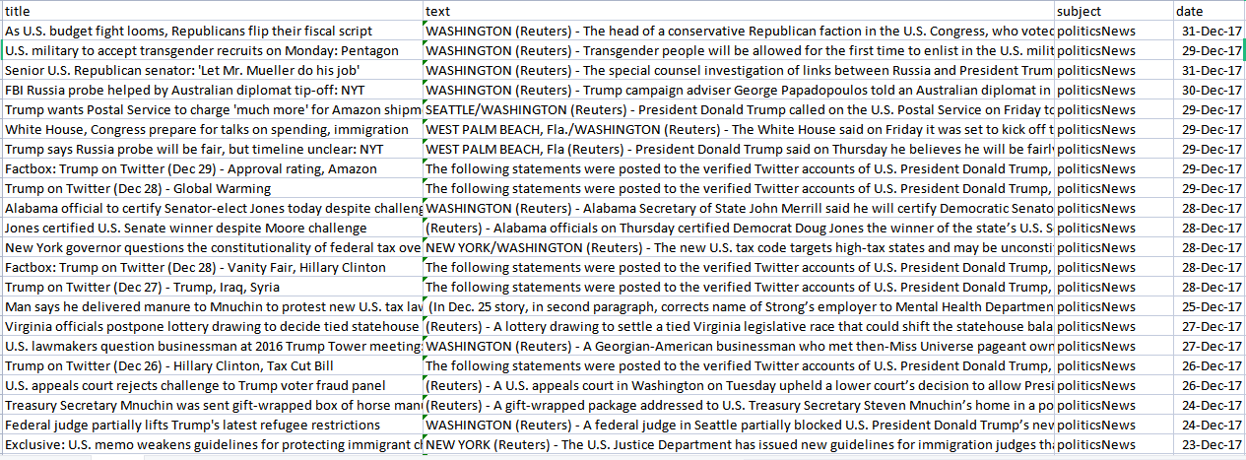
FAKE NEWS:
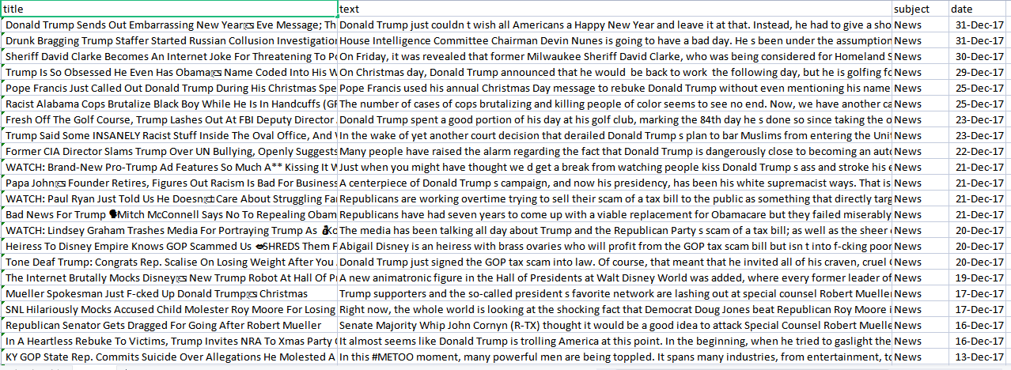

Techniques Used:
TF (Term Frequency): In the document, words are present so many times that is called term frequency. In this section, if you get the largest values it means that word is present so many times with respect to other words. when you get word is parts of speech word that means the document is a very nice match.
IDF (Inverse Document Frequency): in a single document, words are present so many times, but also available so many times in another document also which is not relevant. IDF is a proportion of how critical a term is in the whole corpus.collection of word Documents will convert into the matrix which contains TF and IDF features using Tfidf-Vectorizer.

LIBRARIES:
The following libraries are some of the libraries used in the design of the predicting system.
Numpy - for linear algebra.
Pandas - for data processing.
Sk-learn - To implement machine learning model and statistical modelling.
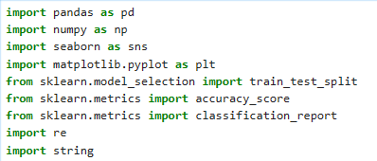

Data Pre-processing:
In data processing, we will focus on the text column on this data which actually contains the news part. We will modify this text column to extract more information to make the model more predictable. To extract information from the text column, we will use a library, which we know by the name of ‘nltk’.
Here we will use functionalities of the ‘nltk‘ library named Removing Stop words, Tokenisation, and Lemmatization. So we will see these functionalities one by one with these three examples. Hope you will have a better understanding of extracting information from the text column after this.
Using Logistic Regression:
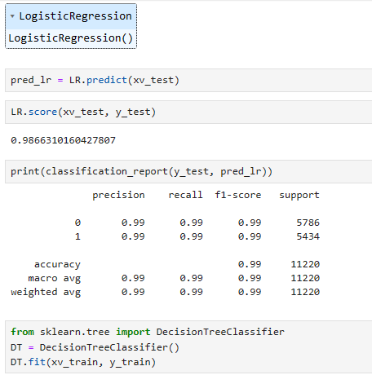
Using Decision tree Classifier:
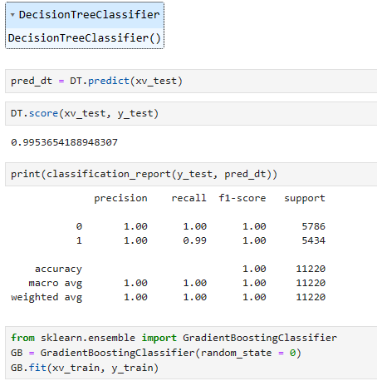
Using Gradient Boosting Classifier:
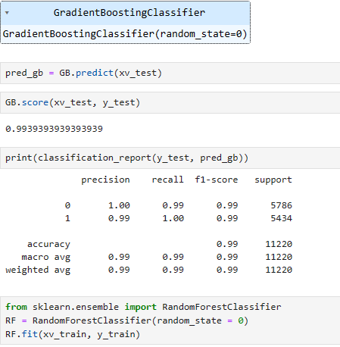
Process:
Fake news detection techniques can be divided into those based on style and those based on content, or fact-checking. Too often it is assumed that bad style (bad spelling, bad punctuation, limited vocabulary, using terms of abuse, ungrammaticality, etc.) is a safe indicator of fake news.
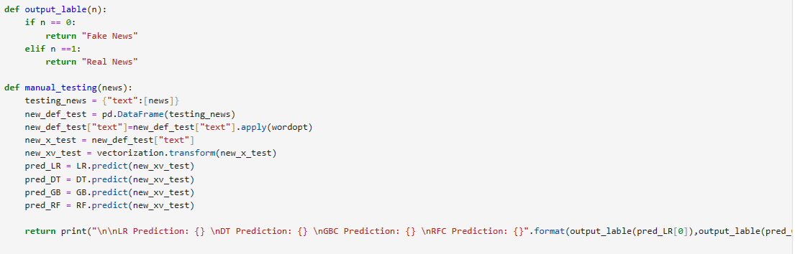

CONCLUSION:
The passive-aggressive classifier performed the best here and gave an accuracy of 93.12%.
We can print a confusion matrix to gain insight into the number of false and true negatives and positives
More than ever, this is a case where the machine’s opinion must be backed up by clear and fully verifiable indications for the basis of its decision, in terms of the facts checked and the authority by which the truth of each fact was determined.
Collecting the data once isn’t going to cut it given how quickly information spreads in today’s connected world and the number of articles being churned out.

