|  |
| --- |
|  |
| Web Application Security Testing Report |
| Task 1 |

|  |
| --- |
| Jeffery Tetteyfio  4-17-2025 |

Contents

**1. Executive Summary** 1

**2. Tools Used** 1

**3. Testing Procedure** 2

**3.1 Test Cases:** 2

**4.** **Findings & Risk Assessment** 6

**5.** **Recommendations** 6

**6.** **Conclusion** 7

## **Introduction**

This report documents the discovery of **SQL injection (SQLi)** vulnerabilities in DVWA (Damn Vulnerable Web App). Manual testing revealed critical flaws allowing unauthorized database access, including extraction of user credentials.

## **2. Tools Used**

| **Tool** | **Purpose** |
| --- | --- |
| DVWA | Vulnerable test environment |
| Web Browser (Chrome/Firefox) | Manual testing interface |
| OWASP ZAP | Automated vulnerability scanning (optional) |

## **3. Testing Procedure**

Step 1: Setup

1. Launched DVWA on http://127.0.0.1
2. Set security level to **"Low"** (DVWA - Security)

### **3.1 Test Cases:**

*■* ***SQL Injection:***

**Test 1: Basic Authentication Bypass**

* **Target**: 127.0.0.1/DVWA/vulnerabilities/sqli/
* **Payload**: ' OR '1'='1
* **Result**:
  + Returned **all 5 users** (first/last names)
  + Proof of Broken Authentication

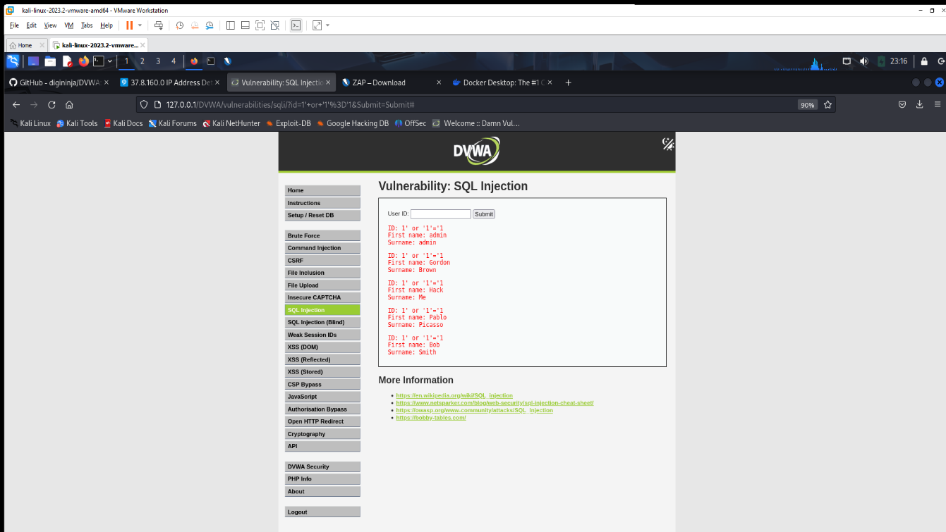

**Test 2: *Database Schema Extraction***

* **Payload**:  ' UNION SELECT user, password FROM users #
* **Result**:
  + Exposed **usernames and MD5-hashed passwords as Surnames**

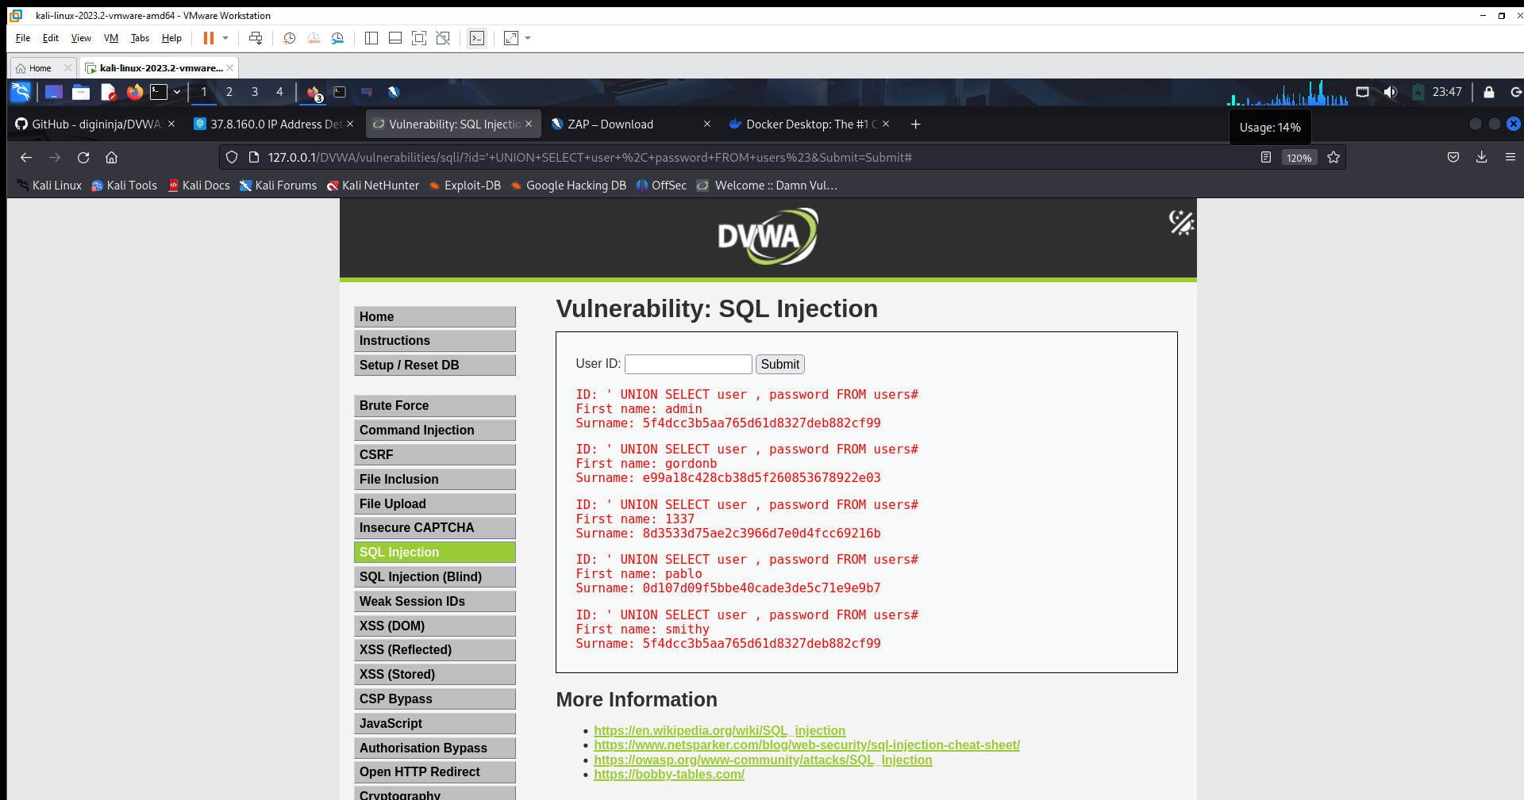

**Impact Analysis:**

* Extracted all user credentials (5 records)
* Critical data leakage risk
* Bypassed authentication mechanisms
* Potential for complete database compromise

***■ Cross-Site Scripting (REFLECTED XSS):***

|  |  |  |  |
| --- | --- | --- | --- |
|  | **Reflected XSS** | **XSS DOM (DOM Based Cross Site Scripting )** | **XSS STORED** |
| Link | http://127.0.0.1/vulnerabilities/xss_d/?name=# | http://127.0.0.1/vulnerabilities/xss_d/?default=<script>alert('English by Jeff DOM XSS')</script> | http://127.0.0.1/vulnerabilities/xss_d/ |
| Payload Used | <script>alert('An XSS attack by Jeffery')</script> | <script>alert('English by Jeff DOM XSS')</script> | <script>alert('Hack by Jeff Stored XSS’)</script> |
| Impact | Attackers can steal cookies or redirect users. |  | All users viewing the page get attacked. |

**PROOF:**

**Reflected XSS**

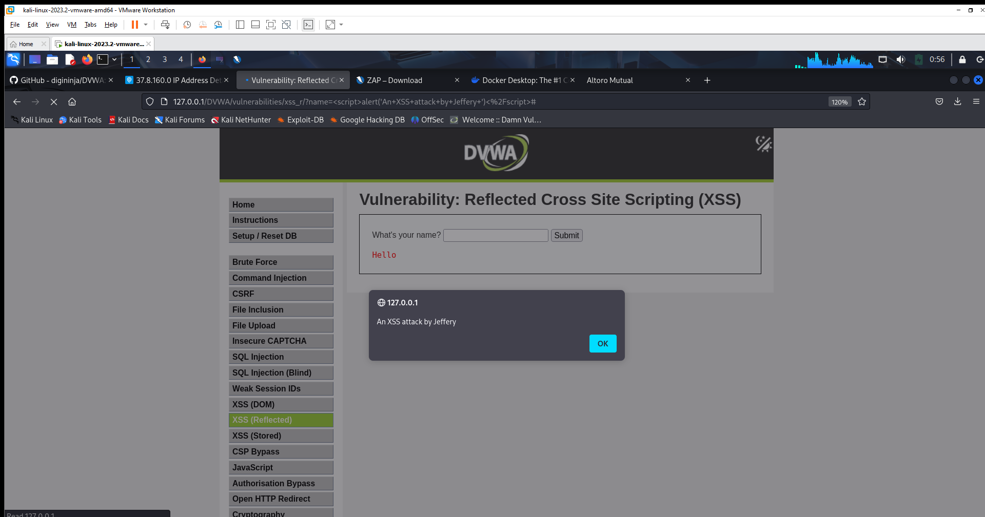

**DOM XSS**

**STORE XSS**

## **Findings & Risk Assessment**

| **Vulnerability** | **Risk** | **Proof** |
| --- | --- | --- |
| SQL Injection (Union-based) | Critical | Extracted user credentials |
| Reflected XSS | High | Executed alert('XSS') |
| Stored XSS | High | Persistent script in guestbook |

## **Recommendations**

**Technical Fixes**

SQLi Prevention:

Implement parameterized queries:

$stmt = $conn->prepare("SELECT * FROM users WHERE id = ?");

$stmt->bind_param("i", $input);

XSS Mitigation:

Implement htmlspecialchars():

htmlspecialchars($input, ENT_QUOTES, 'UTF-8')

echo htmlspecialchars($user_input, ENT_QUOTES, 'UTF-8')

Add Content Security Policy (CSP) headers.

## **Conclusion**

The vulnerabilities identified demonstrate critical web application security risks. Immediate remediation is recommended following OWASP guidelines.

NB: -Test conducted on DVWA (Damn Vulnerable Web App)

-No real users were affected

Appendix A: Screenshots

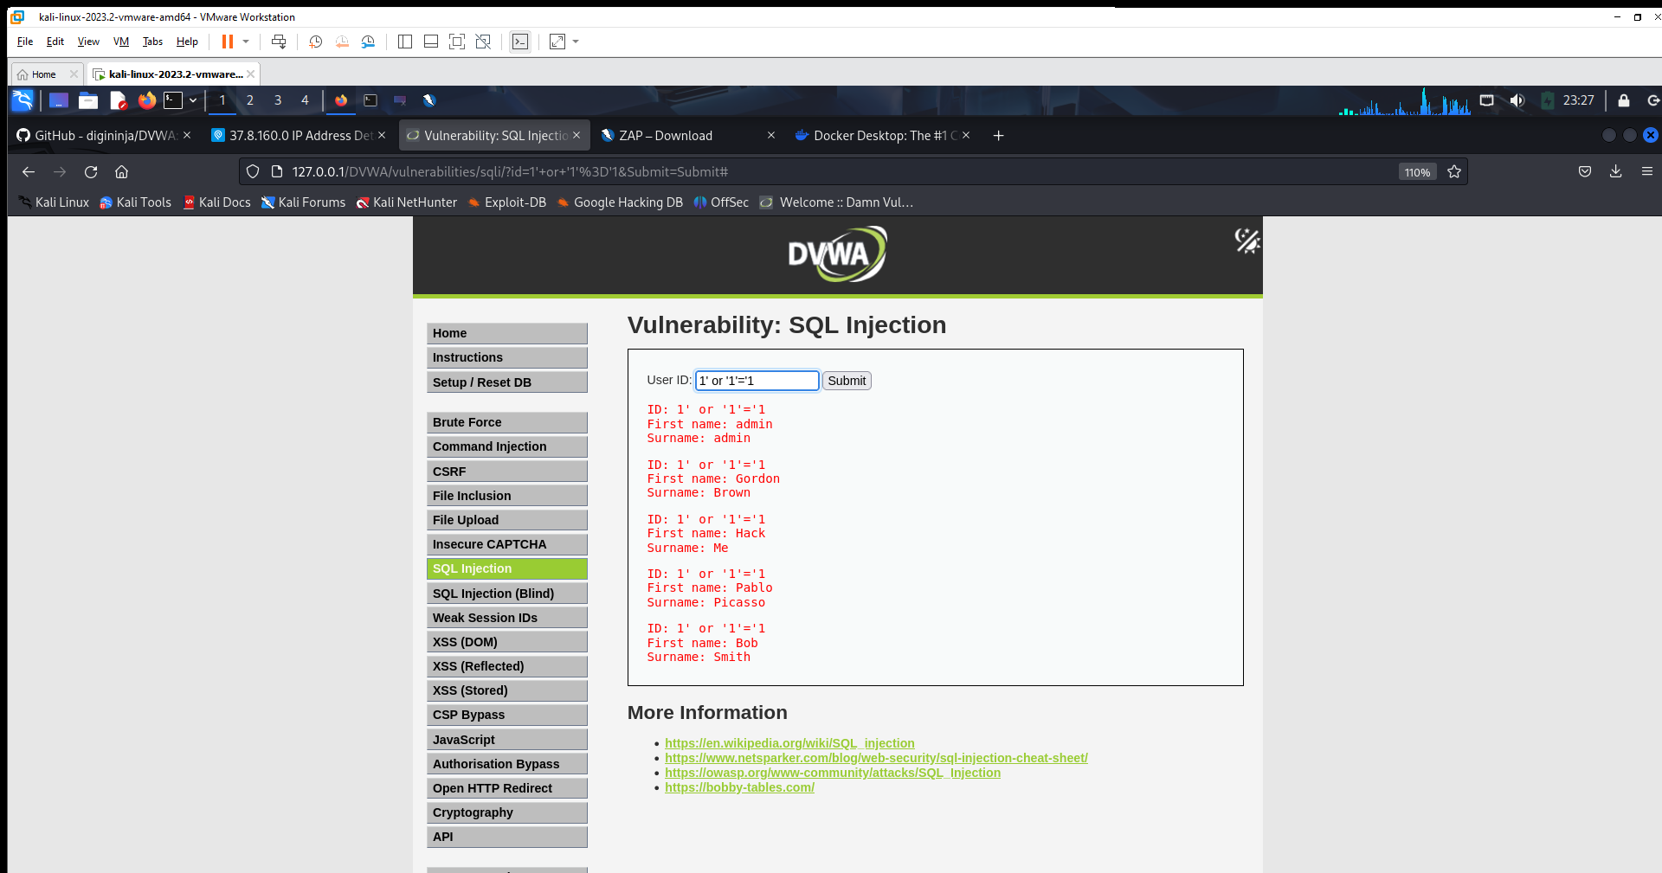

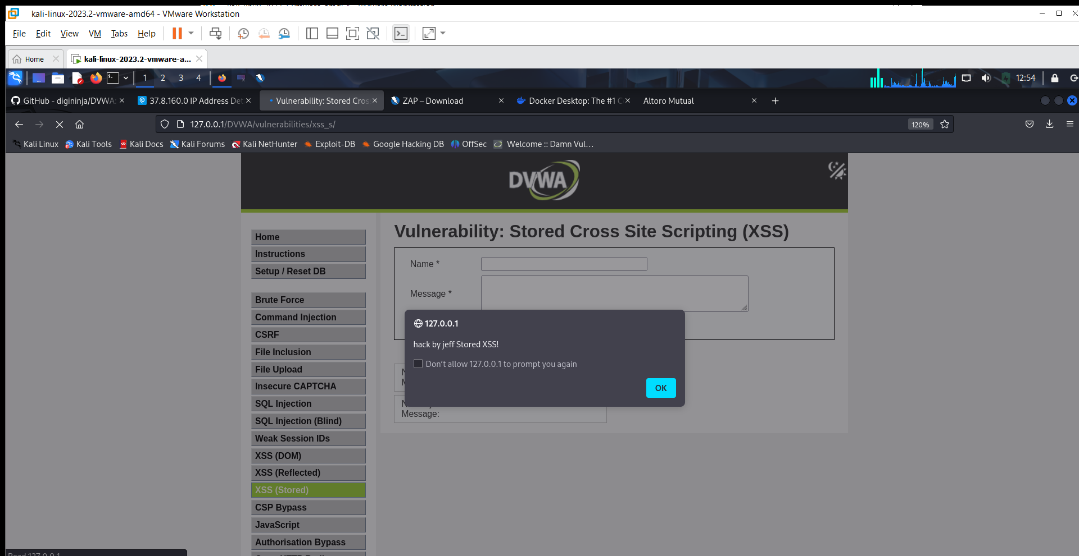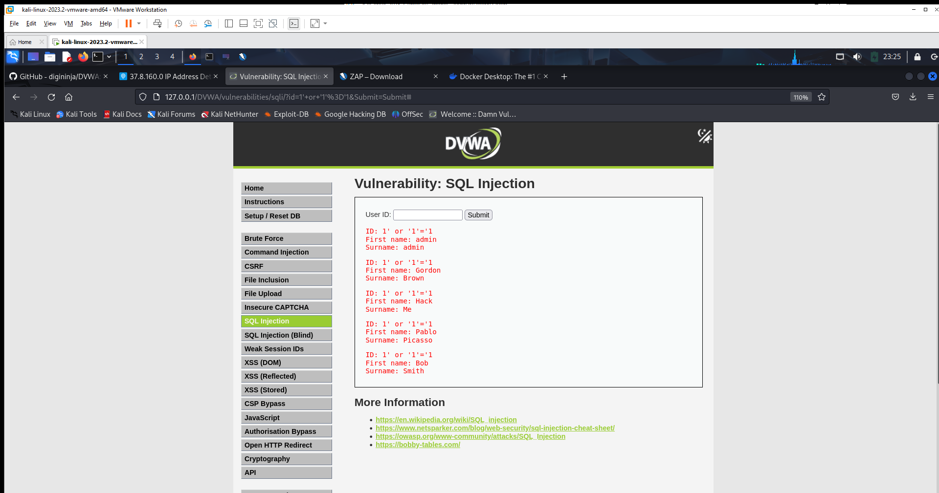

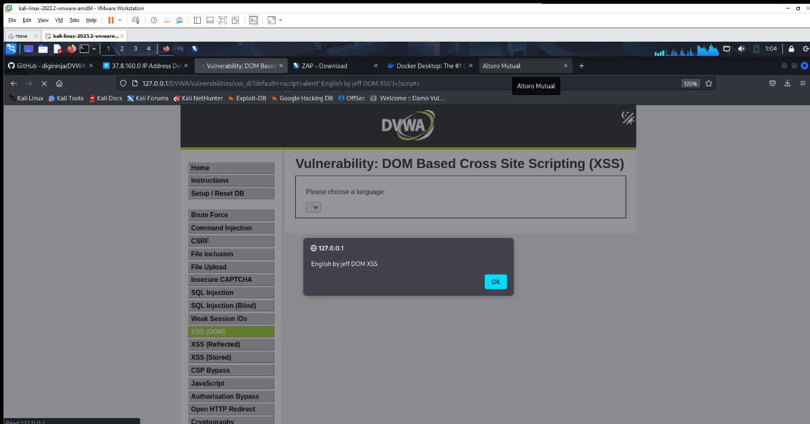

Appendix B: Payloads Used

• SQLi:

' OR '1'='1

' UNION SELECT user, password FROM users #

• XSS:

<script>alert('An XSS attack by Jeffery')</script>

<script>alert('Hack by Jeff Stored XSS’)</script>

<script>alert('English by Jeff DOM XSS')</script>