**ENVIRONMETAL MONITORING**

**Project Definition:**

* The project involves setting up IoT devices to monitor environmental conditions in public parks, including temperature and humidity.
* The primary objective is to provide real-time environmental data to park visitors through a public platform, enabling them to plan their outdoor activities accordingly.
* This project includes defining objectives, designing the IoT sensor system, developing the environmental monitoring platform, and integrating them using IoT technology and Python.

**Design Thinking:**

**Project Objectives:**

Define objectives such as real-time environmental monitoring, aiding park visitors in activity planning, promoting outdoor experiences, and enhancing visitor satisfaction.

**IoT Devices Designs:**

Plan the deployment of IoT sensors (e.g., temperature and humidity sensors) in public parks.

**Environmental Monitoring Platform:**

Design a web-based platform to display real time environmental data to the public.

**Integration Approach:**

Determine how IoT devices will send data to the environmental monitoring platform.

# Components and modules used

## Software: Arduino IDE

## Introduction

AVR controllers and PIC microcontrollers are increasingly common and more complete but we can say the appearance of Arduino in 2005 in Italy opened a new direction for microcontrollers.

The appearance of Arduino has eased the work of people in programming and design.

According to the main website of Arduino, Arduino is using the electronics platform as an open-source base to help user easy to use hardware and software.

Arduino is an IDE with the built-in editor, compiler, programmer and it comes with firmware with the boot loader, built-in library kits and easy integration.

It means whenever you have an idea and want to build something, you can just focus on designing and programming and not concern totally about the hardware and electronics stuff.

The language used is C / C++. All are open source and contributed by the community.

There are several parts as Arduino Boards, Arduino programming language (based on Wiring) and Arduino Software IDE (based on Processing).

## The properties of Arduino IDE

Arduino hides the complexity of electronics with simple concepts.

Setting up an output for a MCU by setting the register is so complicated that a professional even has to open a data sheet.

With Arduino, a function is called and everything is solved.

Because of its common, the user only needs to focus on product features rather than protocol, datasheet.

It means anyone can make great products without much knowledge in electronics field.

Debug by console.

The IDE is well designed that it can integrate many types of compilers easily and a variety of hardware without losing performance.

## Arduino programming language

The Arduino programming language has compiled on the Arduino IDE

This programming language is based on a simple hardware programming language called Processing, which is very similar to C language.

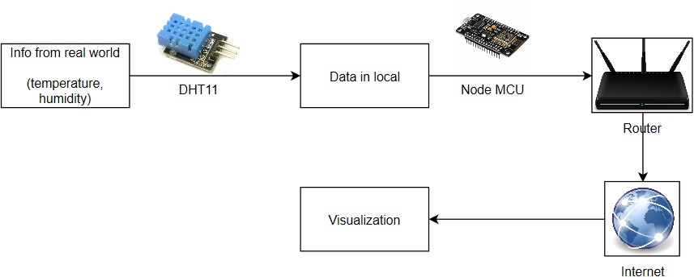

## PROJECT-ID:Proj_224686_Team_1

## NAME:Jegadheswaran.S.R

## COLLEGE CODE:4204

## REGISTER NO.:420421106022