**Biology Safety IBC Log Book Project**

**Client Deliverable 2**

**Version 1**

**10-24-2012**

**Table of Contents**

System Vision Document……………………………………………………………………..3

Activity Diagram…..………………………………………………………………………………4

Open Issues List…………………………………………………………………………………5-6

**System Vision Document**

**Problem Description**

The IBC formerly used Microsoft Access to store information, but due to the system conversion to eRA for Temple Research Administration, Access was disabled. The system storage reconstruction happened more than five years ago and the IBC was the only regulatory committee that was not given a place in eRA. The IBC record keeping remains primitive and inefficient, using paper and excel sheets to document their information. While not changing the process, they need web-based data entry and a query system with a database to store the information within one complete registration log. IBC needs to meet the 21st Century before paper overhead becomes too cumbersome.

**System Capabilities**

This document identifies the required system capabilities to provide the IBC with a web-based database for managing Biosafety Registration Logs.

* User Interface
  + User friendly interface to interact with the entire web-based database
* Report Generation
  + Generate various report types by selection of information and dates to be included
* Notifications
  + Automatic email notifications sent post set date
* Close/Archive
  + Secure completed projects
* Related Documentation Storage and Linking
  + Process for storing and linking related documentation

**Business Benefits**

The primary business benefits of these capabilities include:

* Electronically stored as opposed to paper file-cabinet storage
* Electronic Log reports generated from the Biosafety Submissions
* User-friendly method of storing related documentation

**Activity Diagram**

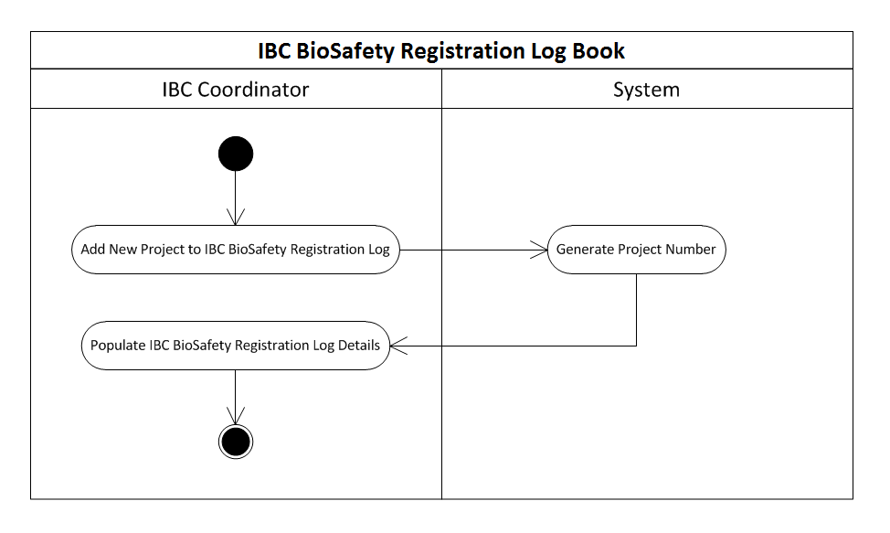

**Open Issues List**

|  |  |  |  |  |  |
| --- | --- | --- | --- | --- | --- |
| *ID* | *Issue* | *Date*  *Identified* | *Target Date* | *Assigned to* | *Contact* |
| **1** | **Registration Log: Required Information** | **10/11/12** | **TBD** | **Team** | **Mary Pultro** |
| **Comments and Questions:** | | | | |
| * Does one record contain all forms from project? * Do amendments/renewals get added to record or start own record? * What is the significance of the Number with additional letters?   + Ex. “589A.” * What does JR and design review mean? (in plan column) * What fields need to be present within each project log? * Does a project/form need approval before being entered as new log record? | | | | |
| **2** | **BoiSafety Registration Log: Data Entry** | **10/11/12** | **TBD** | **Team** | **Mary Pultro** |
| **Comments and Questions:** | | | | |
| * What info should be automatically generated? * For what fields would drop down lists be preferable? * Are all fields within record required to be populated? | | | | |
| 3 | **BoiSafety Registration Log: Date Planning** | **10/11/12** | **TBD** | **Team** | **Mary Pultro** |
| **Comments and Questions:** | | | | |
| * Do biohazards and plan date need have related constraints or any other dates that would create restraints?   + Can plan date surpass biohazard expiration? | | | | |
| **4** | **Registration Log:**  **Data Storage/Archive** | **10/11/12** | **TBD** | **Team** | **Mary Pultro** |
| **Comments and Questions:** | | | | |
| * Will the data be deleted, archived or deactivated? * After project completion:   + Will the archived records be displayed in “current existing” projects?   + Will this require a new field that determines which project is “archived/closed/deactivated/active?” * What can trigger a project closure/archive?   + Project completion, project funding out, etc. | | | | |
| 5 | **Notification System** | **10/11/12** | **TBD** | **Team** | **Mary Pultro** |
| **Comments and Questions:** | | | | |
| * What would the IBC coordinator want to be notified about?   + Ex. Record closing, renewal form date, reports and when? * PI or Admin only? * Each project or all projects?   Project or Process? | | | | |