**Biology Safety IBC Log Book Project**

**Client Deliverable 3**

**Version 1**

**10-24-2012**

**Table of Contents**

Event Table…………………………………………………………………………………………..3

Use Case Diagram…………………………………………………………………………………4

Use Cases……….………………………………………………………………………………5-10

**Event Table**

|  |  |  |  |  |
| --- | --- | --- | --- | --- |
| **EVENT TABLE IBC BOOK LOG** | | | | |
| **Event** | **Event Type** | **Trigger** | **Use Case** | **Response** |
| Administrator query log data | External | Data inquiry | Display/Query Log Records | Records including requested data are returned |
| Administrator add log record | External | New biosafety registration form received | Enter New Log Record | Biosafety log record number generated |
| Administrator review log record | External | Record has need to be viewed | Display/Query Log Records | Read form |
| Administrator modify log record | External | Record details need change or additional information | Update Log Record | Changes detailed within log record |
| Administrator add attachment to log record | External | New amendment form or related documentation received | Update Log Record | New attachment shown within log record |
| Create report | External | Report needed | Generate Report | Report is created |
| Set notification | External | IBC protocol dictates need for reminder | Notification | Notification set |
| Reminder notifications | Temporal/State | Pre-set time reached | Notification | Email notification sent |
| Archive finished project | External | Project ended | Close/Archive Record | Report is archived |

**Use Case Diagram**

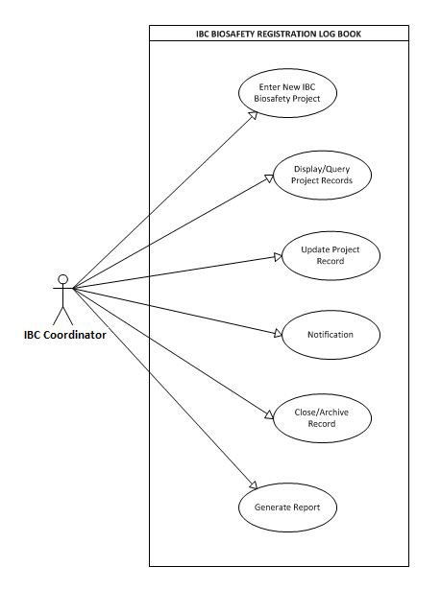

**Use Cases**

|  |  |  |
| --- | --- | --- |
| Use Case Name: | Enter New IBC Biosafety Project | |
| Scenario: | IBC Coordinator enters new IBC Biosafety project | |
| Triggering Event: | IBC coordinator receives documentation for a new IBC Biosafety project | |
| Brief Description: | IBC Biosafety Project record is created by IBC coordinator after receipt of supporting project documentation. A sequential biosafety registration number is generated | |
| Actors: | IBC coordinator | |
| Related use cases: | Display/Query Project Records, Update Project Records | |
| Stakeholders: | IBC Coordinator , PI | |
| Preconditions: | System must have record space to house new record, Project documentation must exist, PI must exist | |
| Postconditions: |  | |
| Flow of Activities: | Actor | System |
| 1. Requires a new record 2. Populates all fields in record | * 1. System creates space for new record   1.2 Biosafety Registration number is generated  2.1 System saves record and displays record |
| Exception Conditions: | 2.1 If record doesn’t have all fields populated, then record will not be saved until they are | |

|  |  |  |
| --- | --- | --- |
| Use Case Name: | Display/Query Project Records | |
| Scenario: | IBC Coordinator requires the capability to query project records | |
| Triggering Event: | For auditing purposes, detailed information about biosafety registration projects that require quick retrieval | |
| Brief Description: | IBC coordinator has quick retrieval capabilities. System displays specific queried project records and fields within. For example: Date, PI, Project name, Biohazard type, and plan | |
| Actors: | IBC Coordinator | |
| Related use cases: | Enter new record, update records, archive/deactivate records, generate reports | |
| Stakeholders: | IBC Coordinator, IBC Chair | |
| Preconditions: | Project must exist, Record must exist | |
| Postconditions: | Generates report | |
| Flow of Activities: | Actor | System |
| 1. Actor browses all projects in the log 2. Chooses specific field to be searched | * 1. Registration log displays all existing records   2.1 Displays all projects records according to specific field |
| Exception Conditions: | 2. If project doesn’t exist, it’s not displayed | |

|  |  |  |
| --- | --- | --- |
| Use Case Name: | Update Project Record | |
| Scenario: | Enter amendment information | |
| Triggering Event: | IBC Coordinator receives an amendment to project which might include: PI, Biohazard, date, or title change. As well as generates a new biosafety registration amendment number added to record. | |
| Brief Description: | Amendment changes existing record | |
| Actors: | IBC coordinator | |
| Related use cases: | Display/Query Log Records, Generate Report | |
| Stakeholders: | IBC Coordinator, PI | |
| Preconditions: | Record must exist , Amendment must exist | |
| Postconditions: |  | |
| Flow of Activities: | Actor | System |
| 1. Edits new amendment on existing record | * 1. System adds amendment to record   2. System updates IBC Biosafety registration log |
| Exception Conditions: |  | |

|  |  |  |
| --- | --- | --- |
| Use Case Name: | Notification | |
| Scenario: | Email notification sent to IBC Coordinator | |
| Triggering Event: | Predetermined set date is met | |
| Brief Description: | IBC Coordinator sets predetermined notification manually and system automatically emails notification to IBC Coordinator | |
| Actors: | IBC Coordinator | |
| Related use cases: | Close/Archive Records, Generate Report | |
| Stakeholders: | IBC Coordinator | |
| Preconditions: | Predetermined set date must exist | |
| Postconditions: | Notification is deleted from system | |
| Flow of Activities: | Actor | System |
| 1a. Sets date for notification  1b. Change set date | 1.1 System records set date  1.2 System updates changed set date  1.3 System sends email notification to IBC Coordinator |
| Exception Conditions: | * 1. If predetermined set date is already in use, Systems triggers 1.2 | |

|  |  |  |
| --- | --- | --- |
| Use Case Name: | Close/Archive Record | |
| Scenario: | Project is past due and requires archival | |
| Triggering Event: | Project has been completed | |
| Brief Description: | After project completion, project is designated as closed requires to be archived or deactivated | |
| Actors: | IBC Coordinator | |
| Related use cases: | Notifications, Update project record | |
| Stakeholders: | IBC Coordinator | |
| Preconditions: | Project must exist within system and must be complete | |
| Postconditions: | Project archived are marked closed | |
| Flow of Activities: | Actor | System |
| 1. IBC coordinator updates project status as closed | * 1. System closes project   2. Project is archived |
| Exception Conditions: | 1.1 Project must exist and must be completed | |

|  |  |  |
| --- | --- | --- |
| Use Case Name: | Generate Report | |
| Scenario: | Report is generated | |
| Triggering Event: | IBC Coordinator receives notification | |
| Brief Description: | Regularly scheduled notification is automatically generated when a predetermined time is met. | |
| Actors: | IBC Coordinator | |
| Related use cases: | Enter New Log Record, Display/Query Log Records | |
| Stakeholders: | IBC Coordinator | |
| Preconditions: | Log Records must exist, notification is sent to IBC Coordinator | |
| Postconditions: | Report logged | |
| Flow of Activities: | Actor | System |
| 1. IBC Coordinator configures report information to be generated | 1. Notification sent to IBC Coordinator 2. Generates report |
| Exception Conditions: |  | |