**IBC Biosafety Registration Log Project**

**Client Deliverable 5**

**Version Final 1.0**

**11-12-12**

**Table of Contents**

Domain Model Class Diagram ………..…………………………………………………..3

Team Sign-off Sheet ….………………………………………………………………………..4

**Domain Model Class Diagram**

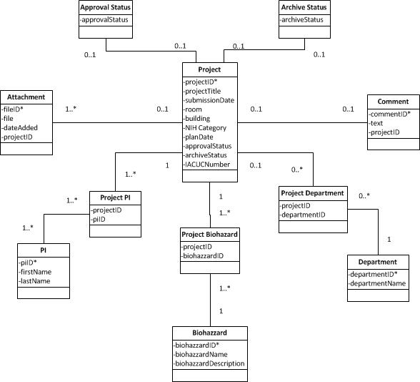

**Team Sign-off Sheet**

Matthew Shirley

Joshua Jodesty

Werawati Phang

Jonathan Marlo Gampon

Nikita Gmiryansky