**IBC Biosafety: Registration System**

**Screen Design Flow**

***CD 7 Final v1.0***

11-19-2012

**Table of Contents**

1. **Login Screen …………………………………………………………………………………………….…..…………... 3**
   1. Login Screen View ______________________________________________ 3
   2. Contact Screen View ____________________________________________ 4
2. **IBC Coordinator Home Screen …………………………………………………………………………………….. 5**
   1. Home Screen View ______________________________________________ 5
   2. Add Project Screen View _________________________________________ 6
   3. View/Edit Project Screen View ____________________________________ 7
   4. Approval Status Pull Down View ___________________________________ 8
3. **Search Screen ……………….……………………………………………………………………………………………. 9**
   1. Search Screen View ____________________________________________ 9
   2. Search Results Screen View ______________________________________ 10
4. **Notifications ……………………………………………………………………………………………………………… 11**
   1. Notifications Screen View_ _______________________________________ 11
   2. Add Notification Screen View _____________________________________ 11
   3. Edit Screen View _______________________________________________ 11
5. **Sign Off ………………………….………………………………………………………………………………………….. 12**
6. **Login Screen**
   1. **Login Screen View**

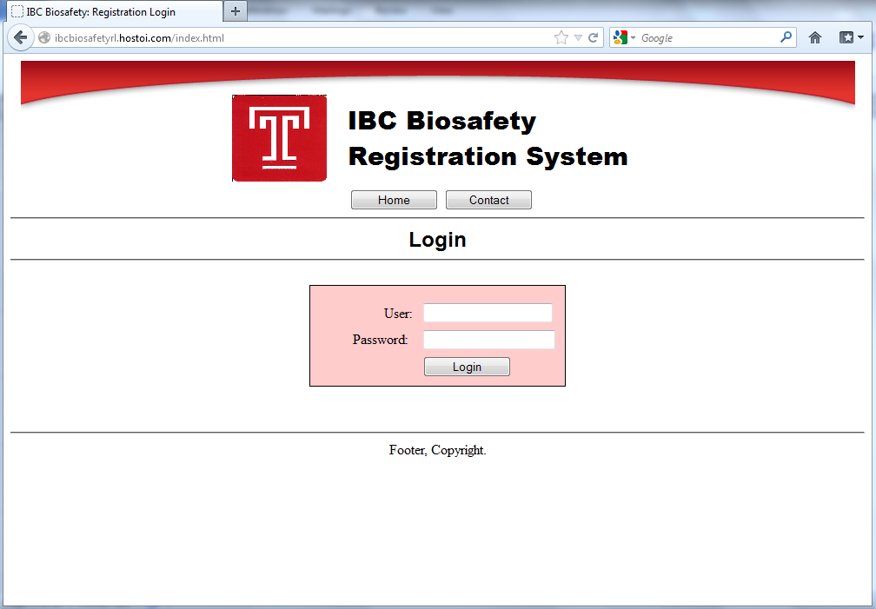

**User is brought to this main screen which requires a login. User may login or click ‘Contact’ in the navigation bar.**

* 1. **Contact Screen View**

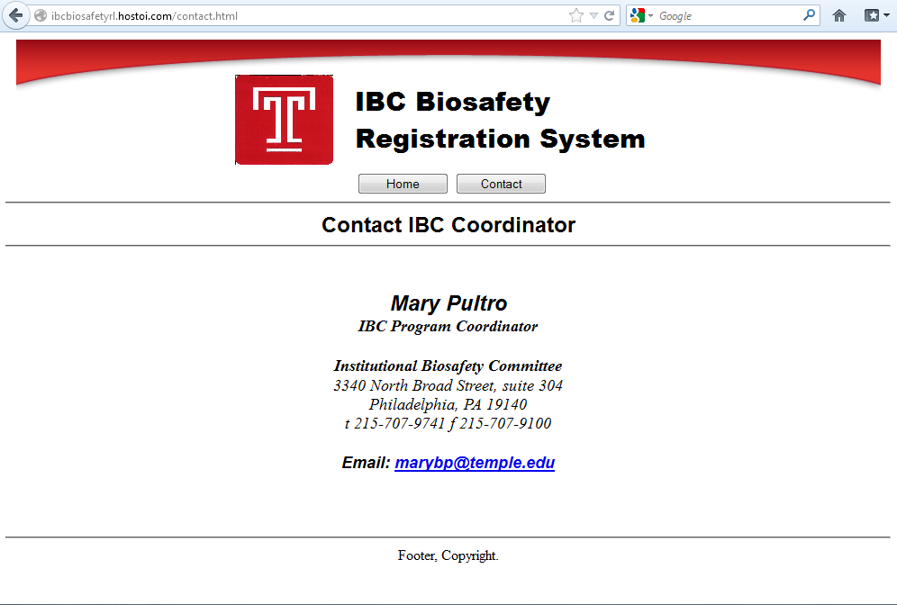

**User is brought to this screen when clicking the ‘Contact’ button in the navigation bar. The screen displays the IBC Coordinator’s contact information.**

1. **IBC Coordinator Home Screen**

**2.1 Home Screen**

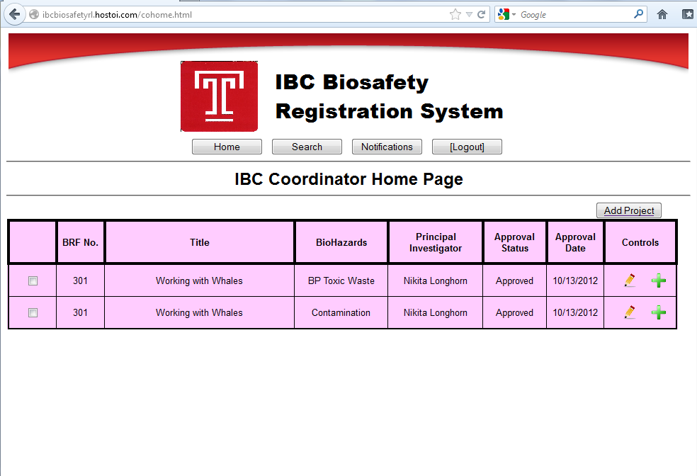

**The user will be brought to this screen after he/she logs in. This is the homepage of the Registration System which displays all the projects. The user also has controls to edit or add projects. A checkbox is provided for the user to view multiple or certain projects. From the navigation bar, the user can perform tasks:**

* **Search**
* **Notifications**
* **[Logout]**

**2.2 Add New Project Screen View**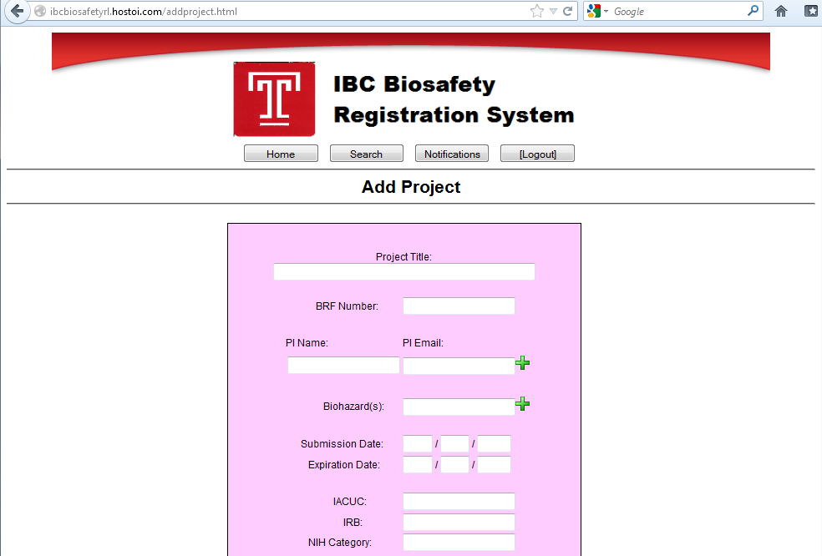

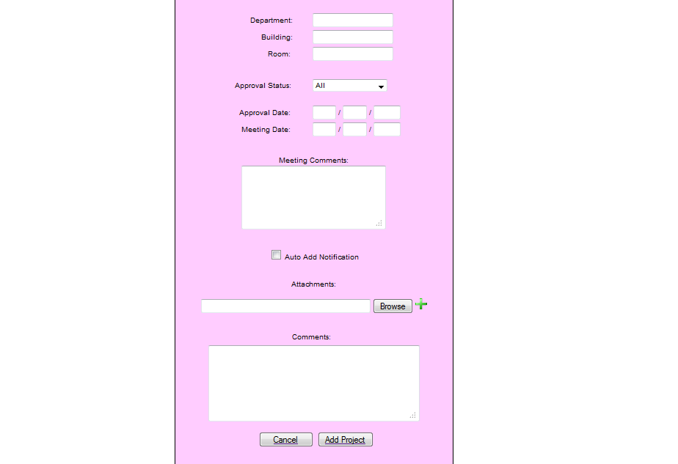

**The user is brought to this screen when he or she clicks the ‘Add Project’ button or the ‘+’ button. Screen displays data fields that inputs information it is provided. The user may add multiple PI’s to a project including its email. The user may also add multiple Biohazards to a project. The user may add attachments to a project by browsing for the file and clicking ‘+’ to attach it.**

**2.3 View/Edit Project Screen View**

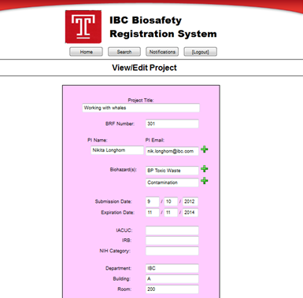

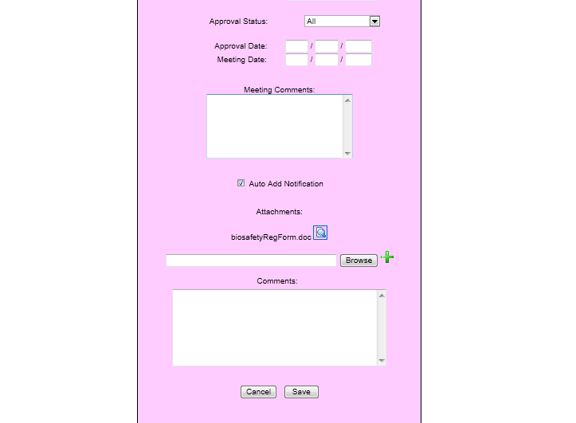

**Similar to ‘Add Project’ Screen, the user may view and edit the information for a project. The attachments are viewable and the user may save or cancel the changes.**

**2.4 Approval Status Pull Down**

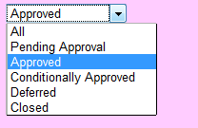

**The pull down menu lists the Project Approval Status. The approval status has the ability to change throughout the duration of each project.**

1. **Search Screen**

**3.1 Search Screen View**

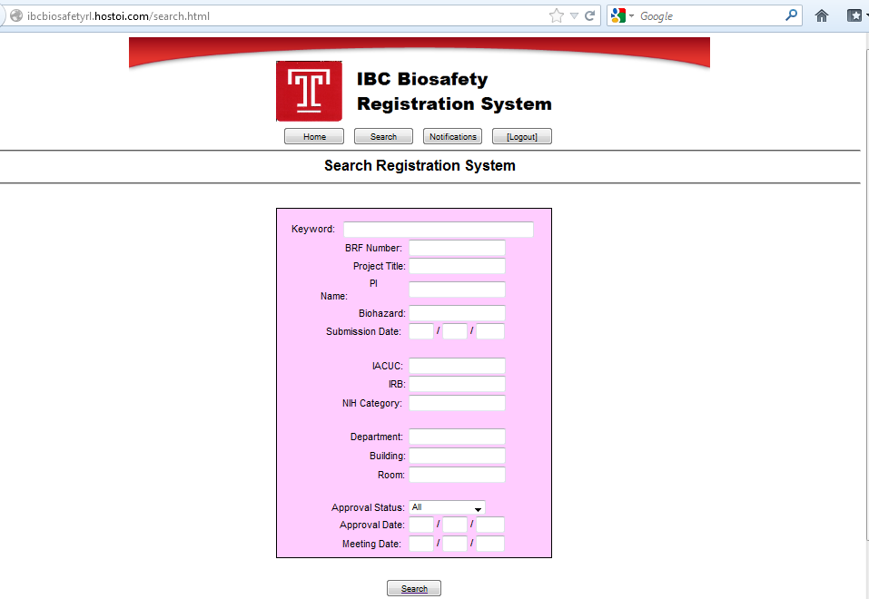

**The user may require the use of any of the fields to search the database.**

* 1. **Search Results Screen View**

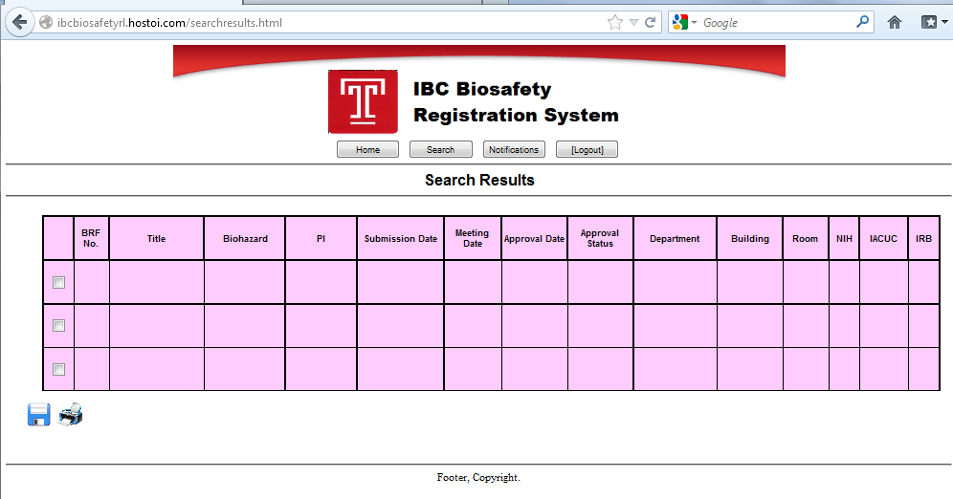

**The user is brought to this screen to display the search results. The user may use the checkboxes provided to save or print the searched results.**

1. **Notification**

**4.1 Notifications Screen View**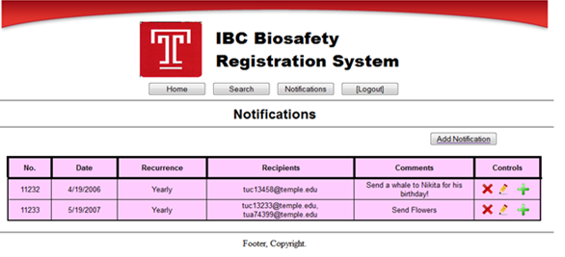

**The user is brought to this screen when he/she clicks ‘Notifications’. The screen displays all current notifications as well as special controls to delete, edit, and add. The user may also click the ‘Add Notification’ button to add a notification.**

**4.2 Add Notification Screen View**

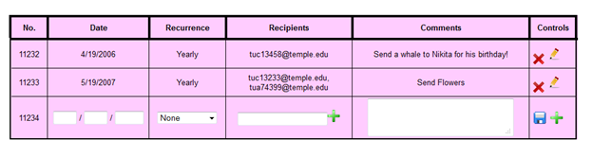

**4.3 Edit Notification Screen View**

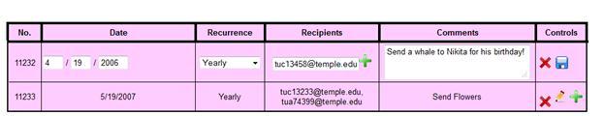

**4.4 Recurrence**

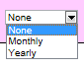

1. **Sign Off**

**Date: ___ /___ /______**

______________________________________________________________________________

**Jonathan Gampon**

**____________________________________**

______________________________________________________________________________

**Nikita Gmiryansky**

**____________________________________**

______________________________________________________________________________

**Josh Jodesty**

**____________________________________**

______________________________________________________________________________

**Werawati Phang**

**____________________________________**

______________________________________________________________________________

**Matthew Shirley**

**____________________________________**