|  |  |  |  |  |  |
| --- | --- | --- | --- | --- | --- |
| Intent Classifier | Entity Classifier | Intent Precision | Intent Recall | Entity Precision | Entity Recall |
| Diet Classifier | Diet Classifier | 0.933 | 0.9 | 0.905 | 0.571 |
| Sklearn Classifier | CRF Entity Extractor | 0.667 | 0.7 | 0.571 | 0.429 |
| Diet Classifier | Diet Classifier (masked language model) | 0.933 | 0.9 | 0.905 | 0.571 |
| Keyword Intent Classifier | Diet Classifier | 0.4 | 0.2 | 0.905 | 0.571 |

CRF Confusion Matrix and DIET Confusion Matrix

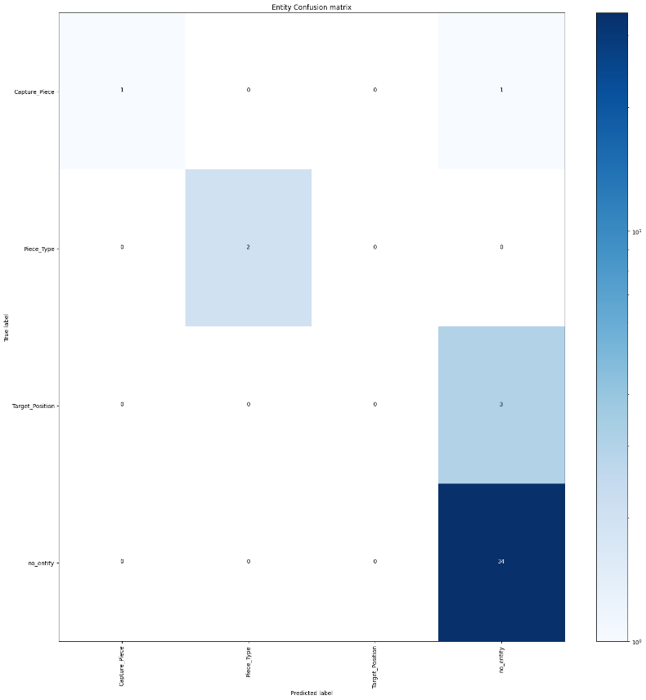 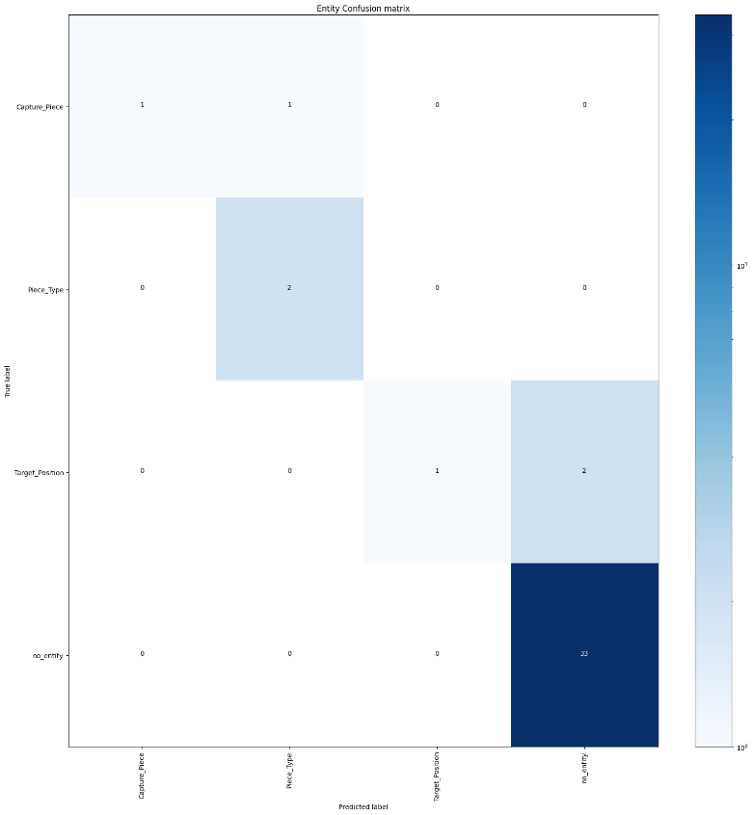

DIET Classifier Intent Classification

