NAAN MUDHALVAN

**INTERNET OF THINGS PHASE-4**

**SMART PARKING**

TEAM MEMBERS

ASHVIKA D JEMIMAH E RAKSAN S

GOKUL S KAVIRAJAN M THARUN SRIRAM

**PROCEDURE :**

The Application revolutionizes the way you find and reserve parking spaces. With its user-friendly interface and a range of features. It ensures a seamless and stress-free parking experience. Here's a breakdown of its main features:

**HOME SCREEN:**

Upon opening the app, you are greeted with a clean and intuitive home screen that provides quick access to all the essential features.

**RESERVATION TAB:**

Under the "Reservation" tab, you can easily reserve your parking spot by providing the following details:

1**. Name**: Input your name or the name of the person using the parking space.

2. **House Number**: Specify the house or apartment number for precise location.

3. **Vehicle Type:** Choose from options like sedan, SUV, motorcycle, or other to ensure the right parking space is assigned.

4. **Vehicle Number**: Enter your vehicle's license plate number for identification.

5. **Type of Visitor**: Select whether you're a resident, guest, or visitor to tailor the parking experience accordingly.

**LIVE AVAILABILITY TAB:**

The "Live Availability" tab provides real-time information on parking spots available at the parking facility. This feature is further enhanced by offering a detailed breakdown of parking availability at every floor, helping you make an informed decision quickly.

**Key features of the "Live Availability" tab include:**

- Color-Coded Indicator: Each floor is color-coded to show its current occupancy status, making it easy to identify available spaces at a glance.

- Detailed Floor Maps: Tap on a specific floor to see a detailed map of available parking spots, ensuring you can navigate the facility effortlessly.

- Filter and Search: Use filters to narrow down your search based on your vehicle type or preferred parking spot location.

- Real-Time Updates: The availability information is updated in real time, so you can trust that the information is always accurate.

**ParkSmart offers the following benefits:**

- Time and Stress Savings: No more driving in circles looking for a parking space. Reserve your spot in advance, or find the nearest available one effortlessly.

- Optimized Parking:* The app ensures that parking spaces are assigned based on vehicle type and visitor type, creating a more efficient and organized parking experience.

- Enhanced Safety: Easily locate your vehicle with precise information on its parking location.

- Reduced Environmental Impact: With real-time availability information, you can minimize your carbon footprint by quickly finding a parking spot.

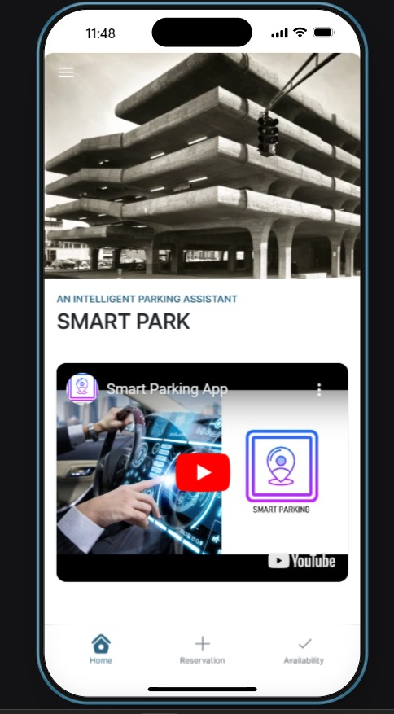MOBILE APPLICATION:  
PAGE 1  
  
  
  
  
 