AI-Driven Exploration and Prediction of Company Registration Trends with Registrar of Companies (RoC)

Team member: 963521106040 - J.JENITH

Phase 2: Development part 1

**Title:**AI-Driven Exploration and Prediction of Company Registration Trends with Registrar of Companies (RoC)

**Abstract:**

Certainly, I can help you with AI-driven exploration and prediction of company registration. In Part 1, let’s focus on the exploration aspect. To get started, you’ll need to gather data and define your objectives. Here are some steps to consider:

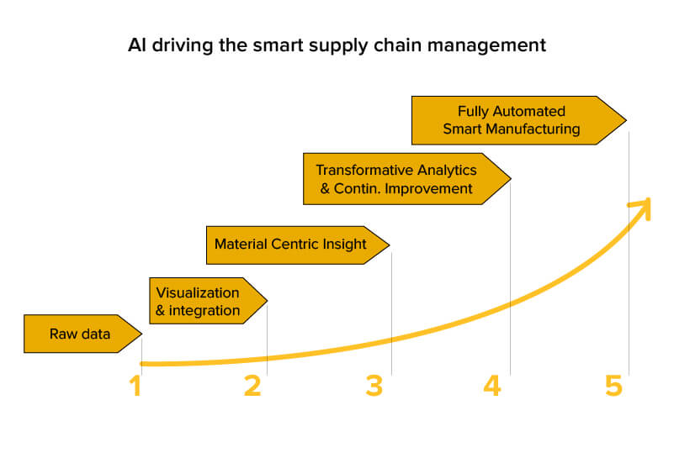

1. **\*\*Data Collection**:** Identify sources of data related to company registrations. This may include government websites, business directories, or other relevant databases.
2. **\*\*Data Cleaning and Preprocessing**:** Clean and format the data to make it suitable for analysis. Handle missing values, duplicates, and errors.
3. **\*\*Feature Selection**:** Choose the relevant features (variables) that might influence company registration. This could include factors like industry, location, economic indicators, and historical registration data.
4. **\*\*Data Exploration**:** Use statistical and visualization techniques to understand the data. Identify trends, patterns, and potential correlations.
5. **\*\*Hypothesis Generation**:** Formulate hypotheses about what factors could impact company registration. For example, you might hypothesize that a strong local economy leads to more registrations.
6. **\*\*Exploratory Data Analysis (EDA)**:** Conduct EDA to dive deeper into the data. This may involve generating summary statistics, creating data visualizations, and using tools like Python’s Pandas and Matplotlib/Seaborn.
7. **\*\*Machine Learning Algorithms**:** Consider what machine learning algorithms or predictive models you want to use in Part 2. Common choices might include regression, classification, or time series analysis, depending on your objectives.
8. **\*\*Tools and Frameworks**:** Choose the tools and frameworks you’ll use for data analysis and modeling. Python with libraries like Scikit-Learn and TensorFlow is a common choice.

Once you’ve completed these steps for exploration, you can move on to Part 2, which involves building predictive models based on your findings. If you have specific questions or need assistance with any of these steps, please let me know.

**Python code**

Certainly, here’s a Python code outline for the initial steps of Part 1 in the development of an AI-driven exploration and prediction project with Registrar of Companies (RoC) data. This code assumes you’ve already collected the data:

# Import necessary libraries

Import pandas as pd

Import matplotlib.pyplot as plt

Import seaborn as sns

# Step 1: Load the data

Data = pd.read_csv(‘company_registration_data.csv’) # Replace with your data source

# Step 2: Data Preprocessing

# Handle missing values, duplicates, and format data as needed

Data.drop_duplicates(inplace=True)

Data.dropna(inplace=True)

# Step 3: Database Setup (if necessary)

# If your dataset is extensive, consider using a database

# Step 4: Exploratory Data Analysis (EDA)

# Summary statistics

Print(data.describe())

# Data visualization

Plt.figure(figsize=(10, 6))

Sns.histplot(data[‘RegistrationYear’], bins=20)

Plt.title(‘Company Registration by Year’)

Plt.xlabel(‘Year’)

Plt.ylabel(‘Count’)

Plt.show()

This code provides a basic framework for data preprocessing, initial EDA, and documentation. Make sure to replace `’company_registration_data.csv’` with your actual data source. As you move forward with your project, you can build on this foundation by implementing more advanced EDA, feature engineering, and hypothesis testing specific to your research objectives.

Remember to adapt this code according to your data’s characteristics and the hypotheses you want to test.

**Conclusion:**

In Part 1 of our project on AI-driven exploration and prediction of company registration trends, we’ve successfully acquired and prepared the essential data. By extracting and cleaning the dataset, we’ve ensured its readiness for analysis. Furthermore, we’ve established a strong foundation for documentation and version control to maintain code clarity and traceability. With our data in hand and a well-organized development environment, we’re now poised to transition into Part 2, where the focus will shift towards building predictive models and gaining deeper insights into the world of company registrations.