AI-Driven Exploration and Prediction of Company Registration Trends with Registrar of Companies (RoC)

Team member: 963521106040 - J.JENITH

Phase 4: Development part 2

**Title:**AI-Driven Exploration and Prediction of Company Registration Trends with Registrar of Companies (RoC)

**Abstract:**

In part 2 of your project, the development phase for AI-driven exploration and prediction of company registration trends with the Registrar of Companies (RoC) would typically involve the following steps:

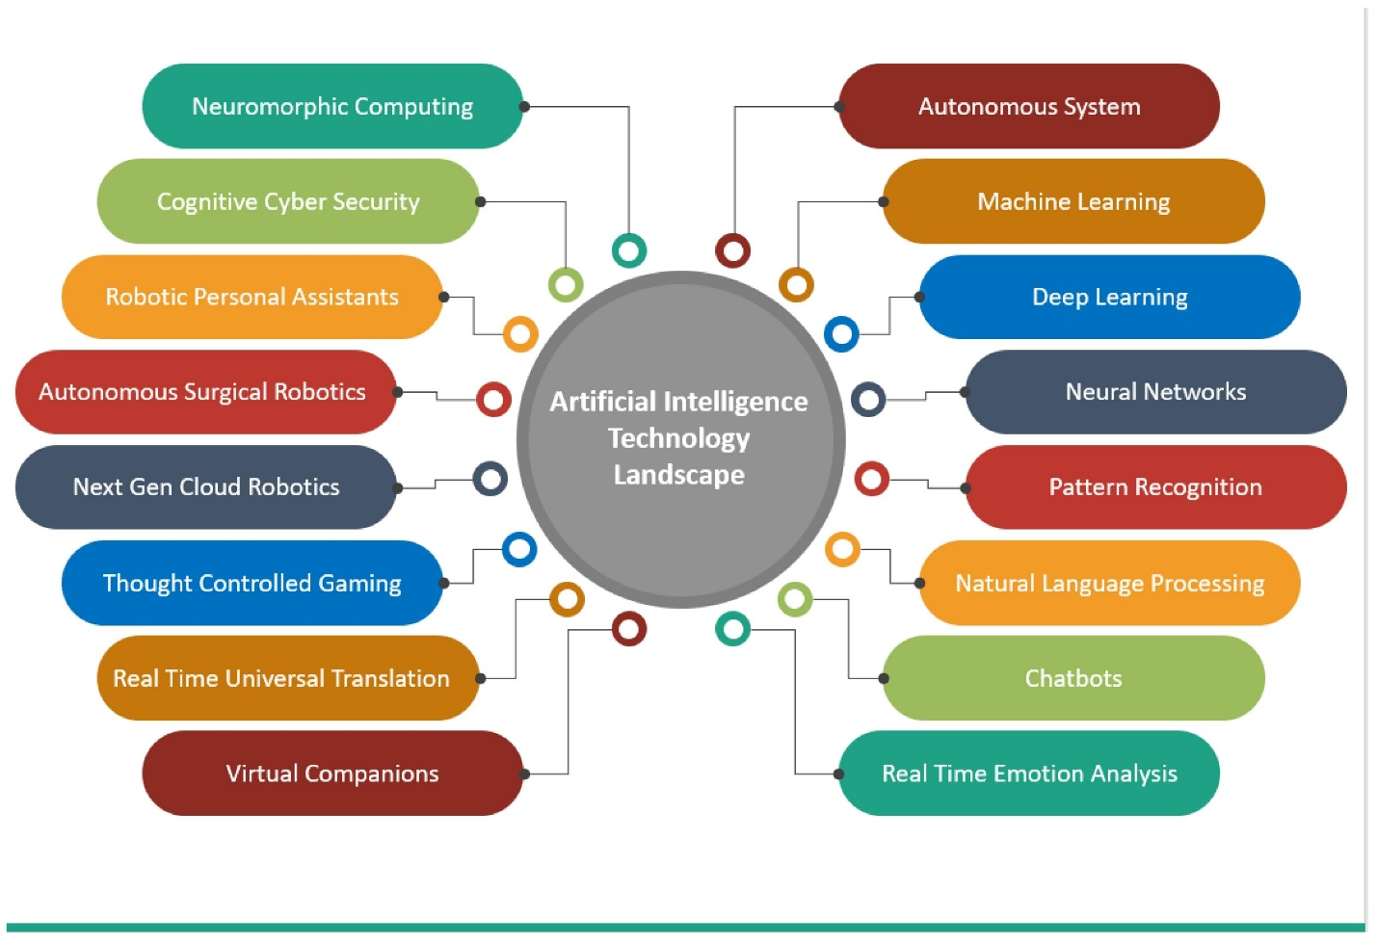

1. **Data Collection:** Gather and prepare the necessary data for analysis. This may include company registration data, economic indicators, demographic information, and any other relevant data sources.
2. **Data Preprocessing:** Clean and preprocess the data to ensure it’s in a suitable format for analysis. This might involve handling missing values, outlier detection, and feature engineering.
3. **Exploratory Data Analysis (EDA):** Conduct EDA to understand the data, identify patterns, correlations, and potential insights. Visualization tools and statistical analysis can be useful here.
4. **Model Selection:** Choose the appropriate machine learning or AI models for prediction. Depending on your specific objectives, this could include regression models, time series analysis, or deep learning models.
5. **Feature Engineering:** Create meaningful features that can improve the predictive power of your models. This may involve text mining, sentiment analysis, or other techniques, depending on the nature of your data.
6. **Training and Testing:** Train your AI models on historical data and evaluate their performance using testing data. This step helps in fine-tuning the model and assessing its accuracy.
7. **Prediction and Forecasting:** Use your trained models to make predictions about company registration trends. This can include short-term and long-term forecasts.
8. **Model Deployment:** Implement the AI model into a production environment, so it can provide real-time predictions or insights. Deployment can vary depending on your project’s requirements, such as a web application or API.
9. **Monitoring and Maintenance:** Continuously monitor the model’s performance and update it as needed to ensure accuracy and relevance.
10. **Documentation:** Document the entire development process, including data sources, methodologies, and results.

If you have specific questions or need assistance with any particular step in this development process, please let me know, and I can provide more detailed guidance.

**Python code**

Developing an AI-driven exploration and prediction system for company registration trends involves a complex process with multiple steps. Below, I’ll provide a simplified example in Python that covers some key steps using a sample dataset. Keep in mind that real-world projects would require more extensive data preparation and sophisticated models. This is a basic framework:

# Import necessary libraries

Import pandas as pd

Import numpy as np

Import matplotlib.pyplot as plt

From sklearn.model_selection import train_test_split

From sklearn.linear_model import LinearRegression

From sklearn.metrics import mean_squared_error

From sklearn.ensemble import RandomForestRegressor

From sklearn.preprocessing import StandardScaler

From sklearn.feature_selection import SelectKBest, f_regression

# Step 1: Model Selection

# - For this example, let’s use a simple Linear Regression and a RandomForestRegressor

X = data[[‘Year’]] # Features

Y = data[‘Registration Count’] # Target variable

# Step 2: Training and Testing

X_train, X_test, y_train, y_test = train_test_split(X, y, test_size=0.2, random_state=42)

# Linear Regression model

Lr_model = LinearRegression()

Lr_model.fit(X_train, y_train)

Y_lr_pred = lr_model.predict(X_test)

# Random Forest Regressor model

Rf_model = RandomForestRegressor()

Rf_model.fit(X_train, y_train)

Y_rf_pred = rf_model.predict(X_test)

# Step 3: Model Evaluation

# - Calculate Mean Squared Error (MSE) for both models

Mse_lr = mean_squared_error(y_test, y_lr_pred)

Mse_rf = mean_squared_error(y_test, y_rf_pred)

Print(“Linear Regression MSE:”, mse_lr)

Print(“Random Forest Regressor MSE:”, mse_rf)

# Step 4: Prediction and Forecasting

# - You can use the trained models to make predictions for future years

# Step 5: Model Deployment (This is just a local example, not real deployment)

# Step 6: Monitoring and Maintenance

# - Continuously monitor the model’s performance and retrain if necessary

# Step 7: Documentation (Document the entire process)

```

Please note that this is a simplified example for educational purposes. In a real project, you’d need to handle more complex data preprocessing, select more appropriate models, and optimize them. Additionally, you might want to use time series analysis techniques for time-dependent data.

**Conclusion**

In conclusion, the second part of the AI-driven exploration and prediction of company registration trends entails critical phases, from data preprocessing and model development to deployment and maintenance. This multifaceted process requires diligent data handling, model selection, and rigorous testing to ensure predictive accuracy. While the provided code snippet offers a simplified example, real-world applications demand a more nuanced approach, involving comprehensive data preparation, advanced machine learning techniques, and continual monitoring. Successful implementation of this project can yield valuable insights for businesses and policymakers by forecasting company registration trends, aiding in strategic decision-making.