SALESFORCE AGENTFORCE PROJECT

CUSTOMER SUPPORT TICKET PRIORITY PREDICTION AND AUTOMATED ASSIGNMENT SYSTEM USING AGENTFORCE
Auto-Launched Flow • Agentforce Subagent • Support Ticket Intelligence Object
Project Detail | Information
Prepared by | Hari Haran S
Platform | Salesforce Developer Edition (Agentforce)
Custom Object | Support_Ticket_Intelligence__c
Automation | Auto-Launched Flow – Support Ticket Intelligence
AI Component | Agentforce Subagent – Support Ticket Priority Analysis
Document Date | October 2026

Table of Contents
1. Introduction
2. Ideation Phase
3. Requirement Analysis Phase
4. Project Design Phase
5. Project Planning & Scheduling
6. Project Development Phase
7. Functional & Performance Testing
8. Advantages & Disadvantages
9. Conclusion
10. Future Scope
11. Appendix

User Story
The Customer Support Ticket Priority Prediction and Automated Assignment System uses Salesforce and Agentforce to analyze customer support ticket descriptions, automatically determine priority as High, Medium, or Low, and trigger backend automation for appropriate support handling. The solution uses the Support Ticket Intelligence custom object, an Auto-Launched Flow, and an Agentforce subagent named Support Ticket Priority Analysis. High-priority tickets create an urgent handling task and are assigned to a senior support agent, reducing manual effort and improving response time.

1. Introduction

1.1 Project Overview
Customer support teams receive a large number of tickets daily, while prioritization and assignment are often done manually. This project provides a Salesforce-based solution that analyzes ticket information, classifies urgency, assigns the appropriate support level, and initiates automation for critical cases.

1.2 Purpose
- Automatically classify support tickets as High, Medium, or Low priority.
- Retrieve the latest support ticket associated with a customer Account.
- Reduce manual prioritization and assignment effort.
- Create an urgent handling task for High-priority tickets.
- Use Agentforce to analyze ticket details and trigger backend automation.
- Improve ticket response and resolution efficiency.

2. Ideation Phase

2.1 Problem Statement
The following customer problem statements capture the pain points of support agents, customers, and support managers that this project addresses.
ID | I am (Customer) | I'm trying to | But | Because | Which makes me feel
PS-1 | Support Agent | focus on critical tickets first | tickets are not always prioritized automatically | ticket prioritization can be manual | Frustrated
PS-2 | Customer | get urgent issues resolved quickly | critical issues may wait behind lower-priority tickets | support teams handle large ticket volumes | Concerned
PS-3 | Support Manager | assign tickets to the right support level | assignment may require manual decisions | ticket urgency is not consistently analyzed | Overwhelmed
PS-4 | Support Agent | identify urgent issues from descriptions | important keywords can be missed | ticket descriptions contain different urgency signals | Uncertain
PS-5 | Support Manager | reduce SLA-related risk | older unresolved tickets may remain unnoticed | SLA risk needs additional checking | Concerned

Need: A smart, automated system that can classify ticket priority, assign tickets to the right support level, and reduce response time using AI.
Goal: Faster resolutions, higher customer satisfaction, and a more efficient support team.

2.2 Empathy Map Canvas
User Persona: Support Agent
Quadrant | Description
Think & Feel | Wants critical issues identified quickly so urgent customer problems receive attention.
Hear | Receives customer issue descriptions and support requests.
See | Ticket status, issue type, description, priority level, assignment, and SLA risk.
Say & Do | Reviews tickets, handles assigned cases, and focuses on urgent support issues.
Pain | Manual prioritization, missed urgency signals, and delays in handling critical tickets.
Gain | Automatic priority classification, clearer assignment, urgent-task creation, and reduced manual effort.

2.3 Brainstorming & Idea Prioritization

Ideas Considered
Idea | Evaluation
Manual ticket registers | No automation; prone to errors and missed urgency
Spreadsheet-based ticket tracking | Limited automation; hard to scale with ticket volume
Standalone support portal | Separate system; needs integration with customer data
Salesforce CRM with Agentforce | Selected – native automation, AI assistance, and customer data in one platform

Final Selection
Salesforce CRM was selected due to:
- Automation through Salesforce Flow
- AI-assisted ticket analysis through Agentforce
- Automatic priority classification
- Automatic urgent-task creation
- Reduced manual support effort

3. Requirement Analysis Phase

3.1 Customer Journey Map
The ticket moves through the following stages from creation to resolution.
Stage | Activity | System Action
1. Ticket Creation | Customer reports an issue; a ticket is logged | Record created in Support Ticket Intelligence
2. Account Identification | Support user provides the Account Name to Agentforce | Flow looks up the Account by name
3. Ticket Retrieval | No direct action | Latest ticket for the Account is retrieved
4. Description Analysis | No direct action | Description is checked for urgency keywords
5. Priority Classification | No direct action | Priority set to High, Medium, or Low
6. Agent Assignment | No direct action | High priority assigned to Senior Support Agent
7. Urgent Task Creation | No direct action | Task "Urgent Ticket Handling" created for High priority
8. Support Handling & Resolution | Agent works on the ticket and resolves it | Outcome returned to the user in Agentforce

3.2 Solution Requirements

Functional Requirements
FR No | Requirement | Implementation Status
FR-1 | Support ticket creation and management | Implemented
FR-2 | Account and Contact association | Implemented
FR-3 | Ticket description analysis | Implemented
FR-4 | Automatic priority classification | Implemented
FR-5 | High-priority task creation | Implemented
FR-6 | Support agent assignment | Implemented
FR-7 | SLA breach risk checking | Optional enhancement (field available)
FR-8 | Agentforce conversational analysis | Implemented

Non-Functional Requirements
NFR | Description
Usability | Clear Agentforce interaction and understandable priority messages
Reliability | Consistent priority classification based on configured conditions
Performance | Quick retrieval and analysis of the latest support ticket
Security | Controlled Salesforce access to customer and ticket information
Maintainability | Flow and Agentforce configuration can be updated
Scalability | Supports increasing support-ticket volumes through Salesforce automation

3.3 Data Flow
Backend flow: Customer / Support Request → Account → Latest Support Ticket → Ticket Description → Analyze Description → Priority Level → High/Medium/Low Decision → Agent Assignment → High-Priority Task (if applicable) → Final Response.
Agentforce flow: User provides Account Name → Agentforce Support Ticket Priority Analysis → Auto-Launched Flow → Ticket Analysis → Priority and Assignment Output → Response to User.

3.4 Technology Stack
Layer | Technology
Platform | Salesforce
Database | Support_Ticket_Intelligence__c with Account, Contact, User and Task records
Logic | Auto-Launched Flow
AI | Agentforce
Agent Configuration | Support Ticket Priority Analysis subagent
Automation | Flow Decision, Assignment and Create Records
Output | Agentforce conversation response

4. Project Design Phase

4.1 Problem–Solution Fit
Problem | Solution | Benefit
Manual ticket prioritization | Flow analyzes the description and sets priority | Faster identification of urgent cases
Urgent issues may be missed | High-priority keyword decision | Critical cases receive attention
Manual task creation | Flow creates a Task for High priority | Reduced manual effort
Manual support assignment | Flow sets the assigned support level | More consistent handling
SLA risk can be overlooked | Optional SLA risk decision | Better risk awareness
Need for conversational access | Agentforce subagent AI-assisted interaction | Easy, natural-language access

4.2 Proposed Solution
Parameter | Description
Problem | Manual ticket prioritization and assignment causing delays in handling critical customer support issues
Solution | Salesforce-based Customer Support Ticket Priority Prediction and Automated Assignment System
Innovation | Agentforce AI + Auto-Launched Flow for analyzing ticket descriptions, automatically classifying priority, assigning support level, and triggering urgent-task automation
Impact | Faster identification of critical tickets, reduced manual effort, improved response time, and better support-team productivity
Business Model | Customer support operations involving customers, support agents, support managers, and AI-assisted ticket handling
Scalability | Supports increasing support-ticket volumes through Salesforce automation, with scope for additional assignment rules, SLA monitoring, and priority indicators

4.3 Solution Architecture
The solution is organised in layers, from the user-facing conversation down to the data layer:
Layer | Component | Role
1. User Interface | Users / Support Team | Ask Agentforce to analyze a ticket by Account Name
2. AI Layer | Agentforce – Support Ticket Priority Analysis subagent | Collects the Account Name and invokes the Flow action
3. Automation Layer | Auto-Launched Flow | Retrieves data, analyzes description, decides priority
4. Data Layer | Account & Support_Ticket_Intelligence__c | Source of customer and latest ticket data
5. Action Layer | Task / Assignment | Creates urgent task and sets assigned agent for High priority
6. Response | Final Message → Agentforce Response | Returns Account Id, Ticket Id, priority, agent and message

5. Project Planning & Scheduling

5.1 Project Planning
- Agile methodology
- Epics → Stories → Story Points
- Sprint-based execution
- Velocity calculation used for estimation

Product Backlog, Sprint Schedule, and Estimation
Sprint | Epic | USN | User Story / Task | Pts | Priority | Member
Sprint-1 | Developer Setup | USN-1 | As a system administrator, I want to configure the Salesforce environment for Support Ticket Intelligence so that the support automation solution can be developed. | 3 | High | Member 1
Sprint-2 | Data Modeling | USN-2 | As an admin, I want to create the Support Ticket Intelligence object with required fields and relationships so that customer support ticket information is stored systematically. | 5 | High | Member 2
Sprint-2 | Data Modeling | USN-3 | As a support user, I want support tickets to be associated with Accounts and Contacts so that the latest customer ticket can be identified for analysis. | 3 | High | Member 3
Sprint-3 | Automation | USN-4 | As a support agent, I want an Auto-Launched Flow to retrieve the latest ticket and analyze its description so that ticket priority can be determined automatically. | 5 | High | Member 4
Sprint-3 | Automation | USN-5 | As a support agent, I want tickets to be automatically classified as High, Medium, or Low based on configured urgency conditions so that critical issues receive attention first. | 5 | High | Member 4
Sprint-4 | Agentforce & Automation | USN-6 | As an AI Agent (Agentforce), I want to analyze support ticket details and trigger the backend Flow so that manual ticket prioritization is reduced. | 8 | High | Member 1
Sprint-4 | Task & Assignment | USN-7 | As a support manager, I want High-priority tickets to automatically create an urgent handling task and assign the appropriate support level so that critical tickets are handled quickly. | 5 | High | Member 2
Sprint-5 | SLA Management | USN-8 | As a support manager, I want the system to check SLA breach risk for older unresolved tickets so that potential SLA issues can be identified. | 5 | Medium | Member 3
Sprint-6 | Agentforce & Conversational Support | USN-9 | As a support user, I want to provide an Account Name to Agentforce and receive the ticket ID, priority, assigned agent, and action message so that I can understand the ticket handling outcome conversationally. | 5 | Medium | Member 4

Project Tracker, Velocity & Burndown Chart
Sprint | Total Story Points | Duration | Sprint Start | Sprint End (Planned) | Points Completed | Release Date (Actual)
Sprint-1 | 3 | 6 Days | 24 Aug 2026 | 29 Aug 2026 | 3 | 29 Aug 2026
Sprint-2 | 8 | 6 Days | 31 Aug 2026 | 05 Sep 2026 | 8 | 05 Sep 2026
Sprint-3 | 10 | 6 Days | 07 Sep 2026 | 12 Sep 2026 | 10 | 12 Sep 2026
Sprint-4 | 13 | 6 Days | 14 Sep 2026 | 19 Sep 2026 | 13 | 19 Sep 2026
Sprint-5 | 5 | 6 Days | 21 Sep 2026 | 26 Sep 2026 | 5 | 26 Sep 2026
Sprint-6 | 5 | 6 Days | 28 Sep 2026 | 03 Oct 2026 | 5 | 03 Oct 2026

Velocity: Total story points = 3 + 8 + 10 + 13 + 5 + 5 = 44 over 6 sprints. Average velocity = 44 ÷ 6 ≈ 7.3 story points per sprint.
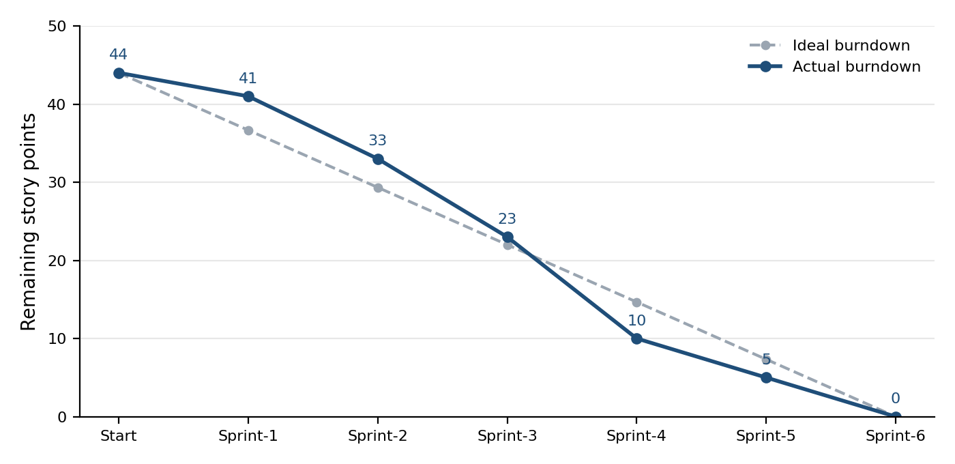
Figure 1: Sprint burndown chart (remaining story points)

6. Project Development Phase

Milestone 1: Salesforce Developer Account

Activity 1: Creating a Developer Account
A Salesforce Developer Edition org was created at https://developer.salesforce.com/signup using the first name, last name, email, role (Developer), company, country (India), postal code, and a unique username.

Activity 2: Account Activation
- Open the verification email and click Verify Account.
- Set a password and answer the security question, then click Change Password.
- The user is redirected to the Salesforce Setup page.

Milestone 2: Data Management – Custom Object
The custom object Support Ticket Intelligence (API name Support_Ticket_Intelligence__c) was created as the data store for support tickets. Reports, activity tracking, and field history tracking are enabled and the object is deployed.
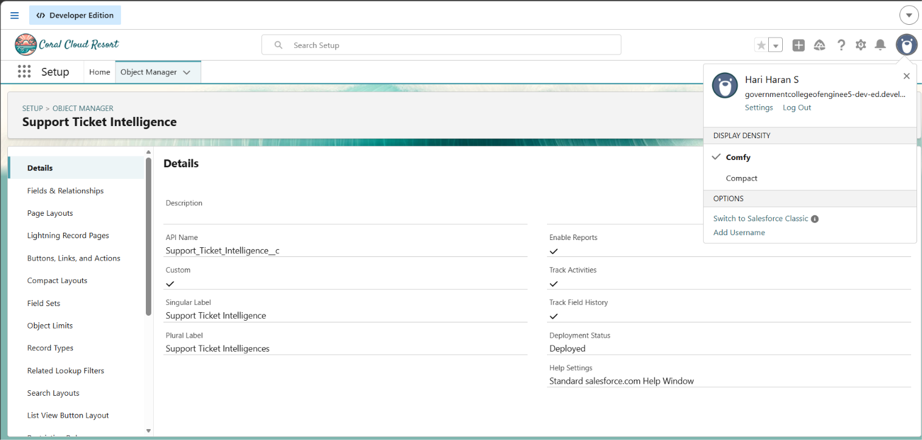
Figure 2: Support Ticket Intelligence object details in Object Manager
The object contains 15 fields, including the standard system fields. The custom fields used by the solution are listed below and shown in Figure 3.
Field Label | API Name | Data Type | Description
Ticket Number | Name | Auto Number | Ticket identifier (TKT-0001 format)
Customer | Customer__c | Lookup (Customer) | Related customer record
Account | Account__c | Lookup (Account) | Related Account
Contact | Contact__c | Lookup (Contact) | Customer contact
Issue Type | Issue_Type__c | Picklist | Technical, Billing, General
Description | Description__c | Long Text Area (32768) | Issue details
Priority Level | Priority_Level__c | Picklist | Low, Medium, High
Status | Status__c | Picklist | New, In Progress, Resolved
Created Date | Created_Date__c | Date | Ticket date
Assigned To | Assigned_To__c | Lookup (User) | Support agent
SLA Breach Risk | SLA_Breach_Risk__c | Checkbox | Risk flag
Resolution Time | Resolution_Time__c | Number (18, 0) | Time taken to resolve

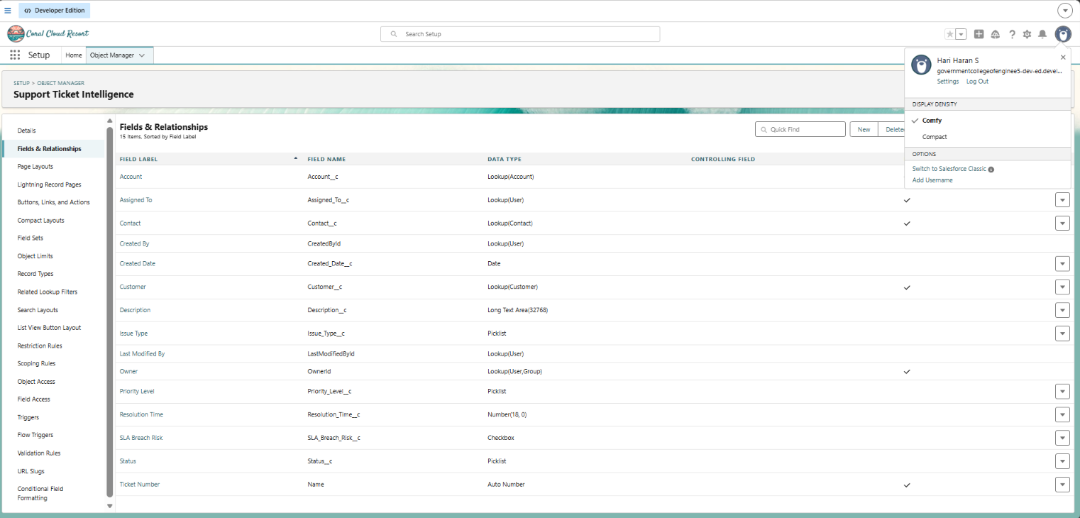
Figure 3: Fields & Relationships of Support Ticket Intelligence

Milestone 3: Auto-Launched Flow
An Auto-Launched Flow (no trigger) was built to retrieve the latest ticket for an Account, analyze its description, and return the priority outcome to Agentforce. The flow is called from the Agentforce action.

Flow Variables
The flow uses one input variable (AccountName) and five output variables that are returned to Agentforce. Record variables store the Account, the Support Ticket Intelligence record, and the created Task. The two decision outcomes (High Priority, Medium Priority) are also listed in the Manager panel.
Variable | Type | Direction | Purpose
AccountName | Text | Input | Account name entered by the user
AccountId | Text | Output | Id of the Account found
TicketId | Text | Output | Id of the latest ticket analyzed
PriorityLevel | Text | Output | High, Medium or Low
AssignedAgent | Text | Output | Support level assigned (Senior Support Agent for High)
ActionMessage | Text | Output | Final message shown to the user
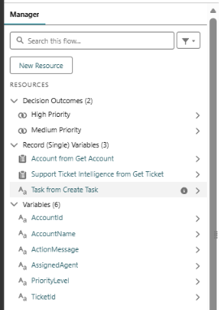
Figure 4: Flow resources, record variables and variables in the Manager panel

Step 1 – Get Account
A Get Records element finds the Account whose Account Name equals the AccountName input, sorted by CreatedDate descending, storing only the first record with all fields. An assignment element (Store Account Id) then sets AccountId from the retrieved Account.
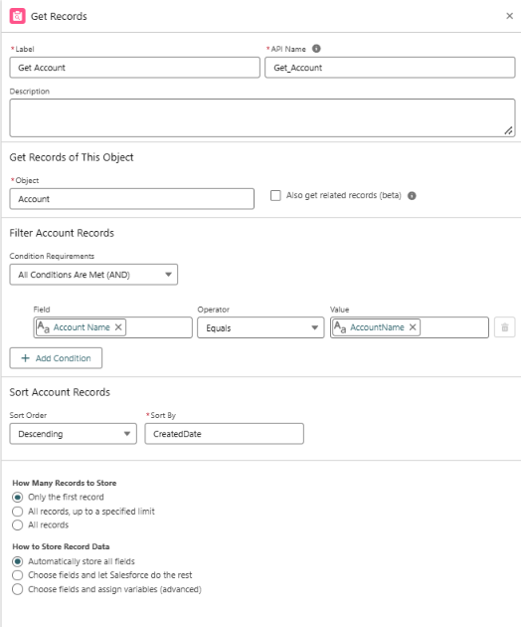
Figure 5: Get Records element – Get Account

Step 2 – Get Ticket and Store Ticket Id
A second Get Records element retrieves the latest Support_Ticket_Intelligence__c record for the Account (sorted by CreatedDate descending, first record only). The Store Ticket Id assignment sets TicketId from this record.

Step 3 – Decision: Analyze Description
The Analyze Description decision evaluates the ticket description using Contains conditions:
Outcome | Condition (Description contains)
High Priority | "urgent" OR "not working" OR "failure" (any condition is met)
Medium Priority | "issue" OR "slow" OR "delay"
Low Priority (default) | None of the above keywords
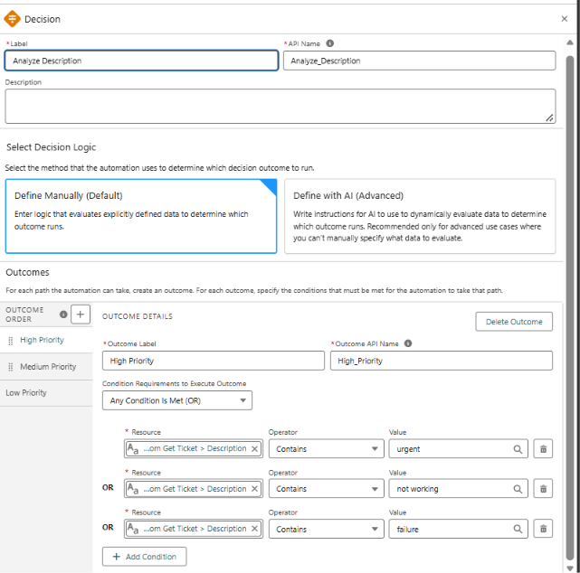
Figure 6: Decision element – High Priority outcome conditions

Step 4 – Priority Paths
Path | Elements executed | Result
High | High Priority path → Create Task → Set Assigned Agent → Set Final Message | PriorityLevel = High; Task "Urgent Ticket Handling" created; AssignedAgent = Senior Support Agent; message: "High priority ticket detected. Assigned to senior agent."
Medium | Medium Priority path → Medium Final Message | PriorityLevel = Medium; message: "Ticket marked as medium priority. Will be handled shortly."
Low | Low Priority path → Low Final Message | PriorityLevel = Low; message: "Tickets are low priority and queued for processing."

Final Flow Structure
Start → Get Account → Store Account Id → Get Ticket → Store Ticket Id → Analyze Description (Decision) → High / Medium / Low path → Final Message → End.
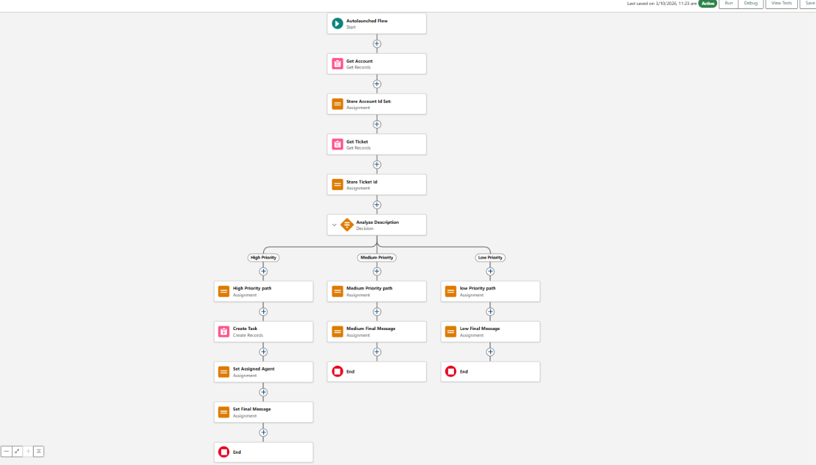
Figure 7: Overall Auto-Launched Flow (Active)

Milestone 4: Agentforce Configuration

Step 1 – Open Salesforce Go
From the gear icon in the Setup menu, select Salesforce Go.
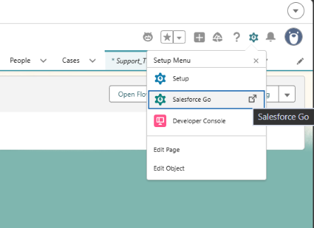
Figure 8: Setup menu – Salesforce Go

Step 2 – Search and Select Agentforce (Default)
In Salesforce Go, search for "default" and select Agentforce (Default).
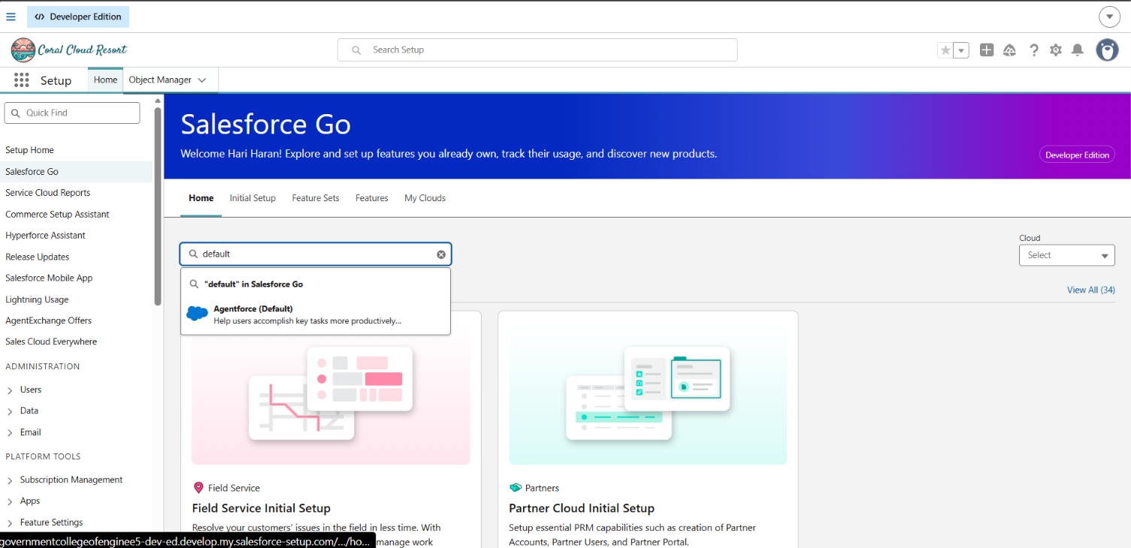
Figure 9: Searching for Agentforce (Default) in Salesforce Go

Step 3 – Turn On Agentforce
Turn on Agentforce Studio and Einstein Generative AI. The setup shows 3 of 3 steps completed, the feature status is On, and all 5 Agentforce (Default) licenses are assigned.
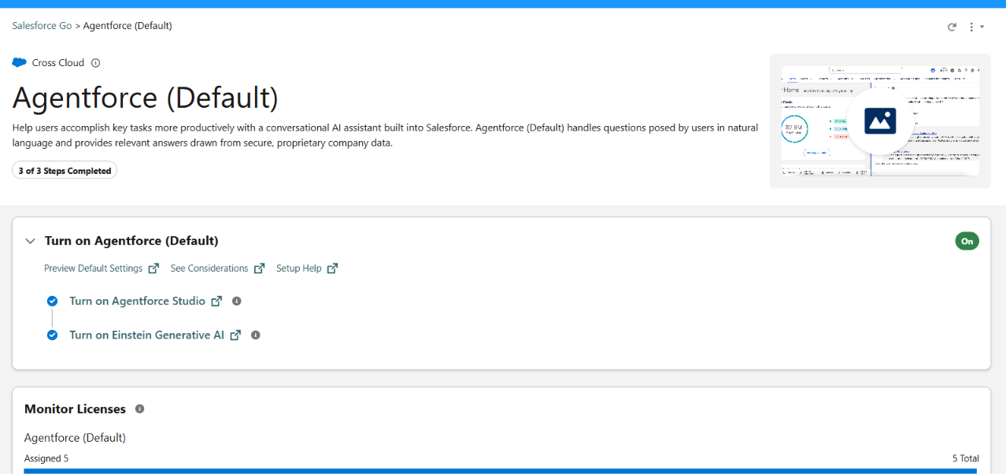
Figure 10: Agentforce (Default) turned on with setup steps completed

Step 4 – Create the Subagent
Open the agent in Agentforce Builder, go to Subagents, click New, and choose New Subagent. The new subagent Support Ticket Priority Analysis appears in the list of assigned subagents.
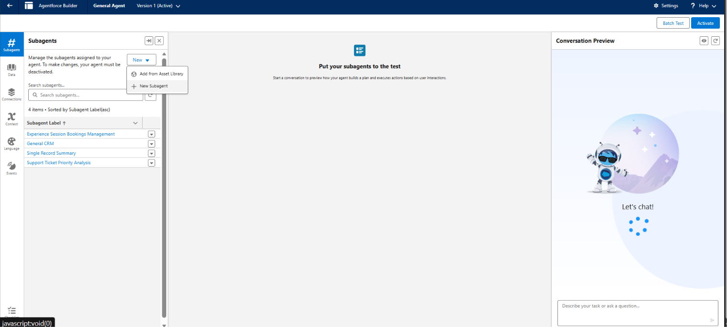
Figure 11: Agentforce Builder – creating a new subagent

Subagent Configuration
Setting | Value
Name | Support Ticket Priority Analysis
API Name | Support_Ticket_Priority_Analysis
Classification Description | This topic analyzes customer support tickets to determine priority based on issue description and urgency. It handles user requests related to ticket status, issue severity, and support prioritization.
Scope | Your job is only to analyze support ticket descriptions, determine the priority level (High, Medium, Low), and trigger backend automation for task assignment. Do not handle unrelated requests such as billing, subscription management, or account updates.

Subagent Instructions
- Ask the user to provide the Account Name if not already given.
- Retrieve the latest support ticket associated with the Account.
- Read and analyze the ticket description.
- Determine priority based on keywords: High – "urgent", "not working", "failure"; Medium – "issue", "slow", "delay"; Low – none of the above.
- Set the priority level accordingly.
- If the ticket is High Priority, trigger the Auto-Launched Flow and ensure a task is created for immediate handling.
- Assign the ticket to the appropriate support level (e.g., senior agent for high priority).
- Return a clear response: High – urgent handling is initiated; Medium – will be handled shortly; Low – ticket is queued.
- Do not update records directly or send emails. Use Flow for all actions.

Step 5 – Create the Agent Action
Under This Topic's Actions, a new action is created with Reference Action Type = Flow, referencing the Support Ticket Intelligence flow.
Setting | Value
Agent Action Description | Analyzes customer support tickets based on the provided account name, determines ticket priority using issue description, and triggers automation to assign tasks for high-priority cases.
Loading Text | Analyzing ticket details and determining priority...
Input – AccountName | Enter the customer account name to fetch the latest support ticket and analyze its priority. Type: lightning__textType; Require Input and Collect data from user enabled.
Output – AccountId | Returns the unique identifier of the customer account used to retrieve the support ticket. Show in conversation enabled; rendering: Text.
Output – TicketId | Returns the unique identifier of the support ticket analyzed by the system.
Output – PriorityLevel | Represents the calculated ticket priority level (High, Medium, Low) based on the issue description.
Output – AssignedAgent | Indicates the support agent or team assigned to handle the ticket.
Output – ActionMessage | Displays the final message indicating ticket priority and actions taken by the system.
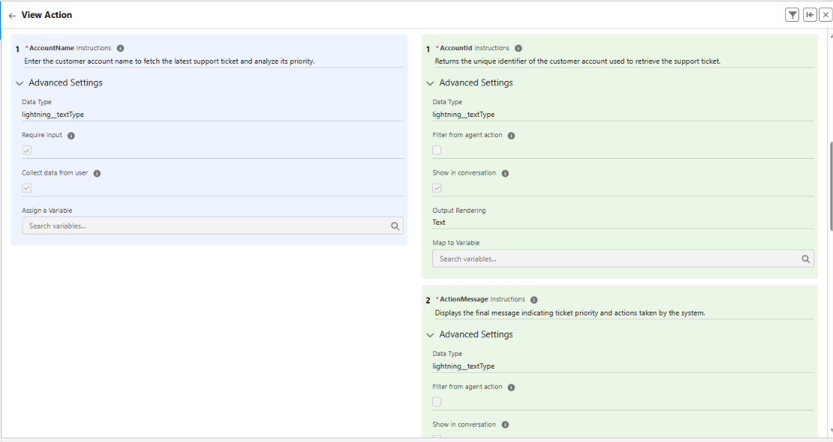
Figure 12: Agent action – input (AccountName) and output (AccountId, ActionMessage) configuration

Milestone 5: Final Outcome
The completed solution takes an Account Name as input, fetches the latest support ticket, analyzes the description using keywords, sets the priority automatically, creates a task for urgent cases, and returns the output to Agentforce.

7. Functional & Performance Testing
The solution was tested end to end from the Agentforce chat panel. The agent prompts for the Account Name, runs the flow action, and returns the outcome. Two scenarios were tested using the latest ticket of each Account.

7.1 Test Cases
TC | Account | Ticket Description | Expected | Actual Result | Status
TC-1 | Kani | urgent: application not working (TKT-0006, Technical) | High priority, Senior Support Agent | High; Senior Support Agent; "High priority ticket detected. Assigned to senior agent."; Ticket Id a0FdM00000Q5Cj7UAF | Pass
TC-2 | Siva | ISSUE: The application is running slowly and the customer is experiencing delays while accessing the system. (TKT-0007, General) | Medium priority, handled shortly | Medium; "Ticket marked as medium priority. Will be handled shortly."; Ticket Id a0FdM00000Q5CpZUAV | Pass

7.2 Test Case 1 – High Priority (Account: Kani)
Agentforce asks for the Account Name and the user enters "Kani". The ticket description contains the keywords "urgent" and "not working", so the flow classifies it as High priority and assigns it to the Senior Support Agent.
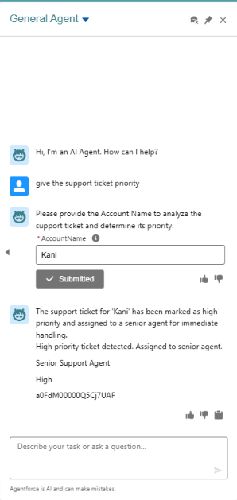
Figure 13: Agentforce response for Account "Kani"
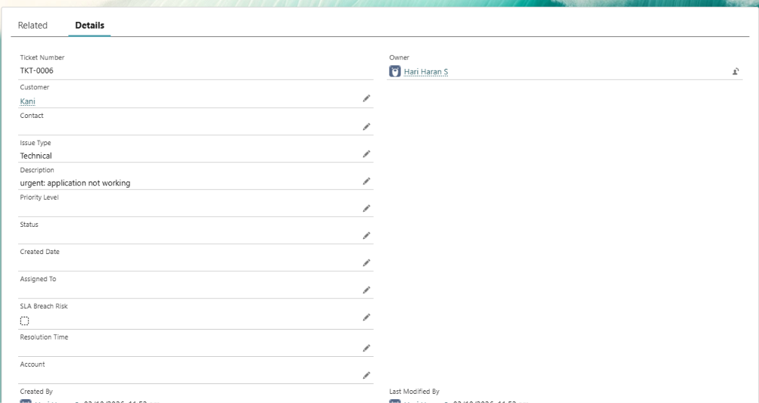
Figure 14: Ticket TKT-0006 for Kani (description: urgent: application not working)

7.3 Test Case 2 – Medium Priority (Account: Siva)
For the Account "siva", the latest ticket describes a slow application with delays. The keywords "issue", "slow" and "delay" match the Medium condition, so the ticket is marked Medium priority and will be handled shortly.
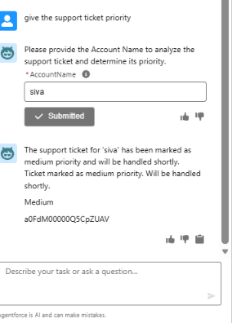
Figure 15: Agentforce response for Account "siva"
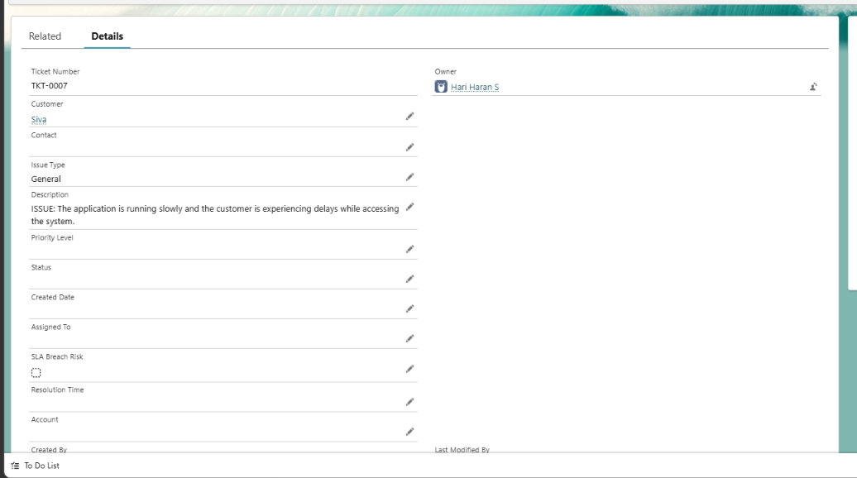
Figure 16: Ticket TKT-0007 for Siva (description: application running slowly with delays)

7.4 Performance Observations
- The agent displays the loading text while the flow retrieves the Account and latest ticket.
- Priority, assigned agent, action message, Account Id and Ticket Id are all returned in a single conversational response.
- The flow handles each request with two record lookups and one decision, so analysis is lightweight.
- Priority results were consistent with the configured keyword conditions in both tests.

8. Advantages & Disadvantages

Advantages
- Automatic Ticket Prioritization – Classifies support tickets as High, Medium, or Low based on ticket description.
- Faster Identification of Critical Issues – Helps support agents focus on urgent tickets first.
- Reduced Manual Effort – Automates ticket analysis, priority setting, task creation, and assignment.
- Intelligent Ticket Handling – Agentforce analyzes ticket details and initiates the appropriate backend automation.
- Automatic Urgent Task Creation – High-priority tickets automatically create an Urgent Ticket Handling task.
- Improved Support Assignment – Assigns High-priority tickets to a senior support agent.
- Conversational Support – Support users interact with Agentforce to analyze ticket information and receive the outcome.
- Better Response Time – Automation reduces delays in handling critical customer issues.
- Scalable Support Operations – Salesforce automation can support increasing volumes of tickets.
- Improved Team Productivity – Reduces repetitive work so teams can concentrate on resolution.

Disadvantages
- Keyword-Based Priority Logic – Classification depends on configured keywords such as urgent, not working, failure, issue, slow, and delay.
- Limited Understanding of Context – The logic may not capture every possible urgency signal.
- Dependence on Accurate Ticket Data – Correct Account, Contact, and ticket information is required.
- Flow and Agentforce Configuration Dependency – Changes require maintenance of the Flow and subagent instructions.
- Limited Scope of Agentforce – The subagent is focused on ticket analysis; unrelated requests such as billing are out of scope.
- Priority Not Written Back – The calculated priority and assigned agent are returned to the chat; the Priority Level and Assigned To fields on the ticket record are not updated by the current flow (see Figure 14 and Figure 16).
- SLA Monitoring is Limited – Only an optional SLA-risk check is documented rather than full SLA monitoring and escalation.
- Assignment Logic May Need Expansion – Additional teams or sophisticated rules require further configuration.
- Limited Analytics – Advanced analytics for priority trends and resolution performance are future scope.

9. Conclusion
The Customer Support Ticket Priority Prediction and Automated Assignment System demonstrates how Salesforce Flow and Agentforce can work together to reduce manual support-ticket handling. The solution retrieves the latest ticket for an Account, analyzes its description, classifies priority, creates an urgent task for High-priority cases, assigns a support level, and returns a clear conversational response. Testing with real Accounts confirmed that urgent tickets are routed to the Senior Support Agent and slower, non-critical tickets are classified as Medium. This supports faster ticket handling, reduced manual effort, intelligent prioritization, and better team productivity.

10. Future Scope
- Write the calculated Priority Level and Assigned To values back to the ticket record.
- Add more priority indicators and business rules.
- Extend Agentforce outputs with additional ticket information.
- Add more sophisticated SLA monitoring and escalation.
- Support additional support teams or assignment rules.
- Introduce analytics for priority trends and resolution performance.
- Add more variables and configure them in the Agentforce action for richer outputs.

11. Appendix
Ref | Item
A | Custom Object: Support Ticket Intelligence (Support_Ticket_Intelligence__c)
B | Key Salesforce Records: Account, Contact, User, Task
C | Flow: Support Ticket Intelligence – Auto-Launched Flow
D | Agentforce Subagent: Support Ticket Priority Analysis
E | Agentforce Action: Flow-based Support Ticket Intelligence action
Thank You

