**Analysis Document**

**1DV507 - Project Course in Computer Science**

**Group 1:**

Jesper Bergström

Daniel Alm Grundström

Oscar Eklund Berggren

Mustafa Alsaid

Zacky Kharboutli

Vikrant Mainali

Tomás Vieira Quental Mendes

# **Non-functional requirements**

## Documentation

In addition to the program, a comprehensive manual shall be written that explains how a user can do the tasks available in the program. This manual will be written at the end of the development cycle, when most of the implementation is finished.

## Usability

To make sure that the final product is easy and intuitive to use, the usability of the user interface will be taken into extra consideration during the design phase.

# **Functional requirements**

## Base requirements

These are the requirements that must be fulfilled in order for the project to be considered complete.

|  |  |
| --- | --- |
| ID | Requirement |
| R1 | The user shall be able to create any number of new timelines. |
| R1.1 | When adding a timeline, the user shall be able to specify a name for the timeline. |
| R1.2 | When adding a timeline, the user shall be able to specify a start and end time for the timeline. |
| R2 | The user shall be able to delete an entire timeline. |
| R2.1 | Before a timeline is deleted, the user shall be prompted to confirm the deletion. |
| R3 | The user shall be able to save a timeline to a text file. |
| R4 | The user shall be able to open a timeline from a text file. |
| R5 | The user shall be able to add any number of events to a timeline. |
| R5.1 | When adding an event, the user shall be able to specify whether it is an event with duration or without duration. |
| R5.2 | When adding a duration event, the user shall be able to specify a title, description as well as a start date and end date. |
| R5.3 | When adding an event without duration, the user shall be able to specify a title, description and the date on which the event occurs. |
| R6 | The user shall be able to delete an event on a timeline. |
| R7 | The user shall be able to edit an event’s title, description or date(s). |
| R8 | The user shall be able to switch between create mode and display mode with a toggle button. |
| R9 | When a timeline is displayed, all its events shall be shown. |
| R9.1 | The events shall be placed at the correct time in the timeline. |
| R9.2 | The title shall be shown for all events. |
| R9.3 | For events with duration, the time span shall be shown with a bar. |
| R9.4 | For events without duration, the events shall be shown as points on the timeline. |
| R9.5 | If all events on the timeline cannot be shown on the screen, the user shall be able to scroll horizontally and/or vertically. |
| R10 | The user shall be able to switch between open timelines via a dropdown menu. |
| R11 | When hovering the mouse over an event, a popup shall appear showing title, description and date(s) for the event. |

## Extra requirements

These lower priority requirements are not strictly necessary for the final product but are requirements that we feel will improve the usability and the overall quality of the program.

|  |  |
| --- | --- |
| ID | Requirement |
| E1 | The user shall be able to change start and end date for a duration event visually by clicking and dragging its edges. |
| E2 | The user shall be able to specify a color for an event when creating it. When editing an event, the user shall also be able to change the color. |
| E3 | The user shall be able to change the background color of a timeline. |
| E4 | The user shall be able to mark one or more events on a timeline as important. |

# **Use Case Diagram**

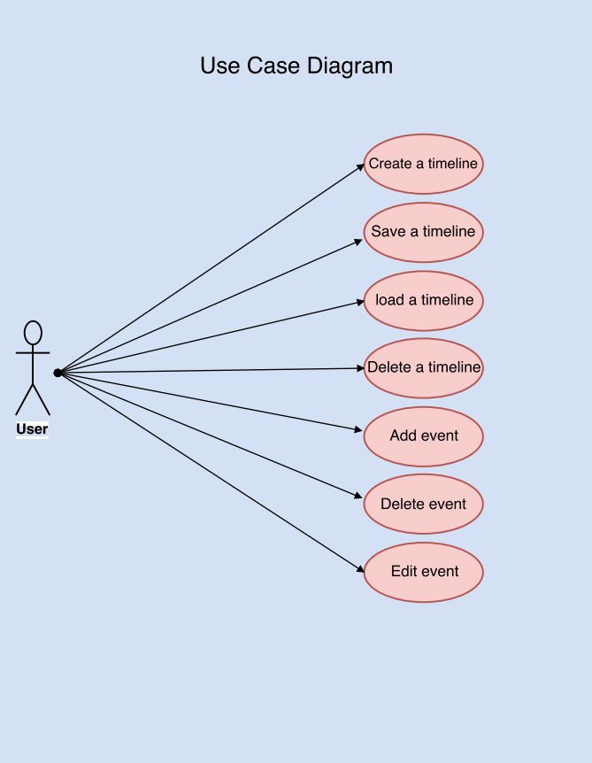

# **Use Cases**

|  |  |
| --- | --- |
| **Use Case** | TUC-01: Create a timeline |
| **Description** | For the user to use the application, a timeline needs to be created with a name and a duration. |
| **Preconditions** | 1. Users can create timelines 2. Users can enter names for their timeline 3. Users can enter duration for their timeline |
| **Actor(s)** | User |
| **Normal Sequence** | 1. The user requests to create a new timeline 2. User is prompted to a new window where they can enter the details of their timeline (name and duration) 3. Timeline is created |
| **Postconditions** | A new timeline should be created and visible |
| **Exceptions** | 1. If the user does not input a name or date, they are prompted to update those correctly |
| **Comments** | For now, we have only considered adding a timeline with parameters name and duration, there are many other implementations that can be added to it such categories, priority, etc. |

|  |  |
| --- | --- |
| **Use Case** | EUC-01: Add an event |
| **Description** | An event will be added by the user to the timeline. The Event should hold a few properties: Start time, End time, Description, Title, etc. |
| **Preconditions** | 1. An event object for this type of event exists. 2. An event can be added to a timeline. |
| **Actor(s)** | User |
| **Normal Sequence** | 1. The user clicks a button to add a new event. 2. A new window will pop up, where the user will enter information for the event. This information consists of: Title, description, start time, end time, etc. 3. Event will be added to timeline. |
| **Postconditions** | The event is added to the timeline. |
| **Exceptions** | The start time cannot be bigger than the end time. |
| **Comments** | - |

|  |  |
| --- | --- |
| **Use Case** | EUC-02: Edit an event |
| **Description** | The information of an event already added to the timeline will be edited. You will change the values for the different types of information of the event such as: start time, end time, description, title, etc. |
| **Preconditions** | 1. An event can be added to the timeline. 2. The information of the event can be accessed. |
| **Actor(s)** | User |
| **Normal Sequence** | 1. The user selects an event in the timeline and a window or box with the event information pops up. 2. In the window, there will be a button for editing the event. When the button is pressed, the information will be editable. 3. When the user is done editing the information, a “save” button will be pressed and the new information will be saved. |
| **Postconditions** | The edited information of the object should match the information that was entered. |
| **Exceptions** | The start time cannot be bigger than the end time. |
| **Comments** | - |

|  |  |
| --- | --- |
| **Use Case** | EUC-03: Delete an event |
| **Description** | An event already added to the timeline will be deleted by the user. When an event is deleted, it means that it is removed from the timeline. |
| **Preconditions** | 1. An event can be added to a timeline. 2. An event in the timeline can be selected and viewed. |
| **Actor(s)** | User |
| **Normal Sequence** | 1. The user selects an event in the timeline and a window or box with the event information pops up. 2. In the window, there will be a button for deleting the event. When the button is pressed, the event will be deleted from the timeline. |
| **Postconditions** | The event should be deleted from the timeline. |
| **Exceptions** | - |
| **Comments** | - |

|  |  |
| --- | --- |
| **Use Case** | TUC-02: Save timeline |
| **Description** | After the creation of a timeline, the users should be able to save it to load it in the future so they can view it. |
| **Preconditions** | 1. Users have created a timeline |
| **Actor(s)** | User |
| **Normal Sequence** | 1. User clicks on the save button 2. User is prompted to choose a location to store the timeline (using JavaFX File Chooser) 3. The timeline is then stored as a unique file (since we can have multiple timelines and do not want all information to be saved on one file) |
| **Alternate Sequence** | If the user forgets to save changes made to one or more timelines before exiting the following should happen:   1. User clicks the close window button 2. A popup window appears that asks if the user wishes to save the changes before closing. 3. The user clicks “Yes” 4. The timeline is saved. |
| **Postconditions** | Timeline should be saved in the target location |
| **Exceptions** | - |
| **Comments** | This should be a basic save function allowing the user to save their timeline to a location of their choice. |

|  |  |
| --- | --- |
| **Use Case** | TUC-03: Load timeline |
| **Description** | The users should be allowed to load the timeline they saved using the save key so that they can view their timeline. |
| **Preconditions** | 1. Timeline has been created 2. Timeline has also been saved |
| **Actor(s)** | User |
| **Normal Sequence** | 1. User clicks on the load file button 2. User is then prompted to a window where they locate and choose the file to open (again, using File Chooser) 3. The timeline file that user chooses is opened |
| **Postconditions** | Timeline is loaded onto the client |
| **Exceptions** | 1. User chooses a non-timeline file 2. User is prompted with an error |
| **Comments** | Again, another simple file loader where the user can load the saved timelines, if the user tries to load another type of file then they should be prompted with an error. |

|  |  |
| --- | --- |
| **Use Case** | TUC-04: Delete timeline |
| **Description** | The user should be able to create a timeline they have created (for example after the events in the timeline are complete). |
| **Preconditions** | 1. Timeline has been created |
| **Actor(s)** | User |
| **Normal Sequence** | 1. User picks the timeline to be deleted 2. User deletes the timeline using the delete function 3. Timeline is then deleted |
| **Postconditions** | Deleted timeline should not exist |
| **Exceptions** | - |
| **Comments** | This function should allow the user to manage their client by clearing up unused and/or outdated timelines. |

|  |  |
| --- | --- |
| **Use Case** | GUC-01: Switch theme |
| **Description** | The user should be able to switch the application theme between a light and dark theme. |
| **Preconditions** | None |
| **Actor(s)** | User |
| **Normal Sequence** | 1. User clicks on the theme button in the menu bar. 2. The theme toggles from light to dark or from dark to light. |
| **Postconditions** | The theme has changed |
| **Exceptions** | - |
| **Comments** | - |

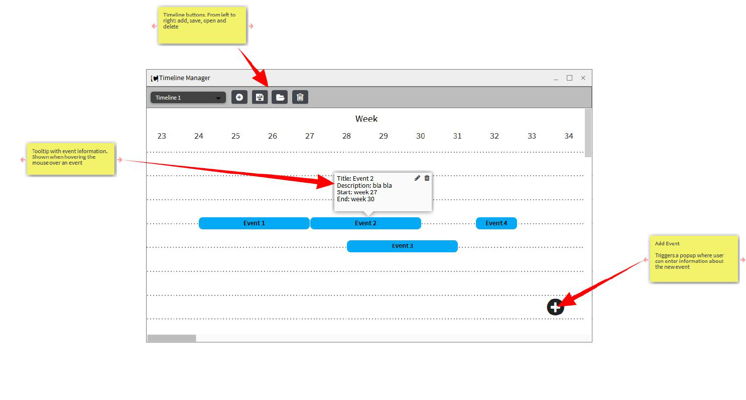**User Interface design mock-up**

# **Github repository:** https://github.com/Kramg0/Timeline-Manager