ABSTRACT

Prison Manager

Prison Manager is an application to automate the process for maintaining and tracking the day to day activities of any prison. This software is an Internet (Intranet) based online portal, which allows users to access the application from allover the world. The Portal’s major responsibility is to take care of the proper maintenance of any prison.
This application maintains the centralized database so that any changes done by any one at any location reflects on fly. This is an online application that allows multi-user access of system and to track or manage the data simultaneously

The aim of this application is to reduce the manual effort needed to manage transactions and historical data used by jail admin team. Also this application provides an interface to police officials and other important government officials to view the details of prisoners, case details and to generate required reports. This helps to prevent unnecessary delays and human errors. This system helps in generating foolproof reports with in not time by users which is very difficult in current system (manual system).
This system design is modularized into various categories. This system has enriched UI so that a novice user did not feel any operational difficulties. This system mainly concentrated in designing various reports requested by the users as well as higher with export to excel options.

TABLE OF CONTENTS
1. INTRODUCTION
- ABOUT ORGANIZATION
- ABOUT PROJECT
2. SYSTEM ANALYSIS
- FEASIBILITY STUDY
- PROPOSED SYSTEM
- EXISTING SYSTEM
3. SYSTEM REQUIREMENT SPECIFICATION
- OPERATING ENVIRONMENT
- SOFTWARE REQUIREMENTS
- HARDWARE REQUIREMENTS
4. SYSTEM DESIGN
- DATA DICTIONARY
- MODULE DESCRIPTION
- UML DIAGRAMS
5. SYSTEM TESTING
6 .SAMPLE CODE
7. SCREENS
8. CONCLUSION
9. BIBLIOGRAPHY

About Project :
This intranet application has been developed to be implemented in place of existing manual system. This project would automate the transactions of a prison and would retain the present functionality available in the current system. The specific purpose of this system is to store and process information about prisoners, In-out register, staff details, interview details and parole details and generate the reports as and when required. The administrator is responsible for the maintenance of this system. Based on the category of the user i.e. staff or administrator, the various parts of the system are made available to the users of the prison.

Problem Statement:

Problem statement is one of the basic and important phases of project phase. When the basic problem is determined, it is documented and the symptomatic problem is analyzed, then the current list of basic problem is completed. A system is simply a set of components that interact to accomplish some purpose.
In “Prison Manager System” maintaining the details of different prisoners, their status (Imprison or remand), and their case details, timing schedules of the prisoners in in-out register, staff details, user logins, interview details and parole details are to be kept in a database and also can be retrieved easily when the authorized user wants to update the data.
Actually the process going on here is when the prisoner enters into the prison and then all the details related to him will be stored manually and if the user wants to generate a the report then he needs to concern with different departments physically, get the data and can prepare the report.

System Analysis

System Analysis is first stage according to System Development Life Cycle model. This System Analysis is a process that starts with the analyst.
Analysis is a detailed study of the various operations performed by a system and their relationships within and outside of the system. One aspect of analysis is defining the boundaries of the system and determining whether or not a candidate system should consider other related systems. During analysis, data are collected on the available files, decision points, and transactions handled by the present system.
Logical system models and tools that are used in analysis. Training, experience, and common sense are required for collection of the information needed to do the analysis.

Feasibility Study:

All projects are feasible given unlimited resources and infinite time. But the development of software is plagued by the scarcity of resources and difficult delivery rates. It is both necessary and prudent to evaluate the feasibility of a project at the earliest possible time.

Three key considerations are involved in the feasibility analysis.

Economic Feasibility:

This procedure is to determine the benefits and savings that are expected from a candidate system and compare them with costs. If benefits outweigh costs, then the decision is made to design and implement the system. Otherwise, further justification or alterations in proposed system will have to be made if it is to have a chance of being approved. This is an ongoing effort that improves in accuracy at each phase of the system life cycle.

Technical Feasibility:

Technical feasibility centers on the existing computer system (hardware, software, etc.,) and to what extent it can support the proposed addition. If the budget is a serious constraint, then the project is judged not feasible.

Operational Feasibility:

People are inherently resistant to change, and computers have been known to facilitate change. It is understandable that the introduction of a candidate system requires special effort to educate, sell, and train the staff on new ways of conducting business.

Feasibility Study in This Project:

Technical Feasibility:

This project, Prison Management needs the support to transactions are already being implemented in the prisons. It requires PC’s and a modem with normal configuration for Internet access. Almost all administrators have their own PC on their desk. Thus it is technically feasible to implement the new system here.

Economic Feasibility:

“Prison Management” is a small-scale project. It is very much useful to maintain all the departments of the prison. The system is developed at no additional cost. Hence it is economically feasible for the new system to be implemented.

Operational Feasibility:

This new system meets their requirement and covers all aspects required much better than the old manual system. Most of the people involved in this branch are computer literate and do not need much training if this system is implemented. Hence it is operationally feasible.

Existing System:

The existing system is a manual one. When the prisoner enters into the prison then all the transactions related to him has to be stored manually at different departments which may leads to erroneous results due to human errors. This system doesn’t provide proper security for the data.

Disadvantages:
- Difficulty in storing and finding the data from various departments.
- Difficult to handling more prisoners.
- Difficulty of maintaining frequently asked questions in a database
- Difficulty in generating a report
- Difficulty in tracking different activities of prisoners.

Proposed System:
The Prison Manager system is to replace the existing manual system with a software solution.
The Central Prisons Management People wants to maintain all the prisoner transaction details in the database prison wise, to avail them to all the employees. And they will update the prisoner details as and when required according to their authorization in online.
The proposed system has one administrator to control the data, creating the users in a prison. The administrator is responsible to update prisoner’s details, in-out register details, user details, staff details, interview details and parole details.
Staff is responsible for all the activities same as the administrator except user details. Another type of user called normal user is responsible for viewing the prisoner details, in-out register, make and view interview requests, make and view parole requests.

Merits of This System:

- Faster processing when compared to existing one.
- Maintaining prisoner details centrally.
- Modifications of details can be carried out immediately
- Role-Based dynamically changed authorization feature.
- Easy Generation of reports.

Features of the Project:
- 24x7 availability
- Better component design to get better performance at peak time
- Flexible service based architecture will be highly desirable for future extension
- Professional look and feel
SYSTEM REQUIREMENTS ANALYSIS

The requirement phase basically consists of three activities:
1.Requirement Analysis
2.Requirement Specification
3.Requirement Validation

Requirement Analysis:
Requirement Analysis is a software engineering task that bridges the gap between system level software allocation and software design. It provides the system engineer to specify software function and performance indicate software’s interface with the other system elements and establish constraints that software must meet.
The basic aim of this stage is to obtain a clear picture of the needs and requirements of the end-user and also the organization. Analysis involves interaction between the clients and the analysis. Usually analysts research a problem by asking questions and reading existing documents. The analysts have to uncover the real needs of the user even if they don’t know them clearly. During analysis it is essential that a complete and consistent set of specifications emerge for the system. Here it is essential to resolve the contradictions that could emerge from information got from various parties. This is essential to ensure that the final specifications are consistent.
It may be divided into 5 areas of effort.
- Problem recognition
- Evaluation and synthesis
- Modeling
- Specification
- Review

Each Requirement analysis method has a unique point of view. However all analysis methods are related by a set of operational principles. They are
- The information domain of the problem must be represented and understood.
- The functions that the software is to perform must be defined.
- The behavior of the software as a consequence of external events must be defined.
- The models that depict information function and behavior must be partitioned in a hierarchical or layered fashion.
- The analysis process must move from essential information to implementation detail.

Requirement Analysis in this Project:

The main aim in this stage is to assess what kind of a system would be suitable for a problem and how to build it. The requirements of this system can be defined by going through the existing system and its problems. They discussing (speak) about the new system to be built and their expectations from it. The steps involved would be

Problem Recognition:

The main problem here is the more time is taken to manage the activities of a prison. This has to be eliminated. A comprehensive solution has to be developed which will facilitate to fulfill the requirements faster and more efficient way.

Evaluation and Synthesis:

The system has to be designed only after complete evaluation of the existing one, upon which we can see that a lot depends on the medium of communication. The proposed system is used to maintain all the prisoner transaction details in the database prison wise, to avail them to all the employees. So this has to be used such that there is no waste of time.

Specification:

The specifications from the user, here maintaining all departments of a prison manually lead to manual errors. The appearance of forms, and their field names, the different screens he desired, the stages of this database etc., were all given. The system has been built following all the specifications.

Requirements Specification Document:

According to Roger Pressman in Software Engineering: A Practitioner's Approach (McGraw-Hill Publications) [SEPA–1997], the requirement specification document is produced at the end of Analysis of the system. This document is a very comprehensive document & contains all the User requirements & Analysis diagrams. The Requirements are broadly divided into two groups:

1. Functional requirements
2. Non-functional requirements

Functional Requirements:
The main purpose of functional requirements within the requirement specification document is to define all the activities or operations that take place in the system. These are derived through interactions with the users of the system. Since the Requirements Specification is a comprehensive document & contains a lot of data, it has been broken down into different Chapters in this report. The depiction of the Design of the System in UML is presented in a separate chapter. The Data Dictionary is presented in the Appendix of the system.

But the general Functional Requirements arrived at the end of the interaction with the Users are listed below. A more detailed discussion is presented in the Chapters, which talk about the Analysis & Design of the system.

- Administrator of this system can add a new user as well as delete an existing user and he can view all the existing users of the system.
- Administrator of the system can manage different transactions related to reports, staff, interview, payroll, in-out and prisoners.
- An administrator, User or a staff is allowed to enter the details of the prisoner and his/her demographic details should be captured.
- Case register: All the details of the cases against the prisoner should be captured and must include the sentence details, remand/conviction details, etc. by the administrator, user or staff
- Parole register: This allows the administrator, user or staff should track all prisoners on parole and provide necessary reports on this data.
6. Duty register: Who was where, why and when should be entered by
the administrator, user or a staff.

7. Interview requests: All interview requests by the relatives of the prisoners need to be recorded and tracked by the administrator, user or staff.

Non-Functional Requirements:

The non-functional requirements consist of

1. Analysis, Design & Data requirements (Use-case diagrams, textual analysis, sequence diagrams, data dictionary etc.)
2. Constraints.
3. Guidelines.
4.Validation Criteria.

Introduction to HTML

The hypertext markup language (HTML) is a simple markup language. Used to create a hypertext documents that are portable from one platform to another HTML documents are SGML (Standard generalized mark up language) documents with generic semantics that are appropriate for representing information from a wide range of applications. This specification defines HTML version 3.2.HTML 3.2 aims to capture recommended practice as of early ’96 and as such a replacement for HTML2.0 (RFC 1866).
A set of instructions embedded in a document is called mark up language. These instructions describe what the document text means and hoe it should look like in a display. Hyper Text Mark Up language (HTML) is the language used to encode World Wide Web documents.
WHY TO USE HTML

Website is a collection of pages, publications, and documents that reside on web server. While these pages publications and a document as a formatted in a single format, you should use HTML for home page and all primary pages and the site. This will enable the millions of web users can easily access and to take advantage of your website.
HTML is considered first for formatting any new material you plan to publish on the web. HTML documents are platform independent, meaning that they don’t confirm to any standard. If they are created properly you can move home page to any server platform or you can access them with any complaint www browser.

HTML LAYOUT:
An HTML document consists of text, which comprises the content of the document and tags, which, defines the structure, and appearance of the document. The structure of an HTML document is simple, consists of outer.
<HTML>tag enclosing the document header and body
<HTML>
<HEAD>
<TITLE>the title of HTML document</TITLE>
</HEAD>
<BODY>
This is where the actual HTML documents
Text lies, which is displayed in the browser
</BODY>
</HTML>

Each document has a head and body delimited by the <HEAD> and <BODY> tag. The head is where you give your HTML document a title and where you indicate other parameters the browser may use when displaying the document. This includes the text for displaying the text. Tag also references special and indicates the hot spots that link your document to other documents.

INTRODUCTION TO JAVA

CREATION OF JAVA

Java was conceived by James Gosling, Patrick Naughton, Chris Warth, Ed Frank and Mike Sheridan at SUN Microsystems Incorporation in the year 1991.It took 18 months to develop the 1st working version. This language was initially called “OAK”, but was renamed “JAVA” in 1995, many more contributed to the design and evolution of the language.

JAVA OVERVIEW

Java is a powerful but lean object-oriented programming language. It has generated a lot of excitement because it makes it possible to program for Internet by creating Applets. Programs that can be embedded in web page. The context of an applet can be an animation with sound, an interactive game or a ticker tape. With constantly updated stock prices. Applets can be just little decorations to liven up web page, or they can be serious applications like Word processor or Spreadsheet.

But Java is more than a programming language for writing Applets. It is being used more and more for writing standalone applications as well. It is becoming so popular that many people believe it will become standard language for both general purpose and Internet programming.

There are many buzzwords associated with Java, but because of its spectacular growth in popularity, a new buzzword has appeared ubiquitous. Indeed, all indications are that it will soon be everywhere.

Java builds on the strength of C++. It has taken the best features of C++ and discarded the more problematic and error prone parts. To this lean core, it has added garbage collection (automatic memory management), multithreading (the capacity for one program to do more than one thing at a time), security capabilities. This result is that Java is simple, elegant, and powerful and easy-to-use.

Java is actually a platform consisting of 3 components:
- Java Programming Language.
- Java Library of Classes and Interfaces.
- Java Virtual Machine

The following sections will say more about these components.

JAVA IS OBJECT-ORIENTED

The Java programming language is OBJECT-ORIENTED, which makes program design focus on what you are dealing with, rather than on how your are

going to do something. This makes it more useful for programming in sophisticated projects, because one can break the things into understandable components. A big benefit is that these components can then be reused.
Object-Oriented Languages use the paradigm of classes. In simplest term, a class includes both the data and the functions to operate on data. You can create an instance of a class, also called an object, which will have all the data members and functionality of its class.

JAVA DEVOLPMENT EVNIRONMENT

To code, edit, debug and test the java programs, one needs to have a java development environment. At the minimum this will consists of a java compiler interpreter and applet viewer where applets can be tested.
Sun’s java development kit (JDK) latest version is 2.2 can be freely downloaded from the Internet.
Java compiler is available on DOS, Win95, WIN’NT, Solaris and MAC etc.

Introduction to JavaScript
JavaScript is a new scripting language for WebPages scripts written with java script can be embedded into your HTML pages. With java script you have very many possibilities for enhancing your HTML page with interesting elements. For example you are able to respond to user-initiated events quite easily. Some effects that are now possible with java script were some time ago only possible with CGI. So you can create really sophisticated pages with the helps of java script script on the Internet.

Difference between java and Java Script

Although the names are almost the same Java is not the same as Java Script. These are two different techniques for Internet programming. Java is programming language. JavaScript is a scripting language as the name implies. The difference is that we can create real programs with java. But about real programming. So Java Script is meant to be easy to understand and easy to use. JavaScript authors should not have to care too much about programming. We could say that Java Script is rather an extension to HTML than a separate computer language. Of course this is not the official definition but it makes it easier to understand the difference between java and java script.

Input elements.

Use the <input> tag to define any one of a number of common form elements including text fields multiple choice lists click able images and submission buttons. There are many attributers for this tag only that types and name attributes are required for each element, each type of input element uses only a subset of the followed attributes. Additional <input> attributes may be required based upon which type of the form element you specify.

Submit button:

The submit button (<input type=submit> ) does what its name implies, settings in motion the form’s submission to the server from the browser. We many have more than submit buttons will be added to the parameter list the browser sends along to the server.

Example
< Input type =”submit”>
<Input type=”submit” value=”submit” name=”name”>

Reset button:

The reset button if firm <input> button is nearly self- explanatory; it lets the user reset erase or set to some default value all elements in the form. By default the browser displays a reset button worth the label “reset”. We can change that by specifying a value attribute with tour own button label.

INTRODUCTION TO JDBC

JDBC (Java Database connectivity) is a front-end tool for connecting to a server to ODBC in that respect, however JDBC can connect only java client and it uses ODBC for the connectivity. JDBC is essentially a low-level API since any data manipulation, storage and retrieval has to be done by the program itself. Some tools, which provide a higher-level abstraction, are expected shortly.
The next question that needs to be answered is why we need JDBC, once we have ODBC on hand. We can use the same ODBC to connect the entire database and ODBC is a proven technology.
Problem for doing this is ODBC gives a ‘c’ language API, which uses pointers extensively. Since java does not have any pointes and is object-oriented sun Microsystems, inventor of java developed to suit its needs.

Requirements to use JDBC:

To use JDBC you need a basic knowledge of databases and SQL.A part from this you need the jdk1.1 (Java Development Kit1.1 available javasoft’s website) or a version of Java since jdk1.1 and above come bundled with JDBC software.
After that you need to have a back-end database engine for which a JDBC driver is available. When JDBC drivers are not available JDBC-ODBC bridge drivers are used to access the database through ODBC.Back-end is not needed when JDBC driver is capable of storing and retrieving the data itself, or if JDBC-ODBC Bridge and the ODBC driver can be used to store and retrieve the information.
.

DATABASE MODELS

JDBC and accessing the database through applets and JDBC.API via an intermediate server resulted server resulted in a new type of database model which
is different from the client-server model. Based on number of intermediate server through the request should go it is named as single tire, two tire and multi tire architecture

Single Tier:

In a single tier the server and client are the same in the sense that a client program that needs information (client) and the source of this type of architecture is also possible in java, in case flat files are used to store the data. However this is useful only in case of small applications. The advantage with this is the simplicity and portability of the application developed.

Server and client

Database

Two Tier (client-server):

In two architecture the database resides in one machine the network. In this type of architecture a database management takes control of the database and provides access to clients in a network. This software bundle is also called as the server. Software in different machines, requesting for information are called as the clients.

Server

Client

Database

Client

Three Tier and N-Tier

In the three-tier architecture, any number servers can access the database that resides on server. Which in turn serve clients in a network. For example, you want to access the database using java applets, the applet running in some other machine, can send request only to the server from which it is down loaded. For this reason we will need to have a intermediate server which will accept the requests from applets and them to the actual database server. This intermediate server acts as a two-way communication channel also. This is the information or data from the database is passed on to the applet that is requesting it. This can be extended to make n tiers of servers, each server carrying to specific type of request from clients, however in practice only 3 tiers architecture is popular.

JDBC Driver Types:

The JDBC drivers that we are aware of at this time fit into one of four categories

1. JDBC-ODBC BRIDGE PLUS ODBC DRIVER

The java soft bridge product provides JDBC access via ODBC drivers. Note that ODBC binary code end in many cases database client code must be loaded on each client machine that uses this driver. As a result, this kind of driver is most appropriate on a corporate network where client installations are not major problem, or for application server code written in java in a 3-tier architecture.

2. NATIVE API PARTLY-JAVA DRIVER

This kind of driver converts JDBC calls into calls on the client API for oracle Sybase, Informix, DB2, or other DBMS. Note that, like the bridge driver, this style of driver requires that some binary code be loaded on each client machine.

3.JDBC-NET ALL-JAVA DRIVER

This driver translates JDBC calls into a DBMS independent net protocol, which is then translated, to a DBMS protocol by a server. This net server middle-ware is able to connect its all java clients to many different databases. The Specific protocol used depends on the vendor. In general, this most flexible JDBC alternative. It is likely that all vendors of this solution will provide products suitable for intranet use. In order for these products to also support Internet access, they must handle the additional requirements for security, access through firewalls, etc that the web imposes. Several vendors are adding JDBC drivers to their existing database middleware products.

4.NATIVE PROTOCOL ALL-JAVA DRIVER

This kind of driver converts JDBC calls into the network protocol used by DBMS directory. This allows a direct call from the client machine to the DBMS server that is practical solution for intranet access. Since many of these protocols are proprietary, the database vendors themselves will be the primary source. Several database vendors have these in progress. Eventually, we expect that driver categories 3 and 4 will be the preferred way to access databases from JDBC.Driver categories one and two are interim solutions where direct all java drivers are not yet available. Category 4 is in some sense the ideal; however, there are many cases where category 3 may be preferable: eg: -where a thin DBMS-independent client is desired, or if a DBMS –independent protocol is standardized and implemented directly by many DBMS vendors.

Servlets

Servlets provides a Java-Based solution used to address the problems currently associated with doing server side programming, including inextensible scripting solutions, platform specific APIs, and incomplete interfaces. Servlets are objects conform to a specific interface that can be plugged into a Java-based server. Servlets are to the server-side what applets are to the client-side-object byte codes that can be dynamically loaded off the net. They differ from applets in that they are faceless objects (without graphics or a GUI component). They serve as platform independent, dynamically loadable, plug gable helper byte code objects on the server side that can be used to dynamically extend server-side functionality.

For example, an HTTP servlet can be used to generate dynamic HTML content. When you use servlets to do dynamic content you get the following advantages:
They’re faster and cleaner than CGI scripts.
They use a standard API (the Servlet API)
They provide all the advantages of Java (run on a variety of servers without needing to be rewritten)

The attractive of Servlets
There are many features of servlets that make them easy and attractive to use. These include:

Easily configured using the GUI-based Admin Tool.

Can be loaded and invoked from a local disk or remotely across the network.

Can be linked together, or chained, so that one servlet can call another servlets, or several servlets in sequence.

Can be called dynamically from within HTML pages, using server-side include tags

Invoking the servlet:

To invoke a servlet you call it by creating a URL with “/servlet/” pretended to the servlet name. Then enter this URL in your favorite browser to see the output of the Servlet.
Example:
After installing according to the directions above, access the HelloServlet by entering the following URL in your favorite browser:
http://server-host-name:8080/servlet/hell

Internal Servlets:

The Java Server servlet architecture is very flexible and the server takes advantage of this by dividing up its work among several internal servlets. These are
File Servlet
Invoker Servlet
Server side include servlet
Admin Servlet
CGI Servlet
Image map servlet
File Servlet:
The file servlet provides the standard document serving capabilities of java server. This servlet includes a caching mechanism to speed up response times of frequently accesses files. In addition it recognizes files that are to be parsed for server side includes and passes them on to the SSInclude Servlet.
Servlets are an effective substitute for CGI scripts and provide a faster and cleaner way to generate dynamic documents.
The java server is both flexible and extensible. Using the java serer APIs you can write your own servlet and incorporate it into the server. To do this follows these three steps
1. Write the servlet
2. Configure the servlet
3. Invoke the servlet

Writing the Servlet:
Unless they are used with the http protocol, servlets subclass the servlet. GenericServlet class and override the service (ServletRequest, ServletResonse) method.
Servlets use with the HTTP protocol should subclass the javax.servlet.HttpServlet class override one or both of the doGet (HttpServletRequest, HttpServletResonse) and
doPost (HttpServletRequest, HttpServletResonse) methods
Servlets class may choose to override the default implementations of the servlet “lifecycle” servlet methods, init (ServletConfig) and destroy ().

Configuring the Server:

The real beauty of the java server is that it is extensible. But, before you can use a Servlet to add an extended functionality to the JavaServer.You have to use the Java Server administration applet to install the Servlet and specify the default parameters and arguments.
Display the Administration Applet by connecting to:
http://server_Host_Name:9090/index.html
Are secure-even when downloading across the network, the servlets security model and the Servlet sandbox to protect your system from unfriendly behavior.
The advantage of the Sevlet API
One of the great advantages of the Servlet API is protocol independence. It assumes nothing about:

The protocol being used to transmit on the net.
How it is loaded.
The server environment it will be running in.
These qualities are important, because it allows the Servlet API to be embedded in many different kinds of Servers. There are other advantages to the servlet API as well.
Servlet Features

The Java Server provides several important Servlet features. These include:

- Loading & Invoking Servlets.
- Servlets can be loaded both locally and remotely.
- Filters and Servlets change.
- The Java Server uses MIME types to call Servlets sequentially.
- Server size includes:
- Servlets can be invoked from dynamic HTML documents using Server side include tags.
- Replacing the CGI Scripts.

Software and hardware requirements
Development Environment:

- Operating System: Windows 2000/XP
The system will be built on windows compatible environment.
The application will be web based using Java technology
- Web Server:
Apache Tomcat Web Server to serve as Servlet\JSP engine.
The system requires Apache Tomcat Web Server
- Server side Application Software: Java Server Pages (JSP)
- Client Side Application Software: Java Script, HTML
- Data Base: MySQL 5.0
- Client Browsers:
Internet Explorer 6.0 or Netscape Navigator 4.7
- Java Software : JDK1.5.0
- Hardware: Pentium PCs with 256 MB RAM/ 40 GB HDD.

SYSTEM DESIGN

The most creative and challenging phase of the life cycle is system design. The term design describes a final system and the process by which it is developed. It refers to the technical specifications that will be applied in implementations the candidate system. The design may be defined as “the process of applying various techniques and principles for the purpose of defining a device, a process or a system in sufficient details to permit its physical realization”.

The designer’s goal is how the output is to be produced and in what format samples of the output and input are also presented. Second input data and database files have to be designed to meet the requirements of the proposed output. The processing phases are handled through the program Construction and Testing. Finally, details related to justification of the system and an estimate of the impact of the candidate system on the user and the organization are documented and evaluated by management as a step toward implementation.

The importance of software design can be stated in a single word “Quality”. Design provides us with representations of software that can be assessed for quality. Design is the only way that we can accurately translate a customer’s requirements into a finished software product or system without design we risk building an unstable system, that might fail it small changes are made or may be difficult to test, or one who’s quality can’t be tested. So it is an essential phase in the development of a software product.

SYSTEM DESIGN phase follows system analysis phase. Design is maintaining record proof design divisions and providing a blueprint for the implementation phase. Design is the bridge between system analysis and system implementation.
System design is transition from a user oriented, document oriented to programmers or database personnel. The design is a solution, a “how to” approach to the creation a new system. This is composed of several steps. It provides the understanding and procedural details necessary for implementing the system recommended in the feasibility study. Design goes through logical and physical stages of development, logical design reviews the present physical system, prepare input and output specifications, detail the implementation plan, and prepare a logical design walkthrough.
The database tables are designed by analyzing various functions involved in the system and the format of the fields is also designed. The fields in the database table should define their role in the system. The unnecessary fields should be avoided because it affects the storage areas of the system. Care is to be taken to encode the lengthy names. Then in the input and the output screen design, the design should be made user friendly. The menu should be precise and compact.

Database Dictionary:

The logical characteristics of current systems data stores, including name, description, aliases, contents, and organization. Identifies processes where the data are used and where immediate access to information needed. Serves as the basis for identifying database requirements during system design.

Uses of Data Dictionary:

1. To manage the detail in large systems
2. To communicate a common meaning for all system elements
3. To Document the features of the system
4. To locate errors and omissions in the systems

TABLE NAME: CASEDETAILS

FIELD | DATATYPE | SIZE | DESCRIPTION
CASEID | NUMBER | 10 | ID of the case
CASETYPE | VARCHAR | 50 | Type of the case
CASEDETAILS | VARCHAR | 50 | Details of the case
COURTADDRESS | VARCHAR | 100 | Address of the court
JUDGENAME | VARCHAR | 100 | Name of the judge
JUDGEMENTDATE | DATE |  | Date of the judgment
CASESTARTDATE | DATE |  | Starting date of the case
CASESTARTDATE | VARCHAR | 100 | Starting date of the case
EXIHIBIT | VARCHAR | 100 | Showing the details
EVIDENCEDETAILS | VARCHAR | 100 | Details of the evidence
PRISONARID | NUMBER | 10 | Id of the prisonar
COURTNAME | VARCHAR | 50 | Name of the court

DESCRIPTION:
This table can be useful to maintain all the case details in the prison. In this table the case id is the primary key

Table Name: DUTYREGISTER

FIELD | DATATYPE | SIZE | DESCRIPTION
DUTYID | NUMBER | 11
STAFFID | NUMBER | 10
DUTYON | DATE
SHIFTSTARTAT | TIME
SHIFTENDAT | TIME
DUTYAS | VARCHAR | 50

TABLE NAME: INTERVIEWREQUESTS

FIELD | DATATYPE | SIZE | DESCRIPTION
INTERVIEWID | NUMBER | 11
REQUESTDATE | DATE
REQUESTEDBY | VARCHAR | 50
PRISONARID | NUMBER | 10
RELATIONSHIP | VARCHAR | 30
ADDRESS | VARCHAR | 255
TIMESLOTFROM | VARCHAR | 10
TIMESLOTTO | VARCHAR | 10
STAFFID | NUMBER | 10
REQUESTSTATUS | VARCHAR | 20
PURPOSE | VARCHAR | 30

DESCRIPTION:
This table can be useful to maintain all the interview requests in the prison. The interviews of the relative persons and the officials are maintained. In this table the interview id is the primary key

TABLE NAME: LOCATIONDETAILS

FIELD NAME | FIELD TYPE | SIZE
LOCATIONID | NUMBER | 11
STATIONCODE | VARCHAR | 255
LOCATION | VARCHAR | 100
STATE | VARCHAR | 100

TABLE NAME: LOGIN
FIELD NAME | FIELD TYPE | SIZE
USERID | VARCHAR | 25
PASSWORD | VARCHAR | 10
AUTH | VARCHAR | 10

DESCRIPTION:
This table can be useful to login the admin, staff and the user

TABLE NAME: MENU_BASE
FIELD NAME | FIELD TYPE | SIZE
MENU ID | NUMBER | 11
LABEL | VARCHAR | 100
DESCRIPTION | VARCHAR | 255

TABLE NAME: MENU_FRAME_EXECUTABLE_MAPPING
FIELD NAME | FIELD TYPE | SIZE
SNO | NUMBER | 11
MENURELATIONSHIPID | NUMBER | 11
TARGETFRAME | VARCHAR | 100
EXECUTABLE | VARCHAR | 255

TABLE NAME: MENU_ROLL_RELATIONSHIP
FIELD NAME | FIELD TYPE | SIZE
MENURELATIONSHIPID | NUMBER | 11
ROLL | VARCHAR | 20
DESCRIPTION | VARCHAR | 255

TABLE NAME: MENUITEM_RELATIONSHIP
FIELD NAME | FIELD TYPE | SIZE
MENURELATIONSHIPID | NUMBER | 11
PARENTMENUID | NUMBER | 11
CHILDMENUID | NUMBER | 11
RELATIONSHIPDESCRIPTION | VARCHAR | 255
MENULEVEL | NUMBER | 11

TABLE NAME: PAROLE
FIELD NAME | FIELD TYPE | SIZE
PAYROLLID | NUMBER | 11
PRISONARID | NUMBER | 10
STAFFID | NUMBER | 10
REQUESTDATE | DATE
REASON | VARCHAR | 255
STATUS | VARCHAR | 50
APPROVALDATE | VARCHAR | 20
FROM | DATE
TO | DATE
APPROVEDBY | VARCHAR | 100

TABLE NAME: PRISONERS

FIELD NAME | FIELD TYPE | SIZE
PRISONARID | NUMBER | 11
NAME | VARCHAR | 255
AGE | NUMBER | 3
CASEID | NUMBER | 10
FROMDATE | DATE
TODATE | DATE
MODE | VARCHAR | 20
ADDRESS | VARCHAR | 100

TABLE NAME: STAFFDETAILS

FIELD NAME | FIELD TYPE | SIZE
STAFFID | NUMBER | 11
NAME | VARCHAR | 100
AGE | NUMBER | 3
DESIGNATION | VARCHAR | 50
DATEOFJOINING | DATE
ADDRERSS | VARCHAR | 100
SALARY | NUMBER | 10
LOCATIONID | NUMBER | 10

Input Design:
Input design includes data mediums used for inputting data and validations that are to be done during data entry. Different messages regarding data are given to guide users during data entry. Validation checks are done for each input.
Data entry screens are designed so that the system interacts with the user in providing an effective dialogue. Fields in the screen are logically arranged to help the user.
The design is the process of converting the user-originated inputs into a compute-based format. The goal of the input design is to make the data entry easier, logical and free from error. Errors in the input data are controlled by input design.
The application has been developed in a user-friendly manner. The windows have been designed in such a way that during the processing the cursor is placed in the position where the data must be entered. If any of the data going into the system is wrong then the process and output will magnify these errors.
1.The decisions made during design of input are:
2.To achieve the highest possible level of accuracy.
To provide a list of possible choices and help while accepting the input for an important field wherever possible outputs from computer system are required primarily to communicate the results of processing to the users. They are also used to provide a permanent copy of these results for later consultation/verification.

Output Design:
Output refers to the results and information that are generated by the system. Output is the main reason for developing the system and based on this, the usefulness and applicability of system are evaluated.
Outputs from computer systems are required primarily to communicate the results of processing to users. Efficiently designed outputs enhance the understandability of the information.
According to the requirements of the system, various types of outputs are considered and designed as follows.
1.Internal outputs, whose destination is within the organization and which require careful design because they, are the user’s main interface with the computer.
2.Interactive outputs, in which the user communication with the Computer is essential.

Module Description:

We have identified the following modules

Prisoners & In-Out Register Module: This module is responsible for managing Prisoner personal, case details, status and their in-out register details. Whenever a prisoner enters into prison then the administrator, user or staff can enter update his details inside the database. If the prisoner is in imprisonment status then he is not allowed to go for the court for attending cases if the prisoner is in remand status then he is allowed go out with our staff for attending the court case. This information will be stored inside In-out register.

Administration Module: This module is responsible for managing the user logins and generating different kinds of reports (Today’s releases reports, Today’s duty report, Today’s interview slots report and Today’s In-out report). It allows the administrator or staff to store the staff information details which include adding, editing and deleting the staff. It provides a facility to enter the employee duty timings inside duty register.

Today’s releases report – Displays the prisoners who are releasing today.
Today’s duty report – Displays the today employee duty timings info.
Today’s interview slots – Displays the interview slots for today.
Today’s in-out report – Displays the in-out timings of different prisoners.

Interviews: It allows the staff to raise an interview request from prisoner side person which will be displayed for the administrator for validating this request so that the administrator can go through the requests, validate them and approve them by providing a slot for that person which will be displayed for the staff for allowing that person in to that slot.

Parole Module: It allows the staff to raise a parole request from prisoner side person which will be displayed for the administrator for validating this request so that the administrator can go through the requests, validate them and approve them by giving some time to bring the person outside by completing all the formalities in the person and check whether the same person came back to the prison with in the stipulated time or not. It stores complete details of the person who is supporting for this parole. I stores previous parole information related to this person and generate as report as and when required.

E R DIGRAMS AND UML DIAGRAMS

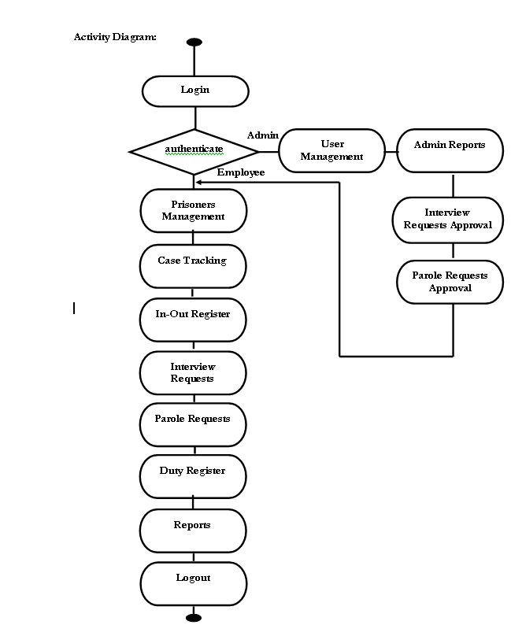

USECASE

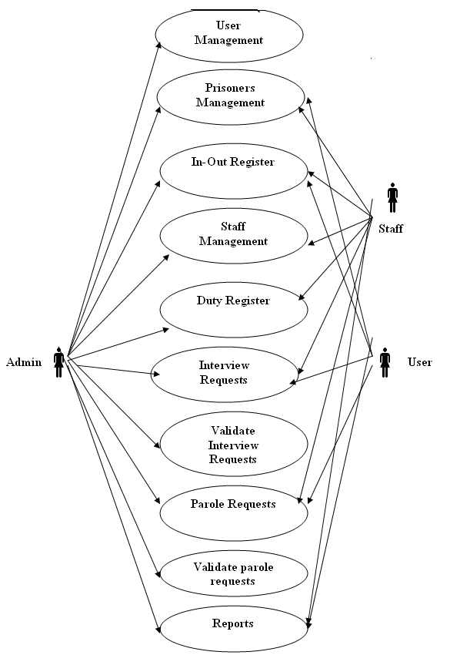
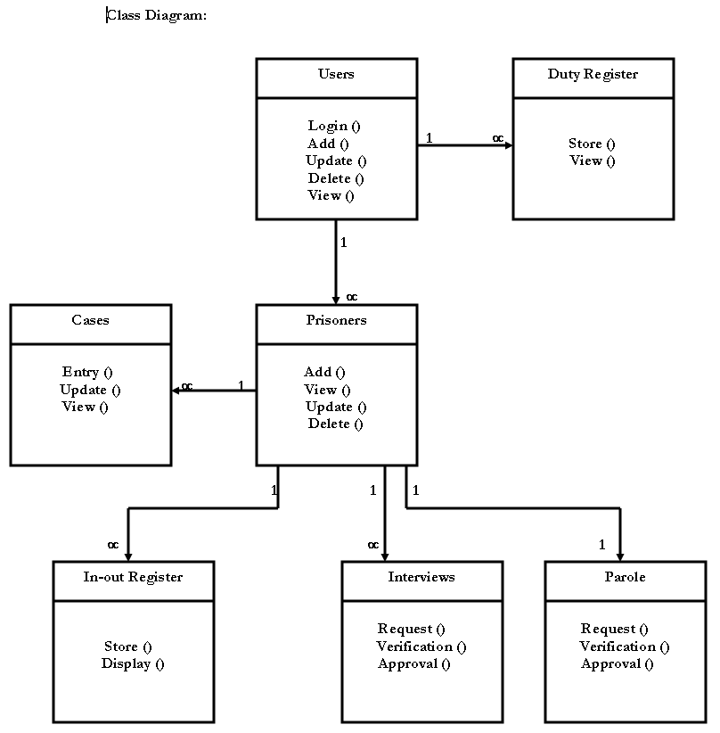

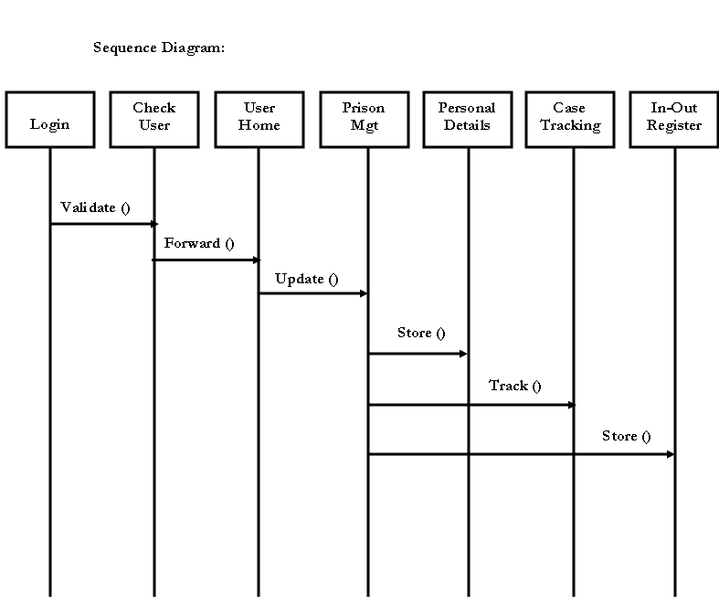

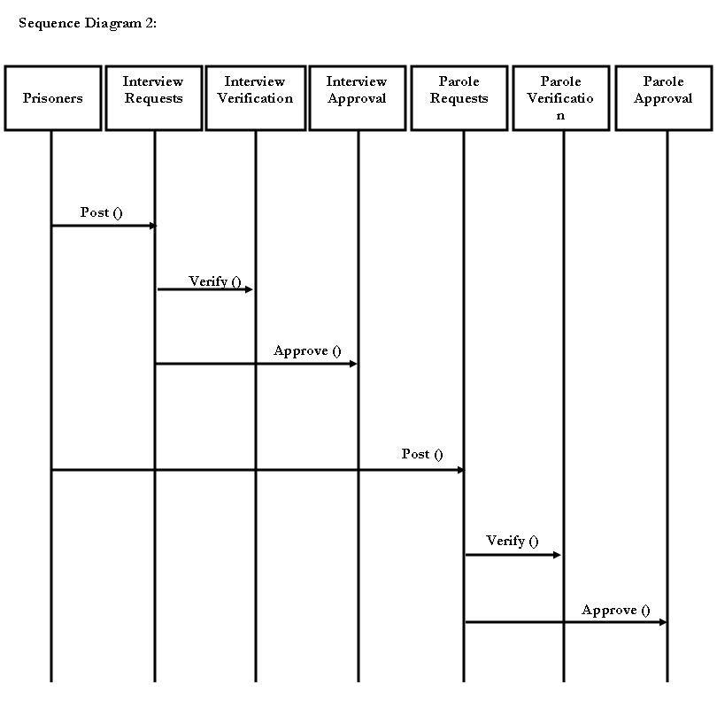

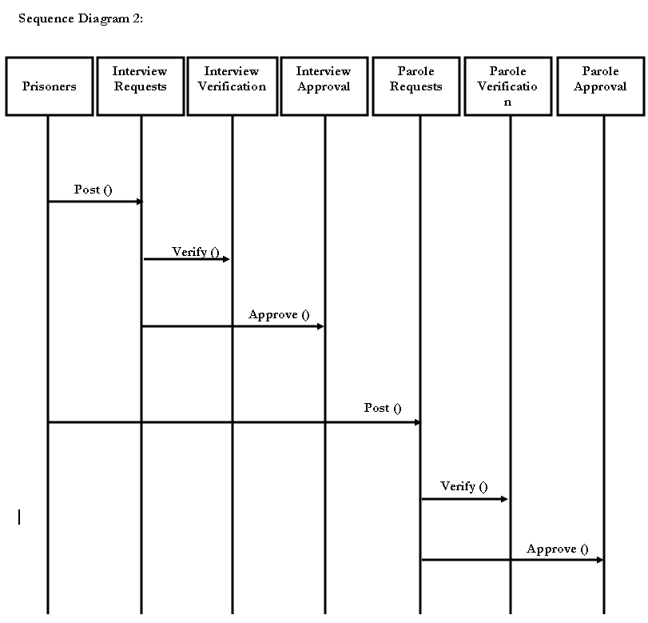

SOFTWARE TESTING

Software Testing is a critical element of software quality assurance and represents the ultimate review of specification, design and coding, Testing presents an interesting anomaly for the software engineer.

Testing Objectives include:
1.Testing is a process of executing a program with the intent of finding an error
2.A good test case is one that has a probability of finding an as yet undiscovered error
3.A successful test is one that uncovers an undiscovered error

Testing Principles:
- All tests should be traceable to end user requirements
- Tests should be planned long before testing begins
- Testing should begin on a small scale and progress towards testing in large
- Exhaustive testing is not possible
- To be most effective testing should be conducted by a independent third party

Testing Strategies

A Strategy for software testing integrates software test cases into a series of well planned steps that result in the successful construction of software. Software testing is a broader topic for what is referred to as Verification and Validation. Verification refers to the set of activities that ensure that the software correctly implements a specific function Validation refers he set of activities that ensure that the software that has been built is traceable to customer’s requirements

Unit Testing:

Unit testing focuses verification effort on the smallest unit of software design that is the module. Using procedural design description as a guide, important control paths are tested to uncover errors within the boundaries of the module. The unit test is normally white box testing oriented and the step can be conducted in parallel for multiple modules.

Integration Testing:

Integration testing is a systematic technique for constructing the program structure while conducting test to uncover errors associated with the interfacing. The objective is to take unit tested methods and build a program structure that has been dictated by design.

Top-down Integration:
Top down integrations an incremental approach to construction of program structure. Modules are integrated by moving downward through the control hierarchy, beginning with the main control program. Modules subordinate to the main program are incorporated in the structure either in the breath-first or depth-first manner.
Bottom-up Integration:

This method as the name suggests, begins construction and testing with atomic modules i.e., modules at the lowest leveling the program structure. Because the modules are integrated in the bottom up manner the processing required for the modules subordinate to a given level is always available and the need for stubs is eliminated.

Validation Testing:

At the end of integration testing software ids completely assembled as a package. Validation testing is the next stage which can be defined as successful when the software functions in the manner reasonably expected by the customer. Reasonable expectations are those defined in the software requirements specifications. Information contained in those sections form a basis for validation testing approach.
System Testing:

System testing is actually a series of different tests whose primary purpose is to fully exercise the computer-based system. Although each test has a different purpose, all work to verify that all system elements have been properly integrated to perform allocated functions.
Recovery Testing:
It is a system test that forces the system to fail in a variety of ways and verities that the recovery is properly performed.
Security Testing:

Attempts to verify the protection mechanisms built into the system.

Performance Testing:
This method is designed to test runtime performance of software within the context of an integrated system.

Limitations and Enhancements
1). Limitations:
- Once the user (employee) raised an interview request or parole request then he is not going to have the immediate response from the authorized person. We call this is as offline response. Some times it is better to provide online response in that situation user can get the status of his request immediately and gets wide thinking.
- It is only the intranet application. Because of this if any employee in the court wants to update the prisoner case details then it has to be done by the prison employee and it takes much time to forward that information to prison and update. It will not allow to update case info directly from the court.

2) Enhancements:

- Extendibility ----provides high level extendibility. It means it provides all the basic features and allows us to extend their features very easily with out disturbing the existing code.
- We can make this Internet application if we desire.
- We can make this application is suitable to work on any application just by changing the deployment files.
- By providing some more features like providing accessibility to court people to update the case details of a prisoner immediately.

SAMPLE CODE

//CODE TO ADD CASE DETAILS
<%@ page language="java" %>
<%@ page session="true" %>
<%@ page import="java.sql.*,java.io.*"%>
<%@ page isErrorPage="false" %>
<%@ page errorPage="errorPage.jsp" %>
<%
java.util.ArrayList DataList = com.PrisonManager.MyFunctions.getPropList("prisonerid","prisoners");
java.util.Iterator DataItr = null;

if(DataList!=null){
System.out.println("Data"+DataList);
DataItr = DataList.iterator();
}
java.util.ArrayList sDataList = com.PrisonManager.MyFunctions.getPropList("staffid","staffdetails");
java.util.Iterator sDataItr = null;

if(sDataList!=null){
System.out.println("sData"+sDataList);
sDataItr = sDataList.iterator();
}
String PrisonerId = request.getParameter("PrisonerId");
%>
<HEAD>
<LINK href="styles/styles.css" type="text/css" rel="stylesheet">
<script LANGUAGE="Javascript" SRC="utilities.js"></script>
<script LANGUAGE="Javascript" SRC="Images/calender.js"></script>
<script LANGUAGE="Javascript" >
function ChkMandatoryField(F,T){
var val= F.value;
if(val==""){alert(T+" is mandatory");return false;}
}
function ChkNumField(F,T){
var val = F.value;
if(isNaN(val)==true||val==""){alert("Please enter numbers for "+T);return false;}
}
function ChkAlphaNumericField(F,T){
var val = F.value;
var pattern = /^([a-zA-Z0-9]{1,250})$/;
if(!(pattern.test(val)==true)){alert("Please enter alphabets or numbers for "+T);return false;}
}
function ChkAlphaField(F,T){
var val = F.value;
var pattern = /^([a-zA-Z ]{1,250})$/;
if(!(pattern.test(val)==true)){alert("Please enter text for "+T);return false;}
}
function ChkEmailField(F,T){
var val = F.value;
var pattern = /^([a-zA-Z0-9\_\.]{4,25})$/;
if(!(pattern.test(val)==true)){alert("Please enter valid email for "+T);return false;}
}
function ChkDateField(F,T)
{
var val = F.value;
var pattern = /^[0-9]{4}-[0-9]{2}-[0-9]{2}$/;
if(!(pattern.test(val)==true)){alert("Please enter valid date format (yyyy-mm-dd) for "+T);return false;}
}
function validate()
{
var frm = document.forms(0);
if(ChkMandatoryField(frm.CaseType,'CaseType')==false) return false;
if(ChkAlphaField(frm.CaseType,'CaseType')==false) return false;
if(ChkMandatoryField(frm.CaseDetails,'CaseDetails')==false) return false;
if(ChkMandatoryField(frm.CourtName,'CourtName')==false) return false;
if(ChkAlphaField(frm.CourtName,'CourtName')==false) return false;
if(ChkMandatoryField(frm.CourtAddress,'CourtAddress')==false) return false;
if(ChkMandatoryField(frm.JudgeName,'JudgeName')==false) return false;
if(ChkAlphaField(frm.JudgeName,'JudgeName')==false) return false;
if(ChkDateField(frm.JudgementDate,'JudgementDate')==false) return false;
if(ChkMandatoryField(frm.CaseStartDate,'CaseStartDate')==false) return false;
if(ChkDateField(frm.CaseStartDate,'CaseStartDate')==false) return false;
if(ChkMandatoryField(frm.VictimsDetails,'VictimsDetails')==false) return false;
if(ChkMandatoryField(frm.exhibits,'exhibits')==false) return false;
if(ChkMandatoryField(frm.evidenceDetails,'evidenceDetails')==false) return false;
if(ChkMandatoryField(frm.PrisonerId,'PrisonerId')==false) return false;
if(ChkNumField(frm.PrisonerId,'PrisonerId')==false) return false;
}
function viewDetails(objid,tablename)
{
var obj = document.getElementById(objid);
var frm = document.forms(0);
var val = obj.options(obj.options.selectedIndex).value;
if(val==""){
alert("Please select "+obj.name+" to view details");
return false;
}
var url="";
if(tablename=="StaffDetails")
url = "ShowStaffPopup.jsp?"+obj.name+"="+val+"&TableName="+tablename;
if(tablename=="Prisoners")
url = "ShowPrisonersPopup.jsp?"+obj.name+"="+val+"&TableName="+tablename;
fnPopupWindow(url,300,300);
}
</script>
</HEAD>
<Body class=SC>
<BR><BR><BR>
<FORM ACTION="SaveCaseDetails.jsp" onsubmit="return validate()">
<TABLE align=center width="50%">

<TR>
<TH align="left">Case Type<FONT COLOR="red">*</FONT></TH>
<TD><select name=CaseType><option value=Civil>Civil</option><option value=Criminal>Criminal</option></select></TD>
</TR>
<TR>
<TH align="left">Case Details<FONT COLOR="red">*</FONT></TH>
<TD><textarea class="TextField" name=CaseDetails></textarea></TD>
</TR>
<TR>
<TH align="left">Court Name<FONT COLOR="red">*</FONT></TH>
<TD><Input type=text class="TextField" name='CourtName' value=''></TD>
</TR>
<TR>
<TH align="left">Court Address<FONT COLOR="red">*</FONT></TH>
<TD><textarea class="TextField" name=CourtAddress></textarea></TD>
</TR>
<TR>
<TH align="left">Judge Name<FONT COLOR="red">*</FONT></TH>
<TD><Input type=text class="TextField" name='JudgeName' value=''></TD>
</TR>
<TR>
<TH align="left">Judgement Date</TH>
<TD><Input type=text class="TextField" name='JudgementDate' value='' readonly><img onkeypress="fnCalendar(this)" id="imgDate" style="CURSOR: hand" onClick="fnCalendar(this)" height="16" src="Images/CalDis.gif" width="16" border="0" name="imgDate" onMouseOver="fnEnableCalLookup(this)" onMouseOut="fnDisableCalLookup(this)" ></TD>
</TR>
<TR>
<TH align="left">Case Start Date<FONT COLOR="red">*</FONT></TH>
<TD><Input type=text class="TextField" name='CaseStartDate' value='' readonly><img onkeypress="fnCalendar(this)" id="imgDate" style="CURSOR: hand" onClick="fnCalendar(this)" height="16" src="Images/CalDis.gif" width="16" border="0" name="imgDate" onMouseOver="fnEnableCalLookup(this)" onMouseOut="fnDisableCalLookup(this)" ></TD>
</TR>
<TR>
<TH align="left">Victims Details<FONT COLOR="red">*</FONT></TH>
<TD><textarea class="TextField" name=VictimsDetails></textarea></TD>
</TR>
<TR>
<TH align="left">Exhibits<FONT COLOR="red">*</FONT></TH>
<TD><textarea class="TextField" name=exhibits></textarea></TD>
</TR>
<TR>
<TH align="left">Evidence Details<FONT COLOR="red">*</FONT></TH>
<TD><textarea class="TextField" name=evidenceDetails></textarea></TD>
</TR>
<TR>
<TH align="left">PrisonerId<FONT COLOR="red">*</FONT></TH>
<TD> <Select name="PrisonerId" value= "<%=PrisonerId%>" class=ListBox>
<Option value="<%=PrisonerId%>"><%=PrisonerId%></Option>

<a class=genlinks onclick = "viewDetails('PrisonerId','Prisoners')">View Details</a>
</TD>
</TR>
<TR><TH><INPUT TYPE="submit" value='Submit'></TH><TH><INPUT TYPE="reset" value='Clear'></TH></TR>
</TABLE>
<H6 align=center>Fields with <FONT SIZE="" COLOR="red">*</FONT> are mandatory </H6>
</FORM> </BODY>
// CODE TO ADD NEW CASE DETAILS

<HTML>
<HEAD>

<script LANGUAGE="Javascript" SRC="validate.js"></script>

<LINK href="styles.css" type="text/css" rel="stylesheet">
<script LANGUAGE="Javascript" SRC="Images/calender.js"></script>
<script LANGUAGE="Javascript" >
function ChkMandatoryField(F,T){
var val= F.value;
if(val==""){alert(T+" is mandatory");return false;}
}
function ChkNumField(F,T){
var val = F.value;
if(isNaN(val)==true||val==""){alert("Please enter numbers for "+T);return false;}
}
function ChkAlphaNumericField(F,T){
var val = F.value;
var pattern = /^([a-zA-Z0-9]{1,250})$/;
if(!(pattern.test(val)==true)){alert("Please enter alphabets or numbers for "+T);return false;}
}
function ChkAlphaField(F,T){
var val = F.value;
var pattern = /^([a-zA-Z ]{1,250})$/;
if(!(pattern.test(val)==true)){alert("Please enter text for "+T);return false;}
}
function ChkEmailField(F,T){
var val = F.value;
var pattern = /^([a-zA-Z0-9\_\.]{4,25})$/;
if(!(pattern.test(val)==true)){alert("Please enter valid email for "+T);return false;}
}
function ChkDateField(F,T)
{
var val = F.value;
var pattern = /^[0-9]{4}-[0-9]{2}-[0-9]{2}$/;
if(!(pattern.test(val)==true)){alert("Please enter valid date format (yyyy-mm-dd) for "+T);return false;}
}
function validate()
{
var frm = document.forms(0);
if(ChkMandatoryField(frm.CaseType,'CaseType')==false) return false;
if(ChkAlphaField(frm.CaseType,'CaseType')==false) return false;
if(ChkMandatoryField(frm.CaseDetails,'CaseDetails')==false) return false;
if(ChkMandatoryField(frm.CourtName,'CourtName')==false) return false;
if(ChkAlphaField(frm.CourtName,'CourtName')==false) return false;
if(ChkMandatoryField(frm.CourtAddress,'CourtAddress')==false) return false;
if(ChkMandatoryField(frm.JudgeName,'JudgeName')==false) return false;
if(ChkAlphaField(frm.JudgeName,'JudgeName')==false) return false;
if(ChkMandatoryField(frm.JudgementDate,'JudgementDate')==false) return false;
if(ChkDateField(frm.JudgementDate,'JudgementDate')==false) return false;
if(ChkMandatoryField(frm.CaseStartDate,'CaseStartDate')==false) return false;
if(ChkDateField(frm.CaseStartDate,'CaseStartDate')==false) return false;
if(ChkMandatoryField(frm.VictimsDetails,'VictimsDetails')==false) return false;
if(ChkMandatoryField(frm.exhibits,'exhibits')==false) return false;
if(ChkMandatoryField(frm.evidenceDetails,'evidenceDetails')==false) return false;
}
</script>
</HEAD>
<Body class=SC>
<H2 align=center>Case</H2>
<FORM ACTION="SaveNewCaseDetails.jsp" onsubmit="return validate()">
<TABLE align=center width="50%">

<TR>
<TH align="left">CaseType<FONT COLOR="red">*</FONT></TH>
<TD><select name=CaseType class='ListBox'><option value=Civil>Civil</option><option value=Criminal>Criminal</option></select></TD>
</TR>
<TR>
<TH align="left">CaseDetails<FONT COLOR="red">*</FONT></TH>
<TD><textarea name=CaseDetails></textarea></TD>
</TR>
<TR>
<TH align="left">CourtName<FONT COLOR="red">*</FONT></TH>
<TD><Input type=text name='CourtName' value=''></TD>
</TR>
<TR>
<TH align="left">CourtAddress<FONT COLOR="red">*</FONT></TH>
<TD><textarea name=CourtAddress></textarea></TD>
</TR>
<TR>
<TH align="left">JudgeName<FONT COLOR="red">*</FONT></TH>
<TD><Input type=text name='JudgeName' value=''></TD>
</TR>
<TR>
<TH align="left">JudgementDate<FONT COLOR="red">*</FONT></TH>
<TD><Input type=text name='JudgementDate' value=''><img onkeypress="fnCalendar(this)" id="imgDate" style="CURSOR: hand" onClick="fnCalendar(this)" height="16" src="Images/CalDis.gif" width="16" border="0" name="imgDate" onMouseOver="fnEnableCalLookup(this)" onMouseOut="fnDisableCalLookup(this)" ></TD>
</TR>
<TR>
<TH align="left">CaseStartDate<FONT COLOR="red">*</FONT></TH>
<TD><Input type=text name='CaseStartDate' value=''><img onkeypress="fnCalendar(this)" id="imgDate" style="CURSOR: hand" onClick="fnCalendar(this)" height="16" src="Images/CalDis.gif" width="16" border="0" name="imgDate" onMouseOver="fnEnableCalLookup(this)" onMouseOut="fnDisableCalLookup(this)" ></TD>
</TR>
<TR>
<TH align="left">VictimsDetails<FONT COLOR="red">*</FONT></TH>
<TD><textarea name=VictimsDetails></textarea></TD>
</TR>
<TR>
<TH align="left">exhibits<FONT COLOR="red">*</FONT></TH>
<TD><textarea name=exhibits></textarea></TD>
</TR>
<TR>
<TH align="left">evidenceDetails<FONT COLOR="red">*</FONT></TH>
<TD><textarea name=evidenceDetails></textarea></TD>
</TR>
<TR><TH><INPUT TYPE="submit" value='Submit'></TH><TH><INPUT TYPE="reset" value='Clear'></TH></TR>
</TABLE>
<H6 align=center>Fields with <FONT SIZE="" COLOR="red">*</FONT> are mandatory </H6> </FORM> </BODY>
// CODE TO LOGIN

<%@ page language="java" import="java.util.*" pageEncoding="UTF-8"%>
<%
String path = request.getContextPath();
String basePath = request.getScheme()+"://"+request.getServerName()+":"+request.getServerPort()+path+"/";
%>

<!DOCTYPE HTML PUBLIC "-//W3C//DTD HTML 4.01 Transitional//EN">
<html>
<head>
<base href="<%=basePath%>">

<title>User Login</title>

<meta http-equiv="pragma" content="no-cache">
<meta http-equiv="cache-control" content="no-cache">
<meta http-equiv="expires" content="0">
<meta http-equiv="keywords" content="keyword1,keyword2,keyword3">
<meta http-equiv="description" content="This is my page">
<script LANGUAGE="Javascript" SRC="Images/validate.js"></script>
<LINK href="styles/styles.css" type="text/css" rel="stylesheet">
<script LANGUAGE="Javascript" SRC="Images/calender.js"></script>
<script LANGUAGE="Javascript" >
function ChkMandatoryField(F,T){
var val= F.value;
if(val==""){alert(T+" is mandatory");return false;}
}
function ChkNumField(F,T){
var val = F.value;
if(isNaN(val)==true||val==""){alert("Please enter numbers for "+T);return false;}
}
function ChkAlphaNumericField(F,T){
var val = F.value;
var pattern = /^([a-zA-Z0-9]{1,250})$/;
if(!(pattern.test(val)==true)){alert("Please enter alphabets or numbers for "+T);return false;}
}
function ChkAlphaField(F,T){
var val = F.value;
var pattern = /^([a-zA-Z ]{1,250})$/;
if(!(pattern.test(val)==true)){alert("Please enter text for "+T);return false;}
}
function ChkEmailField(F,T){
var val = F.value;
var pattern = /^([a-zA-Z0-9\_\.]{4,25})$/;
if(!(pattern.test(val)==true)){alert("Please enter valid email for "+T);return false;}
}
function ChkDateField(F,T)
{
var val = F.value;
var pattern = /^[0-9]{4}-[0-9]{2}-[0-9]{2}$/;
if(!(pattern.test(val)==true)){alert("Please enter valid date format (yyyy-mm-dd) for "+T);return false;}
}
function validate()
{
var frm = document.forms(0);
if(ChkMandatoryField(frm.UserID,'UserID')==false) return false;
if(ChkAlphaField(frm.UserID,'UserID')==false) return false;
if(ChkMandatoryField(frm.Password,'Password')==false) return false;
if(ChkAlphaNumericField(frm.Password,'Password')==false) return false;

}
</script>
</head>
<%! String ErrCode="0",LoginCode="A";%>

<Body Class='Main'>
<img src="Images/Logo.jpg" alt="Prison Manager"/>
<BR><BR><BR><BR>
<FORM ACTION="Validate.jsp" method = "POST" onsubmit="return validate()">
<%
ErrCode = request.getParameter("ErrCode");
LoginCode = request.getParameter("LoginCode");
if(ErrCode!=null){
if(ErrCode.equals("1")){
%><script>alert("Login failed..please try again");</script><%
}
}
%>

<TABLE align=center width="40%" class="notepad">
<TR class="row_title">
<TH align="center" colspan=3>Login</TH>
</TR>
<TR>
<TD align="left">User ID<FONT COLOR="red">*</TD>
<TD><Input type=text class=TextField name='UserID' value='' size=20></TD></tr>
<TR><TD align="left">Password<FONT COLOR="red">*</TD>
<TD><Input type=password name='Password' class=TextField value='' size=20></TD>
<TR><TD colspan=2 align=center><INPUT TYPE="submit" value='Login'></TD></TR>
</TABLE></FORM></BODY></html>

SCREENS

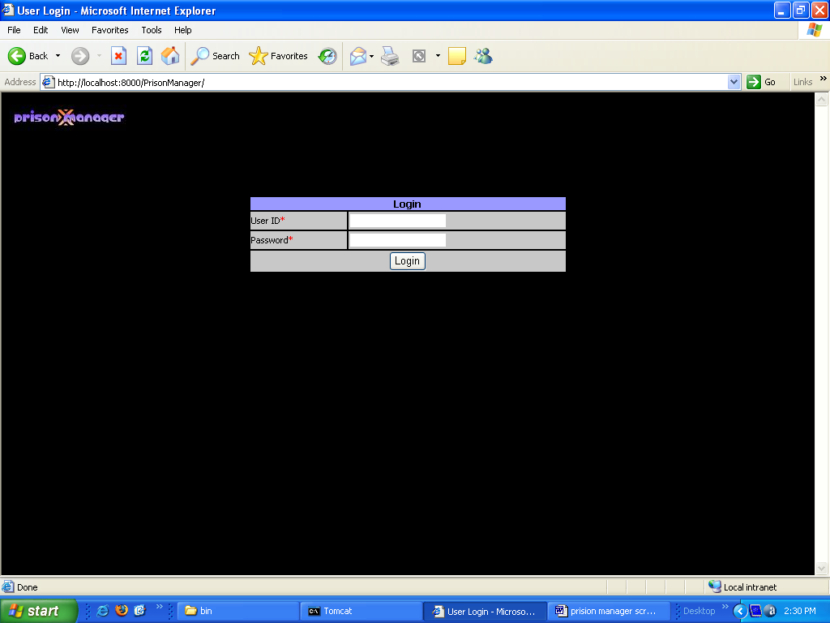

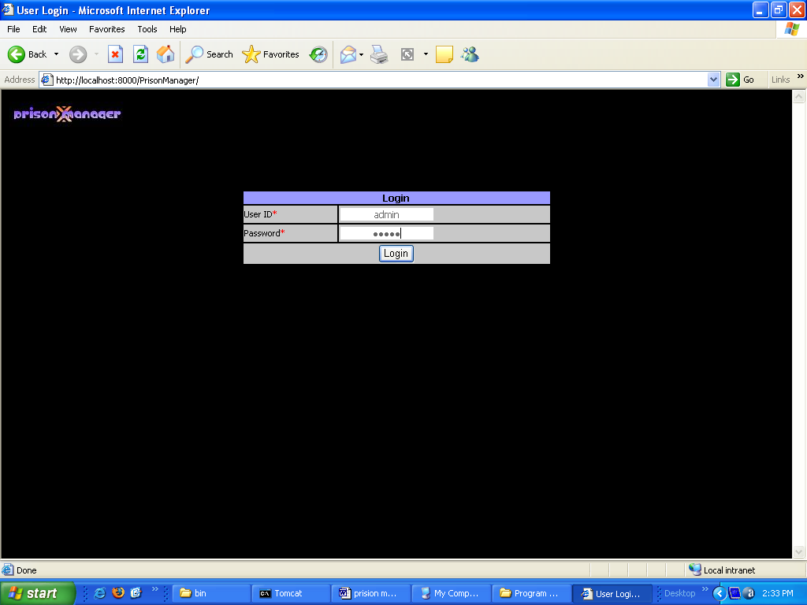

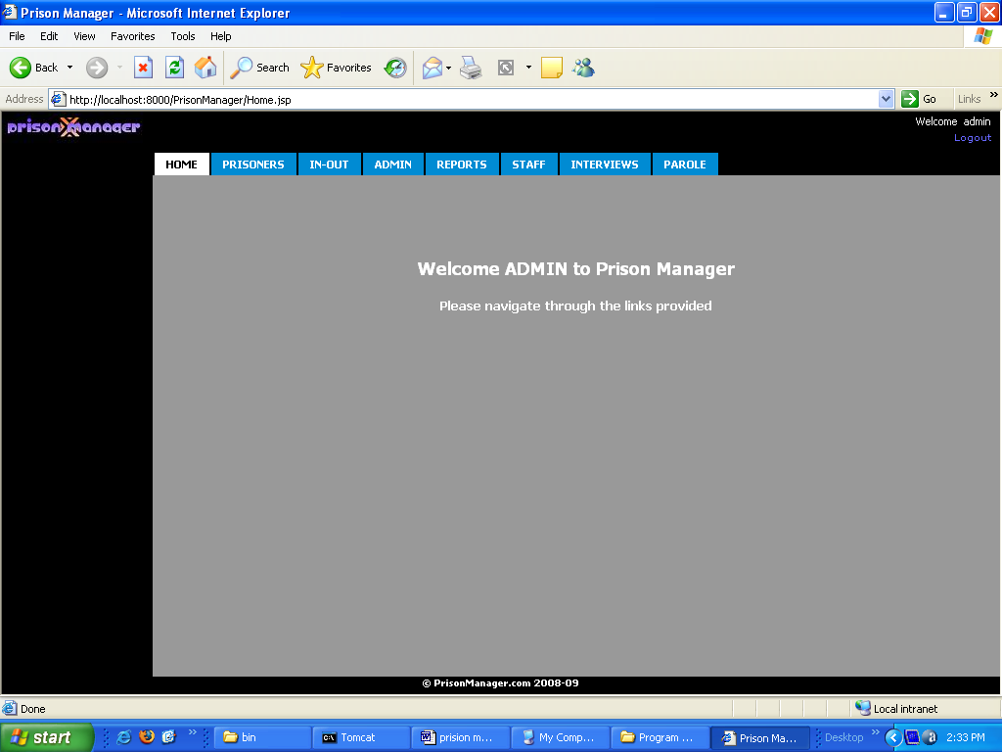

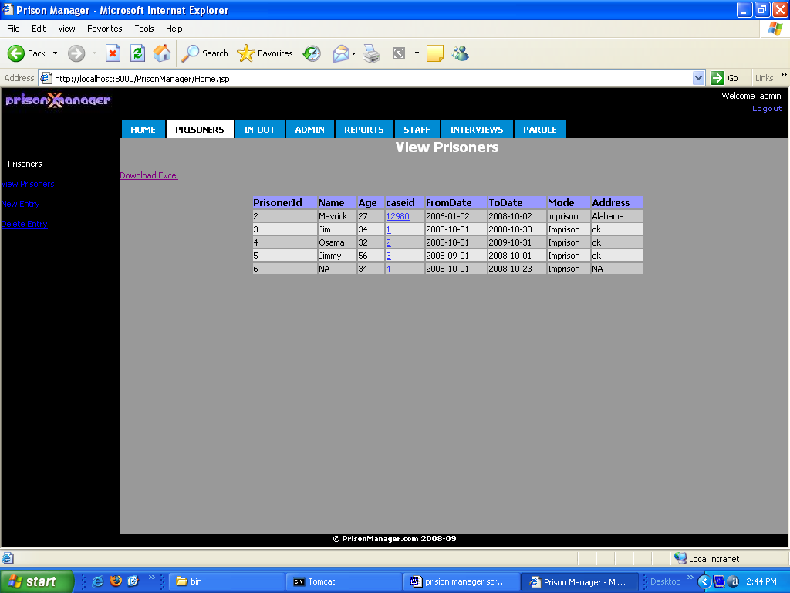

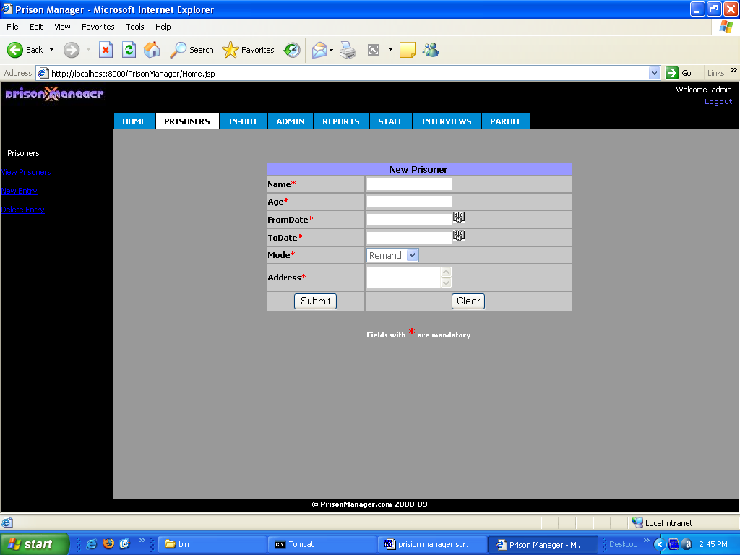

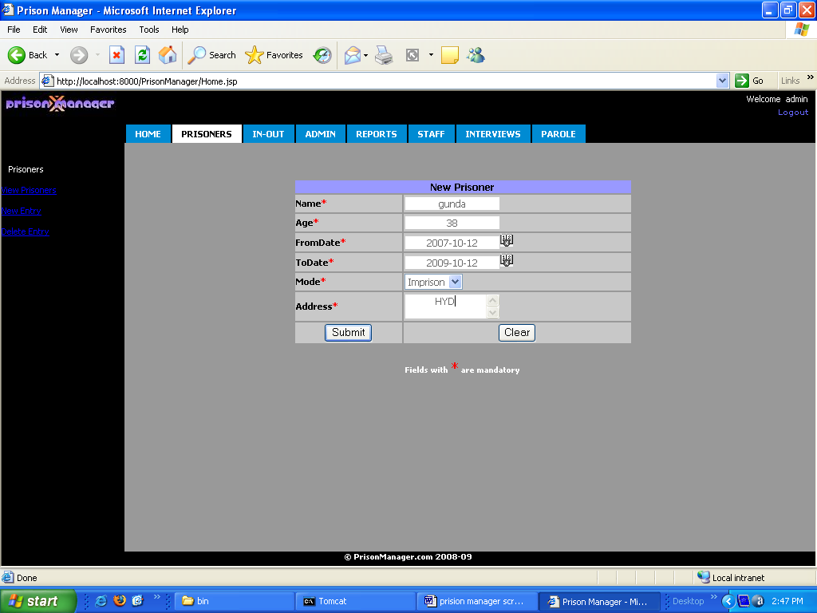

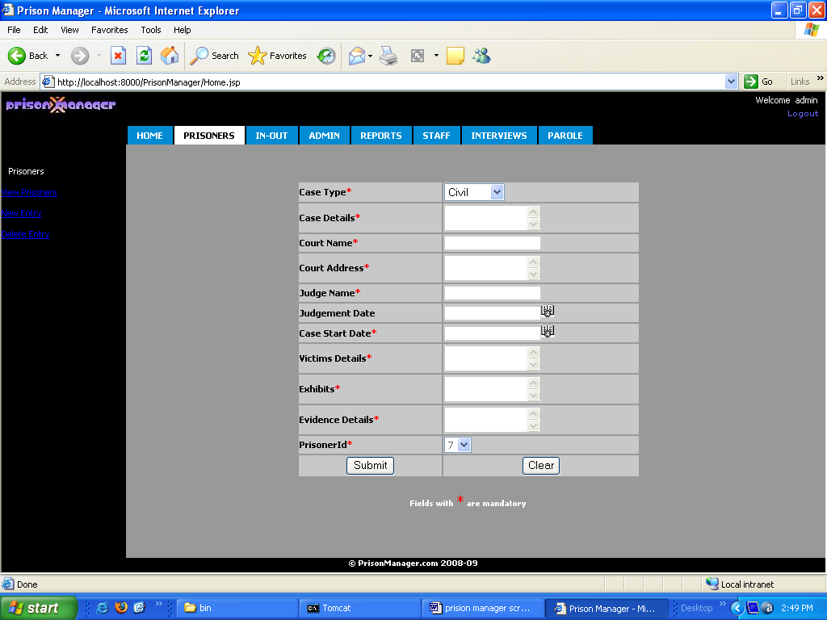

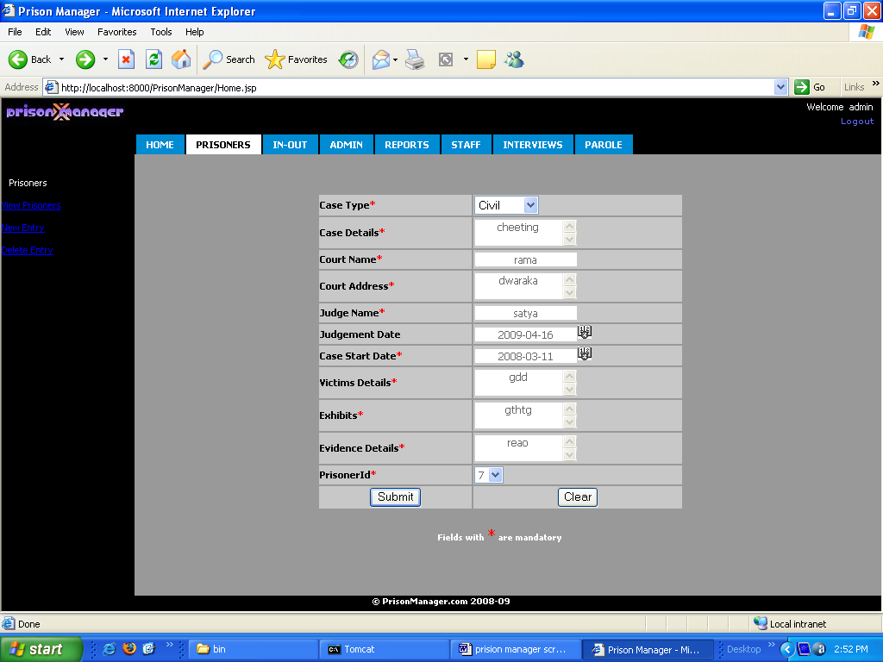

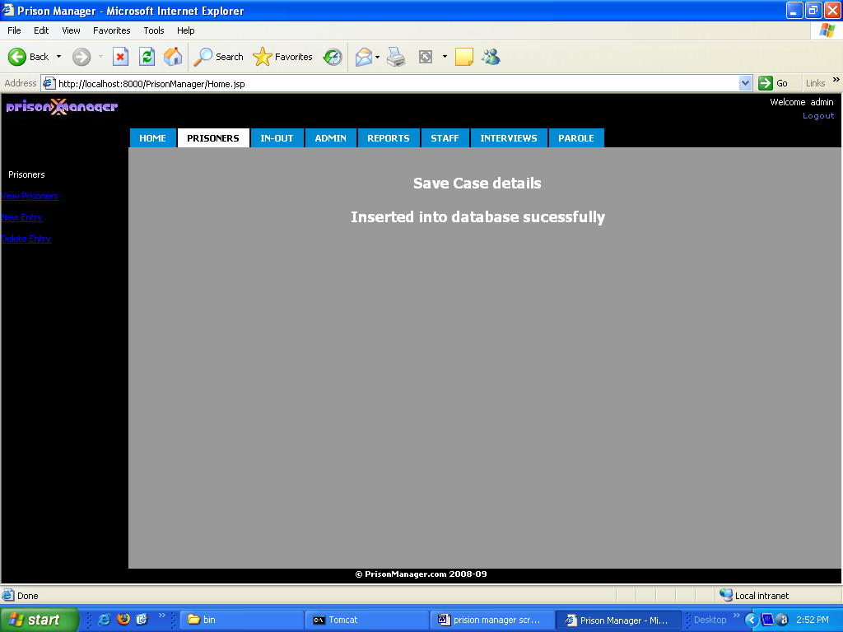

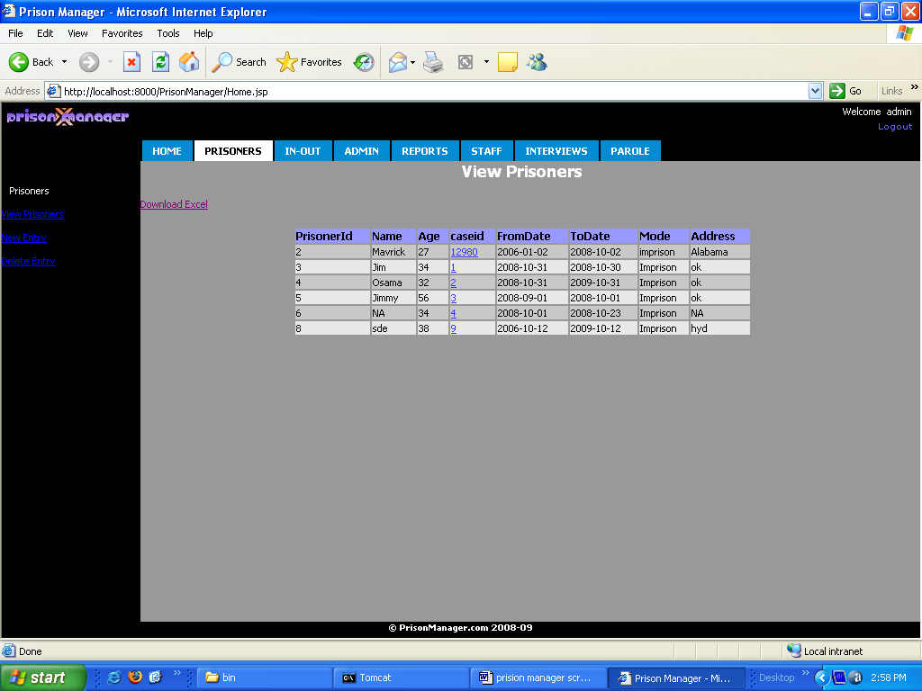

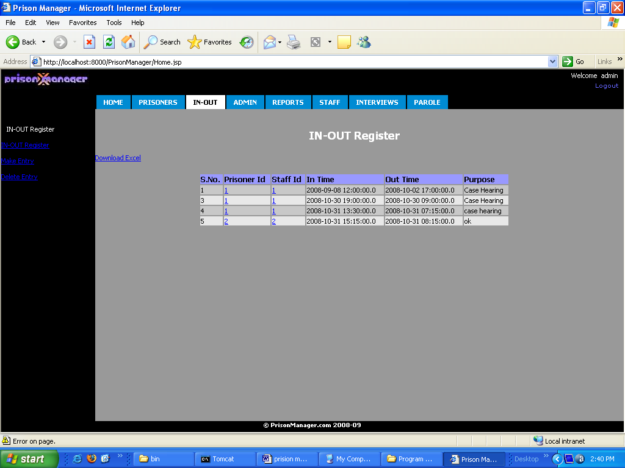

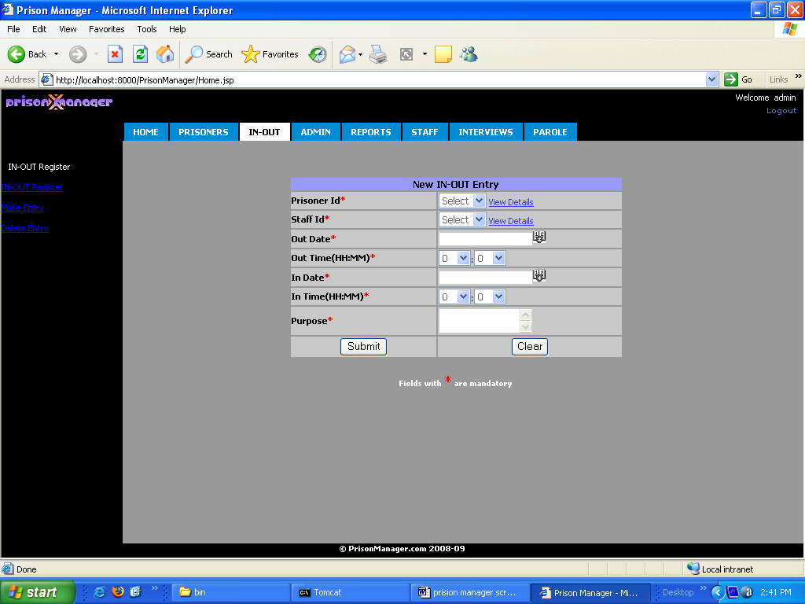

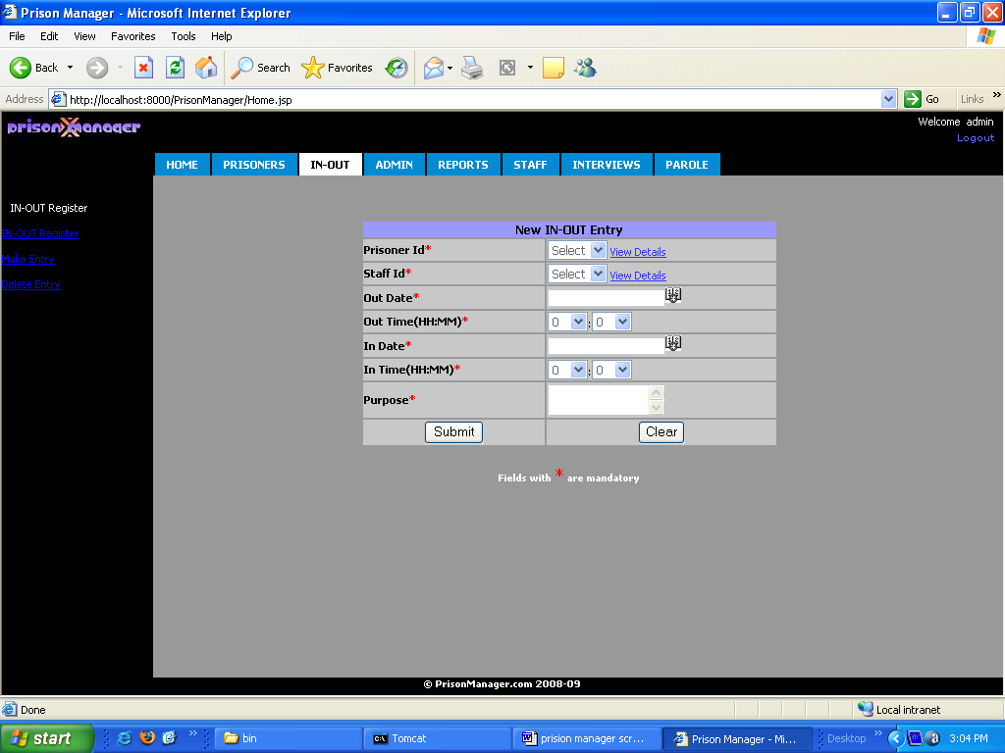

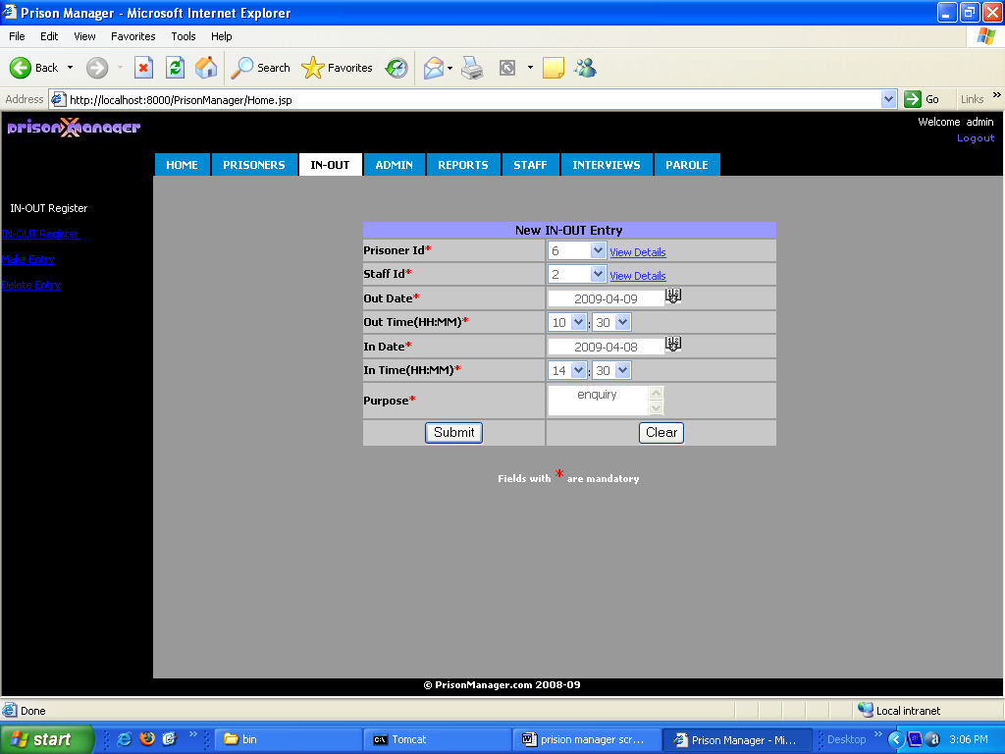

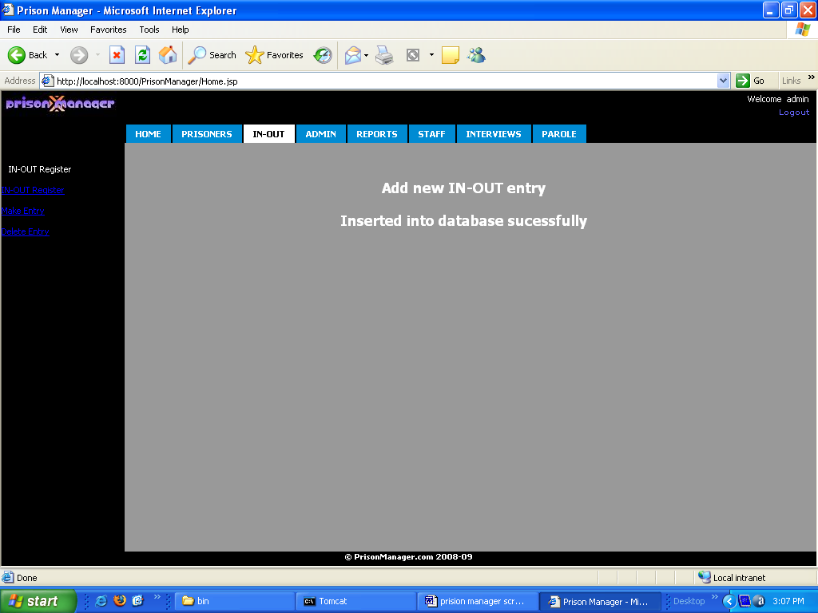

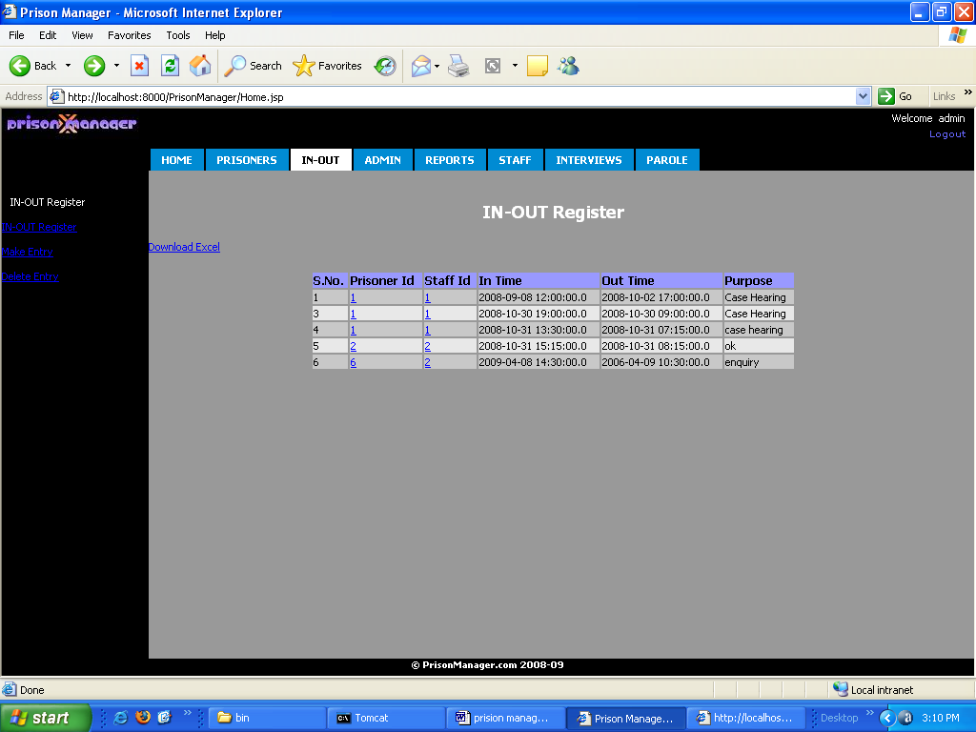

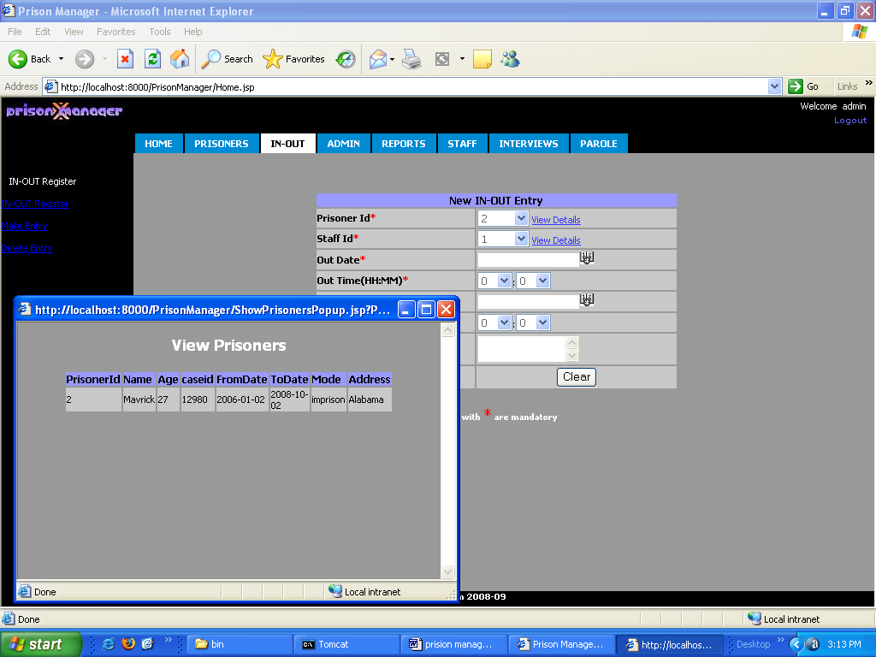

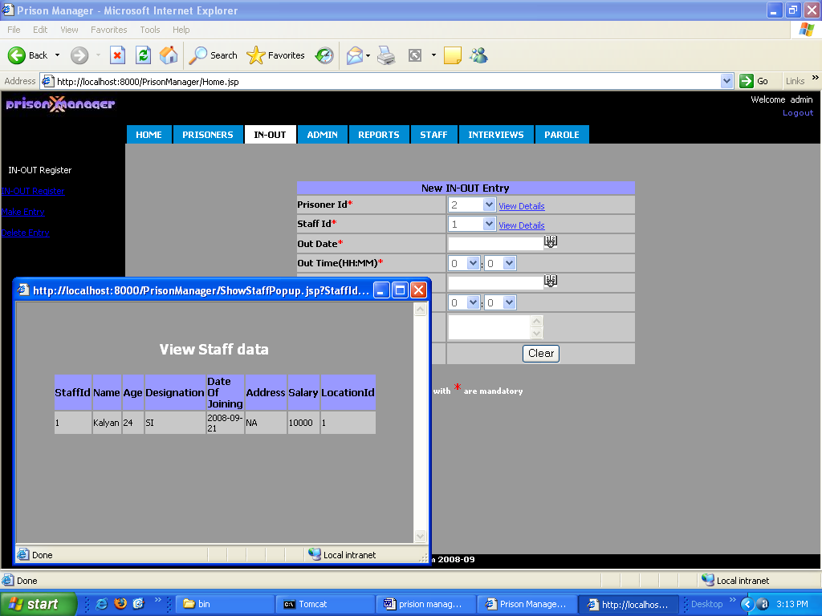

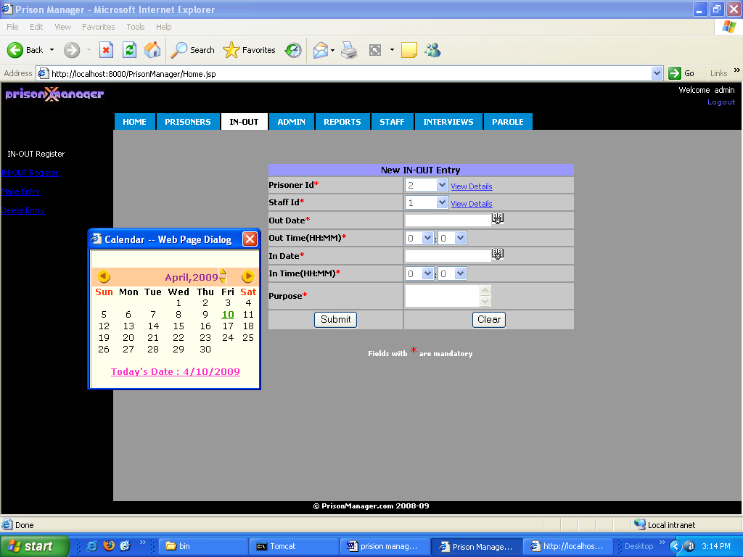

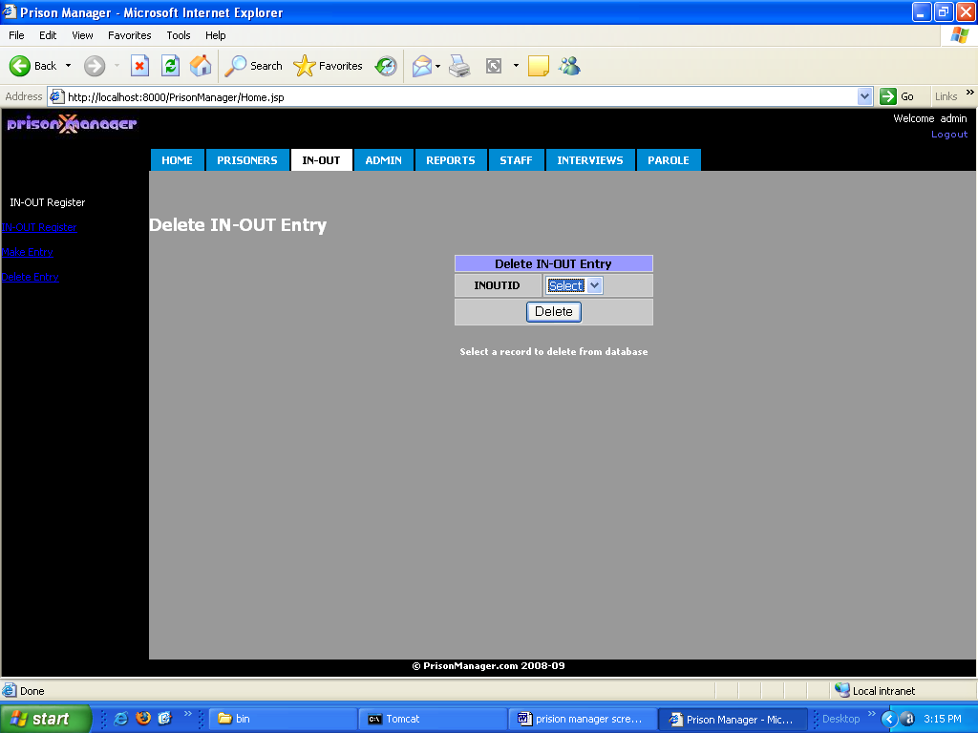

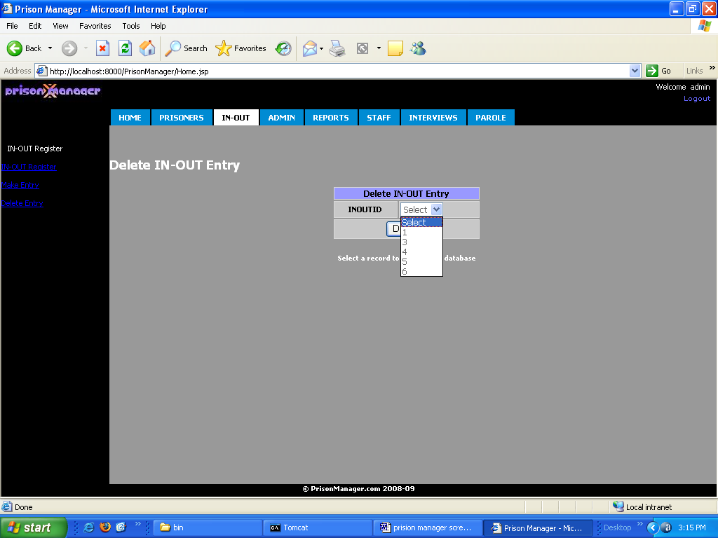

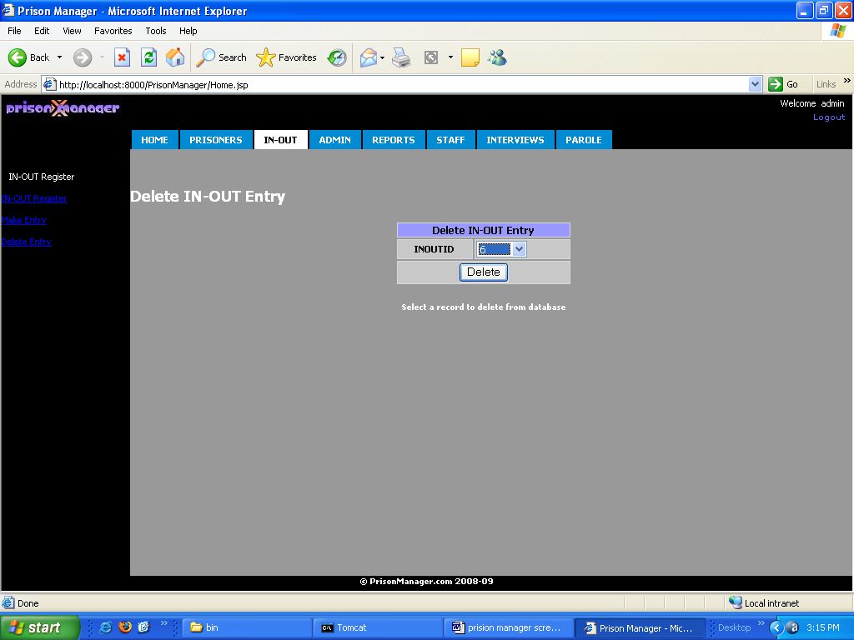

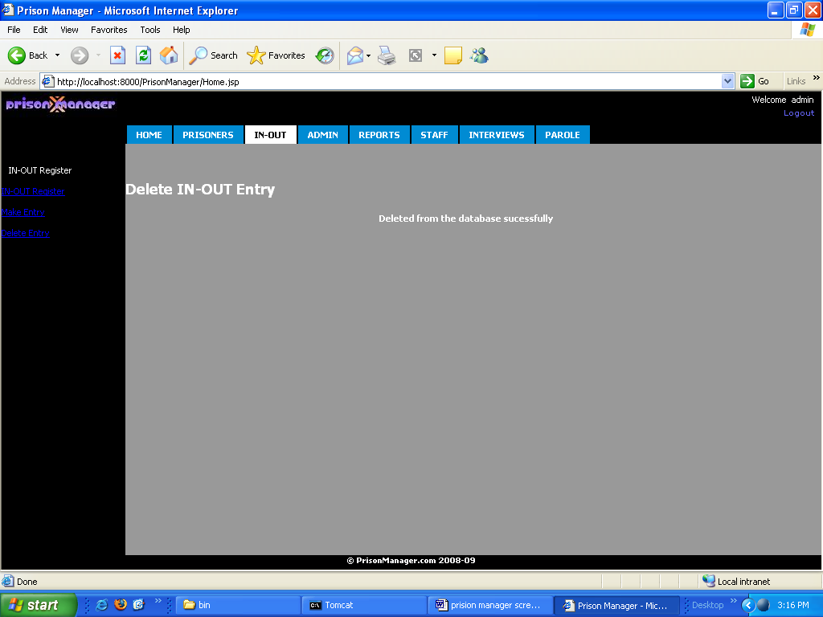

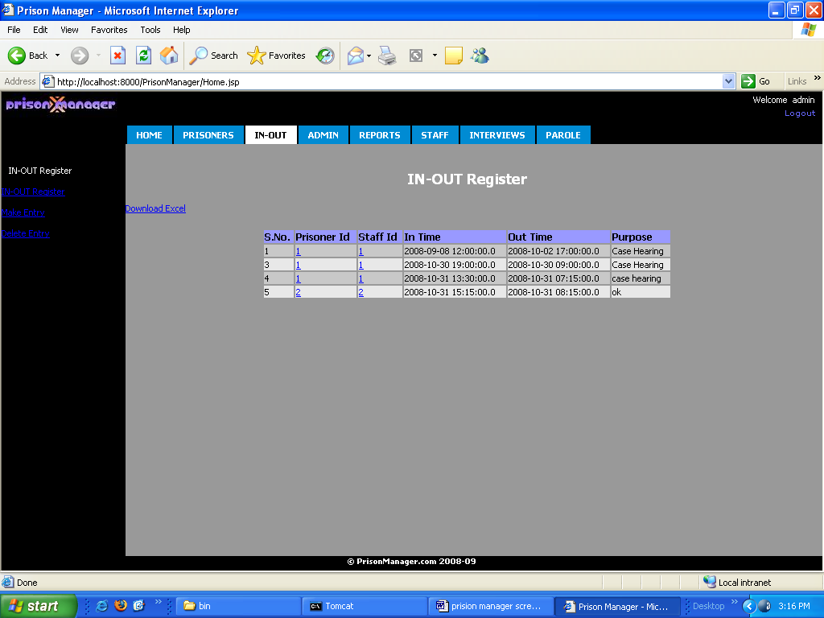

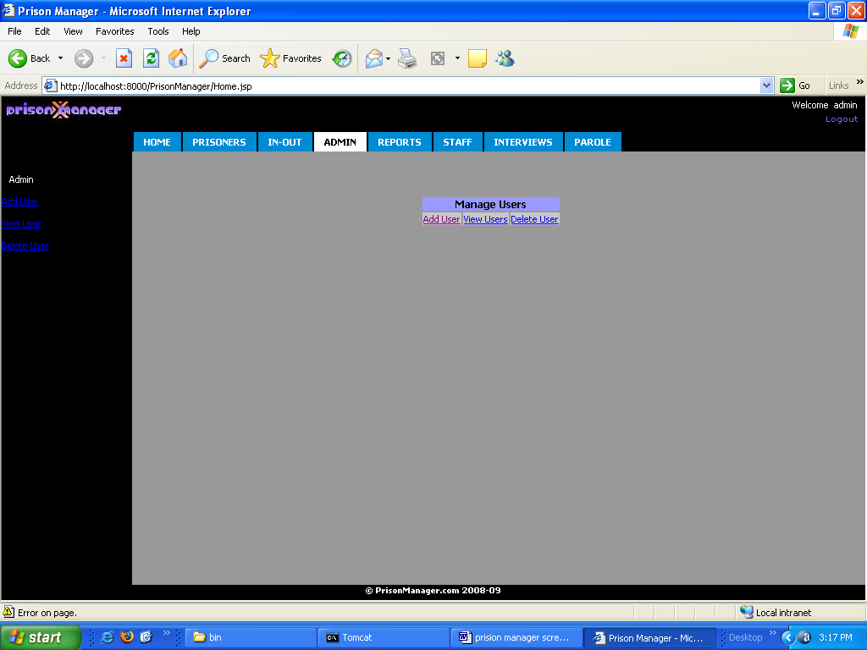

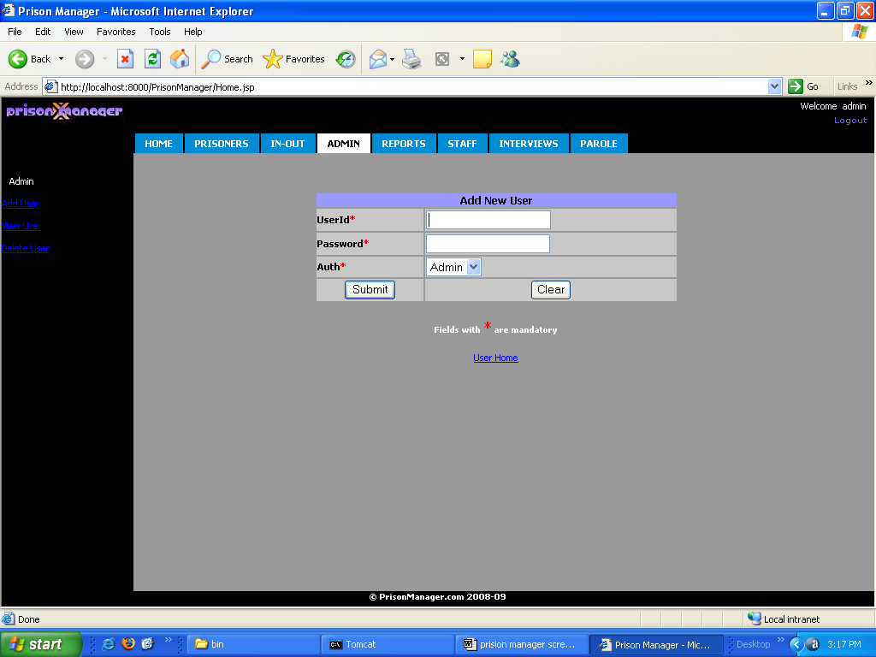

Conclusion

The new system, Prison Management has been implemented. The present system has been integrated with the already existing. The database was put into the My SQL server. This was connected by JDBC. The database is accessible through Intranet on any location. This system has been found to meet the requirements of the users and departments and also very satisfactory.

The database system must provide for the safety of the information stored, despite system crashes or attempts at unauthorized access. If data are to be shared among several users, the system must avoid possible anomalous results.

Bibliography

- Core java volume-II Advanced features 7th edition by Cay S.Horstmann and Gary Cornell (Pearson education).
- Java Servlet Programming by O’relly publishers
- Algorithm and applications in java 3rd edition by Satraj Sahni (Tata McGraw Hill).
- Classical Data Structures by Samantha (Pearson education).
- Java Server Programming 2.0 with complete J2EE concepts included (apress).
- Software Engineering practice and principles 6th edition by Roger Pressmen (Tata McGraw Hill).
- Java How to program 5th edition Deitel and Deitel (Prentice Hall of India).

Websites
- www.javaworld.com
- www.apaache.org
- www.java.sun.com
- www.w3schools.com
- www.itpapers.com

