Project 3: Create a chatbot in Python

**Development Part 1**

In this part you will begin building your project by loading and pre-processing the dataset.

Start building the Chatbot by preparing the environment and implementing basic user interactions. Install required libraries, like transformers for GPT-3 integration and flask for web app development.

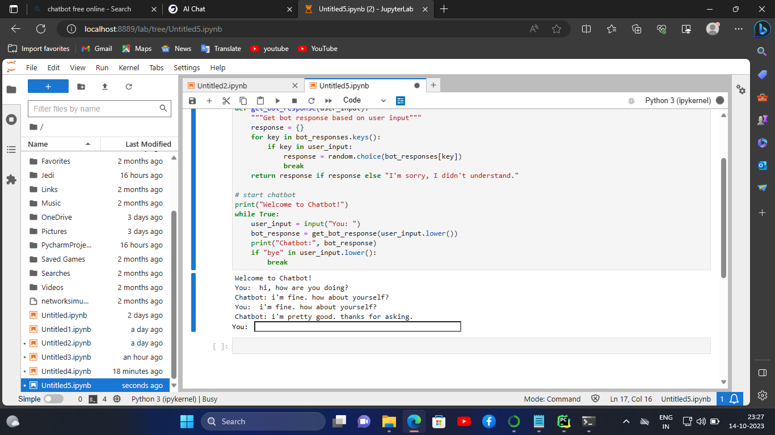

In this program, we imported the dataset.Then, Get data from the dataset.So, the dataset is clear and check the punctuation. Then, The data is preprocessed.