***DATABASE MANAGEMENT SYSTEM LAB***

***TITLE:***

***Restaurant Management Ordering System***

***TEAM MEMBERS:***

20PW13 - JERSHA HEARTLY X

20PW39 – TRISHA M

***TABLE CREATION:***

CREATE DATABASE rmos;

USE rmos;

CREATE TABLE USER

(

UserId INT NOT NULL,

Fname VARCHAR(50) NOT NULL,

Lname VARCHAR(50) NOT NULL,

PRIMARY KEY (UserId)

);

CREATE TABLE USER_LOGIN

(

UserId INT NOT NULL,

UserName VARCHAR(50) NOT NULL,

Pwd VARCHAR(50) NOT NULL,

PRIMARY KEY(UserId),

FOREIGN KEY (UserId) REFERENCES USER(UserId) ON UPDATE CASCADE

);

CREATE TABLE RESTAURANT

(

Name VARCHAR(100) NOT NULL,

Loc VARCHAR(100) NOT NULL,

Contact VARCHAR(100) NOT NULL,

OCTime VARCHAR(100) NOT NULL,

Details VARCHAR(500) DEFAULT NULL,

PRIMARY KEY (Name)

);

DROP TABLE RESTAURANT;

CREATE TABLE OWNER

(

Fname VARCHAR(15) NOT NULL,

Lname VARCHAR(15) NOT NULL,

Contact CHAR(100) NOT NULL,

RestName VARCHAR(100) NOT NULL,

PRIMARY KEY (Fname, Lname, Contact),

FOREIGN KEY (RestName) REFERENCES RESTAURANT(Name) ON UPDATE CASCADE

);

DROP TABLE BILL;

CREATE TABLE BILL

(

OrderId INT NOT NULL,

CustomerFname VARCHAR (20) NOT NULL,

CustomerLname VARCHAR (20) NOT NULL,

Customerid VARCHAR(9) NOT NULL,

TotalAmount DECIMAL(9, 2) NOT NULL,

Type VARCHAR(10) NOT NULL,

PRIMARY KEY (OrderId)

);

DROP TABLE MENU_BILL;

CREATE TABLE MENU_BILL

(

OrderId INT NOT NULL,

Type VARCHAR(25) NOT NULL,

Name VARCHAR(100) NOT NULL,

Quantity INT NOT NULL,

UnitPrice INT NOT NULL,

Price INT NOT NULL,

FOREIGN KEY(OrderId) REFERENCES BILL(OrderId)

);

DROP TABLE CUSTOMER;

CREATE TABLE CUSTOMER

(

OrderId INT NOT NULL,

Fname VARCHAR(15) NOT NULL,

Lname VARCHAR(15) NOT NULL,

CustomerId CHAR(9) NOT NULL,

Contact CHAR(20) DEFAULT NULL,

EmailId VARCHAR(50) DEFAULT NULL,

RestName VARCHAR(100) NOT NULL,

PRIMARY KEY (CustomerId),

FOREIGN KEY (OrderId) REFERENCES BILL(OrderId),

FOREIGN KEY (RestName) REFERENCES RESTAURANT(Name)

);

DROP TABLE WAITER;

CREATE TABLE WAITER

(

WaiterId INT NOT NULL,

Name VARCHAR(15) NOT NULL,

RestName VARCHAR(15) NOT NULL,

Contact VARCHAR(20) NOT NULL,

Address VARCHAR(30) DEFAULT NULL,

Salary VARCHAR(30) DEFAULT NULL,

Sex CHAR(1) DEFAULT NULL,

JoinDate DATE NOT NULL,

PRIMARY KEY (WaiterId),

FOREIGN KEY(ResTName) REFERENCES RESTAURANT(Name) ON UPDATE CASCADE

);

DROP TABLE CASHIER;

CREATE TABLE CASHIER

(

CashierId INT NOT NULL,

Name VARCHAR(15) NOT NULL,

RestName VARCHAR(15) NOT NULL,

City VARCHAR(30) DEFAULT NULL,

Salary VARCHAR(30) DEFAULT NULL,

Sex CHAR(1) DEFAULT NULL,

JoinDate DATE NOT NULL,

PRIMARY KEY (CashierId),

FOREIGN KEY(ResTName) REFERENCES RESTAURANT(Name) ON UPDATE CASCADE

);

DROP TABLE CHEF;

CREATE TABLE CHEF

(

Name VARCHAR(15) NOT NULL,

RestName VARCHAR(15) NOT NULL,

Contact VARCHAR(20) NOT NULL,

ChefId INT NOT NULL,

Salary VARCHAR(30) DEFAULT NULL,

Sex CHAR(1) DEFAULT NULL,

Specialization VARCHAR(50) DEFAULT NULL,

JoinDate DATE NOT NULL,

PRIMARY KEY (ChefId),

FOREIGN KEY(RestName) REFERENCES RESTAURANT(Name) ON UPDATE CASCADE

);

DROP TABLE HOME_DELIVERY;

CREATE TABLE HOME_DELIVERY

(

DeliveryId VARCHAR(9) NOT NULL,

Address VARCHAR(50) NOT NULL,

DateTime DATETIME NOT NULL,

Contact VARCHAR(20) NOT NULL,

CustId CHAR(9) NOT NULL,

OrderId INT NOT NULL,

PRIMARY KEY(DeliveryId),

FOREIGN KEY (CustId) REFERENCES CUSTOMER(CustomerId),

FOREIGN KEY (OrderId) REFERENCES BILL(OrderId)

);

DROP TABLE DELIVERY_BOY_DETAILS;

CREATE TABLE DELIVERY_BOY_DETAILS

(

Fname VARCHAR(15) NOT NULL,

Lname VARCHAR(15) NOT NULL,

Contact VARCHAR(20) NOT NULL,

DeliveryBoyId INT NOT NULL,

Address VARCHAR(30) DEFAULT NULL,

Salary VARCHAR(30) DEFAULT NULL,

Sex CHAR(1) DEFAULT NULL,

Bdate DATE DEFAULT NULL,

JoinDate DATE NOT NULL,

PRIMARY KEY (DeliveryBoyId)

);

DROP TABLE DELIVERY_BOY;

CREATE TABLE DELIVERY_BOY

(

BoyId INT NOT NULL,

DeliveryId VARCHAR(50) NOT NULL,

PRIMARY KEY(BoyId, DeliveryId),

FOREIGN KEY (BoyId) REFERENCES DELIVERY_BOY_DETAILS(DeliveryBoyId),

FOREIGN KEY (DeliveryId) REFERENCES HOME_DELIVERY(DeliveryId)

);

DROP TABLE MENU;

CREATE TABLE MENU

(

MenuId INT NOT NULL,

Name VARCHAR(100) NOT NULL,

Price INT NOT NULL,

Type VARCHAR(20) DEFAULT NULL,

Category VARCHAR(30) NOT NULL,

PRIMARY KEY(MenuId)

);

DROP TABLE TABLES;

CREATE TABLE TABLES

(

TableNum VARCHAR(9) NOT NULL,

Details VARCHAR(200) DEFAULT NULL,

PRIMARY KEY (TableNum)

);

DROP TABLE BOOKING;

CREATE TABLE BOOKING

(

BookingId INT NOT NULL AUTO_INCREMENT,

TableNum VARCHAR(9) NOT NULL,

DateTime VARCHAR(30) NOT NULL,

CustId CHAR(9) NOT NULL,

PRIMARY KEY (BookingId),

FOREIGN KEY (CustId) REFERENCES CUSTOMER(CustomerId),

FOREIGN KEY (TableNum) REFERENCES TABLES(TableNum)

)AUTO_INCREMENT = 1000;

***INSERTION:***

INSERT INTO USER VALUES(101,"John","Watson");

INSERT INTO USER VALUES(102,"Sherlock","Holmes");

INSERT INTO USER VALUES(103,"Joey","Tribbiani");

INSERT INTO USER VALUES(104,"Rachel","Green");

INSERT INTO USER VALUES(105,"Monica","Geller");

INSERT INTO USER VALUES(106,"Ross","Geller");

INSERT INTO USER VALUES(107,"Phoebe","Buffay");

INSERT INTO USER VALUES(108,"Chandler","Bing");

INSERT INTO USER VALUES(109,"Mark","Smith");

INSERT INTO USER VALUES(110,"David","Beckham");

INSERT INTO USER VALUES(111,"Emily","Blunt");

INSERT INTO USER VALUES(112,"Adam","Levine");

INSERT INTO USER VALUES(113,"Joanne","Watson");

INSERT INTO USER VALUES(114,"Irene","Adler");

INSERT INTO USER VALUES(115,"Jessica","Pearson");

INSERT INTO RESTAURANT VALUES("Taco Bell","New York","932-108","8:00 am - 9:00 pm","Continental");

INSERT INTO RESTAURANT VALUES("Crispy Crunch","London","912-108","7:00 am - 10:00 pm","Snacks");

INSERT INTO RESTAURANT VALUES("Italiano Bakes","Rome","234-108","6:00 am - 9:00 pm","Italian");

INSERT INTO RESTAURANT VALUES("Swiss Cream","Bern","932-111","10:00 am - 10:00 pm","Ice creams");

INSERT INTO RESTAURANT VALUES("Bikaneriwaala","Jaipur","123-108","6:00 am - 9:00 pm","North Indian");

INSERT INTO RESTAURANT VALUES("Beijinzi"," Beijing","190-308","8:00 am - 9:00 pm","Chinese");

INSERT INTO RESTAURANT VALUES("Teppan","Tokyo","932-102","6:00 am - 8:00 pm","Japanese");

INSERT INTO RESTAURANT VALUES("KFC","California","915-208","11:00 am - 9:00 pm","Fast Food");

INSERT INTO RESTAURANT VALUES("Shree Mithai","Chennai","111-578","6:00 am - 8:00 pm","Sweets");

INSERT INTO RESTAURANT VALUES("Cream Centre","Boston","682-138","8:00 am - 9:00 pm","Continental");

INSERT INTO OWNER VALUES("Liam","Smith","123-456","Taco Bell");

INSERT INTO OWNER VALUES("Olivia","Coleman","134-426","KFC");

INSERT INTO OWNER VALUES("Sean","Connery","235-456","Cream Centre");

INSERT INTO OWNER VALUES("Eden","Joanne","523-456","Beijinzi");

INSERT INTO OWNER VALUES("Ashley","Britt","567-416","Swiss Cream");

INSERT INTO OWNER VALUES("Rohit","Agarwal","987-254","Shree Mithai");

INSERT INTO OWNER VALUES("Charlotte","Evans","412-405","Crispy Crunch");

INSERT INTO OWNER VALUES("Noah","Wood","120-234","Italiano Bakes");

INSERT INTO OWNER VALUES("Ritika","Anand","111-456","Bikaneriwaala");

INSERT INTO OWNER VALUES("Akemi","Suki","983-456","Teppan");

SELECT * FROM OWNER;

INSERT INTO DELIVERY_BOY_DETAILS VALUES("Jason","Roy","1234-2345",200,"19,NYC","1230 USD",'M',"1988-11-03","2009-03-02");

INSERT INTO DELIVERY_BOY_DETAILS VALUES("Kane","Smith","1114-2345",201,"12,London","1130 USD",'M',"1979-11-03","2003-02-12");

INSERT INTO DELIVERY_BOY_DETAILS VALUES("Steve","Warner","1555-2125",202,"34,Rome","1123 USD",'M',"1984-12-02","2007-07-08");

INSERT INTO DELIVERY_BOY_DETAILS VALUES("Frank","Hayden","2222-2345",203,"33,Bern","890 USD",'M',"1985-11-03","2002-03-02");

INSERT INTO DELIVERY_BOY_DETAILS VALUES("John","Roy","2312-4231",204,"19,California","1600 USD",'M',"1975-09-04","2002-10-09");

INSERT INTO DELIVERY_BOY_DETAILS VALUES("James","Corden","1002-2341",205,"34,Beijing","1222 USD",'M',"1980-11-12","2005-02-01");

INSERT INTO DELIVERY_BOY_DETAILS VALUES("Arjun","Sharma","9087-2345",206,"23,Mumbai","1200 USD",'M',"1983-12-12","2012-02-04");

INSERT INTO DELIVERY_BOY_DETAILS VALUES("Rahul","Subbramanian","1243-2345",207,"71,Chennai","1987 USD",'M',"1988-11-03","2003-03-02");

INSERT INTO DELIVERY_BOY_DETAILS VALUES("Azi","Kento","1234-9871",208,"91,Tokyo","1290 USD",'M',"1990-11-03","2020-03-02");

INSERT INTO DELIVERY_BOY_DETAILS VALUES("Tim","Smith","1983-2345",209,"19, Boston","1830 USD",'M',"1985-11-08","2008-02-27");

SELECT * FROM DELIVERY_BOY;

INSERT INTO MENU VALUES(10,"Noodles",250,"Main Course","Chinese");

INSERT INTO MENU VALUES(11,"Malai Kofta",6,"Main Course","Indian");

INSERT INTO MENU VALUES(12,"Chicken 65",20,"Starters","Indian");

INSERT INTO MENU VALUES(13,"Pizza",23,"Fast food","Italian");

INSERT INTO MENU VALUES(14,"Pasta",50,"Main Course","Italian");

INSERT INTO MENU VALUES(15,"Momos",30,"Fast food","Continental");

INSERT INTO MENU VALUES(16,"Sushi",20,"Main Course","Japanese");

INSERT INTO MENU VALUES(17,"Panneer masala",10,"Main Course","Indian");

INSERT INTO MENU VALUES(18,"Mutton Biriyani",40,"Main Course","Indian");

INSERT INTO MENU VALUES(19,"Sandwich",20,"Fast food","Continental");

INSERT INTO MENU VALUES(20,"Swiss icecream",30,"Desserts","Ice creams");

INSERT INTO MENU VALUES(21,"Kaju Katli",10,"Desserts","Sweets");

INSERT INTO MENU VALUES(22,"Butter Naan",250,"Main Course","Indian");

INSERT INTO MENU VALUES(23,"Yorkshire Pudding",30,"Main Course","Continental");

INSERT INTO MENU VALUES(24,"Sashimi",22,"Main Course","Japanese");

INSERT INTO MENU VALUES(25,"Veg Biriyani",8,"Main Course","Indian");

INSERT INTO MENU VALUES(26,"Butter Chicken",25,"Main Course","Indian");

INSERT INTO MENU VALUES(27,"Spaghetti",23,"Main Course","Italian");

INSERT INTO MENU VALUES(28,"Butter Roti",35,"Main Course","Indian");

INSERT INTO MENU VALUES(29,"Macaroni Magic",28,"Starters","Continental");

INSERT INTO MENU VALUES(30,"Cheese Balls",50,"Starters","Continental");

INSERT INTO MENU VALUES(31,"Panneer Sizzler",38,"Main Course","Indian");

INSERT INTO MENU VALUES(32,"Chocolate Mousse",40,"Desserts","Ice creams");

INSERT INTO MENU VALUES(33,"Cheesecake",35,"Desserts","Cakes");

INSERT INTO MENU VALUES(34,"Miso soup",24,"Starters","Japanese");

INSERT INTO MENU VALUES(35,"Baked Aubergines",25,"Starters","Continental");

INSERT INTO MENU VALUES(36,"Sausage Plait",14,"Starters","Continental");

SELECT * FROM MENU;

INSERT INTO CHEF VALUES("Tamjid","Taco Bell","12-34-56",501,"2300 USD",'M',"Continental","2003-12-12");

INSERT INTO CHEF VALUES("Sanjith","Shree Mithai","22-23-12",502,"1200 USD",'M',"Sweets","2004-09-12");

INSERT INTO CHEF VALUES("Anirudh","Cream Centre","12-33-22",503,"1500 USD",'M',"Continental","2007-12-12");

INSERT INTO CHEF VALUES("Rakshith","Beijinzi","12-19-13",504,"1250 USD",'M',"Chinese","2003-01-12");

INSERT INTO CHEF VALUES("RK","Italiano Bakes","12-88-99",505,"3090 USD",'M',"Italian","2003-12-04");

INSERT INTO CHEF VALUES("Mathi","Swiss Cream","11-23-12",506,"2100 USD",'M',"Ice Creams","2006-05-11");

INSERT INTO CHEF VALUES("Pranav","Teppan","19-89-45",507,"1200 USD",'M',"Japanese","2005-11-12");

INSERT INTO CHEF VALUES("Sam","KFC","12-19-08",508,"1300 USD",'M',"Fast Food","2006-11-12");

INSERT INTO CHEF VALUES("Hema","Crispy Crunch","12-86-56",509,"3300 USD",'F',"Snacks","2007-01-12");

INSERT INTO CHEF VALUES("Maanasa","Bikaneriwaala","12-12-56",510,"2300 USD",'F',"North Indian","2006-11-11");

INSERT INTO CHEF VALUES("Swetha","KFC","13-12-09",511,"1400 USD",'F',"Fast Food","2003-06-12");

INSERT INTO CHEF VALUES("Akshaya","Crispy Crunch","19-99-66",512,"2400 USD",'F',"Snacks","2008-01-12");

INSERT INTO CHEF VALUES("Jersha","Bikaneriwaala","12-44-66",513,"1400 USD",'F',"North Indian","2008-11-11");

SELECT * FROM CHEF;

INSERT INTO WAITER VALUES(701,"Shawn","Taco Bell","123-456","18,London","890 USD",'M',"2009-12-12");

INSERT INTO WAITER VALUES(702,"Gina","Cream Centre","111-666","19,Mumbai","770 USD",'F',"2006-11-11");

INSERT INTO WAITER VALUES(703,"Deepthi","KFC","999-999","20,California","790 USD",'F',"2008-01-01");

INSERT INTO WAITER VALUES(704,"Harini","Crispy Crunch","112-376","7,Rome","120 USD",'F',"2010-12-12");

INSERT INTO WAITER VALUES(705,"Britne","Beijinzi","145-236","12,Bern","890 USD",'F',"2008-12-12");

INSERT INTO WAITER VALUES(706,"Mona","Swiss Cream","100-906","11,Chennai","120 USD",'F',"2007-01-12");

INSERT INTO WAITER VALUES(707,"Shree","Teppan","111-456","45,New York","1200 USD",'F',"2008-05-12");

INSERT INTO WAITER VALUES(708,"Arnav","Italiano Bakes","122-333","20,Tokyo","1230 USD",'M',"2004-01-12");

INSERT INTO WAITER VALUES(709,"Dhivya","Bikaneriwaala","555-333","13,Jaipur","1200 USD",'F',"2007-11-11");

INSERT INTO WAITER VALUES(710,"Karthik","Shree Mithai","112-456","18,London","890 USD",'M',"2009-12-12");

INSERT INTO WAITER VALUES(711,"Dinesh","Taco Bell","113-423","12,London","900 USD",'M',"2008-11-12");

INSERT INTO WAITER VALUES(712,"Kaycee","Cream Centre","133-126","19, New York","670 USD",'F',"2008-12-12");

SELECT * FROM WAITER;

INSERT INTO CUSTOMER VALUES(900,"Jonathan","Cecil","C1","9923-2345","jc@gmail.com", "Taco Bell");

INSERT INTO CUSTOMER VALUES(901,"Tejas","Srinivas","C2","1230-0980","tejas@gmail.com", "Cream Centre");

INSERT INTO CUSTOMER VALUES(902,"Krishna","Shree","C3","1290-9876","krishna@gmail.com", "KFC");

INSERT INTO CUSTOMER VALUES(903,"Rhubanraj","Palani","C4","2390-0987","rhuban@gmail.com", "Swiss Cream");

INSERT INTO CUSTOMER VALUES(904,"Nikhilesh","Shaji","C5","1290-0909","nikhi@gmail.com", "Crispy Crunch");

INSERT INTO CUSTOMER VALUES(905,"Naveen","Kumar","C6","1209-1234","naveen@gmail.com", "Beijinzi");

INSERT INTO CUSTOMER VALUES(906,"Chandru","Sehar","C7","1235-2312","chandru@gmail.com", "Teppan");

INSERT INTO CUSTOMER VALUES(907,"Shriram","Sundar","C8","1209-1278","shriram@gmail.com", "Italiano Bakes");

INSERT INTO CUSTOMER VALUES(908,"Anantha","Raman","C9","1277-1245","anantha@gmail.com", "KFC");

INSERT INTO CUSTOMER VALUES(909,"Navin","Krishna","C10","1288-2390","navink@gmail.com", "Taco Bell");

INSERT INTO CUSTOMER VALUES(910,"Mona","Milan","C11","9089-1234","milan@gmail.com", "Shree Mithai");

INSERT INTO CUSTOMER VALUES(911,"Rahul","Gunaseelan","C12","9876-1245","rahulg@gmail.com", "KFC");

INSERT INTO CUSTOMER VALUES(912,"Sai","Deepika","C13","6785-1234","saideep@gmail.com", "KFC");

INSERT INTO CUSTOMER VALUES(913,"Ishita","Dwivedi","C14","1245-1294","ishita@gmail.com", "Teppan");

INSERT INTO CUSTOMER VALUES(914,"Ananyaa","Sanjeev","C15","1200-3400","ananyaa@gmail.com", "Bikaneriwaala");

INSERT INTO CUSTOMER VALUES(915,"Pragadeesh","Murugan","C16","7890-2105","praga@gmail.com", "Swiss Cream");

INSERT INTO CUSTOMER VALUES(916, "Trisha", "Murali", "C17", "4319-2021", "ts@gmail.com", "Cream Centre");

INSERT INTO CUSTOMER VALUES(917,"Harry","Potter","C18","1209-1270","hp@gmail.com", "Italiano Bakes");

INSERT INTO CUSTOMER VALUES(918,"Sherlock","Holmes","C19","1209-1370","sh@gmail.com", "Italiano Bakes");

INSERT INTO CUSTOMER VALUES(919,"Joey","Tribbiani","C20","1277-3450","jt@gmail.com","Teppan");

INSERT INTO CUSTOMER VALUES(920,"Chandler","Bing","C21","9999-4444","bing@gmail.com","Cream Centre");

INSERT INTO CUSTOMER VALUES(921,"Ross","Geller","C22","1200-3400","rg@gmail.com","Beijinzi");

INSERT INTO CUSTOMER VALUES(922,"Monica","Geller","C23","1000-5000","mon@gmail.com","KFC");

INSERT INTO CUSTOMER VALUES(923,"Rachel","Green","C24","2300-4500","rach@gmail.com","Taco Bell");

INSERT INTO CUSTOMER VALUES(924,"Phoebe","Buffay","C25","2000-9987","pheebs@gmail.com","Italiano Bakes");

INSERT INTO CUSTOMER VALUES(925,"Karthik","Manian","C26","1220-5660","mani@gmai.com","Swiss Cream");

INSERT INTO CUSTOMER VALUES(926,"Tommy","Shelby","C27","1520-0929","tom@gmail.com","Shree Mithai");

SELECT * FROM CUSTOMER;

INSERT INTO BILL VALUES(900,"Jonathan","Cecil","C1",173,"Online");

INSERT INTO BILL VALUES(901,"Tejas","Srinivas","C2",224,"Dine-in");

INSERT INTO BILL VALUES(902,"Krishna","Shree","C3",220,"Online");

INSERT INTO BILL VALUES(903,"Rhubanraj","Palani","C4",350,"Dine-in");

INSERT INTO BILL VALUES(904,"Nikhilesh","Shaji","C5", 66,"Dine-in");

INSERT INTO BILL VALUES(905,"Naveen","Kumar","C6",700,"Online");

INSERT INTO BILL VALUES(906,"Chandru","Sehar","C7",140,"Dine-in");

INSERT INTO BILL VALUES(907,"Shriram","Sundar","C8",340,"Dine-in");

INSERT INTO BILL VALUES(908,"Anantha","Raman","C9",376,"Online");

INSERT INTO BILL VALUES(909,"Navin","Krishna","C10",87,"Dine-in");

INSERT INTO BILL VALUES(910,"Mona","Milan","C11",306,"Dine-in");

INSERT INTO BILL VALUES(911,"Rahul","Gunaseelan","C12",374,"Dine-in");

INSERT INTO BILL VALUES(912,"Sai","Deepika","C13",230,"Online");

INSERT INTO BILL VALUES(913,"Ishita","Dwivedi","C14",210,"Dine-in");

INSERT INTO BILL VALUES(914,"Ananyaa","Sanjeev","C15",460,"Dine-in");

INSERT INTO BILL VALUES(915,"Pragadeesh","Murugan","C16",376, "Online");

INSERT INTO BILL VALUES(916,"Trisha","Murali","C17",176, "Online");

INSERT INTO BILL VALUES(917,"Harry","Potter","C18",120,"Dine-in");

INSERT INTO BILL VALUES(918,"Sherlock","Holmes","C19",87,"Dine-in");

INSERT INTO BILL VALUES(919,"Joey","Tribbiani","C20", 257,"Dine-in");

INSERT INTO BILL VALUES(920,"Chandler","Bing","C21", 194,"Online");

INSERT INTO BILL VALUES(921,"Ross","Geller","C22", 807 ,"Online");

INSERT INTO BILL VALUES(922,"Monica","Geller","C23", 194, "Dine-in");

INSERT INTO BILL VALUES(923,"Rachel","Green","C24", 340,"Online");

INSERT INTO BILL VALUES(924,"Phoebe","Buffay","C25", 495,"Dine-in");

INSERT INTO BILL VALUES(925,"Karthik","Manian","C26", 373,"Online");

INSERT INTO BILL VALUES(926,"Tommy","Shelby","C27", 498,"Dine-in");

SELECT * FROM BILL;

INSERT INTO MENU_BILL VALUES(900, "Starters", "Chicken 65", 3, 20, 60);

INSERT INTO MENU_BILL VALUES(900,"Fast Food","Pizza",1,23,23);

INSERT INTO MENU_BILL VALUES(900,"Main Course","Sushi",2,20,40);

INSERT INTO MENU_BILL VALUES(900,"Main Course","Panneer masala",4,10,40);

INSERT INTO MENU_BILL VALUES(900,"Desserts","Kaju Katli",1,10,10);

INSERT INTO MENU_BILL VALUES(900,"Main Course","Malai Kofta",1,6,6);

INSERT INTO MENU_BILL VALUES(901,"Main Course","Sashimi",2,22,44);

INSERT INTO MENU_BILL VALUES(901,"Fast food","Momos",3,30,90);

INSERT INTO MENU_BILL VALUES(901,"Desserts","Swiss icecream",1,30,30);

INSERT INTO MENU_BILL VALUES(901,"Starters","Chicken 65",1,20,20);

INSERT INTO MENU_BILL VALUES(901,"Main Course","Panneer masala",4,10,40);

INSERT INTO MENU_BILL VALUES(902,"Main Course","Italian",2,50,100);

INSERT INTO MENU_BILL VALUES(902,"Main Course","Italian",2,50,100);

INSERT INTO MENU_BILL VALUES(902,"Desserts","Kaju Katli",2,10,20);

INSERT INTO MENU_BILL VALUES(903,"Main Course","Noodles",1,250,250);

INSERT INTO MENU_BILL VALUES(903,"Main Course","Yorkshire Pudding",2,30,60);

INSERT INTO MENU_BILL VALUES(903,"Fast food","Sandwich",2,20,40);

INSERT INTO MENU_BILL VALUES(904,"Main Course","Sushi",1,20,20);

INSERT INTO MENU_BILL VALUES(904,"Fast food","Pizza",2,23,46);

INSERT INTO MENU_BILL VALUES(905,"Main Course","Mutton Biriyani",3,40,120);

INSERT INTO MENU_BILL VALUES(905,"Fast food","Momos",2,30,60);

INSERT INTO MENU_BILL VALUES(905,"Main Course","Butter Naan",2,250,500);

INSERT INTO MENU_BILL VALUES(905,"Main Course","Panneer masala",2,10,20);

INSERT INTO MENU_BILL VALUES(906,"Fast food","Sandwich",2,20,40);

INSERT INTO MENU_BILL VALUES(906,"Main Course","Sushi",2,20,40);

INSERT INTO MENU_BILL VALUES(906,"Desserts","Swiss icecream",2,30,60);

INSERT INTO MENU_BILL VALUES(907,"Main Course","Pasta",2,50,100);

INSERT INTO MENU_BILL VALUES(907,"Starters","Chicken 65",3,20,60);

INSERT INTO MENU_BILL VALUES(907,"Fast food","Momos",4,30,120);

INSERT INTO MENU_BILL VALUES(907,"Desserts","Kaju Katli",6,10,60);

INSERT INTO MENU_BILL VALUES(908,"Main Course","Noodles",1,250,250);

INSERT INTO MENU_BILL VALUES(908,"Main Course","Sashimi",3,22,66);

INSERT INTO MENU_BILL VALUES(908,"Fast food","Sandwich",3,20,60);

INSERT INTO MENU_BILL VALUES(909,"Main Course","Malai Kofta",3,6,18);

INSERT INTO MENU_BILL VALUES(909,"Fast food","Pizza",3,23,69);

INSERT INTO MENU_BILL VALUES(910,"Main Course","Yorkshire Pudding",3,30,90);

INSERT INTO MENU_BILL VALUES(910,"Main COurse","Sashimi",3,22,66);

INSERT INTO MENU_BILL VALUES(910,"Main Course","Mutton Biriyani",3,40,120);

INSERT INTO MENU_BILL VALUES(910,"Desserts","Kaju Katli",3,10,30);

INSERT INTO MENU_BILL VALUES(911,"Main Course","Noodles",1,250,250);

INSERT INTO MENU_BILL VALUES(911,"Main Course","Malai Kofta",3,6,18);

INSERT INTO MENU_BILL VALUES(911,"Starters","Chicken 65",3,20,60);

INSERT INTO MENU_BILL VALUES(911,"Fast food","Pizza",2,23,46);

INSERT INTO MENU_BILL VALUES(912,"Main Course","Pasta",2,50,100);

INSERT INTO MENU_BILL VALUES(912,"Fast food","Momos",3,30,90);

INSERT INTO MENU_BILL VALUES(912,"Main Course","Sushi",2,20,40);

INSERT INTO MENU_BILL VALUES(913,"Main Course","Panneer masala",3,10,30);

INSERT INTO MENU_BILL VALUES(913,"Main Course","Mutton Biriyani",3,40,120);

INSERT INTO MENU_BILL VALUES(913,"Fast food","Sandwich",3,20,60);

INSERT INTO MENU_BILL VALUES(914,"Desserts","Swiss icecream",3,30,90);

INSERT INTO MENU_BILL VALUES(914,"Desserts","Kaju Katli",3,10,30);

INSERT INTO MENU_BILL VALUES(914,"Main Course","Butter Naan",1,250,250);

INSERT INTO MENU_BILL VALUES(914,"Main Course","Yorkshire Pudding",3,30,90);

INSERT INTO MENU_BILL VALUES(915,"Main Course","Sashimi",3,22,66);

INSERT INTO MENU_BILL VALUES(915,"Main Course","Noodles",1,250,250);

INSERT INTO MENU_BILL VALUES(915,"Starters","Chicken 65",3,20,60);

INSERT INTO MENU_BILL VALUES(916,"Fast Food","Pizza",2,23,46);

INSERT INTO MENU_BILL VALUES(916,"Main Course","Sushi",4,20,80);

INSERT INTO MENU_BILL VALUES(916,"Main Course","Panneer masala",5,10,50);

INSERT INTO MENU_BILL VALUES(917,"Main Course","Panneer masala",2,10,20);

INSERT INTO MENU_BILL VALUES(917,"Starters","Chicken 65",2,20,40);

INSERT INTO MENU_BILL VALUES(917,"Desserts","Swiss icecream",2,30,60);

INSERT INTO MENU_bill VALUES(918,"Fast food","Pizza",1,23,23);

INSERT INTO MENU_BILL VALUES(918,"Desserts","Kaju Katli",2,10,20);

INSERT INTO MENU_BILL VALUES(918,"Main Course","Sashimi",2,22,44);

INSERT INTO MENU_BILL VALUES(919,"Main Course","Spaghetti",2,23,46);

INSERT INTO MENU_BILL VALUES(919,"Starters","Macaroni Magic",2,28,56);

INSERT INTO MENU_BILL VALUES(919,"Desserts","Cheesecake",1,35,35);

INSERT INTO MENU_BILL VALUES(919,"Main Course","Butter Roti",2,35,70);

INSERT INTO MENU_BILL VALUES(919,"Main Course","Butter Chicken",2,25,50);

INSERT INTO MENU_BILL VALUES(920,"Fast food","Pizza",2,23,46);

INSERT INTO MENU_BILL VALUES(920,"Main Course","Malai Kofta",2,6,12);

INSERT INTO MENU_BILL VALUES(920,"Desserts","Chocolate Mousse",2,40,80);

INSERT INTO MENU_BILL VALUES(920,"Starters","Macaroni Magic",2,28,56);

INSERT INTO MENU_BILL VALUES(921,"Main Course","Pasta",2,50,100);

INSERT INTO MENU_BILL VALUES(921,"Fast food","Momos",4,30,120);

INSERT INTO MENU_BILL VALUES(921,"Starters","Baked Aubergines",3,25,75);

INSERT INTO MENU_BILL VALUES(921,"Main Course","Butter Naan",2,250,500);

INSERT INTO MENU_BILL VALUES(921,"Main Course","Malai Kofta",2,6,12);

INSERT INTO MENU_BILL VALUES(922,"Desserts","Cheesecake",3,35,70);

INSERT INTO MENU_BILL VALUES(922,"Main Course","Panneer Sizzler",2,38,76);

INSERT INTO MENU_BILL VALUES(922,"Starters","Miso Soup",2,24,48);

INSERT INTO MENU_BILL VALUES(923,"Starters","Sausage Plait",4,14,56);

INSERT INTO MENU_BILL VALUES(923,"Desserts","Chocolate Mousse",4,40,160);

INSERT INTO MENU_BILL VALUES(923,"Main Course","Veg Biriyani",4,8,32);

INSERT INTO MENU_BILL VALUES(923,"Fast food","Pizza",4,23,92);

INSERT INTO MENU_BILL VALUES(924,"Main Course","Mutton Biriyani",3,40,120);

INSERT INTO MENU_BILL VALUES(924,"Main Course","Sushi",4,20,80);

INSERT INTO MENU_BILL VALUES(924,"Fast food","Pizza",5,23,115);

INSERT INTO MENU_BILL VALUES(924,"Desserts","Swiss icecream",6,30,180);

INSERT INTO MENU_BILL VALUES(925,"Fast food","Pizza",5,23,115);

INSERT INTO MENU_BILL VALUES(925,"Main Course","Sushi",6,20,120);

INSERT INTO MENU_BILL VALUES(925,"Main Course","Sashimi",4,22,88);

INSERT INTO MENU_BILL VALUES(925,"Desserts","Kaju Katli",5,10,50);

INSERT INTO MENU_BILL VALUES(926,"Fast food","Sandwich",5,20,100);

INSERT INTO MENU_BILL VALUES(926,"Main Course","Yorkshire Pudding",5,30,150);

INSERT INTO MENU_BILL VALUES(926,"Starters","Cheese Balls",4,50,200);

INSERT INTO MENU_BILL VALUES(926,"Main Course","Veg Biriyani",6,8,48);

INSERT INTO TABLES VALUES("T1", "4 Seats");

INSERT INTO TABLES VALUES("T2", "6 Seats");

INSERT INTO TABLES VALUES("T3", "3 Seats");

INSERT INTO TABLES VALUES("T4", "3 Seats");

INSERT INTO TABLES VALUES("T5", "2 Seats");

INSERT INTO TABLES VALUES("T6", "8 Seats");

INSERT INTO TABLES VALUES("T7", "4 Seats");

INSERT INTO TABLES VALUES("T8", "4 Seats");

INSERT INTO TABLES VALUES("T9", "6 Seats");

INSERT INTO TABLES VALUES("T10", "6 Seats");

INSERT INTO TABLES VALUES("T11", "2 Seats");

INSERT INTO TABLES VALUES("T12", "4 Seats");

INSERT INTO TABLES VALUES("T13", "4 Seats");

INSERT INTO TABLES VALUES("T14", "8 Seats");

INSERT INTO TABLES VALUES("T15", "6 Seats");

SELECT * FROM TABLES;

INSERT INTO BOOKING VALUES(NULL, "T1", "27/DEC/21-12AM", "C1");

INSERT INTO BOOKING VALUES(NULL, "T6", "27/DEC/21-12AM", "C1");

INSERT INTO BOOKING VALUES(NULL, "T3", "27/DEC/21-12AM", "C1");

INSERT INTO BOOKING VALUES(NULL, "T4", "09/OCT/21-2PM", "C3");

INSERT INTO BOOKING VALUES(NULL, "T9", "09/OCT/21-2PM", "C3");

INSERT INTO BOOKING VALUES(NULL, "T2", "11/AUG/21-12AM", "C2");

INSERT INTO BOOKING VALUES(NULL, "T3", "28/OCT/21-6AM", "C12");

INSERT INTO BOOKING VALUES(NULL, "T1", "28/OCT/21-6AM", "C12");

INSERT INTO BOOKING VALUES(NULL, "T2", "28/OCT/21-6AM", "C12");

INSERT INTO BOOKING VALUES(NULL, "T5", "28/OCT/21-6AM", "C12");

INSERT INTO BOOKING VALUES(NULL, "T7", "31/JAN/21-6PM", "C4");

INSERT INTO BOOKING VALUES(NULL, "T9", "20/NOV/21-12AM", "C5");

INSERT INTO BOOKING VALUES(NULL, "T5", "07/APR/21-8AM", "C7");

INSERT INTO BOOKING VALUES(NULL, "T10", "07/APR/21-8AM", "C7");

INSERT INTO BOOKING VALUES(NULL, "T6", "07/APR/21-8AM", "C7");

INSERT INTO BOOKING VALUES(NULL, "T7", "07/APR/21-8AM", "C7");

INSERT INTO BOOKING VALUES(NULL, "T4", "11/JUL/21-9PM", "C8");

INSERT INTO BOOKING VALUES(NULL, "T2", "27/DEC/21-9AM", "C15");

INSERT INTO BOOKING VALUES(NULL, "T7", "02/JUN/21-3PM", "C18");

INSERT INTO BOOKING VALUES(NULL, "T5", "22/SEP/21-7PM", "C19");

INSERT INTO BOOKING VALUES(NULL, "T15", "20/AUG/21-3AM", "C20");

INSERT INTO BOOKING VALUES(NULL, "T11", "21/JUN/21-2AM", "C23");

INSERT INTO BOOKING VALUES(NULL, "T12", "21/JUN/21-2AM", "C23");

INSERT INTO BOOKING VALUES(NULL, "T10", "21/JUN/21-2AM", "C23");

INSERT INTO BOOKING VALUES(NULL, "T14", "17/OCT/21-7AM", "C25");

INSERT INTO BOOKING VALUES(NULL, "T13", "05/MAR/21-10AM", "C27");

INSERT INTO HOME_DELIVERY VALUES("D101", "London","2021-12-27 12:30:45","9923-2345","C1",900);

INSERT INTO HOME_DELIVERY VALUES("D102", "Paris","2021-03-23 19:41:00",'1290-9876',"C3",902);

INSERT INTO HOME_DELIVERY VALUES("D103", "New York","2021-01-27 04:36:05",'1209-1234',"C6",905);

INSERT INTO HOME_DELIVERY VALUES("D104", "Tokyo","2021-07-17 00:00:00",'1277-1245',"C9",908);

INSERT INTO HOME_DELIVERY VALUES("D105", "London","2021-02-05 23:20:55",'6785-1234',"C13",912);

INSERT INTO HOME_DELIVERY VALUES("D106", "Paris","2021-11-06 08:22:31",'7890-2105',"C16",915);

INSERT INTO HOME_DELIVERY VALUES("D107", "Paris", "2021-10-09 11:32:09","4319-2021","C17",916);

INSERT INTO HOME_DELIVERY VALUES("D108","Beijing","2021-10-11 11:21:10" ,"9230-0000","C21",920);

INSERT INTO HOME_DELIVERY VALUES("D109","Mumbai","2021-12-12 03:24:24","9876-2345","C22",921);

INSERT INTO HOME_DELIVERY VALUES("D110","Chennai","2021-04-09 09:30:23","3490-1209","C24",923);

INSERT INTO HOME_DELIVERY VALUES("D111","Bangalore","2021-06-06 08:25:12","1255-3400","C26",925);

UPDATE HOME_DELIVERY SET DateTime = "2021-12-09 11:32:09" WHERE DeliveryId = "D107";

SELECT * FROM HOME_DELIVERY;

INSERT INTO DELIVERY_BOY VALUES(200,"D101");

INSERT INTO DELIVERY_BOY VALUES(209,"D102");

INSERT INTO DELIVERY_BOY VALUES(205,"D103");

INSERT INTO DELIVERY_BOY VALUES(203,"D104");

INSERT INTO DELIVERY_BOY VALUES(202,"D105");

INSERT INTO DELIVERY_BOY VALUES(207,"D106");

INSERT INTO DELIVERY_BOY VALUES(208,"D107");

INSERT INTO DELIVERY_BOY VALUES(209,"D108");

INSERT INTO DELIVERY_BOY VALUES(201,"D109");

INSERT INTO DELIVERY_BOY VALUES(202,"D110");

INSERT INTO DELIVERY_BOY VALUES(202,"D111");

SELECT * FROM DELIVERY_BOY;

INSERT INTO CASHIER VALUES(80,"Steve","Taco Bell","London","2500 USD",'M',"2007-12-09");

INSERT INTO CASHIER VALUES(81,"Reve","Cream Centre","New York","2300 USD",'M',"2008-04-03");

INSERT INTO CASHIER VALUES(82,"Stephen","KFC","California","2350 USD",'M',"2010-03-09");

INSERT INTO CASHIER VALUES(83,"Olivia","Shree Mithai","Jaipur","2400 USD",'F',"2009-12-10");

INSERT INTO CASHIER VALUES(84,"Avanti","Swiss Cream","Bern","1200 USD",'F',"2006-11-10");

INSERT INTO CASHIER VALUES(85,"Ryan","Italiano Bakes","London","1300 USD",'M',"2009-10-12");

INSERT INTO CASHIER VALUES(86,"Rohan","Bikaneriwaala","Chennai","1200 USD",'M',"2007-02-11");

INSERT INTO CASHIER VALUES(87,"Susan","Crispy Crunch","Mumbai","1800 USD",'F',"2008-02-02");

INSERT INTO CASHIER VALUES(88,"Bob","Beijinzi","Beijing","1700 USD",'M',"2010-09-09");

INSERT INTO CASHIER VALUES(89,"Eric","Teppan","Tokyo","2900 USD",'M',"2008-07-08");

***UML DIAGRAM:***

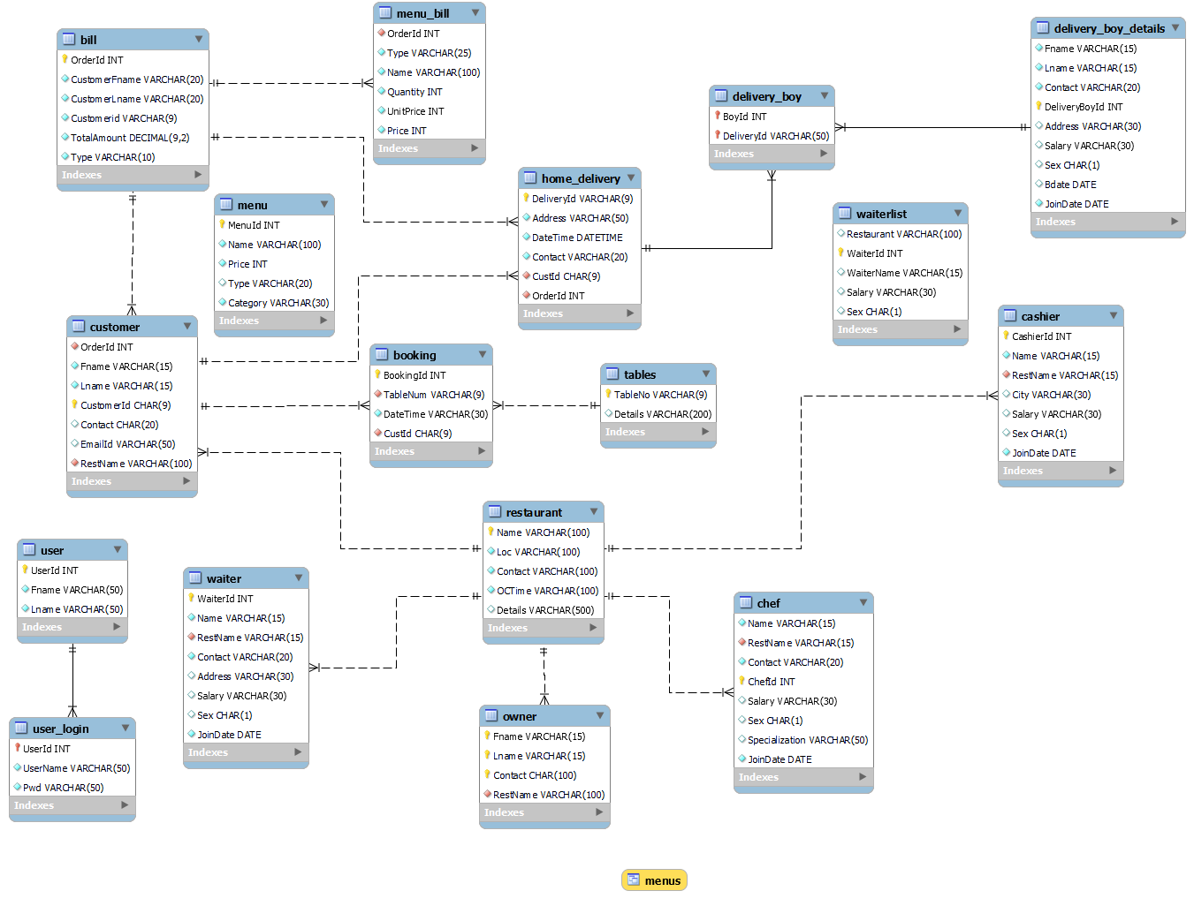

***QUERIES:***

1. Identify the restaurant where the food item with lowest price is eaten by maximum number of customers.

SELECT RestName, MAX(c) AS MaxCount FROM (SELECT RestName, COUNT(*) AS C FROM customer WHERE CustomerId IN (SELECT CustomerId FROM Bill WHERE OrderId IN (SELECT OrderId FROM Menu_bill WHERE Name = (SELECT Name FROM Menu WHERE Price = (SELECT MIN(Price) FROM Menu)))) GROUP BY RestName)T;



1. Identify the location of the restaurant where chef with highest salary is working.

SELECT R.Name, R.Loc AS RestaurantLocation, C.ChefId, C.Salary FROM Chef C JOIN Restaurant R ON R.Name = C.RestName WHERE C.Salary = (SELECT MAX(CAST(Salary AS SIGNED)) AS MX FROM Chef);



1. Identify the online orders done from city where maximum online orders have been placed.

SELECT * FROM (SELECT * FROM Bill WHERE Type = "Online")A JOIN Home_Delivery USING(OrderId) WHERE Address = (SELECT Address FROM Bill JOIN Home_Delivery USING(OrderId) WHERE Type = "Online" GROUP BY Address HAVING COUNT(*) = (SELECT MAX(C) FROM (SELECT Address, COUNT(*) AS C FROM Bill JOIN Home_Delivery USING(OrderId) WHERE Type = "Online" GROUP BY Address)T));



1. Which restaurant has the highest number of tables booked currently?

SELECT RestName FROM Customer C, Booking B, Tables T WHERE C.CustomerId = B.CustId AND B.TableNum = T.TableNum GROUP BY RestName HAVING COUNT(*) = (SELECT MAX(C) FROM (SELECT COUNT(*) AS C FROM Customer C, Booking B, Tables T WHERE C.CustomerId = B.CustId AND B.TableNum = T.TableNum GROUP BY C.RestName)A);



1. Find the details of tables booked in the restaurant where the highest paid waiter is working.

SELECT C.CustomerId, C.FName, C.Contact, B.RestName, Book.BookingId, Book.DateTime, T.TableNum, T.Details FROM Customer C, (SELECT WaiterId, Name, RestName FROM (SELECT * FROM Waiter WHERE Salary = (SELECT MAX(CAST(Salary AS SIGNED)) FROM Waiter))A)B, Booking Book, Tables T WHERE C.RestName = B.RestName AND Book.CustId = C.CustomerId AND T.TableNum = Book.TableNum;

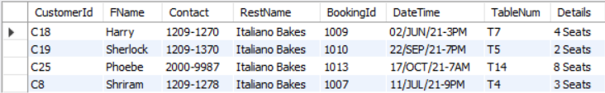

1. Display the details of restaurant and its chef where the order with maximum bill amount is made.

SELECT C.CustomerId, C.FName, C.LName, R.Name as RestaurantName, Ch.Name, Ch.Specialization, Ch.Salary, B.TotalAmount FROM Customer C, Bill B, Restaurant R, Chef Ch WHERE C.OrderId = B.OrderId AND C.RestName = R.Name AND R.Name = Ch.RestName AND TotalAmount = (SELECT MAX(TotalAmount) FROM bill);



1. Display the food items ordered by customer id C1.

SELECT C.CustomerId, C.Fname, C.EmailId, M.Name, M.Type, M.Quantity, M.UnitPrice, M.Price FROM Customer C, Bill B, Menu_bill M WHERE C.CustomerId = B.CustomerId AND C.CustomerId = "C1" AND B.OrderId = M.OrderId;

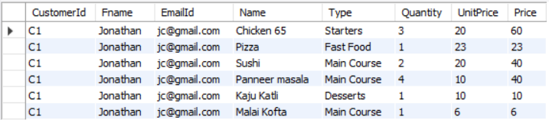

1. List the total amount gained by all owners in descending order.

SELECT * FROM Owner O NATURAL JOIN (SELECT C.RestName, SUM(B.TotalAmount) AS TotalAmount FROM Customer C JOIN Bill B USING(CustomerId) GROUP BY(C.RestName))A ORDER BY TotalAmount DESC;

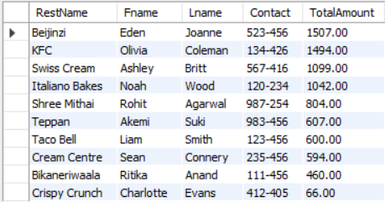

1. Display the orders placed by youngest delivery boy.

SELECT * FROM Delivery_Boy DB, Delivery_Boy_Details DBD, Home_Delivery HD WHERE HD.DeliveryId = DB.DeliveryId AND DB.BoyId = DBD.DeliveryBoyId AND BDate = (SELECT MAX(BDate) FROM Delivery_Boy_Details);



1. Display all employees working in a restaurant.

SELECT * FROM Waiter W JOIN (SELECT * FROM Cashier C JOIN Owner O USING(RestName))A USING (RestName);

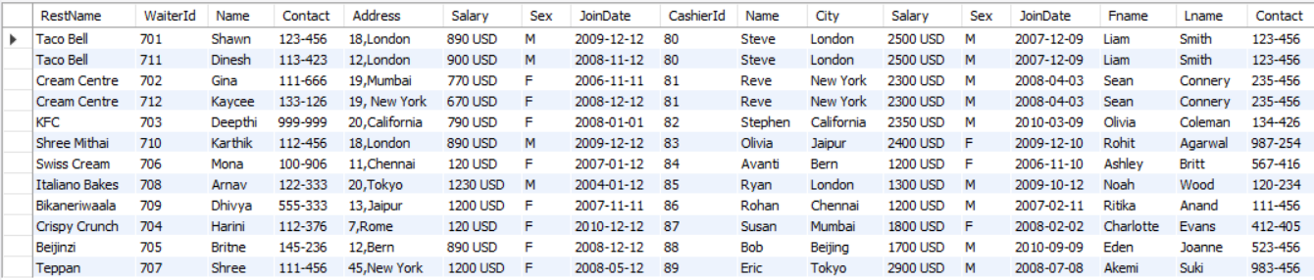

1. Which restaurant’s Indian dishes is liked by many people?

SELECT RestName, COUNT(*) AS MaxCount FROM Customer WHERE OrderId IN (SELECT DISTINCT OrderId FROM Menu_Bill WHERE Name IN (SELECT Name FROM Menu WHERE Category = "Indian")) GROUP BY RestName HAVING COUNT(*) = (SELECT MAX(C) FROM (SELECT RestName, COUNT(*) AS C FROM Customer WHERE OrderId IN (SELECT DISTINCT OrderId FROM Menu_Bill WHERE Name IN (SELECT Name FROM Menu WHERE Category = "Indian")) GROUP BY RestName)A);

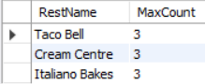

1. Display customer names who ate all dishes eaten by customer Id C5. (division)

SELECT CustomerId, FName, LName FROM Customer C WHERE NOT EXISTS (SELECT Name FROM (SELECT Name FROM Menu_Bill WHERE OrderId IN (SELECT OrderId FROM Customer WHERE CustomerId = "C5"))A WHERE Name NOT IN (SELECT Name FROM Menu_Bill MB WHERE MB.OrderId = C.OrderId));

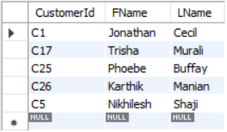

1. Find the restaurant which works for minimum hours.

SELECT * FROM Restaurant WHERE CAST(SUBSTR(OCTime, 11,3) AS SIGNED)+12 - CAST(SUBSTR(OCTime, 1, 2) AS SIGNED) = (SELECT MIN(diff) FROM (SELECT CAST(SUBSTR(OCTime, 11,3) AS SIGNED)+12 - CAST(SUBSTR(OCTime, 1, 2) AS SIGNED) AS diff FROM Restaurant)A);

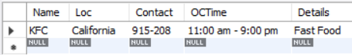

1. Get the details of vacant tables in restaurant .

SELECT TableNum, Details FROM Tables WHERE TableNum NOT IN (SELECT TableNum FROM Customer C, Booking B WHERE C.CustomerId = B.CustId AND C.RestName = "KFC");

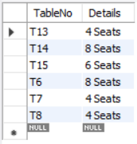

1. List, for every table, the number of times it has been booked, including those tables that have never been booked.

SELECT * FROM Tables LEFT OUTER JOIN Booking USING(TableNum);

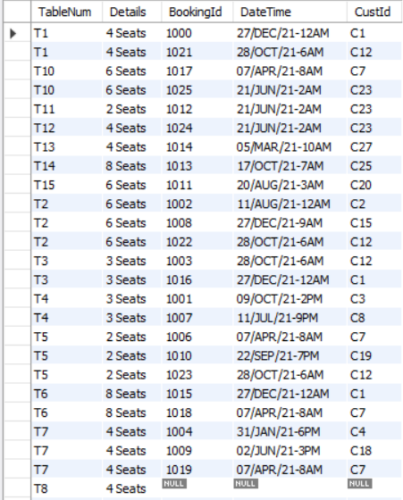



1. Create a view for Menu with its name and Price.

CREATE VIEW MENUS AS SELECT Name, Price FROM Menu;

DELIMITER //

CREATE PROCEDURE SHOW_MENU()

BEGIN

SELECT * FROM MENUS;

END //

CALL SHOW_MENU();

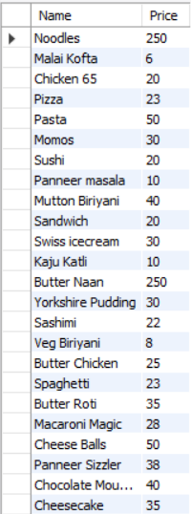

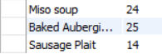

1. Display the details of the waiters who are working in the same restaurant.

CREATE PROCEDURE DEMO()

BEGIN

DECLARE Restaurant VARCHAR(100);

DECLARE WaiterId INT;

DECLARE Name VARCHAR(15);

DECLARE Salary VARCHAR(30);

DECLARE Sex CHAR(1);

DECLARE NoDatafound INT DEFAULT 0;

DECLARE Cur CURSOR FOR SELECT DISTINCT R.Name, W.Waiterid, W.Name, W.Salary, W.Sex FROM Restaurant R, Waiter W WHERE R.Name = W.RestName AND R.Name IN (SELECT DISTINCT Re.Name FROM Restaurant Re, Waiter Wa WHERE Re.Name = Wa.RestName GROUP BY Re.Name HAVING COUNT(*) >= 2) ORDER BY R.Name;

DECLARE CONTINUE HANDLER FOR NOT FOUND SET NoDatafound = 1;

DECLARE CONTINUE HANDLER FOR SQLSTATE '02000' SET NoDatafound = 1;

DECLARE CONTINUE HANDLER FOR SQLSTATE '23000' SET NoDatafound = 1;

OPEN Cur;

LABEL: LOOP

IF NoDatafound = 1 THEN

LEAVE LABEL;

END IF;

IF NOT NoDatafound = 1 THEN

FETCH Cur INTO Restaurant, WaiterId, Name, Salary, Sex;

INSERT INTO WaiterList VALUES(Restaurant, WaiterId, Name, Salary, Sex);

END IF;

END LOOP LABEL;

CLOSE Cur;

END $$

CALL DEMO();

SELECT * FROM WaiterList;

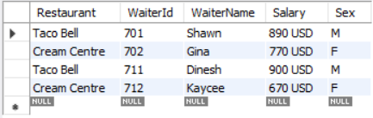

1. Write a trigger for updating salary of chef by 10% when customer orders more than 5 food items from his/her restaurant.

DELIMITER ^^

CREATE TRIGGER OnUpdate AFTER INSERT ON Customer FOR EACH ROW

BEGIN

DECLARE cou INT;

SELECT COUNT(*) INTO cou FROM Customer GROUP BY new.RestName;

IF cou > 5 THEN

UPDATE chef SET Salary = Salary + Salary*0.10 WHERE RestName = new.RestName;

END IF;

END ^^

INSERT INTO BILL VALUES(927,"Enola","Holmes","C28",100,"Dine-in");

INSERT INTO MENU_BILL VALUES(927,"Main Course","Sushi",5,20,100);

INSERT INTO CUSTOMER VALUES(927,"Enola","Holmes","C28","1908-8989","eno@gmail.com","KFC");

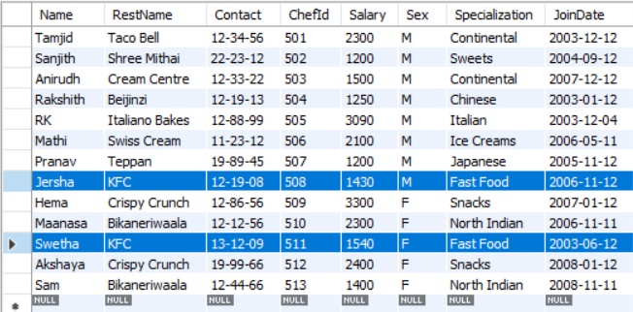

1. Display the cashier who got highest salary who lives in city which has letter ‘a’.

SELECT * FROM Cashier WHERE Name IN (SELECT Name FROM Cashier WHERE city LIKE "%a%") AND Salary = (SELECT MAX(Salary) FROM cashier WHERE city LIKE "%a%");

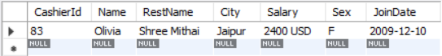

1. Delete menu which is ordered least.

DELETE FROM MENU WHERE Name IN (SELECT Name FROM MENU_BILL GROUP BY Name HAVING COUNT(*)=(SELECT MIN(c) FROM (SELECT COUNT(*) AS c FROM MENU_BILL GROUP BY Name)A));

