SELECT CONCAT(a.fName, ' ', a.mName, ' ', a.lName) AS fullname,

SUM(c.requestedQty) AS requestedQty, b.title FROM tbl_customer_info a

JOIN tbl_rents_info c ON a.id = c.tbl_customer_info_id

JOIN tbl_movie_info b ON b.id = c.tbl_movie_info_id

GROUP BY fullname, b.title;

SELECT CONCAT(a.fName, ' ', a.mName, ' ', a.lName) AS fullname, b.title,

DATE_FORMAT(c.requestedDate, '%M') AS month,

YEAR(c.requestedDate) AS year,

SUM(c.requestedQty) AS requestedQty

FROM tbl_customer_info a

JOIN tbl_rents_info c ON a.id = c.tbl_customer_info_id

JOIN tbl_movie_info b ON b.id = c.tbl_movie_info_id

GROUP BY fullname, b.title, month, year ORDER BY fullname, year, STR_TO_DATE(month, '%M'), b.title;

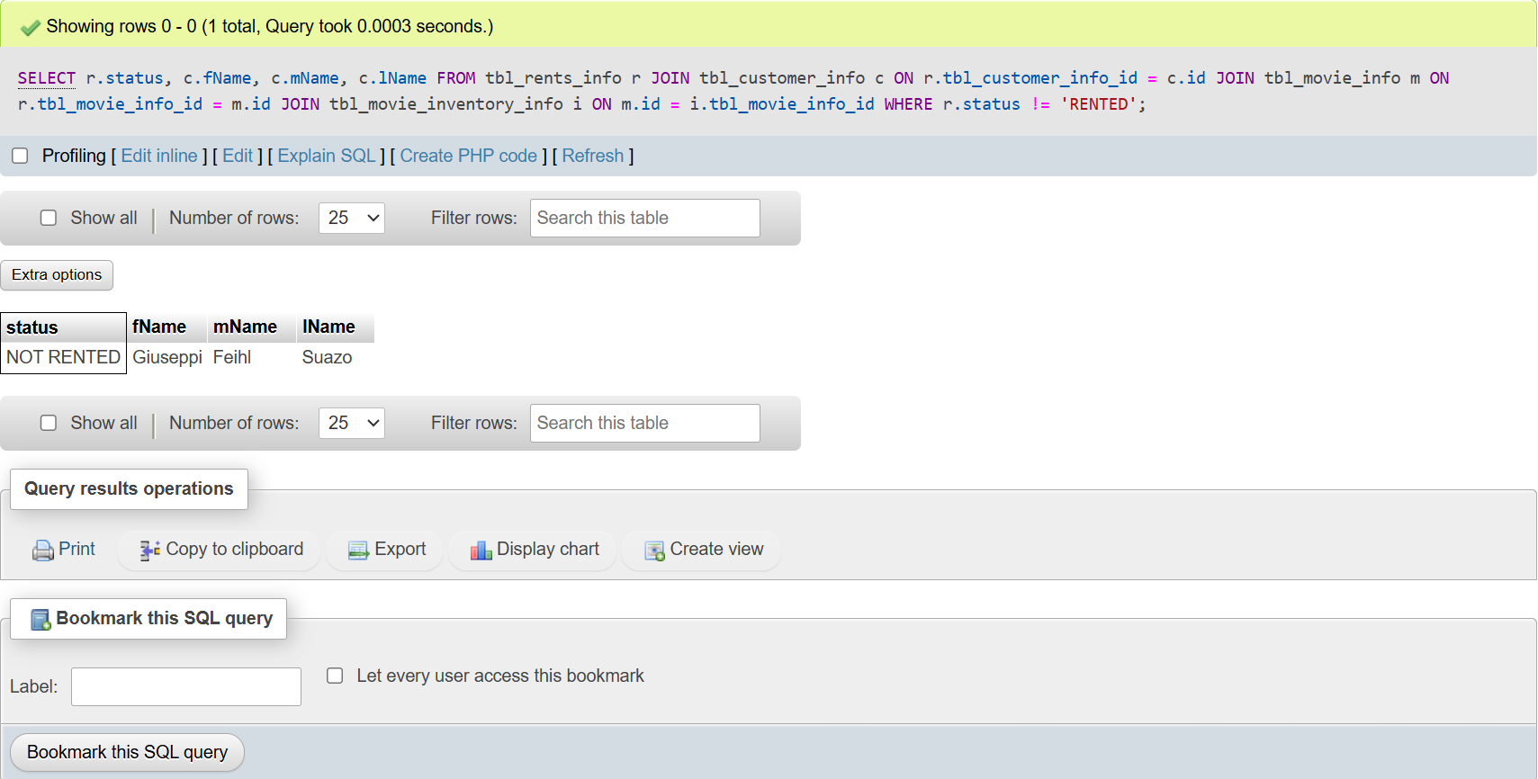

SELECT r.status, c.fName, c.mName, c.lName

FROM tbl_rents_info r

JOIN tbl_customer_info c ON r.tbl_customer_info_id = c.id

JOIN tbl_movie_info m ON r.tbl_movie_info_id = m.id

JOIN tbl_movie_inventory_info i ON m.id = i.tbl_movie_info_id

WHERE r.status = 'NOT RENTED';