**Mathematics Learning Experience for Grade 3 (C10)**

Game : Peel Me !

Solving Problems Involving Multiplication and Addition/Subtraction

How to Play :

1. The class will be grouped into 4 and sat in a circle.

Tumpukun in klas pa 4 iban limingkud magtibulung.

2. Play some cool music and have the children pass the cabbage around the circle. When the music stops, the group to which the pupil belongs who was holding the cabbage must peel off a layer.

Buhian in kalangan iban papagpaspasun in manga bata-iskul sin cabbage ha katilibut sin circle. Pagduhung sin kalangan, in tumpukan kiyalamuran sin bata-iskul nag-uulin sin cabbage igun in hangkalapis pais.

3. The group will read and solve the word problem using the appropriate strategy that they know. If they get the correct answer the group will earn 5 points. If they failed other groups will be given a chance to answer and earn 5 points if they answer it correctly.

Bassahun iban jawabun sin tumpukan in word problem mag-usal sin patut strategy kaingatan nila. Bang amu in jawab sin tumpukan makakawa sila 5 points. Bang bukun amu in jawab nila sumubli in dugaing tumpukan iban makakawa sila 5 points bang amu in jawab nila.

4. Same procedure will follow. The group with highest point will be the winner.

Sibu aturan in agarun. In tumpukan makakawa mataud tuud points amuin dumaug.

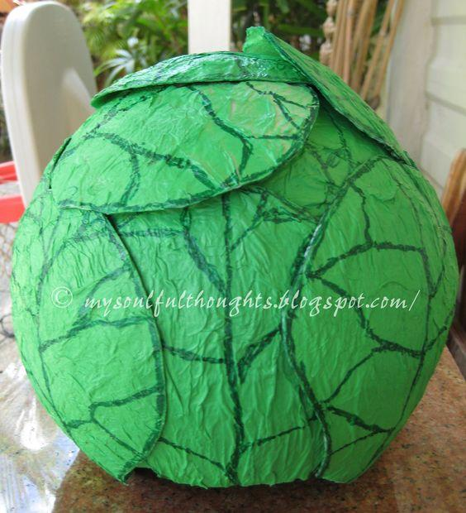

Note: The cabbage that will be use is made up green papers.

Each problem will be written on each layer.

Sample word problems to be place in each layer of the cabbage.

1. Raul bought 3 shirts for P 120.00 each. If he had P 400.00, how

much change would he get?

Nami hi Raul 3 badju ha halga P 120.00 in hambuuk. Bang sila awn P 400.00, pilasin in makawa niya hulug?

2. In a school canteen , 4 pupils can sit in a square table. How

many pupils can sit in three square tables placed end to end?

Ha school canteen, 4 bata-iskul in makalingkud ha magpasagi lingkuran. Pila bata-iskul in makalingkud ha 3 magpasagi lingkuran hibutang ha ruhul pa ruhul?

3. In a food chain, Marie treated her 5 friends with value meals. If

each meal costs P 75.00, how much did Marie pay in all ?

Ha food chain, Libri hi Marie in 5 bagay ha value meals. Bang in halga sin tiyaptiyap meal P 75.00, pilasin in kiyabayad hi Marie?

4. Noli and Lito have 40 marbles each. Their playmate Joel has 3

times the number of Noli’s marbles. How many marbles does

Joel have?

Hi Noli kay Lito awn kaniya-kaniya 40 marbles. In iban nila hi Joel maka 3 lipatun in taud sin marbles niya dayng kan Noli. Pila in marbles hi Joel?

5. Aling Nida sold 55 mangoes on Monday and 110 on Tuesday. Each mango cost P 20.00, how much sale did Aling Nida have ?

Nagdagang hi Babu Nida 55 mangga sin Isnin iban 110 sin Salasa. P 20.00 in halga sin tiyaptiyap mangga, pilasin in nagbaya kan Babu Nida?

6. Mr. Santos has 25 boxes of noodles. Each box contains 100

packs. She gave 1 850 packs to the victims of Mount Mayon

evacuees. How many more packs of noodles were left?

Awn 25 labban noodles hi Mr. Santos. In tiyaptiyap labban 100 pusut in luun. Nagdihil siya 1 850 pusut pa paguy sin Mount Mayon. Pila pusut noodles pa in nakapin?

7. Mrs. Reyes has a son and 2 daughters. She gave each of them

P 20.00 for their snacks everyday. How much does Mrs. Reyes

give his children everyday?

Awn hambuuk anak usug iban 2 anak babai hi Mrs. Reyes. Dihilan niya P 20.00 in tiyaptiyap hangkatau para snacks nila adlaw-adlaw. Pilasin in hipagdihil hi Mrs. Reyes pa manga anak hangkaadlaw?

8. Liz and Ness have one garden plot each. Liz has 3 rows of 11

okra each while Ness has 5 rows of 10 okras each. How many

okra plants do they have altogether?

Hi Liz kay Ness awn kaniya-kaniya pagtatanuman. Hi Liz awn 3 tiranan ukra salta 11 ukra in tiyaptiyap tiranan ubus hi Ness awn 5 tiranan salta 10 ukra in tiyaptiyap tiranan. Pilangkapuun in ukra nila katan?

9. A carnival ticket costs P 150.00 for adults and P 75.00 for

children. There were 35 adults and 25 children who went to the

carnival. How much did they pay in all ?

In halga sin ticket karnibal P150.00 para ha manga taumaas iban P 75.00 ha manga bata-bata. 35 in manga taumaas iban 25 in manga bata-bata miyadtu pa karnibal. Pilasin in kiyabayad nila katan?

10. There are 3 bundles of popsicle sticks. If each bundle contains

5 dozens, how many popsicle sticks are there in all?

Awn 3 butuk tangkay ayskarap. Tiyaptiyap butuk 5 dusina in luun, pila katan in taud sin tangkay ayskarap?

11. Miss Gonzales bought 9 cans of milk at P 48.00 per can. How

much change did she receive from her one thousand peso bill?

Nami hi Miss Gonzales 9 mital gatas ha halga P 48.00 in hambuuk. Pilasin in kiyahulug ha pinta hang-ibu niya?

12. Paring bought 4 boxes of eggs. Each box has 12 eggs. If 22 eggs

are red, how many eggs are white?

Nami hi Paring 4 labban iklug. Tiyaptiyap labban 12 iklug in luun. Bang pula in 22 iklug, pila iklug in puti?