Retina blood vessel segmentation with a convolution neural network (U-net)

In this project we are using CNN U-net model to segment retina images and to get retina blood vessel and to train this model we need thousands of images to get better result but those images are not available on internet and the images are available at DRIVE DATABASE but this website not allowing to download so we are using STARE dataset which contains only 28 images due to that reason our model not showing segmentation clearly but able to segmented image. Below is the dataset screen shots used to train U-net model

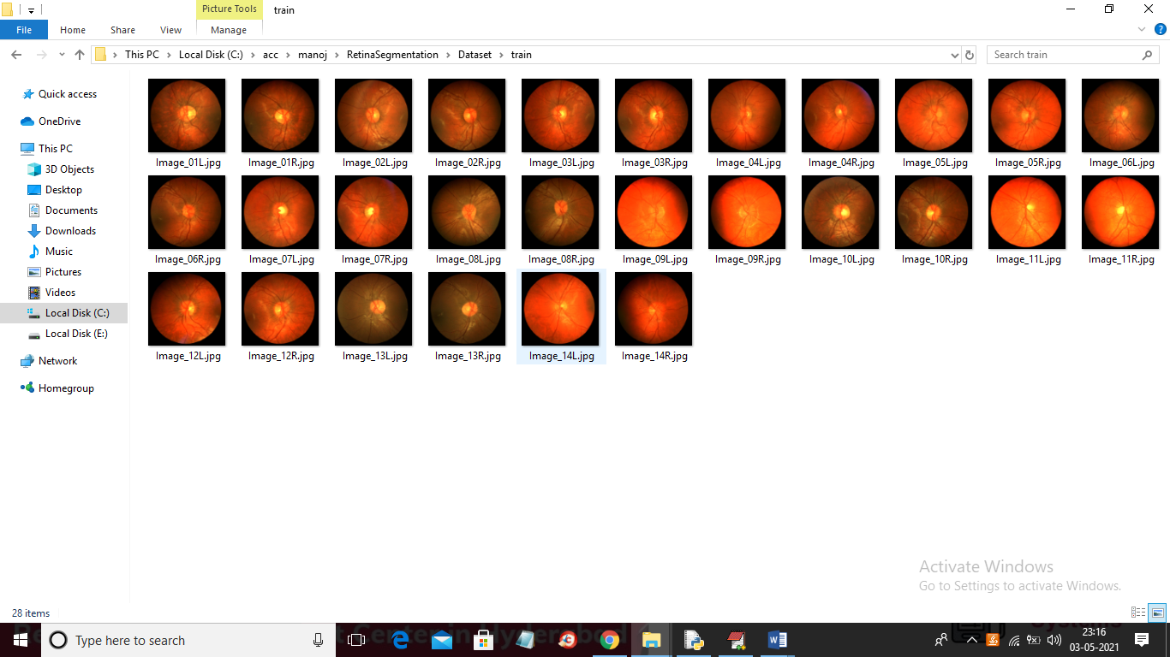

Below is the segmented images used to train U-net model

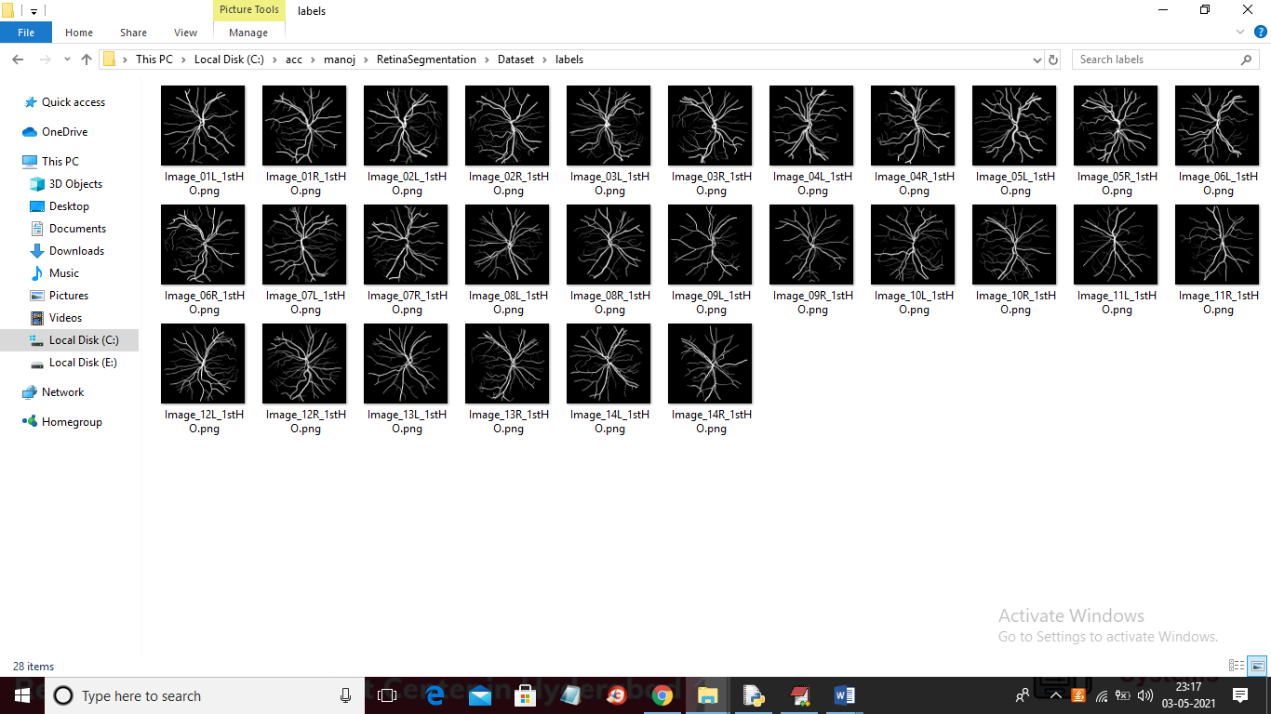

By using above dataset we are training U-net model and when we upload new test image then U-net will give segmented image as output.

SCREEN SHOTS

To run project double click on ‘run.bat’ file to get below screen

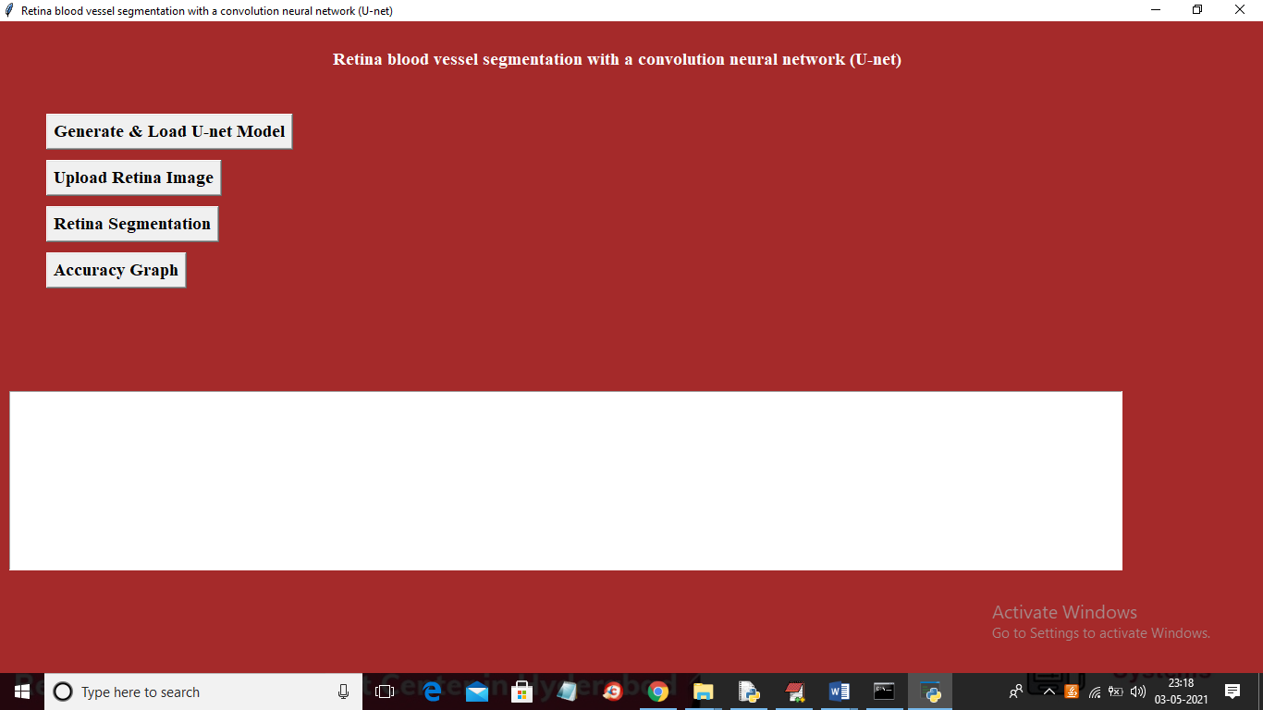

In above screen click on ‘Generate & Load U-net Model’ button to load U-net model

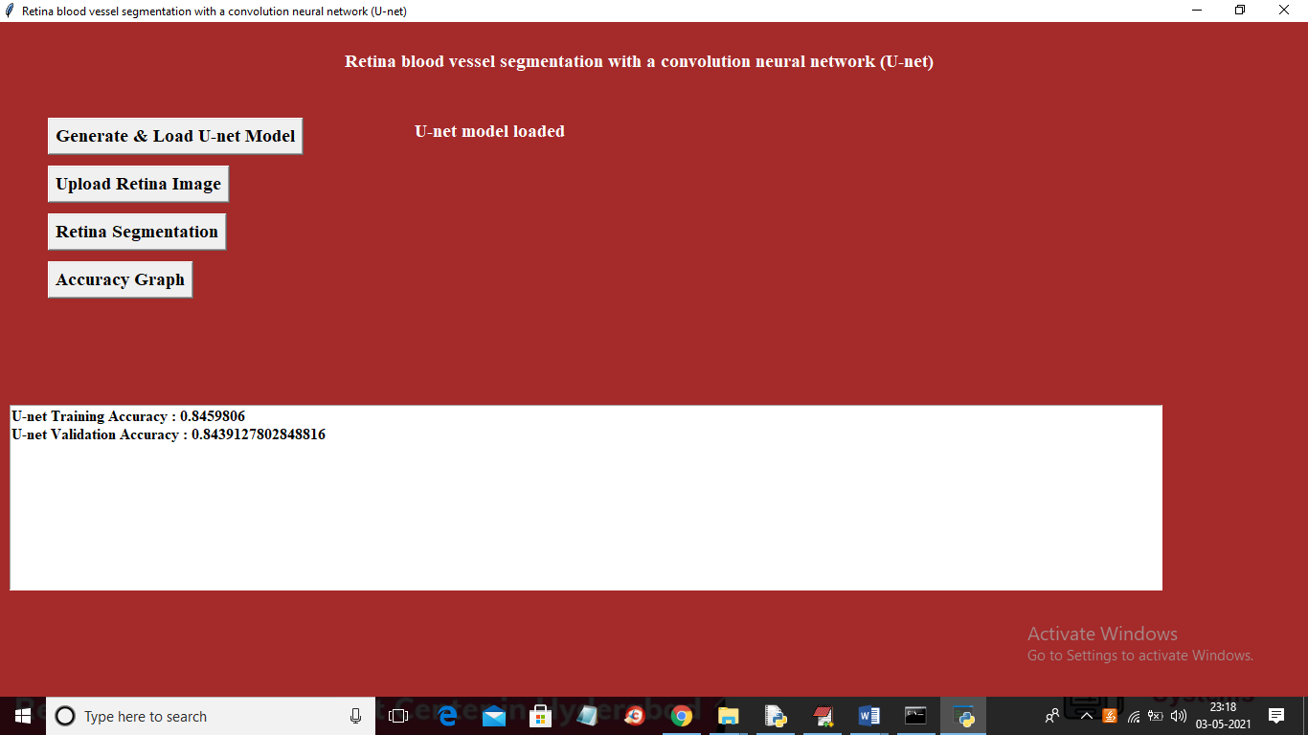

In above screen U-net model generated and we got its accuracy as 0.84% and because of less dataset size accuracy is not better and if you provide huge size dataset then this accuracy can be increase. Now click on ‘Upload Retina Image’ button to upload retina image

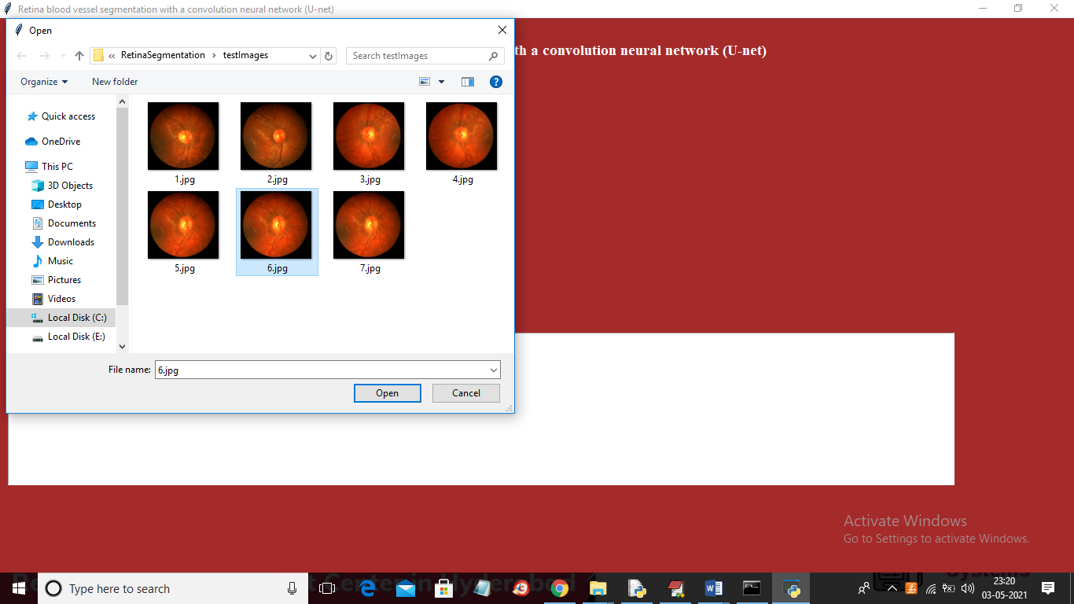

In above screen selecting and uploading ‘6.jpg’ file and then click on ‘Open’ button to load image and to get below screen

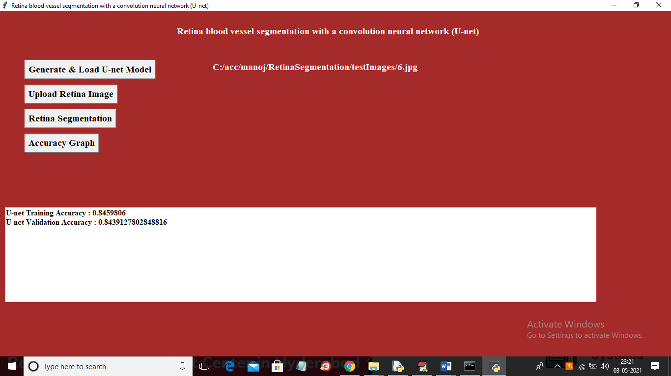

In above screen test image is loaded and now click on ‘Retina Segmentation’ button to get below output

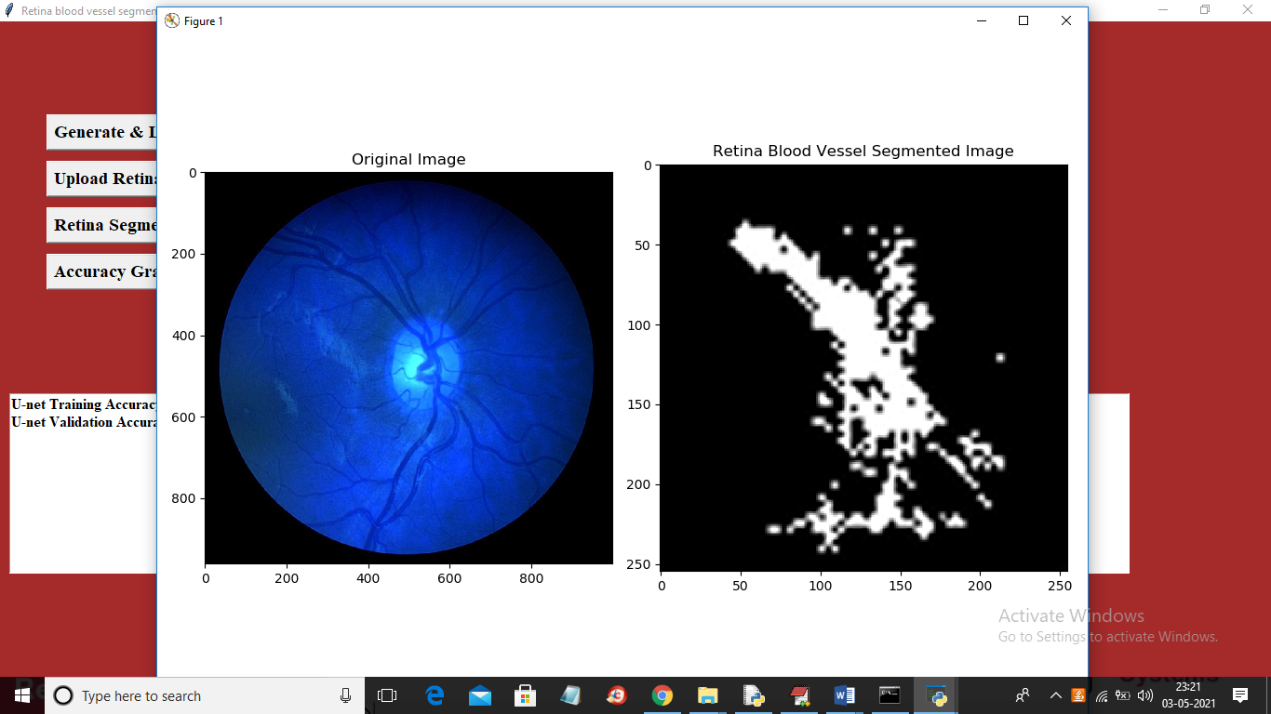

In above screen first image is the original image and second image is the segmented image and in dataset also you can see segmented image contains only lines. Now test other image

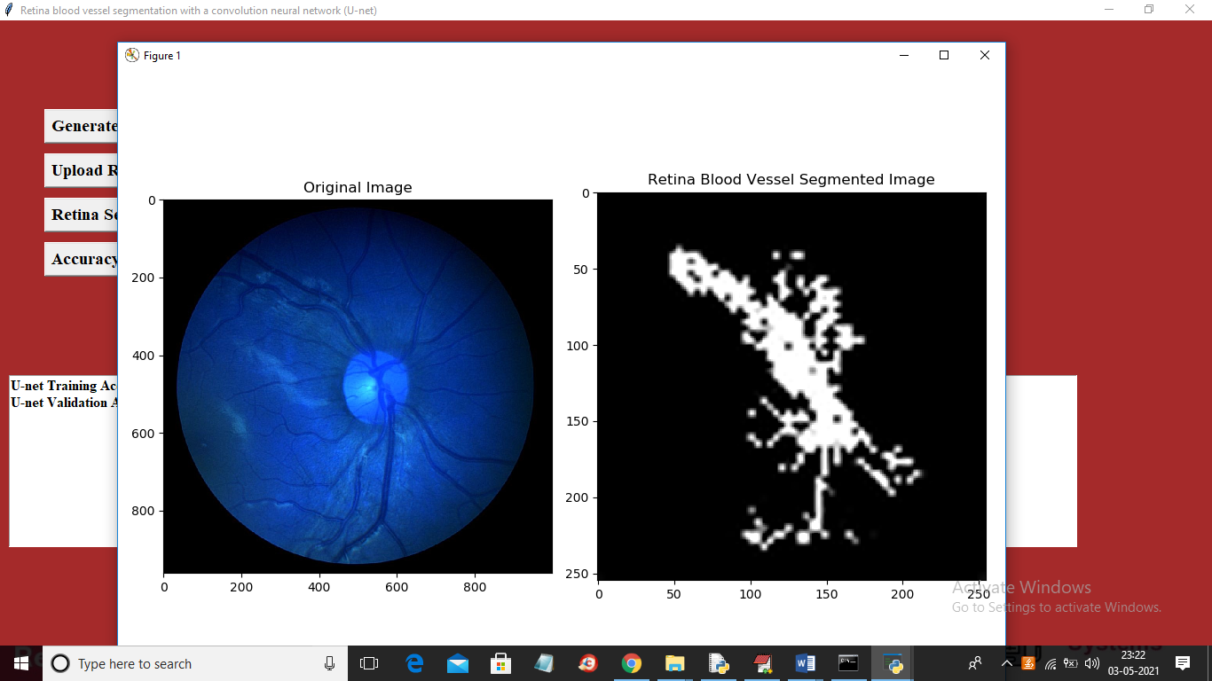

Similarly you can upload other images and test.

Note: Due to short dataset size segmentation output is not clear but still application able to do segmentation and if you provide nearly 3000 images dataset then application can perform segmentation properly and it will take days of time also for training. Now click on ‘Accuracy Graph’ button to get below graph

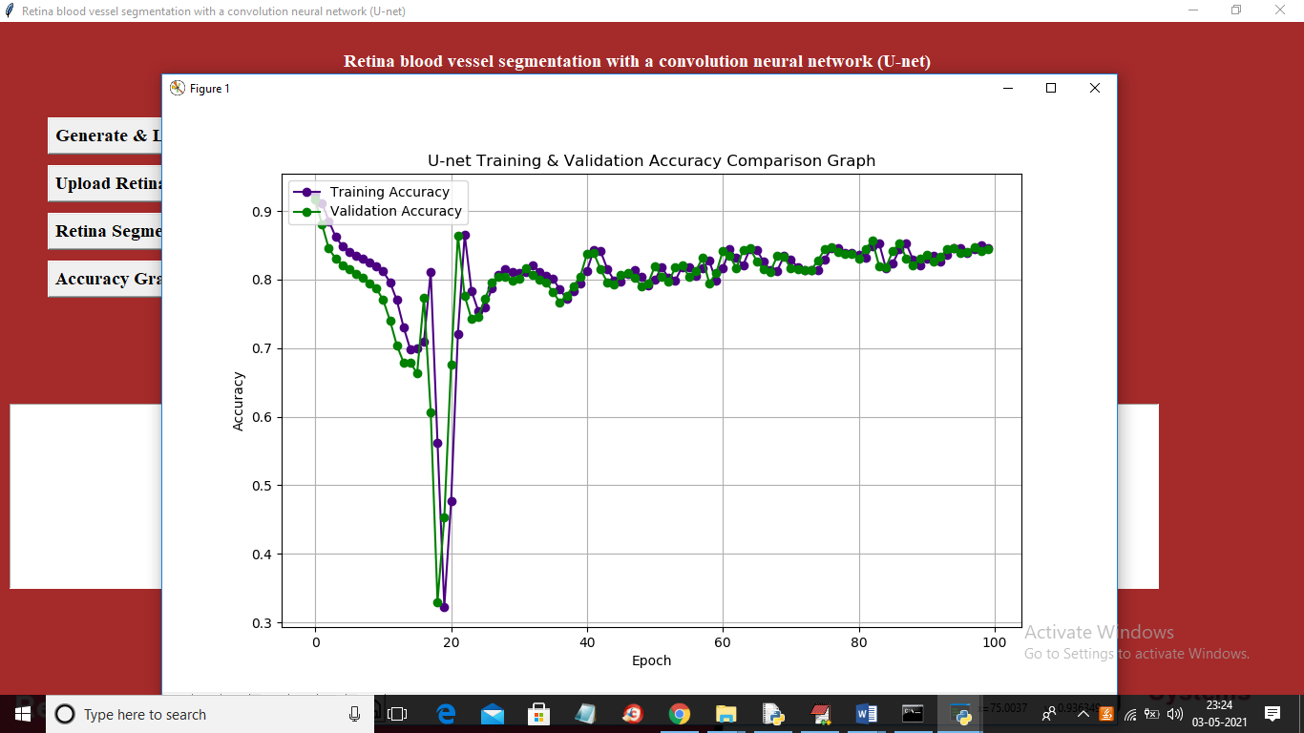

In above graph x-axis represents EPOCH and y-axis represents accuracy and in above graph blue line represents training accuracy and green line represents validation accuracy and in above graph we can see with each increasing epoch both training and validation accuracy gets better and better