John Scales

Bradley Keizer

Christopher Weichlein

**Contributions**

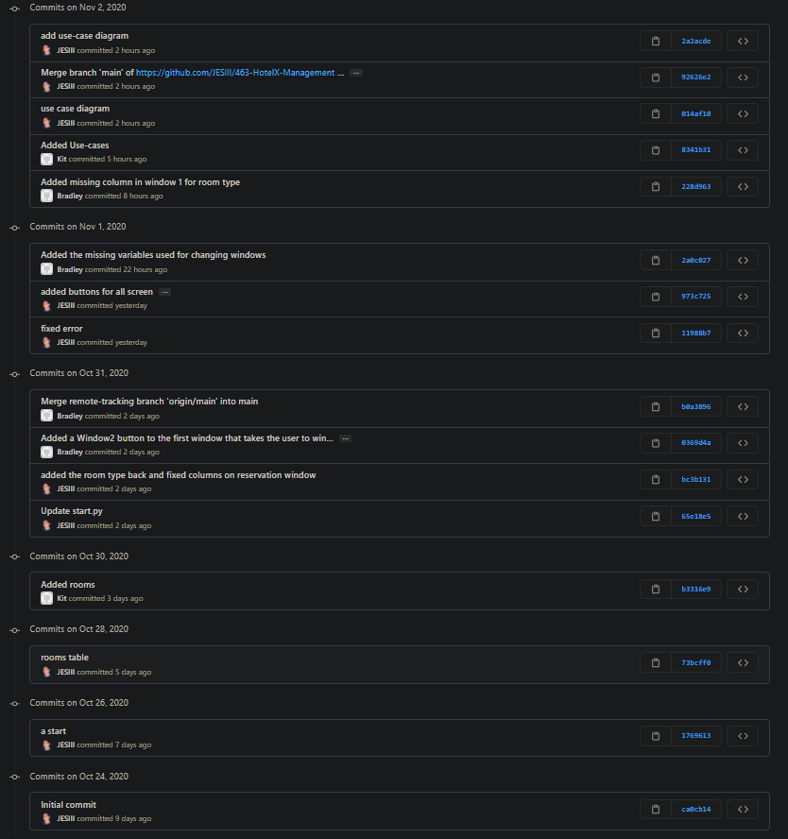

**Screens**



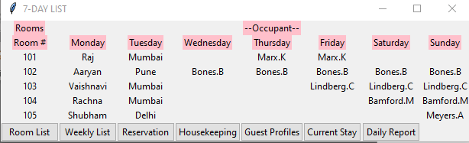



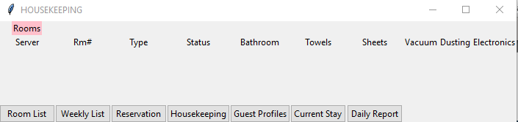







(UPDATE: Fixed Guest Search)

