DIGITAL IMAGE PROCESSING
ASSIGNMENT 2

NAME: Arham Naeem
ID: F2023266440

SECTION: V2

Q1: Given an input Image Fig1.
Write down MATLAB code to produce results in
Fig.2, 3, & 4 by applying only Gamma
Transformation forc = 1.

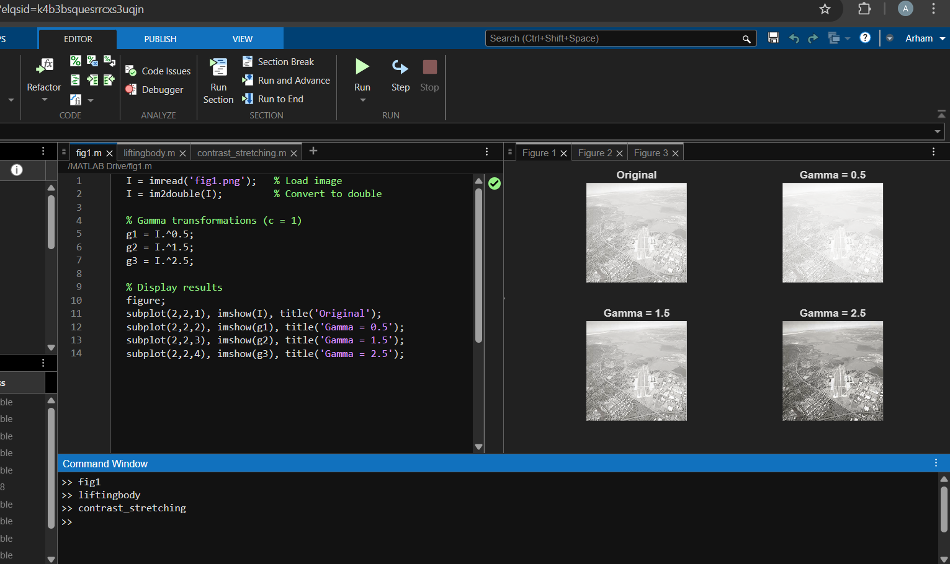
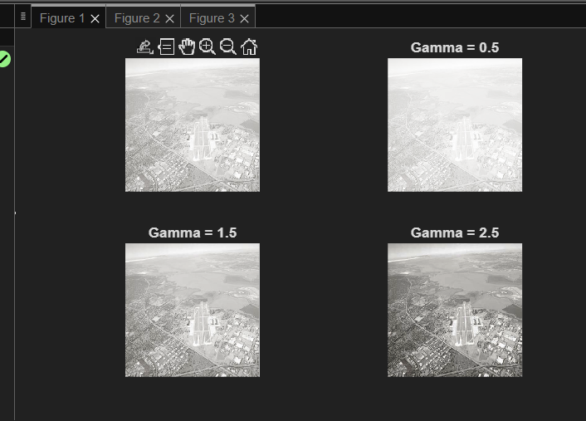
Q2: Identify which intensity transformation was used on MATLAB's built-in liftingbody.png
To create each of the four results below.
Write a complete MATLAB script to reproduce the results using the intensity transformation functions.

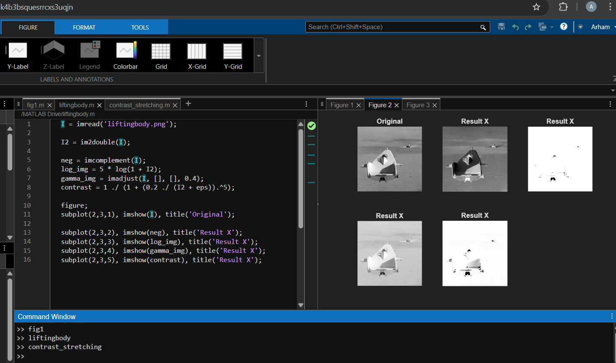
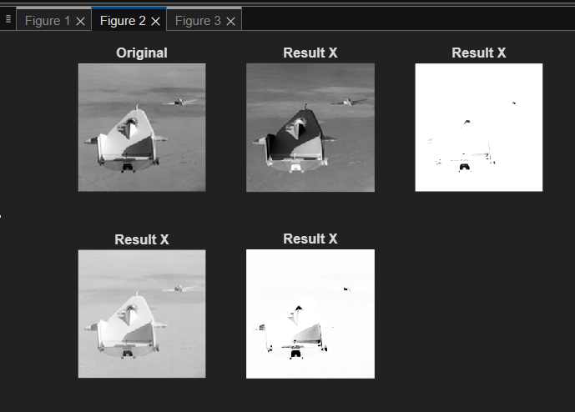

Q3: Write a MATLAB Code to produce figure in right hand from input image on left side by only Contrast Stretching technique?

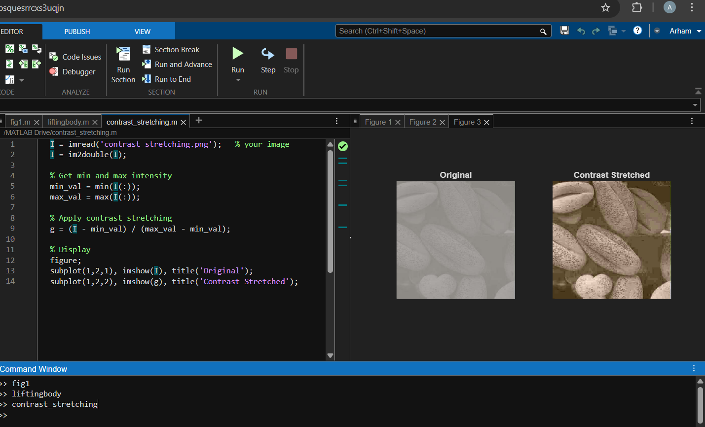
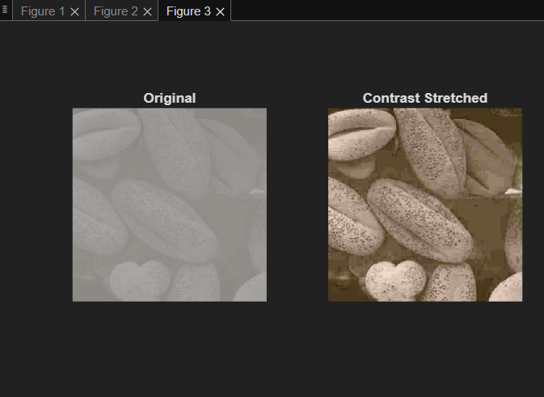

Q4: Write a MATLAB function for following Task

Exercise: itrans.m
is capable of doing all of the intensity transformations mentioned above.
function g = intrans(f, varargin)

ANS:

function g = intrans(f, varargin)

% Convert to double
f = im2double(f);

% Get transformation type
type = varargin{1};

switch lower(type)

% Negative
case 'neg'
g = imcomplement(f);

% Log Transformation
case 'log'
c = varargin{2};
g = c * log(1 + f);

% Gamma Transformation
case 'gamma'
gamma = varargin{2};
g = f .^ gamma;

% Contrast Stretching
case 'stretch'
m = varargin{2};
E = varargin{3};
g = 1 ./ (1 + (m ./ (f + eps)).^E);

otherwise
error('Unknown transformation type');
end

end

Q5: Write a MATLAB function for following Task

Write an M-Function to scale the image to the full, maximum range, [0, 255] or [0,65535]. In addition, the function should map the output levels to a specified range.

Syntax: g = gscale(f, method, low, high) Valid methods: full8 or full16.

ANS:
function g = gscale(f, method, low, high)

% Convert to double for processing
f = double(f);

% Get min and max of input image
f_min = min(f(:));
f_max = max(f(:));

% Normalize to [0,1]
g = (f - f_min) / (f_max - f_min);

% Scale to required output range [low, high]
g = low + (high - low) * g;

% Convert to required full range
switch lower(method)

case 'full8'
% Clamp and convert to uint8
g = uint8(255 * (g - low) / (high - low));

case 'full16'
% Clamp and convert to uint16
g = uint16(65535 * (g - low) / (high - low));

otherwise
error('Invalid method. Use full8 or full16');
end

end

