DIGITAL IMAGE PROCESSING
ASSIGNMENT 3

NAME: ARHAM NAEEM
ID: F2023266440
SECTION: V2

Q1: Linear Spatial Filtering — Explanation of Code & Results
The code performs linear spatial filtering using a 31×31 box filter (all ones) on boxes.tif.
Why imshow(g, []) is needed for uint8 result?
When filtering with w = ones(31) (961 ones), each output pixel is the sum (not average) of 961 neighborhood pixels. For a uint8 image with max value 255:
Maximum possible output = 255 × 961 = 245,055
This far exceeds the uint8 range [0, 255], causing overflow/saturation almost all values clip to 255, making the image appear mostly white. Using imshow(g, []) auto-scales the display to the actual min/max range, revealing the true filtered result.
For the double version (gd), values are in [0,1] range, so after filtering the output range is [0, 961] imshow(gd, []) again auto-scales correctly.

Q2: Linear Spatial Filtering

Part (a): Conceptual Explanations
i. Why is boxes.tif NOT blurred around the outside boundary of black boxes?
The 'replicate' padding option replicates the border pixels of the image outward before filtering. Since the background pixels surrounding the black boxes are white (255), the replicated padding fills the border with white values. When the filter kernel overlaps the boundary, it averages white background values — so no blurring/spreading of black edges occurs at the outer boundary. The black box edges that touch the image border appear sharp because the padding mimics more white background, not black box pixels.
ii. Why don't corners of black boxes join when using uint8 data type?
With uint8, the convolution result saturates at 255 (overflows). The filter ones(31) sums 961 values. Even a small number of white pixels in the neighborhood pushes the sum above 255, which gets clipped to 255 — displaying as white. So the blurred "halos" around black regions that might otherwise create a bridge between boxes are clipped to white, preventing the corners from appearing to join. With double, no clipping occurs, so the gray halos are visible and boxes appear to merge at corners.

B: Consider an image f=[1 0 0 0 0; 0 2 0 0 0; 0 0 3 0 0; 0 0 0 4 0; 0 0 0 0 5]. Filter it by hand with mask w=[-1 -1 -1; -1 8 -1; -1 -1 -1] with padding of i. Zeroes ii. Symmetric iii. Replicate iv. Circular Verify your results through Matlab.

Padded f (zero padding):
[0 0 0 0 0 0 0]
[0 1 0 0 0 0 0]
[0 0 2 0 0 0 0]
[0 0 0 3 0 0 0]
[0 0 0 0 4 0 0]
[0 0 0 0 0 5 0]
[0 0 0 0 0 0 0]

For pixel (1,1), value=1:
Neighborhood × mask:
[0×(-1) + 0×(-1) + 0×(-1)]
[0×(-1) + 1×(8) + 0×(-1)]
[0×(-1) + 0×(-1) + 2×(-1)]
= 0+0+0+0+8+0+0+0-2 = 6

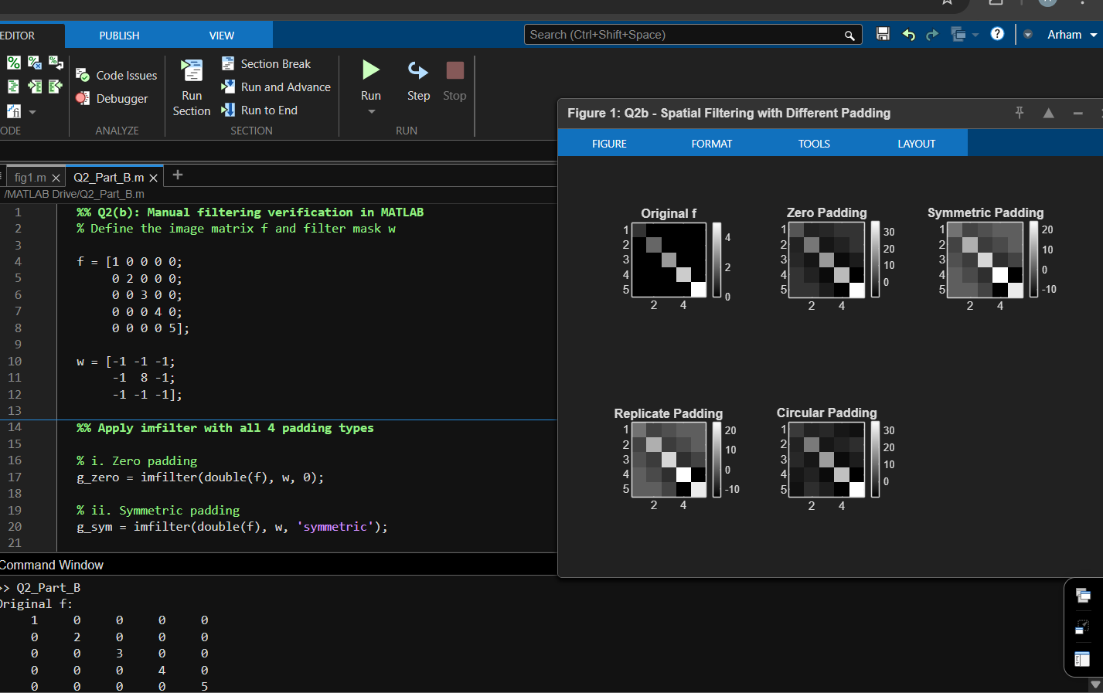

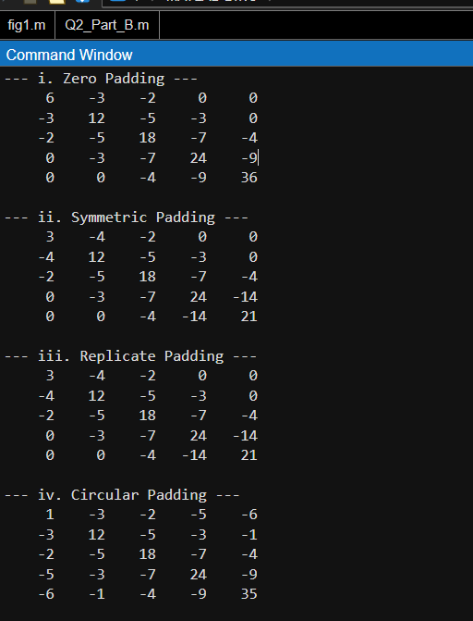

Q3: Averaging Mask for Gap Bridging

Part (a): Minimum Mask Size
Problem Setup:
After binarization and thinning, characters appear as strings of binary 1s on a background of 0s. Due to noise, gaps of 1 to 3 pixels appear in these strings. The worst-case gap to bridge is therefore 3 pixels wide.
Reasoning:
Consider the worst-case scenario — a 3-pixel gap between two string segments:
1 1 [0 0 0] 1 1pos: 1 2 3 4 5 6 7
The critical pixel is at the leftmost edge of the gap (position 3). This is the hardest pixel to bridge because the nearest binary 1 on its right side is at position 6 — a distance of 3 pixels away.
For the averaging mask centered at position 3 to produce a nonzero output, it must reach far enough to include that 1 at position 6. This requires a mask radius of at least 3:
Radius r = 3 → n = 2r + 1 = 2(3) + 1 = 7
Verification: A 7-pixel mask centered at position 3 spans positions (3−3)=0 to (3+3)=6, which includes the 1 at position 6. The output is nonzero — the bridge is successfully created.
A 5×5 mask (radius = 2) centered at position 3 would only reach position 5, which is still 0. The bridge would fail. So 5×5 is insufficient.
Answer: The minimum odd-sized averaging mask is 7×7.

Part (b): Minimum Threshold After Blurring
Setup:
After blurring with the 7×7 averaging mask, we threshold the result back to binary. The threshold must be:
- Low enough to preserve all bridged gap pixels (which have small nonzero values)
- The true background pixels (surrounded entirely by 0s) remain exactly 0, so any positive threshold will correctly exclude them
Worst-Case Blurred Value at a Gap Pixel:
The worst case is again the leftmost gap pixel (position 3). Since the character string is only 1 pixel wide after thinning, the 7×7 mask window centered at position 3 captures exactly 2 ones from the surrounding row — one from the left segment (position 2) and one from the right segment (position 6):
Blurred value = (number of 1s in window) / (window size) = 2/49 ≈ 0.0408
Determining the Threshold:
The absolute minimum blurred value any gap pixel can have is when only a single 1 falls within the mask window:
Minimum possible blurred value = 1/49 ≈ 0.02
The threshold must be less than or equal to this minimum to ensure no bridged pixel is lost:
T_min = 1/49 ≈ 0.02 (normalized, pixel values in [0, 1])
For an 8-bit image this is equivalently T_min = 255/49 ≈ 5 out of 255.
Any pixel that received even a single 1 from the blurring step will have value ≥ 1/49 and will survive the threshold. True background pixels have blurred value = 0 and are correctly excluded.
Answer: The minimum threshold is T = 1/49 ≈ 0.02 (normalized), or ≈ 5 for an 8-bit image.

Q4: Why Smaller Mask (n=25) Merges Bars but Larger Mask (n=45) Does Not?
Given:
- Vertical bars: 5 pixels wide, separation: 20 pixels
- Images blurred with masks: (a) n=23, (b) n=25, (c) n=45
The total period of the bar pattern = bar width + gap = 5 + 20 = 25 pixels
For mask n = 25 (image b) bars MERGE:
When the mask size equals exactly the period of the pattern (25 pixels), the averaging window integrates exactly one full period. At any position, the mask captures the same proportion of bar vs. gap, producing a uniform output — all pixels get the same average value. This makes the bars completely disappear/merge into a flat gray region.
This is equivalent to the mask acting as a perfect low-pass filter that completely eliminates the fundamental frequency (1/25 cycles/pixel) of the bar pattern.
For mask n = 23 (image a) bars remain visible:
n=23 < 25: the mask is smaller than the period. It does not integrate a full period, so some variation between bar and gap pixels is preserved. The bars are blurred but still distinguishable.
For mask n = 45 (image c) bars remain visible:
n=45 > 25 but n=45 = 1 period (25) + 20 pixels extra. While larger, 45 is not a perfect multiple of 25. The frequency response of a rectangular filter has nulls at multiples of 1/n. The bar frequency 1/25 is NOT a null of the 45-point filter (null at 1/45, 2/45, ...). Therefore the filter does not completely cancel the bar frequency and some contrast remains.
n=25 hits the bar frequency exactly at a null of its frequency response, perfectly canceling it. n=45 does not.
Conclusion:
The mask of size n = 25 merges the bars because 25 equals the exact spatial period of the bar pattern (5px bar + 20px gap), causing the averaging filter to integrate exactly one complete cycle and produce uniform output. The larger mask (n=45) doesn't hit this resonance and thus preserves some bar contrast.

